Evidências — Módulo 1 (Básico 1): exercícios solicitados × implementados
Plataforma: app.worldteachingschool.com.br — módulo "Basico 1 - Introducao ao Ingles"
Data: 14/10/2026
Como ler: para cada exercício dos documentos da cliente, a coluna da esquerda traz o texto solicitado e a da direita o print do exercício como aparece na plataforma, com o número do exercício dentro do tópico. O contador "1/N" no topo da tela foi recortado porque os prints foram abertos individualmente.
Resumo: 144 exercícios solicitados nos documentos → 142 implementados integralmente, 2 parciais, 0 ausentes. O Tópico 4 (Numbers, Colors & Basic Adjectives) não consta neste documento porque a cliente não enviou especificação para ele.

Tópico 1 — Alphabet & Sounds
Documento da cliente: Básico — Alphabet & Letter Sounds • 15 exercícios solicitados

Reading 1. Wrong Name Tag
✅ FEITO → Plataforma: Tópico 1, exercício(s) #21 (reading_comprehension)
Solicitado no documento  Ben introduces himself:  “Hi, I'm Ben. B-E-N.”  His name tag says:  VEN  What's wrong?  A) The first letter is wrong ✅  B) The last letter is wrong  C) Ben has a new name  Correct answer: A  Feedback: Ben starts with B, not V. B-E-N. | Na plataforma  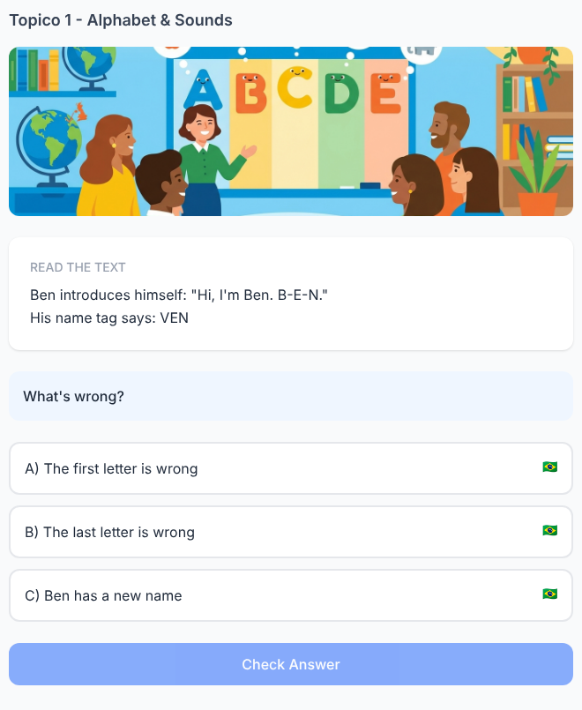

Reading 2. One Letter, Different Person
✅ FEITO → Plataforma: Tópico 1, exercício(s) #22 (multiple_choice)
Solicitado no documento  The receptionist has two names:  Mia — M-I-A  Nia — N-I-A  A woman says:  “My name starts with M.”  Who is she?  A) Mia ✅  B) Nia  Correct answer: Mia  Feedback: M-I-A. Listen carefully to M and N when people spell names. | Na plataforma  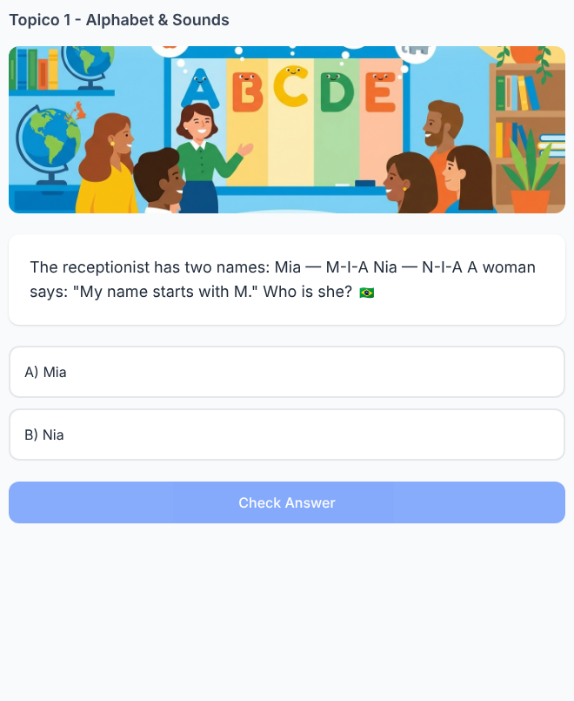

Reading 3. The Email Problem
✅ FEITO → Plataforma: Tópico 1, exercício(s) #23 (reading_comprehension)
Solicitado no documento  Lucas writes his name:  L-U-C-A-S  Emma types:  L-U-K-A-S  Lucas says:  “That's not my name.”  Which letter should Emma change?  A) U  B) K ✅  C) A  D) S  Correct answer: K → C  Feedback: Lucas spells his name L-U-C-A-S. | Na plataforma  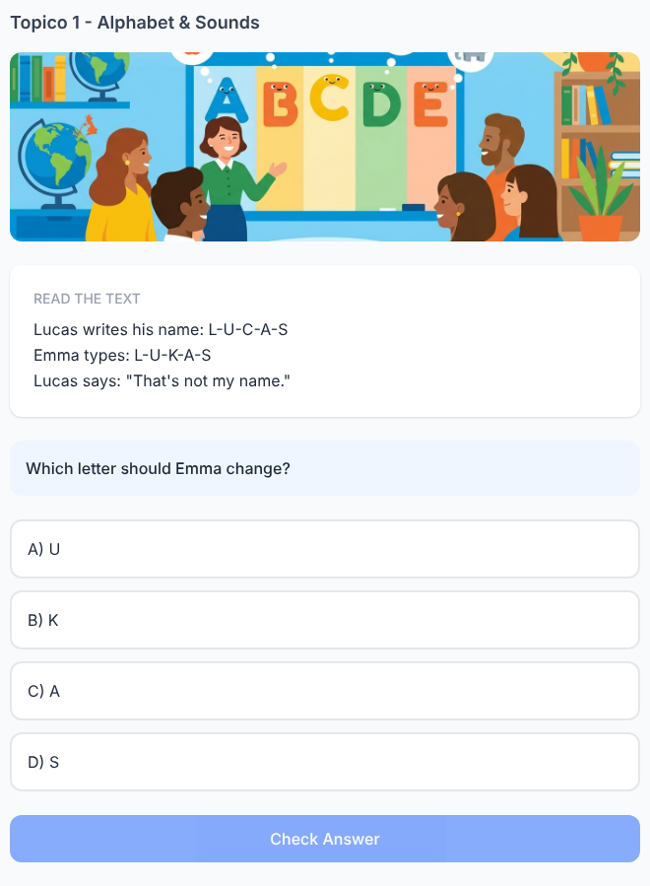

Reading 4. Two Very Similar Names
✅ FEITO → Plataforma: Tópico 1, exercício(s) #24 (multiple_choice)
Solicitado no documento  The teacher reads:  Jane — J-A-N-E  Gene — G-E-N-E  The new student says:  “My name is J-A-N-E.”  Which name is correct?  A) Gene  B) Jane ✅  Correct answer: Jane  Feedback: J-A-N-E spells Jane. Watch J and G when spelling. | Na plataforma  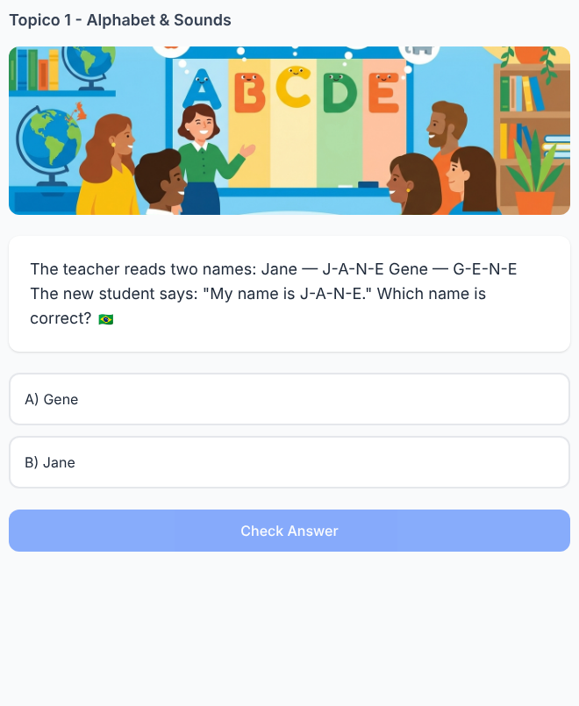

Reading 5. The Hotel Reservation
✅ FEITO → Plataforma: Tópico 1, exercício(s) #25 (multiple_choice)
Solicitado no documento  The hotel has a reservation for:  M-A-R-K  A man arrives and writes:  “My name is Marc. M-A-R-C.”  Is the spelling the same?  A) Yes  B) No ✅  Correct answer: No  Feedback: Mark ends in K. Marc ends in C. Same pronunciation, different spelling! | Na plataforma  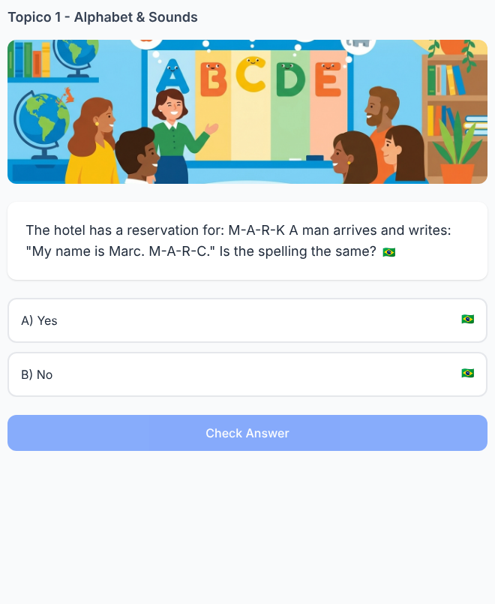

Grammar / Language Practice 6. At Reception
✅ FEITO → Plataforma: Tópico 1, exercício(s) #1 (fill_blank)
Solicitado no documento  The receptionist asks Anna:  “How do you ___ your name?”  A) speak  B) spell ✅  C) listen  D) say letter  Correct answer: spell  Feedback: We say: “How do you spell your name?” | Na plataforma  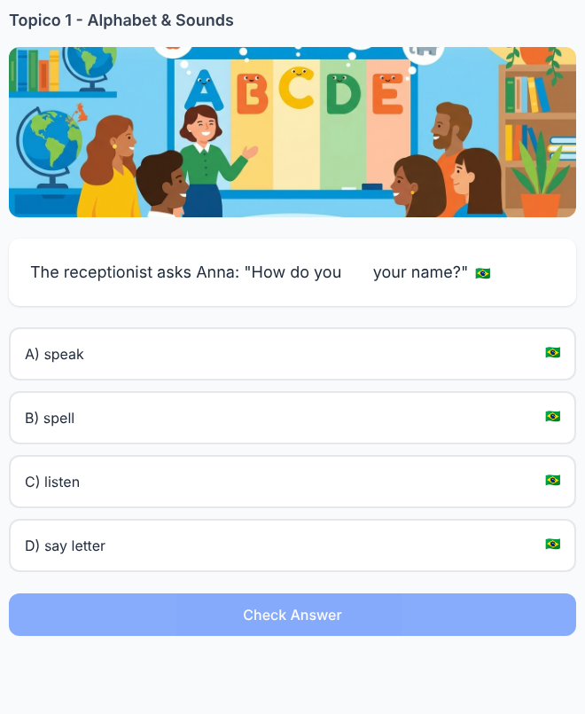

Grammar / Language Practice 7. Can You Repeat That?
✅ FEITO → Plataforma: Tópico 1, exercício(s) #2 (multiple_choice)
Solicitado no documento  Tom says:  “My last name is Kline. K-L-I-N-E.”  Sara didn't understand.  What should she say?  A) “What's your favorite letter?”  B) “Can you spell that again?” ✅  C) “Do you speak alphabet?”  D) “What letter are you?”  Correct answer: B  Feedback: “Can you spell that again?” is useful when you don't understand a name. | Na plataforma  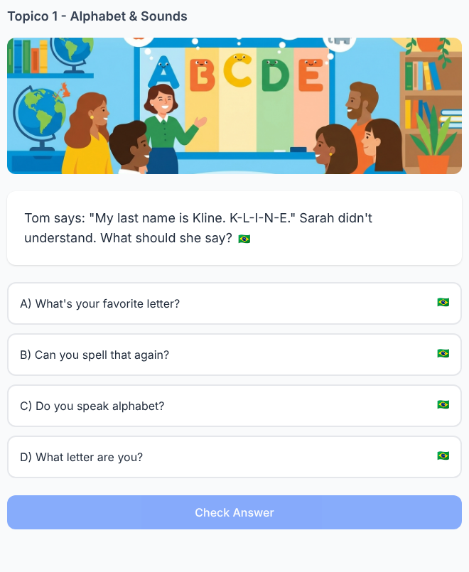

Grammar / Language Practice 8. The Missing Letter
✅ FEITO → Plataforma: Tópico 1, exercício(s) #4 (multiple_choice)
Solicitado no documento  James is spelling his email:  “J-A-M-E-S... at...”  Mia interrupts:  “Sorry, was that M or N?”  What is Mia doing?  A) Asking James to repeat a similar letter sound ✅  B) Asking his age  C) Changing his name  Correct answer: A  Feedback: When letters sound similar, you can ask: “Was that M or N?” | Na plataforma  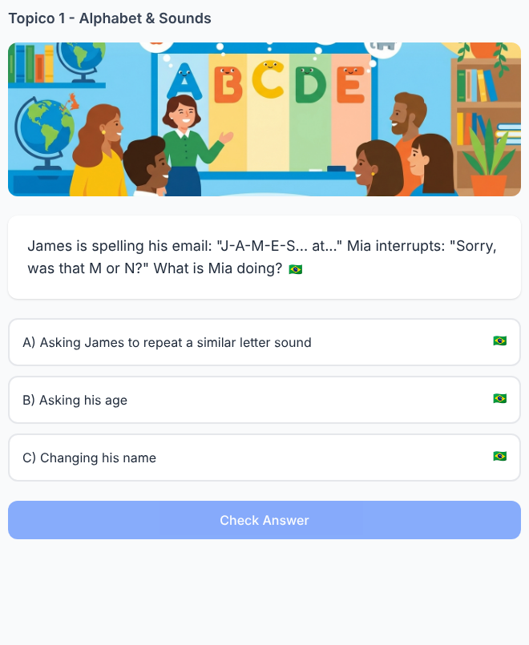

Grammar / Language Practice 9. Help the Barista
✅ FEITO → Plataforma: Tópico 1, exercício(s) #6 (multiple_choice)
Solicitado no documento  The barista asks:  “Name?”  She says:  “Kate.”  The barista looks confused.  What can she say next?  A) “I am a letter.”  B) “It's K-A-T-E.” ✅  C) “My alphabet is Kate.”  D) “K is my coffee.”  Correct answer: B  Feedback: You can spell your name to make it clear: “It's K-A-T-E.” | Na plataforma  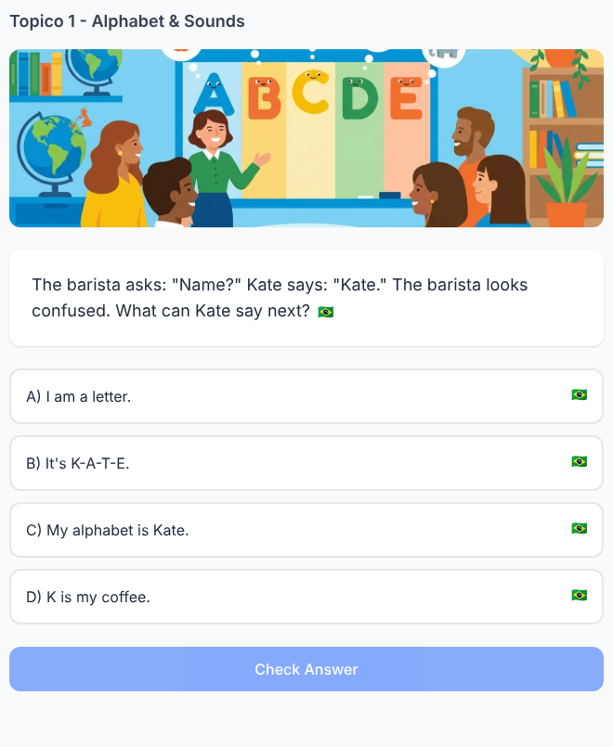

Grammar / Language Practice 10. B or V?
✅ FEITO → Plataforma: Tópico 1, exercício(s) #8 (multiple_choice)
Solicitado no documento  Victor says:  “V. V as in Victor.”  Why does he say “as in Victor”?  A) To make the letter clear ✅  B) To introduce his brother  C) Because Victor is a verb  D) To change the letter  Correct answer: A  Feedback: “V as in Victor” helps clarify the letter you mean. | Na plataforma  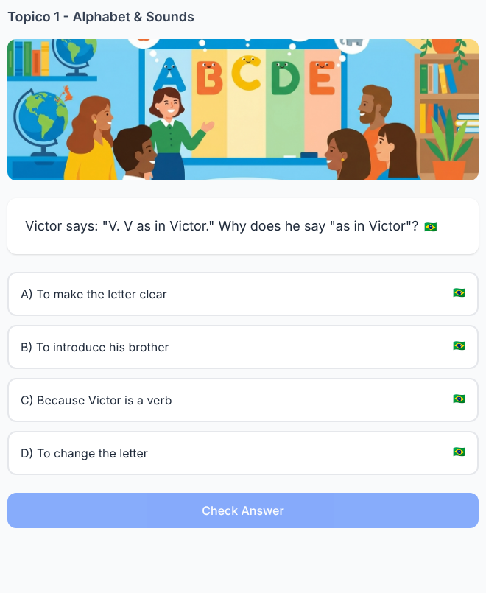

Listening 11. The Coffee Shop
✅ FEITO → Plataforma: Tópico 1, exercício(s) #11 (audio_question)
Solicitado no documento  Audio Script:  Barista: “Coffee for K-A-T-E!”  Who should take the coffee?  A) Katie  B) Kate ✅  C) Jake  Correct answer: Kate  Feedback: You heard K-A-T-E. Kate. | Na plataforma  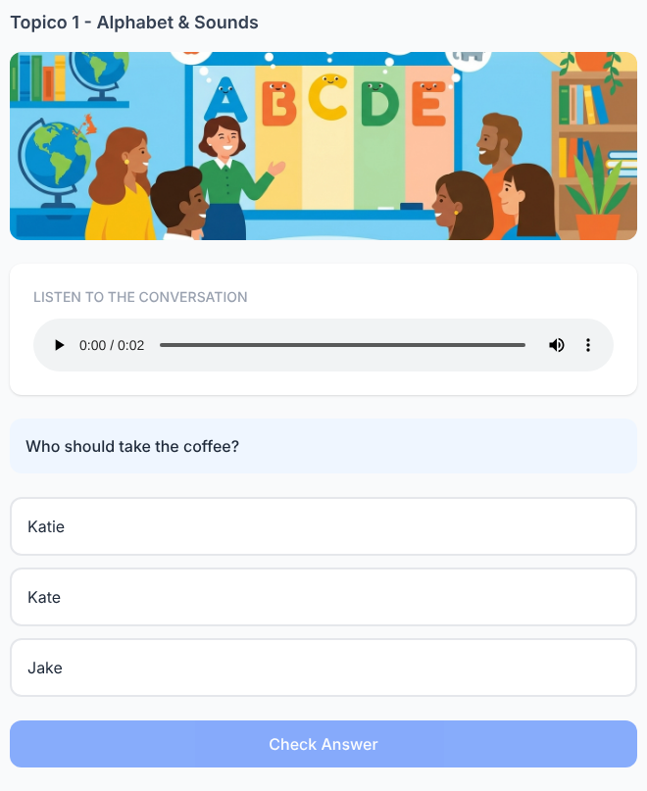

Listening 12. Bad Phone Connection
✅ FEITO → Plataforma: Tópico 1, exercício(s) #12 (audio_question)
Solicitado no documento  Audio Script:  Leo: “My name is Leo. L-E-O.”  Sara: “L-A-O?”  Leo: “No. L-E-O.”  Which letter did Sara get wrong?  A) L  B) A ✅  C) O  Correct answer: A  Feedback: Leo said E, not A. L-E-O. | Na plataforma  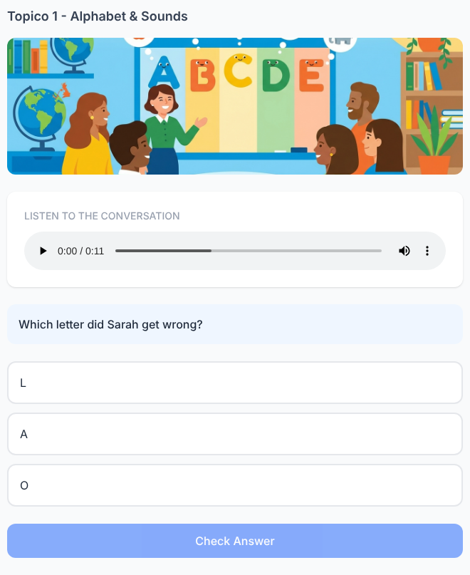

Listening 13. The Hotel Room
✅ FEITO → Plataforma: Tópico 1, exercício(s) #13 (audio_question)
Solicitado no documento  Audio Script:  Receptionist: “Can I have your name?”  Guest: “Sure. It's Ben. B-E-N.”  Receptionist: “V-E-N?”  Guest: “No. B. B as in Ben.”  Which letter is correct?  A) V  B) B ✅  Correct answer: B  Feedback: The guest says B — B as in Ben. | Na plataforma  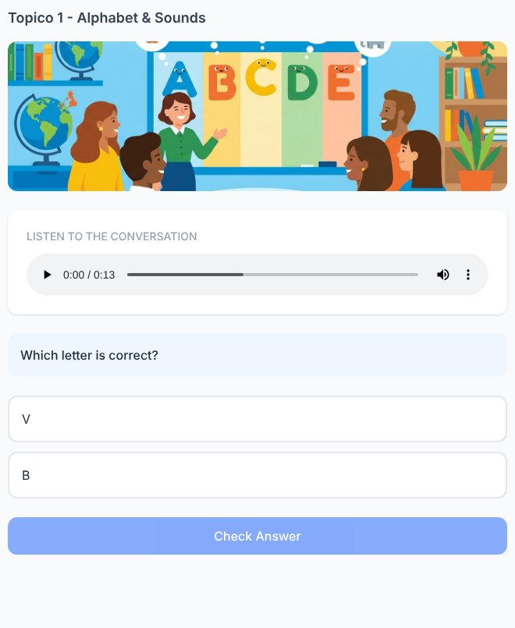

Listening 14. New Gamer
✅ FEITO → Plataforma: Tópico 1, exercício(s) #14 (word_order)
Solicitado no documento  Audio Script:  “My username is Jax. J-A-X.”  Build the username you hear.  Available letters:  G — A — J — E — X — S  Correct sequence: J → A → X ✅  Feedback: You heard J-A-X. Jax. | Na plataforma  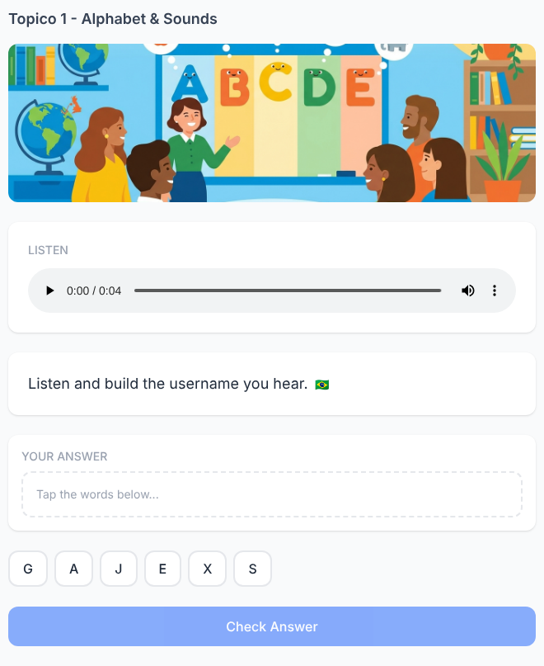

Listening 15. Who Is Calling?
✅ FEITO → Plataforma: Tópico 1, exercício(s) #15 (audio_question)
Solicitado no documento  Audio Script:  “Hi, it's Mia. M-I-A.”  Two contacts appear:  Mia — M-I-A  Nia — N-I-A  Who is calling?  A) Mia ✅  B) Nia  Correct answer: Mia  Feedback: You heard M, not N. M-I-A spells Mia. | Na plataforma  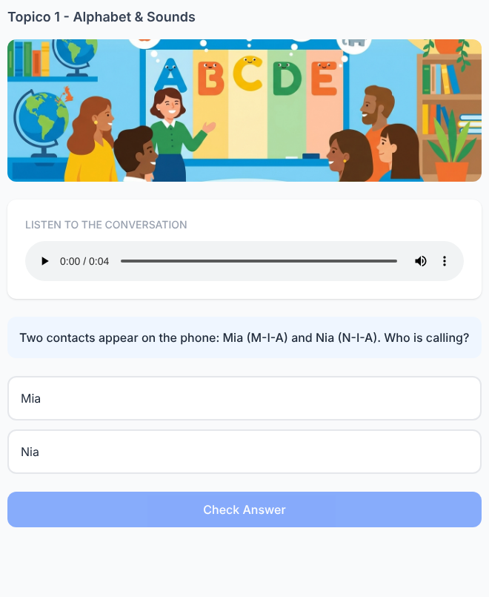

Tópico 2 — Greetings
Documento da cliente: Módulo Básico 1 — Greetings • 30 exercícios solicitados

Grammar 1. One person changes
✅ FEITO → Plataforma: Tópico 2, exercício(s) #1 (fill_blank)
Solicitado no documento  Read:  Mia: How are you, Ben?  Ben: I'm good!  Now Mia talks to Leo.  Mia: How are ___, Leo?  A) I  B) you ✓  C) he  Answer: you  Pattern: How are you? | Na plataforma  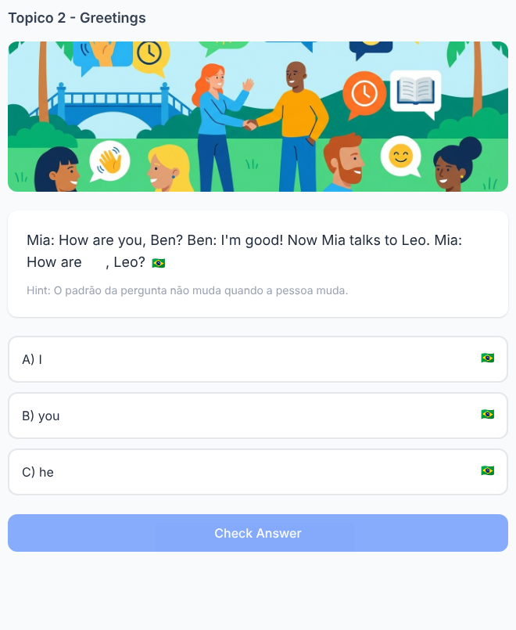

Grammar 2. Ben asks. Mia answers.
✅ FEITO → Plataforma: Tópico 2, exercício(s) #2 (multiple_choice)
Solicitado no documento  Ben: How are you?  Mia: I'm fine.  Complete the pattern:  How are ___?  ___'m good.  A) you / I ✓  B) I / You  C) are / How  Answer: you / I  Pedagogical focus: the student notices the change YOU → I between question and answer. | Na plataforma  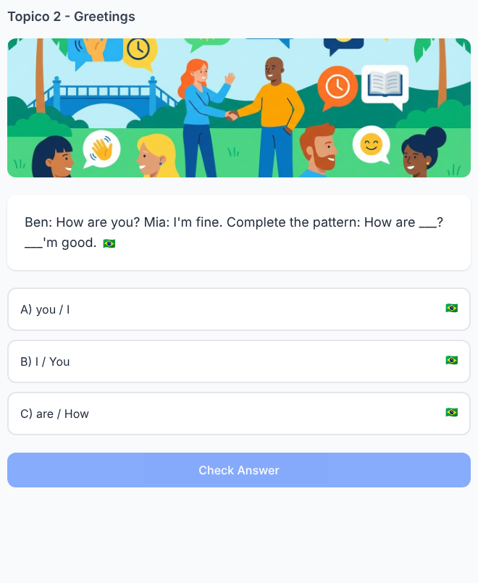

Grammar 3. One word is in the wrong place
✅ FEITO → Plataforma: Tópico 2, exercício(s) #3 (word_order)
Solicitado no documento  Mia writes:  How you are?  Move ARE to the correct place.  Correct answer:  How are you?  Pattern: HOW + ARE + YOU | Na plataforma  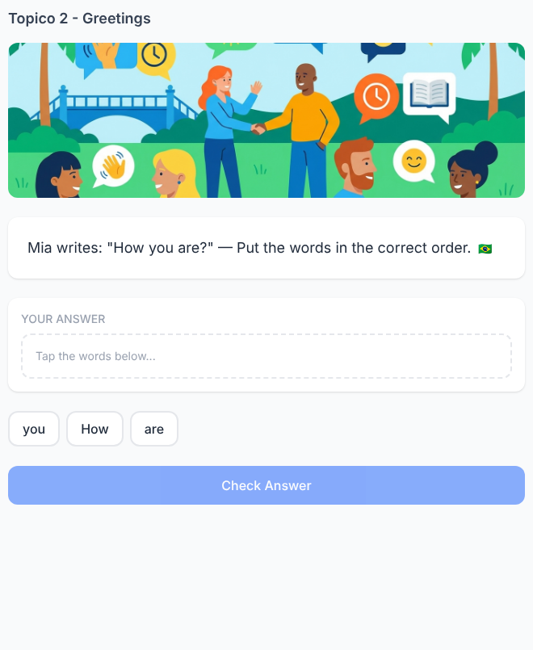

Grammar 4. Three answers, same beginning
✅ FEITO → Plataforma: Tópico 2, exercício(s) #4 (multi_blank)
Solicitado no documento  I'm fine.  I'm good.  I'm great.  Complete:  ___ fine.  ___ good.  ___ great.  Answer: I'm  Pedagogical focus: identify the repeated grammatical pattern. | Na plataforma  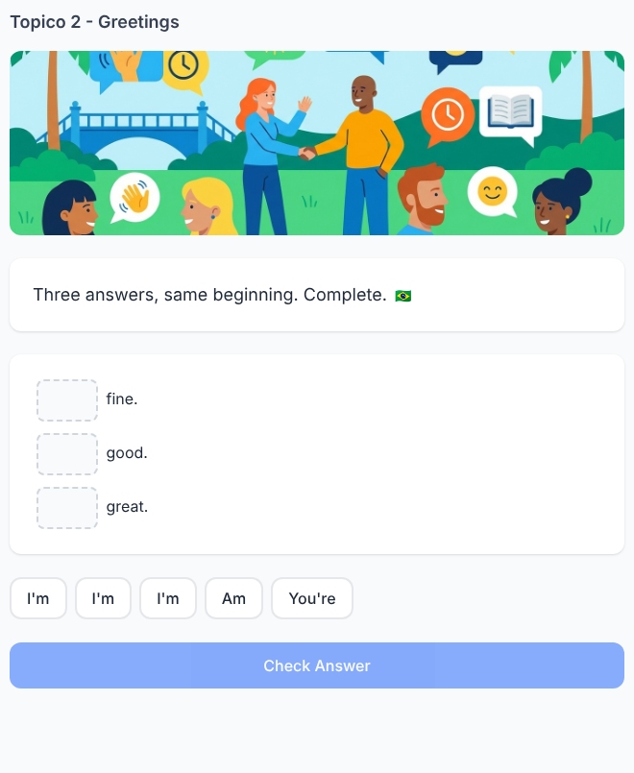

Grammar 5. Repair the chat
✅ FEITO → Plataforma: Tópico 2, exercício(s) #5 (tap_wrong_word)
Solicitado no documento  One word is wrong:  Leo: Hi! How are you?  Anna: You'm good, thanks!  Tap the wrong word:  YOU'M  Replace it with:  I'M  Final chat:  I'm good, thanks! | Na plataforma  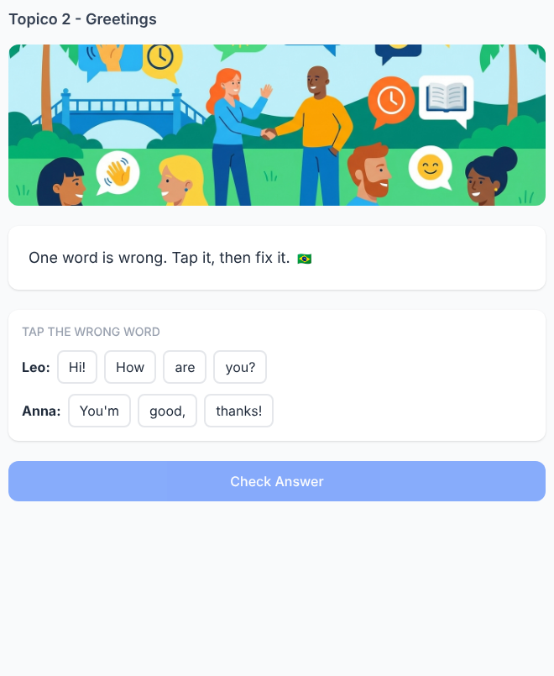

Reading 6. Mia sends the same message to three friends
✅ FEITO → Plataforma: Tópico 2, exercício(s) #21 (reading_comprehension)
Solicitado no documento  To Ben: Hi, Ben! How are you?  To Leo: Hi, Leo! How are you?  To Anna: Hi, Anna! How ___ ___?  Complete Mia's message.  A) is Anna  B) are you ✓  C) you are  Answer: are you  Pedagogical focus: use the pattern from the previous messages. | Na plataforma  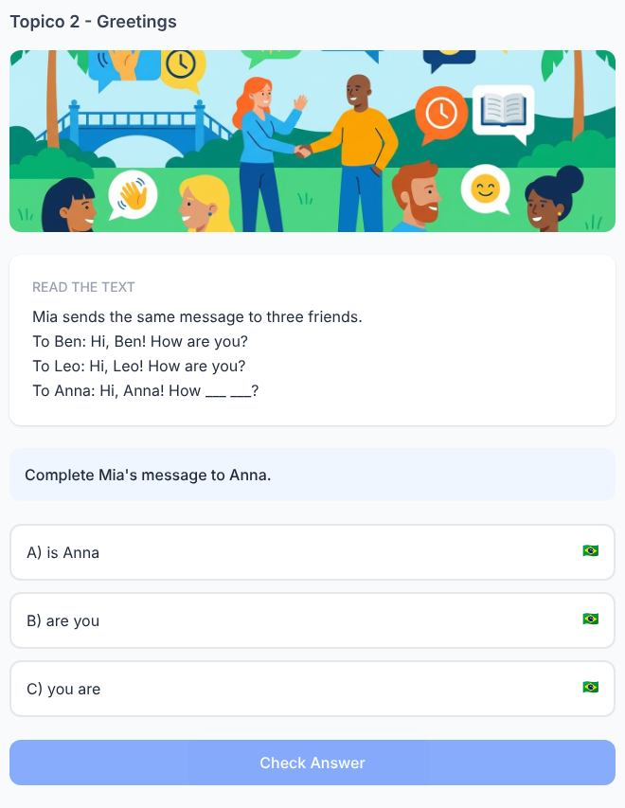

Reading 7. Ben types too fast
✅ FEITO → Plataforma: Tópico 2, exercício(s) #22 (tap_wrong_word)
Solicitado no documento  Ben wants to write:  Hello! How are you?  But his message says:  Hello! How is you?  Change one word.  IS → ARE  Final message:  Hello! How are you? | Na plataforma  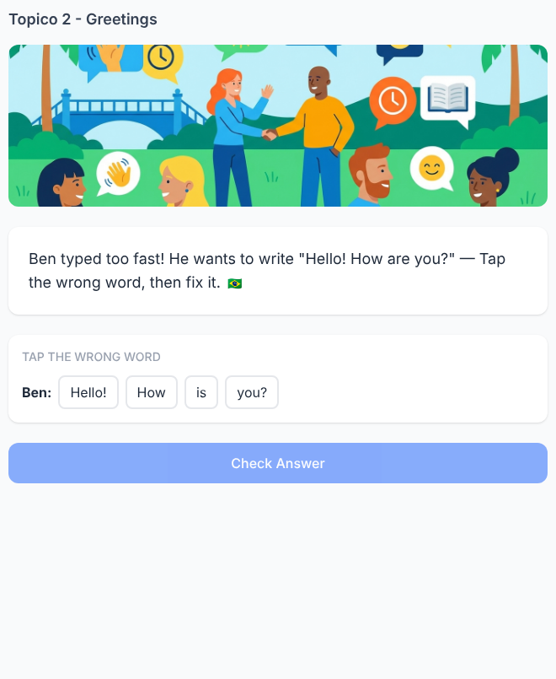

Reading 8. Three people answer Mia
✅ FEITO → Plataforma: Tópico 2, exercício(s) #23 (reading_comprehension)
Solicitado no documento  Ben: I'm fine, thanks!  Leo: I'm good, thanks!  Emma: I'm great, thanks!  Complete Emma's message:  I'm ___, thanks!  A) are  B) great ✓  C) how  Answer: great  Notice: fine / good / great can complete the same response pattern. | Na plataforma  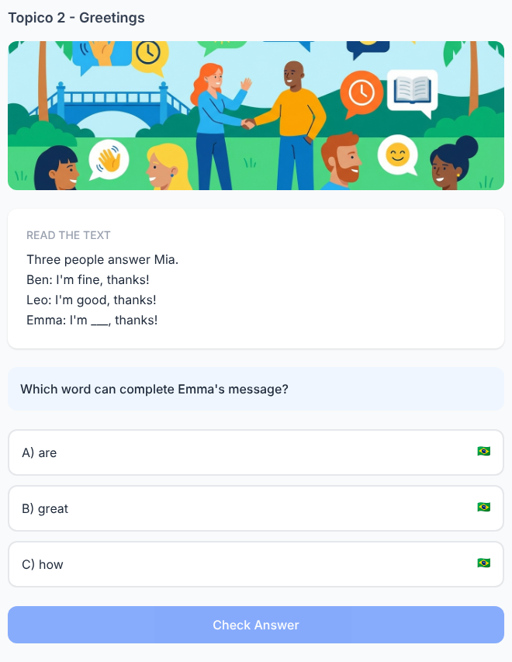

Reading 9. The chat lost three words
✅ FEITO → Plataforma: Tópico 2, exercício(s) #24 (multi_blank)
Solicitado no documento  Mia: ___, Ben!  Ben: Hi, Mia! How are ___?  Mia: I'm good, ___!  Words:  YOU — THANKS — HELLO  Place each word once.  Correct conversation:  Mia: Hello, Ben!  Ben: Hi, Mia! How are you?  Mia: I'm good, thanks! | Na plataforma  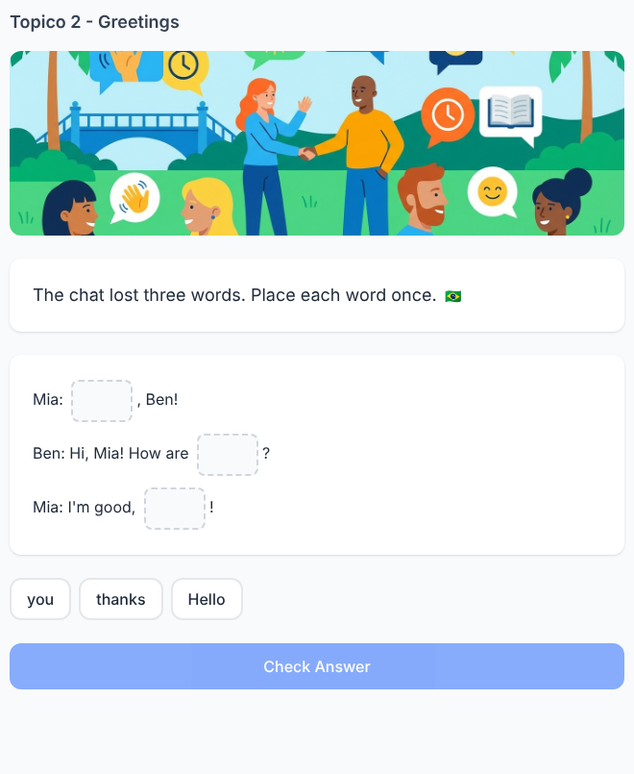

Reading 10. Which chat is written correctly?
✅ FEITO → Plataforma: Tópico 2, exercício(s) #25 (multiple_choice)
Solicitado no documento  Chat A  Hi, Leo!  How you are?  I'm good!  Chat B  Hi, Leo!  How are you?  I'm good!  Chat C  Hi, Leo!  How are I?  You'm good!  Choose the correct chat.  Answer: Chat B  Pedagogical focus: compare complete structures. | Na plataforma  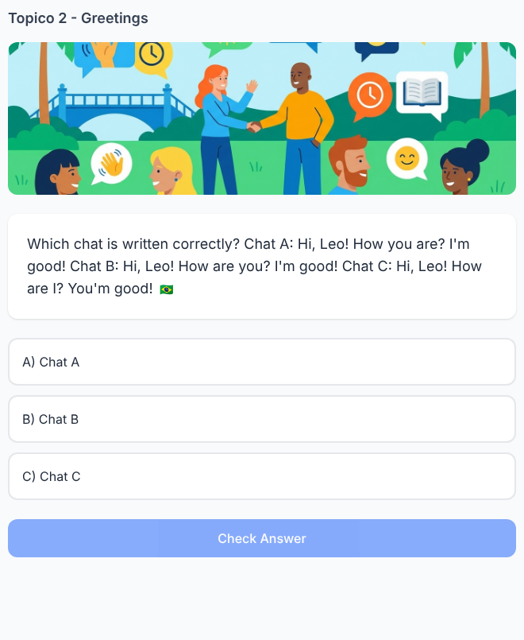

Writing 11. Change only the name
✅ FEITO → Plataforma: Tópico 2, exercício(s) #37 (writing)
Solicitado no documento  Example:  Hello, Mia!  Now greet Ben.  Write:  __________  Expected answer:  Hello, Ben!  Pedagogical focus: reuse the greeting structure. | Na plataforma  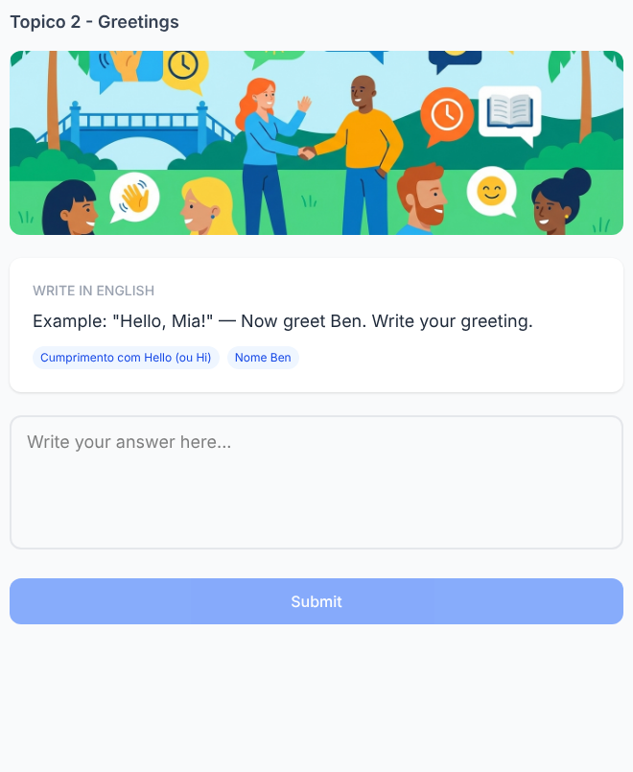

Writing 12. Turn the answer into a question
✅ FEITO → Plataforma: Tópico 2, exercício(s) #38 (writing)
Solicitado no documento  Mia says:  I'm good!  You want to ask about Ben.  Complete:  How ___ ___?  Answer: are you  Final phrase:  How are you? | Na plataforma  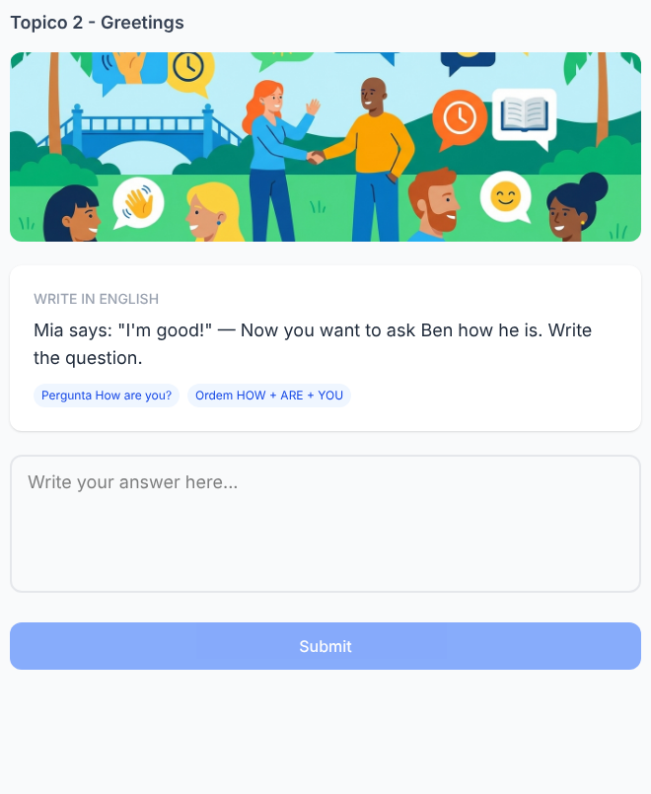

Writing 13. Upgrade the answer
✅ FEITO → Plataforma: Tópico 2, exercício(s) #39 (writing)
Solicitado no documento  Start:  I'm good.  Add THANKS.  Write the new sentence:  I'm good, thanks!  Pedagogical focus: expand a known structure. | Na plataforma  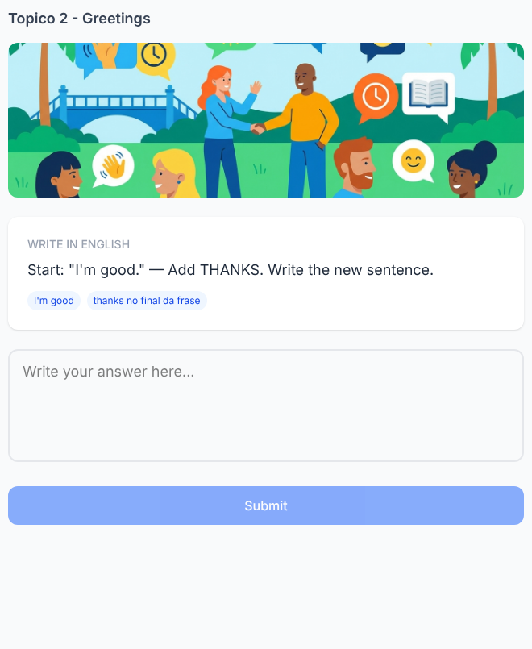

Writing 14. Write Mia's missing message
✅ FEITO → Plataforma: Tópico 2, exercício(s) #40 (writing)
Solicitado no documento  Ben: Hi, Mia!  Mia: __________  Ben: I'm great!  What did Mia probably ask?  Expected answer:  How are you?  Pedagogical focus: recover the greeting question from the response. | Na plataforma  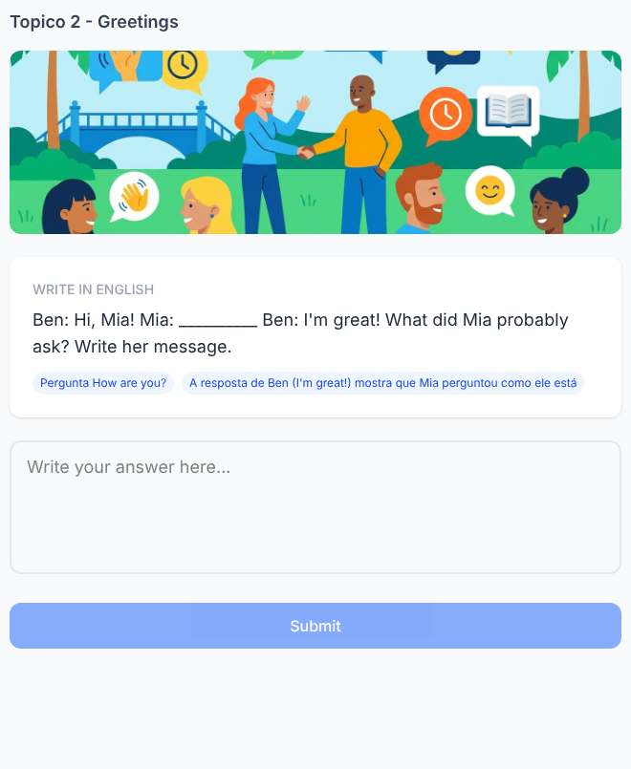

Writing 15. Build your first greeting
✅ FEITO → Plataforma: Tópico 2, exercício(s) #41 (writing)
Solicitado no documento  Complete with your own information:  Hi, ______! How are you?  Then answer:  I'm ______, thanks!  Accepted answers:  fine / good / great  Example:  Hi, Anna! How are you?  I'm great, thanks! | Na plataforma  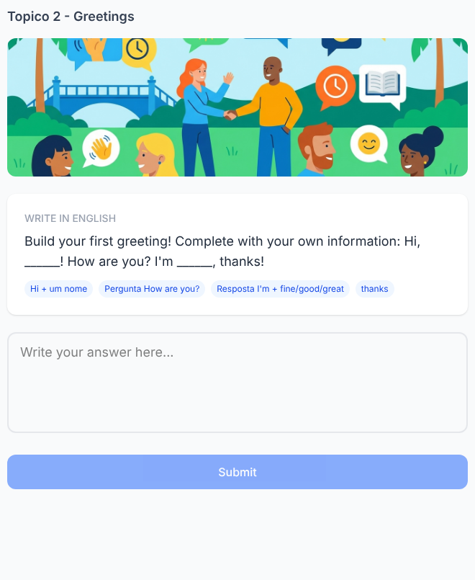

Listening 16. One word changes
✅ FEITO → Plataforma: Tópico 2, exercício(s) #11 (audio_question)
Solicitado no documento  Audio 1:  “I'm good.”  Audio 2:  “I'm great.”  The screen shows:  I'm ______.  Which word changes?  A) I'm  B) good / great ✓  Pedagogical focus: compare sounds inside the same structure. | Na plataforma  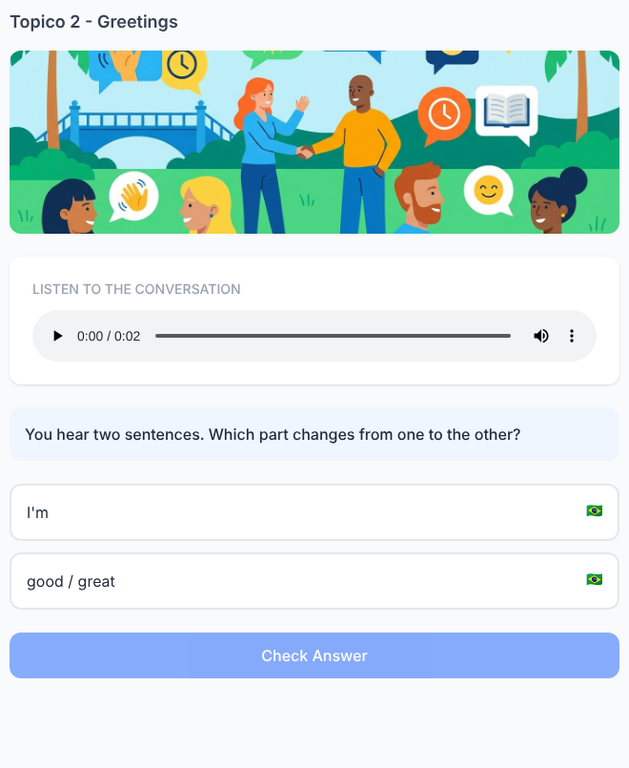

Listening 17. Catch the question
✅ FEITO → Plataforma: Tópico 2, exercício(s) #12 (word_order)
Solicitado no documento  Audio:  “Hi, Mia! How are you?”  Words appear:  HI — MIA — HOW — ARE — YOU  Tap only the words from the question.  Correct sequence:  HOW → ARE → YOU  Final phrase:  How are you? | Na plataforma  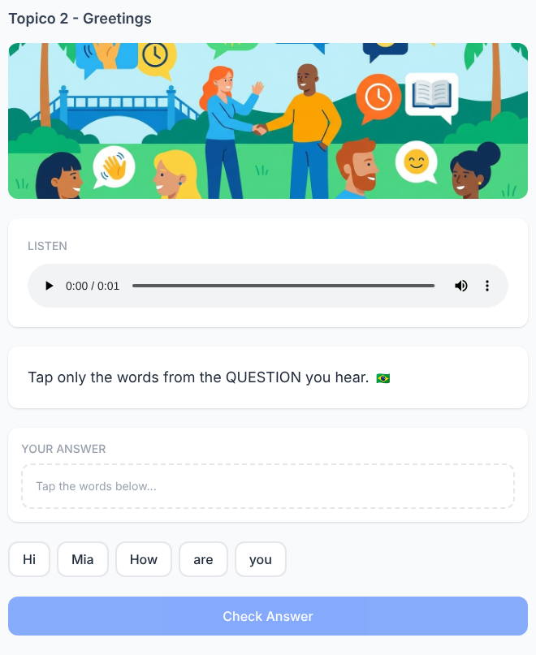

Listening 18. Did Ben say “I” or “you”?
✅ FEITO → Plataforma: Tópico 2, exercício(s) #13 (audio_question)
Solicitado no documento  Audio:  “I'm fine, thanks!”  Complete what you hear:  ___'m fine, thanks!  A) I ✓  B) You  Answer: I  Replay:  I'm fine, thanks!  Listening focus: the sound of “I'm”. | Na plataforma  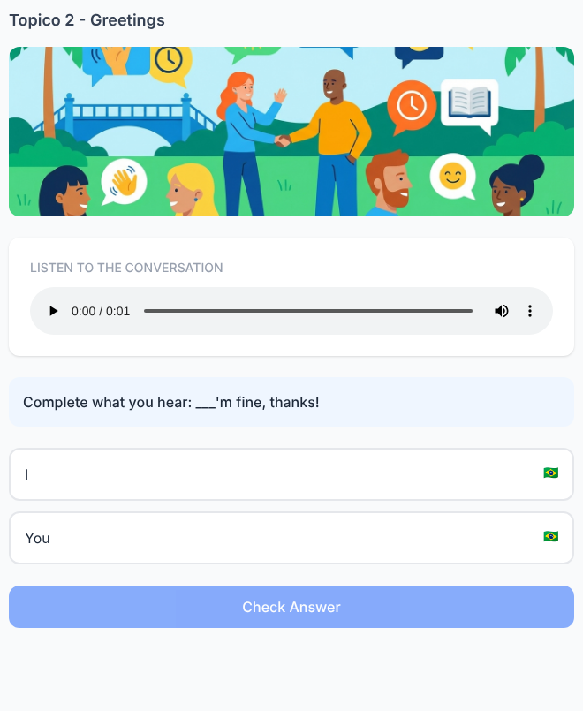

Listening 19. The audio stops
✅ FEITO → Plataforma: Tópico 2, exercício(s) #14 (multi_blank)
Solicitado no documento  Audio:  “Hello, Leo! How are—”  The audio cuts out.  Complete the expression you started hearing:  How are ___?  Answer: you  Pedagogical focus: anticipate a learned language chunk. | Na plataforma  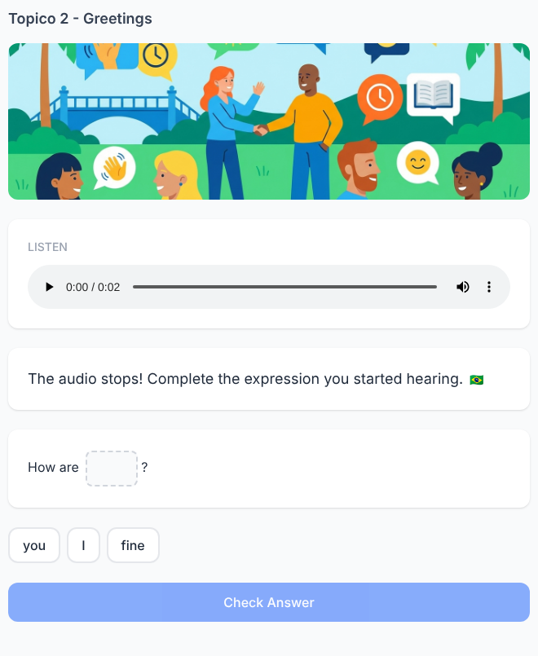

Listening 20. Greeting Puzzle — Final Challenge
✅ FEITO → Plataforma: Tópico 2, exercício(s) #20 (multi_blank)
Solicitado no documento  Audio:  Mia: “Hey, Ben! How are you?”  Ben: “Hi, Mia! I'm great, thanks!”  The screen shows:  Mia: “Hey, Ben! How ___ ___?”  Ben: “Hi, Mia! ___ great, thanks!”  Type the three missing parts.  1. are  2. you  3. I'm  Final conversation:  Mia: Hey, Ben! How are you?  Ben: Hi, Mia! I'm great, thanks! | Na plataforma  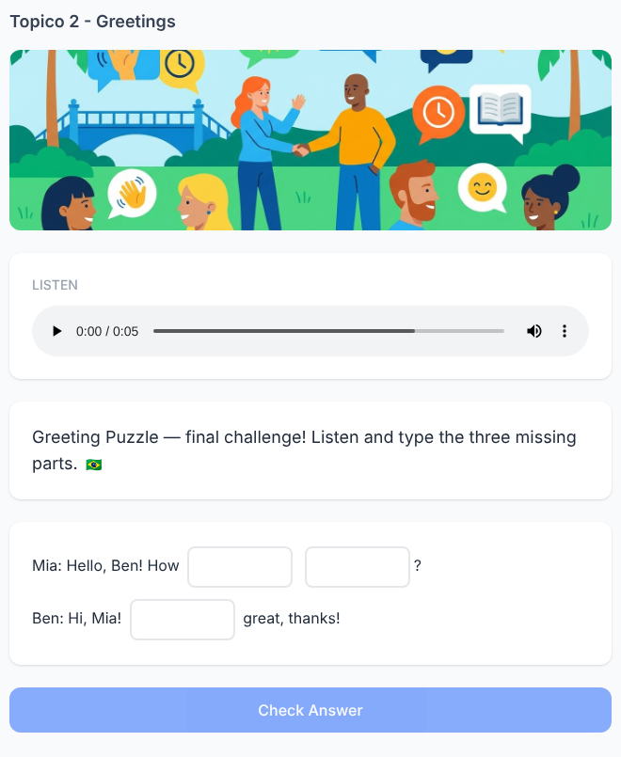

Speaking 1. Morning at the Bakery
✅ FEITO → Plataforma: Tópico 2, exercício(s) #27 (speaking)
Solicitado no documento  Listen:  Anna: “Good morning, Leo!”  Leo: “Good morning, Anna! How are you?”  Anna: “I'm great, thanks!”  Now be Leo. Listen and repeat:  “Good morning, Anna! How are you?”  Expected speech:  Good morning, Anna! How are you?  Focus: greeting + question as one natural chunk. | Na plataforma  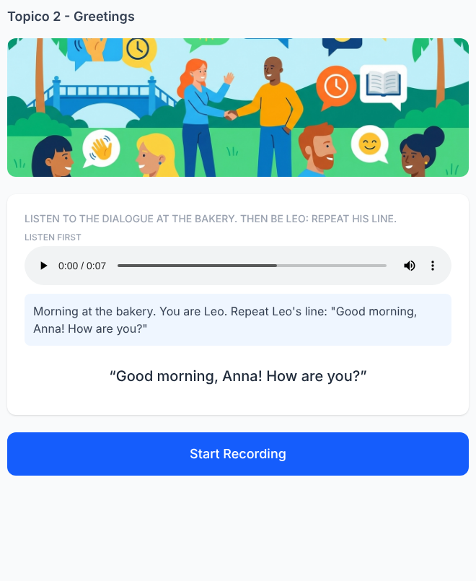

Speaking 2. Mia Is Waiting for Your Answer
✅ FEITO → Plataforma: Tópico 2, exercício(s) #28 (speaking)
Solicitado no documento  Listen:  Mia: “Hello! How are you?”  Ben: “I'm fine, thanks!”  Now the conversation changes.  Mia says to you:  “Hello! How are you?”  Complete the conversation orally.  Accepted answers:  I'm fine, thanks.  I'm good, thanks.  I'm great, thanks.  Mia replies:  “That's great!” | Na plataforma  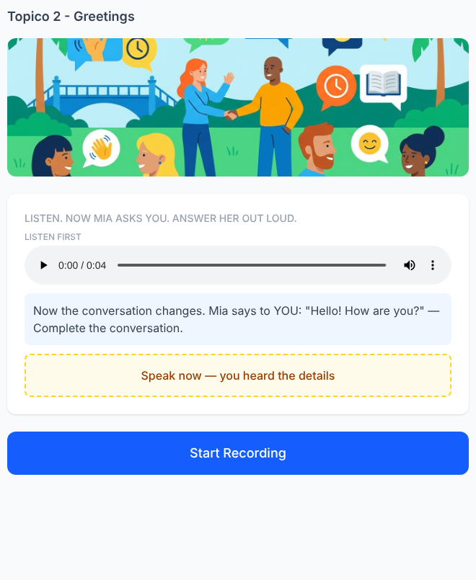

Speaking 3. The New Neighbor
✅ FEITO → Plataforma: Tópico 2, exercício(s) #29 (speaking)
Solicitado no documento  Listen to the conversation:  Sofia: “Hello! I'm Sofia.”  Daniel: “Hi, Sofia. I'm Daniel.”  Sofia: “How are you, Daniel?”  Daniel: “I'm good, thanks.”  Listen again and repeat Daniel's lines.  First:  “Hi, Sofia. I'm Daniel.”  Then:  “I'm good, thanks.”  Focus: practice greetings inside a short dialogue. | Na plataforma  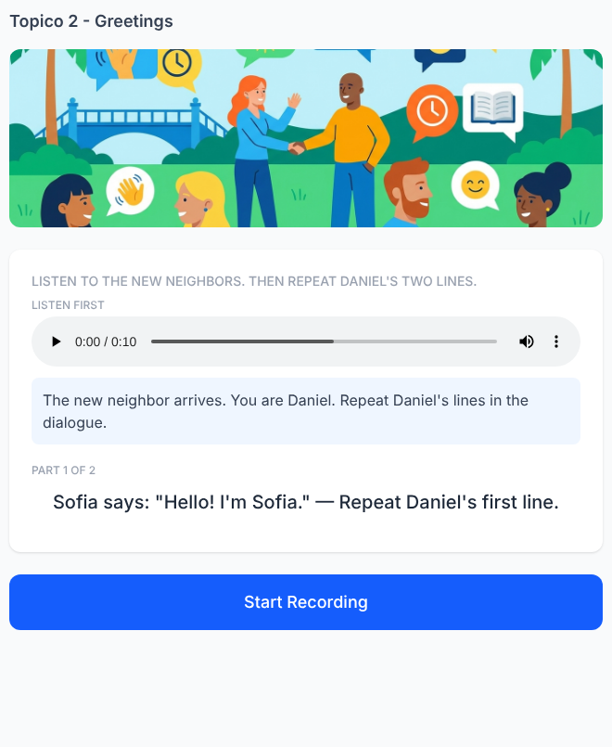

Speaking 4. Anna Stops Talking
✅ FEITO → Plataforma: Tópico 2, exercício(s) #30 (speaking)
Solicitado no documento  Listen:  Lucas: “Good morning, Anna!”  Anna: “Good morning, Lucas! How...”  The audio stops.  Finish Anna's sentence orally.  Expected speech:  How are you?  Then the complete audio plays:  “Good morning, Lucas! How are you?” | Na plataforma  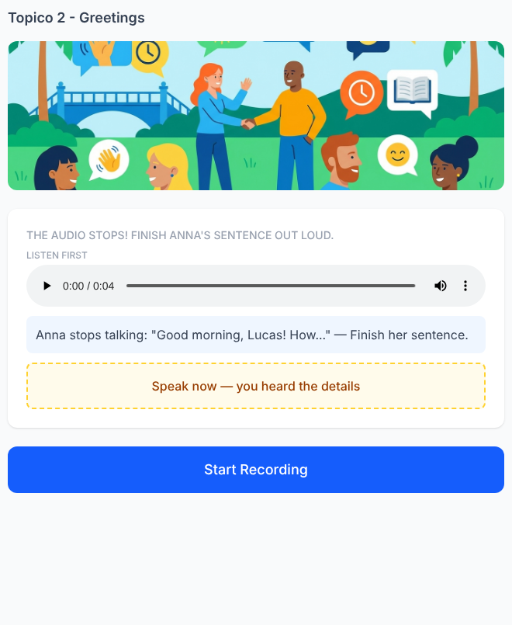

Speaking 5. Your Turn in the Conversation
✅ FEITO → Plataforma: Tópico 2, exercício(s) #31 (speaking)
Solicitado no documento  Listen:  Emma: “Hello, Tom!”  Tom: “Hi, Emma!”  Emma: “How are you?”  Tom: “I'm great, thanks!”  Now Tom disappears from the conversation.  Emma:  “Hello!”  You are Tom. Answer orally.  Then Emma asks:  “How are you?”  Answer again.  Accepted flow:  Hi, Emma!  I'm great, thanks!  OR  Hello, Emma!  I'm good, thanks!  Focus: two connected oral responses. | Na plataforma  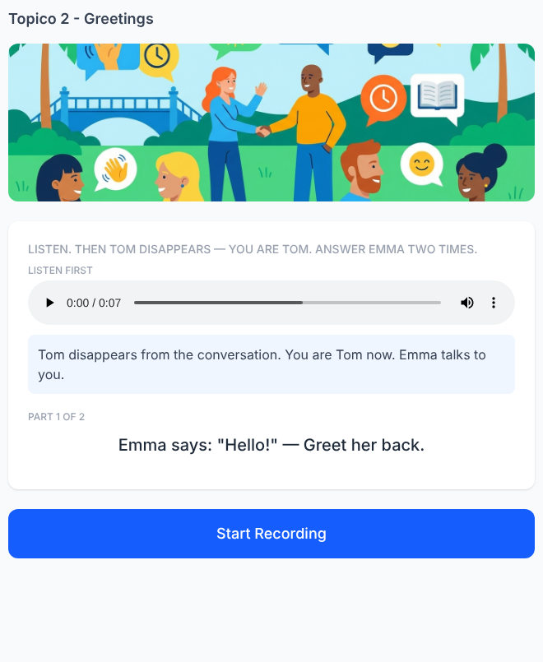

Speaking 6. The Wrong Recording
✅ FEITO → Plataforma: Tópico 2, exercício(s) #32 (speaking)
Solicitado no documento  Listen to Ben's recording:  “Hello, Mia. How you are?”  Mia says:  “Hmm... try again, Ben.”  Record Ben's message correctly.  Expected speech:  Hello, Mia. How are you?  Then compare:  Ben: “Hello, Mia. How are you?”  Student recording  Focus: oral reconstruction of the greeting. | Na plataforma  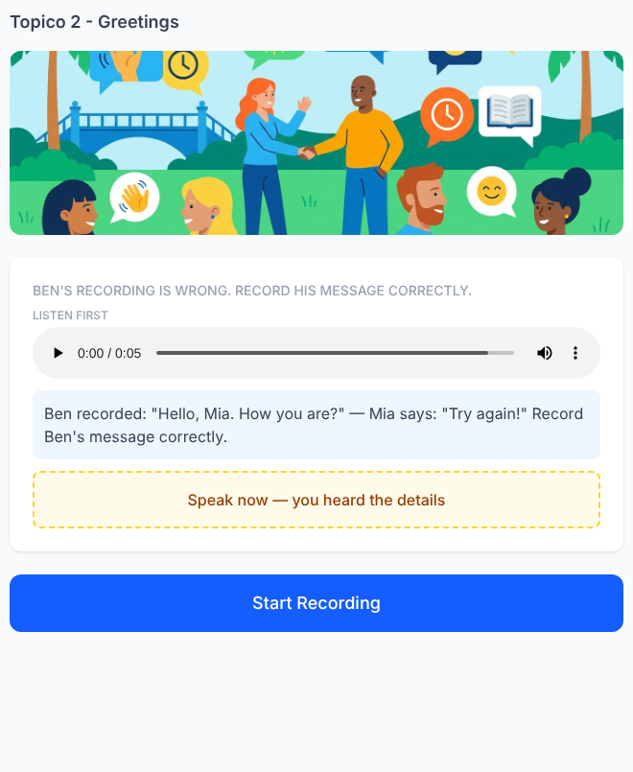

Speaking 7. Two Mornings
✅ FEITO → Plataforma: Tópico 2, exercício(s) #33 (speaking)
Solicitado no documento  Listen to Conversation 1:  Teacher: “Good morning, Emma.”  Emma: “Good morning, Mr. Lee.”  Listen to Conversation 2:  Leo: “Hi, Anna!”  Anna: “Hi, Leo! How are you?”  Now listen to the teacher:  “Good morning, Lucas.”  You are Lucas. Respond naturally.  Expected speech:  Good morning, Mr. Lee.  Focus: use the dialogue model from the scene. | Na plataforma  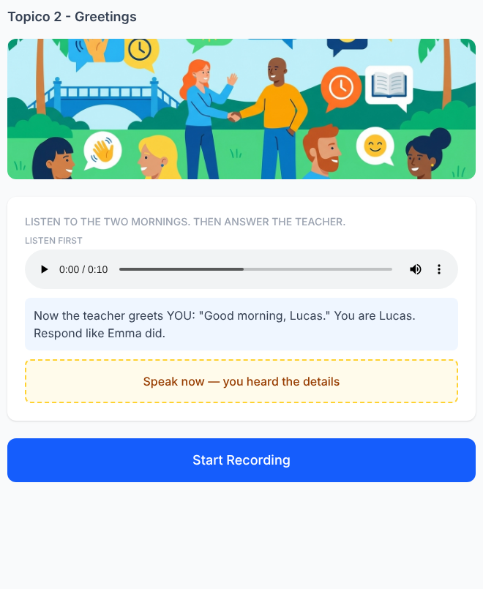

Speaking 8. The Voice Message
✅ FEITO → Plataforma: Tópico 2, exercício(s) #34 (speaking)
Solicitado no documento  Mia sends a voice message:  “Hello, Anna! How are you? I'm great today!”  Reply to Mia. Greet her and answer the question orally.  Accepted examples:  Hello, Mia! I'm good, thanks.  Hi, Mia! I'm great, thanks.  Hello! I'm fine, thanks.  Required elements:  - greeting  - I'm + fine / good / great  Focus: recover two parts of the conversation. | Na plataforma  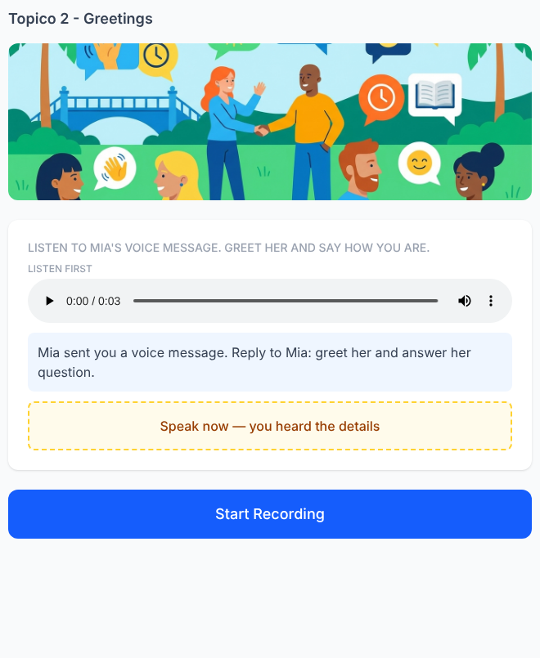

Speaking 9. Follow the Conversation
✅ FEITO → Plataforma: Tópico 2, exercício(s) #35 (speaking)
Solicitado no documento  Listen first. Do not speak yet.  Sarah: “Good morning, Ben!”  Ben: “Good morning, Sarah.”  Sarah: “How are you?”  Ben: “I'm fine, thanks. How are you?”  Sarah: “I'm great!”  Now listen again.  Sarah:  “Good morning, Ben!”  Speak Ben's line.  Expected:  Good morning, Sarah.  Sarah:  “How are you?”  Speak Ben's next line.  Expected:  I'm fine, thanks. How are you?  Focus: follow the role of one character through the dialogue. | Na plataforma  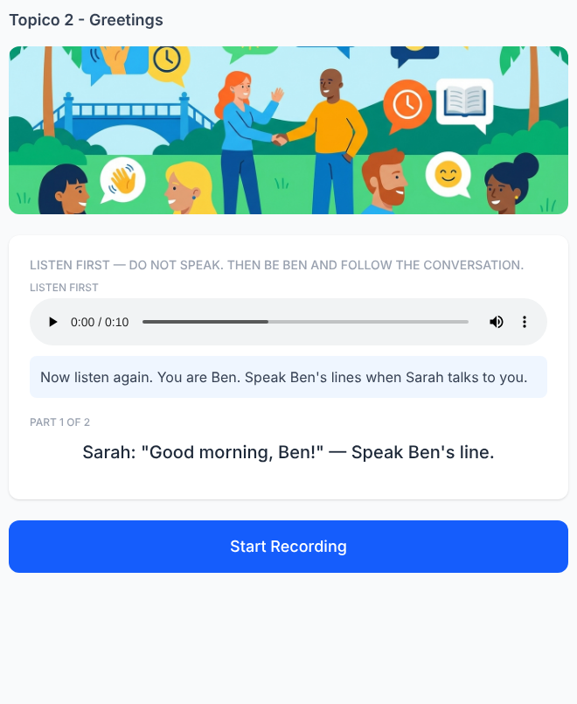

Speaking 10. Complete the Morning Scene
✅ FEITO → Plataforma: Tópico 2, exercício(s) #36 (speaking)
Solicitado no documento  Listen to the beginning:  Anna enters the classroom.  Leo looks at her and smiles.  Leo:  “Good morning, Anna! How are you?”  Anna's voice is missing.  You are Anna. Complete the conversation orally.  Possible answers:  Good morning, Leo! I'm good, thanks.  Good morning, Leo! I'm fine, thanks.  Good morning! I'm great, thanks.  Hi, Leo! I'm good, thanks.  Then Leo answers:  “Great! Have a good class!”  Conversation complete.  Focus: greeting + response in a complete short scene. | Na plataforma  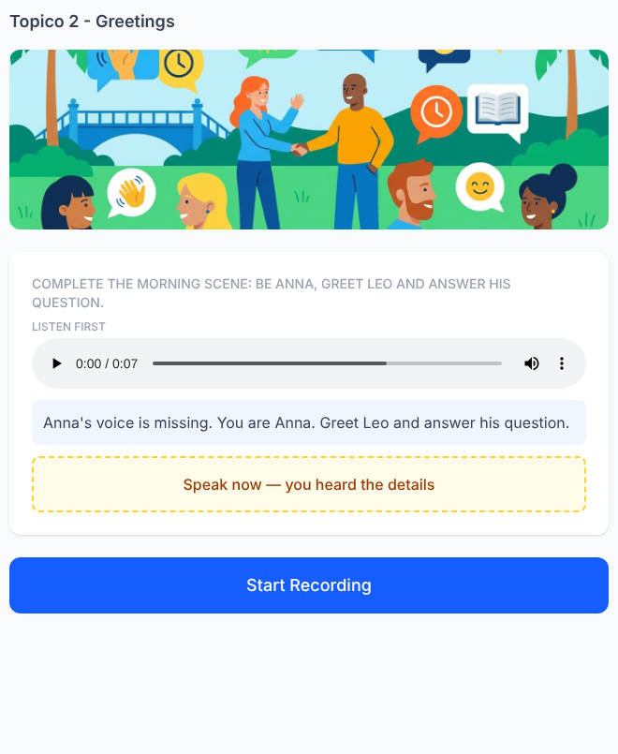

Tópico 3 — Personal Pronouns & Verb To Be
Documento da cliente: Básico 1 — Personal Pronouns & Verb To Be • 25 exercícios solicitados

Grammar 1. Mia changes the speaker
✅ FEITO → Plataforma: Tópico 3, exercício(s) #1 (multiple_choice)
Solicitado no documento  Mia says:  “I am tired.”  Leo talks about Mia:  “___ is tired.”  A) I  B) She ✓  C) We  D) You  Answer: She  Focus: I → she when the speaker changes. | Na plataforma  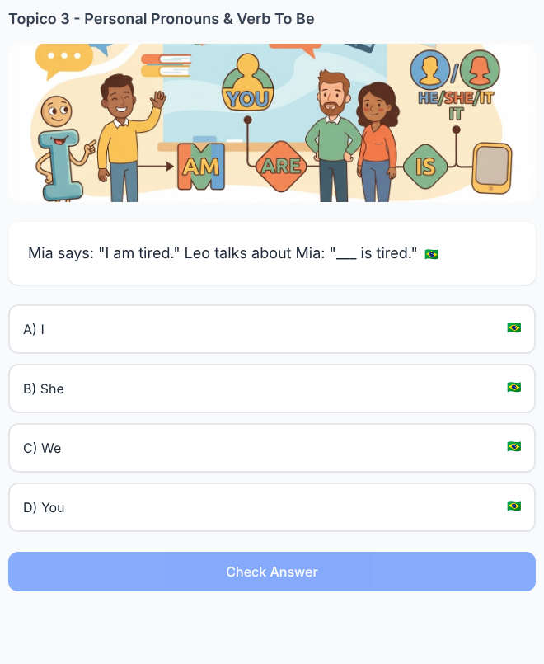

Grammar 2. One message, two writers
✅ FEITO → Plataforma: Tópico 3, exercício(s) #2 (multiple_choice)
Solicitado no documento  Lucas writes:  “I am ready.”  Lucas and Ben write together:  “___ are ready.”  A) He  B) I  C) We ✓  D) She  Answer: We  Focus: understand who is speaking. | Na plataforma  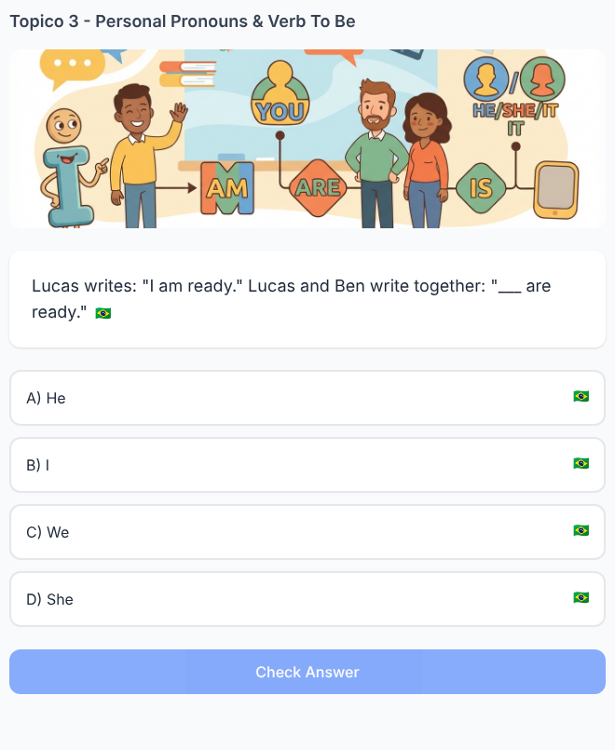

Grammar 3. Repair Emma's sentence
✅ FEITO → Plataforma: Tópico 3, exercício(s) #3 (tap_wrong_word)
Solicitado no documento  Emma is talking about herself:  “I is very happy today.”  Change one word.  IS → AM  Correct sentence:  I am very happy today. | Na plataforma  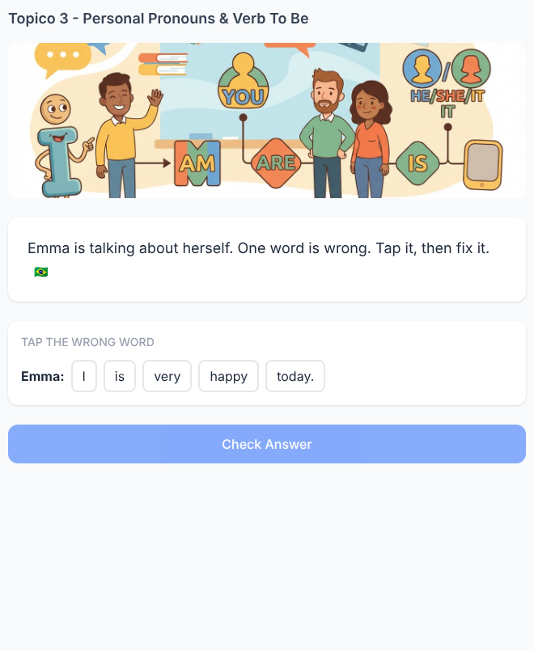

Grammar 4. Who is “they”?
✅ FEITO → Plataforma: Tópico 3, exercício(s) #4 (multiple_choice)
Solicitado no documento  Anna is Brazilian.  Tom is Canadian.  Now talk about Anna and Tom together:  “___ are students.”  A) She  B) He  C) They ✓  D) We  Answer: They  Focus: two other people become they. | Na plataforma  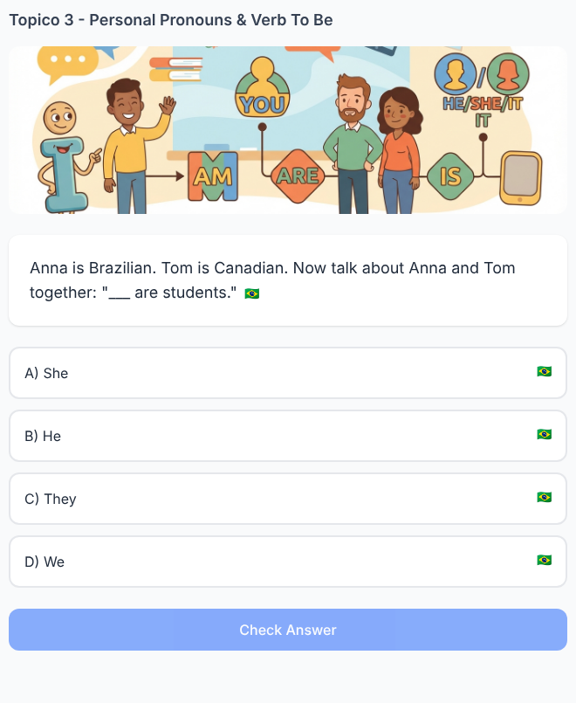

Grammar 5. The pronouns changed
✅ FEITO → Plataforma: Tópico 3, exercício(s) #5 (fill_blank)
Solicitado no documento  I am at home.  She is at home.  They ___ at home.  A) am  B) is  C) are ✓  Answer: are  Pattern: I am / She is / They are. | Na plataforma  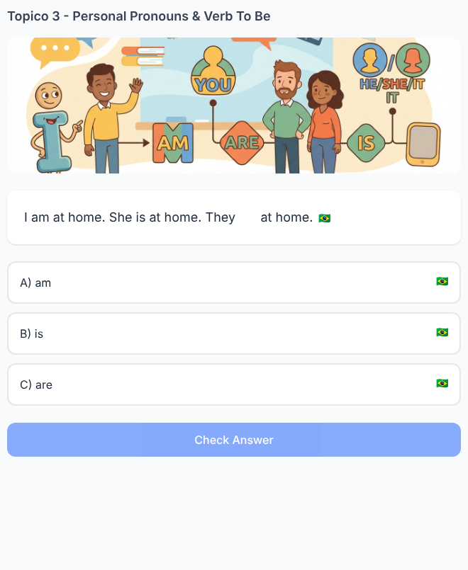

Listening 6. Who is tired?
✅ FEITO → Plataforma: Tópico 3, exercício(s) #11 (audio_question)
Solicitado no documento  Audio Script:  Mia: “I'm tired.”  Leo: “I'm fine.”  Complete:  “___ is tired.”  A) He  B) She ✓  C) They  Answer: She  Focus: follow who says “I'm tired” and change I → she. | Na plataforma  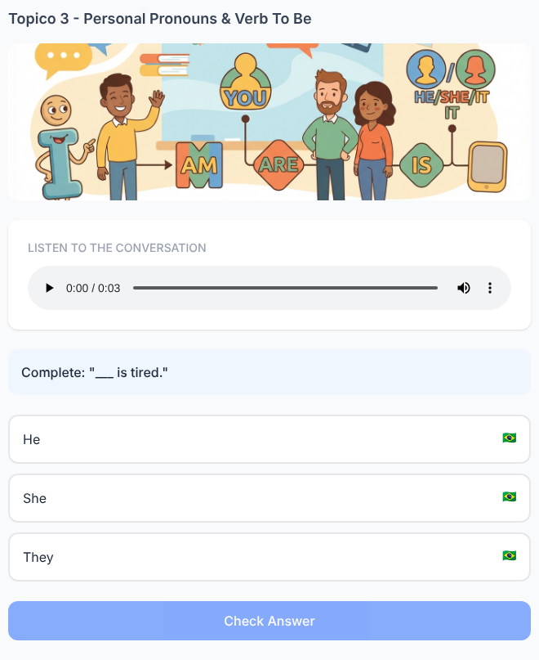

Listening 7. Listen to the change
✅ FEITO → Plataforma: Tópico 3, exercício(s) #12 (multi_blank)
Solicitado no documento  Audio 1:  “I am ready.”  Audio 2:  “We are ready.”  Complete what changes:  I → ___  am → ___  Answers:  I → we  am → are. | Na plataforma  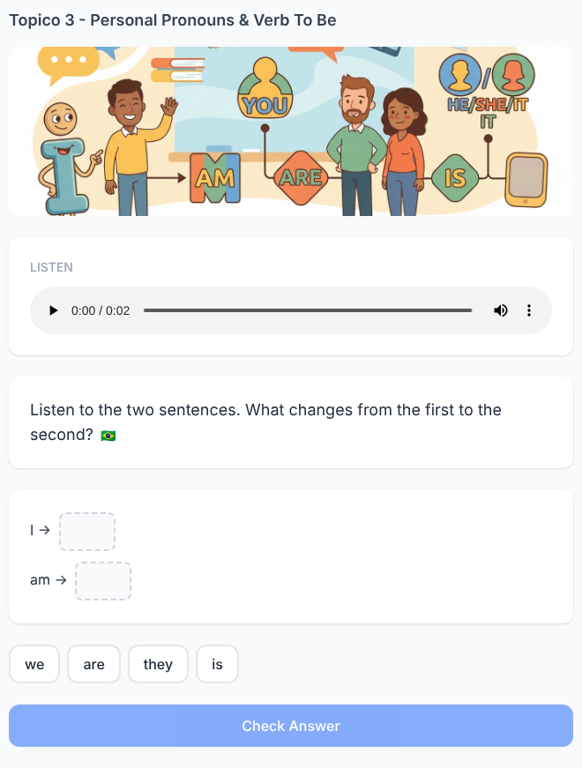

Listening 8. The wrong transcript
✅ FEITO → Plataforma: Tópico 3, exercício(s) #13 (tap_wrong_word)
Solicitado no documento  Audio:  “She is my teacher.”  The app writes:  “She are my teacher.”  Tap the word that does NOT match the audio.  ARE  Replace it with:  IS  Correct sentence:  She is my teacher. | Na plataforma  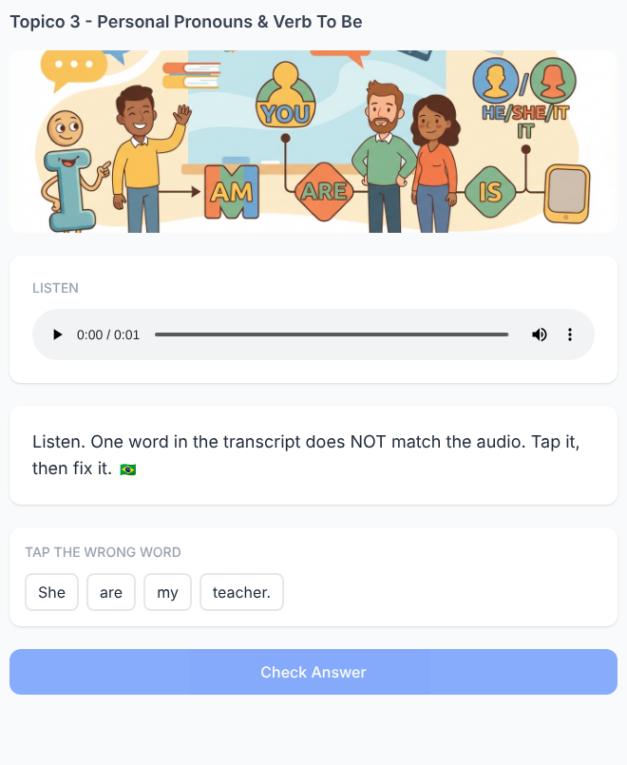

Listening 9. Follow the voices
✅ FEITO → Plataforma: Tópico 3, exercício(s) #14 (audio_question)
Solicitado no documento  Audio:  Anna: “I'm from Brazil.”  Ben: “I'm from Brazil, too.”  A narrator says:  “___ are from Brazil.”  A) We  B) They ✓  C) He  D) She  Answer: They  Focus: convert two I statements into they from the narrator's perspective. | Na plataforma  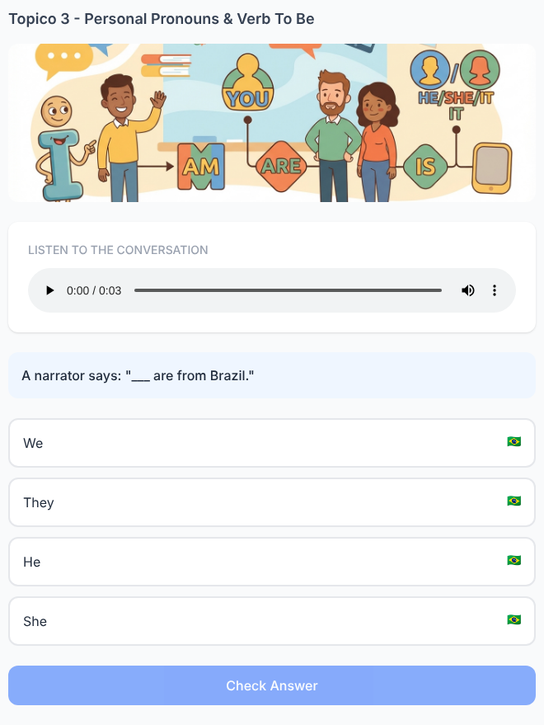

Listening 10. The audio changes speaker
✅ FEITO → Plataforma: Tópico 3, exercício(s) #15 (multi_blank)
Solicitado no documento  Audio:  Mia: “I am happy.”  Ben talks about Mia: “She is happy.”  Complete:  Mia says: ___ am happy.  Ben says: ___ is happy.  Answers:  I am happy.  She is happy. | Na plataforma  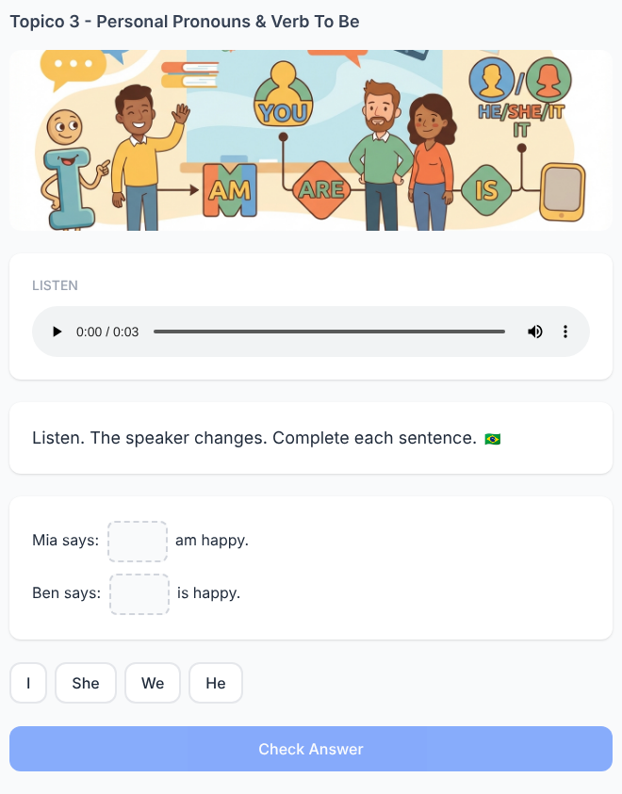

Writing 11. Speak for Leo
✅ FEITO → Plataforma: Tópico 3, exercício(s) #32 (writing)
Solicitado no documento  Leo says:  “I am hungry.”  Write about Leo:  ________ hungry.  Expected answer:  He is hungry.  Focus: change perspective. | Na plataforma  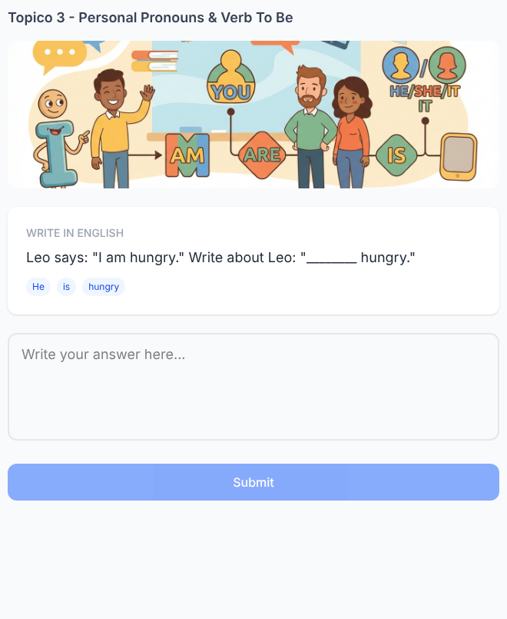

Writing 12. Mia speaks for the group
✅ FEITO → Plataforma: Tópico 3, exercício(s) #33 (writing)
Solicitado no documento  Mia says:  “Lucas and I are ready.”  Now Mia speaks directly for the group.  Complete:  ___ are ready.  Expected answer:  We are ready. | Na plataforma  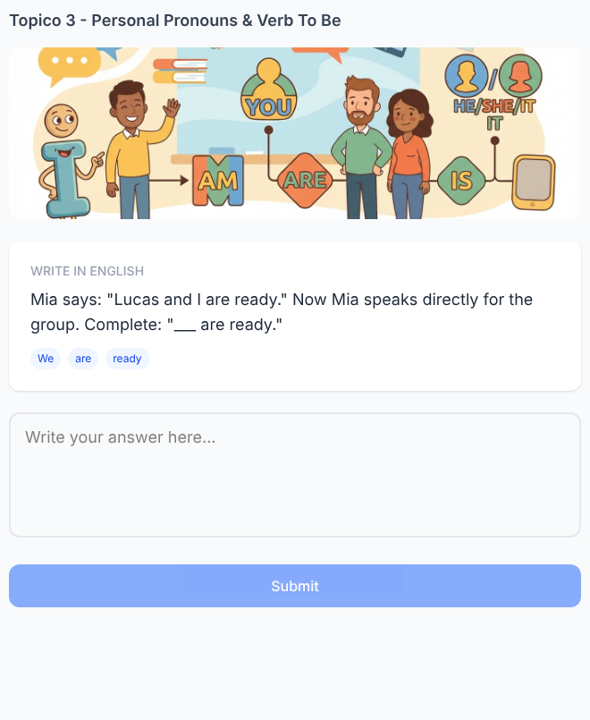

Writing 13. Replace the name
✅ FEITO → Plataforma: Tópico 3, exercício(s) #34 (writing)
Solicitado no documento  Start with:  Emma is happy.  Rewrite using a pronoun.  Expected answer:  She is happy. | Na plataforma  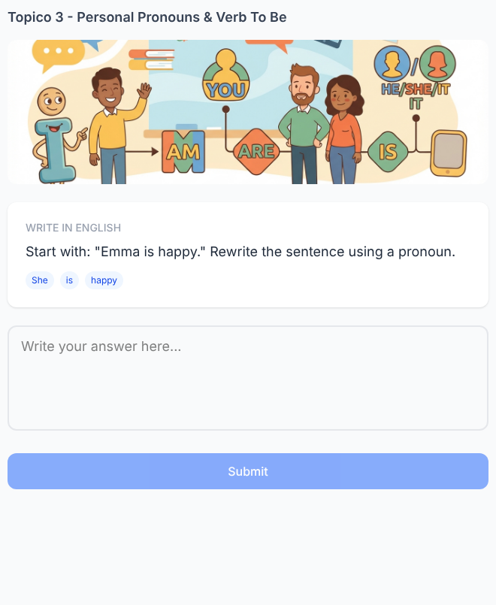

Writing 14. Two sentences become one
✅ FEITO → Plataforma: Tópico 3, exercício(s) #35 (writing)
Solicitado no documento  Ben is tired.  Leo is tired.  Write one sentence about both.  Expected answer:  They are tired.  Focus: choose both the pronoun and the correct form of to be. | Na plataforma  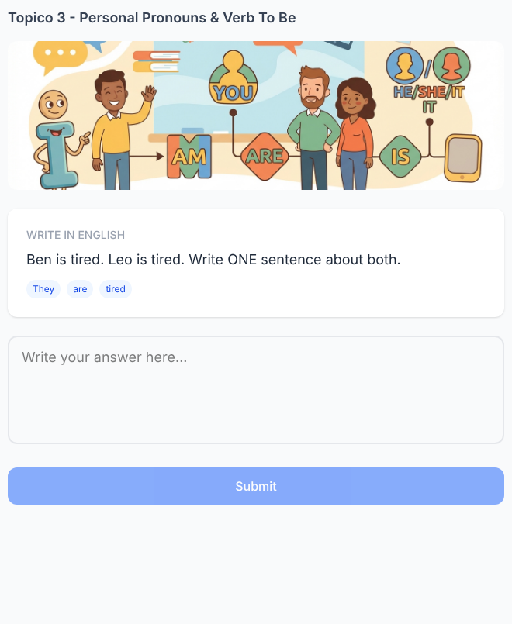

Writing 15. Change the speaker
✅ FEITO → Plataforma: Tópico 3, exercício(s) #36 (writing)
Solicitado no documento  Anna writes:  “I am at school.”  You tell Lucas about Anna.  Write:  ____________________  Expected answer:  She is at school.  Correction targets:  She  is  at school | Na plataforma  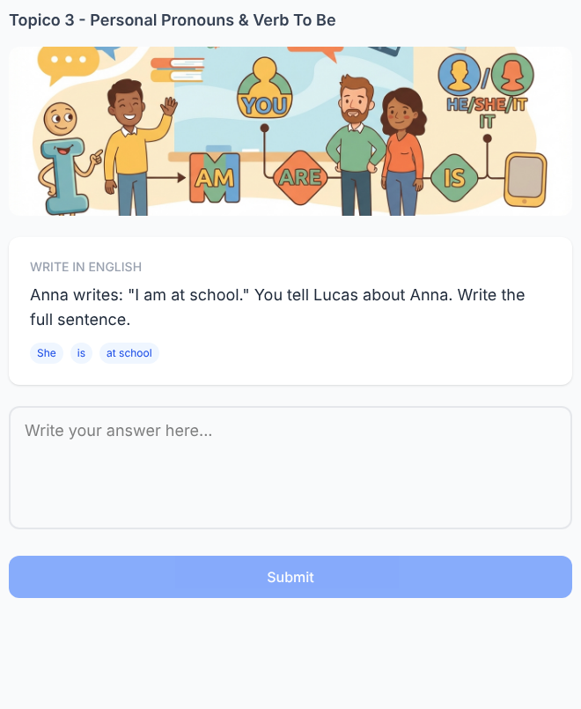

Reading 16. Mia's profile changes voice
✅ FEITO → Plataforma: Tópico 3, exercício(s) #21 (multi_blank)
Solicitado no documento  Mia writes:  “Hi! I'm Mia. I am from Brazil. I am a student.”  Leo talks about Mia:  “___ is from Brazil. ___ is a student.”  A) I / I  B) She / She ✓  C) They / They  D) We / We  Answer: She / She. | Na plataforma  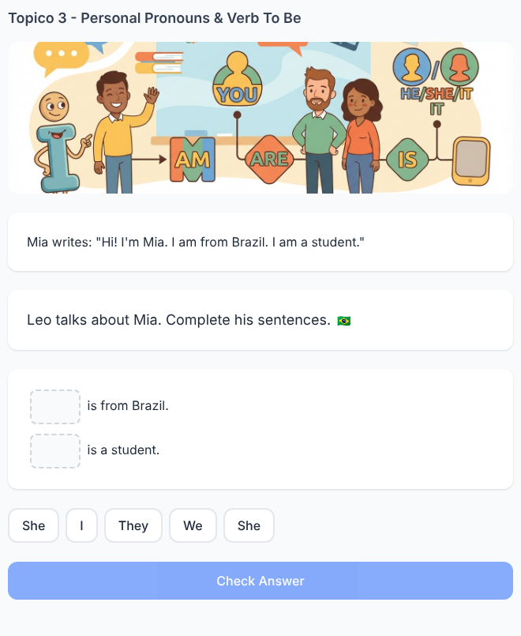

Reading 17. Read the group chat
✅ FEITO → Plataforma: Tópico 3, exercício(s) #22 (reading_comprehension)
Solicitado no documento  Anna: I am ready.  Lucas: I am ready.  Ben: I am not ready.  Complete:  Anna and Lucas: “___ are ready.”  A) We  B) They ✓  C) He  D) You  Answer: They  Focus: read which people the sentence refers to. | Na plataforma  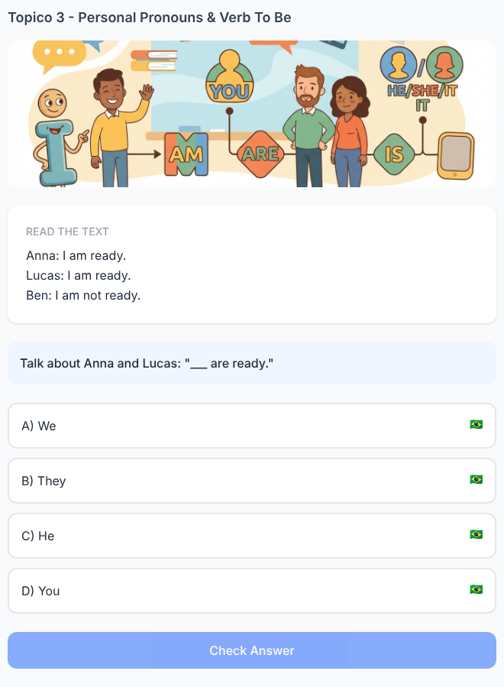

Reading 18. Who can say “we”?
✅ FEITO → Plataforma: Tópico 3, exercício(s) #23 (reading_comprehension)
Solicitado no documento  Mia says:  “Lucas and I are at school.”  Complete Mia's next sentence:  “___ are in English class.”  A) They  B) She  C) We ✓  D) He  Answer: We  Focus: Lucas and I → we when Mia is speaking. | Na plataforma  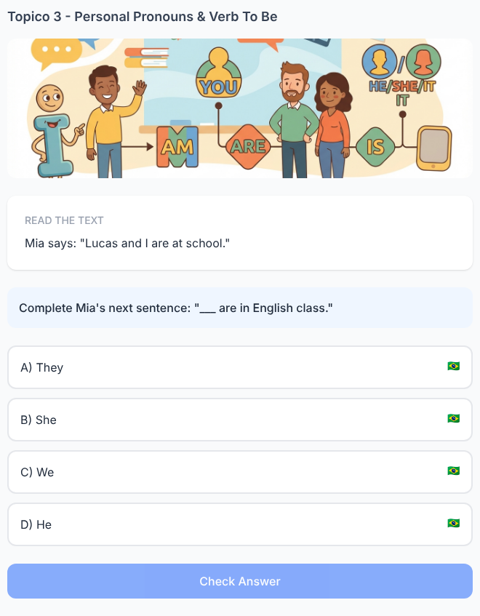

Reading 19. Same people, different speaker
✅ FEITO → Plataforma: Tópico 3, exercício(s) #24 (reading_comprehension)
Solicitado no documento  Mia says:  “Leo and I are friends.”  Anna talks about Mia and Leo:  “___ are friends.”  What changes?  A) We → They ✓  B) They → I  C) He → We  Answer: We → They  Focus: same people, different speaker, different pronoun. | Na plataforma  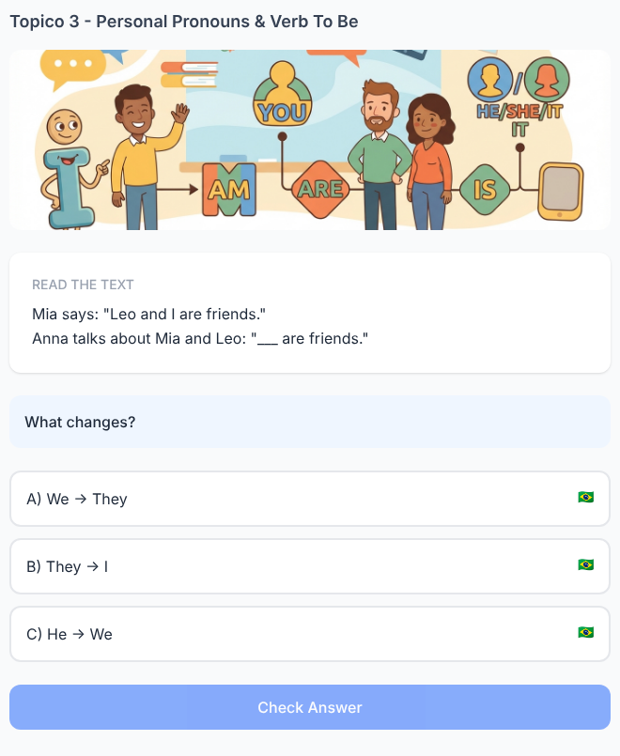

Reading 20. The profile puzzle
✅ FEITO → Plataforma: Tópico 3, exercício(s) #25 (multi_blank)
Solicitado no documento  My name is Daniel. I am 19. My sister is Sofia. She is 22. We are students.  Complete:  Daniel: ___ am 19.  Sofia: ___ is 22.  Daniel and Sofia: ___ are students.  Answers:  I am 19.  She is 22.  They are students.  Focus: three pronoun perspectives from one short text. | Na plataforma  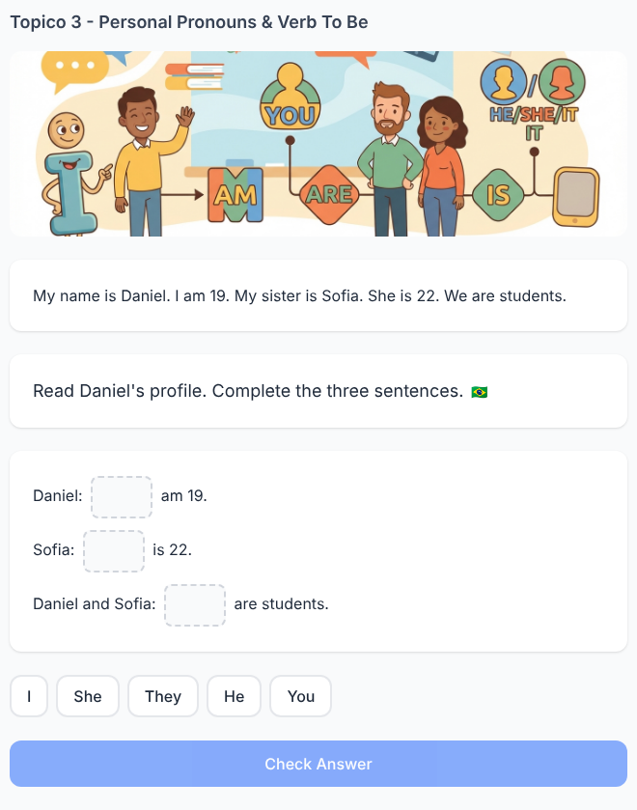

Speaking 21. Listen to Mia. Talk about Mia.
✅ FEITO → Plataforma: Tópico 3, exercício(s) #27 (speaking)
Solicitado no documento  Listen:  Mia: “Hello. I'm Mia. I am a student.”  Lucas asks:  “Who is Mia?”  Answer orally about Mia.  Expected speech:  She is a student.  Focus: hear I am and produce she is. | Na plataforma  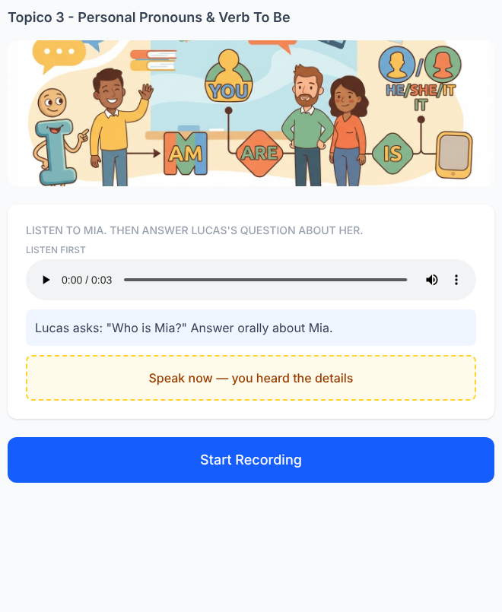

Speaking 22. Ben and Leo introduce themselves
✅ FEITO → Plataforma: Tópico 3, exercício(s) #28 (speaking)
Solicitado no documento  Listen:  Ben: “I'm Ben. I am from Canada.”  Leo: “I'm Leo. I am from Canada, too.”  Anna asks:  “What about Ben and Leo?”  Complete orally:  “They ______ from Canada.”  Expected speech:  They are from Canada. | Na plataforma  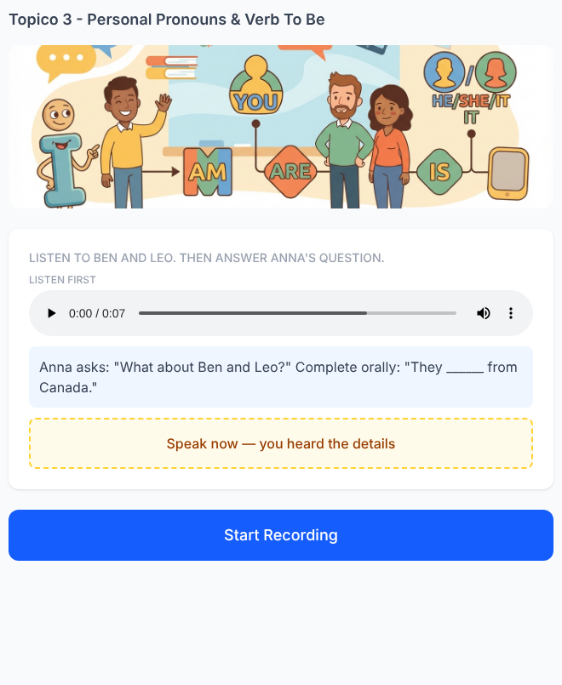

Speaking 23. You join Anna
✅ FEITO → Plataforma: Tópico 3, exercício(s) #29 (speaking)
Solicitado no documento  Listen:  Anna: “I am ready.”  The screen says:  “You are ready, too.”  Anna asks:  “And now?”  Speak as part of the group.  Expected speech:  We are ready.  Focus: I + you → we in this situation. | Na plataforma  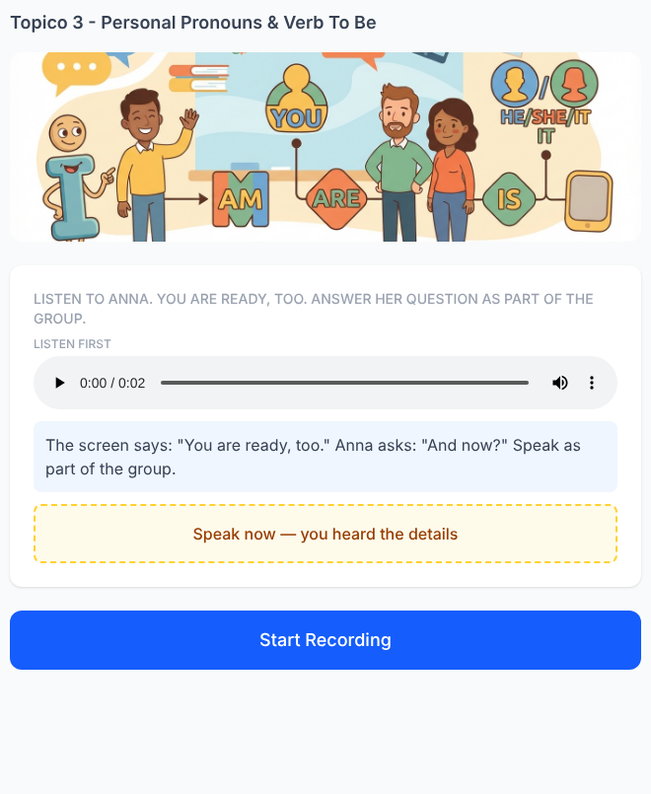

Speaking 24. Follow Daniel's story
✅ FEITO → Plataforma: Tópico 3, exercício(s) #30 (speaking)
Solicitado no documento  Listen:  Daniel: “I'm Daniel. I am tired.”  Emma: “Daniel is tired.”  Now Daniel speaks again:  “___ am tired.”  Complete orally.  Expected:  I am tired.  Then Emma says:  “___ is tired.”  Complete orally.  Expected:  He is tired.  Focus: same information, two perspectives. | Na plataforma  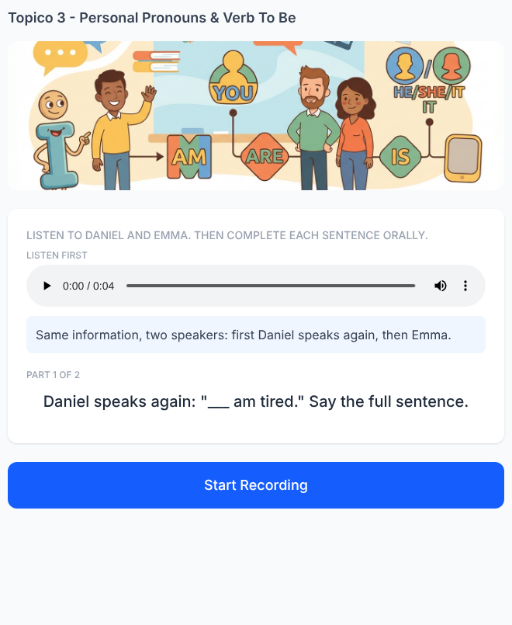

Speaking 25. The Pronoun Switch — Final Challenge
✅ FEITO → Plataforma: Tópico 3, exercício(s) #31 (speaking)
Solicitado no documento  Listen:  Anna: “I'm Anna. I am a student.”  Leo: “I'm Leo. I am a student, too.”  The narrator asks:  “Tell me about Anna.”  Expected speech:  She is a student.  Then:  “Tell me about Leo.”  Expected speech:  He is a student.  Finally:  “Tell me about Anna and Leo.”  Expected speech:  They are students.  Progression:  I am a student.  She is a student.  He is a student.  They are students. | Na plataforma  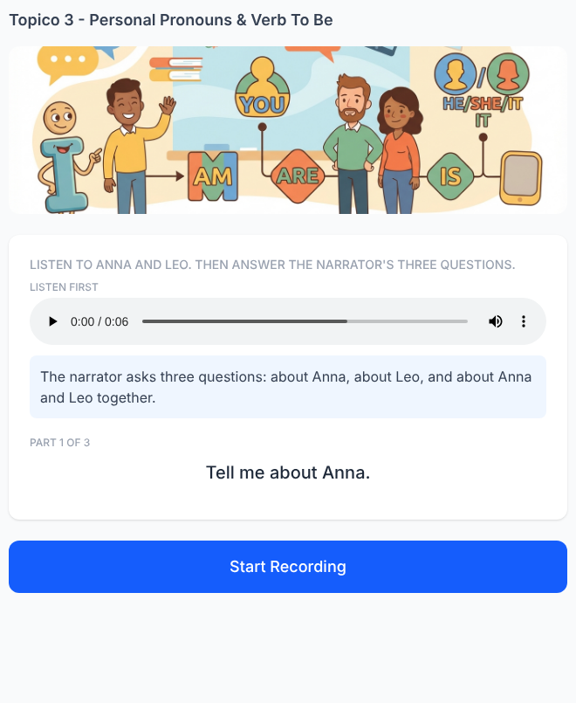

Tópico 5 — Days, Months & Time
Documento da cliente: Básico 1 — Days of the Week, Months & Time • 20 exercícios solicitados

Reading 1. Mia Changed Her Class
✅ FEITO → Plataforma: Tópico 5, exercício(s) #21 (reading_comprehension)
Solicitado no documento  Mia: “My English class is on Monday.”  Leo: “Mine is on Tuesday.”  Mia: “Wait! I'm in your class now.”  Complete:  “We are in class on ______.”  A) Monday  B) Tuesday ✓  C) Wednesday  Answer: Tuesday  Focus: understand “your class now” and use we. | Na plataforma  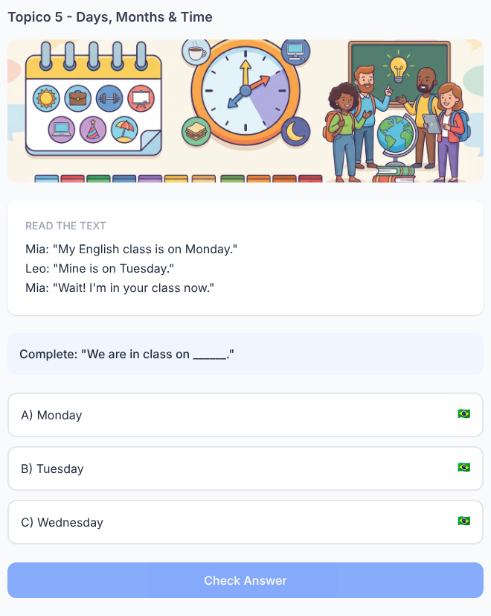

Reading 2. Two Birthdays, One Month
✅ FEITO → Plataforma: Tópico 5, exercício(s) #22 (multi_blank)
Solicitado no documento  Anna: “My birthday is in May.”  Ben: “Really? My birthday is in May, too!”  Complete Ben's sentence:  “Anna and I are May babies. ___ are both born in May.”  A) They  B) We ✓  C) She  D) He  Then complete:  “Our birthdays are in ______.”  Answers: We / May. | Na plataforma  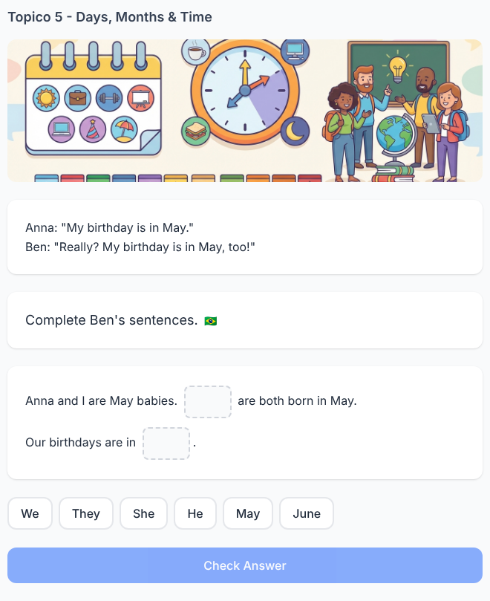

Reading 3. The Meeting Wasn't at Three
✅ FEITO → Plataforma: Tópico 5, exercício(s) #23 (reading_comprehension)
Solicitado no documento  Lucas: “Emma, are we late?”  Emma: “No. The meeting is at four o'clock.”  Lucas: “Oh! I thought it was at three.”  Complete:  “We are not late. It is at ______.”  Answer: four o'clock.  Focus: distinguish correct information from Lucas's mistaken idea. | Na plataforma  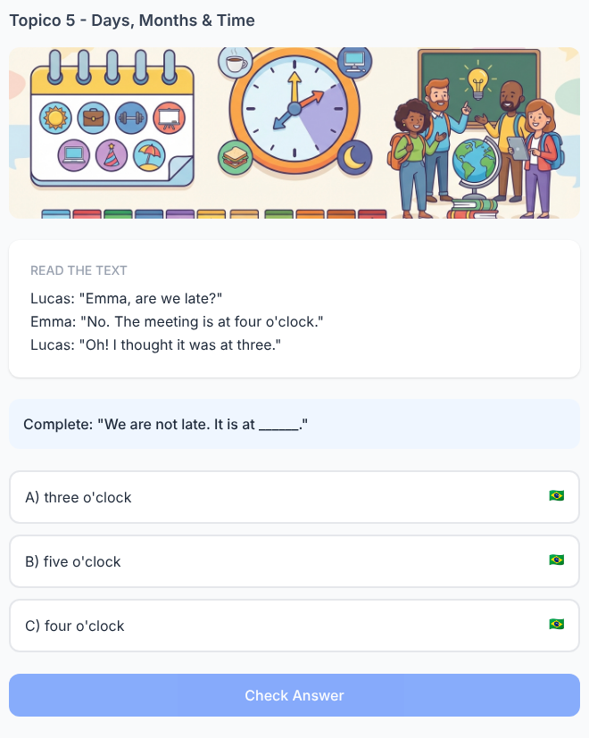

Reading 4. Sofia Talks. Daniel Reports.
✅ FEITO → Plataforma: Tópico 5, exercício(s) #24 (multi_blank)
Solicitado no documento  Sofia: “I am free on Friday. My class is at six o'clock.”  Daniel reports:  “Sofia is free on ______. Her class is at ______.”  Answers: Friday / six o'clock.  Now replace Sofia:  “___ is free on Friday.”  Answer: She.  Focus: I / my → she / her. | Na plataforma  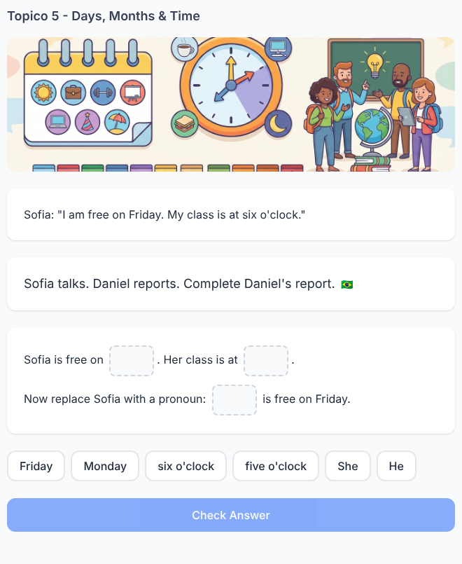

Reading 5. Which Message Is About Leo?
✅ FEITO → Plataforma: Tópico 5, exercício(s) #25 (reading_comprehension)
Solicitado no documento  Mia: “I am busy on Thursday. My class is at seven.”  Leo: “I am free on Thursday. My class is at five.”  Anna: “I am free on Friday. My class is at seven.”  “He is free on Thursday and his class is at five.”  Who is he?  A) Mia  B) Leo ✓  C) Anna  Answer: Leo. | Na plataforma  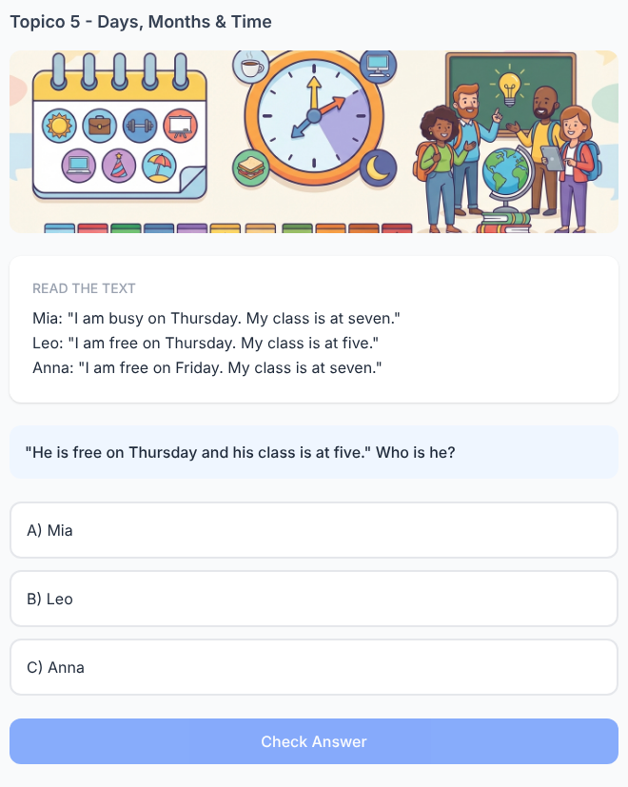

Writing 6. Mia's Words Become Leo's Report
✅ FEITO → Plataforma: Tópico 5, exercício(s) #39 (writing)
Solicitado no documento  Mia: “I am busy on Monday. My class is at eight o'clock.”  Write about Mia:  She ____________________________.  Her class ______________________.  Expected:  She is busy on Monday.  Her class is at eight o'clock. | Na plataforma  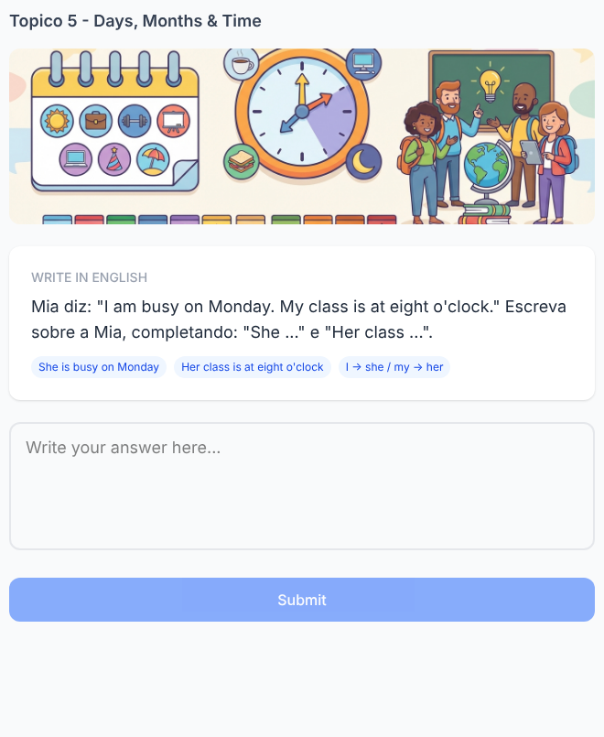

Writing 7. Join the Two Messages
✅ FEITO → Plataforma: Tópico 5, exercício(s) #40 (writing)
Solicitado no documento  Anna: “I am free on Sunday.”  You are free on Sunday, too.  Write one sentence for both of you.  Expected:  We are free on Sunday. | Na plataforma  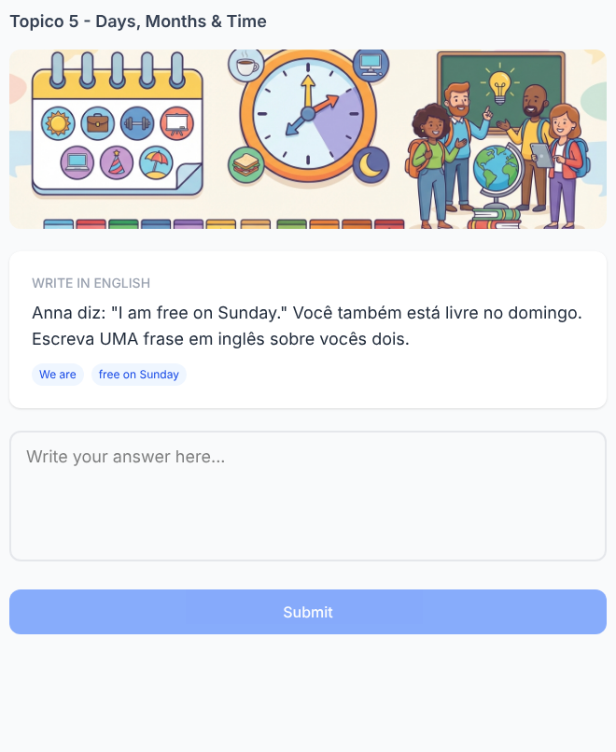

Writing 8. The Calendar Changed
✅ FEITO → Plataforma: Tópico 5, exercício(s) #41 (writing)
Solicitado no documento  Old message:  “My class is on Tuesday at four o'clock.”  New information:  Thursday / six o'clock  Rewrite the complete message.  Expected:  My class is on Thursday at six o'clock. | Na plataforma  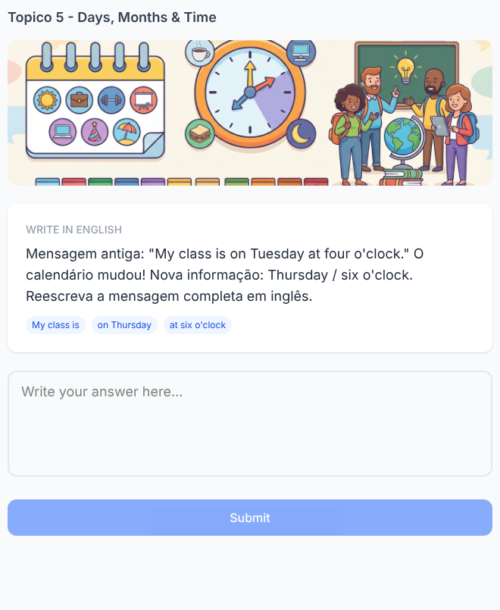

Writing 9. Write About Ben
✅ FEITO → Plataforma: Tópico 5, exercício(s) #42 (writing)
Solicitado no documento  Ben: “My birthday is in August. I am twenty.”  Write about Ben using HE.  Expected:  His birthday is in August. He is twenty.  Focus: my → his / I → he. | Na plataforma  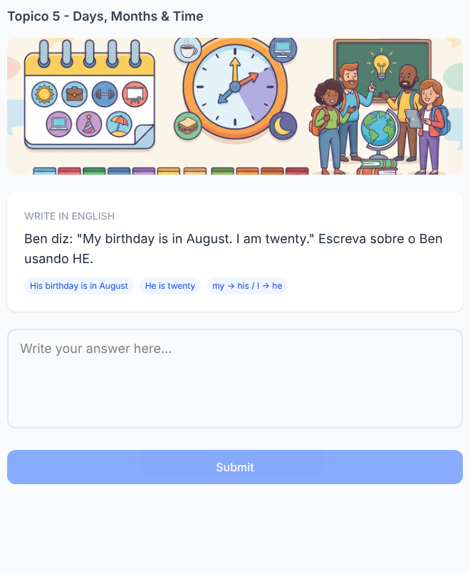

Writing 10. Recover Mia's Message
✅ FEITO → Plataforma: Tópico 5, exercício(s) #43 (writing)
Solicitado no documento  Leo replies:  “Really? I'm free on Friday, too! See you at seven!”  Mia's message is missing.  Complete:  “I am free on ______. I am at the café at ______.”  Expected:  I am free on Friday. I am at the café at seven. | Na plataforma  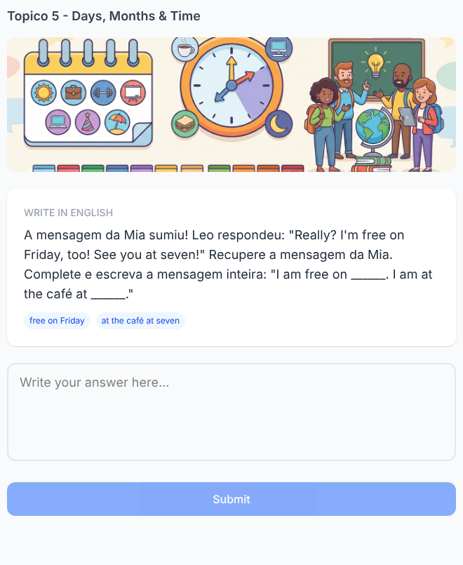

Listening 11. Anna Corrects the Day
✅ FEITO → Plataforma: Tópico 5, exercício(s) #11 (multi_blank)
Solicitado no documento  Audio Script:  Leo: “Your class is on Monday, right?”  Anna: “No. I'm busy on Monday. My class is on Wednesday.”  Complete:  She is busy on ______.  Her class is on ______.  Answers: Monday / Wednesday. | Na plataforma  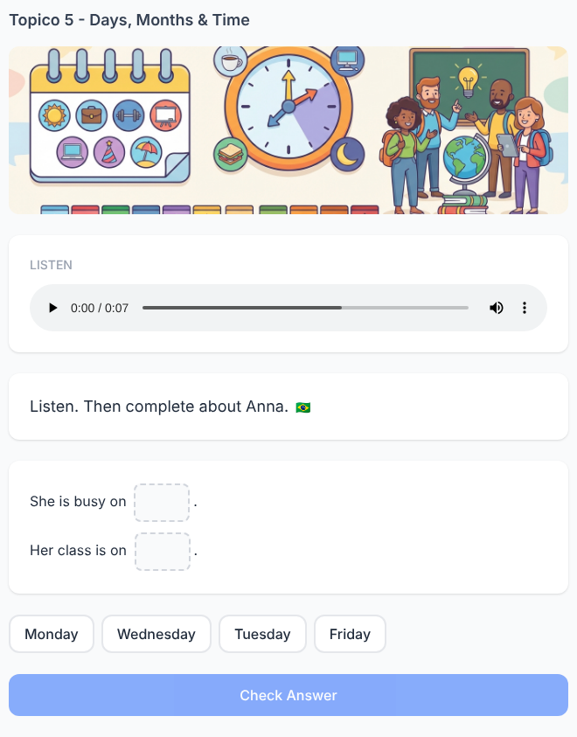

Listening 12. Which Time Is Final?
✅ FEITO → Plataforma: Tópico 5, exercício(s) #12 (audio_question)
Solicitado no documento  Audio Script:  “The movie is at six... sorry, it is at seven o'clock.”  Complete:  It is at ______.  Answer: seven o'clock.  Focus: identify the final corrected information. | Na plataforma  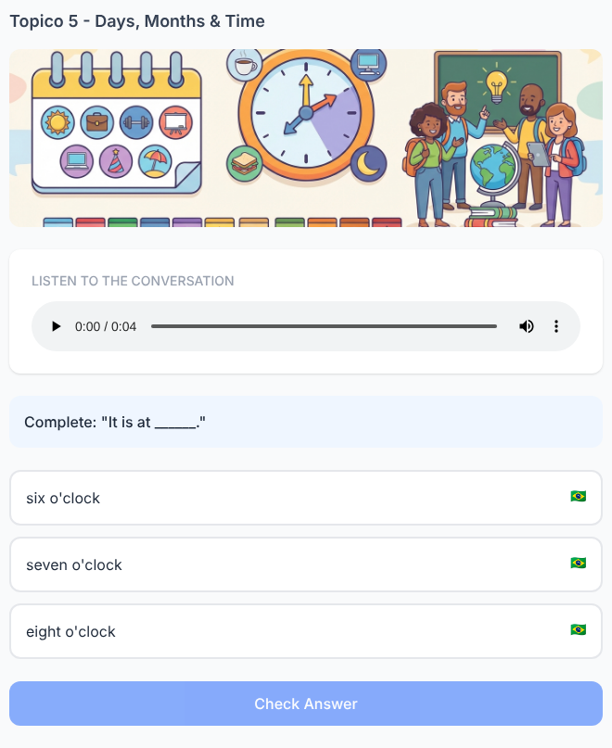

Listening 13. Follow Mia and Ben
✅ FEITO → Plataforma: Tópico 5, exercício(s) #13 (audio_question)
Solicitado no documento  Audio Script:  Mia: “I'm free on Saturday.”  Ben: “I'm free on Saturday, too.”  Complete:  “They ___ free on ______.”  A) is / Sunday  B) are / Saturday ✓  C) am / Saturday  Answer: are / Saturday. | Na plataforma  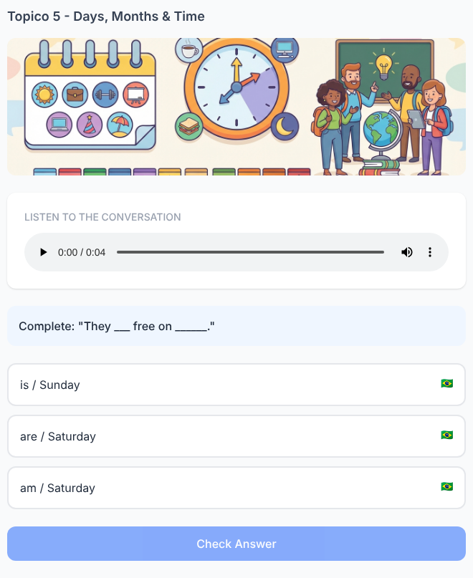

Listening 14. January or June?
✅ FEITO → Plataforma: Tópico 5, exercício(s) #14 (multi_blank)
Solicitado no documento  Audio Script:  Emma: “My birthday is in January.”  Leo: “Mine is in June.”  Emma: “So, we are not born in the same month.”  Complete:  Her birthday is in ______.  His birthday is in ______.  Answers: January / June. | Na plataforma  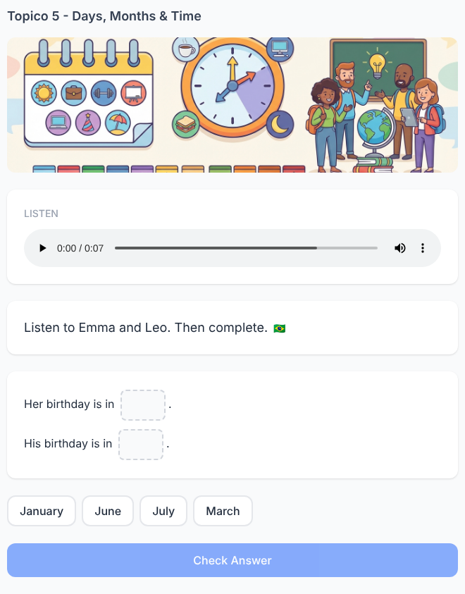

Listening 15. The Schedule Challenge
✅ FEITO → Plataforma: Tópico 5, exercício(s) #15 (multi_blank)
Solicitado no documento  Listen once:  “I'm Daniel. I am busy on Tuesday. My English class is on Thursday at five o'clock.”  Complete:  He is busy on ______.  His English class is on ______ at ______.  Answers:  Tuesday  Thursday  five o'clock. | Na plataforma  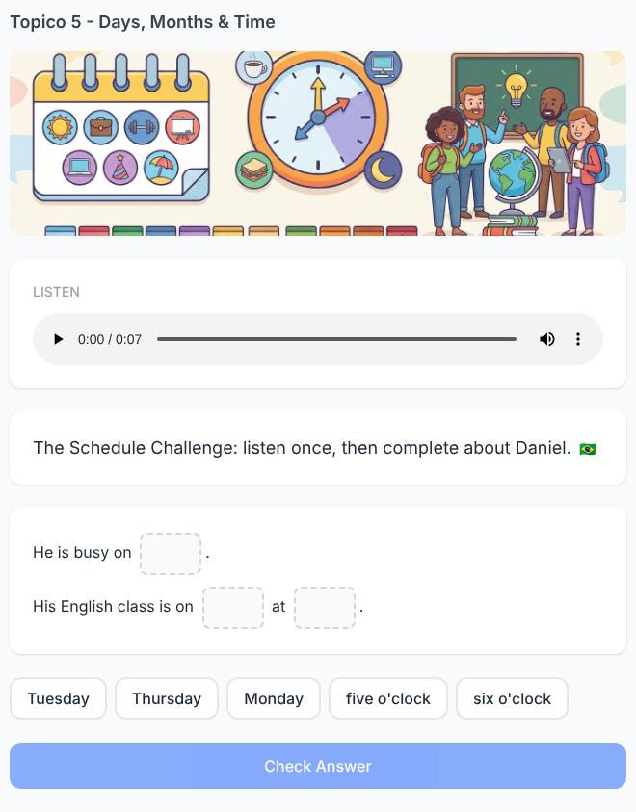

Speaking 16. Listen to Emma. Report to Ben.
✅ FEITO → Plataforma: Tópico 5, exercício(s) #27 (speaking)
Solicitado no documento  Emma: “I'm free on Wednesday. My class is at four o'clock.”  Ben asks:  “What did Emma say?”  Tell Ben orally.  Expected:  She is free on Wednesday. Her class is at four o'clock. | Na plataforma  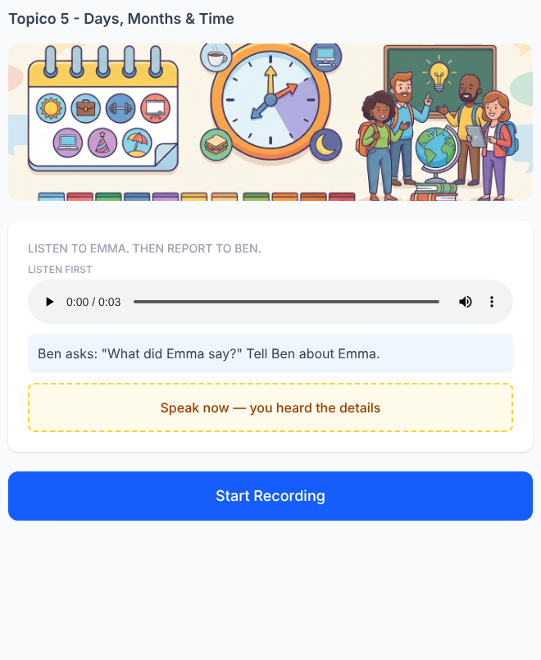

Speaking 17. The Wrong Schedule
✅ FEITO → Plataforma: Tópico 5, exercício(s) #28 (speaking)
Solicitado no documento  Lucas: “My class is on Friday at six.”  The app says:  “Lucas is in class on Thursday at six.”  Correct the app orally.  Expected:  He is in class on Friday at six. | Na plataforma  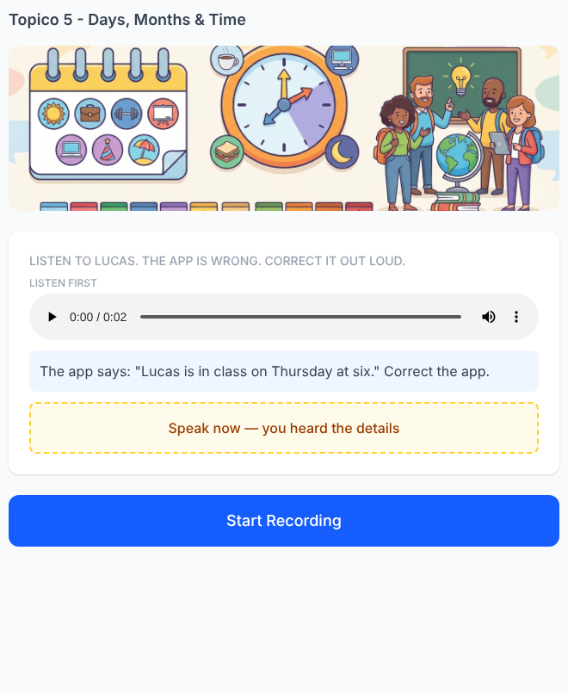

Speaking 18. Anna and You Have the Same Day
✅ FEITO → Plataforma: Tópico 5, exercício(s) #29 (speaking)
Solicitado no documento  Anna: “I am free on Sunday.”  You are free on Sunday, too.  Anna asks:  “What about us?”  Expected:  We are free on Sunday. | Na plataforma  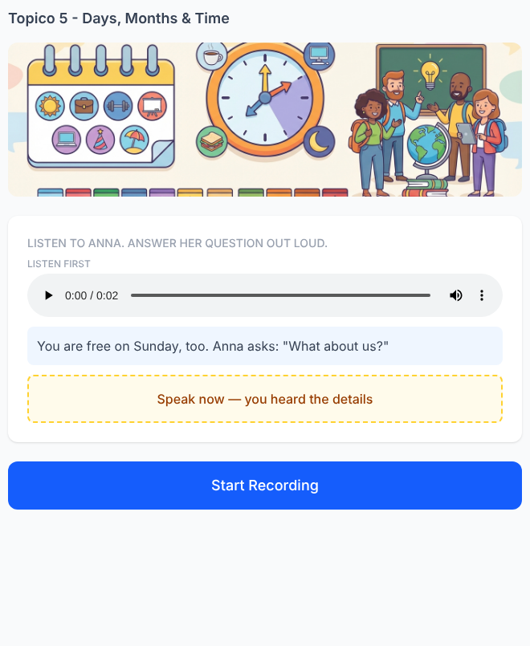

Speaking 19. Listen to the Calendar Story
✅ FEITO → Plataforma: Tópico 5, exercício(s) #30 (speaking)
Solicitado no documento  Mia: “My birthday is in March.”  Leo: “My birthday is in March, too.”  Anna: “Mine is in July.”  Tell me about Mia and Leo.  Expected:  Their birthdays are in March.  Tell me about Anna.  Expected:  Her birthday is in July. | Na plataforma  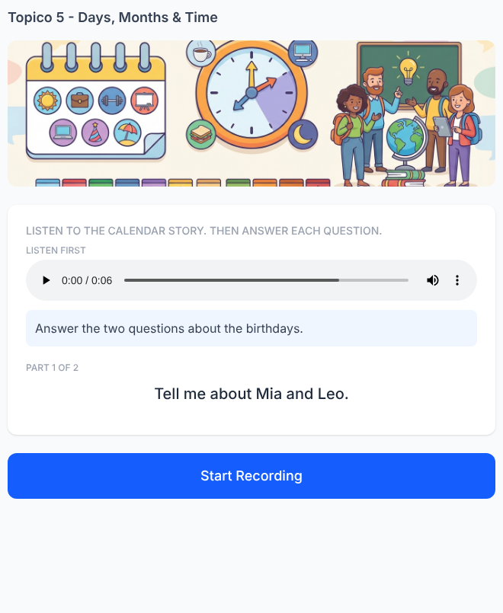

Speaking 20. The Weekly Memory Challenge
✅ FEITO → Plataforma: Tópico 5, exercício(s) #31 (speaking)
Solicitado no documento  Listen only once:  “Hello! I'm Sofia. I am busy on Monday. My English class is on Wednesday at seven o'clock. I am free on Friday.”  Tell me about Sofia.  Target:  She is busy on Monday.  Her English class is on Wednesday at seven o'clock.  She is free on Friday.  Scoring:  - she / her  - busy + Monday  - class + Wednesday  - seven o'clock  - free + Friday  5 details = Perfect schedule! | Na plataforma  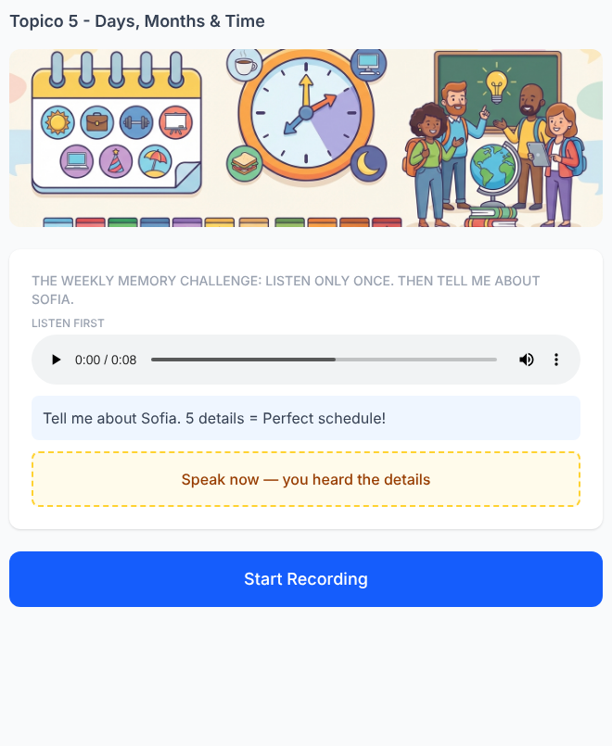

Tópico 6 — Family, Countries & Professions
Documento da cliente: Básico 1 — Family Members, Countries & Professions • 20 exercícios solicitados

Reading 1. Two People Named Anna
✅ FEITO → Plataforma: Tópico 6, exercício(s) #21 (multi_blank)
Solicitado no documento  Read Leo's message:  “My sister is Anna. She is a nurse. She is from Canada. She is at the hospital on Monday at seven.”  Ben says:  “My mother is Anna, too! She is a teacher from Brazil. She is at school on Monday at eight.”  Complete the correct profile for Leo's Anna:  Anna is his ______.  She is a ______.  She is from ______.  She is at the hospital on ______ at ______.  Answers:  sister  nurse  Canada  Monday  seven  Focus: follow family member, profession, country and schedule when two people have the same name. | Na plataforma  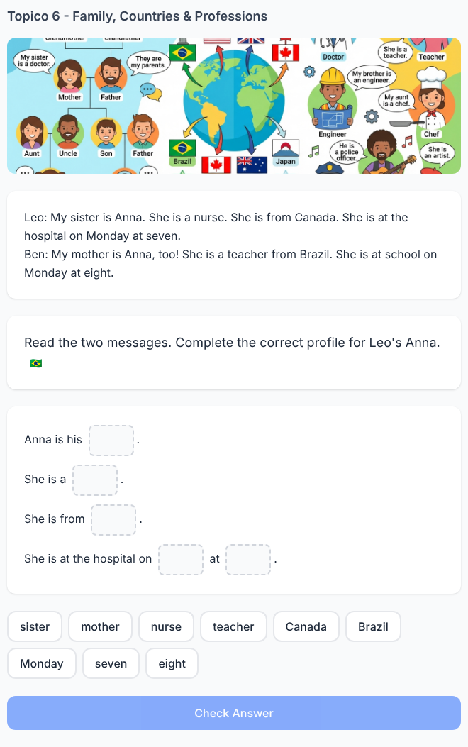

Reading 2. Who Is “He”?
✅ FEITO → Plataforma: Tópico 6, exercício(s) #22 (multi_blank)
Solicitado no documento  Read:  “My father is Daniel. He is a doctor from Spain. My brother is Lucas. He is a student. Lucas is free on Friday, but Daniel is at the hospital at six.”  Mia writes:  “He is from Spain and he is at the hospital at six.”  Who is he?  A) Lucas  B) Daniel ✓  C) Mia  Then complete:  Daniel is her ______. He is a ______.  Answers:  father  doctor  Focus: follow the reference instead of choosing only from the pronoun. | Na plataforma  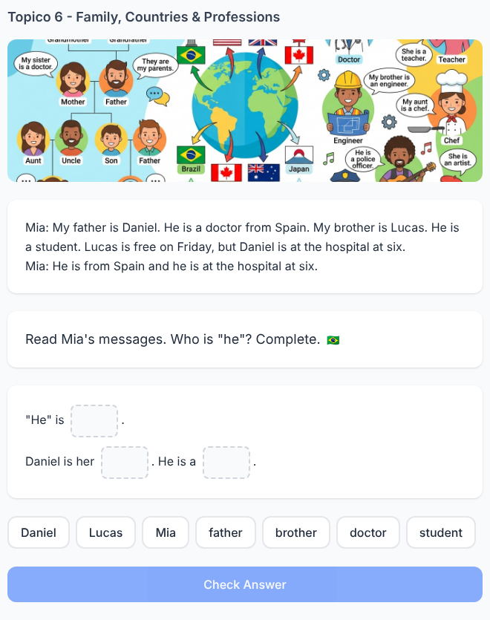

Reading 3. The Family Schedule Changed
✅ FEITO → Plataforma: Tópico 6, exercício(s) #23 (multi_blank)
Solicitado no documento  Read:  Monday: Sofia's mother is at the hospital at eight.  Tuesday: Sofia's brother is at school at nine.  Wednesday: Sofia's father is at the restaurant at six.  Then Sofia says:  “My father is a chef.”  Complete:  He is at the ______ on ______ at ______.  Expected:  restaurant / Wednesday / six  Then complete:  Sofia's father is a ______.  Answer:  chef  Focus: connect family member → pronoun → profession → place → day → time. | Na plataforma  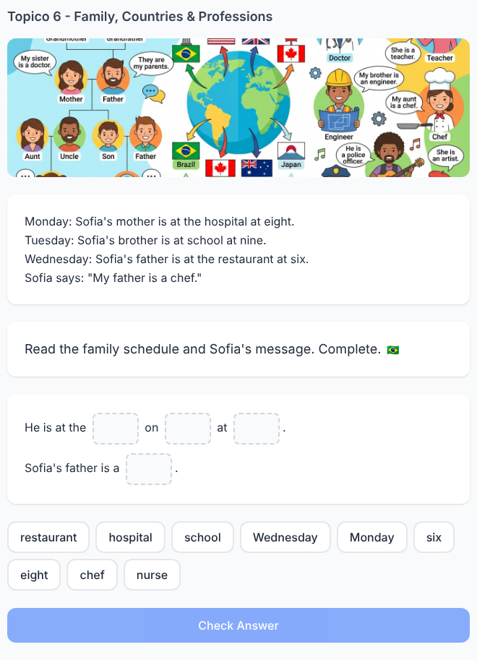

Reading 4. The Wrong Family Report
⚠️ PARCIAL → Plataforma: Tópico 6, exercício(s) #24 (tap_wrong_word)
PARCIAL: a 2ª parte do doc ("Ben is her ___. He is from ___") não foi implementada; o exercício virou "toque na palavra errada".
Solicitado no documento  Read Emma's message:  “My mother is Julia. She is a teacher from Italy. My uncle is Ben. He is a doctor from Canada.”  The app writes:  “Julia is Emma's mother. She is a doctor from Italy. Ben is her uncle. He is a doctor from Canada.”  One profession is wrong. Rewrite the sentence.  Expected:  Julia is a teacher from Italy.  Then complete:  Ben is her ______. He is from ______.  Answers:  uncle  Canada. | Na plataforma  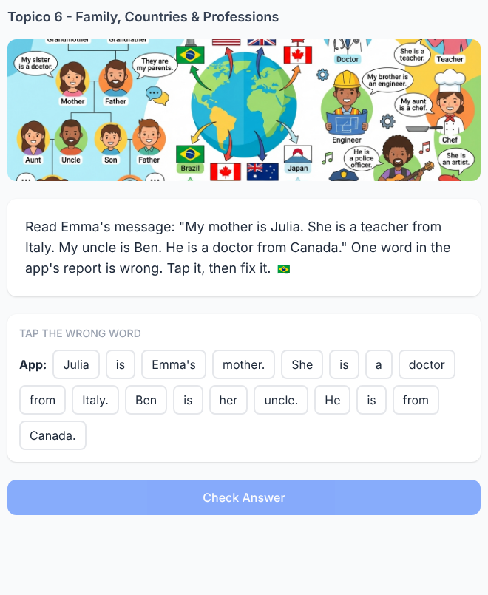

Reading 5. Sunday Dinner
✅ FEITO → Plataforma: Tópico 6, exercício(s) #25 (multi_blank)
Solicitado no documento  Read:  “My name is Leo. My mother, Emma, is a doctor. My father, Ben, is a teacher. My sister, Mia, is a student. We are from Brazil. On Sunday, we are at my grandmother's house at seven.”  Complete Leo's family notes:  Emma is his ______ and she is a ______.  Ben is his ______ and he is a ______.  Mia is his ______ and she is a ______.  They are from ______.  They are together on ______ at ______.  Answers:  mother / doctor  father / teacher  sister / student  Brazil  Sunday / seven  Focus: recover multiple connected details from one short text. | Na plataforma  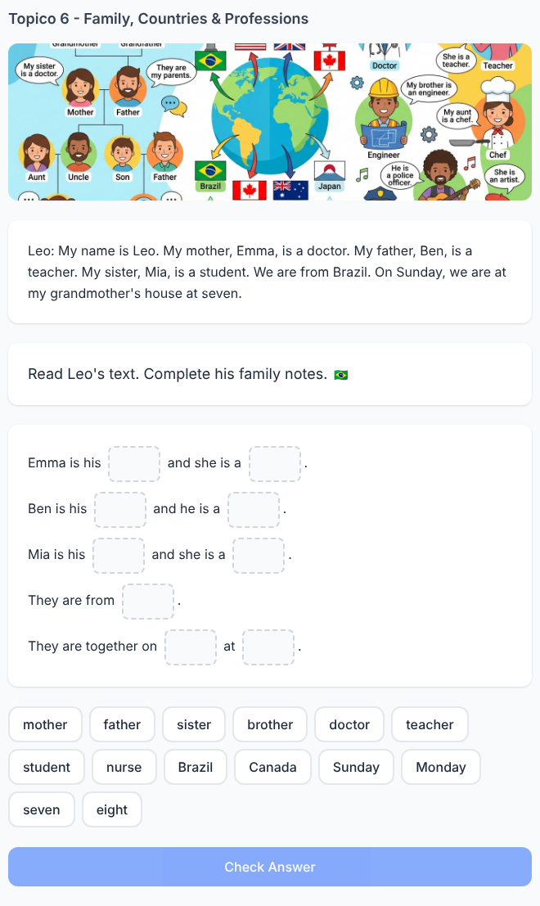

Listening 6. Don't Follow the First Profession
✅ FEITO → Plataforma: Tópico 6, exercício(s) #11 (multi_blank)
Solicitado no documento  Audio Script:  Anna: “Is your sister a teacher?”  Leo: “No. My mother is a teacher. My sister is a nurse.”  Complete:  His mother is a ______.  His sister is a ______.  Answers:  teacher  nurse  Focus: follow mother / sister instead of the first profession heard. | Na plataforma  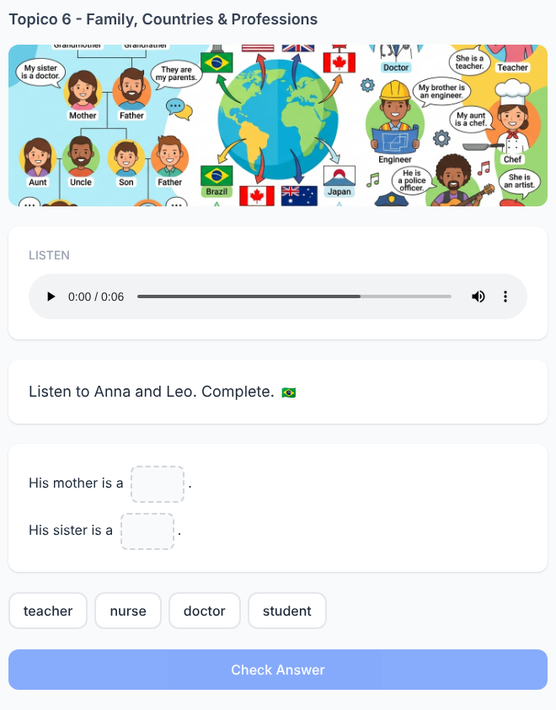

Listening 7. Daniel's Family Has Two Countries
✅ FEITO → Plataforma: Tópico 6, exercício(s) #12 (multi_blank)
Solicitado no documento  Audio Script:  Daniel: “I'm from Brazil. My father is from Brazil, too. My mother is from Mexico.”  Complete:  Daniel and his father are from ______.  His mother is from ______.  Answers:  Brazil  Mexico  Then complete:  They are from Brazil. She is from Mexico.  Focus: connect people and pronouns after listening. | Na plataforma  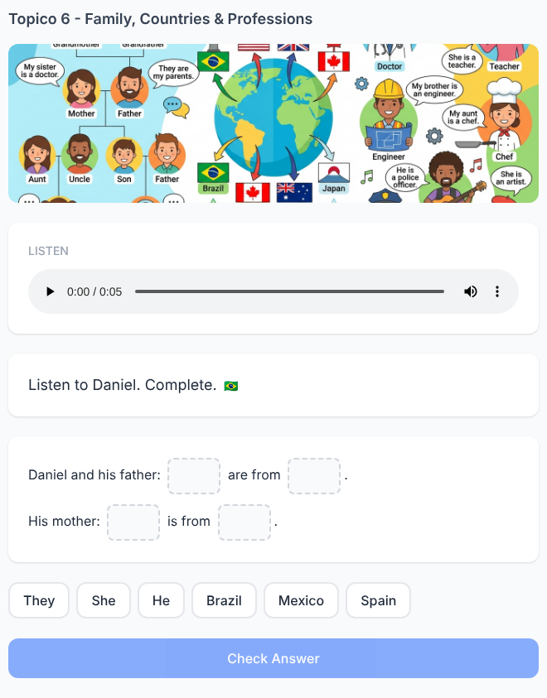

Listening 8. Which Brother?
✅ FEITO → Plataforma: Tópico 6, exercício(s) #13 (multi_blank)
Solicitado no documento  Audio Script:  “My brother Leo is a doctor. He is at the hospital on Tuesday at six. My brother Tom is a chef. He is at the restaurant on Tuesday at seven.”  Complete:  ______ is at the hospital at six.  ______ is at the restaurant at seven.  Answers:  Leo  Tom  Then:  “He is a doctor.”  Who is he?  Answer:  Leo  Focus: distinguish two brothers with the same day but different professions and times. | Na plataforma  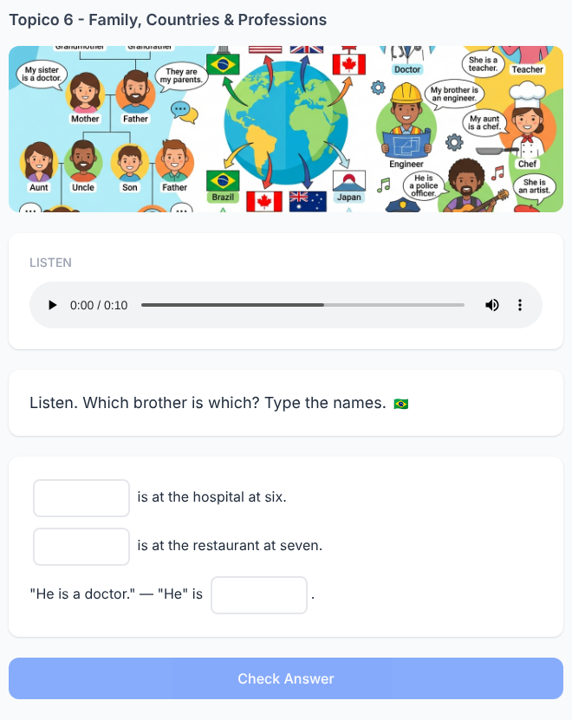

Listening 9. Anna Corrects Three Details
✅ FEITO → Plataforma: Tópico 6, exercício(s) #14 (multi_blank)
Solicitado no documento  Audio Script:  Ben: “Your father is a doctor from Canada. He is free on Monday.”  Anna: “No! My uncle is a doctor from Canada. My father is a teacher. He is busy on Monday.”  Complete Anna's correct family report:  Her ______ is a doctor from Canada.  Her father is a ______.  He is ______ on Monday.  Answers:  uncle  teacher  busy  Focus: abandon incorrect associations from the first speaker. | Na plataforma  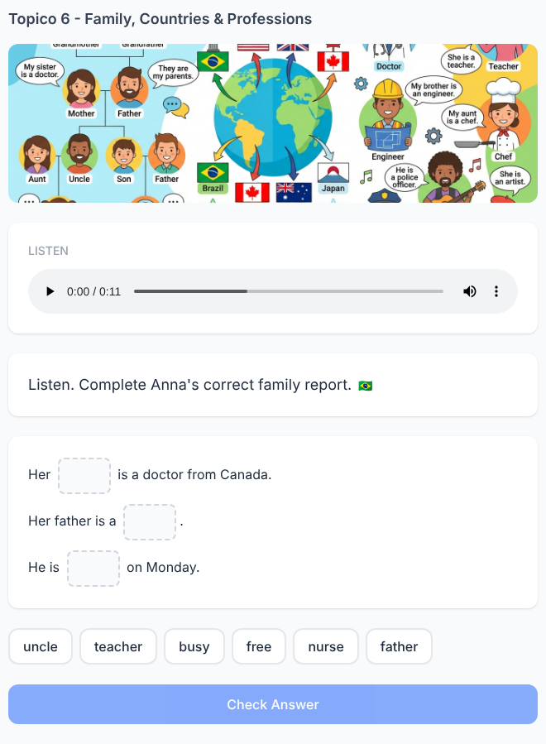

Listening 10. The Family Voice Message
✅ FEITO → Plataforma: Tópico 6, exercício(s) #15 (multi_blank)
Solicitado no documento  Listen once:  “Hello, I'm Mia. My mother is Sofia. She is a nurse from Spain. My father is Lucas. He is a chef. He is at the restaurant on Friday at eight.”  The audio disappears.  Complete:  Sofia is Mia's ______.  She is a ______ from ______.  Lucas is her ______.  He is a ______.  He is at the restaurant on ______ at ______.  Answers:  mother  nurse  Spain  father  chef  Friday  eight  Focus: maintain a small tree of information in auditory memory. | Na plataforma  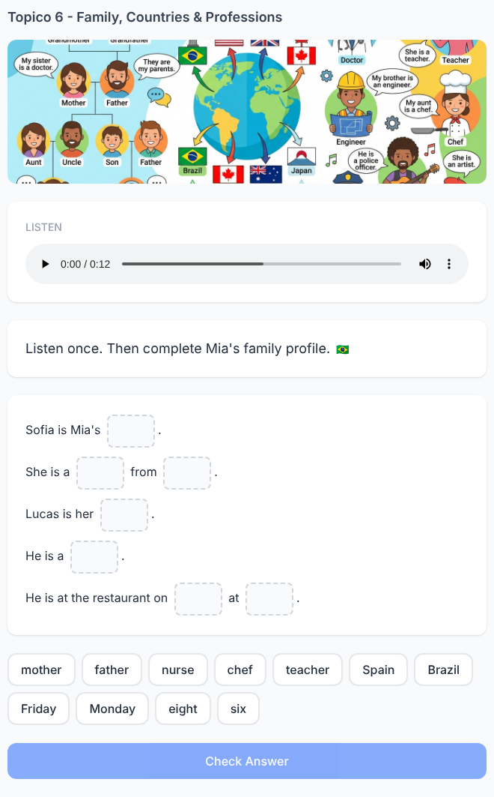

Speaking 11. Listen to Ben. Talk About His Family
✅ FEITO → Plataforma: Tópico 6, exercício(s) #26 (speaking)
Solicitado no documento  Listen:  Ben says:  “My sister is Emma. She is a teacher from Canada. She is at school on Monday at eight.”  Mia didn't hear Ben.  Mia: “Tell me about Ben's sister.”  Report what you heard orally.  Expected:  His sister is Emma. She is a teacher from Canada. She is at school on Monday at eight.  Focus: my → his while maintaining the information. | Na plataforma  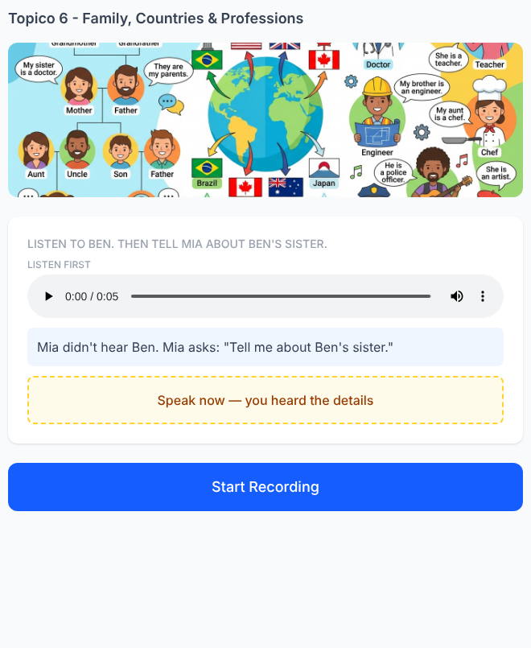

Speaking 12. Two Daniels, One Family
✅ FEITO → Plataforma: Tópico 6, exercício(s) #27 (speaking)
Solicitado no documento  Listen:  Anna: “My father is Daniel. He is a doctor.”  Leo: “My brother is Daniel. He is a student.”  The narrator asks:  “Tell me about Anna's Daniel.”  Expected:  He is her father. He is a doctor.  Then:  “Tell me about Leo's Daniel.”  Expected:  He is his brother. He is a student.  Focus: maintain the correct reference despite the same name. | Na plataforma  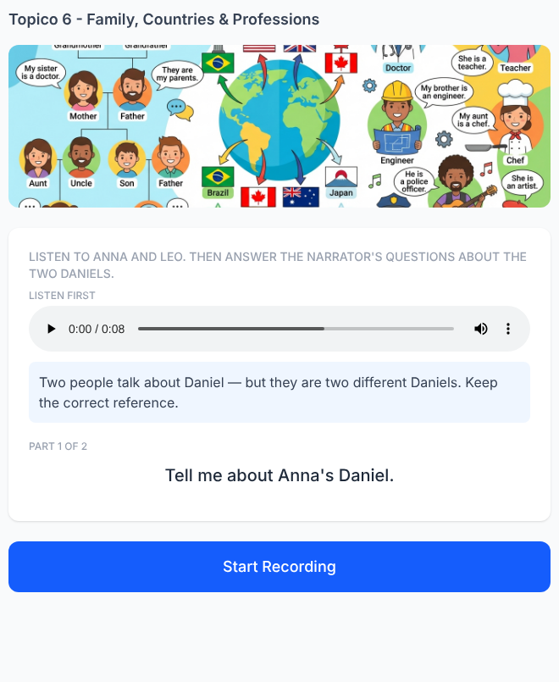

Speaking 13. The Schedule Is Mixed Up
✅ FEITO → Plataforma: Tópico 6, exercício(s) #28 (speaking)
Solicitado no documento  Listen:  Mia: “My mother is a nurse. She is at the hospital on Wednesday at seven. My father is a teacher. He is at school on Thursday at eight.”  The app says:  “Mia's father is at the hospital on Wednesday.”  Mia says:  “No!”  Correct the app with a complete sentence.  Expected:  Her mother is at the hospital on Wednesday at seven.  Then the app asks:  “And her father?”  Expected:  He is at school on Thursday at eight. | Na plataforma  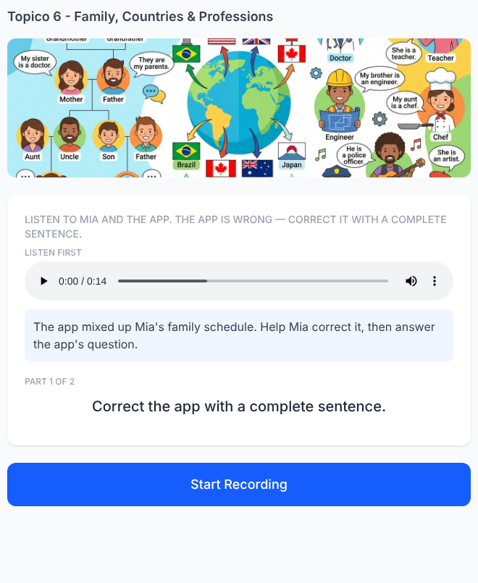

Speaking 14. Become the Family Narrator
✅ FEITO → Plataforma: Tópico 6, exercício(s) #29 (speaking)
Solicitado no documento  Listen:  Sofia: “I'm from Italy. My brother Leo is from Italy, too. I'm a doctor. Leo is a chef.”  The narrator asks:  “Where are Sofia and Leo from?”  Expected:  They are from Italy.  Then:  “Tell me about Sofia.”  Expected:  She is a doctor.  Then:  “And Leo?”  Expected:  He is a chef.  Focus: they → she → he inside the same scene. | Na plataforma  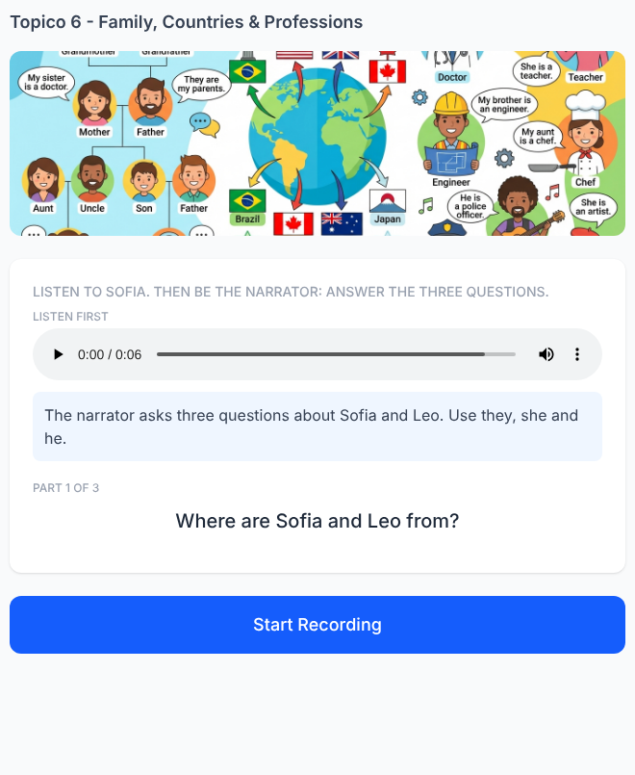

Speaking 15. The Family Profile Challenge
✅ FEITO → Plataforma: Tópico 6, exercício(s) #30 (speaking)
Solicitado no documento  Listen only once:  “I'm Anna. My mother is Emma. She is a teacher from England. My father is Leo. He is a doctor from Brazil. Emma is at school on Monday at eight. Leo is at the hospital on Tuesday at seven.”  The audio disappears.  The narrator asks:  “Tell me about Anna's family.”  The student speaks freely.  Target information:  Her mother is Emma.  She is a teacher from England.  She is at school on Monday at eight.  Her father is Leo.  He is a doctor from Brazil.  He is at the hospital on Tuesday at seven.  Scoring:  - mother / Emma  - she / teacher / England  - Monday / eight  - father / Leo  - he / doctor / Brazil  - Tuesday / seven  6 details = Family Expert! | Na plataforma  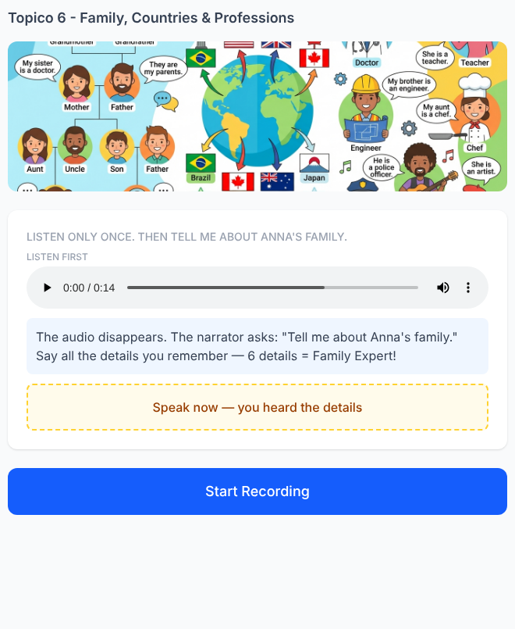

Writing 16. Anna Speaks. You Write Her Profile
✅ FEITO → Plataforma: Tópico 6, exercício(s) #31 (writing)
Solicitado no documento  Anna says:  “My brother is Ben. He is a doctor from Canada. He is at the hospital on Friday at six.”  Write about Ben without using his name again.  Ben is Anna's ______.  ___ is a ______ from ______.  ___ is at the hospital on ______ at ______.  Expected:  Ben is Anna's brother.  He is a doctor from Canada.  He is at the hospital on Friday at six. | Na plataforma  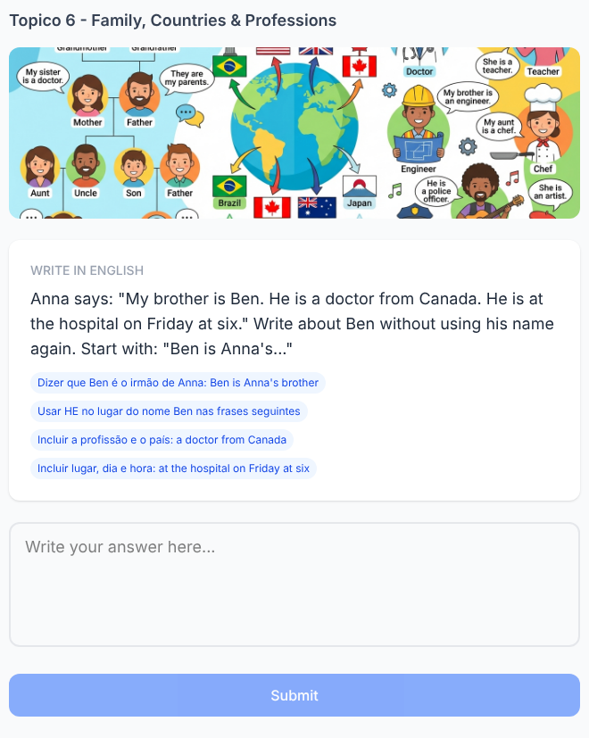

Writing 17. Two Family Messages Become One
✅ FEITO → Plataforma: Tópico 6, exercício(s) #32 (writing)
Solicitado no documento  Mia writes:  “My mother is a teacher from Brazil.”  Leo writes:  “My father is a teacher from Brazil.”  Write one sentence about Mia's mother and Leo's father.  Expected:  They are teachers from Brazil.  Focus: transform two different people into they and pluralize teacher → teachers. | Na plataforma  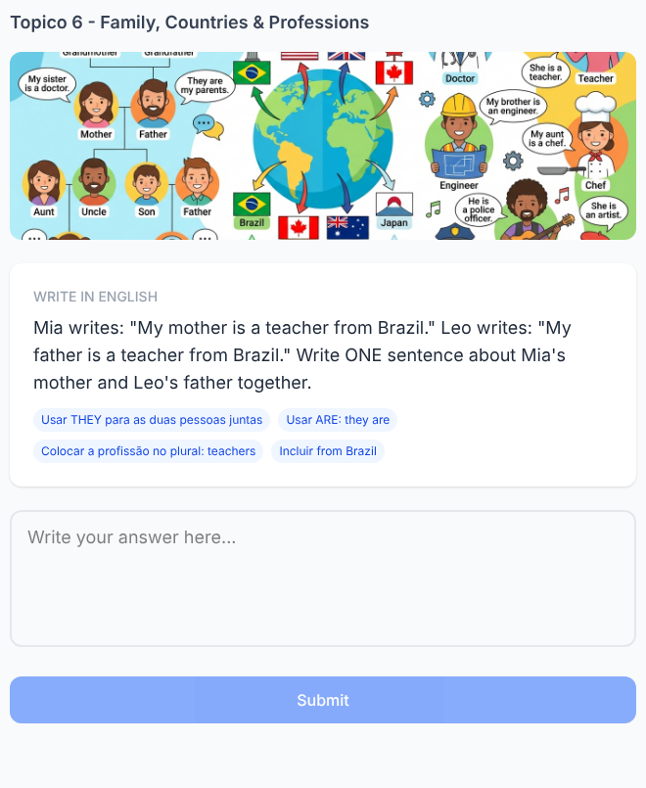

Writing 18. Change the Family Member
✅ FEITO → Plataforma: Tópico 6, exercício(s) #33 (writing)
Solicitado no documento  Original profile:  “My sister is Anna. She is a nurse. She is from Spain.”  New information:  brother / Leo / doctor / Italy  Rewrite the complete profile.  Expected:  My brother is Leo. He is a doctor. He is from Italy.  Focus: update family member + name + pronoun + profession + country. | Na plataforma  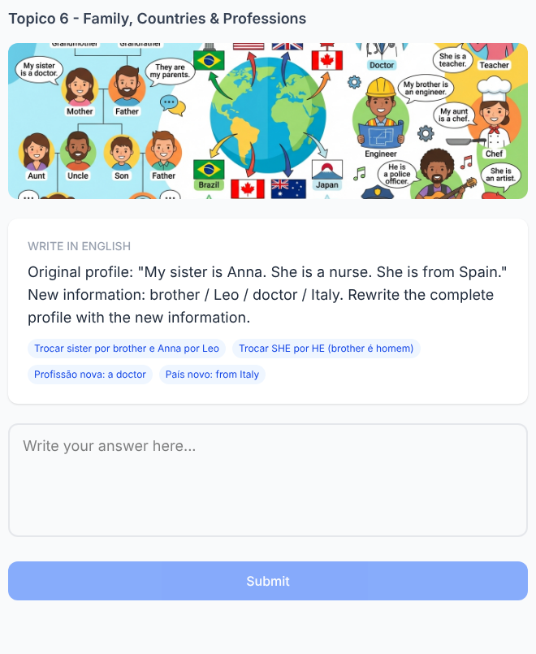

Writing 19. Recover the Missing Family Message
✅ FEITO → Plataforma: Tópico 6, exercício(s) #34 (writing)
Solicitado no documento  Emma replies:  “Your mother is a nurse, too? My mother is a nurse from Canada. She is at the hospital on Monday at seven.”  Mia's original message is partly missing:  “My ______ is a ______. She is from Brazil.”  Complete the missing information.  Expected:  My mother is a nurse. She is from Brazil.  Focus: use information from an English reply. | Na plataforma  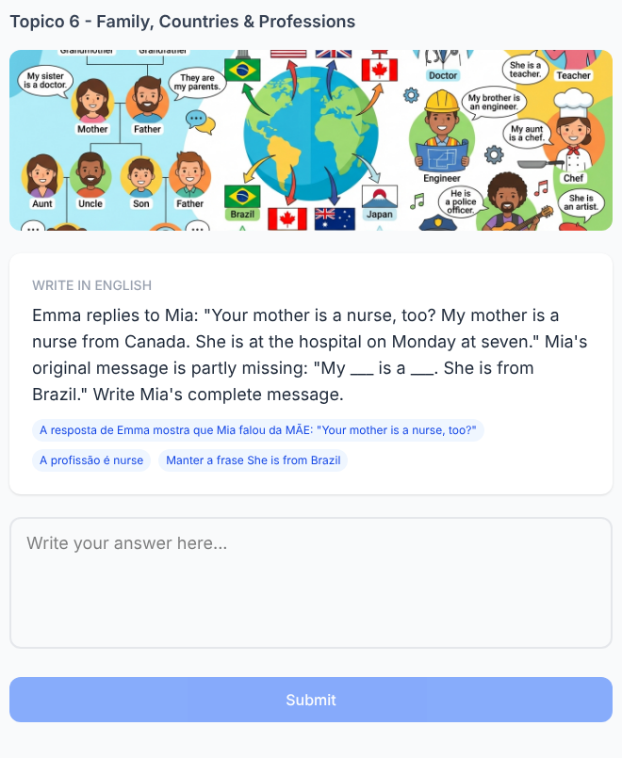

Writing 20. Build a Family Schedule
⚠️ PARCIAL → Plataforma: Tópico 6, exercício(s) #35 (writing)
PARCIAL: o doc pede dois perfis (Sofia e Daniel); a plataforma entrega o da Sofia pronto como exemplo e só pede o de Daniel.
Solicitado no documento  Information:  Sofia / Anna's aunt / chef / Mexico / restaurant / Sunday / six  Write a short profile about Sofia.  Expected:  Sofia is Anna's aunt. She is a chef from Mexico. She is at the restaurant on Sunday at six.  Now change the information:  Daniel / Anna's uncle / doctor / Canada / hospital / Tuesday / eight  Write the new profile.  Expected:  Daniel is Anna's uncle. He is a doctor from Canada. He is at the hospital on Tuesday at eight.  Focus: construct connected English descriptions from structured information. | Na plataforma  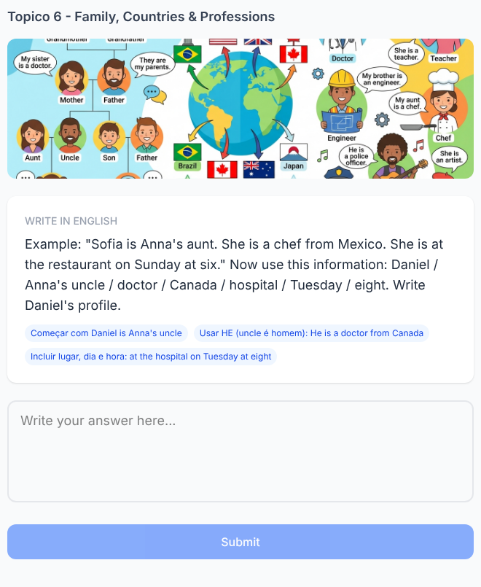

Tópico 7 — Object Pronouns
Documento da cliente: Básico 1 — Object Pronouns • 20 exercícios solicitados

Reading 1. Two Annas, One Message
✅ FEITO → Plataforma: Tópico 7, exercício(s) #21, #22 (reading_comprehension, multi_blank)
Solicitado no documento  Read:  Leo: “My sister Anna is a doctor. My aunt Anna is a teacher.”  Ben: “I know your sister. I see her at the hospital on Monday.”  Complete:  Ben sees ______ at the hospital.  A) Leo's aunt  B) Leo's sister ✓  C) Leo  Now complete Ben's sentence:  “I see ______ on Monday.”  Answer:  her  Focus: identify the correct Anna before using her. | Na plataforma  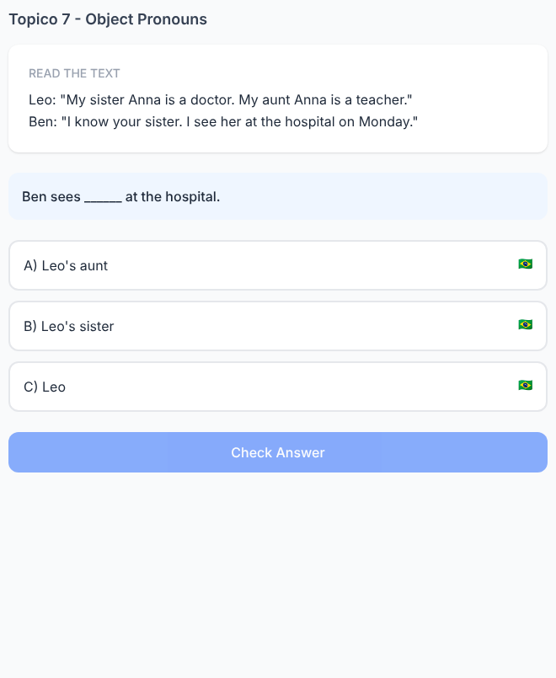  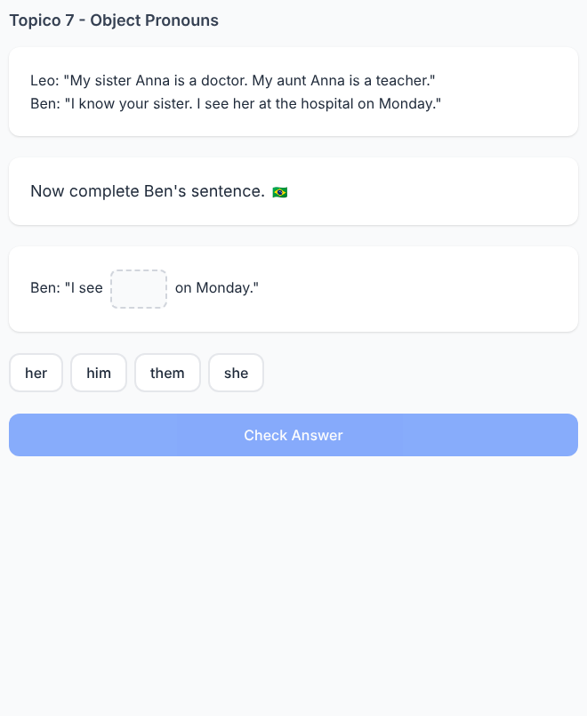

Reading 2. Daniel Changes the Person
✅ FEITO → Plataforma: Tópico 7, exercício(s) #23 (fill_blank)
Solicitado no documento  Read:  “My father is Daniel. He is a chef. I visit him on Sunday.”  Later:  “My mother is Emma. She is a nurse. I visit ___ on Monday.”  A) him  B) her ✓  C) them  Answer:  her  Compare:  father → him  mother → her | Na plataforma  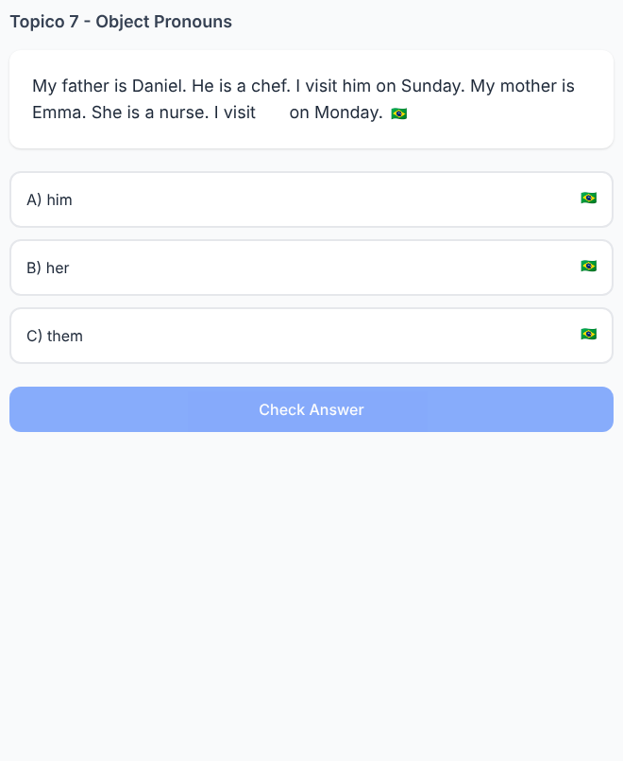

Reading 3. Who Is “Them”?
✅ FEITO → Plataforma: Tópico 7, exercício(s) #24, #25 (reading_comprehension, multi_blank)
Solicitado no documento  Read:  “My brother Leo is a teacher. My sister Mia is a doctor. They are from Canada. I call them on Friday.”  Who does the speaker call?  A) Leo only  B) Mia only  C) Leo and Mia ✓  Complete:  “I call ______ on Friday.”  Answer:  them | Na plataforma  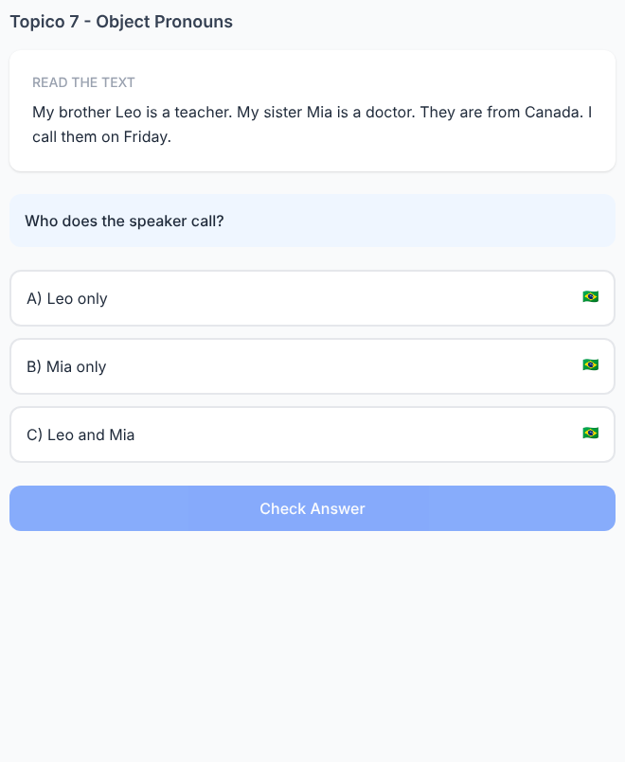  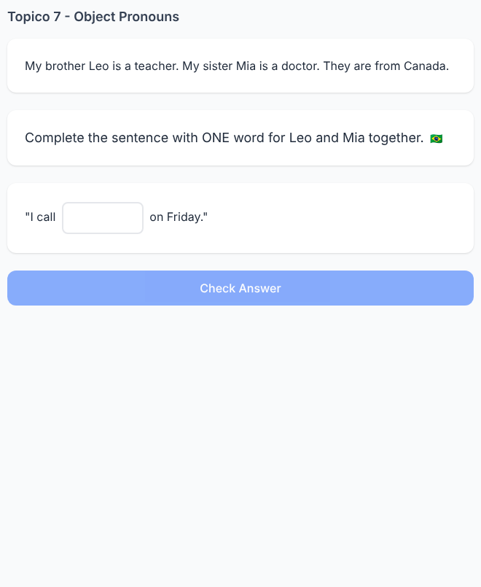

Reading 4. Follow the Family Conversation
✅ FEITO → Plataforma: Tópico 7, exercício(s) #26 (multi_blank)
Solicitado no documento  Anna: “My parents are in Brazil.”  Leo: “Do you call them?”  Anna: “Yes. I call them on Sunday.”  Complete:  Them = Anna's ______.  Answer:  parents  Now change the sentence:  “My mother is in Brazil. I call ______ on Sunday.”  Answer:  her  Focus: plural → singular. | Na plataforma  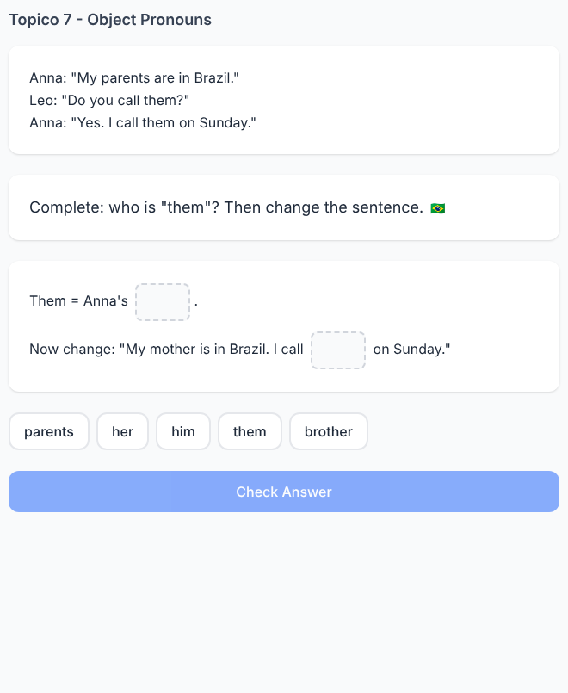

Reading 5. The Pronoun Changed the Meaning
✅ FEITO → Plataforma: Tópico 7, exercício(s) #27 (fill_blank)
Solicitado no documento  Read:  “Ben is my brother. I work with him.”  “Emma is my sister. I work with her.”  “Ben and Emma are doctors. I work with ___.”  Answer:  them  Final sentence:  I work with them. | Na plataforma  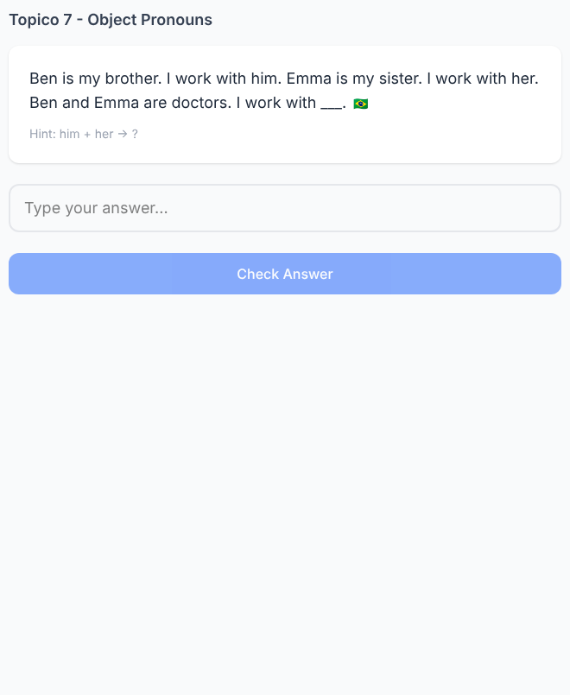

Listening 6. Who Does Mia Call?
✅ FEITO → Plataforma: Tópico 7, exercício(s) #11 (multi_blank)
Solicitado no documento  Audio Script:  Leo: “Do you call your brother on Monday?”  Mia: “No. I call my sister. I call her on Monday.”  Complete:  Mia calls ______.  A) her brother  B) her sister ✓  Then:  “I call ______.”  Answer:  her | Na plataforma  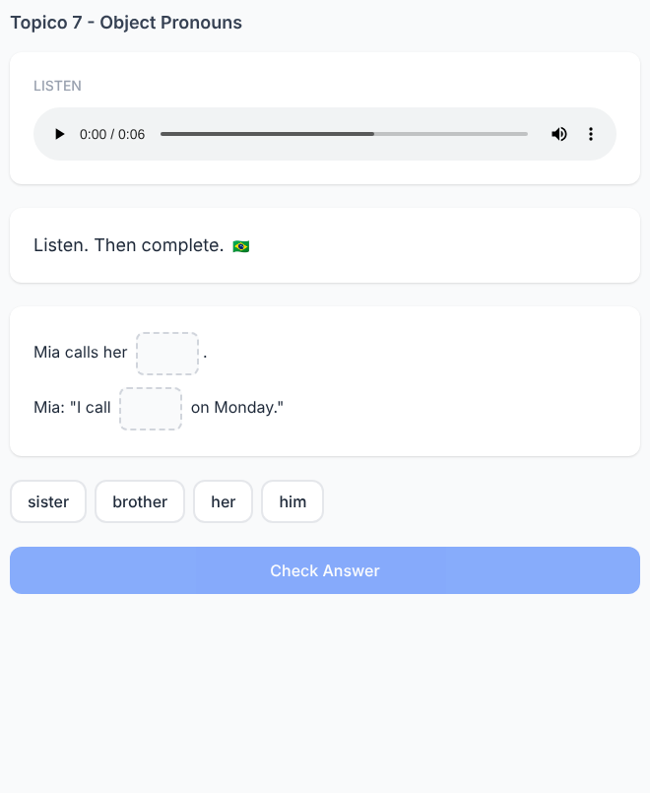

Listening 7. Him or Them?
✅ FEITO → Plataforma: Tópico 7, exercício(s) #12 (multi_blank)
Solicitado no documento  Audio Script:  “My father is in Spain. I visit him in July. My brothers are in Canada. I visit them in August.”  Complete:  father → ______  brothers → ______  Answers:  him  them  Focus: follow two references in the audio. | Na plataforma  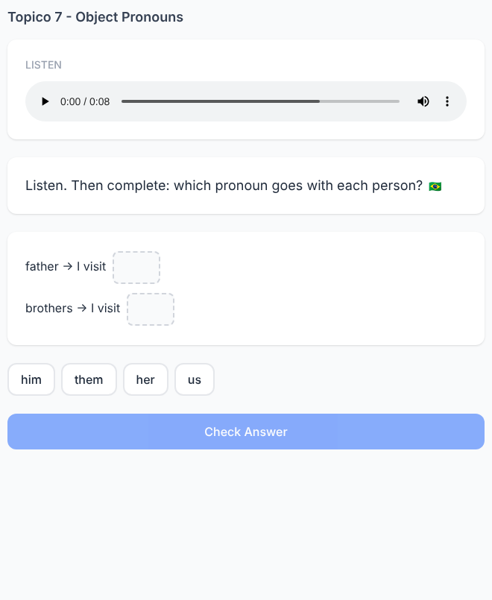

Listening 8. The Wrong Transcript
✅ FEITO → Plataforma: Tópico 7, exercício(s) #13 (tap_wrong_word)
Solicitado no documento  Audio Script:  “Emma is my mother. I call her on Sunday.”  The subtitle says:  “Emma is my mother. I call him on Sunday.”  Tap the word that does not match the audio.  Answer:  him  Replace it with:  her | Na plataforma  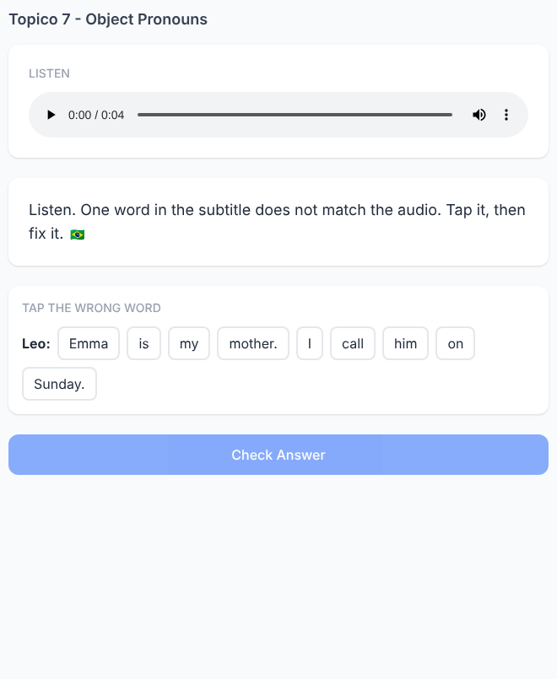

Listening 9. Follow Daniel's Week
✅ FEITO → Plataforma: Tópico 7, exercício(s) #14 (multi_blank)
Solicitado no documento  Audio Script:  “My sister is a nurse. I see her on Monday. My brothers are students. I see them on Friday.”  Complete:  Monday → I see ______.  Friday → I see ______.  Answers:  her  them  Focus: organize the references through the English audio. | Na plataforma  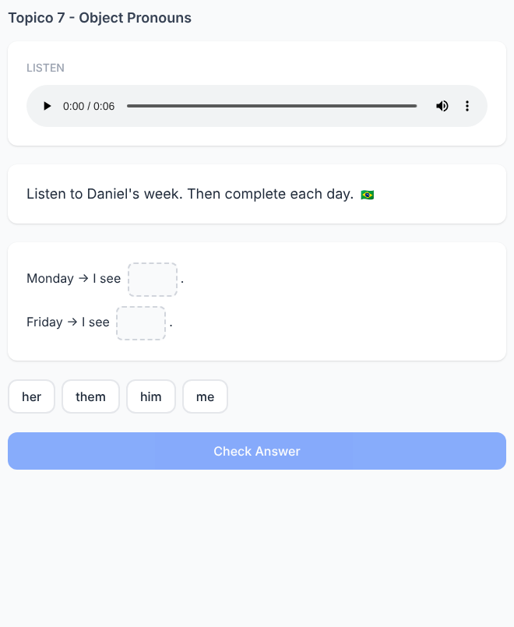

Listening 10. Who Is Missing?
✅ FEITO → Plataforma: Tópico 7, exercício(s) #15 (audio_question)
Solicitado no documento  Audio Script:  Anna: “Where are Leo and Ben?”  Mia: “They are at school.”  Anna: “I need them!”  Complete:  “I need ______!”  A) him  B) her  C) them ✓  Answer:  them | Na plataforma  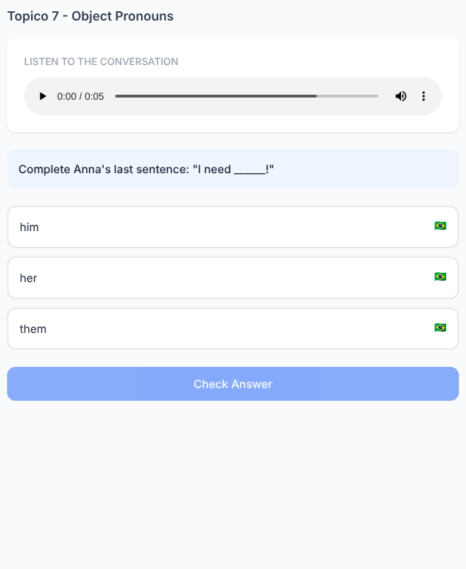

Writing 11. Don't Repeat Daniel
✅ FEITO → Plataforma: Tópico 7, exercício(s) #33 (writing)
Solicitado no documento  Start:  Daniel is my brother. I call Daniel on Friday.  Rewrite the second sentence without repeating Daniel.  Expected:  I call him on Friday. | Na plataforma  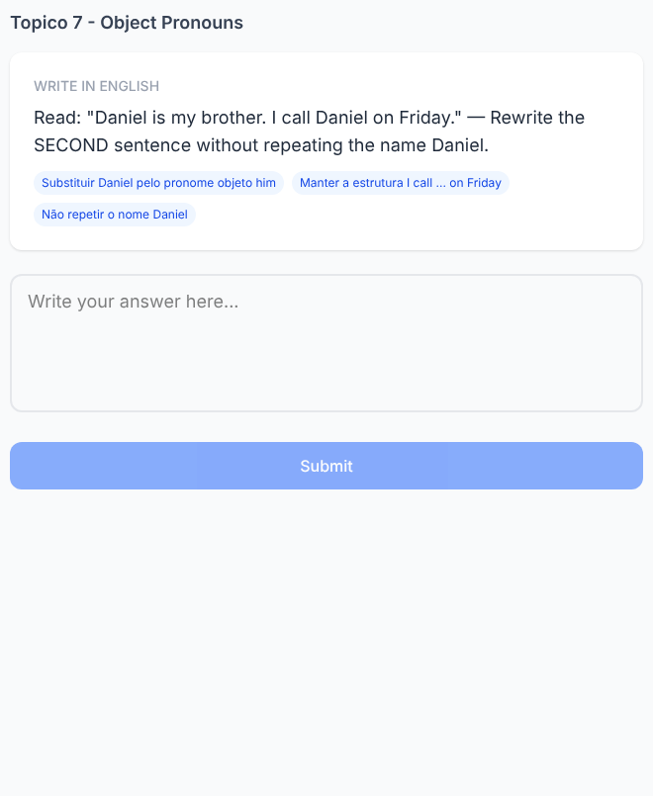

Writing 12. Emma Replaces Daniel
✅ FEITO → Plataforma: Tópico 7, exercício(s) #34 (writing)
Solicitado no documento  Original:  Daniel is my brother. I visit him on Sunday.  New information:  Emma / sister / Monday  Rewrite:  Emma is my sister. I visit her on Monday.  Focus: change person + family member + object pronoun + day. | Na plataforma  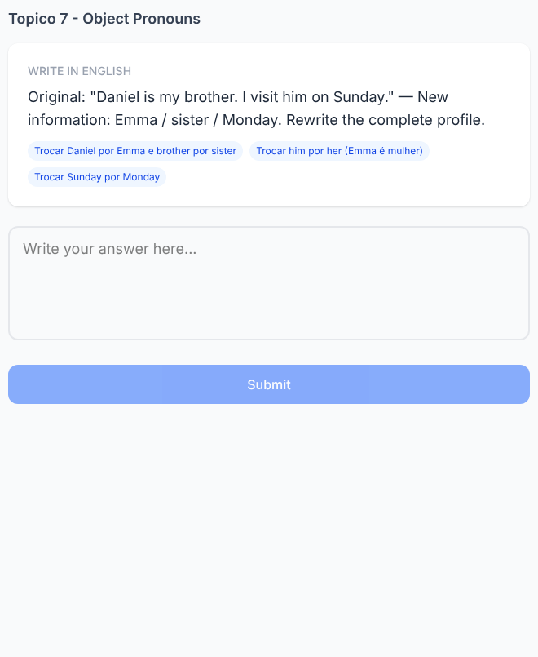

Writing 13. Two People Become One Pronoun
✅ FEITO → Plataforma: Tópico 7, exercício(s) #35 (writing)
Solicitado no documento  Read:  I work with Leo.  I work with Mia.  Write one sentence.  Expected:  I work with them. | Na plataforma  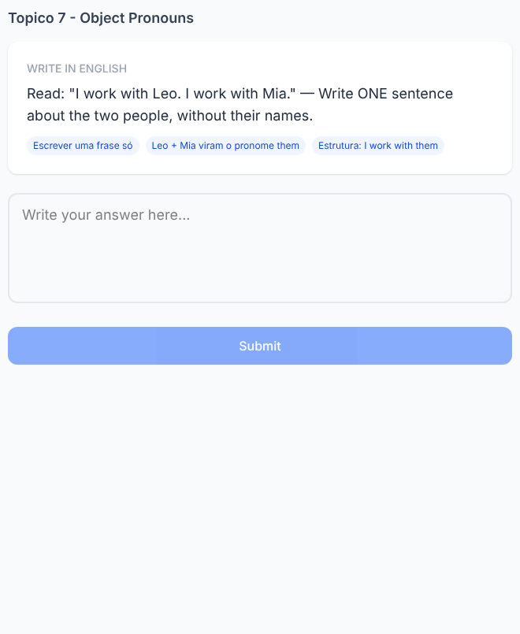

Writing 14. Write About Your Family
✅ FEITO → Plataforma: Tópico 7, exercício(s) #36 (writing)
Solicitado no documento  Complete with a family member:  My ______ is ______.  I call ______ on Sunday.  Example:  My sister is Anna.  I call her on Sunday.  Accepted object pronouns:  him / her / them  Focus: controlled personal production. | Na plataforma  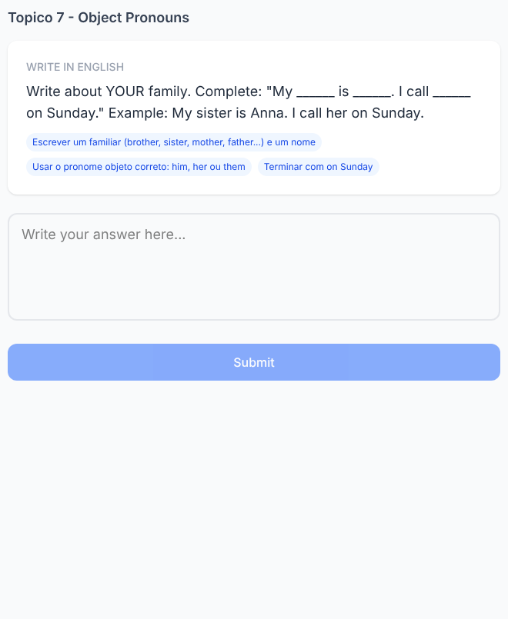

Writing 15. Change the Object
✅ FEITO → Plataforma: Tópico 7, exercício(s) #37 (writing)
Solicitado no documento  Start:  I see him on Monday.  Now the person is Emma.  Rewrite:  I see her on Monday.  Now the people are Emma and Leo.  Rewrite:  I see them on Monday.  Progression:  him → her → them | Na plataforma  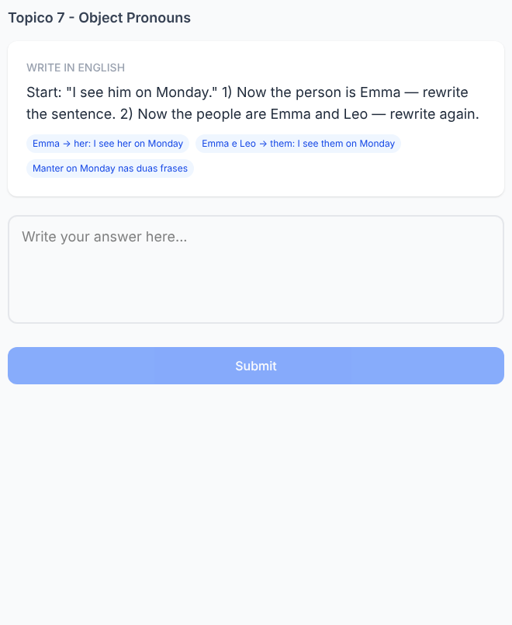

Speaking 16. Listen and Report
✅ FEITO → Plataforma: Tópico 7, exercício(s) #28 (speaking)
Solicitado no documento  Listen:  Anna says:  “My brother is Leo. He is a doctor. I see him at the hospital on Monday.”  The narrator asks:  “Who does Anna see?”  Answer using him.  Expected:  She sees him on Monday.  Focus: I → she while him remains the object. | Na plataforma  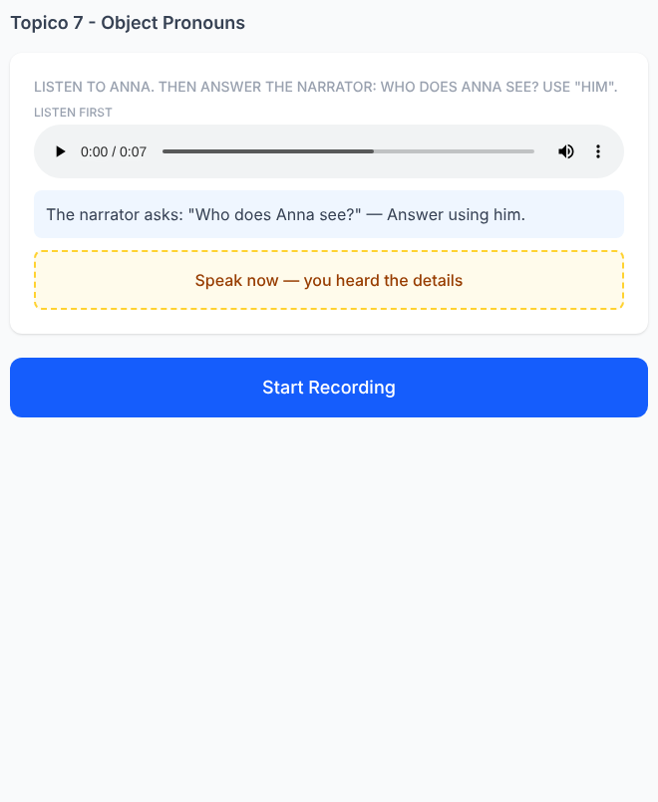

Speaking 17. The Family Switch
✅ FEITO → Plataforma: Tópico 7, exercício(s) #29 (speaking)
Solicitado no documento  Listen:  Ben: “I call my father on Friday. I call him at seven.”  The narrator changes one detail:  “Not his father. His mother.”  Say the new sentence orally.  Expected:  He calls her at seven.  Focus: him → her. | Na plataforma  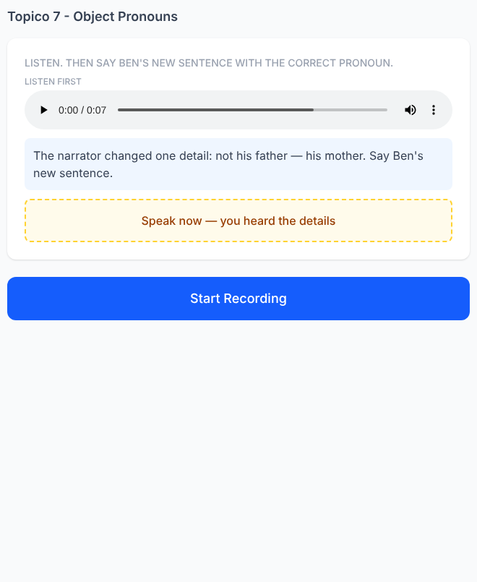

Speaking 18. Anna Needs Two People
✅ FEITO → Plataforma: Tópico 7, exercício(s) #30 (speaking)
Solicitado no documento  Listen:  Anna: “Where are Leo and Mia?”  Ben: “They are at school.”  Anna: “I need Leo and Mia.”  The narrator says:  “Don't repeat their names.”  Say Anna's sentence again.  Expected:  I need them. | Na plataforma  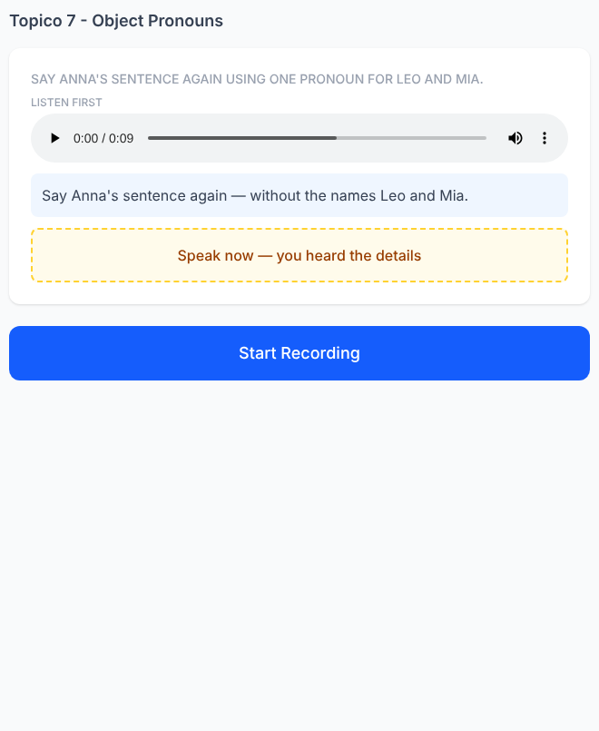

Speaking 19. Follow the Pronouns
✅ FEITO → Plataforma: Tópico 7, exercício(s) #31 (speaking)
Solicitado no documento  Listen:  Mia: “My brother is a chef. I work with him.”  Leo: “My sisters are doctors. I work with them.”  The narrator asks:  “Who does Mia work with?”  Expected:  She works with him.  Then:  “Who does Leo work with?”  Expected:  He works with them.  Focus: maintain subject pronoun + object pronoun. | Na plataforma  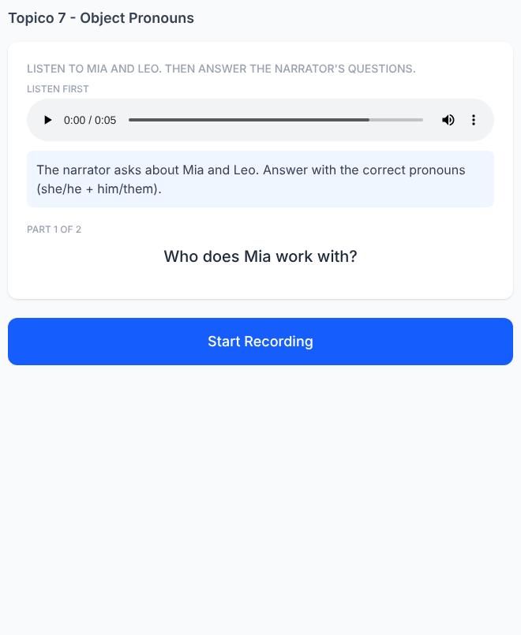

Speaking 20. The Family Call Challenge
✅ FEITO → Plataforma: Tópico 7, exercício(s) #32 (speaking)
Solicitado no documento  Listen once:  “I'm Sofia. My father is in Brazil. I call him on Monday. My sister is in Canada. I call her on Wednesday. My brothers are in Spain. I call them on Sunday.”  The audio disappears.  Prompt:  Father — Monday  Expected:  She calls him on Monday.  Prompt:  Sister — Wednesday  Expected:  She calls her on Wednesday.  Prompt:  Brothers — Sunday  Expected:  She calls them on Sunday.  Progression:  father → him  sister → her  brothers → them | Na plataforma  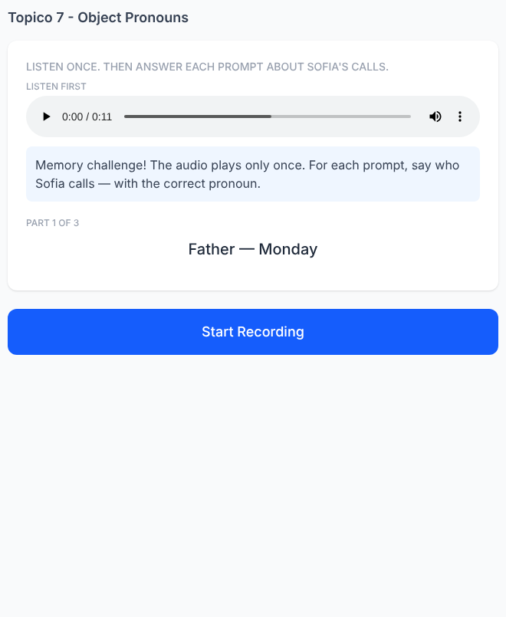

Tópico 5 — Days, Months & Time — pedido extra no final do doc
✅ FEITO → 7 exercícios de Writing (#44–#50) + 7 de Speaking "Listen and repeat" (#32–#38)
Solicitado no documento: "Faça na parte de writing outros exercícios assim: Ela está em casa na Segunda-Feira (faça com todos os dias da semana) – Utilize esses exercícios no speaking para o aluno ouvir e repetir"
Tópico 5 — exercício #44  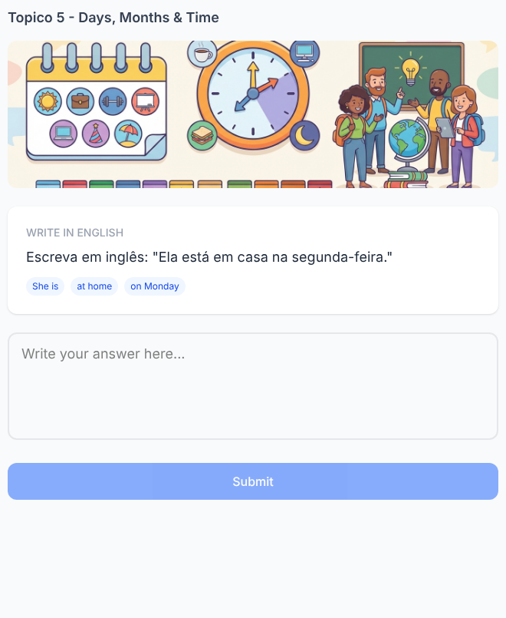  Tópico 5 — exercício #46  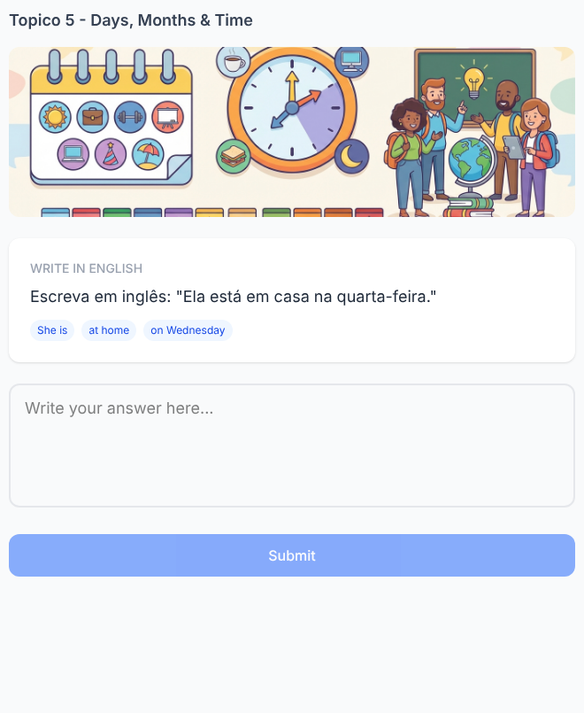  Tópico 5 — exercício #48  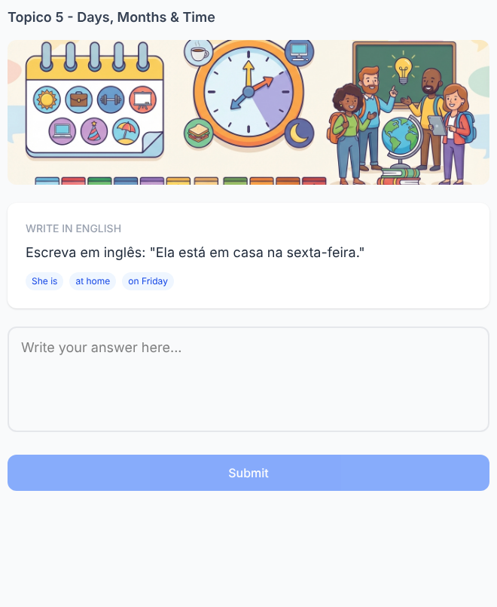  Tópico 5 — exercício #50  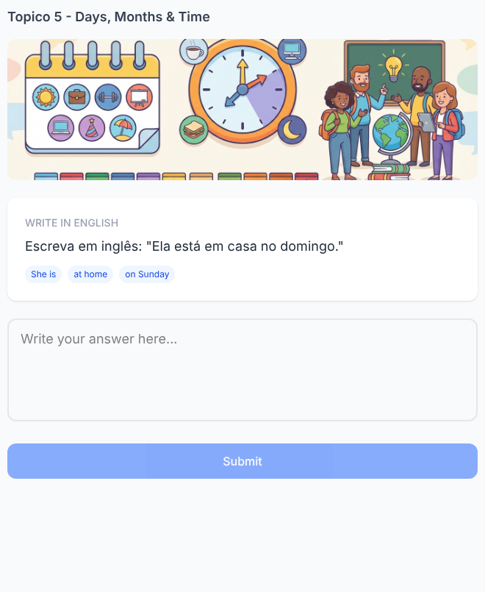  Tópico 5 — exercício #33  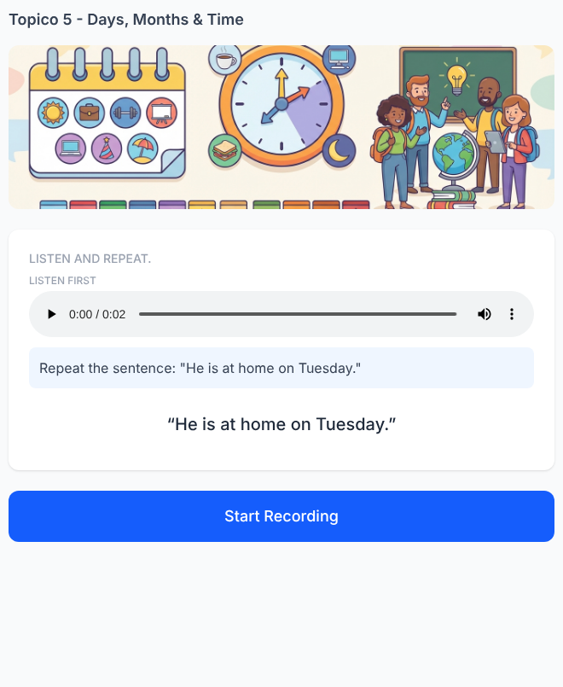  Tópico 5 — exercício #35  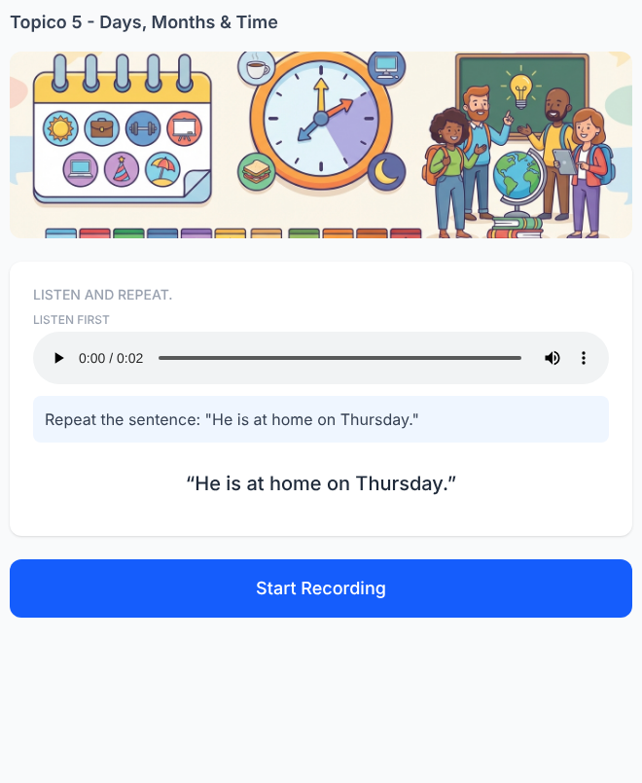  Tópico 5 — exercício #37  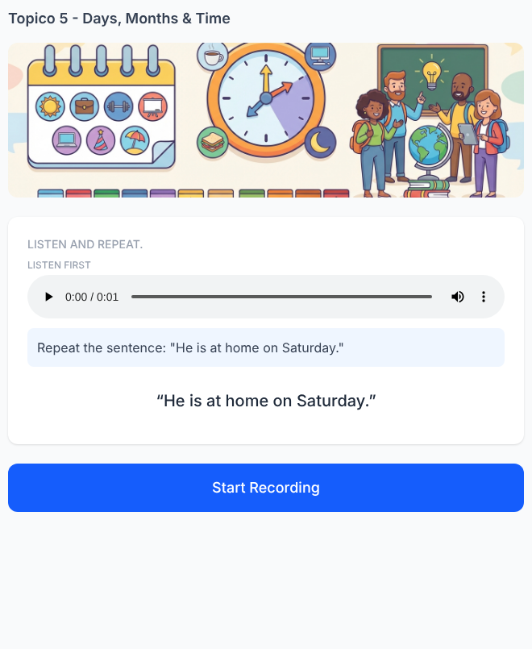 | Tópico 5 — exercício #45  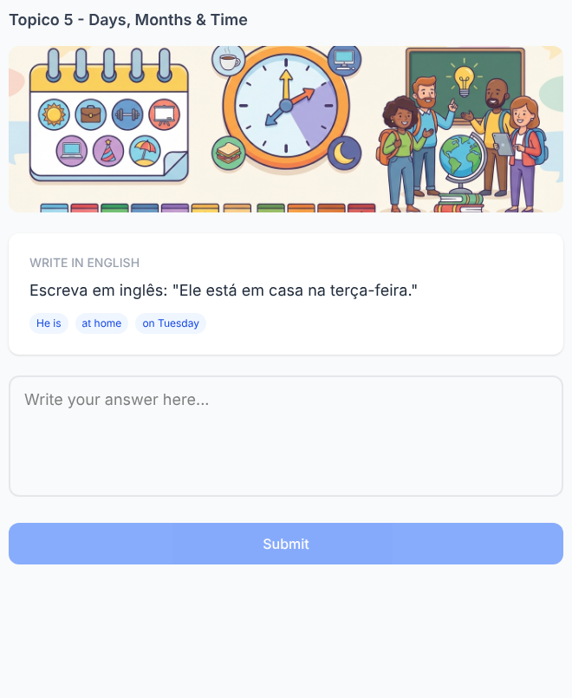  Tópico 5 — exercício #47  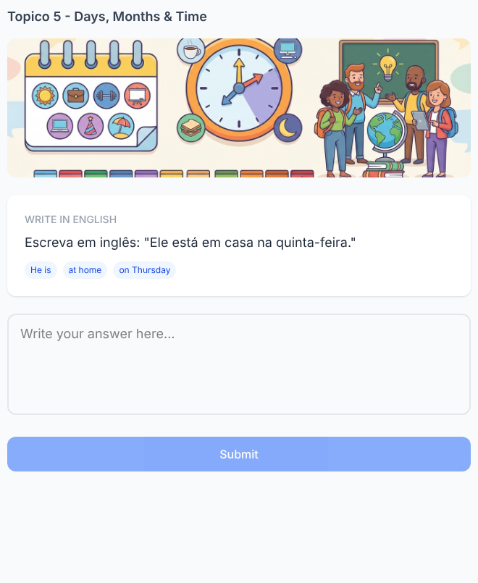  Tópico 5 — exercício #49  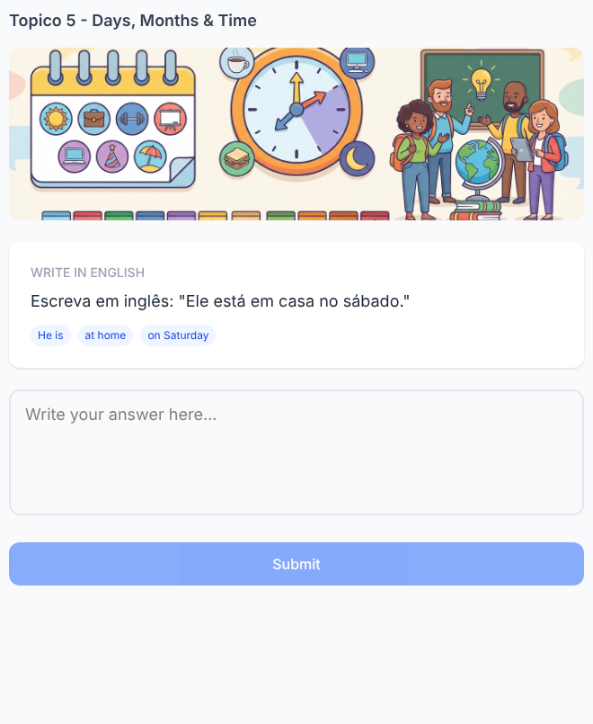  Tópico 5 — exercício #32  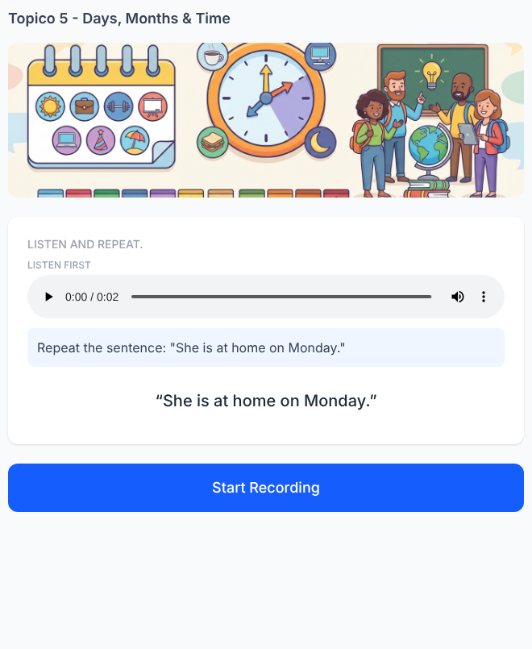  Tópico 5 — exercício #34  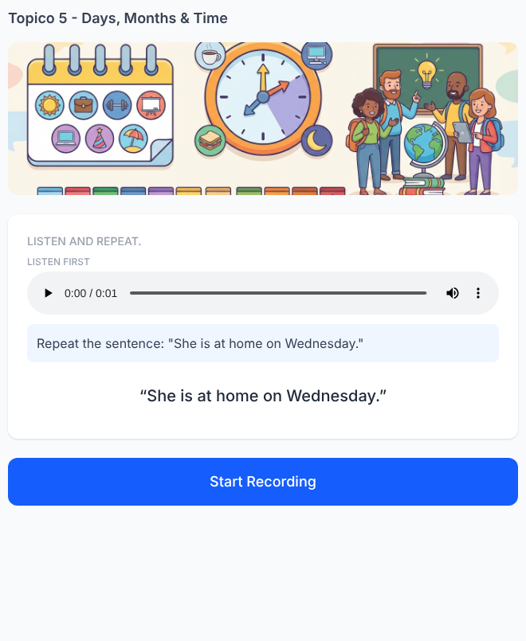  Tópico 5 — exercício #36  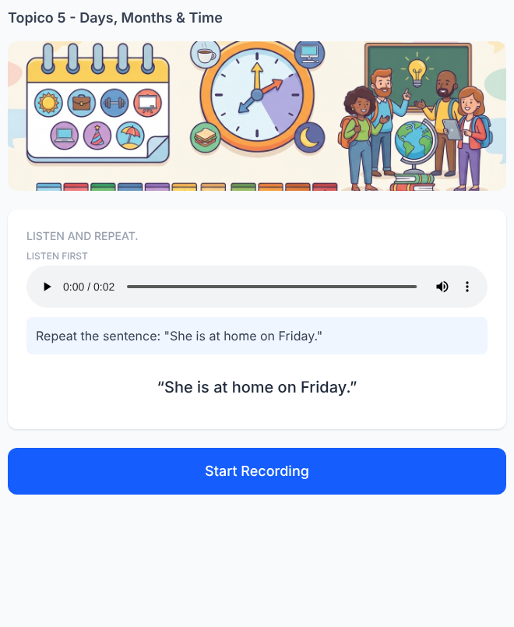  Tópico 5 — exercício #38  