2.4 Product Specification

According to the market analysis described above, among the platform variation of ERJ145, the best aircraft to be used as a basis of comparison is ERJ 145 LR due to
it performance characteristics, and the current situation of the global market.
The table below, compares the product specification data.
The first two columns describes the estimative obtained from the performance calculation templates. Based with those data and ERJ 145 LR real specification (third column), it was possible to obtain the 145 G real specification and lastly, the difference between those two aircrafts.

Table 1: Weight specification
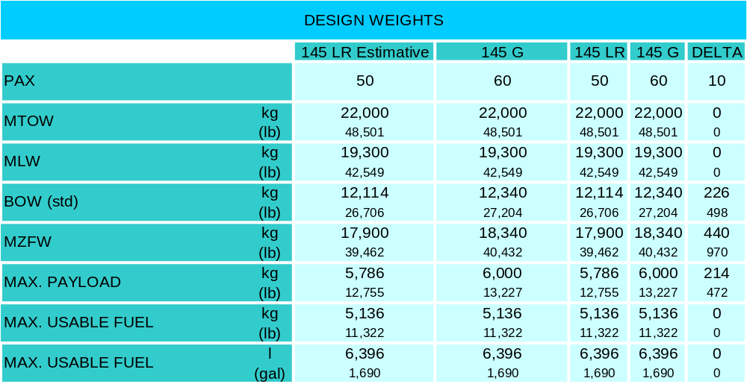

Table 2: Performance Characteristics
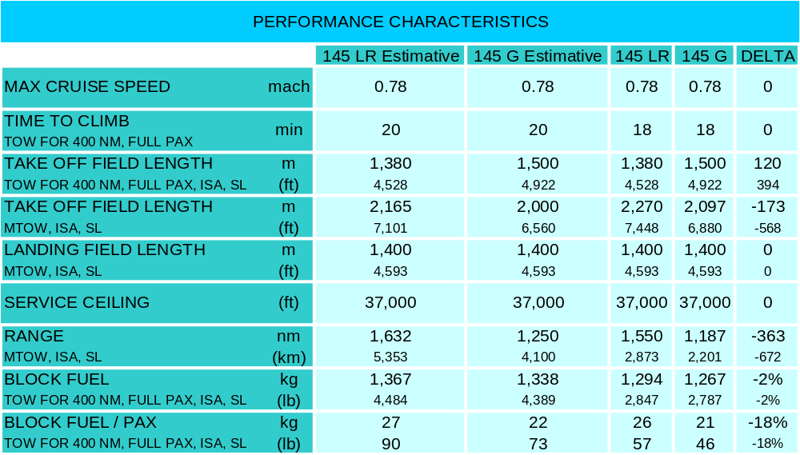
From the table above, it's very clear that the GENESIS aircraft brings a good amount of block fuel / PAX reduction if compared with 145 LR. Nevertheless, there is a small impact on aircraft range and take off field length. With that in mind a market study took course in order to analyze on how much this reduction would impact on 145 G future sales.
Taking into account all the markets the ERJ 145 LR, a graph comparing the field length and route distance of each market was plotted and it was compared the performance of 145 LR and 145 G.

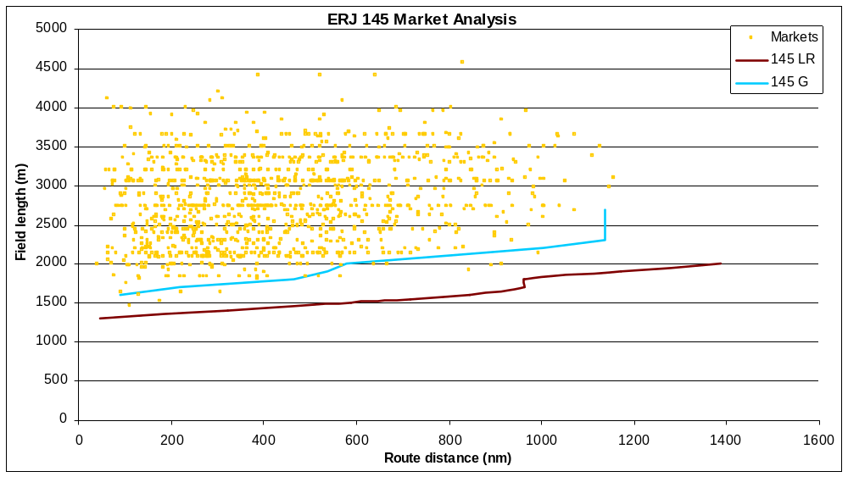
Figure 1: 145 market analysis

From the figure above, it's very clear that only amount of markets would be lost with the range reduction and field length (only 0.5% of the markets).
In conclusion, the 145 G offers a great improvement in block fuel and still didn't suffer a market lost due to performance decrease.

