Report 2

- Configured Vscode Intellisense to recognize Parallax’s libraries.
Copied the folder from /opt/parallax to the projects folder.
Copied the folder from /home/${USER}/Documents/SimpleIDE/Learn to the projects folder.

This way Vscode recognizes the functions and allows for better development environment.
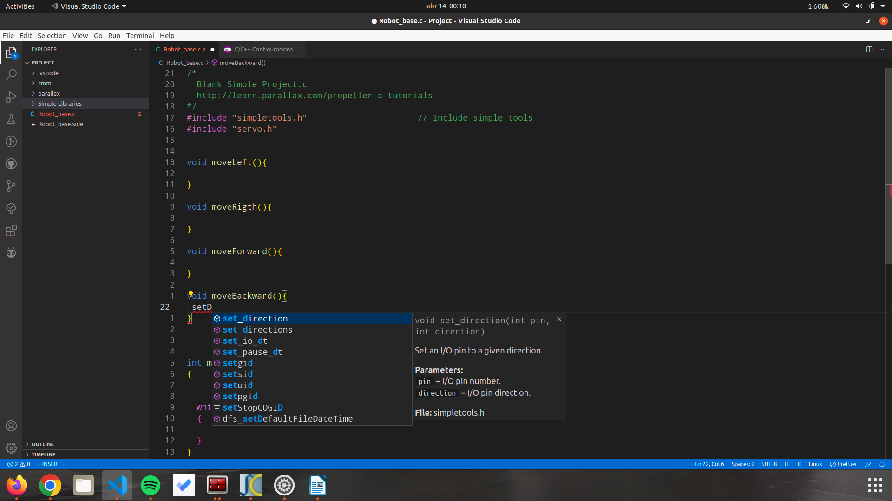Figure 1: Intellisense working with Parallax's libraries

- Coded some basic functions to be able to move the robot arround.
For some reason, the input for the right wheel is inverted.
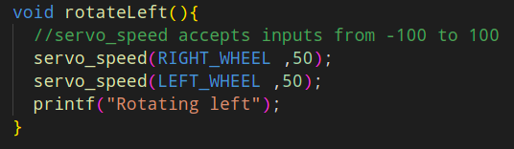Figure 2: Simple function to rotate the robot using the servo.h library
- Researched how I/O pins work. Tested with a button to reverse direction of movement.
- Installed depth sensor and fixed the physical problem of it being too loose with some rubber bands.
- Tested the depth sensor with the ping.h library, the sensor is working as expected.

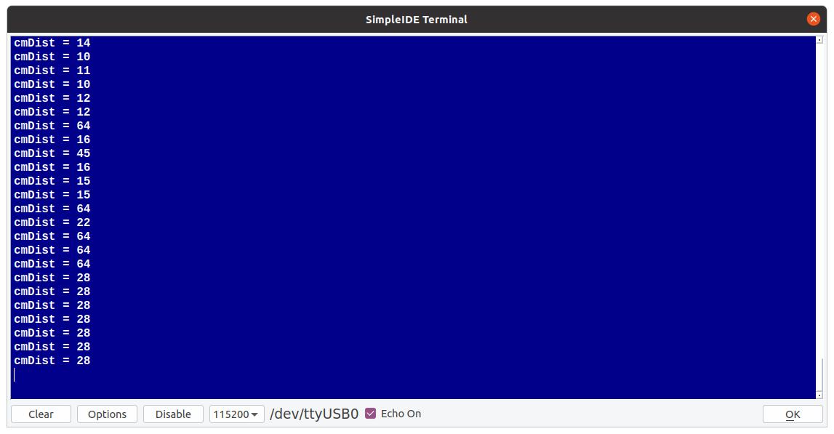Figure 3: Depth sensor experimenting

