**The h-index Paradox: Your coauthors have higher h-index than you**

Fabrício Benevenuto, Alberto H. F. Laender, Bruno Leite Alves

Department of Computer Science

Universidade Federal de Minas Gerais

Belo Horizonte, Brazil

{fabricio,laender,bruno}@dcc.ufmg.br

***Abstract****. H-index is a metric widely used in academia to capture both quality and quantity of an individual’s scientific output. It is natural to expect that a researcher may use her coauthors’ h-indexes as a way to infer whether her own h-index is adequate in her research area. Nevertheless, in this article, we show that if a researcher compares her h-index with those of her coauthors, she might feel below the average. We present empirical evidence of this paradox and explore its potential consequences.*

**Introduction**

H-index is a metric originally proposed to measure an individual’s scientific output [2]. Its calculation is quite simple as it is based on the researcher’s set of most cited papers and the number of citations they have received. More specifically, a researcher has an h-index *h* if she published *h* papers that received at least *h* citations. Thus, if a researcher has 10 papers with at least 10 citations, her h-index is 10.

Like any metric that attempts to summarize in a single number a complex and subjective evaluation, h-index has its limitations, including being biased towards the researcher’s scientific lifetime, not accounting for the number of coauthors in the publications and ignoring the distinct citation patterns across different areas. Nevertheless, the h-index became popular as it provides a notion of both quality and quantity of a researcher’s scientific output in a simple and easy to compute metric.

Often, researchers are tempted to evaluate themselves based on h-index. Systems like Google Scholar[1] and ArnetMiner[2] help researchers to track their publication impact and coauthors, as well as to maintain their profiles, where the h-index is stamped like a medal of honor.

Thus, it is natural to assume that researchers may use their coauthors h-indexes as a way to estimate whether they, themselves, have an adequate h-index in their areas or within a department or university. For instance, if you search Google Scholar for a piece of your email (e.g., dcc.ufmg.br) you can obtain a ranking of your department colleagues according to their citation numbers.

There is nothing wrong with this. It is actually fun to browse others’ profiles to get a sense of how we are in comparison with other colleagues, especially our coauthors. However, this article seeks to show that this kind of comparison may lead to a classical paradox of sociology. We show that if an individual compares her h-index with the h-index of her coauthors, she might feel below the average.

We name this phenomena as the “~~The~~ h-index paradox” and present empirical results and sociological theories to support our arguments. We show that the mean h-index of a researcher’s coauthors is usually greater than her own h-index. We further explore potential consequences of this paradox to academics. Next, we briefly discuss how we estimate the h-index for researchers from distinct computer science research communities, and then we provide empirical results on the measurement of the h-index of those researchers and their coauthors.

**Estimating the h-index of researchers and their coauthors**

In order to provide evidence of the h-index paradox, we need to be able to (1) identify the coauthors of a large set of researchers and (2) estimate the h-index of these researchers as well as of their respective coauthors.

To construct the coauthorship network of Computer Science researchers of different areas, we gathered data from DBLP[3], as it offers its entire database in XML format for download. We gathered this data for those researchers who published in the flagship conferences of 24 ACM SIGs (Special Interest Groups) [1]. Here, however, we focus on analyzing the researchers’ h-index in eight of them: SIGDOC, SIGCHI, SIGIR, KDD, SIGCOMM, SIGGRAPH, SIGMETRICS, POPL, and SIGMOD.

There are several tools that measure the h-index of researchers, out of which Google Scholar is today the most prominent one. However, to have a profile in this system, a researcher needs to sign up and explicitly create her research profile. In a preliminary collection of part of the profiles of the DBLP authors, we found that less than 30% of these authors had a profile at Google Scholar [1]. Thus, this strategy would largely reduce our dataset.

To overcome this limitation, we used data from the SHINE (Simple HINdex Estimator) project[4] to estimate the researchers' h-index. SHINE provides a website that shows the h-index of almost two thousand Computer Science conferences. It was created based on a large scale crawl of Google Scholar. Its strategy consisted of searching for the title of all papers published in several conferences, thus, effectively estimating conferences’ h-index based on the citations computed by Google Scholar. Although SHINE only allows one to search for the h-index of conferences, the SHINE developers kindly allowed us to access to their dataset to infer the h-index of researchers based on the conferences they crawled.

As SHINE does not track all existing Computer Science conferences, researchers' h-index might be underestimated when computed with this data. To investigate this issue, we compared the h-index of a set of researchers with a profile on Google Scholar with their estimated h-index based on the SHINE data. For this, we randomly selected 10 researchers for each of the ACM SIG’s flagship conferences and extracted their h-indexes from their Google Scholar profiles. In comparison with the h-index we estimated from SHINE, the Google Scholar values are, on average, 50% higher, but they are highly correlated (Pearson's correlation coefficient is 0.85), which indicates that researchers have proportional h-index estimations in both systems [1].

**Comparing the h-index of a researcher with her coauthors’**

Having accurately estimated the h-index of each researcher, we can compare her h-index with her coauthors’. Table 1 shows the fraction of authors with h-index smaller than the average of their coauthors for the eight conferences we consider. We can note that even focusing on authors that published in flagship conferences of ACM SIGs, the fraction of authors that might be below the average is quite high, varying from 69% to 81%. When we look at the percentage of authors with at least one coauthor with higher h-index than hers, the numbers are higher than 90% for most of the conferences.

**Figure 1:** Comparison results of one’s h-index with coauthors.

These results are quite related to a known phenomenon in social networks, called friendship paradox [3, 4], which says that one’s friends in a social network have, on average, more friends than her. The reasons behind the h-index paradox might also have similar sources as discussed next.

Figure 2 shows the distribution of the number of authors as a function of h-index. It clearly resembles a long tail distribution, suggesting that some authors contribute disproportionally to the average h-index. This disproportion on the average h-index might be even accentuated with the typical structural properties of coauthorship networks, which are similar to many social networks [6, 8] - i.e., they have a long tail degree distribution, where highly connected authors create bridges across multiple highly connected components, leading to the properties of high clustering coefficient and short diameter. The correlation between an author’s h-index and her degree is 0.36, which, although not so high, is positive, suggesting ~~meaning~~ that some authors have high h-index and are also more connected in the network.

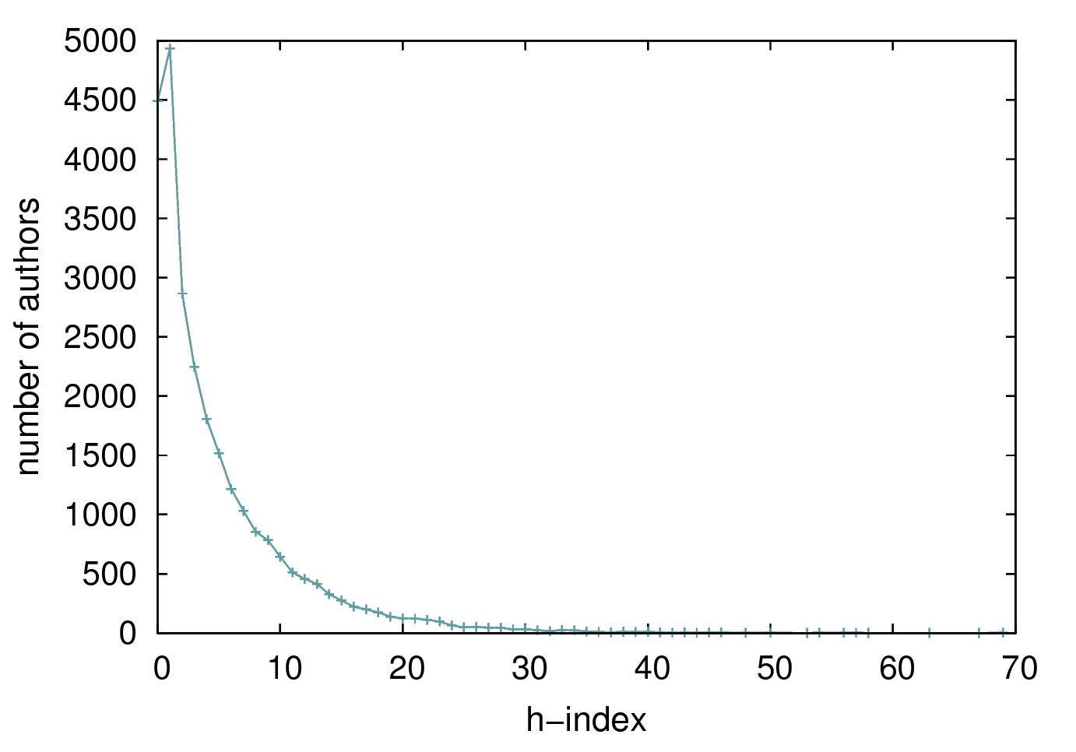

**Figure 2:** Distribution of authors according to their h-indexes.

~~Both~~Thus, the disproportion on the h-index distribution associated with ~~the network~~ specific properties of coauthorship networks contributes to a scenario where most of ~~the~~ authors have an h-index below ~~to~~ the average of her coauthors’. Next, we discuss potential consequences of this paradox.

**Consequences of the h-index Paradox**

The easy comparison among peers that today’s systems offer might accentuate the pressure that exists for publication as one might tend to feel strained by the sensation of being below coauthors. Humans are natural competitors, not only in research, but in several aspects of life [10]. The competition among researchers is just an instantiation of a sensation that occurs in different scenarios and even culminated in an expression that is common to different languages and cultures: “The neighbor’s grass is always greener on the other side”.

Competition in science can be good as it gives extra motivation for researchers to work hard, but it also may lead to undesirable scenarios, especially when researchers cross ethical boundaries tempted to “sell” better their publications. For instance, a recent work in the field of Medicine evaluated 788 retracted articles [9] and focused on 180 of them, which involved experiments with patients. From these, 70 were retracted by fraud and 110 by mistakes. These articles received more than 5,000 citations and involved thousands of patients. In Computer Science, retractions are not so common, although reproducibility is still an issue. As an illustration, the papers accepted for presentation at 2009 SIGMOD Conference were invited to a reproducibility test [7]. Surprisingly, only 19 papers (less than 30%) had ~~submitted~~ their data submitted for such evaluation. Out of these papers, 10 were completely reproduced, 7 were partially reproduced and 2 could not be reproduced. In an ideal scenario, one would expect that all papers would be submitted to ~~the~~ such a test and all of them would be completely reproduced.

Another potential consequence of the h-index paradox is that some individuals may try to adapt research ~~strategies~~ practices to bias their own scores towards gaming the system. The term “salami science” ~~was~~ has been used to designate when research results are split in pieces of publication to increase publication count [5]. It is possible that slicing results in minimal publishable pieces not only makes a researcher to produce more papers, but it may also increase an individual’s h-index. For instance, suppose that instead of publishing one paper, a researcher splits its results into some pieces containing incremental steps. If these pieces account for increasing her h-index then ~~the~~ this strategy worked for increasing h-index. However, by using this or other strategies, the goal of advancing the state-of-the-art and producing high quality science becomes secondary.

**~~Concluding Remarks~~**

Summarizing, in this article we show some empirical evidence that if a researcher compares her h-index with those of her coauthors, she might feel below the average. We name this phenomenon as the h-index paradox and show ~~empirical evidence~~ that the disproportion on the h-index distribution associated with the network properties of coauthorship networks ~~are~~ is among its main causes. We argue that, by feeling below the average, it is possible that researchers might be tempted to game the system, adapting research ~~strategies~~ practices or even being careless with the published papers.

**References**

[1] Alves, B. L., Benevenuto, F., and Laender, A. H. F. The Role of Research Leaders on the Evolution of Scientific Communities. In *Proceedings of the* *International Conference on World Wide Web (Companion Volume)*. ACM Press, New York, NY, 2013, 649-656.

[2] Hirsch, J. E. An index to quantify an individual's scientific research output. Proceedings of the National Academy of Science 102, 46 (2005), 16569–16572.

[3] Hodas, N. O., Kooti, F., and Lerman, K. Friendship Paradox Redux: Your Friends Are More Interesting Than You. *arXiv preprint arXiv:1304.3480* (2013).

[4] Feld, Scott L. Why your friends have more friends than you do. *American Journal of Sociology 96*, 6 (1991), 1464-1477.

[5] Hoit, J. D. Salami science.  *American Journal of Speech-Language Pathology*  *16*, 2 (2007), 94.

[6] Huang, J., and Li, J. Collaboration Over Time: Characterizing and Modeling Network Evolution. In *Proceedings of the International Conference on Web Search and Web Data Mining*. ACM, New York, NY, 2008, 107-116.

[17] Manegold, S., Manolescu, I., Afanasiev, L., Feng, J., Gou, G., Hadjieleftheriou, M., Harizopoulos, S., Kalnis, P., Karanasos, K., Laurent, D., Lupu, M., Onose, N., Ré, C., Sans, V., Senellart, P., Wu, T., and Shasha, D. Repeatability & Workability Evaluation of SIGMOD 2009. SIGMOD Record. *38*, 3 (2010), 40-43.

[8] Mislove, A., Marcon, M., Gummadi, K. P., Druschel, P., and Bhattacharjee, B. Measurement and Analysis of Online Social Networks. In *Proceedings of the 7th ACM SIGCOMM Conference on Internet Measurement*. ACM Press, New York, NY, 2007, 29-42.

[9] Steen, R. G. Retractions in the medical literature: How many patients are put at risk by flawed research?  *Journal of Medical Ethics* *37*, 11 (2011), 688-692.

[10] Sterelny, K. *Thought in a Hostile World: The Evolution of Human Cognition*. Blackwell Publishers, 2003.

1. http://scholar.google.com
2. http://arnetminer.org
3. http://www.informatik.uni-trier.de/~ley/db/
4. http://shine.icomp.ufam.edu.br/