Hyperspatial remote sensing and polarimetric SAR for urban and environmental applications
Final ASSIGNMENT
Bruno Masoller
2025
  - Project summary:
Subtitle | Final assignment on the short course “Hyperspatial remote sensing and polarimetric SAR for urban and environmental applications”
Description | This report presents the final assignment developed for the course “Hyperspatial Remote Sensing and Polarimetric SAR for Urban and Environmental Applications”. The work focuses on the extraction and analysis of structural and environmental information over the city of Milan through the combined use of dual-polarization Sentinel-1 SAR data and PRISMA hyperspectral imagery. The project includes the derivation of SAR descriptors, the extraction of hyperspectral indicators and material abundance maps, the harmonization of both datasets onto a common spatial grid, and their joint comparison with the Copernicus Urban Atlas land-use/land-cover (LULC) reference. The objective is to assess how SAR and HSI products relate to different urban classes and to explore the complementarities between structural information captured by SAR and material composition revealed by hyperspectral data.
University | Universidad de la República – Facultad de Ingeniería | Università di Pavia
Professors | - Paolo Gamba (UNIPV)  - Luigi Russo (UNIPV)  - Alvaro Gomez (FING)
Student | Bruno Masoller (brunomaso1@hotmail.com)
Repository | https://github.com/brunomaso1/fing-cpap/tree/tele-hiper-sar
Date | 23/11/2025


Open the project notebook on nbviewer

Table of content
ASSIGMENT 3
Topic 3
EO Datasets 3
Tasks 3
1. Dual-pol descriptors 4
1.2. Descriptors computation 5
1.3. Index and $α$ visualization 6
1.4. RGB visualization of scattering components 8
2. Spectral indicators 8
2.1. PRISMA HSI Preprocessing 8
2.1.1. Dataset 8
2.1.2. Unmixing 9
2.1.3. Data exploration 9
2.1.4. Endmember extraction 12
2.2.5. Abundance estimation 14
3. Products comparison 16
3.1. LULC data preprocessing 16
3.2. Harmonization of products 20
3.3. Qualitative analysis 21
3.3.1. Abundance map 2 22
3.3.2. Abundance Map 4 23
3.3.3. Abundance Map 6 24
3.3.4. Abundance Map 7 24
3.3.5. Abundance Map 8 25
3.3.6. Abundance Map 9 25
3.3.7. Dual-pol radar built-up index ($DpRBI$) 25
3.3.8. SAR surface scattering index ($DpRSI$) 26
4. Investigate relationships (conclusions) 27

Assignment

Topic
Extraction of structural and environmental information in Milan using dual-pol SAR and hyperspectral data

EO Datasets
- Sentinel-1 IW SLC (VV/VH) image over Milan
- PRISMA hyperspectral imagery (HSI) over the same AOI
- Copernicus Urban Atlas [link] as land use/land cover (LULC) reference

Tasks
- Derive dual-pol descriptors to characterize the structural and environmental properties of the urban landscape.
- Extract spectral indicators and fractional information describing the distribution of urban and natural surface materials.
- Harmonize SAR- and HSI-derived products to a common spatial grid and compare them against the different LULC classes.
- Investigate the relationships between SAR and hyperspectral indicators across urban categories, highlighting how their integration enhances the characterization of urban form and environmental composition.

1. Dual-pol descriptors
  - Derive dual-pol descriptors to characterize the structural and environmental properties of the urban landscape
The first part of this assignment is based on obtaining descriptors to characterize urban components, surfaces, or vegetation. Specifically, the objective is to compute several indices mentioned in the paper “Scattering power components from dual-pol Sentinel-1 SLC and GRD SAR data”.
The goal is to obtain the normalized descriptors $g_{1},g_{2},g_{3}$, and then compute the indices $DpRBI$ (dihedral-like constructions) and $DpRSI$ (surface-like). Finally, the objective is to obtain the coefficient $α$ and the scattering powers.
In class, we performed this process, which consisted of several steps detailed in the following table:
Step | Objective | Description
1 | Preprocessing | Load data
2 | Preprocessing | Select polarizations
3 | Preprocessing | Apply orbit file
4 | Preprocessing | Radiometric calibration
5 | Preprocessing | Deburst
6 | Covariance matrix | Matrix generation
7 | Covariance matrix | Multilooking
8 | Covariance matrix | Polarimetric speckle filtering
9 | Slope | Compute gradient
10 | AOI | Specify area of interest

The result of the processing can be seen in the following image:
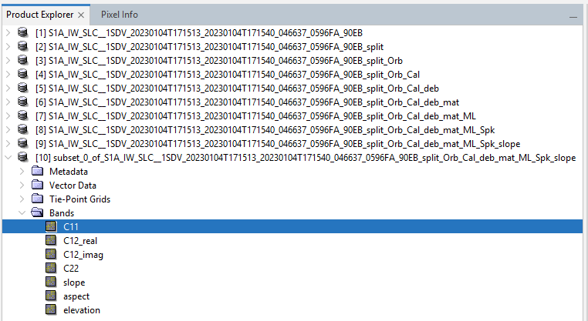

1.2. Descriptors computation
After obtaining the final SNAP product, the requested descriptors are computed. The steps carried out are detailed below, but are the same as seen in class:
- First, the product is loaded.
- Then, we show the C2 matrix components:
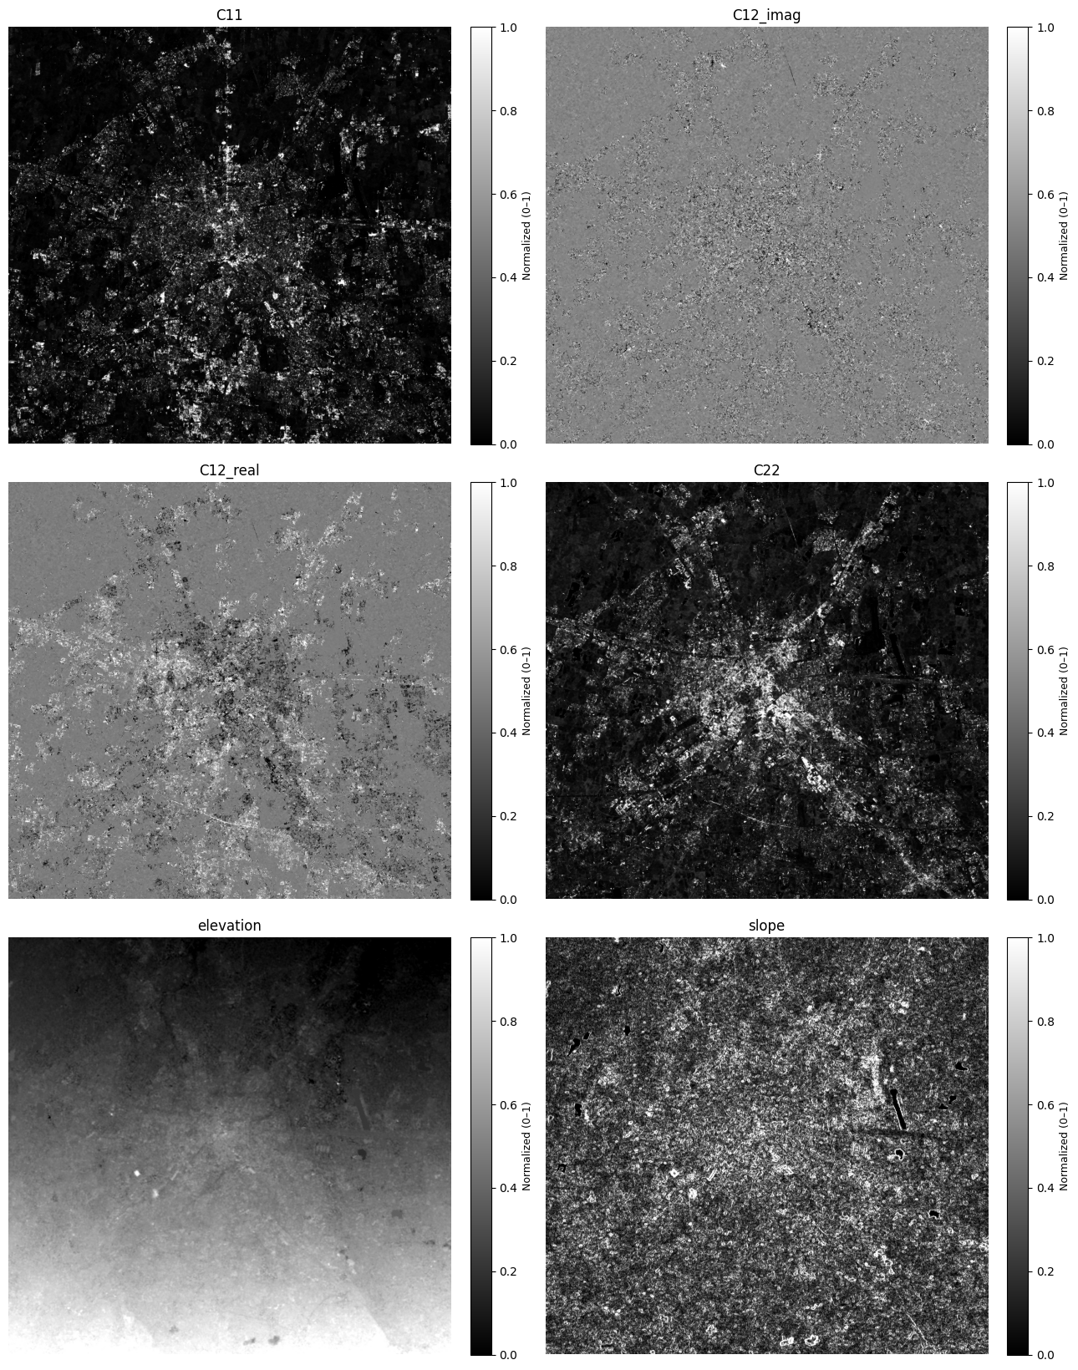
- Finally, we compute the requested descriptors from the C2 matrix components and slope information with the same code used in class. To print the descriptors, we use an auxiliary function:
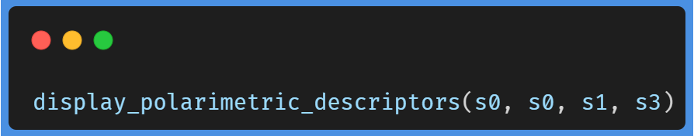
And this is the result of $g_{0},g_{1},g_{2},g_{3}$:
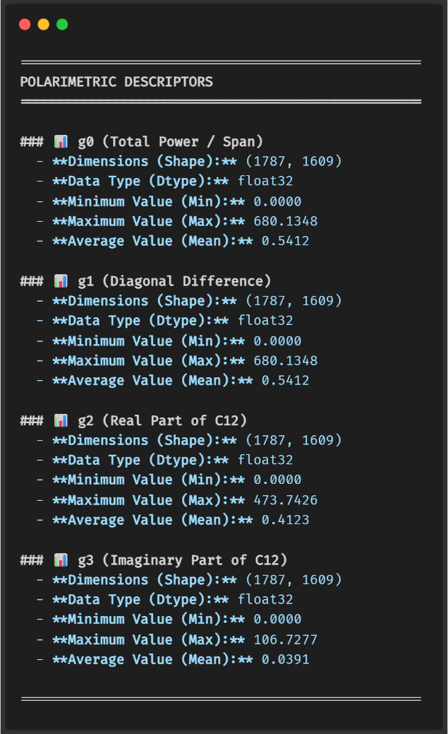

1.3. Index and $α$ visualization
After calculating the descriptors, we proceed to visualize the indices and the $α$ coefficient:
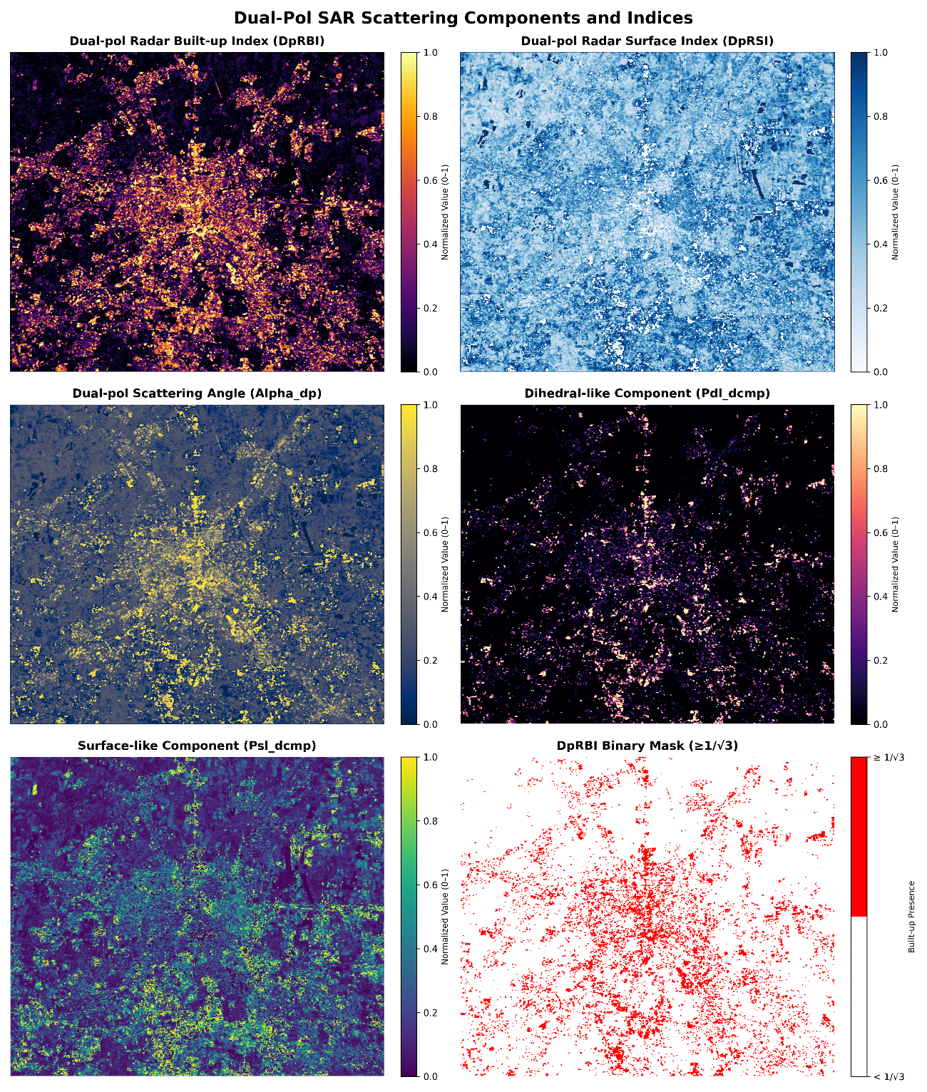
This image shows the results of the indices and the $α$ coefficient (that later it’s used to derive the scattering power components). We can observe that the $DpRBI$ index highlights urban areas, especially those in the city center, while the $DpRSI$ index emphasizes open and smooth surfaces, such as agricultural areas surrounding the city (we can also check that the center has more white colors). The power $Pdl_dcmp (P_{d-l})$ component emphasizes even more the urban areas in the center of the city, which is consistent with the $DpRBI$ index and the fact that most of dihedral-like structures are located in urban areas.

1.4. RGB visualization of scattering components
Finally, we can also visualize the scattering components in RGB format:
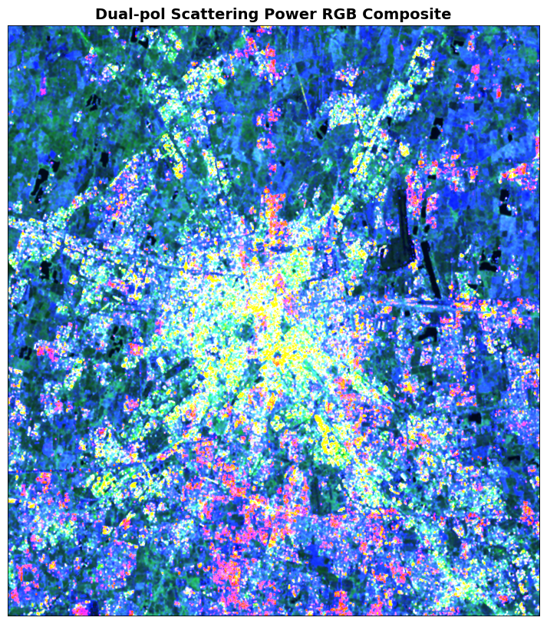

2. Spectral indicators
  - Extract spectral indicators and fractional information describing the distribution of urban and natural surface materials

2.1. PRISMA HSI Preprocessing

2.1.1. Dataset
PRISMA (Hyperspectral Precursor of the Application Mission), it's a fully funded mission by Italian Space Agency (ASI). It’s objective is being an Earth Observation system with innovative electro-optical instrumentation that combine a hyperspectral sensor with a medium-resolution panchromatic camera.

The advantages of this combination are that in addition to the usual capability of observation based on recognizing the geometric characteristics of the scene there are hyperspectral sensors which determine the chemical-physical composition of the objects present on the scene.
More information about PRISMA mission can be found here.

2.1.2. Unmixing
Unmixing is a technique used in hyperspectral image analysis to decompose the spectral signature of each pixel into a collection of constituent spectra, known as endmembers, and their corresponding proportions, referred to as abundances. This process is essential for understanding the composition of mixed pixels, which often occur in remote sensing data due to the limited spatial resolution of sensors.
One can assume 4 main types of mixing types:
- Linear Mixing: Materials are spatially separated within the pixel.
- Multi-Layer Mixing: Materials are arranged in layers (e.g., leaves over soil).
- Intimate Mixing: Materials are mixed at microscopic scales (smaller than the wavelength).
- Spectral Variability: The same material shows spectral changes due to illumination, moisture, or geometry.
The best suited unmixing model for this task is the Linear Mixing Model (LMM), which assumes that the observed spectrum of a pixel is a linear combination of the spectra of the endmembers present in that pixel, weighted by their respective abundances.
The objective is to estimate both the endmember matrix $Ε$ and the abundance matrix $A$ from the observed spectra $X$.

2.1.3. Data exploration
When checking the PRISMA information, it is indicated that the spatial resolution is 30 meters and that there are several types of bands. According to it’s documentation, there are two types of channels (VNIR and SWIR):
- VNIR (Visible and Near Infrared): 400 $nm$ to 1010 $nm$ (bands 1 to 66) → 66 bands
- SWIR (Short Wave Infrared): 920 $nm$ to 2505 $nm$ (bands 67 to 243) → 173 bands
In total, there are 239 bands (plus one additional panchromatic band).
The format also depends on the type of image. In this case, the image is of type “L2D_STD”, which according to the documentation is a standard Level-2D product that includes radiometric and geometric corrections.
PRISMA contains higher spectral resolution than Sentinel-2. Specifically, the following image is a comparison between the spectral bands of both sensors can be observed:
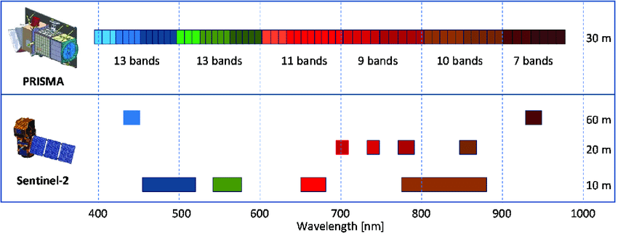
Another comparison can be seen in the following table:
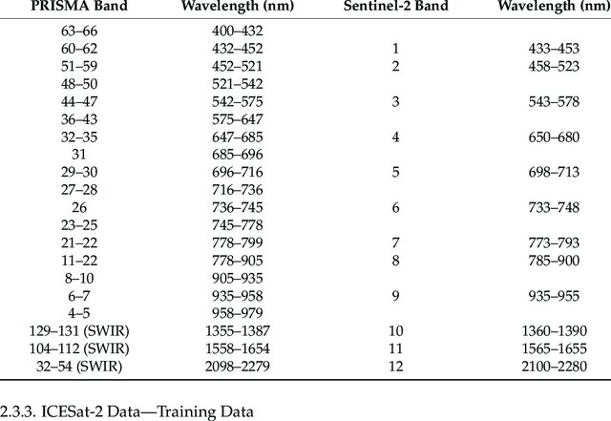
The human eye’s visible spectrum ranges approximately from 400 $nm$ (violet) to 800 $nm$ (red). Within this interval:
- Red: 600–700 $nm$
- Green: 500–600 $nm$
- Blue: 400–450 $nm$
Therefore, the PRISMA bands corresponding to the visible spectrum are those that cover this wavelength range. The following table shows the selected PRISMA bands that correspond to the visible spectrum:
PRISMA Band | Sentinel-2 | Approximate Color
35 | 4 | Red
47 | 3 | Green
59 | 2 | Blue

By setting these bands in QGIS, the following RGB image is obtained: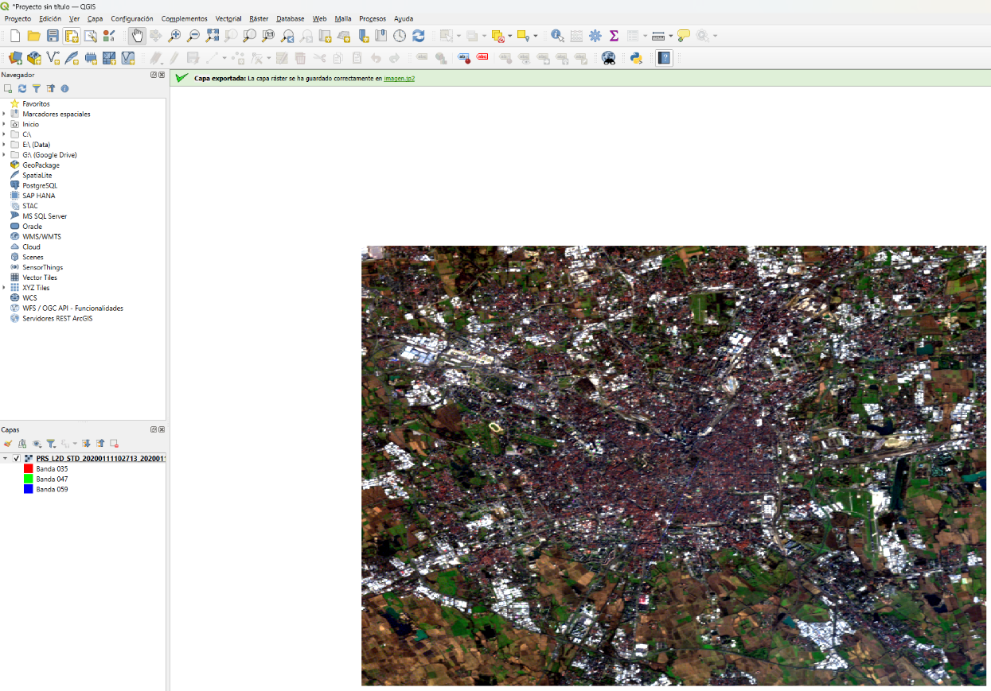
Here is the same image by setting the bands in the code:
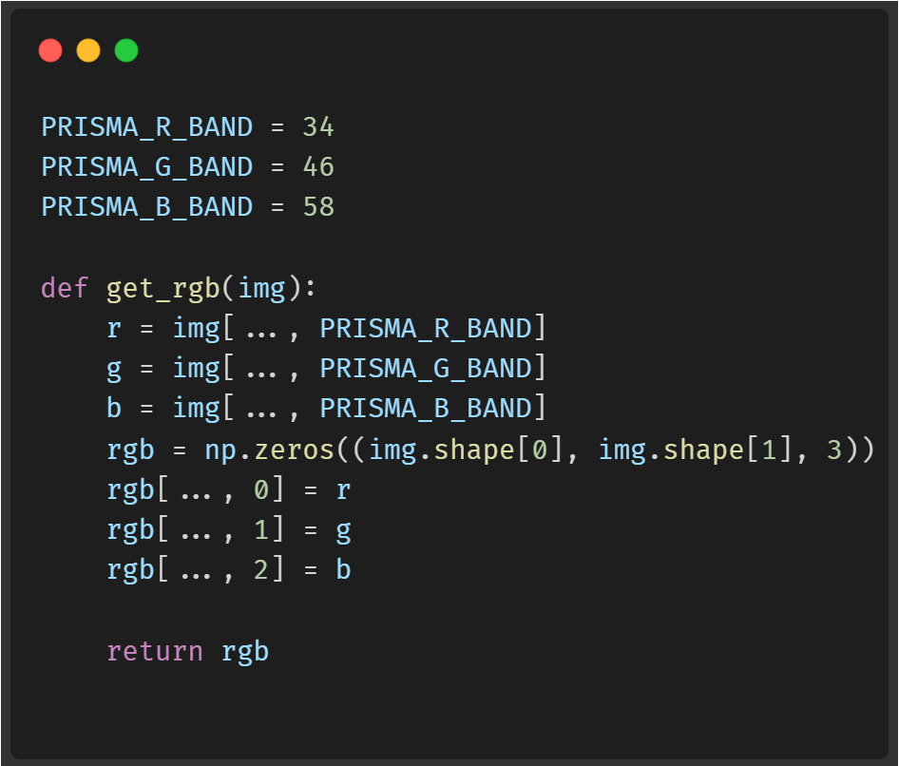
And this is the result:
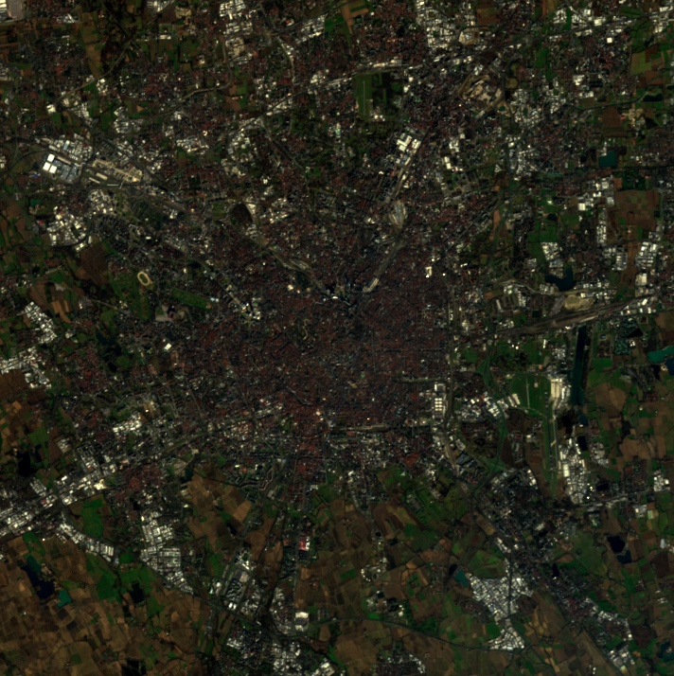
This image will be useful to have a general idea of the area of interest and the different land cover types present in the scene.

2.1.4. Endmember extraction
Based on the image, it is possible to estimate 10 main endmembers (pure pixels) that represent the dominant materials in the scene:
- Heavy dense urban surfaces
- Isolated structures
- Industrial and commercial complexes
- Roads and pavements
Note:
It is worth mentioning that this estimation was initially performed using fewer endmembers, but after analyzing the resulting abundance maps, it became clear that some materials were not being adequately represented. By increasing the number of endmembers to 10, a better representation of the diversity of materials present in the scene was achieved, allowing for a more accurate and detailed characterization of the various types of surfaces and urban structures.
- Construction sites
- Land/soil
- Vegetation
- Water bodies
- Forested areas
- Pasturelands
To manually extract the endmembers, we use the Pixel Purity Index (PPI), assuming the existence of a pure pixel that has maximum spectral purity (i.e., a single material). The following code snippet illustrates this process:
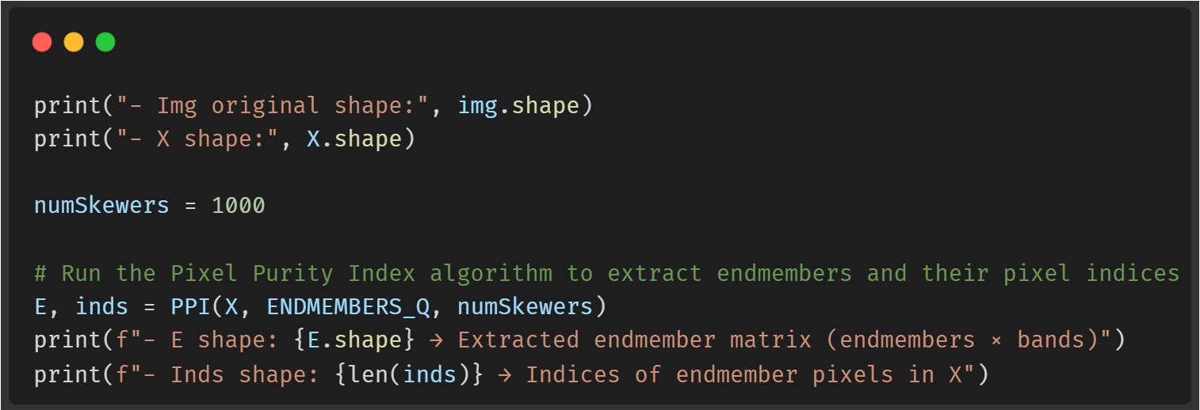
And the result:
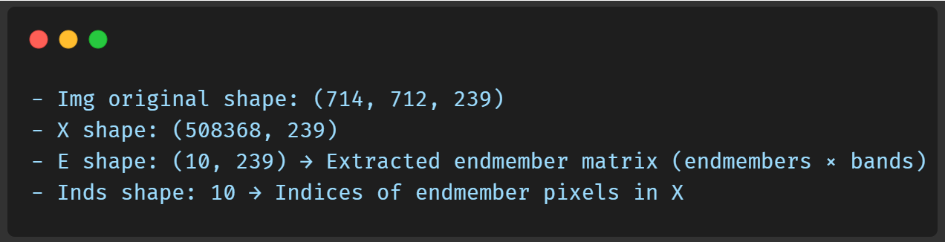
This result specifies that we have successfully extracted 10 endmembers, each represented by a spectral signature across the 239 bands of the PRISMA hyperspectral image. The endmember matrix has a shape of $239 × 10$, indicating that there are 239 spectral bands and 10 distinct endmembers. Each column in the matrix corresponds to the spectral signature of one endmember, capturing its unique reflectance characteristics across the different wavelengths. After obtaining this matrix, the abundance matrix should have a shape of $10 × num_pixels$ so that when multiplied with the endmember matrix, it reconstructs the original hyperspectral data.
Finally, we can plot the extracted endmembers to visualize their spectral reflectance signatures:
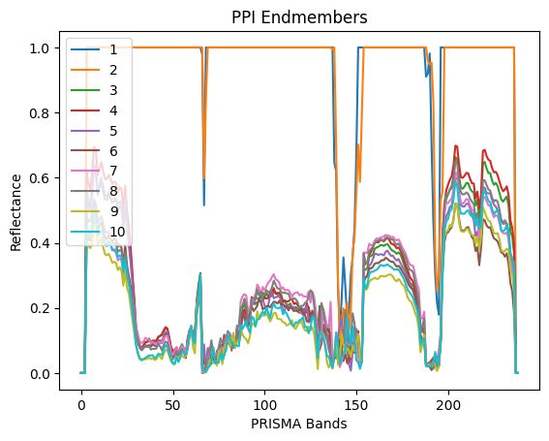

2.1.5. Abundance estimation
Once the endmembers have been estimated, the abundance matrix $A$ can be solved using the Fully Constrained Least Squares (FCLS) method, which minimizes the difference between the observations and the linear reconstruction under the non-negativity and sum-to-one constraints. This is a constrained least squares problem (solvable via Lagrange multipliers or convex optimization methods). Here we use pysptools library to perform the FCLS unmixing:
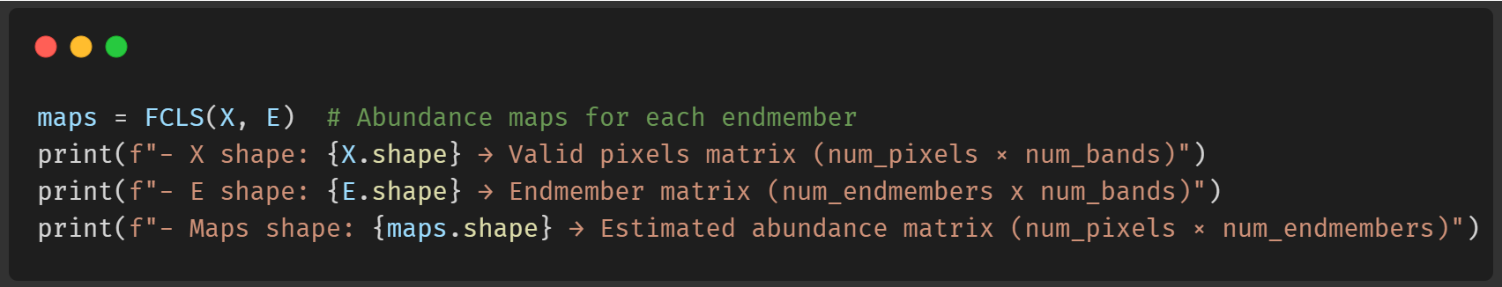
This process took about 12 minutes, and this is the result:
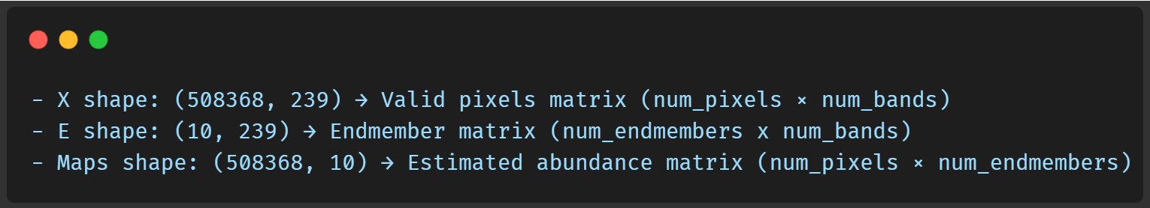
The next step is to visualize the abundance maps for each endmember:
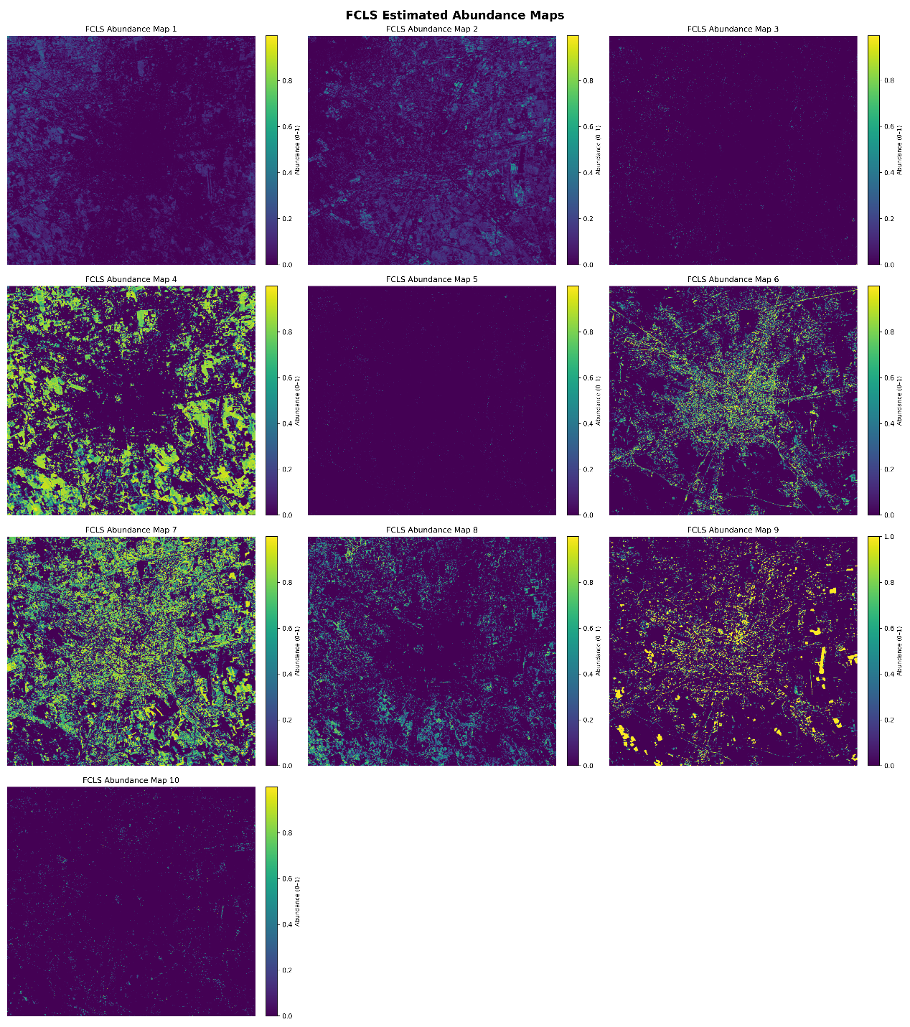
Based on the resulting abundance maps, the following qualitative visual analysis can be made:
- Abundance Map 2: This map appears to discriminate building rooftops, possibly those that appear white in the RGB image. This material could correspond to concrete or metal roofs, which typically exhibit high reflectance in the visible spectrum. It would correspond to the industrial class, given that it is located outside the city center and appears to highlight warehouse-like structures.
- Abundance Map 4: One way to identify what this map is discriminating against is by observing specific points in the RGB image. For example, in the center of the image, there is a clear green structure in the RGB image, suggesting that this map may be representing dense vegetation or green areas. Additionally, this map shows high values in areas that appear to be parks or gardens in the RGB image.
- Abundance Map 6: This map seems to be discriminating against roads and paved pathways, as well as inner-city streets. Areas with high values in this map coincide with roads and pathways visible in the RGB image. This suggests that this endmember may be representing materials associated with paved surfaces, such as asphalt or concrete.
- Abundance Map 7: This map clearly distinguishes highly urbanized zones. This is evident from its high concentration in the city center, where a greater density of buildings and urban structures can be seen in the RGB image. Additionally, this map shows low values in green areas, indicating that it is capturing features associated with dense urban surfaces, such as buildings. An important observation is the comparison with Abundance Map 4: Map 4 seems to fill in the areas where Map 7 has low values, corresponding to vegetated areas. This validates the interpretation of both maps. Finally, note the correlation with Abundance Map 2, which also discriminates against urban zones but seems more focused on specific structures such as rooftops.
- Abundance Map 8: This map appears to capture areas of bare soil and exposed ground. Areas with high values in this map coincide with zones that seem to be vacant land or areas without vegetation in the RGB image. This suggests that this endmember may be representing materials associated with bare soil, such as sand or compacted earth.
- Abundance Map 9: This map seems to represent highly forested zones. In the RGB image, these areas correspond to a dark green (almost black), which we interpret as forested regions. They include parks and other vegetation zones distributed throughout the city.
Finally, the remaining maps could not be easily compared with the RGB image. It is possible that some of them correspond to water bodies in the city.

3. Products comparison
  - Harmonize SAR- and HSI-derived products to a common spatial grid and compare them against the different LULC classes

3.1. LULC data preprocessing
LULC (Land Use/Land Cover) data provides information about the physical and functional characteristics of the Earth's surface. It classifies land into different categories based on its use (e.g., urban, agricultural, forested) and cover (e.g., vegetation, water bodies, bare soil). LULC data is essential for various applications, including environmental monitoring, urban planning, resource management, and climate studies.
The Urban Atlas it’s a Copernicus initiative that provides high-resolution LULC data for urban areas across Europe. It offers detailed information about land use and land cover types within cities, making it a valuable resource for urban analysis and planning. It can be accessed here.
The data is being renewed every six years, with the latest version being from 2018 (there are the versions 2006 and 2012 also). There are several LULC classes that can be considered as ground truth for our analysis.
To obtain the data, we had to register on the Copernicus program, search for the Urban Atlas dataset and select the area of interest (Milano) as shown in the following image:
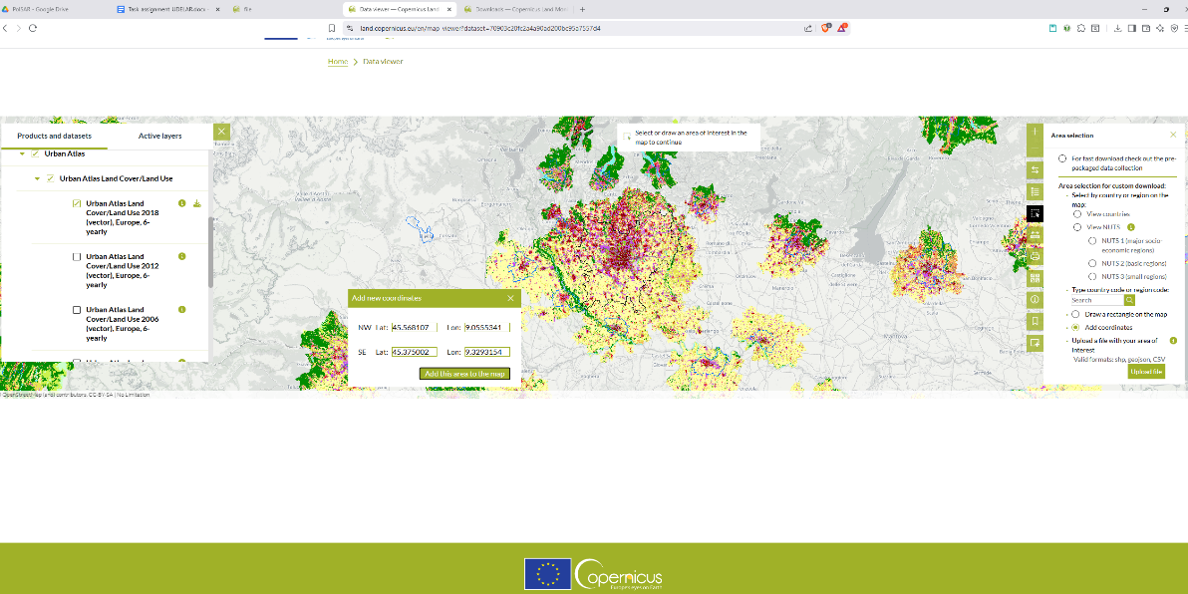
Finally, we downloaded the image from the AOI in GeoPackage format:
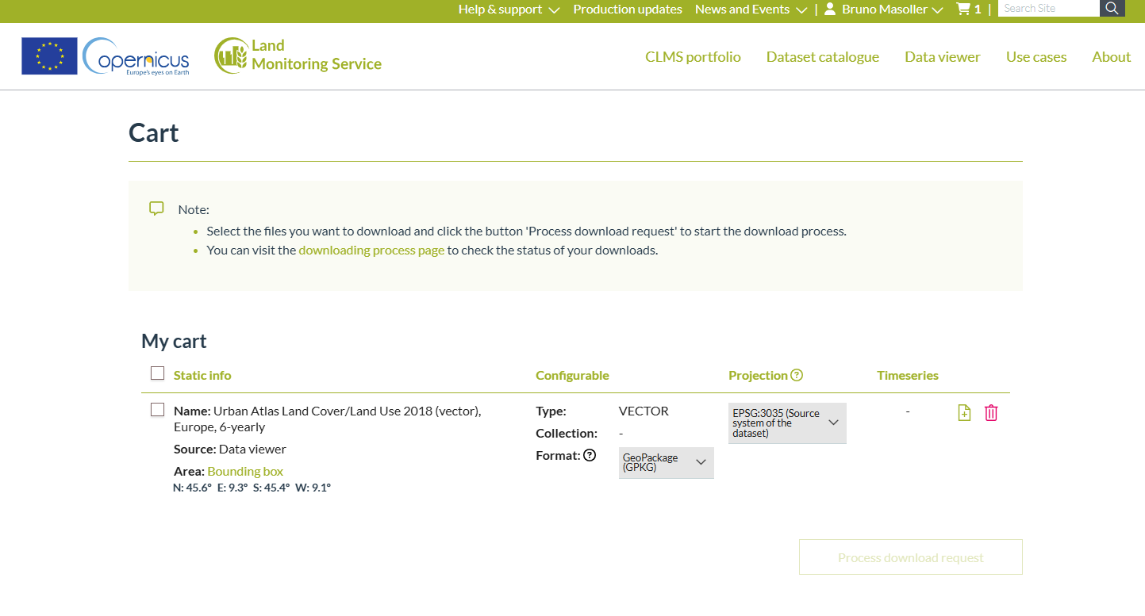
After having this product, we can read it and visualize the different LULC classes:
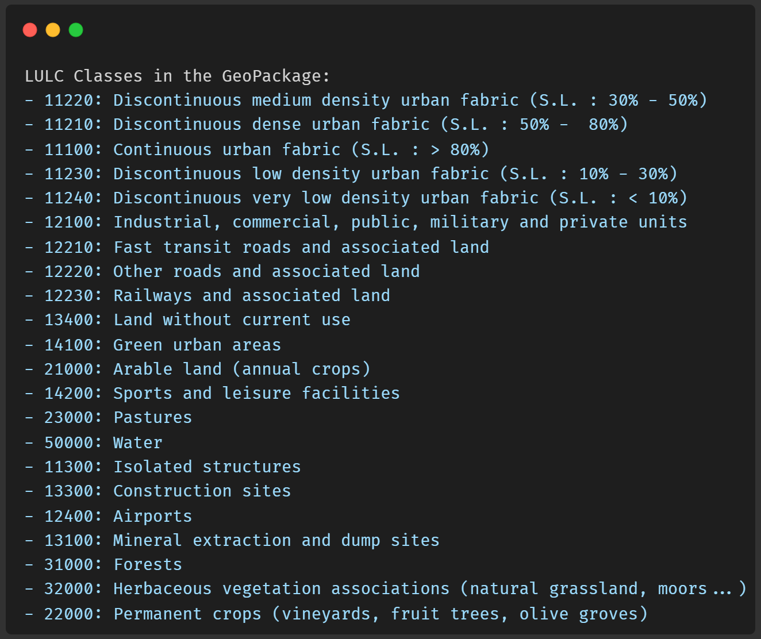
Finally, we can map some colors and plot the data:
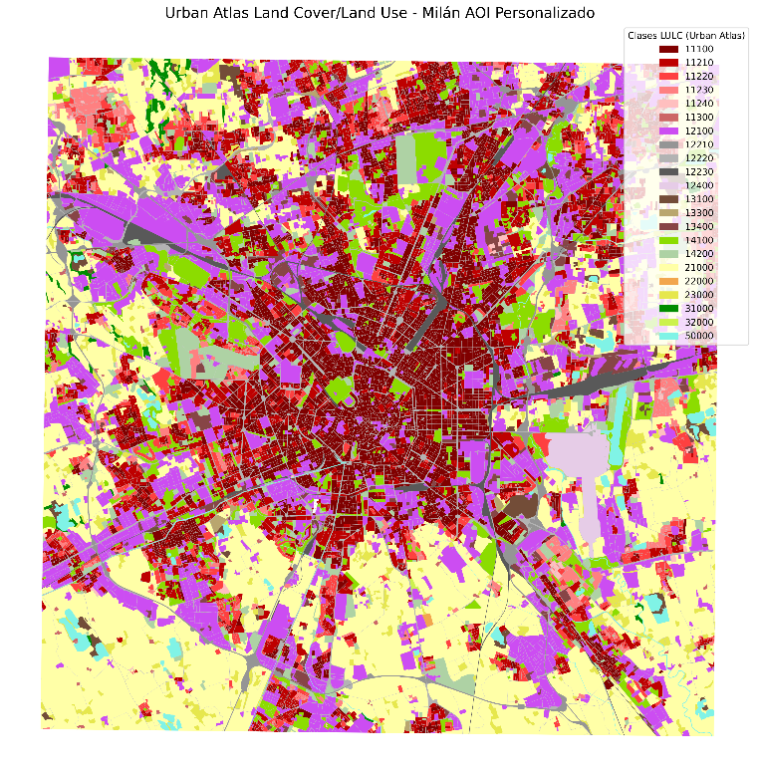
The LULC classes are masks that can be rasterized to match the spatial resolution and grid of the SAR and HSI data. This involves using the rasterio and geopandas libraries to perform the rasterization process:
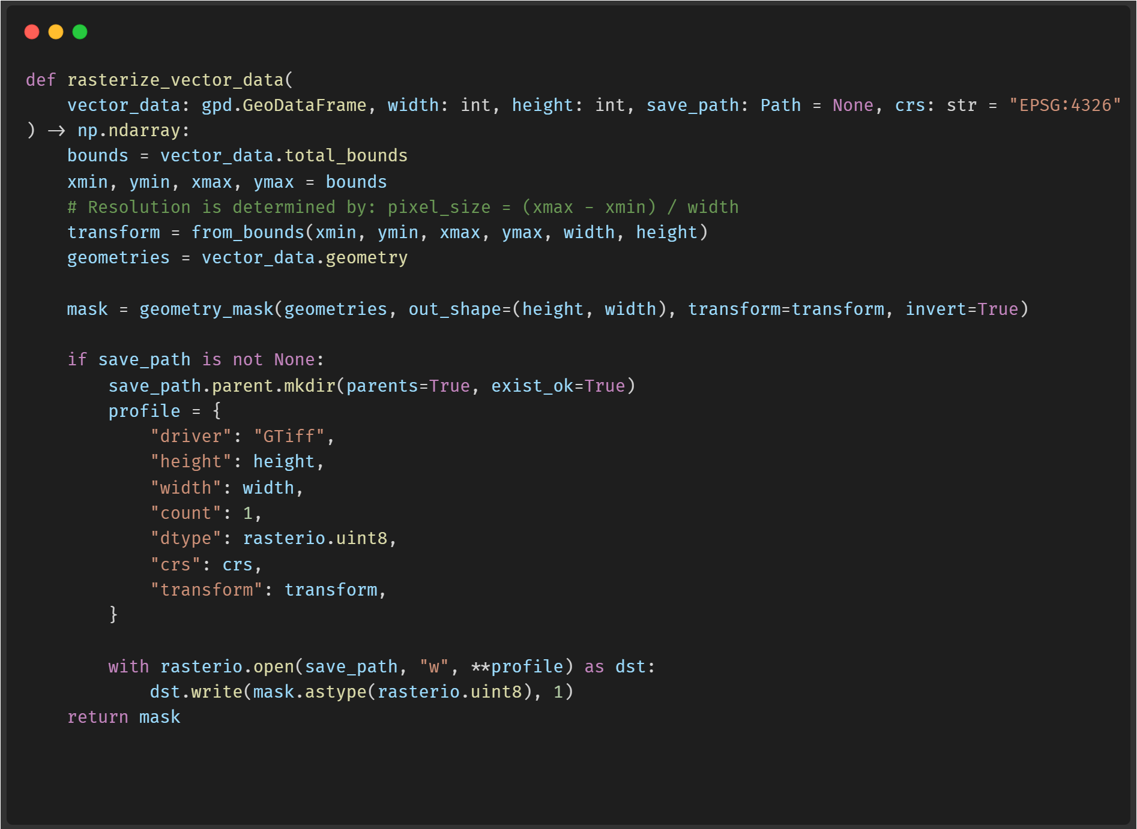

3.2. Harmonization of products
To compare the SAR and HSI-derived products with the LULC classes, we need to ensure that all datasets are harmonized to a common spatial grid and resolution. This involves resizing and aligning the datasets. To do this, we apply this function to all our products, based on the PRISMA image as “master”:
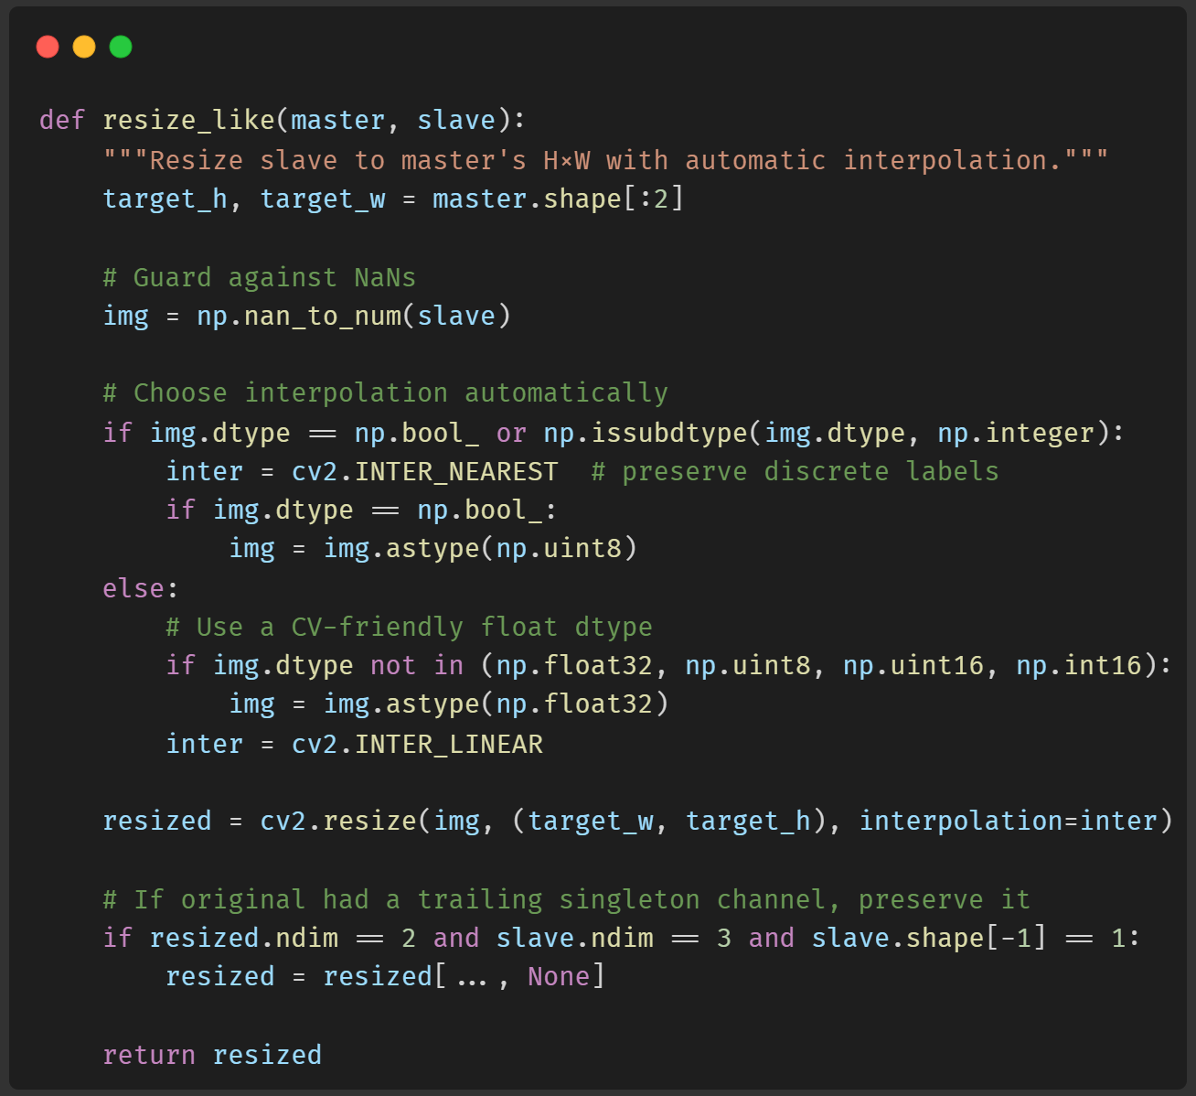
Finally, we have three lists containing all the images:
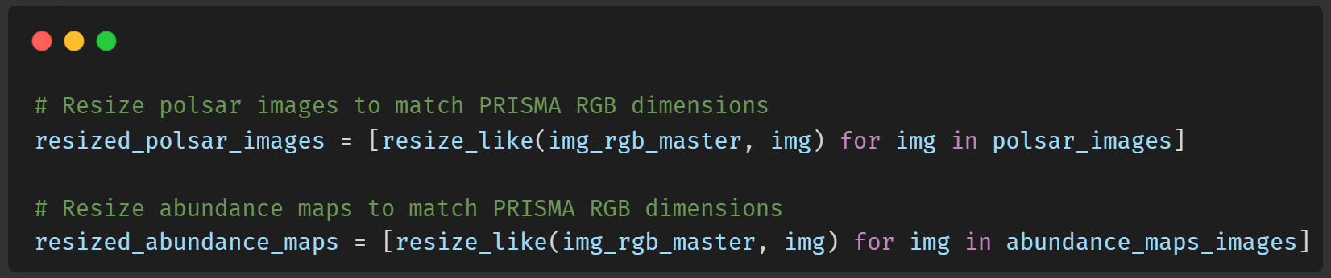
We also decompose every class of the LULC dataset on the same PRISMA size grid, to later compare with the pol-sar and abundance maps:
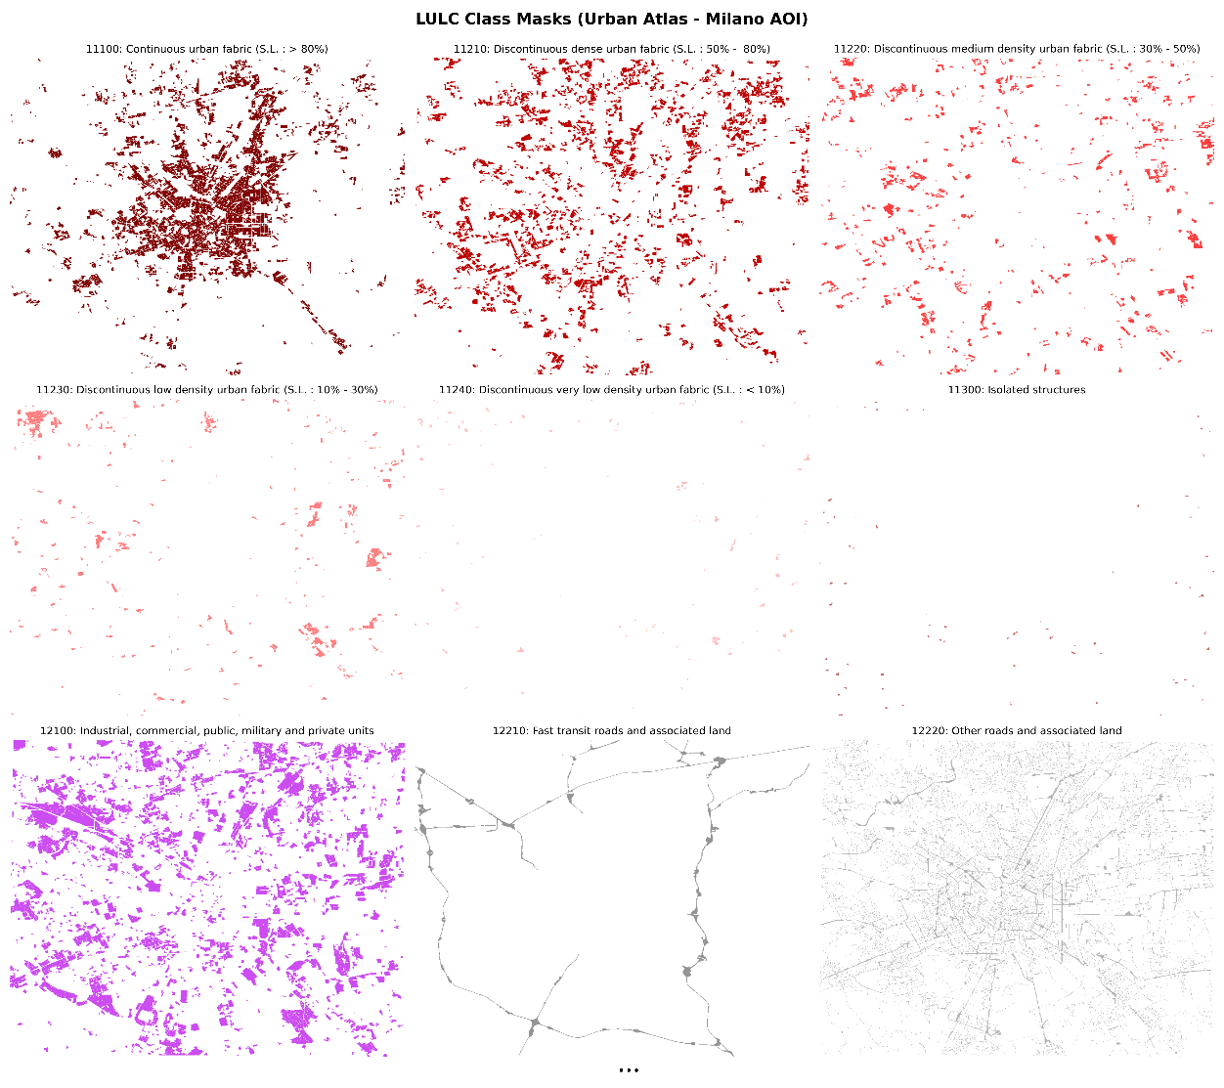
Note:
These are not all the LULC classes, but some of them. You can check the full image (with the other resized images) in this link.

3.3. Qualitative analysis
To compare these products (after harmonization) with the LULC classes, we can visualize them side by side for qualitative analysis. We can use this function to plot the mask over the polsar or hsi images:
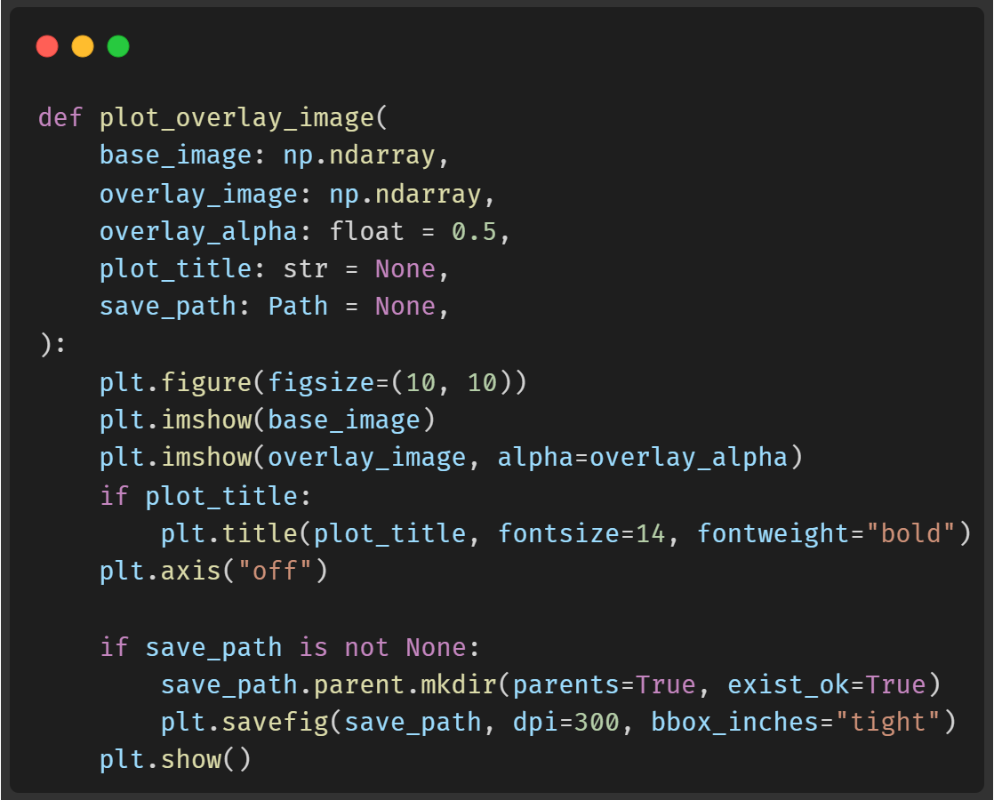

3.3.1. Abundance map 2
We previously assumed this map was discriminating against building rooftops. When observing the LULC masks, this map has high values in areas corresponding to class 12100 ("Industrial, commercial, public, military and private units"), which validates our initial interpretation. It is noteworthy that while there is good correspondence, it is not perfect. It appears that the assumption that building rooftops are homogeneous does not hold in all cases, as some rooftops may have different materials or colors that affect their spectral reflectance. However, these still correspond to class 12100 in the LULC masks.
Overlaying abundance map 2 with LULC mask for class 12100:
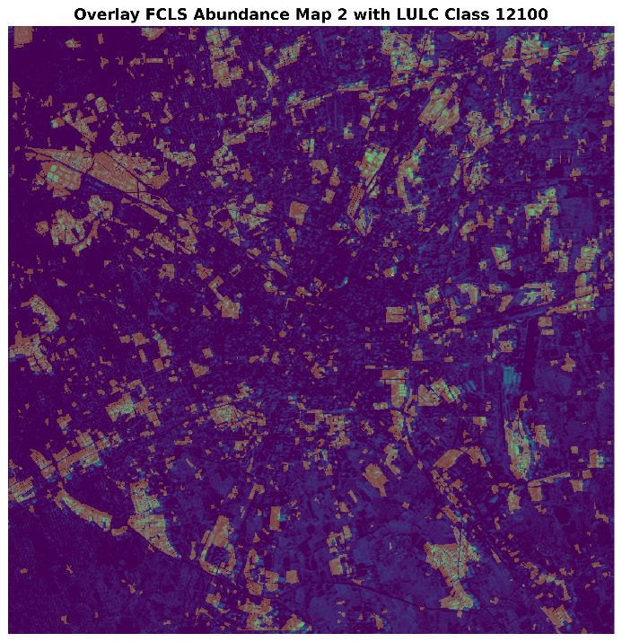
In the overlay, a good correspondence between both can be observed, which reinforces the interpretation that this map is capturing features associated with building rooftops in industrial and commercial areas. However, it can also be seen that abundance map 2 has high value in some areas that do not correspond to class 12100, which could indicate that it is capturing other features besides building rooftops.

3.3.2. Abundance Map 4
In this map, it was assumed that it was discriminating against dense vegetation or green areas. However, when observing the LULC masks, it becomes evident that this is not exactly the case. While there are some areas that coincide with green zones, such as parks or gardens, there are also many other areas where abundance map 4 has high values that do not correspond to the vegetation class in the LULC masks. This suggests that this map could be capturing other features besides dense vegetation, or that the vegetation in these areas is not as dense as initially thought. Specifically, it seems that the previously chosen reference point represents a point in class 14200 ("Sport and leisure facilities"), which could be a sports field or a recreational area that does not necessarily have dense vegetation. It is also observed that there is a high relationship with class 21000 ("Arable land"), which could indicate that this map is capturing agricultural areas or croplands that may have vegetation at certain times of the year, but are not necessarily dense green areas.
Overlaying abundance map 4 with the LULC masks for classes 21000 and 14200:
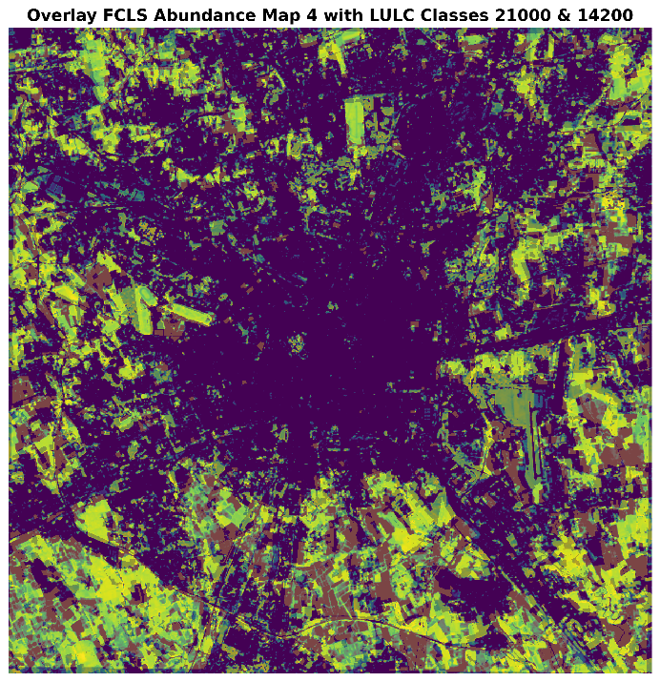

3.3.3. Abundance Map 6
Initially, it was interpreted that this map was discriminating against roads and paved pathways. When observing the LULC masks, this map has high values in areas corresponding to class 12210 ("Fast transit roads and associated land"), 12220 ("Other roads and associated land"), and 12230 ("Railways and associated land"), which partially validates our initial interpretation. This is one of the best cases of correspondence between an abundance map and the LULC masks.
Overlaying abundance map 6 with the LULC masks for classes 12210, 12220, and 12230:
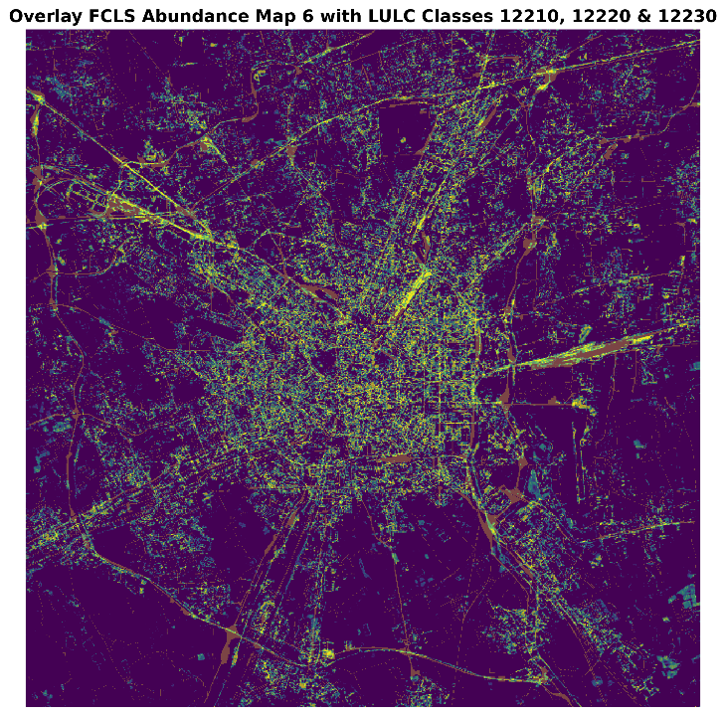

3.3.4. Abundance Map 7
This map was discriminating against highly urbanized areas. It likely refers to materials associated with dense urban surfaces, such as buildings. When observing the LULC masks, the entire 11000 line refers to urban areas, so this map is a combination of most of these classes. However, this map also shows high values in areas that do not correspond to urban zones, including areas like those in the previous map. What can be stated is that this map does not represent areas of class 21000 ("Arable land"), since these show low values in this map.
Overlaying abundance map 7 with class 21000 ("Arable land") to validate that it does not represent agricultural areas:
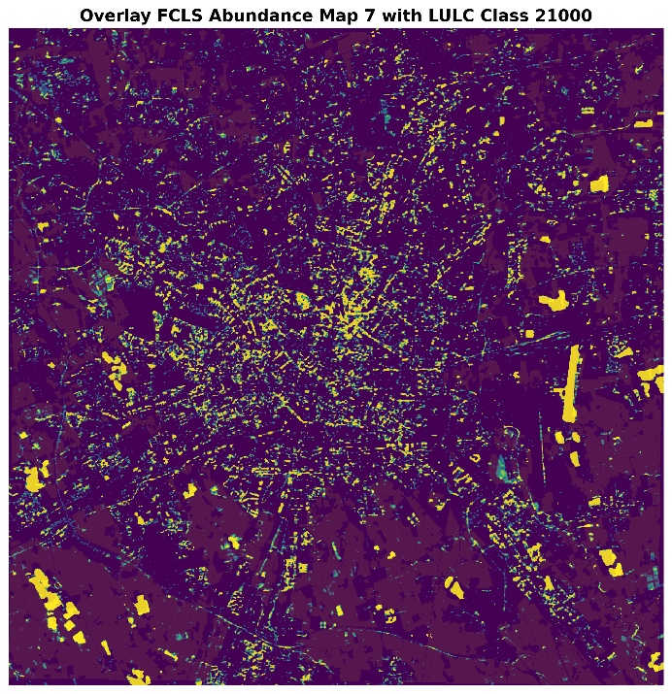
In the image, it can be observed that the values of class 21000 ("Arable land") align precisely with the low values of abundance map 7, confirming that this map is not capturing agricultural areas, but is more related to dense urban zones.

3.3.5. Abundance Map 8
In abundance map 8, it was assumed that it was capturing areas of bare soil and exposed land. When observing the LULC masks, it was not possible to identify a class that clearly relates to this map. There are some places where the map shows high values, such as in the lower left area of the map, which in the LULC classes correspond to class 21000 ("Arable land"), but in general there is no clear correspondence with any specific LULC class. This suggests that this map could be capturing a mixture of different types of surfaces or materials that are not clearly represented in the available LULC classes.

3.3.6. Abundance Map 9
Again, this map did not show clear correspondence with any specific LULC class. Although some areas with high values can be observed that might coincide with green or forested zones, there is no evident relationship with the available LULC classes.

3.3.7. Dual-pol radar built-up index ($DpRBI$)
This index was designed to highlight urban and built-up areas in SAR images. When observing the LULC masks, this index has high values in areas corresponding to the entire 11000 line, where urban zones are located. This validates the effectiveness of the $DpRBI$ for identifying urban areas in SAR images. However, this index does not allow distinguishing between different types of urban areas, since all classes within the 11000 line show similar values in the index.
Overlaying $DpRBI$ with the LULC masks for the entire 11000 line:
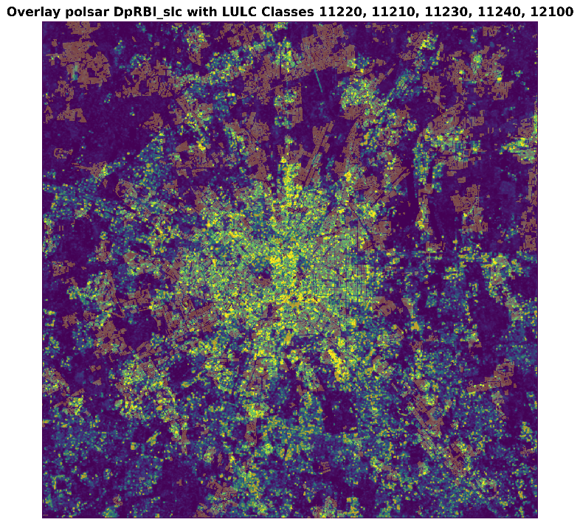
The overlay of the $DpRBI$ index with the LULC masks from the 11000 line shows a good correspondence, reinforcing the usefulness of this index for identifying urban areas in SAR images. There are areas where the mask does not match, which may be due to zones where urban coverage is not dense. However, overall, a good correspondence between both can be observed.

3.3.8. SAR surface scattering index ($DpRSI$)
This index represents smooth and open surfaces, such as water bodies or agricultural areas. When observing the LULC masks, it is inferred that this index should have high values in areas corresponding to class 21000 ("Arable land"), which represents agricultural land.
Overlaying $DpRSI$ with the LULC masks for the "surfaces" clases (21000, 114100, 23000, 50000, 32000):
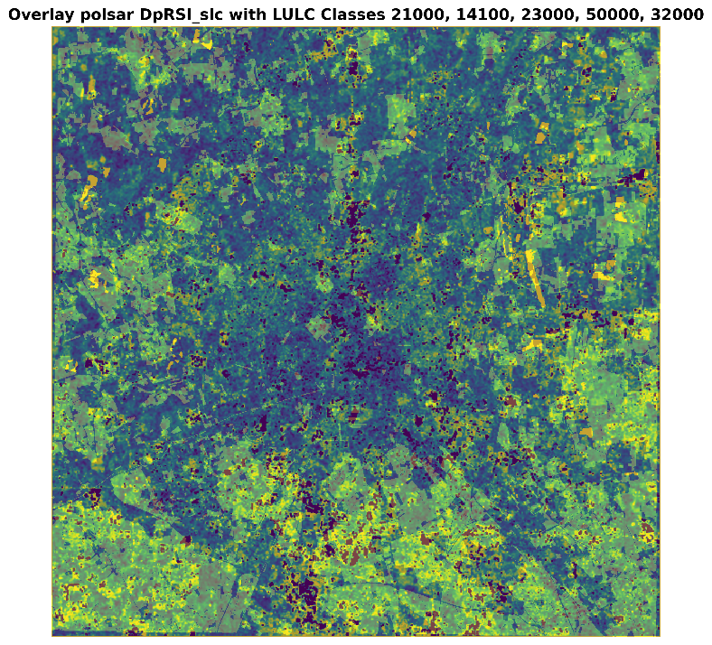
The result shows that there is indeed a good correspondence between the $DpRSI$ index and classes representing open surfaces, such as class 21000 ("Arable land"). This validates the effectiveness of $DpRSI$ for identifying areas with smooth and open surfaces in SAR images.

4. Investigate relationships
  - Investigate the relationships between SAR and hyperspectral indicators across urban categories, highlighting how their integration enhances the characterization of urban form and environmental composition.
This work demonstrated that the integration of descriptors derived from polarimetric SAR data and products obtained from hyperspectral images enables a more complete and detailed characterization of the urban environment and its environmental composition. There are components that can only be observed with one type of sensor; for example, abundance maps derived from hyperspectral images allow the identification of specific materials present on the Earth's surface, such as different types of vegetation, soils, and construction materials. These spectral details are difficult to capture using only SAR data.
On the other hand, the descriptors allow the combination of various types of hyperspectral information into a single index that highlights structural and textural features relevant for identifying urban and built-up areas. This is especially useful in complex urban environments where surfaces can be heterogeneous and multifaceted.
By comparing and correlating the products derived from both types of sensors with land use and land cover (LULC) classes, it was observed how each dataset provides complementary information. For example, certain hyperspectral abundance maps showed good correspondence with specific LULC classes, such as industrial or agricultural areas, while SAR descriptors highlighted structural features associated with dense urban zones.
As a conclusion, it can be stated that to obtain a holistic and accurate view of the urban environment and its environmental composition, it is essential to integrate data from multiple sensors. This combination allows both approaches to be merged for better characterization and analysis of the urban landscape and its environmental dynamics.

Obtained from researchgate.

