1. **Problema Beecrowd 1110 (Nivel - 3)**

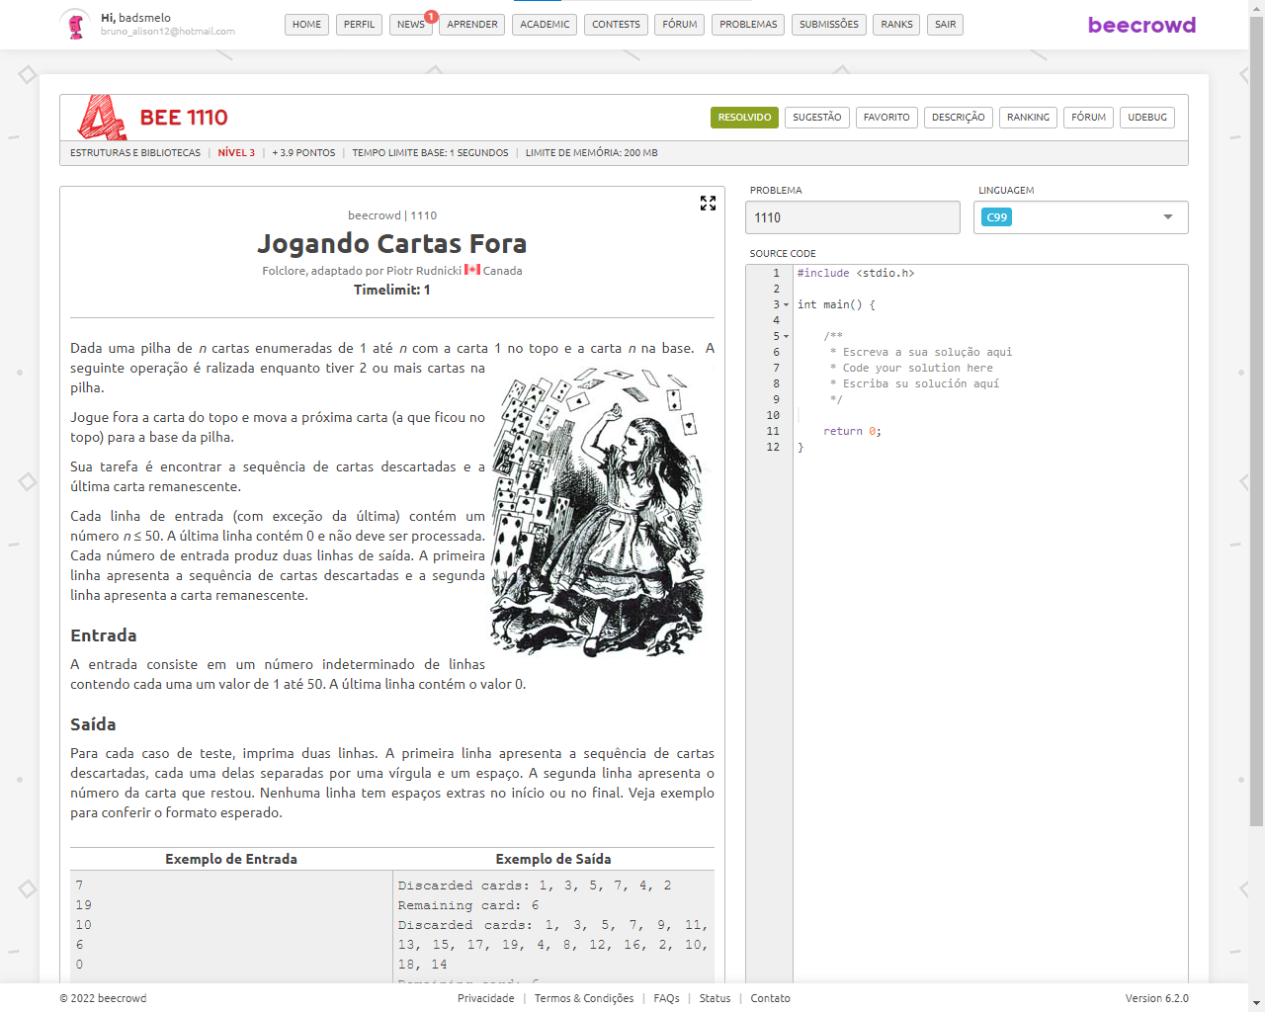

#include<stdio.h>

#include<queue>

int main(void)

{

int n, qtd, i, j = 0;

int topo = 1;

std::queue<int> f;

std::queue<int> fr;

scanf("%d", &n);

while(n > 0 && n <= 50)

{

topo = 1;

if(n == 1)

f.push(n);

for(i=1; i <= n; i++)

{

f.push(i);

}

while(f.size() >= 2)

{

if(topo == 1)

{

fr.push(f.front());

f.pop();

topo = 0;

}

else

{

f.push(f.front());

f.pop();

topo = 1;

}

}

j = 0;

qtd = fr.size();

printf("Discarded cards: ");

while(j < qtd-1)

{

printf("%d, ", fr.front());

fr.pop();

j++;

}

printf("%d", fr.front());

fr.pop();

printf("\n");

if(!f.empty())

{

printf("Remaining card: %d\n", f.front());

f.pop();

}

scanf("%d", &n);

}

return 0;

}