

1. **Videos**

I have attached the four videos for the subpages.

The first one will be for the page “**ABOUT**”.

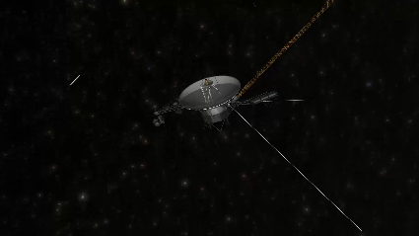

The second one will be for the page “**THE PALE BLUE DOT**” (this is the old page formerly called Red Dot), you can rename it.

The third one will be for the page “**OUR** **WORK**”.

The fourth one is for the page “**CAREER**”.

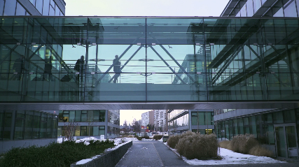They should all work similarly to the contact page video which you have already implemented, i.e. run through exactly once and then freeze on the last frame. I don’t remember exactly how we solved this in the contact page, whether I gave you the freeze frame as a separate image? If you need it, please let me know. I would actually prefer that the freeze frame is a separate image at least for the “Pale Blue Dot” video, because it the whole video heavily compressed which means that also the last frame is highly compressed. I think we can make it look nicer with a separate jpg in higher quality for the last frame.

1. **Content**

I now have most of the content ready. I will attach you a separate file with all the translated text for the homepage.

I have now decided that we will only translate the homepage because it will be too confusing without a CMS to manually copy and update all these pages in many different languages.

Therefore, you can hide or comment-out (but for now, not delete) the language selector in the navbar on every page EXCEPT for the homepage. You can also delete all subpages in other language and just keep the English version.

We will also have to make some changes to the language selector. For this, please see point 4 below.

1. **Social media buttons**

Please remove the social media buttons in the upper right-hand corner (Facebook, Twitter, LinkedIn and Behance) as well as the white line preceding them. We will not be using those (also because I hate social media :-D). Do not simply delete the code (you should never delete code you have previously written. I recommend that you either save it as a component in Bootstrap Studio if this is possible and/or export the social media code snippet into a text file.

1. **Language Flyout Menu**

So, I wasn’t very happy with our language changer in the navbar due to the fact that it’s very difficult to add more languages there. Therefore, I have devised a way to make this more flexible and allow us to add more languages in the future.

Please see the pictures below.

I have attached you the SVGs for both the globe icon and the arrow.

In the normal state, the world icon should be grey, but onmouseover it should be highlighted in blue, like the “EN”. Then, also on hovering, it should open a flyout menu with the choice of languages (see second picture below).

These links should behave the same: Standard = Grey (but maybe a slightly darker grey is required for them to be better readable??). Hover = Dark Blue.

Note that our Europa font does not have support for Chinese and Greek, so we need to use another font here. I want to avoid that we have to download two whole other fonts right at the first load which would slow-down the homepage even more. So please find a way to load either only the glyphs required to spell the language name in the flyout menu; or alternatively to load the font at the very end, after the homepage is already fully displayed.

In the screenshot below, I have used the fonts “**Myriad Pro Semibold**” for Greek and “**Microsoft YaHei UI**” for Chinese. Please check if you have these on your system or I can send them to you.

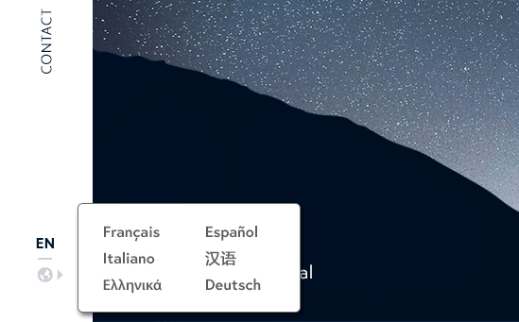

1. **Refactoring**

If all this is finished, I would like you to slightly refactor the code. By this I mean:

* make sure that the code is significantly different from anything we might have “borrowed”, so we cannot be accused of “copy & paste”. I think due to the fact that we use Bootstrap now the code is already much different but you will know what portions you simply “copied” and these should be “cleaned” 😉
* Double check that especially class names and IDs are unique and that they do not have the same name as anything we “borrowed” from the original website. For example:
  + The words “social” or “social media” should not appear in any class names or IDs, as these will usually be blocked by adblockers such as uBlock Origin.
  + Rename “-hero” in class names / IDs to, e.g. “main”
  + etc.
* remove any mentions of “webflow” from the code, incl. CSS, if any remain
* Because of privacy regulations in some countries or places, like the European Union, we cannot just pull in code from US-based companies like Cloudflare for example and if we do do that, we need to adjust the privacy policy which is very complicated. Therefore, it might be necessary remove all external sources (scripts, libraries) that are pulled in through CDNs or from third-party websites. If we need any of these, we should self-host them. I need your advice if you think this is a good idea or not and what the (dis)advantages might be of self-hosting them vs. pulling them in from third parties.
* Please add the favicons which I have sent you some weeks ago already. Contrary to what I wrote there, you do NOT need any code for this, you can add them directly in Bootstrap Studio under “Settings” > “Favicons”. Compare the file dimensions to figure out which file you need to put in which field, or check out this screenshot:

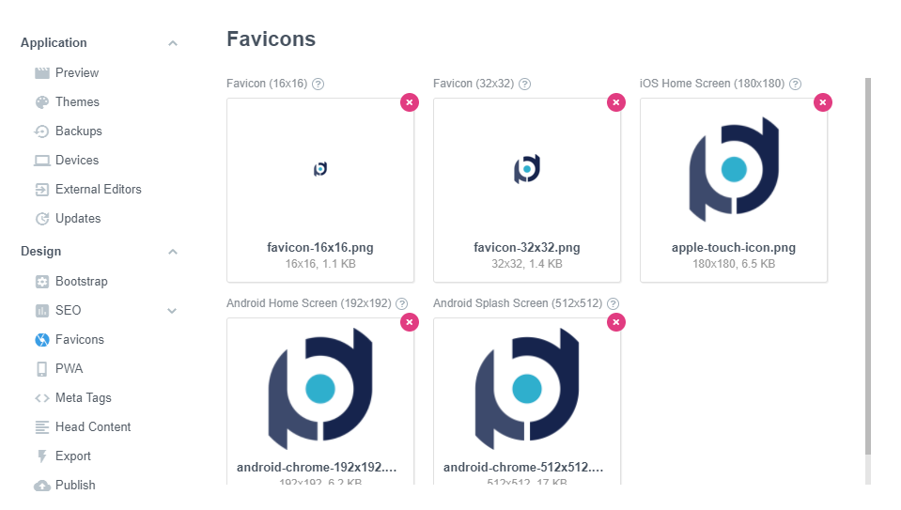

Lastly, as I have previously mentioned, I would like to work with you on some other projects. I have seen somewhere that you also have experience with Delphi, is this correct? In this case, I might have even more jobs for you because I urgently need a capable Delphi developer 😉 I’ll send you more information later this week or next week, as soon as I have the time. Thank you!