**LAST MINUTE HOTEL BOOKING APP**

**1. List of four requirements:**

**a.User Registration and Login:**

**Description:** The system must allow users to register with their details (e.g., name, email, password) and provide a login functionality. Only registered users can search for hotels, make bookings, or manage their reservations.

**Reference:** This is represented by the "User Registration" and "Login" use cases in the diagram.

**b.Hotel Search:**

**Description:** The system must allow users to search for available hotels based on specific criteria such as location, check-in/check-out dates, room type, and price range.

**Reference:** This is covered by the "Search for Hotels" use case.

**c.Hotel Booking and Payment:**

**Description:** The system must enable users to book a hotel room after searching, and allow them to view the reservation details. It must also allow users to make payments for their reservations.

**Reference:** This is represented by the "Book a Hotel Room" and "View/Pay for Reservation" use cases.

**d.Manage Bookings (Modify/Cancel):**

**Description:** The system must provide users with functionality to manage their bookings, including modifying the reservation details (e.g., change dates or room type) or canceling the booking entirely.

**Reference:** This is represented by the "Manage Bookings" use case with extensions for "Modify Booking" and "Cancel Booking".

**2.High-level Use Case Diagram**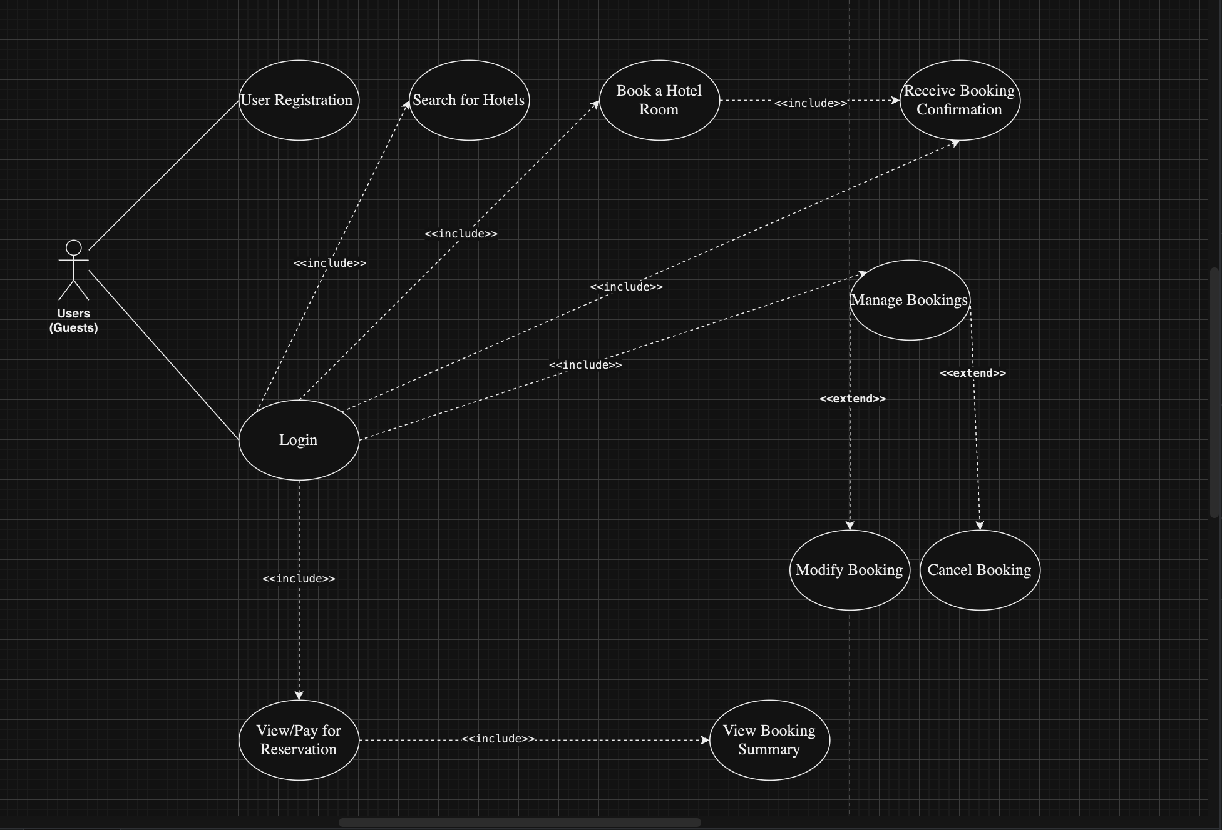

**Link to your updated Azure Boards:**

[**https://dev.azure.com/SaiRohithGovindavajjala01/Last-Minute%20Hotel%20Booking%20App**](https://dev.azure.com/SaiRohithGovindavajjala01/Last-Minute%20Hotel%20Booking%20App)

**Link to your GitHub repository:**

[**https://github.com/brunoo-mb/Last-Minute-Hotel-Bookking**](https://github.com/brunoo-mb/Last-Minute-Hotel-Bookking)