**2.2 - Operation of the Opencart platform**

The Opencart platform works with several languages, according to Vidal a, Opencart was built based on the MVC + L structure, this statement explains the way the information flow works and how the structure of the system.

The author mentions that Opencart works basically with PHP5, HTML and CSS, er Vidal a, warns that for the customization of Opencart it is necessary to know jQuery.

In addition to these languages, Opencart has specific tools designed exclusively for your use as vQmod.

**2.2.1 - Operation of the MVC model**

The Microsoft Developer Network website explains that the acronym MVC stands for Model, View, Controller (Model, View, Control), this method separates the logic from the interface so that it is possible for both parties to be configured separately. Macoratti explains in detail the function of each layer:

• Model: It is responsible for all modifications of the application. Manipulate application data, which is behind the process business. It is responsible only for the data (storage, manipulation and generation). It is the model that encapsulates the data and is regardless of presentation.

• View: Only displays the information. Includes all elements such as: HTML, Asp.net, XML, ASP, Applets. It is also used as input of information.

• Controller: It is responsible for the communication between the view and the model. It is the control layer that maps the actions.

• Language: PHP variables stored in a file containing translation into a particular language.

Figure 4 shows only the functioning of the MVC layers. Vidal b, explains that the language layer is an implementation of Opencart.

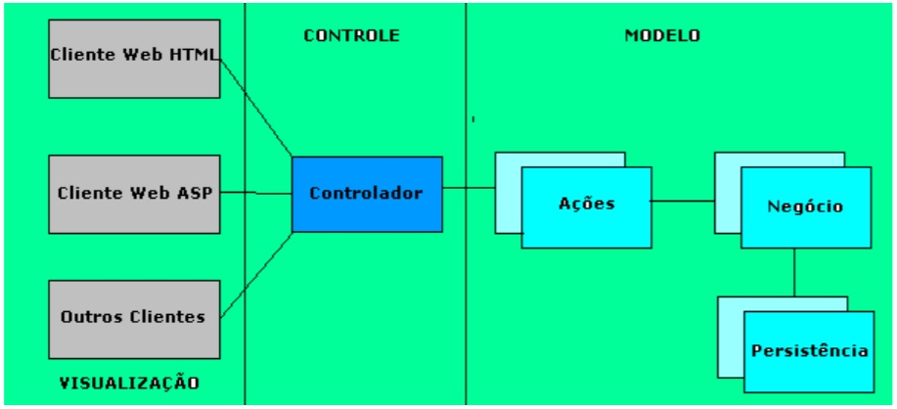

**Figure 4 - MVC model. The MVC structure separates information from presentation.**

**2.3 - Structure of Opencart modules and templates**

To better understand how the Opencart platform works, let's see in detail how the templates and modules that works in Opencart.

**2.3.1 - Structure of templates for Opencart**

Vidal d, explains that Opencart is capable of having several themes, however, at each update Opencart is based on the default theme (default), so it performs all updates based on the default.

The author explains that to create a template for Opencart it is necessary to start from the standard platform theme. As we saw earlier, Opencart is formed in the MVC + L standard so the files are organized separately from the main code, but are interconnected with it.

The view has * .tpl files. Tpl files contain HTML and PHP contente show the data that should be displayed. Opencart themes are interlinked by PHP codes and do not need an engine to be compiled.

The PHP tags are referenced in the tpl files, they are based on the global class reference and variable controllers.

The author explains the syntax:

The control folder is where the variables are created, the structure is placed as:

$ this -> data [‘variable’] = ‘display variable’;

In the tpl file that is responsible for displaying the variable, something like:

<? php echo $ "variable"; php?>

As a final result the value of the variable would be displayed.

**2.3.2 - Structure of Opencart modules**

Vidal and, explains the structure of an Opencart module teaching how develop a basic module step by step. During the explanation it is possible understand that the structure of an Opencart module is divided into two parts, the part known as “admin” which is the part of the store that works as a backend and the front of the store, which works only to display what you want to the user.

The “admin” folder (administration) and the catalog folder (which stores the elements to be viewed by the user) have basically the same structure. A specific file must be mounted in three folders that make up the structure being: controller, view and language

In the controller folder, only what is to be passed to the folder is built view, this connection is made through PHP variables. In the language folder are the translation files for a given language, files in the language folder they are formed by means of variables that contain the translation texts. In the folder view files are stored tpl, are basically formed by what the administrator must view and manipulate, these files in the view folder have HTML, CSS and Java Script (jQuery) codes.