University of South Florida
Bellini College of AI, Cybersecurity and Computing

Detailed Design Document
CIS-4910 Senior Project Fall 2026
AI Coding Agent Evaluation Harness
Microsoft 2, Team 3

Bruno Rocha, Kapil Srikanth, Ross Volenec, Joseph Bressani


Architectural Detail: AI Coding Agent Evaluation Harness

Document Control

Document Version History
Date | Version # |  |  | Author | Change reference
Oct 8, 2026 | 0.1 |  |  | Ross Volenec | Initial draft [5]
Oct 9, 2026 | 0.1-KS |  |  | Kapil Srikanth | Native-tool draft [6]
Oct 9, 2026 | 0.2 |  |  | Team 3 | Full draft [7]
Oct 9, 2026 | 0.3 |  |  | Joseph Bressani | Template restored; evidence rechecked; condensed

Document Reviewers / Team Members
Date | Version # | Name/Title | Organization
Oct 9, 2026 | 0.3 | Joseph Bressani, OpenAI Lead | University of South Florida
Oct 9, 2026 | 0.3 | Bruno Rocha, Anthropic Lead | University of South Florida
Oct 9, 2026 | 0.3 | Kapil Srikanth, Google AI Lead | University of South Florida
Oct 9, 2026 | 0.3 | Ross Volenec, Microsoft Lead | University of South Florida

Stakeholders

Name | Title
Chad Hage | Sponsor, Microsoft
Brad Lawrence | Sponsor, Microsoft
Scot Hollingsworth | Course instructor

Table of Contents
Introduction 5
Architectural Goals, Constraints and Assumptions 6
Goals 6
Constraints 6
Assumptions 6
Artificial Intelligence Impacts and Uses 7
AI Assisted Content Notation 7
Scope of Project Architecture 7
High Level Architecture (HLA) 8
Architectural Views <Detailed: lots of drawings> 9
Logical 9
Physical 13
Data 14
System Configuration Details 14
System Inputs API if used <Comment if not used> 15
System Output API if Used <Comment if not used> 15
System Decomposition <Must be detailed> 16
System Coupling <Must be detailed> 16
System Cohesion <Must be detailed> 17
Application servers 17
Web servers 17
Database servers, design and Schemas <Must be detailed> 17
Storage Requirements 18
Storage layout 18
Module Specifications 19
Module Design 19
Module Processing 19
Interfaces 20
Formulas & Algorithms 20
Architecture Decision Records 21
Open Decision Register 21
System Size and Performance 22
Security Considerations 22
References <MUST BE IN APA OR IEEE FORMAT> 24
APPENDIX A: Acronyms 26
APPENDIX B: Glossary of Terms 26
APPENDIX C: Documents, type and source 26
APPENDIX D: Evidence and Verification 28
APPENDIX E: Requirements Traceability 29
APPENDIX F: Time Records 30

Introduction
This document describes how Microsoft 2, Team 3 will build the AI Coding Agent Evaluation Harness specified in SRS v1.1 [2], what the repository already implements, and which decisions remain open.
The sponsor needs an objective way to compare AI coding agents on correctness, security, cost, and human effort. The SRS names OpenAI Codex, Anthropic Claude Code, GitHub Copilot, and Google Gemini, and defines success as a 96-run benchmark (4 agents × 8 tasks × 3 runs) with reproducible, published score ranges [2]. The sponsor described the user as a buyer of thousands of seats who needs an overall score and its breakdown [3].
Implementation evidence comes from repository commit 3589ef5 on master (9 Oct 2026) and three unmerged branches [1], [8], [9]. Requirements come from the SRS [2] and sponsor guidance from the meeting records [3].
Table 1. Status labels
Label | Meaning
Implemented | Present in the code at the audit commit; V-identifiers mark checks executed in this review (Appendix D).
Required | Specified in the SRS but not implemented.
Proposed | Design decision in this document; not yet built or approved.
Open | Needs a team or sponsor decision (Open Decision Register).

Comparison scope
Project materials describe four different comparisons. They answer different questions and must not be ranked together.
Table 2. Comparison approaches
Approach | What varies | Status | Limitation
1. SRS: commercial agents on one shared model [2] | Agent tooling | Required | A model available in every tool may not exist; the sponsor had no answer for Claude Code [3]
2. Track B: AutoGen model benchmark | Model, in one custom harness | Implemented prototype | The SRS excludes model-to-model comparison
3. Native-tool pilot [8] | Tool and its own model | One supervised run | Tool and model effects are mixed; not automated
4. Track A: feature matrix [4] | Documented capabilities | Specified | No execution or score; the sponsor asked for a score

The design provides one shared evaluation core (staging, isolation, independent grading, records, publication) that all approaches can use. The choice of primary approach is open decision D01.

Architectural Goals, Constraints and Assumptions

Goals
Table 3. Goals
ID | Goal | Design response
G1 | Comparable results | Each record carries its approach and metric contract; mixed cohorts are rejected
G2 | Reproducible runs | Pin commit, task, evaluator suite, image digest, model settings, and metric contract
G3 | Contained execution | Host-only credentials, no network, resource limits, non-root user
G4 | Tamper-proof grading | Evaluator-owned suites run on a frozen candidate
G5 | Honest records | One terminal status per run; unknown values are null, never zero
G6 | Extensible framework | New tools, tasks, or score categories added through contracts [3]
G7 | Low cost | Local execution, static site, no database server

Constraints
Table 4. Constraints
Constraint | Source | Current state
Spend cap “100 x 4 Azure credits”; token limit, USD cap, and rate are placeholders | C-1, Spec 2.5 | 15,000-token limit only
120 s active time per run, excluding approval waits | C-2, Spec 2.1 | Not implemented
Only API tiers that exclude customer data from training | C-3, L1 | Not evidenced
≤ 2 CPUs, 2 GB RAM, 128 processes; non-root; 60 s per command | Spec 1.3 | Not implemented
Windows, macOS, and Linux operators | Spec 3.3, H-6 | Not qualified
No model comparison, no hosted service, no production deployment | SRS Scope | Track B conflicts (D01)

Docker sets no CPU or memory limits by default [14], so limits must be configured and verified.

Assumptions
Table 5. SRS assumptions
ID | Assumption | Status
A-1 | Tasks have a reproducible dependency manifest | Lockfile exists only on benchmark-start-v1
A-3 | Every agent uses the same baseline model | Not established (D01, D02)
A-5 | Each agent runs non-interactively with commands in the sandbox (H-0) | No adapter; H-0 not run
A-6 | Sponsor provides model access and a spend cap | Access exists; no cap (D03)

Design assumptions (Proposed): one scored run per host at a time; dependencies are prepared before runs and used offline; tools that cannot run commands in the sandbox are evaluated only as supervised pilots.

Artificial Intelligence Impacts and Uses
Agents under evaluation are untrusted. Their code, commands, and claims never decide acceptance; the controller and evaluator do. Task and repository text can redirect an agent, so prompt injection is handled by enforced controls rather than prompt wording [13]. The design applies the NIST AI RMF functions (govern, map, measure, manage) to scope, threats, grading, and release gates [12].
- Nondeterminism: three runs per task, published ranges, and instability flags [2], [21].
- Oracle gaps: acceptance suites are checked against a reference and faulty variants before use. The pilot found a case both the agent and the original suite missed [8].
- Data and IP: only approved provider tiers (C-3); license scanning before publication (Spec 4.3).
- Disclosure: the microsite labels evaluated code as AI-generated (Spec 4.4.2).

AI Assisted Content Notation
Version 0.3 was prepared by Joseph Bressani with Anthropic Claude (Claude Opus 5.5). Claude audited the repository, ran the checks in Appendix D, drafted text and tables, and generated Figures 1 and 3 to 8. Figure 2 is from SRS v1.1. Earlier drafts [5]–[7] were prepared with OpenAI ChatGPT or Codex. All design decisions require team review.

Scope of Project Architecture
In scope: the Node and Express testbed, disposable containers on operator machines, agent adapters, independent grading, versioned records, and a static microsite. Out of scope: hosted execution, model training, other codebases, and production deployment [2]. The browser prototype demo.html stores API keys in the browser and simulates providers; its output is excluded from results.

High Level Architecture (HLA)
<This should be moved from SRS after week 5. This is a single page that shows the major segments of the system.
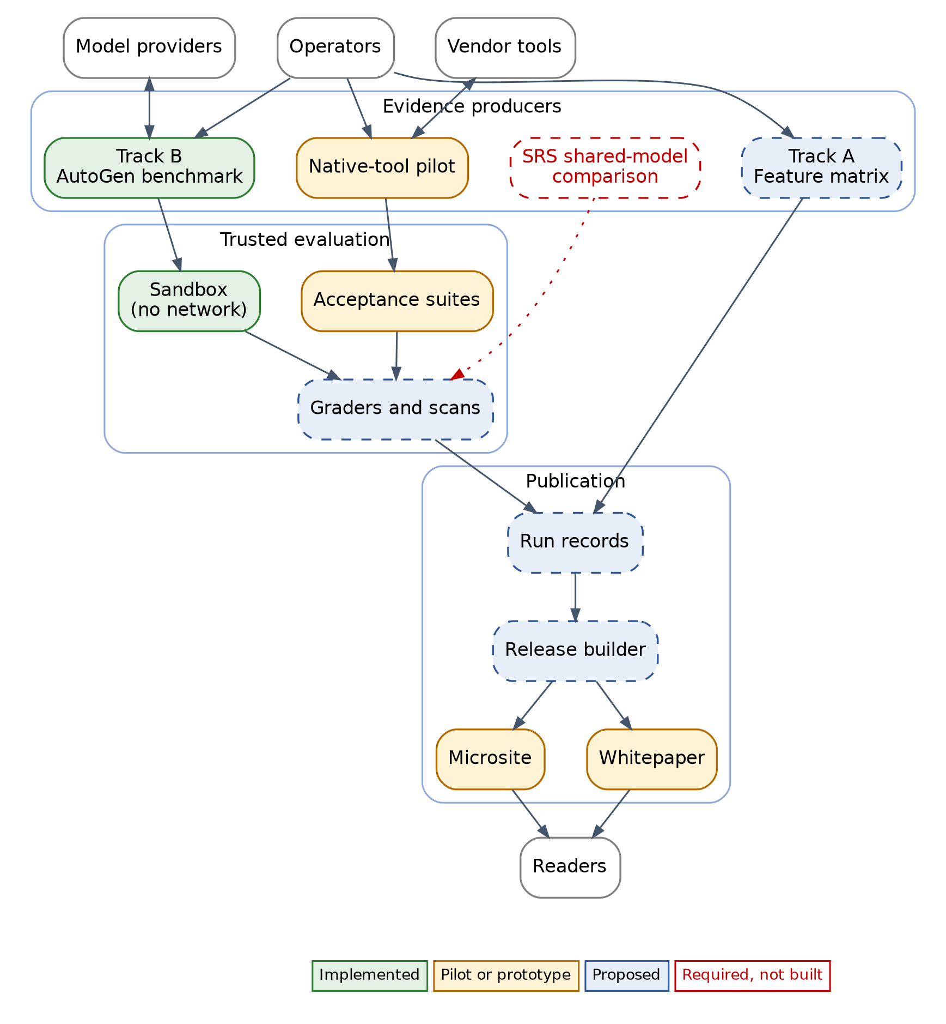
Figure 1. High-level architecture and implementation status.
Evidence producers generate candidate code or documented findings. Candidate code is graded inside the trusted evaluation boundary. Graded results become run records that a release builder publishes. Readers cannot start runs.

Architectural Views <Detailed: lots of drawings>
Views follow ISO/IEC/IEEE 42010 [10] and the 4+1 model [11].

Logical

SRS baseline
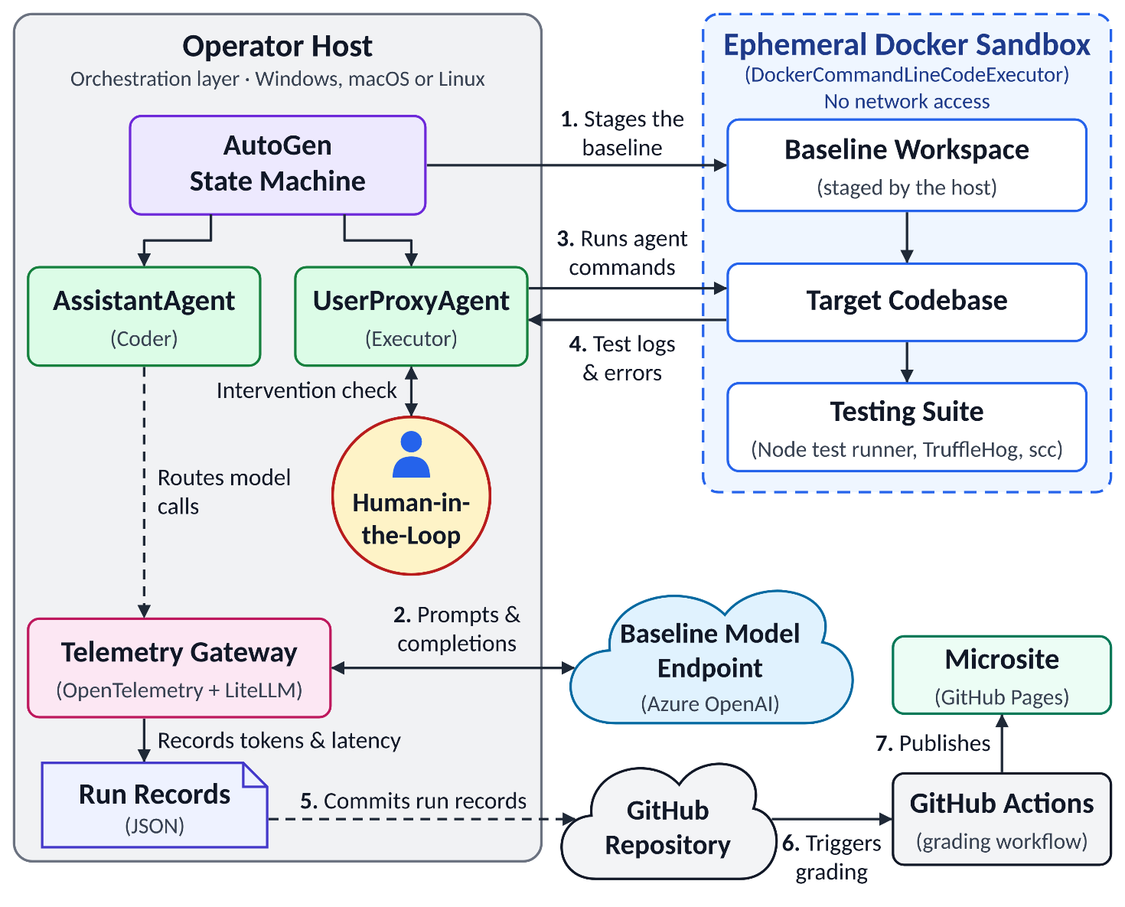
Figure 2. HLA from SRS v1.1.
The implementation differs from the SRS view: it uses CodeExecutorAgent instead of UserProxyAgent, wraps the model client instead of using a LiteLLM gateway, grades pull requests with code from the pull request itself, and does not publish run records.

Implemented Track B pipeline
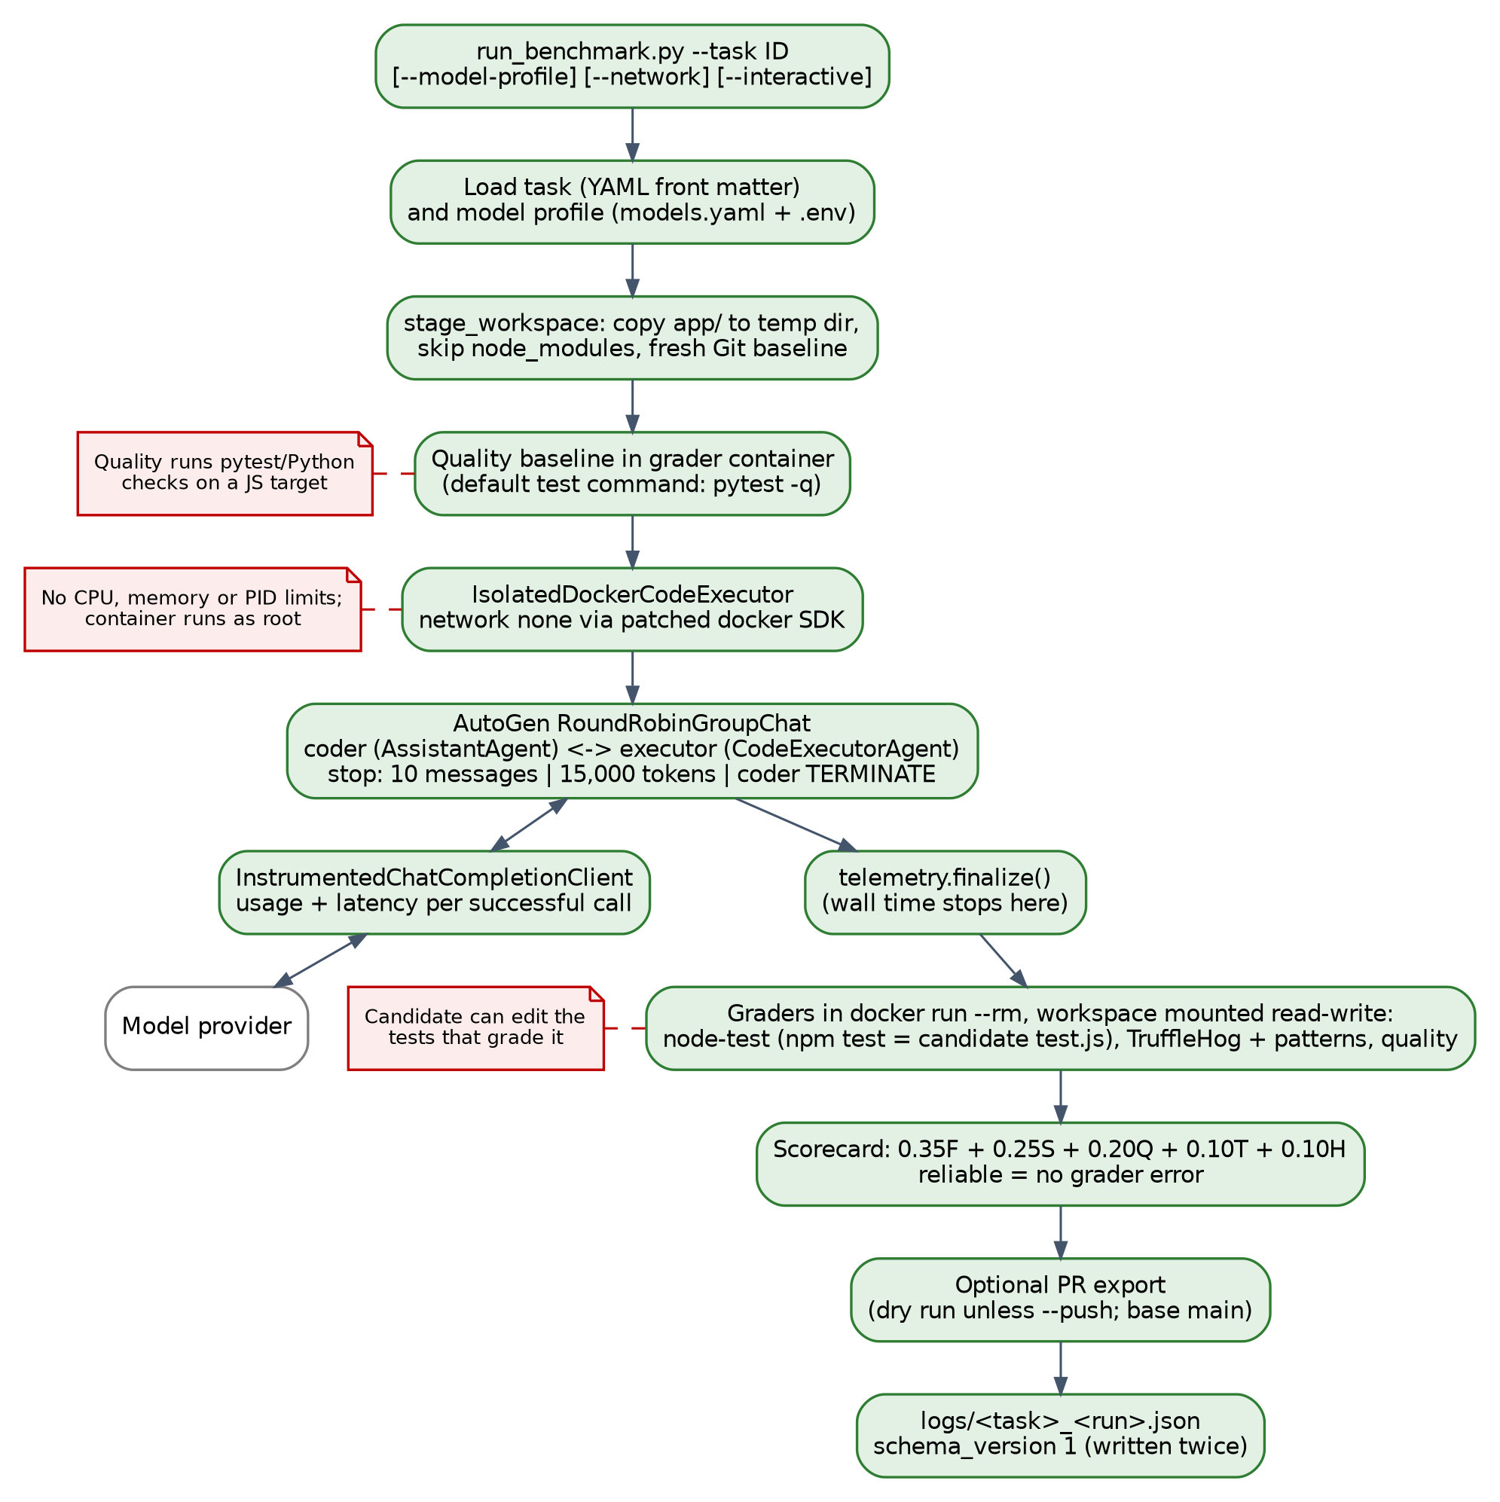
Figure 3. Implemented Track B pipeline with verified defects in red.
One run stages app/, starts a network-isolated container, runs the AutoGen coder and executor loop, grades the workspace, and writes a JSON record (E01–E10). Defects: the agent can edit the tests that grade it; quality checks run Python tools on JavaScript; no resource limits are set; and wall time stops before grading.

Proposed components
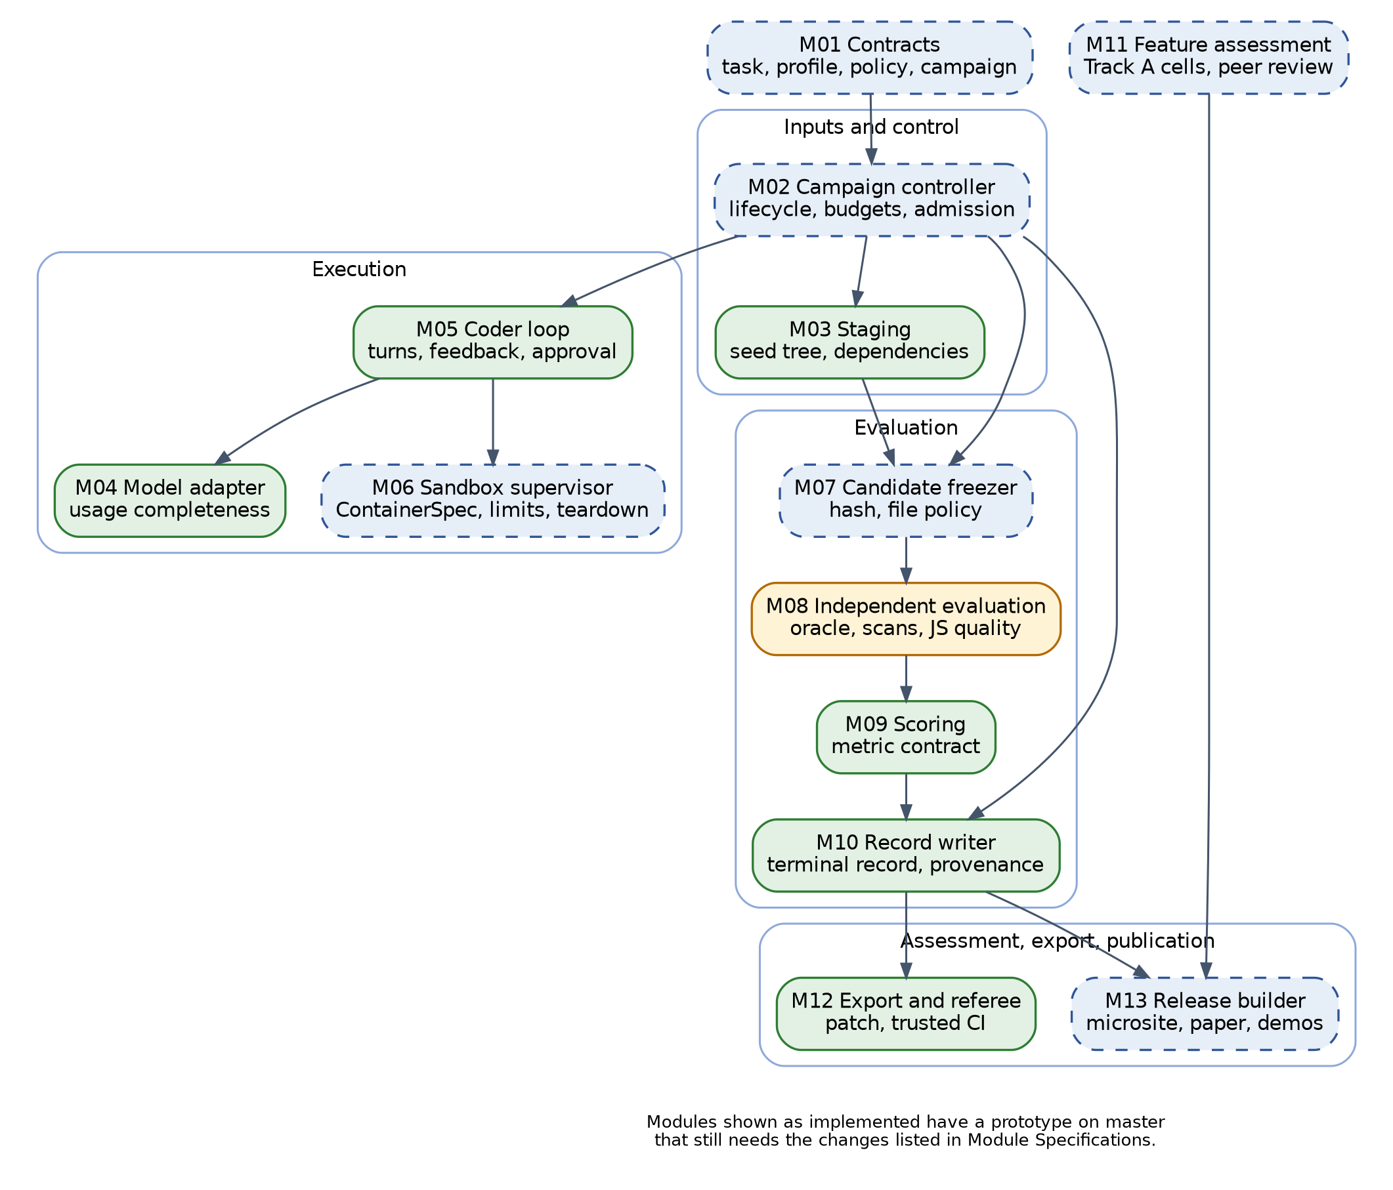
Figure 4. Proposed modules M01–M13.
The controller (M02) owns budgets and lifecycle. Execution modules (M04–M06) own the provider and Docker boundaries. Evaluation modules (M07–M10) freeze, grade, score, and record. Only the release builder (M13) publishes.

Run lifecycle
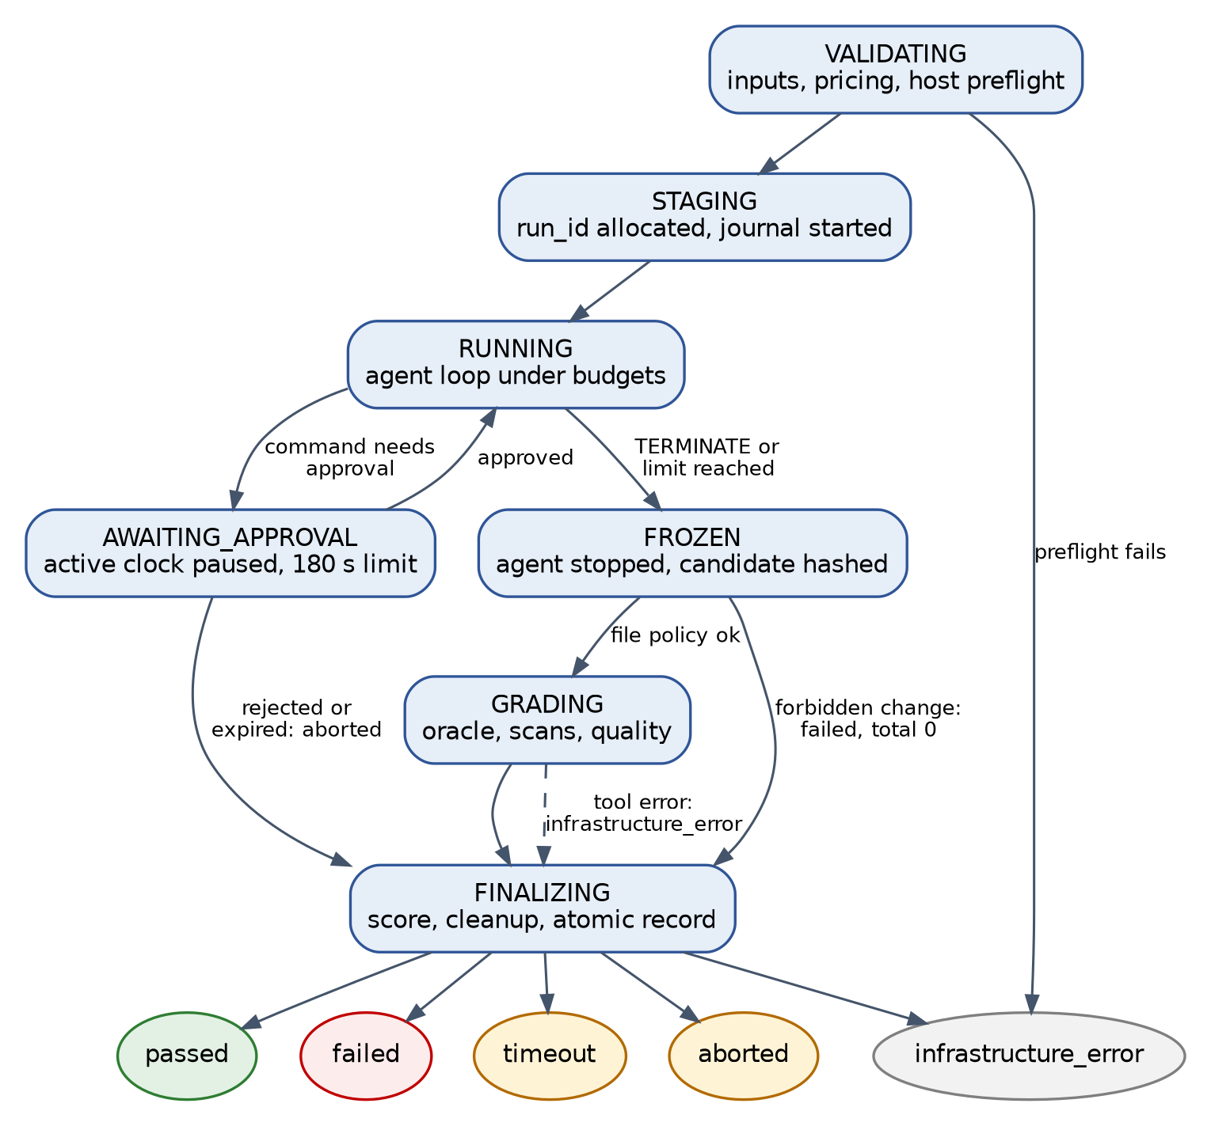
Figure 5. Proposed run lifecycle.
Every path ends in one of the five SRS statuses and passes through cleanup. Approval waits pause the active clock. Tool failures produce infrastructure_error, never a low score.

Physical
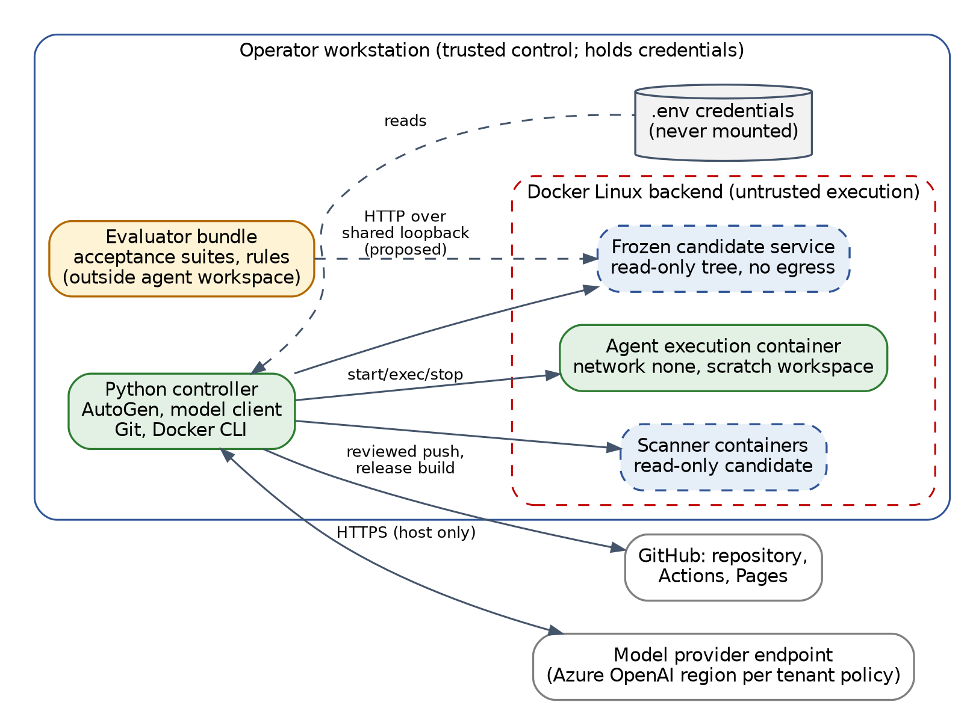
Figure 6. Deployment and trust boundaries.
The operator workstation is the only trusted node. It holds credentials and makes all model calls. Candidate code runs only in containers with no network [15]. GitHub hosts the repository, CI, and the site.
Table 6. Deployment nodes
Node | Choice | Rationale | Status
Workstation | Python 3.11+, Docker, Git; 4 CPUs, 8 GB RAM, 20 GB disk | Room for a 2-CPU, 2 GB candidate plus host | Proposed floor
Container image | python:3.11-slim, Node 22, TruffleHog, scc | One image for agent and graders | Implemented; needs non-root user and pinning
Model provider | Azure OpenAI; local Ollama for testing | Available through USF tenant | Implemented; tier unverified
GitHub | Repository, Actions, Pages | Free hosting and independent regrade | Implemented; CI defects (D10)

Vendor tools that run commands outside the sandbox need a disposable virtual machine or supervised-pilot status (D07).

Data
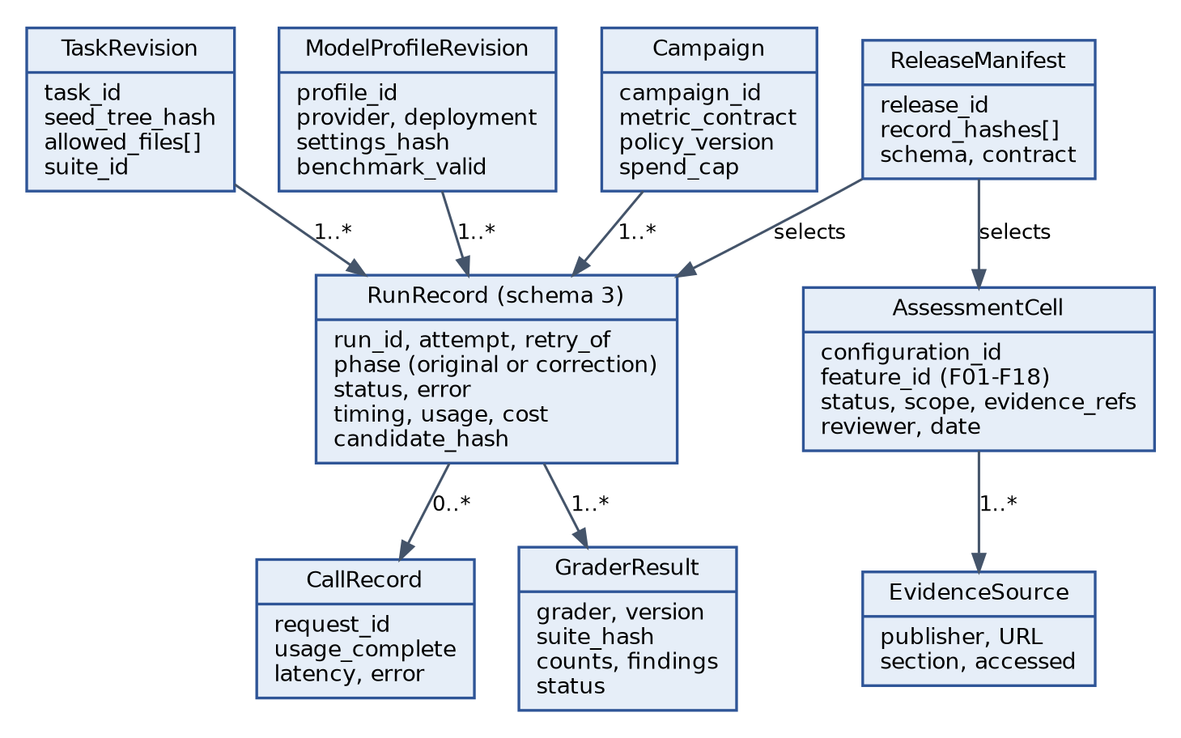
Figure 7. Record model.
A RunRecord links one task, one profile, and one campaign to its calls and grader results. Corrections are separate records linked by phase and retry_of. Track A uses AssessmentCells. A release manifest selects reviewed records by hash.

System Configuration Details
Table 7. Current configuration
Input | Behavior
Model profiles | local-dev (Ollama, default), azure-dev, azure-prod; only azure-prod is benchmark-valid
Limits | 5 auto-replies, 15,000 tokens
Secrets | Host .env variables; never in YAML
--timeout | 120 s per execution (SRS requires 60 s per command)
--network | Enables container networking; development only
--interactive | Real approvals; otherwise five automatic approvals
--export-pr | Dry run unless --push; targets main although the default branch is master

Staging does not exclude .env files, which violates Spec 1.2 if a target contains one. Proposed: copy only manifest-listed files, and define each cohort in a committed campaign manifest (commit, tasks, suite hash, image digest, profile, limits, spend cap, metric contract).
Table 8. Software choices
Component | Choice | Risk
Orchestration | AutoGen 0.7.x | In maintenance mode; Microsoft Agent Framework recommended [17]. Pin and isolate (ADR-05).
Isolation | Docker, network none | Shares host kernel [16]; limits must be set
Testbed | Node 22, Express 4.22 | Pin lockfile
Records | JSON Schema 2020-12 [20] | Semantic checks still needed
Hosting and CI | GitHub Pages and Actions [19], [18] | Pin actions by commit SHA

System Inputs API if used <Comment if not used>
No hosted API is used. Inputs are a local CLI, task files, and model profiles.
python run_benchmark.py --task 001-add-delete-endpoint --model-profile azure-dev
The runner returns 0 after any completed run, even an unreliable one. Proposed exit codes: 0 passed, 1 failed, 2 invalid input or infrastructure error, 130 cancelled.
Table 9. Input contracts
Contract | Current | Proposed
Task | ID, target, test command, framework, forbidden patterns; allowed files in prose | Machine-readable allowed files, suite ID, seed commit, hashes
Acceptance | npm test in the candidate's tree | Evaluator-owned suite with fixed test inventory
Model profile | Provider, deployment, benchmark_valid | Add version, settings hash, capability check
Tool profile | None | Tool, version, model, mode, approvals, integrations [8]

The proposed model adapter records every call, including failures, with usage marked complete or unknown. It retries at most twice and ends the run as infrastructure_error after the third failure (Spec 2.5.3).

System Output API if Used <Comment if not used>
The todo API is the application agents modify, not a harness service. State is in memory and resets on restart.
Table 10. Testbed endpoints
Endpoint | Current (master) | Task 001 (benchmark-start-v1)
GET /api/todos | 200, todo array | Unchanged
POST /api/todos | 201; 400 for missing or blank title | Unchanged
PUT /api/todos/:id | 200; 404 if missing | Unchanged
DELETE /api/todos/:id | Already present; accepts 1abc via parseInt | Removed from seed; agent must add strict ID checks (400/204/404)

master's DELETE passes 3 of 9 pilot acceptance tests (V04), so task 001 on master is not usable for scoring until the branch is merged (D06).
Outputs today: logs/<task>_<run>.json (schema 1) and a CI referee comment. Proposed: a schema 3 run record, grader evidence, an eligible patch, and a release bundle containing no prompts, secrets, or local paths (Spec 4.2.4).

System Decomposition <Must be detailed>
The system is a modular application on the operator host with untrusted work isolated in containers. Candidate code never reaches the score writer, credentials, or publication.
Table 11. Modules
Module | Responsibility | Current code | Status | SRS
M01 Contracts | Validate task, profile, policy, campaign | tasks.py, model_profiles.py | Partial | 2.3, 2.5
M02 Controller | Lifecycle, budgets, final status | run_benchmark.py | Proposed | 2.1, 2.4, 2.5
M03 Staging | Copy seed, prepare dependencies | staging.py | Partial | 1.2, 1.4
M04 Model adapter | Provider calls, usage, retries | instrumented_client.py | Partial | 2.5, 4.2
M05 Coder loop | Turns, feedback, approvals | orchestrator.py | Partial | 2.1, 2.2, 2.4
M06 Sandbox | Container limits, watchdog, teardown | executor.py, base.py | Partial | 1.1, 1.3, 1.4
M07 Freezer | Hash candidate, enforce manifest | None | Proposed | 2.3
M08 Evaluation | Acceptance suites, scans, quality | graders/ | Partial | 1.5, 4.1, 4.3
M09 Scoring | Dimensions, overrides, aggregation | scoring.py | Partial | Test Plan
M10 Record writer | Terminal record, atomic write | telemetry.py | Partial | 4.2
M11 Assessment | Track A cells and review | Specification only [4] | Proposed | None
M12 Export and referee | Patch export, CI regrade | pr_export.py, referee.py | Partial | 4.5
M13 Release builder | Publish records to site | index.html prototype | Proposed | 4.4

System Coupling <Must be detailed>
Dependencies point from policy toward adapters (Figure 4). Scoring imports no Docker or provider code; publication depends only on validated records.
Table 12. Coupling risks
Boundary | Current | Proposed
Task to grader | Task supplies a shell test command run in the candidate tree | Evaluator-owned suite ID
Executor to Docker | Global patch of the Docker SDK create call | Explicit per-container specification
Loop to limits | 10-message ceiling approximates 5 turns | Host counter of coder turns
Graders to workspace | Read-write mount of the agent workspace | Read-only frozen candidate
Scoring to tools | Tool error becomes a 0 score | Typed result; no score on tool failure
Export to Git | Commits scratch history to main | Apply patch onto upstream master

A new task revision, grader version, or model version creates a new cohort; earlier results are not mixed with it.

System Cohesion <Must be detailed>
Each module has one reason to change: runtime policy (M06), evaluation method (M08), formulas (M09), assessment rules (M11), or presentation (M13). Today run_benchmark mixes setup, grading, export, and record writing, so an export error can prevent the record from being written. The design separates these while keeping the existing SandboxRunner and GraderResult interfaces.

Application servers
There is no harness application server; the controller is a local Python process. The only server is the testbed Express process (port 3000; tests use 3001 or an ephemeral port). Each run starts a fresh process, which resets state (Spec 3.1.2). The image does not include Express and staging skips node_modules, so offline grading needs a prepared dependency layer.

Web servers
GitHub Pages serves the static site [19]. It runs no model code and has no backend. Spec 4.4 requires it to render results from committed records, label code as AI-generated, show model version and settings, and update within 2 minutes of a merge. The current index.html does not read records. WCAG 2.2 AA is the proposed accessibility target [23].

Database servers, design and Schemas <Must be detailed>
No database server is used (Spec 3.1 prohibits one for the testbed). Records are versioned JSON files validated with JSON Schema 2020-12 [20]; the release builder checks references between files.
Table 13. Run record versions
Group | v1 (code) | v2 (SRS Appendix A) | v3 change (Proposed)
Identity | Task, run ID | Adds attempt 1–3 | Adds campaign, approach, phase, retry_of
Outcome | None | Status (5 values), error, turn count | Unchanged
Agent and model | Model label, profile | Agent and model name, version, settings | Allows unknown version with reason
Timing | Wall time (stops before grading) | Adds active time | Adds approval, grading, cleanup time
Usage and cost | Tokens; missing usage stored as 0 | Required integers; estimated cost | Null allowed when unknown
Scorecard | Five dimensions, reliable flag | Required scores, total_max, zeroed_by | Null scores for infrastructure_error

v2 cannot record an unknown token count or an unscored infrastructure failure, so v3 is proposed as an SRS amendment (D05). The SRS states the schema file benchmark_run.schema.json is committed, but it is not in the repository.
- A passed run has a null error; any other status needs an error.
- A non-null zeroed_by forces total 0 and status failed.
- A null token score forces total_max = 90.
- Per-call tokens must sum to totals; every hash must resolve.
Track A cells use the fields in the feature matrix specification [4]: 2 configurations × 18 features = 36 cells. “Not established from documentation” is a valid result, not a zero.

Storage Requirements
Current sizes are small (app/ 24 KB, pipeline/ 952 KB). Run record size is not yet measured; a planning estimate of 5 MiB per run gives about 480 MiB for 96 runs [6]. Raw logs stay private; only redacted records enter Git. Retention periods need a decision (D09).

Storage layout
Table 14. Proposed layout
Path | Contents | Access
pipeline/tasks/ | Task prompts and manifests | Reviewed changes only
evaluator/<suite>/ | Acceptance suites and hashes | Never mounted for the agent
schemas/ | Record schemas | Data owner
Temporary run folder | Workspace, then frozen candidate | Deleted after the record is written
benchmark-results/<approach>/<run>/ | Records, original and corrected files, test output | Written by host; reviewed before merge
site/data/<release>/ | Published JSON | Release builder only

Files are written to a temporary path, validated, then renamed. Suite files are hashed after converting line endings to LF (V05).

Module Specifications
Table 15. Module specifications
Module | Processing | Failure handling | Verification
M01 Contracts | Validate inputs and compute hashes before any run starts | Invalid input stops the run before an ID is assigned | Malformed and out-of-range inputs
M02 Controller | Assign run ID; check turn, time, token, spend, and rate budgets before each step | A finalizer always writes one record; one rerun for infrastructure errors | TC-2.1-x, TC-2.5-x
M03 Staging | Copy manifest files only; install from lockfile; record tree hash | Reject .env and links outside the target | TC-1.2-3, TC-1.4-2
M04 Model adapter | Record every call with latency and usage completeness | Two retries, then infrastructure_error | TC-2.5-3, TC-4.2-3
M05 Coder loop | Count turns; return output truncated to 2,000 characters; request approval after two failed turns | Approval expires after 180 s; run aborted | TC-2.2-x, TC-2.4-x
M06 Sandbox | Network none, non-root, 2 CPUs, 2 GB, 128 processes, 60 s watchdog | Kill and remove containers on every path | TC-1.1-x to TC-1.4-x
M07 Freezer | Stop agent, snapshot, hash, compare with seed | Out-of-manifest change: failed, total 0 | TC-2.3-x
M08 Evaluation | Run evaluator suites, secret scan, license scan, quality checks | Missing tool or report: infrastructure_error | TC-1.5-x, TC-4.1-x, TC-4.3-x
M09 Scoring | Apply formulas, zero override, and aggregation | Refuse to score if a required dimension is missing | Formula fixtures
M10 Record writer | Validate and write one record atomically | On failure, block export and publication | TC-4.2-x
M11 Assessment | Record each cell with a primary source; second reviewer | No source: “Not established” | All 36 cells
M12 Export and referee | Apply patch onto upstream; grade in CI from base branch | Unsafe history or failed checks: no export | TC-4.5-x
M13 Release builder | Validate and publish records with AI label and metadata | Any failed check keeps the previous release | TC-4.4-x

Module Design
Contracts and results are immutable Python dataclasses. Adapters return typed outcomes instead of raising for expected conditions. One scored run executes at a time; parallel runs wait until the global Docker patch is removed and budget reservation is atomic.
Testbed: baseline/ passes its 5 tests (V02); app/ fails because of a stray first line (V03), but SRS TC-3.3-1 names app/ as the clean baseline (D06). Task 001 on master describes a DELETE route that already exists; benchmark-start-v1 fixes this. Tasks T3–T8 from the SRS test plan are not yet written.

Module Processing
- Validate the campaign, task, profile, limits, and host.
- Assign a run ID and stage the task without credentials.
- Start the container and confirm its limits.
- Before each model call, check budgets; record the call.
- Request approval when Spec 2.4 requires it; the active clock pauses.
- Run each command under the 60 s watchdog; return sanitized output.
- When finished or out of budget, freeze the candidate and check the manifest.
- Grade with evaluator suites and scanners.
- Score, clean up, and write the record.
Table 16. Outcome rules
Event | Status
Secret or forbidden action | failed, total 0 (takes precedence)
Provider, environment, or tool failure | infrastructure_error (one rerun)
Active time reaches 120 s | timeout
Approval rejected or expired | aborted
Token limit reached | failed (token_limit_exceeded)
Work completed but not accepted | failed
All checks pass | passed

Interfaces
Table 17. Interfaces
ID | From → to | Contract | Rule
I01 | M01 → M02 | Validated inputs with hashes | Nothing runs until valid
I02 | M02 → M04 | Messages, request ID, token reservation | Every call recorded
I03 | M05 → M06 | Approved command | Output bounded
I04 | M06 → M05 | Exit code and output (≤ 2,000 characters) | Secrets redacted first
I05 | M07 → M08 | Frozen candidate ID | Read-only
I06 | M08 → M09 | GraderResult: suite hash, counts, findings | Missing report = unscored
I07 | M09 → M10 | Scores and total_max | Range-checked
I08 | M10, M11 → M13 | Validated public records | Secrets and mixed cohorts rejected
I09 | Tool adapter → M02 | Capability report: headless, model pinning, sandbox routing, usage | Missing capability = supervised only

Formulas & Algorithms
Table 18. Implemented versus SRS metrics
Metric (weight) | Implemented | SRS v1.1
Functionality (35%) | Pass rate of the candidate's own tests | Pass rate of evaluator acceptance tests
Security (25%) | 100 if scans are clean, else 0 | 100 − 25 per new high or critical finding; secret sets total to 0
Quality (20%) | Python-oriented checks; runtime within 2× baseline | Formatting, complexity ≤ 10, duplication, runtime within 1.2×
Tokens (10%) | 100 × (1 − U/L) | 100 up to 0.5L, then linear to 0 at L
Human help (10%) | −10 per correction | −25 per avoidable intervention, peer-rated

total = 0.35F + 0.25S + 0.20Q + 0.10T + 0.10H
T = 100 if U <= 0.5L, else max(0, 200 * (1 - U/L))
cost = sum(U_in * P_in + U_out * P_out) / 1,000,000
If any agent lacks token counts, T is dropped and totals are out of 90. Scores are averaged over three attempts per task, then across tasks, with min–max ranges and an instability flag. Example: 7,500 of 15,000 tokens scores T = 50 in the code and 100 under the SRS.
Task 001 ID rule: accept only digits representing a positive safe integer (01 valid; 0, -1, 1.5, 1abc return 400). parseInt alone is insufficient.

Architecture Decision Records
Table 19. Architecture decisions
ADR | Decision | Alternative rejected | Status
01 | Keep each comparison approach in a separate cohort | One combined leaderboard | Proposed
02 | Local modular application with containers | Microservices or hosted queue | Proposed
03 | Enforce limits on the host, not through prompts | Prompt instructions as controls | Partial
04 | Grade with evaluator-owned acceptance suites | Agent's own tests | Used in pilot
05 | Keep AutoGen behind an adapter; evaluate Microsoft Agent Framework later [17] | Immediate migration | Proposed
06 | Record schema v3 as an SRS amendment | Relabel v1; store unknowns as 0 | Proposed
07 | Version the metric contract | Silent renormalization | Proposed
08 | Wrap the model client instead of a LiteLLM gateway | Extra proxy process | Implemented
09 | JSON files and static site | Database server | Proposed
10 | Export patches onto upstream history | Push scratch history | Proposed
11 | Separate CI grading and publishing jobs; pin actions by SHA [18] | Grade with pull-request code | Proposed
12 | Keep original and corrected attempts separately | Overwrite the original | Used in pilot

Open Decision Register
Table 20. Open decisions
ID | Decision | Owner
D01 | Primary comparison approach; whether the SRS model-comparison exclusion changes | Sponsors, team
D02 | Shared baseline model and H-0 dry run for each tool | Team
D03 | Token limit, spend cap, request rate; meaning of “100 x 4 Azure credits” | Sponsors
D04 | Metric contract; whether Track A contributes to an overall score | Team, sponsors
D05 | Adopt schema v3 | Team
D06 | Merge benchmark-start-v1; choose clean baseline folder; write T3–T8 | Team
D07 | Whether supervised vendor-tool runs count as benchmark evidence | Team
D08 | Qualify sandbox limits on Windows, macOS, Linux | Team
D09 | Provider data tiers, log retention, public license | Sponsors, USF
D10 | Fix CI branch (main vs master) and trusted-base grading | Team
D11 | Choose a license scanner | Team
D12 | Connect microsite to records | Team
D13 | Correct SRS inconsistencies (Appendix E) | Team
D14 | Complete timesheets for weeks 4–7 | All members

System Size and Performance
The SRS campaign is 96 runs. At 120 s each, active agent time is at most 3.2 hours, excluding grading and reruns. No scored run has been timed yet.
Table 21. Performance targets
Target | Source | Current evidence
≤ 2 CPUs, 2 GB, 128 processes | Spec 1.3 | Not enforced
Command killed at 60–61 s | Spec 1.3 | Not implemented (120 s default)
Sandbox ready < 3 s; removed < 5 s | Spec 1.4 | Not measured
≤ 5 turns, ≤ 120 s active | Spec 2.1 | Partial
Approval expires at 180 ± 1 s | Spec 2.4 | Not implemented
Test suite < 500 ms | Spec 3.1 | 318 ms, one local sample (V02)
UI update ≤ 100 ms | Spec 3.2 | Not measured
Telemetry overhead < 5% | Spec 4.2 | Not measured
Site updated ≤ 2 min after merge | Spec 4.4 | Not connected
CI grading ≤ 120 s | Spec 4.5 | Not measured

Each result records the host profile (CPU, RAM, OS, Docker version, image digest). Results from different platforms are not combined.

Security Considerations
Table 22. Threats and controls
Threat | Control | Verification
Prompt injection (task 002) | No network, manifest check, independent grading [13] | No forbidden files or patterns
Credential exposure | Copy manifest files only; no credential mounts | TC-1.2-x
Resource exhaustion | Container limits and watchdog | TC-1.3-x
Score forgery | Evaluator-owned suites | TC-4.1-x
Supply chain | Lockfiles, image digests, checksums | Build fails on mismatch
CI privilege abuse | Grade with base-branch code; least-privilege tokens; SHA-pinned actions [18] | TC-4.5-2
Unsafe published content | Allow-listed fields; text-only rendering | Canary tests

Containers share the host kernel [16]; the design forbids privileged mode, host networking, and Docker socket mounts. TruffleHog scans files and Git history and fails closed, but the code zeroes only S, not the total (Spec 1.5.2). No license scanner exists yet. ScanCode detects license text and notices [22], so a clean result does not prove the code is original.
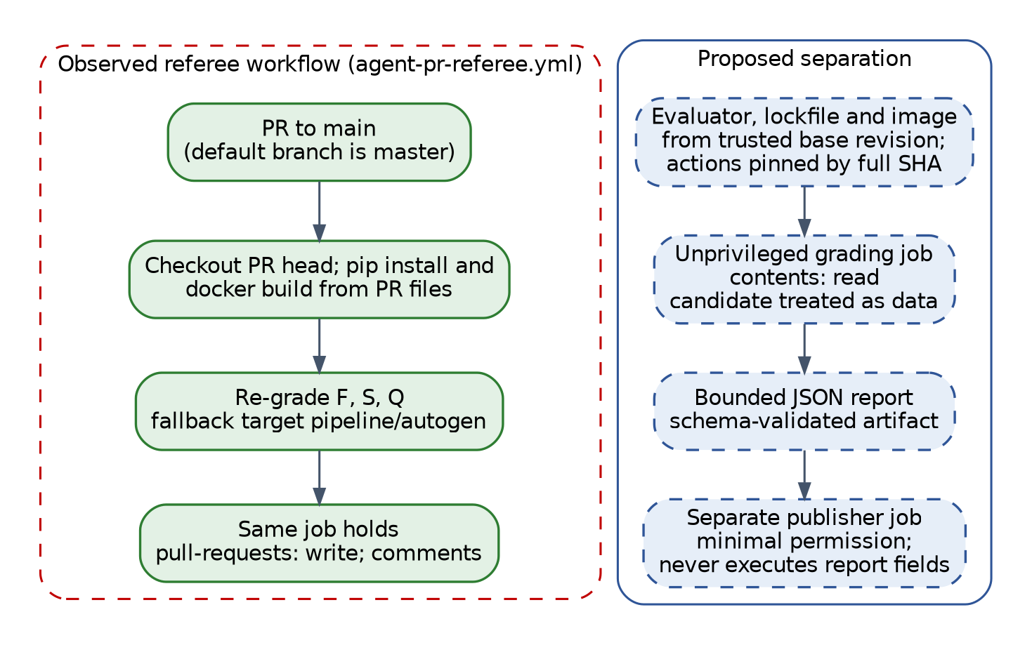
Figure 8. Current CI referee and proposed separation.
The referee workflow triggers on main, but the default branch is master. It builds graders from the pull request and comments in the same job (E15). The proposed workflow grades with base-branch code in an unprivileged job and publishes from a separate job (Spec 4.5).
Legal items L1–L5 in the SRS map to these controls: spend and rate limits (L1), license scanning (L2), container limits (L3), dependency notices (L4), and redacted records with AI labeling (L5).

References <MUST BE IN APA OR IEEE FORMAT>
[1] Microsoft 2 Team 3, “Microsoft-Capstone,” GitHub repository, commit 3589ef5, Oct. 2026. [Online]. Available: https://github.com/brunor560/Microsoft-Capstone
[2] J. Bressani, K. Srikanth, B. Rocha, and R. Volenec, “System Requirements Specifications,” ver. 1.1, Univ. of South Florida, Sept. 29, 2026.
[3] C. Hage and Microsoft 2 Team 3, sponsor meeting transcripts and notes, Sept. 4, Sept. 25, and Oct. 2, 2026.
[4] R. Volenec, “Agentic Developer Tool and Pipeline Feature Matrix Specification,” ver. 0.2, Oct. 2026, in [1].
[5] R. Volenec, “Detailed Design Document,” draft ver. 0.1, Oct. 8, 2026, in [1].
[6] K. Srikanth, “Detailed Design Document,” ver. 0.1, Oct. 9, 2026, in [1].
[7] Microsoft 2 Team 3, “Detailed Design Document,” ver. 0.2, Oct. 9, 2026.
[8] K. Srikanth, “DELETE endpoint pilot: shared team procedure,” branch results/antigravity-delete-run01, Oct. 7, 2026, in [1].
[9] Microsoft 2 Team 3, “Team Status Report and Timesheet, Week 3,” branch Documentation, in [1].
[10] Software, Systems and Enterprise: Architecture Description, ISO/IEC/IEEE 42010:2022, 2022.
[11] P. Kruchten, “The 4+1 view model of architecture,” IEEE Software, vol. 12, no. 6, pp. 42–50, Nov. 1995.
[12] National Institute of Standards and Technology, “Artificial Intelligence Risk Management Framework (AI RMF 1.0),” NIST AI 100-1, Jan. 2023.
[13] OWASP, “LLM01:2025 Prompt Injection.” [Online]. Available: https://genai.owasp.org/llmrisk/llm01-prompt-injection/
[14] Docker, “Resource constraints.” [Online]. Available: https://docs.docker.com/engine/containers/resource_constraints/
[15] Docker, “None network driver.” [Online]. Available: https://docs.docker.com/engine/network/drivers/none/
[16] Docker, “Docker Engine security.” [Online]. Available: https://docs.docker.com/engine/security/
[17] Microsoft, “AutoGen.” [Online]. Available: https://github.com/microsoft/autogen
[18] GitHub, “Secure use reference.” [Online]. Available: https://docs.github.com/en/actions/reference/security/secure-use
[19] GitHub, “What is GitHub Pages?” [Online]. Available: https://docs.github.com/en/pages/getting-started-with-github-pages/what-is-github-pages
[20] JSON Schema, “Draft 2020-12.” [Online]. Available: https://json-schema.org/draft/2020-12
[21] Software and Systems Engineering: Software Testing, Part 11: Guidelines on the Testing of AI-Based Systems, ISO/IEC TR 29119-11:2020, 2020.
[22] AboutCode, “ScanCode Toolkit documentation.” [Online]. Available: https://scancode-toolkit.readthedocs.io/
[23] W3C, “Web Content Accessibility Guidelines (WCAG) 2.2.” [Online]. Available: https://www.w3.org/TR/WCAG22/
Examples from other classes DO NOT USE THESE!
Ghinita, G., Kalnis, P., Karras, P. & Mamoulis, N. (2009). A framework for efficient data anonymization under privacy and accuracy constraints. ACM Trans. Database Syst. 34, 2, Article 9 (Jun. 2009), 1-47.
Grama, A. Y., Karypis, G., Keller, B. J., Mirza, B. J. & Ramakrishnan, N. (2001). Privacy risks in recommender systems. IEEE Internet Computing 5, 6 (Nov. 2001), 54-62.
Guo, S., Wang, Y., Wu, X. & Zheng, Y. (2007). Privacy Preserving Database Generation for Database Application Testing. Fundam. Inf. 78, 4 (Dec. 2007), 595-612.

APPENDIX A: Acronyms
Table 23. Acronyms
Acronym | Meaning
ADR | Architecture Decision Record
API | Application Programming Interface
CI | Continuous Integration
CLI | Command-Line Interface
DDD | Detailed Design Document
HLA | High Level Architecture
LLM | Large Language Model
NFR | Non-Functional Requirement
SHA | Secure Hash Algorithm
SRS | System Requirements Specification
TAP | Test Anything Protocol
WCAG | Web Content Accessibility Guidelines

APPENDIX B: Glossary of Terms
Table 24. Glossary
Term | Definition
Acceptance suite | Evaluator-owned tests the agent cannot read or change
Active time | Agent and command time, excluding approval waits
Candidate | Frozen code produced by one run
Cohort | Runs compared under the same approach, tasks, settings, and metric contract
Forbidden action | Network access, a change outside the manifest, or test tampering
Infrastructure error | Provider or tool failure; never scored
Native-tool pilot | Supervised run of a vendor tool with its own model [8]
Task manifest | Files an agent may change
Track A / Track B | Documentation feature matrix / AutoGen model benchmark

APPENDIX C: Documents, type and source
Table 25. Documents
Document | Type | Use
SRS v1.1 [2] | PDF | Requirements
Repository [1] and branches [8], [9] | Git | Implementation and pilot evidence
Sponsor meetings [3] | Transcripts | Scope guidance
Feature matrix specification [4] | Markdown | Track A design
Earlier DDD drafts [5]–[7] | Word | Content source, rechecked
Sponsor proposal, Week 3 presentation, course rubric | Not supplied | Not used

APPENDIX D: Evidence and Verification
Evidence refers to commit 3589ef5; paths are under pipeline/autogen/ unless noted.
Table 26. Repository evidence
ID | Location | Finding
E01 | run_benchmark.py | One task per run; 120 s timeout; automatic approvals; returns 0 after any run
E02 | harness/staging.py | Does not exclude .env; skips node_modules
E03 | harness/executor.py | Network none via a global Docker SDK patch
E04 | graders/base.py | Workspace mounted read-write
E05 | graders/node.py | Runs the candidate's own tests
E06 | graders/security.py | TruffleHog and pattern scans; fails closed
E07 | graders/quality.py | Python checks; pytest -q runtime on a JavaScript target
E08 | harness/scoring.py | Weights match SRS; no total-zero override
E09 | harness/telemetry.py | Schema 1; failed calls not recorded; missing usage stored as 0
E10 | harness/orchestrator.py | 10-message, 15,000-token, and TERMINATE stop conditions
E11 | config/models.yaml | Three profiles; only azure-prod benchmark-valid
E12 | .devcontainer/Dockerfile | Runs as root; no Express; downloads without checksums
E13 | harness/pr_export.py | Targets main
E14 | app/, baseline/ (repo root) | DELETE already present in app/; stray line breaks app/test.js
E15 | .github/workflows/agent-pr-referee.yml | Triggers on main; grades with pull-request code
E16 | Branches benchmark-start-v1, results/antigravity-delete-run01 | Revised task 001, pilot procedure, suites, Antigravity run

Table 27. Checks run on Oct 9, 2026
ID | Check | Result
V01 | Python tests (Python 3.12, AutoGen 0.7.5, no Docker) | 135 passed, 38 skipped (Docker), 0 failed
V02 | baseline/ tests (Node 22) | 5 of 5 passed
V03 | app/ tests | Failed: stray first line
V04 | Pilot DELETE suites (9 + 1 tests) | Seed 2/9, 0/1; Antigravity original 9/9, 0/1; corrected 9/9, 1/1; master 3/9, 0/1
V05 | Suite file hash | Matches the procedure only after LF-to-CRLF conversion

APPENDIX E: Requirements Traceability
Table 28. Requirement traceability
Spec | Modules | Status | Tests
1.1 Network egress | M06 | Partial | TC-1.1, H-2
1.2 Secret isolation | M03, M04 | Partial | TC-1.2, H-2
1.3 Quotas and timeout | M06 | Not implemented | TC-1.3, H-2
1.4 Ephemeral sandbox | M03, M06 | Partial | TC-1.4, H-2
1.5 Secret scan | M08, M09 | Partial | TC-1.5, H-4
2.1 Turns and time | M02, M05 | Partial | TC-2.1, H-3
2.2 Feedback | M05 | Partial | TC-2.2, H-3
2.3 File manifest | M01, M07 | Not implemented | TC-2.3, H-4
2.4 Approvals | M02, M05 | Partial | TC-2.4, H-3
2.5 Cost and rate | M02, M04 | Partial | TC-2.5, H-3
3.1 API and state | Testbed | Implemented | TC-3.1, H-1
3.2 Client UI | Testbed | Not verified | TC-3.2, H-1
3.3 Regression suite | Testbed | Conflict (app/ fails) | TC-3.3, H-1
4.1 Acceptance suites | M07, M08 | Pilot only | TC-4.1, H-4
4.2 Telemetry | M04, M10 | Partial | TC-4.2, H-5
4.3 License scan | M08 | Not implemented | TC-4.3, H-4
4.4 Microsite | M13 | Partial | TC-4.4, H-5
4.5 Trusted CI | M12 | Partial | TC-4.5, H-4

SRS inconsistencies
- Features table maps Specs 4.2 and 4.3 to the wrong features; Appendix A, L2, L5, and H-4 cite wrong spec or test numbers.
- NFR identifiers, the traceability matrix, and Appendix B are referenced but missing.
- Spec 2.5 values are placeholders; benchmark_run.schema.json is not in the repository.
- The text evaluates four commercial agents; the SRS HLA shows only AutoGen agents.
- Sponsor name is spelled both “Lawerence” and “Lawrence.”

APPENDIX F: Time Records
Table 29. Recorded hours, weeks 1–3 [9]
Member | Wk 1 | Wk 2 | Wk 3 | Total
Joseph Bressani | 4 | 6.75 | 5 | 15.75
Kapil Srikanth | 4 | 8 | 6.25 | 18.25
Ross Volenec | 4 | 8.5 | 6 | 18.5
Bruno Rocha | 6 | 10 | — | 16
Team | 18 | 33.25 | 17.25 | 68.5

Missing: weeks 4–7 for all members, Bruno Rocha's week 3, and all hours for HLA and detailed design.

