  - University of South Florida
Bellini College of AI, Cybersecurity and Computing

Detailed Design Document
  - Agentic Pipeline Evaluation Framework
CIS 4910 Senior Project Fall 2026
Microsoft 2 • Group 3
Joseph Bressani • Bruno Rocha
Kapil Srikanth • Ross Volenec
Industry sponsors: Chad Hage and Brad Lawrence
Version 0.1 • October 8, 2026
Status: AI-assisted draft for team review on October 9, 2026

Purpose of this draft
This document proposes an implementable design for two complementary evaluation tracks and their shared publication system. Track A records evidence about developer-facing tool configurations. Track B runs software tasks through an AutoGen harness with selectable model profiles. Both tracks support a methodology whitepaper and a GitHub microsite.
The design preserves useful parts of the existing prototype while identifying changes needed for trustworthy evaluation. Proposed behavior is not a claim that the code already implements it. The team must review the open decisions before treating this document as a design baseline.

Review conventions
Observed means present in the supplied code, without runtime verification. Proposed means a design recommendation awaiting team agreement. TBD means information is missing. Requirements labeled D01–D08 are proposed additions or revisions; they are not approved SRS requirements.

Document Control
Date | Version | Author or reviewer | Change
2026-10-08 | 0.1 | AI-assisted preparation for Group 3 | Initial draft from SRS, template, rubric, scope clarification, and code snapshot.
2026-10-09 | Planned | Group 3 | Review scope, architecture, open decisions, and implementation priorities.

Reviewers and stakeholders
Stakeholder | Concern | Views or sections
Chad Hage and Brad Lawrence | Evidence supporting enterprise adoption and client needs | Scope, data, decision support, methodology
Group 3 evaluators and operators | Repeatable experiments and manageable workflows | Logical, process, module specifications
Peer reviewers and instructor | Traceability, technical depth, feasibility, AI notation | All views, decisions, validation
Microsite readers | Understand findings and evidence limitations | Interfaces, data, security, publication

Document navigation
Introduction and scope; goals, constraints, and assumptions; AI usage; HLA; logical, physical, process, development, behavioral, and data views; configuration and interfaces; decomposition, coupling, and cohesion; storage; module specifications; formulas; architecture decisions; performance; security and operations; traceability; validation and risks; references and appendices.

Source baseline
The code baseline is the supplied archive dated October 8, 2026. Its Git commit identity is unavailable in this review. A repository commit SHA and container image digest must be recorded before a reproducible benchmark. No live model calls, container runs, or GitHub workflow executions were performed during preparation.
The supplied SRS records revision 1.1 dated September 29, 2026. Later scope clarification takes precedence for this draft; corresponding SRS changes remain pending. Earlier architecture images and README claims must be reconciled against current code.

Introduction and Scope of Project Architecture

System purpose
The framework helps the sponsor assess agentic development configurations using documented capabilities and measured task outcomes. We keep capability availability separate from effectiveness: a tool may support test execution without reliably choosing appropriate tests or correcting failures.

Track A
Evaluators inspect specific IDE, CLI, or composed pipeline configurations against the 18-feature catalog. They record setup requirements, evidence, control mechanisms, and limitations. A second reviewer checks the assessment before publication. The microsite exposes these records through filters and sorting.

Track B
An operator selects a versioned task and model profile. The AutoGen harness stages a clean target, executes the coder and executor feedback loop in a network-isolated container, grades the candidate using trusted checks, and writes an outcome with provenance. Comparisons concern models under this harness and experimental setup; they do not establish the performance of commercial IDE or CLI harnesses.

Deliverables and boundaries
The deliverables are a whitepaper explaining the methodology, educational context, findings, and limitations, plus a GitHub microsite presenting reviewed assessments and valid benchmark results. The first proposed microsite release filters and sorts configurations without an aggregate recommendation score. Weighted rankings remain an open extension.
The system runs evaluation on operator machines. The public site serves static assets and records; it does not run models or execute submitted code. Training models, production deployment of candidate patches, a hosted evaluation service, and enterprise-scale live procurement testing are outside the proposed semester scope.

Required scope changes
The SRS currently compares commercial agents on a shared model and excludes model comparisons. Track B instead varies models inside AutoGen. Track A supplies the separate commercial-tool comparison. These changes must be approved and traced rather than silently inherited from the older SRS.

Architectural Goals Constraints and Assumptions
ID | Goal | Design response
G1 | Reviewable adoption evidence | Versioned configuration and evidence IDs; preserve unknowns.
G2 | Repeatable task outcomes | Fresh staging, trusted tests, fixed inputs, recorded versions.
G3 | Contain untrusted actions | Credential separation, no egress, quotas, manifest checks.
G4 | Extend evaluation without rewriting it | Provider adapters, grader registry, stable data contracts.
G5 | Publish affordable static results | Build JSON bundles and host via GitHub Pages.

Constraints
Reuse the existing Python AutoGen prototype and JavaScript reference application where feasible. Model access requires host-side credentials; public assets must contain none. The site has no persistent database or live model backend. The sponsor-approved spend cap is TBD. Proposed scored execution disables dependency downloads and preinstalls target dependencies.
SRS limits of 2 CPUs, 2 GB RAM, 128 processes, 60 seconds per command, and 120 seconds of active run time remain proposed constraints pending scope review. Current code exposes a command timeout default of 120 seconds and does not itself establish all those controls.

Assumptions requiring verification
ID | Assumption | Validation
A1 | Selected models support the required response and execution pattern | One representative task per profile; record unsupported capability.
A2 | Baseline dependencies and tests work offline | Baseline preflight in the scored container image.
A3 | Operator hosts can enforce Docker controls | Probe quotas, privilege, egress, and teardown on supported hosts.
A4 | Static records meet client decision needs | Sponsor walkthrough of filters and evidence explanations.
A5 | Repository access and hosting permissions are available | Confirm workflows and Pages deployment with repository owner.

Artificial Intelligence Impacts and Uses

AI assisted content notation
AI-assisted draft: All prose, tables, proposed architecture decisions, and diagrams in version 0.1 were prepared with OpenAI ChatGPT/Codex assistance using the supplied project materials. Code observations were obtained by static inspection. The group has not yet approved the generated design decisions. This statement applies throughout the document and distinguishes assistance from independent team validation.

Team review responsibility
The group must verify interface feasibility, scoring rules, security boundaries, references, and deployment choices. In the next revision, record which decisions were accepted or changed by the team, the reviewer, and the date. Do not claim measurements, completed controls, or sponsor approval without evidence.

AI within the evaluated system
Track B uses models to generate candidate code and commands. Those outputs are untrusted. The model cannot determine its own acceptance criteria or publish an authoritative result. The host controller owns permissions, limits, grading, and release eligibility. Track A may use AI for drafting assessments, but a reviewer must establish each capability finding from documentation or observation.

Methodological limits
A successful run establishes behavior only for the recorded task, environment, and settings. Feature availability is not a safety guarantee. A model comparison through AutoGen does not isolate every factor affecting a commercial coding product. The whitepaper must identify those limits and keep simulated UI data separate from measured evidence.

Architectural description approach
We use the concerns-and-views approach associated with ISO/IEC/IEEE 42010 [1] and organize complementary views using the Four Plus One model [2], with an additional data view. This draft is informed by those sources; it does not claim formal standards conformance. The logical view identifies responsibilities; process and behavioral views explain execution; development shows source organization; physical shows deployment; scenarios connect them.

High Level Architecture
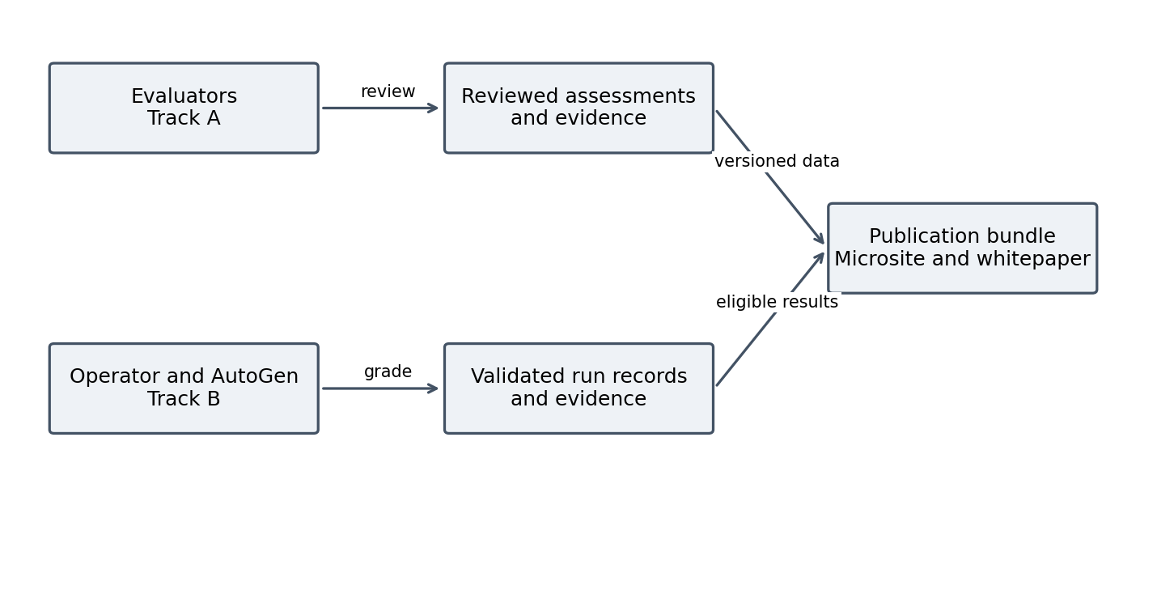
Figure 1. Proposed framework context and shared publication boundary. All diagrams in this draft are AI assisted.

Architecture style and rationale
Track B uses a modular application with layered responsibilities: input validation, orchestration, execution, grading, and output serialization. Model clients and graders are replaceable adapters. Separate processes and containers provide execution boundaries without requiring independently deployed microservices.
Track A uses an editorial workflow over versioned records. Shared publication uses a batch pipeline: review and validate records, build an immutable bundle, then serve it to a static browser client. This matches the small team, local evaluation requirement, and GitHub hosting constraints.

Separation between tracks
The two tracks share stable configuration identities and evidence conventions where applicable, but retain distinct result types. The site must never treat an AutoGen model score as the score of an IDE configuration. A configuration can link to relevant benchmark evidence only when the relationship is explicitly explained.
The whitepaper references released bundle versions and evidence IDs. Its conclusions are authored and reviewed by the team; publication does not automatically generate a procurement recommendation.

Logical Architectural View
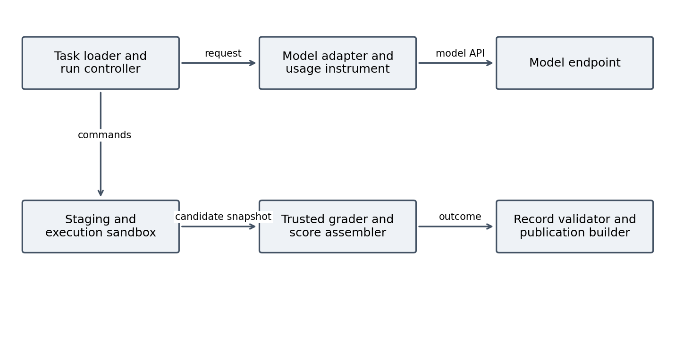
Figure 2. Proposed Track B components and principal dependencies. Command results return to the controller for subsequent coder turns.
Component | Responsibility | Status in supplied snapshot
Input and run controller | Validate task/profile; own lifecycle and limits | Single-task CLI exists; campaign coordination proposed.
Model adapter and instrument | Construct provider client; collect usage and latency | Azure and OpenAI-compatible builders; timing wrapper exist.
Staging and executor | Prepare clean tree; execute approved commands | Temporary staging and default network isolation exist.
Trusted grader and scorer | Grade frozen candidate using external acceptance tests | Grader registry exists; protected tests proposed.
Record and publication services | Validate outcomes; produce eligible public bundle | JSON v1 writer exists; validation and site integration proposed.

Track A adds catalog loading, assessment review, evidence indexing, and a browser query module. These are proposed modules. They have no dependency on the model execution loop and can be implemented and reviewed independently.

Physical Architectural View
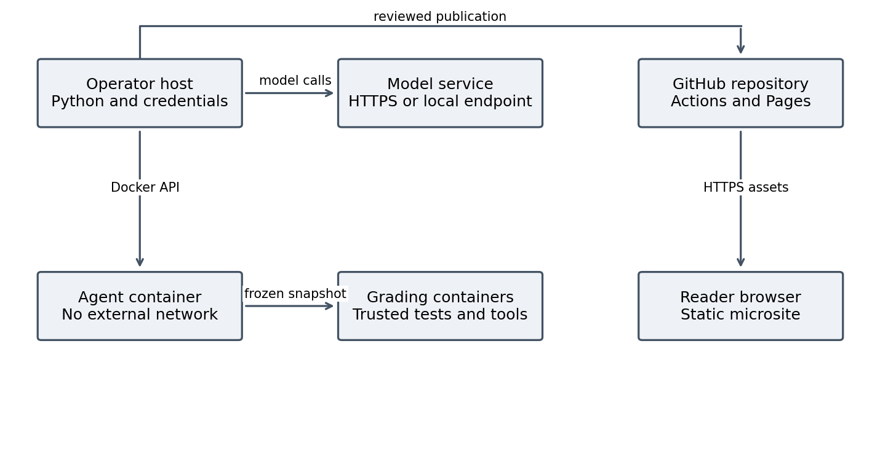
Figure 3. Proposed deployment topology. Agent and grading containers have no external network; model communication occurs on the host.

Application servers and web servers
The Node/Express todo application is the local evaluation target, not a public application server. The Python CLI is an operator process, not a hosted API. GitHub Pages serves the public microsite; readers use a browser to load HTML, CSS, JavaScript, and released JSON.

Database servers
No database server is proposed. The todo application uses in-memory state that resets per run. Evaluation records persist as files under version control or controlled artifact storage. The browser reads a prepared bundle rather than opening a direct connection to private repository contents.

Infrastructure and privilege
The host needs Python, Git, Docker, and access to approved model endpoints. Model credentials stay on the host. Proposed containers run as a non-root user with explicit CPU, memory, and process limits, no Docker socket, and only scoped workspace mounts. The supplied Dockerfile has no explicit non-root USER, so this remains implementation work.
GitHub Actions validates and publishes approved records. Candidate execution receives no publication credentials. Public hosting from a private repository and required account permissions must be confirmed with the repository owner.

Process and Development Architectural Views

Process view
Proposed first release: run one scored task at a time on an operator host. The controller owns a single run ID, monotonic active-time clock, spend accounting, and cancellation signal. Coder/model work and container commands alternate. Approval waiting pauses the active-time clock. Grading starts only after the agent process is stopped and the candidate snapshot is fixed.
Track A reviews may occur concurrently through separate repository branches. Stable assessment IDs and ordinary merge review resolve conflicts. Publication reads one committed revision; it never mixes records from partially completed runs. A future worker pool must reserve budget atomically and isolate each workspace and container.
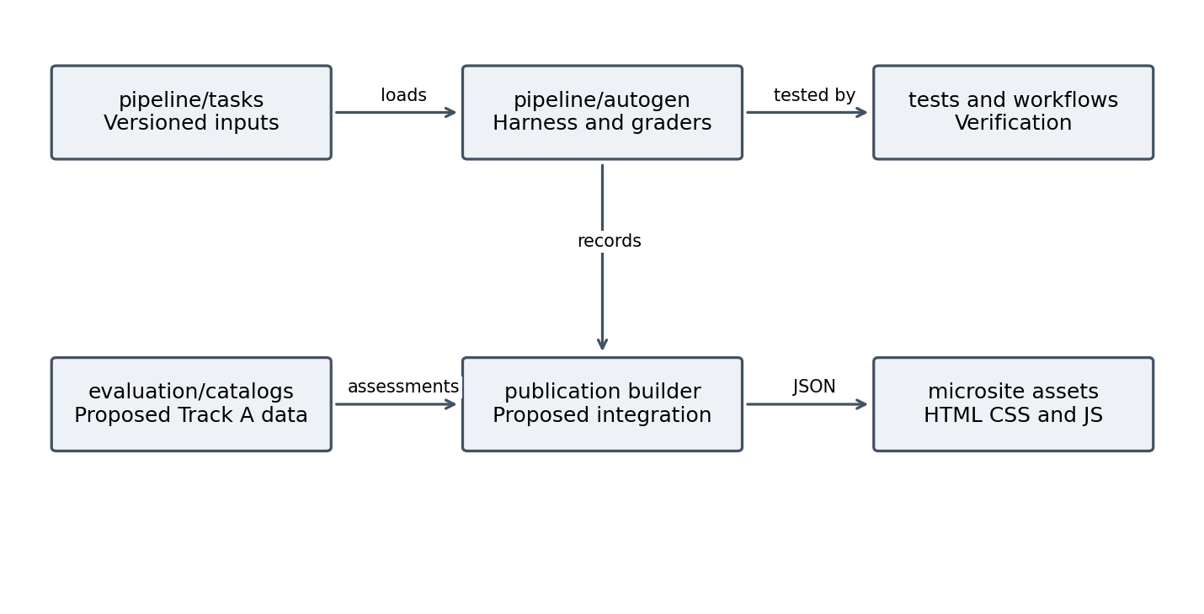
Figure 4. Development view. Track A catalogs and the publication builder are proposed additions; harness and task folders exist.

Configuration management
Current model profiles use YAML and host environment placeholders. Proposed settings also cover timeouts, spend, sandbox quotas, scoring version, and release policy. Validate all required values before a run starts. Pin host dependencies and use a container digest for releases; current dependency ranges and the image latest tag do not provide a fully fixed environment.
The root app and baseline folders overlap in purpose. The group must select a canonical target; current staging uses app. Preserve source integrity and record its revision instead of editing the shared target during a run.

Behavioral View and Key Scenarios
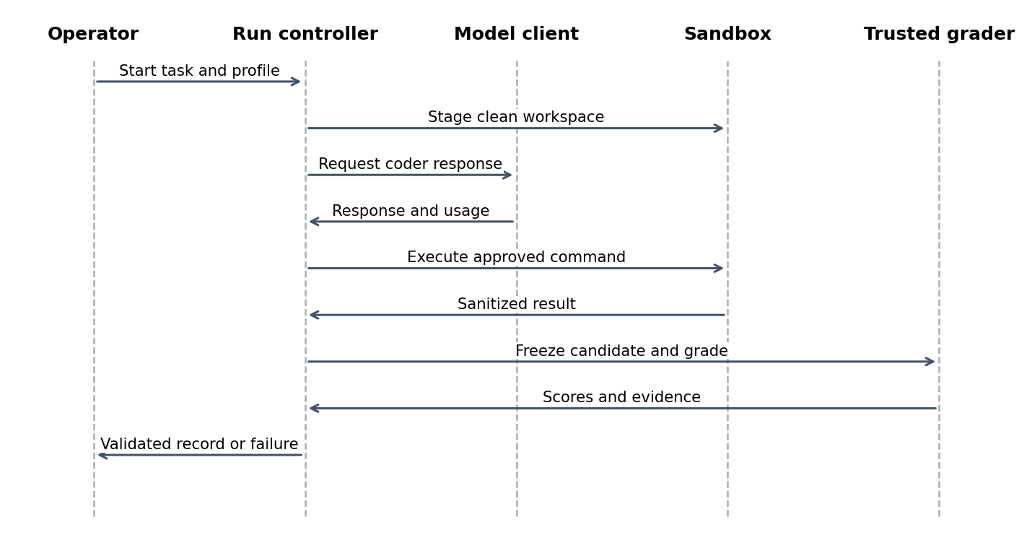
Figure 5. Proposed single-run sequence. The model and execution steps repeat within the configured limits; approval is handled before command execution.

Scenario B1 Execute and grade a task
The operator requests a task/profile pair. Preflight verifies the profile, dependencies, baseline tests, budget, and container policy. The controller stages the target, starts the executor, and begins the coder loop. Each command returns sanitized bounded output. Completion, cancellation, or a limit stops further model requests. The candidate is graded and an outcome is finalized; cleanup runs even if grading fails.

Scenario A1 Assess a tool feature
An evaluator selects a configuration ID and feature ID, captures documentation or a controlled demonstration, and drafts an assessment with evidence references. A second reviewer checks status, scope, and limitations. Approved records enter the next release. Disputed findings remain unverified or unpublished rather than becoming implied support.

Scenario P1 Explore client needs
A reader selects required capabilities, acceptable setup mechanisms, and categories. The site shows matching configurations and explains exclusions or unknowns. The reader inspects evidence and dates before adopting a configuration. Clearing filters restores the full catalog. Exporting a selection, if added, records the bundle version and selected criteria.

Run Outcomes and Fault Handling
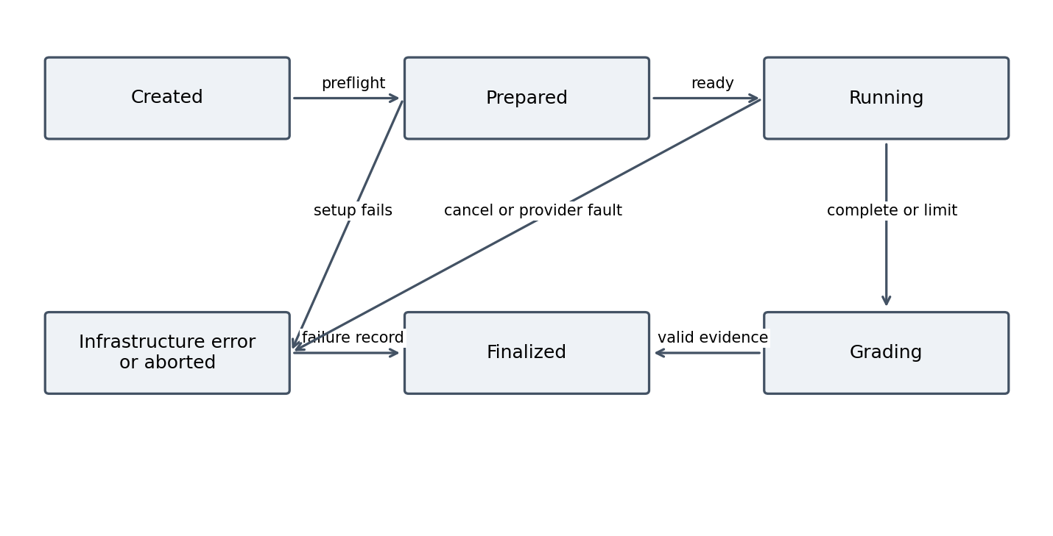
Figure 6. Proposed lifecycle. Final records preserve status and reason; every terminal path includes cleanup. Timeout outcomes proceed to grading only when safe.

Outcome contract
A run has exactly one status: passed, failed, timeout, aborted, or infrastructure_error. Passed means required acceptance and safety checks succeeded; a weighted score alone cannot establish acceptance. Failed means completed evaluation found a task or policy failure. Timeout means an execution limit expired. Aborted records operator cancellation or approval rejection. Infrastructure_error means the environment or provider prevented valid evaluation.

Recovery and retries
Write a failure record even when initialization, model calls, grading, or cleanup fail. Retry infrastructure errors once with the same task/profile/repetition identity and a new run ID; retain the original outcome. Exclude unresolved infrastructure errors from capability averages and show their count. Do not retry a genuine task failure merely to obtain a better result.
Use bounded provider retries with backoff and a finite retry count. Rate-limit waits and provider outages need an explicit time-budget policy. The proposed default counts provider waiting as active time and records outage failures distinctly. Approval waits alone are excluded. Values and retry count require team agreement.
Publication requires a complete, validated, reviewed record. A crashed scanner blocks release; a numeric provisional score must not appear as valid evidence. Current code can mark scores unreliable, but lacks the complete lifecycle contract proposed here.

Data Architectural View
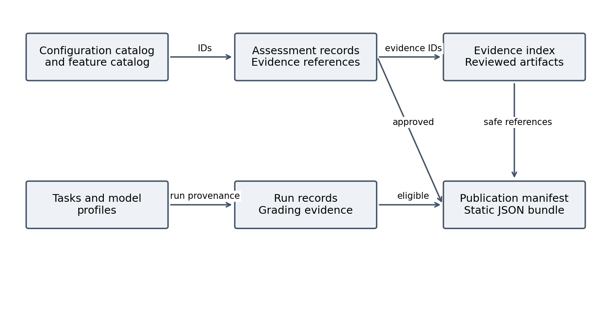
Figure 7. Proposed data relationships and publication flow. References join records without merging capability assessments with model outcomes.
Record | Key fields | Integrity rules
Configuration | configuration_id, tool/version, mode, model/settings, integrations, permissions, date | Stable ID; unknown model details are explicit.
Feature | feature_id, area, definition, applicability | Preserve F01–F18 identifiers across revisions.
Assessment | assessment_id, configuration_id, feature_id, status, evidence_refs, mechanism, reviewer | One primary status; valid references; approved state for release.
Evidence | evidence_id, kind, artifact_ref, capture date, revision, limitations | No real secrets; stable source/artifact reference.
Run | run_id, task/profile revision, attempt, status, usage, timing, scorecard, provenance | Schema valid; finite numeric values; consistent totals.
Publication | bundle_version, source_revision, generated_at, record lists | All references resolve in the released snapshot.

Track A statuses are Built in, Configuration or extension required, Custom implementation required, Unavailable, and Not verified. Delivery mechanism is descriptive; it is not an effectiveness ranking. Evidence basis distinguishes documentation, observed demonstration, and tested behavior.

System Configuration and Interface Details
Proposed interface contracts below are implementation targets. Existing Python signatures may be retained behind adapters; the public data contract must remain independent of those signatures.
ID and boundary | Input and output | Errors and policy
I1 CLI to controller | Task ID, profile, limits, mode → run ID, record path, exit status | Unknown input: nonzero before model call. Exit 0 only for completed valid evaluation; distinguish outcome in JSON.
I2 Controller to model adapter | Conversation plus settings → response, reported usage, latency | Typed auth, rate, timeout, and provider errors; bounded retries; redact error details.
I3 Controller to executor | Command plus run context → exit code, stdout/stderr, duration | Deny disallowed paths/actions; terminate at limit; sanitize and truncate returned output.
I4 Candidate to grader | Frozen candidate, trusted test bundle, manifest, baseline metrics → GraderResult | Missing scanner/test environment → infrastructure_error; task failures remain valid findings.
I5 Builder to browser | GET publication.json → versioned JSON catalogs, assessments, eligible runs | HTTPS static files; loading, empty, and invalid-data states; no model credentials.
I6 Reviewer to release | Approved records and evidence index → validated bundle | Invalid references/schema or sensitive data block publication.

System inputs and output APIs
The initial evaluation entry point is a CLI. Model requests use provider HTTPS APIs or an explicitly configured local endpoint; credentials are resolved only by the host. Static-site HTTP GET requests are the public output interface. No public write API is proposed.

Reference application REST contract
The target exposes GET /api/todos → 200 array and POST /api/todos → 201 created item or 400 invalid input. Task 001 adds DELETE /api/todos/:id → 204, 404 missing, or 400 nonnumeric ID. These are task acceptance targets, not a claim that all routes already exist. Baseline and task test contracts must be versioned separately.

System Decomposition Coupling and Cohesion

Component decomposition
The run controller coordinates modules but does not parse scanner output or construct provider-specific requests. Task parsing validates inputs. Staging owns filesystem lifecycle. Execution enforces container policy. Graders translate trusted tool output into evidence. Scoring computes formulas. Telemetry serializes outcomes. Publication applies review and release policy. Track A assessment review and browser filtering remain independent of execution.

Coupling
The existing grader registry and SandboxRunner protocol provide useful replaceable boundaries. Proposed tests inject model and executor fakes so orchestration can be checked without live calls. All consumers depend on versioned record schemas rather than importing private harness classes. Provider errors map to common types; raw exceptions do not leak into public results.
The current executor temporarily patches the Docker SDK container-creation method globally. This creates coupling to upstream behavior and concurrency risk. Keep execution serial until it is replaced by a scoped container factory or supported adapter that sets policy explicitly and is regression-tested against the chosen AutoGen version.

Cohesion and extensibility
Each module has one primary reason to change: task format, provider support, container policy, grading tool, scoring policy, or publication format. A new model adds a profile/adapter and a capability check. A new task adds a manifest and trusted tests. A new feature adds catalog content and assessment guidance. None should require changes to unrelated scoring or rendering logic.

Design principles
Use separation of concerns and dependency inversion at model/executor/grader boundaries. Apply the open/closed principle through registries and adapters. Keep interfaces narrow so browser rendering does not depend on private prompts or host state. These are proposed design checks; a class hierarchy alone does not establish SOLID adherence.

Storage Requirements Layout and Schemas

Persistence strategy
Keep reviewed catalogs and safe JSON results under version control. Store larger sanitized demonstrations as controlled artifacts with stable references. Untrusted candidate files remain temporary until scans and review permit retention. Public bundles contain summaries and safe evidence references; raw prompts, credentials, environment dumps, and internal paths are excluded.
Proposed path | Contents | Retention
evaluation/catalogs/ | features.json and configurations.json | Versioned through project life.
evaluation/assessments/ | One reviewed record per feature/configuration finding | Preserve superseded findings in history.
evaluation/evidence/ | Safe evidence index; artifact links | Keep through final report; policy TBD.
pipeline/tasks/ | Prompts, manifests, trusted acceptance references | Versioned; acceptance tests hidden during agent turns.
pipeline/autogen/results/ | Final run records and safe grading evidence | Retain failures and retries; publish eligible subset.
publication/ | manifest.json and generated public data | Release version plus source commit.
Temporary host directory | Candidate workspace and agent container files | Remove at run end; debug retention explicitly labeled.

Schema compatibility
The supplied code emits schema_version 1; the SRS defines version 2 with different fields. Proposed action: adopt one revised v2 schema with explicit migration from v1, then validate it before release. Preserve measured versus unavailable usage/cost distinctly using nullable fields and completeness flags. Do not invent missing provenance during migration.
Validate both JSON structure and semantic invariants: usage equals per-call sums, timing is nonnegative, attempts/retry links are valid, zeroing rules agree with status, and references resolve. Schema validation alone cannot prove the score formula or evidence authenticity.

Atomic writes
Write each record to a temporary file in the results directory and rename after validation. Build the publication bundle from a fixed repository revision. Partial files or concurrent edits must not enter a release.

Module Specifications for Evaluation
Module | Inputs and processing | Outputs and failure behavior
M1 Track A catalog and review | Load catalogs; validate IDs; attach findings and evidence; obtain second review. | Approved assessments or validation report. Missing evidence stays Not verified. Proposed.
M2 Task loader | Read Markdown/YAML, task ID, target, manifest, test framework, trusted suite reference. | Validated Task; reject duplicate IDs, missing constraints, or unsupported grader. Parser exists; manifest contract proposed.
M3 Model profiles and client | Resolve selected profile from YAML and host environment; construct client; check required capabilities. | Provider adapter with immutable run settings. Missing credentials stop preflight. Azure/OpenAI-compatible support observed.
M4 Staging | Copy canonical target, exclude dependency caches and credentials, initialize baseline commit, install from approved offline image. | Scoped Workspace with source revision and digest. Cleanup in finally. Temporary staging exists; credential allowlist/preflight proposed.
M5 Orchestration and execution | Alternate coder/executor; check permission, command time, active time, tokens, and budget before actions. | Command feedback and terminal reason. Existing approval and termination loop; complete policy enforcement proposed.

Processing rules
M2 rejects ambiguous task definitions before spending tokens. M3 validates only the chosen profile and never serializes credentials. M4 checks that the untouched baseline passes and dependencies are present. A baseline syntax error is a setup defect unless the task is explicitly designed as a repair scenario; that exception must have a separate trusted oracle.
M5 uses an explicit count of coder turns rather than assuming total messages equal turns. Reserve token allowance before each request and cap completion tokens where supported. A post-response threshold can overshoot; disclose unavoidable provider accounting limits. Headless mode must implement a declared approval policy instead of silently claiming human oversight.

Module Specifications for Grading and Publication
Module | Inputs and processing | Outputs and failure behavior
M6 Trusted grading | Stop agent; check changed files; mount hidden evaluator tests read-only; run functionality, secret/license/security, and quality checks. | Dimension evidence, acceptance, safety result. Missing checks block valid release. Registry and Node/Python graders exist; protected oracle proposed.
M7 Scoring and telemetry | Combine policy-versioned dimensions with measured usage, timing, intervention classification, and explicit status. | Validated run record. Persist errors; distinguish task failure from unavailable measurement. Current v1 differs.
M8 Campaign controller | Enumerate task/profile/repetition combinations; reserve budget; sequence runs; retry infrastructure fault once. | Campaign manifest, outcomes, aggregates, exclusions. Proposed; current CLI runs one task.
M9 Publication builder | Select reviewed assessments and eligible run records; scrub evidence; validate links and schemas. | Atomic static bundle and validation report. Failed validation blocks release. Proposed.
M10 Browser decision support | Load bundle; apply category, required-feature, evidence, and setup filters; sort; expose evidence detail. | Explainable result list. Unknowns remain visible; no aggregate ranking in proposed first version.
M11 Whitepaper assembly | Reference released evidence and describe methodology, results, educational context, and limitations. | Team-reviewed report. No unsupported product recommendation or measured claim. Draft outline exists.

Current prototype limits
Two task definitions are present. A Node grader and Node-enabled Dockerfile are implemented despite older README statements. Current task commands run editable test.js, so passing them does not establish independent correctness. Current scoring assigns zero to the security dimension but does not automatically zero the total score. The public demo contains simulated/random metrics and is not an authoritative consumer of harness results.

Formulas Algorithms and Decision Support

Proposed scoring policy requiring approval
Retain the SRS weights provisionally: total = 0.35F + 0.25S + 0.20Q + 0.10T + 0.10H, with each dimension in [0,100]. F = 100 × trusted tests passed / trusted tests total; zero tests is an infrastructure error. Acceptance requires all mandatory tests, independently of total score.
Provisional SRS token policy: T = 100 when u ≤ 0.5L; otherwise T = max(0, 200 × (1 − u/L)), where u is total tokens and L is the limit. The code currently uses 100 × max(0, 1 − u/L). The team must choose one and version it.
Provisional H = max(0, 100 − 25a), where a counts avoidable substantive interventions under a written rubric. Current code subtracts 10 per substantive reply. Necessary safety approvals should be reported separately. Headless auto-approval cannot demonstrate real developer collaboration.
Q and S require tools and baselines agreed by the group. Do not substitute Python complexity measurements for JavaScript complexity or silently award unmeasured criteria. Secret leakage or a forbidden action zeros the overall score under the proposed retained SRS rule. Scanner failure means infrastructure_error, not a passing safety result.

Aggregating outcomes
For N profiles, K tasks, and R repetitions, planned runs = N × K × R. Average valid task outcomes over repetitions, including genuine task failures; show ranges, counts, and unstable pass/fail outcomes. Infrastructure exclusions and retry counts remain visible. If a dimension is unavailable for any compared profile, compare using a common supported dimension set and disclose the changed maximum; do not impute a favorable value.

Feature filtering algorithm
For each selected required feature, classify the configuration as confirmed match, confirmed absence, or unresolved. A strict filter includes only confirmed matches; an optional include-unverified switch displays unresolved candidates with a clear label. Setup restrictions can exclude custom implementations or extension requirements. Sort by name, category, verification date, or count of confirmed requested features. That count describes coverage, not effectiveness.
Every result explanation lists criteria, matched findings, unknowns, evidence references, and release date. Weighted recommendations require sponsor-approved priorities and a missing-evidence policy before implementation.

Architecture Decision Records
ADR | Proposed decision and rationale | Trade off and review condition
01 | Separate Track A availability from Track B model performance. They answer different questions. | More data types and explanation; prevents unsupported cross-product rankings.
02 | Use modular Python harness plus static publication instead of distributed services. | Lower operating burden; no live shared evaluation service. Revisit only for demonstrated concurrency need.
03 | Use direct AutoGen usage/timing instrumentation. Existing code avoids a proxy solely for telemetry. | Less infrastructure; provider adapters must normalize missing usage. OpenTelemetry tracing remains a separate decision.
04 | Keep model calls on host and disable container egress. | Preinstalled dependencies and build maintenance required. Network-enabled development runs are ineligible for scored release.
05 | Use hidden trusted tests after agent completion. | Maintain two test surfaces; protects acceptance from editable candidate tests.
06 | Store versioned records and publish static bundles. | Simple review and reproducibility; limited multiuser editing and search scale.
07 | Begin decision support with filtering and transparent sorting. | No single ranked winner; avoids premature weighting. Revisit with sponsor priorities.
08 | Run scored jobs serially initially. | Longer campaign duration; easier isolation, rate control, and budget accounting.
09 | Align schemas and formulas before reporting. | Migration effort; prevents mixing incompatible evidence.

All ADRs are proposed in version 0.1. The team should record accepted/rejected status, alternatives considered, decision owner, date, and evidence after discussion. No sponsor approval is implied.

System Size Performance and Capacity
Metric | Estimate or target | Basis and validation
Campaign workload | N × K × R; illustrative 4 × 8 × 3 = 96 | SRS example; final roster and task suite TBD.
Active execution budget | Proposed 120 seconds per run | 96 runs allow up to 3.2 hours of active execution; staging, grading, approval, retries add time.
Container resources | Proposed 2 CPUs, 2 GB, 128 processes | SRS targets; verify enforcement and host overhead.
Model token allowance | Current configuration 15,000 tokens/run | 96 runs imply 1.44 million nominal tokens before retries; post-call overshoot must be controlled.
Public records | 18 × C assessment cells plus run records | At C=4, 72 cells. Proposed client processing is O(C × selected features).
Microsite response | Proposed filter update under 100 ms at 100 configs | Measure in supported browsers with synthetic bundle; not a current measurement.
Publication delay | Proposed within 2 minutes after eligible merge | SRS target; measure warm/cold workflow behavior.

Cost estimation
Estimated API cost = Σ(input_tokens × input_price + output_tokens × output_price) / 1,000,000, with any cache or other provider charges represented separately. Store the pricing snapshot, currency, date, and completeness. Development runs and retries consume budget even when excluded from comparisons. The approved dollar cap and rate policy are TBD.

Storage and scaling
Planning estimate: 96 records at 50 KB each occupy about 4.8 MB, excluding logs, video, patches, and artifacts. This is an assumed sizing envelope, not observed file size. Keep large evidence outside the browser bundle. Paginate or split results if the bundle causes slow loading; add workers only after measuring serial throughput and host capacity.
Benchmark hosts represent evaluation infrastructure. A sponsor scenario involving thousands of developer seats does not mean the student system must support thousands of simultaneous benchmark users.

Security Observability and Operational Concerns

Security boundaries
Threats include instructions planted in repository/task content, arbitrary commands, exfiltration, resource exhaustion, altered tests, malicious output, and credential exposure. Enforce container isolation and quotas outside prompts. A deny policy covers actions beyond the manifest; hidden acceptance tests and trusted grading code protect the oracle. Scan both candidate history and current content before retaining or publishing artifacts.
The current network probe checks a connection outcome, not comprehensive detection of attempted egress. The design must specify how attempts are observed before claiming every blocked attempt is recorded. Container isolation does not prove resistance to every host escape; keep runtimes patched and mounts scoped.

Publication and browser security
Serve reviewed static data and escape all text from records. Avoid injecting record content as executable HTML. Remove API-key entry and direct model calls from the authoritative public-results flow. Keep existing simulation demonstrations clearly labeled and separate. Public evidence must omit prompts and personal data unless a reviewed disclosure policy explicitly permits a safe artifact.

Trusted CI
Proposed grading workflows obtain harness/grading code from a trusted base revision and treat candidate changes as data. The supplied referee workflow uses default checkout and builds from that checkout; it does not establish the required trusted-base separation. Repository branch protection and permissions require owner confirmation. Publishing credentials are available only to the release job.

Observability and fault tolerance
Use run IDs to join lifecycle events, model-call metrics, grader evidence, and cleanup results. Store structured operational events without raw prompts or secrets. Track run counts by outcome, latency, retries, scanner failures, budget consumed, and release exclusions. Direct usage/timing instrumentation exists; full tracing, cost capture, and record redaction need implementation.
A failure to publish preserves the last valid release. A failed run does not halt the campaign unless safety, budget, or infrastructure policy requires it. Record cleanup failures and stop further runs when isolation cannot be guaranteed.

Requirements Traceability and Change Register
Source requirement | Design realization | Validation or change
R1 / Specs 1.1–1.5 | M4–M6; container boundary, quotas, cleanup, secret scanning | Probe controls, errors, canaries, and history; several controls proposed.
R2 / Specs 2.1–2.5 | M3/M5/M8; limits, feedback, manifest, approvals, budget | Test cancellation, overshoot, approval wait, provider outage. Change agent comparison premise.
R3 / Specs 3.1–3.3 | M2/M4/M6; canonical Node target and baseline preflight | Fix or explicitly scope broken baseline; verify routes and browsers.
R4 / Specs 4.1–4.5 | M6/M7/M9; trusted oracle, validated data, scans, Pages, trusted CI | Adopt authoritative schema; isolate grading source; verify release.
D01 proposed scope revision | Track A configurations plus Track B models under AutoGen | Update SRS scope and experiment definition.
D02 proposed capability records | M1; 18 features, status, setup, mechanism, evidence | Validate all cells and second review.
D03 proposed decision support | M10; filters, sorting, explanations and unknowns | Sponsor usability scenario and deterministic filter checks.
D04 proposed evidence provenance | M1/M7/M9/M11; stable IDs and release references | All claims resolve to evidence; no invalid joins.
D05 proposed release eligibility | M9; reviewed, schema-valid, safe records | Invalid or unsafe records block release.
D06 proposed campaign behavior | M8; repetitions, retries, aggregate exclusions | Synthetic campaign verifies counts and formula.
D07 proposed privacy policy | M7/M9; public summaries and controlled artifacts | Canary inspection of records and bundle.
D08 proposed documentation outputs | M11 and microsite; methodology and education | Team/sponsor review; consistency with released results.

The supplied SRS refers to NFRs and a traceability matrix that were not found in the provided body content. Recover or define them before finalizing traceability. This draft provides a major-requirement mapping; the next revision should map each retained numbered clause to a module, interface, and test.

Risks Validation and Team Review
Risk | Mitigation | Validation evidence needed
Model capabilities differ | Preflight each profile and disclose settings/limitations | One representative end-to-end run per scored profile.
Editable tests inflate scores | Hidden external tests after candidate freeze | Tamper tests: deletion, skipping, changed assertions.
Offline dependencies missing | Build target dependencies into approved image | Baseline starts/tests pass with no network.
Records or formulas disagree | Version schema and scoring; migrate explicitly | Schema, semantic and hand-worked score examples.
Sandbox policy incomplete | Non-root, quotas, manifest, egress observation | Host inspection, limit probes, cleanup failure tests.
Simulations appear authoritative | Separate demos from measured results | Publication rejects simulated/dev/unreliable evidence.
Private repo hosting unavailable | Confirm owner permissions and Pages plan | Actual workflow/deployment run; no assumed success.
Scope exceeds semester capacity | Prioritize records, protected grading, site integration | Assign owners and milestones after team review.

Validation plan
First verify schemas, parsing, formulas, filters, and error mapping offline with deterministic fixtures. Then verify container policy and baseline operation without a model. Run a small paid pilot only after both gates pass, record actual usage/timing, and execute a campaign after task/model/repetition decisions are approved. Finally validate publication, evidence links, accessibility, and whitepaper consistency with a released bundle.

October 9 meeting decisions
- Confirm revised scope and canonical target; recover missing SRS material.
- Select configurations, models, tasks, repetitions, and comparison settings.
- Choose filtering/sorting scope and evidence review ownership.
- Approve scoring, protected tests, limits, budget, schema, and privacy rules.
- Assign implementation and DDD/presentation sections; record actual timesheets.
Rubric check: this draft covers the required views, styles, interfaces, modules, trade-offs, quantitative estimates, security, observability, fault handling, configuration, and AI notation. The in-class presentation remains a separate deliverable and must cover the same substantive design.

References and Appendices

References
[1] ISO/IEC/IEEE, ISO/IEC/IEEE 42010:2022, Software, systems and enterprise — Architecture description, 2022. [Online]. Available: https://www.iso.org/standard/74393.html. Accessed: Oct. 8, 2026. Only the public scope description was consulted; formal conformance was not assessed.
[2] P. Kruchten, “Architectural Blueprints—The ‘4+1’ View Model of Software Architecture,” IEEE Software, vol. 12, no. 6, pp. 42–50, Nov. 1995. [Online]. Available: https://www.cs.ubc.ca/~gregor/teaching/papers/4%2B1view-architecture.pdf. Accessed: Oct. 8, 2026.
[3] Group 3, “System Requirements Specifications,” Microsoft 2, CIS 4910, rev. 1.1, Sep. 29, 2026, supplied project document.
[4] University of South Florida, “Detailed Design Document Template” and Architecture/Design grading rubric, CIS 4910, Fall 2026, supplied course materials.
[5] Group 3, “Agentic Developer Tool and Pipeline Feature Matrix Specification,” v0.1, Oct. 6, 2026, supplied draft.
[6] Group 3, “Agentic Development for Software Engineering: An Enterprise Evaluation Framework & Benchmark,” Fall 2026, supplied whitepaper draft.
[7] Group 3, Microsoft-Capstone source snapshot, archive “2026-10-08_MS Senior Project.zip,” Oct. 8, 2026. Examined paths include pipeline/autogen/run_benchmark.py, harness/, graders/, config/models.yaml, .devcontainer/Dockerfile, pipeline/tasks/, .github/workflows/, app/, demo.html, and docs/. Commit SHA TBD.

Appendix A Acronyms
ADR: Architecture Decision Record. API: Application Programming Interface. CI: Continuous Integration. CLI: Command-Line Interface. DDD: Detailed Design Document. HLA: High-Level Architecture. IDE: Integrated Development Environment. IPI: Indirect Prompt Injection. JSON: JavaScript Object Notation. NFR: Non-Functional Requirement. SRS: System Requirements Specification. TBD: To Be Determined.

Appendix B Glossary
Configuration: versioned combination of tool, model, workflow, permissions, and environment. Harness: software that connects a model to actions and feedback. Assessment: evidence-backed feature finding. Trusted oracle: evaluator-owned acceptance criteria and tests. Eligible result: complete, safe, reviewed record approved for publication. Benchmark-valid profile: operator designation of a profile for scored runs; the flag alone does not prove validity.

Appendix C Documents Type and Source
Inputs [3]–[7] are supplied project and course materials. Scope clarification comes from Ross Volenec in the October 8, 2026 discussion. Sponsor intent in this draft is based on that clarification and the supplied whitepaper; no new sponsor decision is asserted. Before submission, reconcile the whitepaper with Chad’s meeting records and record the exact authoritative sources.

