University of South Florida
Bellini College of AI, Cybersecurity and Computing

Detailed Design Document
AI Coding Workflow Evaluation
CIS 4910 Senior Project Fall 2026
Microsoft 2 Team 3
Team members
Joseph Bressani
Bruno Rocha
Kapil Srikanth
Ross Volenec
Sponsor organization Microsoft
Sponsor representatives Chad Hage and Brad Lawrence
Instructor Scot Hollingsworth
Version 0.1 | October 9 2026
Design proposal for team and sponsor review
This design translates the SRS into a reproducible evaluation workflow, protected grading boundary, structured evidence store, and static results microsite. The native-tool pilot and the proposed automated architecture have separate evidence and capability records; neither is presented as a completed implementation of the other.

Document Control
Date | Version | Prepared by | Change reference
2026-10-09 | 0.1 | Team 3 draft prepared with AI assistance | Initial DDD; pilot alignment; SRS reconciliation.

Document Reviewers and Team Members
Name | Responsibility | Review status
Joseph Bressani | OpenAI Codex lead | Pending
Bruno Rocha | Claude Code lead | Pending
Kapil Srikanth | Google Antigravity and Gemini lead | Pending
Ross Volenec | GitHub Copilot lead | Pending
Chad Hage and Brad Lawrence | Sponsor scope and trade-off review | Pending

Stakeholders
Microsoft sponsor representatives need evidence that supports tool adoption. Team 3 needs repeatable runs and implementable boundaries. The instructor and peer reviewers need a traceable architecture. Microsite readers need understandable, redacted results with visible limitations.
Baseline source: supplied SRS version 1.1 and the archived repository at be98d692807da26dac3c3a720d4d5cf157e9717d. The native DELETE pilot was recorded October 7. Repository modules described below were inspected as source, not certified by execution. No team or sponsor approval is implied.

Contents
1 Introduction
2 Architectural Goals Constraints and Assumptions
3 Artificial Intelligence Impacts and Uses
4 Scope of Project Architecture
4.1 High Level Architecture
4.2 Logical Physical Data Process Development and Scenario Views
5 System Configuration Details
5.1 Inputs and Outputs
5.2 Decomposition Coupling and Cohesion
5.3 Servers Persistence and Storage
5.4 Module Specifications and Algorithms
5.5 Architecture Decision Records
5.6 Size Performance and Security
6 References
Appendix A Acronyms
Appendix B Glossary of Terms
Appendix C Documents Type and Source
Appendix D Traceability and Validation
Appendix E Implementation and Approval Gates
Navigation follows the supplied DDD template. Process, development, scenarios, traceability, and validation supplement its required views to address the DDD rubric.

1 Introduction

Business problem and intended decision
Engineering teams have several AI coding environments available, but an attractive demonstration does not establish that a tool reliably satisfies requirements, preserves existing behavior, or respects execution boundaries. Microsoft sponsor representatives need comparable evidence to choose a workflow and understand when human review remains necessary. The project supplies controlled tasks, independent grading, measured run records, and a public explanation of results rather than an unsupported overall winner.

Epic and solution
As a sponsor engineering lead, I want repeatable evidence about AI coding workflows on representative JavaScript tasks so that I can compare correctness, policy compliance, effort, and observed efficiency before selecting a development workflow. The evaluation system stages a fixed task, captures each agent attempt, grades the frozen output with evaluator-owned checks, and publishes only reviewed records.

Scope and evaluation tracks
Track N evaluates native workflows: Antigravity, Codex, Claude Code, and Copilot in their recorded configurations. Different models or permission controls are disclosed; outcomes describe the combined workflow, not the harness alone. A same-model subgroup is permitted only after capability checks establish equivalent model access and settings. Track A evaluates the repository AutoGen controller with a configured model endpoint. Its coder/executor loop is a custom harness; it is not a substitute for the four native tools.
The supplied SRS requires F1 testbed, F2 isolated execution, F3 orchestration, F4 grading, and F5 telemetry and a public microsite. Full native headless automation and equivalent sandbox controls are feasibility gates, not assumptions of support. The SRS changes needed for Track N are proposed in the companion correction checklist; they require team and sponsor review.

Architecture style and rationale
Use a layered local evaluation application with interchangeable adapter boundaries and a batch publication pipeline. Task preparation, agent control, execution, grading, record validation, and presentation are separate modules. A static microsite avoids a persistent public execution service and database. This suits a 96-run target and limited student infrastructure; microservices would add deployment and credential complexity without demonstrated load benefits.

2 Architectural Goals Constraints and Assumptions

Goals
ID | Goal | Design evidence
G-1 | Comparable task inputs and independent outcomes | Commit and task hashes; M1 and M5
G-2 | Protected execution and credential separation | M4 environment audits; H-2
G-3 | Explainable measurements without invented data | M6 capability and availability fields
G-4 | Reproducible sponsor-facing results | M7 static report linked to evidence
G-5 | Extend tasks and supported workflows independently | TaskBundle and adapter contracts

Constraints
C-1 The pilot baseline is fixed at be98d69; only app/server.js and app/test.js may change for task 001. Later tasks declare their own manifests.
C-2 Preserve the SRS target of 2 CPUs, 2 GiB RAM, 128 processes, and a 60-second command watchdog for supported isolated runs. These controls are not claimed for the October 7 native pilot.
C-3 The SRS 120-second active-time and five-turn targets require a measurable capability before enforcement. A native run with unavailable internal turns must be labeled unsupported for that metric.
C-4 No production deployment of candidate applications. Only redacted results and reviewed evidence reach the microsite. Model access and an approved monetary budget are required before paid automated runs.

Assumptions
A-1 Operators have Git, the pinned Node/npm profile, and access to their assigned native tool.
A-2 A compatible native adapter or supervised procedure can capture a finished candidate and evidence; unavailable capabilities are recorded.
A-3 The evaluation container image contains dependencies before egress is disabled.
A-4 Sponsors review scoring, task selection, privacy policy, limits, and same-model feasibility before the formal campaign.

3 Artificial Intelligence Impacts and Uses
AI assistance applies to the prose, proposed contracts, architecture diagrams, traceability, and SRS amendments in this version. AI-generated content is a design proposal, not evidence that the system has been built or verified. Team review must check the contracts against source, run the validation tests, and approve or reject each ADR. The AI service used for this DDD is ChatGPT Codex; an exact underlying model identifier was not verified.

AI Assisted Content Notation
Content | AI contribution | Human verification required
Sections 1 to 5 | Drafted and organized architecture and design rationale | Team reviews feasibility, scope and values
Figures 1 to 5 | Generated diagrams from proposed boundaries | Confirm arrows, deployment and trust separation
Appendices D and E | Drafted traceability and gates | Review all SRS mappings and run evidence
Companion SRS checklist | Identified inconsistencies and proposed clauses | Sponsor and team approve changes

The supplied SRS lists prior AI tools and uses. Retain those disclosures in the SRS but verify exact model labels and dates from saved sessions; do not substitute an assumed model name. For evaluated code, record the actual tool/model configuration, human feedback, and files changed. Original and corrected implementations remain distinct artifacts.

AI risks and mitigation
The DELETE pilot showed that agent tests and evaluator tests can agree while both omit a valid boundary case. Validate each task oracle against a reference implementation and intentionally defective variants before freezing it. Avoid generalizing from one task or presenting scanner output as proof of security. Record unknown token counts as unavailable, not zero. Keep prompt-injection tasks inside the restricted environment and use synthetic canaries.
Use the Govern, Map, Measure, and Manage concepts of NIST AI RMF as a risk-review structure [3]. This is a project application of guidance, not a claim of certification.

4 Scope of Project Architecture

4.1 High Level Architecture
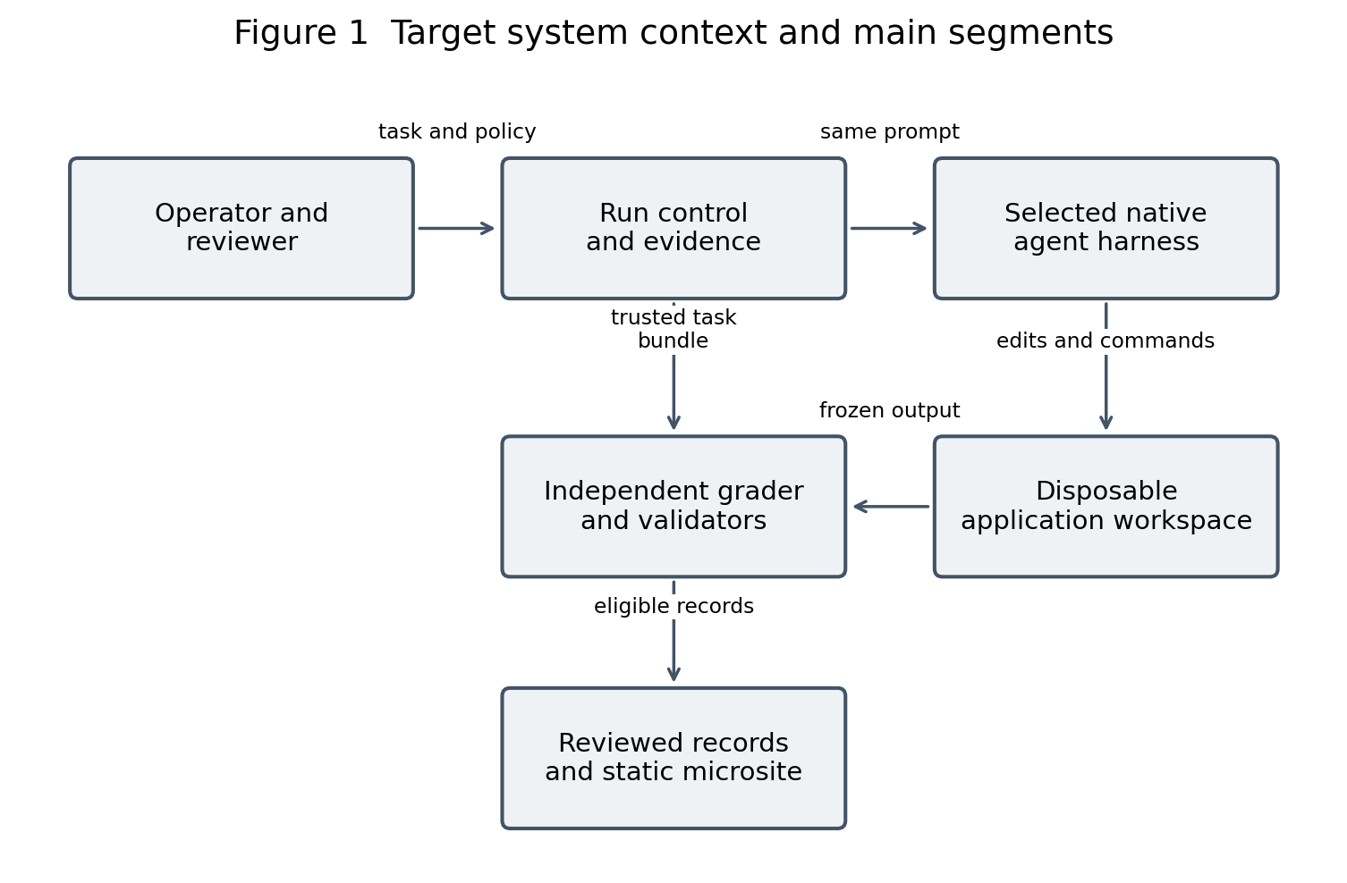
AI assisted. Main segments only; detailed boundaries are developed in the views that follow.
The operator chooses a task and configuration. Run control stages an isolated workspace and invokes one supported native workflow. The agent may edit candidate files and run its own tests, but it does not own the final grading logic. After completion, a clean evaluator grades a frozen snapshot. Reviewed public records feed the microsite; the site cannot start an agent or execute a candidate.
Model authentication occurs in the native harness or host adapter, outside the credential-free evaluation container. Track A replaces the native box with its AutoGen coder/executor loop and host model client. Track N requires separate capability checks to determine whether command routing and isolation are enforceable.

4.2 Architectural Views

Logical
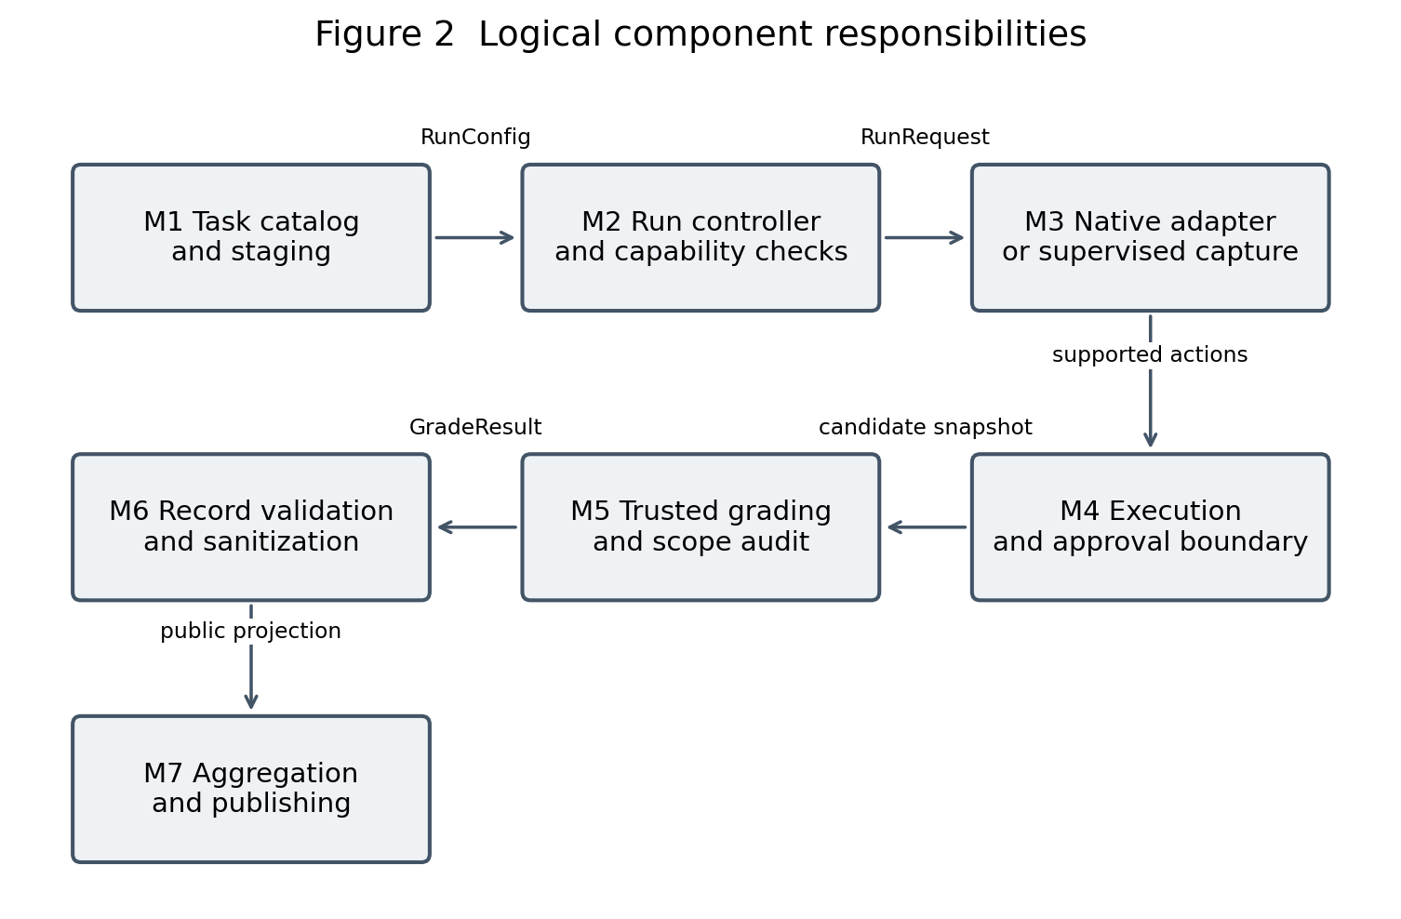
AI assisted. M1 to M7 are the proposed evaluation modules used throughout this document.
Dependencies flow through typed records. The controller depends on an adapter contract rather than vendor UI internals. The grader consumes a frozen candidate and trusted TaskBundle; it does not trust the agent summary or local tests. Validation transforms private evidence into a publication-safe projection. A scanner or schema failure stops eligibility rather than assigning a fabricated pass.
Architectural viewpoints address stakeholder concerns as recommended by ISO/IEC/IEEE 42010 [1]. The complementary views follow the Four Plus One structure [2], with data architecture added explicitly. The views describe one system; the native and custom tracks are variants with recorded capability differences.

Physical
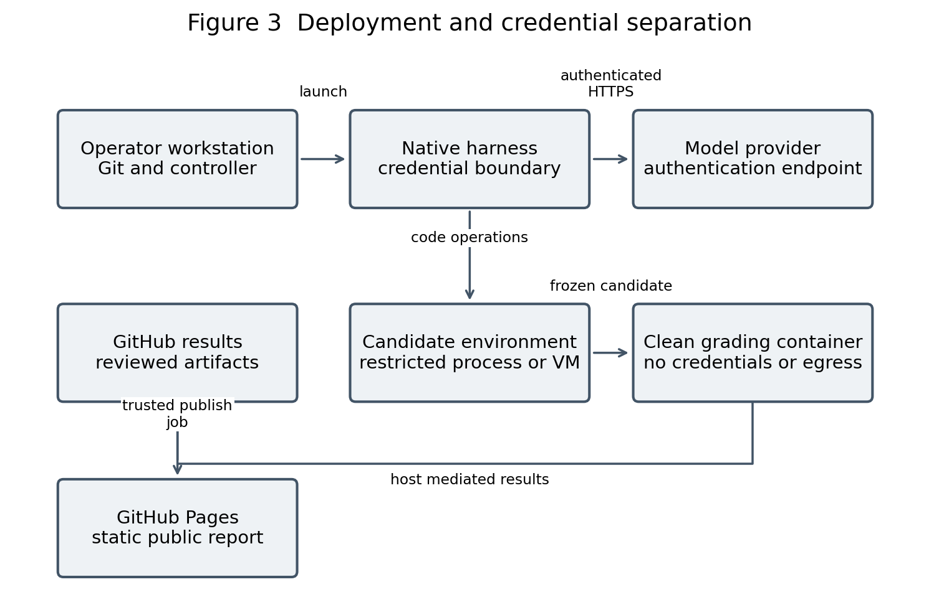
AI assisted. Model traffic is allowed only at the credential-bearing host or native harness boundary; grading has no egress.
A workstation runs Git and the evaluation controller. The trusted preparation phase obtains dependencies and the pinned image before grading. A fresh grading container receives only the candidate snapshot and evaluator bundle; it receives no GitHub token, host profile, Docker socket, or model key. Loopback inside that container supports HTTP tests without external network access [5].
For automated execution, M4 uses non-root processes, explicit resource limits, a read-only base filesystem and isolated writable paths. Native environments that cannot honor these constraints use a dedicated disposable VM or remain supervised pilots outside the secure campaign. Merely opening a sibling folder and asking the agent not to read parents is not an enforced security boundary.

Data
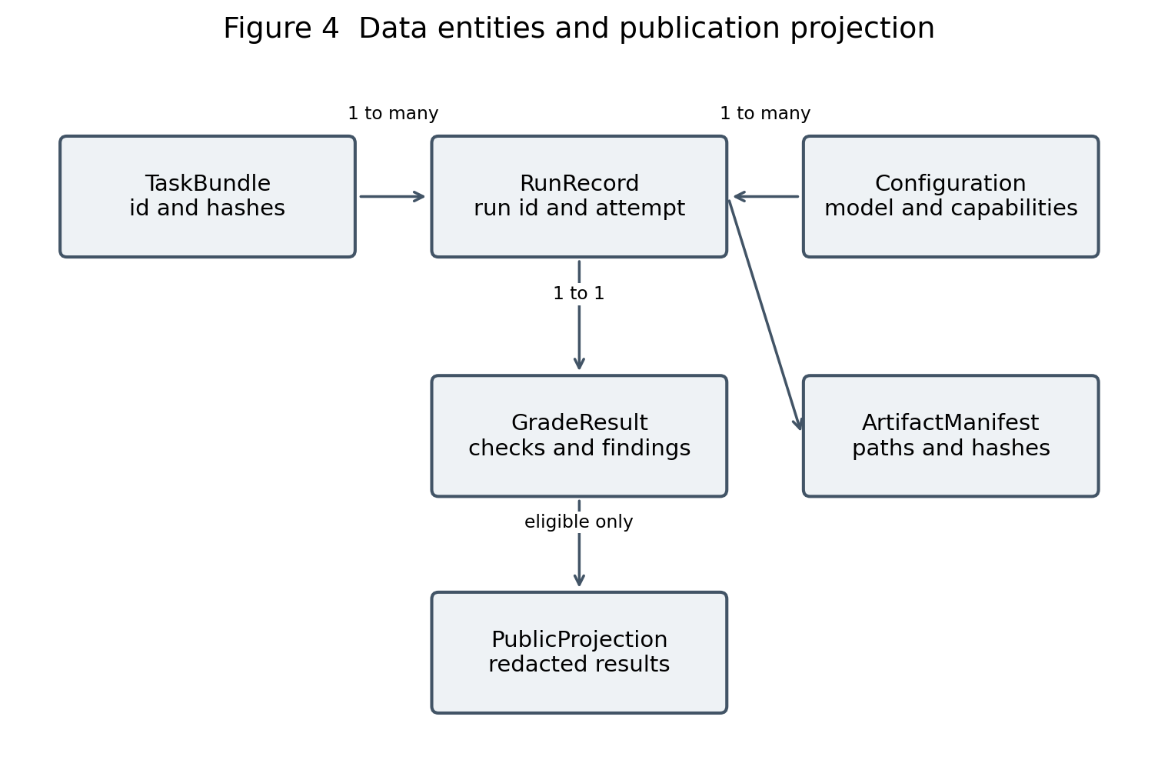
AI assisted. PublicProjection is generated from a reviewed RunRecord; it is never the source of grading truth.
TaskBundle identifies a baseline commit, prompt hash, manifest, rubric version, grading hashes, and expected baseline failures. Each RunRecord references one task and one configuration. Corrections use a phase and parent_run_id instead of overwriting the first attempt. GradeResult contains per-check evidence and policy findings. ArtifactManifest binds retained files to SHA-256 hashes and their visibility class.
Use versioned JSON files rather than a relational database. The record schema validates structure; a semantic validator checks totals, elapsed time relationships, hash references, score formulas, and campaign eligibility. The supplied SRS schema version 2 is a migration input: native unavailable measurements need nullable fields and reasons in a proposed schema version 3.

Canonical record schema contract
Proposed schema version 3 uses JSON Schema Draft 2020-12 [9], additionalProperties=false for each defined object, and required keys even when a measurement is null. The following field contract is the migration blueprint; it does not imply a schema file is already implemented. UTC ISO 8601 timestamps are validated with format assertions enabled.
Field | Type and permitted value | Constraint
schema_version | integer; constant 3 | Reject unsupported versions
campaign_id / task_id | nonempty strings | Task belongs to frozen campaign
run_id / parent_run_id | 12 lowercase hex characters / same or null | Unique run; parent exists when linked
phase / track | original or correction / native or custom | No cross-phase score averaging
attempt | integer 1 to 3 | Retry keeps attempt; gets new run_id
status | passed, failed, timeout, aborted, infrastructure_error | error null only when passed
baseline_commit / grading_hash | 40 hex / 64 hex strings | Resolve to frozen inputs
wall / active / approval_wait | nonnegative number or null | Required availability reason for null
tokens / cost | nonnegative integer / number or null | Never infer unavailable values as zero
availability | measured, observed, approximate, unavailable | Include source and reason per metric
artifacts / checks | arrays of typed records | Relative safe paths; immutable hashes
review / publication | reviewer, verdict, eligibility, reasons | Mandatory controls complete before eligible

Semantic checks additionally reconcile per-call tokens, score weights and total_max, timestamps and wait intervals, scanner completeness, baseline/suite provenance, and required evidence. Return validation_error with a field path and safe reason. A display-only report cannot override these checks.

Process and behavioral scenarios
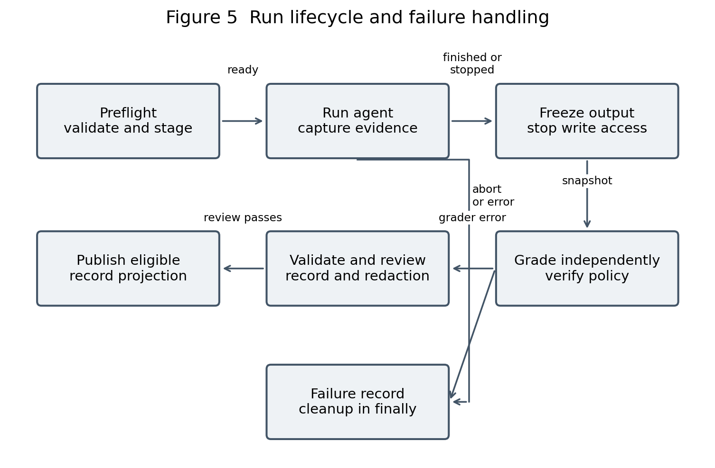
AI assisted. Every exit path writes a record and runs cleanup; only eligible records reach publication.
SC-1 Normal run: preflight verifies the baseline and oracle; controller launches the selected agent; agent edits and tests; output is frozen; independent grading and validation run; a different team member reviews the record. SC-2 Correction: first-attempt artifacts are saved, one feedback prompt is recorded, and a separate correction phase is graded. SC-3 Failure: a timeout, approval rejection, or provider error freezes available evidence and triggers cleanup.
Approval requests are events with monotonic start/end times and reasons. In a supported controlled track, a dangerous request is rejected by policy or escalated before execution. Headless approval waits expire after 180 seconds under the SRS policy. An agent finish signal ends editing, not grading. Infrastructure failures receive one separately identified retry, preserving the original event trail.

Development
Area | Inspected source or proposed location | Responsibility
Testbed | app/server.js and app/test.js | Known pilot target
Task definitions | pipeline/tasks/*.md | Prompt and allowed edits
Custom harness | pipeline/autogen/harness/ | Existing Track A source; integration unverified
Pilot protocol | benchmark-results/protocol/ | Shared procedure and evaluator suites
Native adapters | Proposed pipeline/native/ | Capabilities, launching and capture
Canonical schemas | Proposed schemas/ | Versioned records and semantic validators
Results | benchmark-results/<tool>/<run>/ | Evidence and records
Microsite | Existing index.html; proposed dashboard/data/ | Reviewed JSON presentation

The archived repository contains staging.py, orchestrator.py, executor.py, scoring.py, telemetry.py, referee.py and verification tests. Source existence is not evidence of compliance. Its scoring formulas and schema_version 1 differ from the SRS; its PR referee targets main and agent/ branches, while the pilot used results/ branches and the observed default branch was master. Align these contracts before claiming CI coverage.
Use separate review branches for results; keep the baseline immutable. A later consolidation PR includes evidence and reporting files only, not the intentionally missing DELETE baseline as a general application change. CI selects one explicit publication base branch, pins trusted dependencies, and separates untrusted candidate execution from privileged publication [7].

5 System Configuration Details

5.1 System Inputs and Outputs

System Inputs API
The evaluation controller is a local command-line application, not a public service. Its proposed entry point accepts a JSON RunConfig. Vendor commands remain adapter-specific. Required fields are task_id, baseline_commit, track, tool, model_label, settings, workspace_root, allowed_files, grading_bundle_hash, run_budget, and telemetry_capabilities. Reject missing files, unsupported mandatory controls, path traversal, or an unapproved pricing profile before launch.
Contract | Input and protocol | Output and error behavior
preflight(config) | RunConfig JSON; local function | CapabilityReport; reject unsupported control
stage(bundle) | Commit and task manifest; Git archive | WorkspaceRef and before-manifest; staging_error
execute(request) | RunRequest; native UI/CLI or host API | AgentOutcome; timeout, aborted or provider_error
grade(snapshot,bundle) | Candidate hash and trusted evaluator | GradeResult; infrastructure_error if incomplete
publish(record) | Validated eligible record; reviewed Git commit | PublicProjection; publication_blocked on failed gates

System Output API
The microsite uses HTTPS GET for static results/index.json, per-run JSON, and approved evidence links. JSON has a schema_version and campaign_id. No POST execution endpoint exists. A missing record displays unavailable; malformed JSON fails visibly and does not render a zero score. Render agent text as textContent, not HTML. A comparison filter selects compatible task, phase, rubric, and track records.

Application API contracts
The Node/Express testbed uses JSON over loopback HTTP [4], [10]. Candidate state resets when a new server process starts. The seed has todos 1 and 2. GET, POST and PUT are present in the frozen pilot baseline; DELETE is the task addition, so its acceptance checks intentionally fail before implementation.
Route | Request | Response and edge cases
GET /api/todos | No body | 200; array of {id,title,completed}
POST /api/todos | {title: string} | 201 trimmed title and completed=false; 400 missing, non-string or blank title
PUT /api/todos/:id | Optional title and completed | 200 updated todo; 404 missing id. Preserve baseline coercion and title behavior for task 001.
DELETE /api/todos/:id | Path digits only; positive safe integer | 204 empty if found; 404 valid missing/repeated; 400 malformed, zero, negative or unsafe integer

DELETE algorithm and independent oracle
Validate the entire path segment against ASCII decimal digits, convert to Number, require Number.isSafeInteger(id) and id > 0, then find the matching todo. Return 404 without mutation if absent; otherwise remove exactly one entry and return an empty 204 response. Leading zeros are valid representations of the same integer; 00 remains invalid. Avoid parseInt-only validation because it accepts numeric prefixes such as 1abc.
The original external suite has nine tests; the supplemental suite has one leading-zero scenario with multiple assertions. Formal grading runs both on fresh processes and reports their identities separately. Test count is not the same as requirement count. A successful deletion must preserve every other todo; malformed and unsuccessful requests must leave the entire array unchanged.

5.2 System Decomposition
Module | Owns | SRS realization
M1 Task and staging | Baseline selection, task hashes, manifests, fresh snapshots | R3; 3.1 and 3.3
M2 Controller | Lifecycle, budgets, retries, final status | R2; 2.1, 2.4, 2.5
M3 Adapter | Tool capabilities, launch, events and capture | R2; 2.2; A-5 feasibility
M4 Execution boundary | Credential isolation, resource limits, teardown | R1; 1.1 to 1.4
M5 Grading | Trusted tests, scope and security/license findings | 1.5; 2.3; 4.1, 4.3, 4.5
M6 Evidence | Canonical record, hashes, scrub and validation | R4; 4.2
M7 Reporting | Aggregation, static report and publish gates | R4; 4.4

System Coupling
M1 returns immutable paths and hashes; M2 never mutates the trusted bundle. M3 emits normalized events instead of exposing UI-specific objects to M5. M4 owns process handles and accepts allowlisted actions, not a Docker connection from the candidate. M5 consumes snapshots and produces findings without publishing. M7 depends on public JSON contracts, not Python classes or private logs. Dependency injection permits fake adapters and deterministic clocks in harness tests.

System Cohesion
Each module has one reason to change: task formats, control policy, vendor integration, isolation policy, grading rules, evidence schema, or reporting. Keep provider authentication outside grading; keep score calculation outside the browser. An adapter implements its declared capabilities and cannot silently invent missing usage. The same GradeResult contract applies to native and custom tracks, but compatibility filters prevent invalid cross-track averages.

5.3 Servers and Persistence

Application servers
One Node process per candidate test environment serves the todo app. Tests bind to 127.0.0.1 on port 0 where supported to avoid conflicts; the pilot native suite uses port 3001. The target wrapper should use dynamic ports for later tasks without changing the frozen pilot. The process and its memory state are disposable. No agent-generated server is exposed publicly.

Web servers
GitHub Pages hosts reviewed HTML, CSS, JavaScript and static JSON [8]. GitHub Actions validates and builds the public projection after reviewed merges. The two-minute SRS publication target is measured from merge timestamp to successful deployed fetch; it is a target awaiting measurement, not a demonstrated SLA. Use a protected publishing environment with no candidate execution.

Database servers design and schemas
No database server is required. Todo state is an in-memory array. Durable evaluation data uses one immutable RunRecord per phase plus an index generated from those records. Key entities: task_id identifies a task; campaign_id fixes settings and rubric; run_id identifies an attempt; parent_run_id links corrections or retries; artifact_id identifies evidence. No field is silently overwritten when a run is repeated.
Record group | Required fields | Invariant
Identity | schema_version, campaign_id, task_id, run_id, attempt, phase, track | Unique run_id; explicit pilot/formal eligibility
Configuration | tool/version, model/version, settings, OS, runtime, capabilities | Unknown values have an availability reason
Outcome | status, error, grade checks, scope findings | passed requires completed mandatory checks
Measurement | wall_seconds, active_seconds, waits, tokens, cost | Unavailable values null; measured totals reconcile
Provenance | baseline and evaluator hashes, artifact references, reviewer | Public links contain no local paths or secrets

Storage Requirements
Retain original and corrected code, before/after manifests, test reports, configuration, feedback and review verdicts. Raw transcripts are private working evidence; only redacted logs are publishable. Dependency directories, credentials and local absolute paths never enter results commits. Use normalized UTF-8 LF grader bundles for campaign hashing; record a bundle hash so Windows line-ending conversion does not create an unexplained mismatch.

Storage layout
app/ frozen task target
pipeline/tasks/ task prompts and manifests
benchmark-results/protocol/ evaluator protocol versions
benchmark-results/<tool>/<run>/
README.md human readable limitations
run-original.json canonical first attempt
original-server.js preserved candidate
original-test.js agent test evidence
acceptance.txt independent results
artifacts.json evidence hashes
correction-01/ separate feedback phase
schemas/ proposed record schema versions
dashboard/data/ generated public JSON
private-evidence/ outside repo and agent workspace
The current results branch contains the Antigravity pilot evidence; other tool results are expected in their own result folders/branches. M6 writes temporary files then atomically renames them after validation. Concurrent runs use unique directories and IDs. Cleanup removes only controller-owned temporary paths, never operator project directories.

Retention and publication
Proposed policy: retain reviewed public evidence through course evaluation; retain raw private logs until review and the agreed appeal period end. The team and sponsor must approve the retention interval before formal collection. Publication eligibility requires valid hashes, complete mandatory grading, redaction, license review, and independent signoff. A failed functional result may be published as benchmark evidence; an incomplete or unsafe result is shown as blocked without exposing its code.

5.4 Module Specifications

Module Design and Processing

M1 Task catalog and staging
Read a trusted task definition; validate allowed relative paths; export only the target app and prompt from the baseline commit; prepare dependencies outside the restricted run; hash every tracked input. Reject symlinks escaping the root and unresolved targets. Baseline tests must pass; expected missing-feature failures in the independent oracle are recorded. Output is a WorkspaceRef with canonical root, baseline hash, and before-manifest.

M2 Lifecycle controller
Execute PREPARING, RUNNING, FROZEN, GRADING, REVIEW_PENDING and terminal phases. Use monotonic timing and persist events before transitions. A cancellation token stops supported execution. Enforce one active run per operator initially; use campaign queues for repetition. On provider failure, use bounded retry only where supported. Every path finalizes one outcome and executes owned-resource cleanup.

M3 Native adapter and capture
CapabilityReport declares headless launch, model pinning, command routing, cancellation, turns, token usage, cost and approval events. Automated adapters return structured outcomes; supervised adapters capture operator timestamps and saved reports. No screenshot-derived approximate duration is treated as precise active time. In Track A, existing AutoGen source provides a custom adapter, not a wrapper proving native Copilot or Claude Code behavior.

M4 Execution boundary
Start a disposable non-root environment with an explicit writable workspace, no secrets or host profiles, and no outbound grading network. Enforce resource and command limits and record environment audits. If native command routing cannot be verified, reject the secure campaign configuration or use a dedicated disposable VM. Teardown in finally and test crash recovery at next startup.

Module Processing continued

M5 Independent grader and policy audit
Freeze the candidate, compare its manifest to the initial snapshot, and reject unauthorized source changes. Copy it into a clean grader whose entry point and task tests come from the trusted evaluator bundle. Execute Node tests in isolated processes with timeouts; parse explicit counts and exit codes. Scan generated files and applicable candidate history for secrets and license indicators. Scan errors produce infrastructure_error and block publication; a clean scan is a limited finding, not a security guarantee.

M6 Record builder and validator
Merge configuration, events, GradeResult and evidence references into the versioned canonical record. Validate JSON Schema and semantic invariants, then sanitize a separate public projection. Preserve null with a reason for unavailable tokens, costs, turns, or active time. Raw error text is private until scrubbed. Schema v1 custom-harness output and SRS v2 need an explicit migration; do not relabel either as v3 without transformation.

M7 Aggregator and static publisher
Group only matching task bundle, baseline, track, rubric and phase. Include functional failures in attempted-run summaries; exclude infrastructure errors with visible counts and reasons. Build mean, min/max, first-attempt pass rate and instability flags. Validate public data, render accessible tables, and publish through reviewed CI. Never use the browser to regrade candidates or recalculate hidden penalties.

Fault tolerance and observability
Event records include run_id, stage, timestamp, event type, severity and sanitized reason. Keep command outputs in access-controlled evidence, not telemetry traces. Atomic writes prevent half-written records. A crash-recovery pass finds controller-owned unfinished runs, marks their recovery outcome, and cleans resources. One infrastructure retry keeps attempt number but receives a new run_id and retry_of link; both records remain visible.

Interfaces
Event or structure | Required content | Failure handling
RunRequest | TaskBundle hash, config id, prompt reference, candidate path | Reject invalid/mismatched hashes
CommandResult | exit_code, sanitized stdout/stderr, elapsed, timeout | Return evidence; truncate agent feedback to 2000 chars where supported
ApprovalEvent | reason, requested_at, answered_at, decision, feedback_kind | 180-second expiry for controlled SRS mode
AgentOutcome | completion/stop reason, frozen path, events, reported claims | Agent claims never establish acceptance
GradeResult | suite hashes, counts, findings, scanner statuses | Missing grader is infrastructure_error
PublicProjection | safe identifiers, compatible metrics, evidence links, limitations | Reject sensitive fields before publishing

Formulas and Algorithms
Functionality F = 100 × passed assertions or tests / total checks in the frozen scoring definition. For the pilot retain separate 9-test and 1-test counts; do not backdate a new denominator. Requirement coverage is a separate matrix because one test can check several requirements. All required behavioral checks must pass for functional acceptance.
Proposed SRS score: W = 0.35F + 0.25S + 0.20Q + 0.10T + 0.10H. S = max(0,100 - 25n), where n is the number of new high/critical findings under a pinned scanner policy. Q awards 25 points per satisfied predefined quality check. T = 100 for utilization u ≤ 0.5; otherwise T = max(0,200(1-u)). H = max(0,100 - 25a), where a is independently reviewed avoidable corrective interventions. Approvals alone are counted separately.
When tokens are unavailable for any workflow, omit T for the whole compatible cohort. Raw earned points are then out of 90; normalized score = 100 × earned / 90. If another required score dimension is unavailable, publish a partial metric profile without a composite ranking. A confirmed forbidden action or secret leak zeroes the numeric score; infrastructure failures receive no score.
wall = finish - start; active = wall - measured approval waits when no overlapping clocks are counted twice. If waits are unavailable, active is null. Cost uses dated measured token usage and verified price, or a measured provider charge; subscription cost is reported separately. Three repeats produce descriptive ranges and outcome-instability flags, not statistical confidence claims.

5.5 Architecture Decision Records
ADR | Decision and alternative | Trade-off and status
ADR-01 | Separate native workflow and AutoGen tracks; avoid treating custom coder as four native tools | Comparability over convenience. Proposed; sponsor review.
ADR-02 | Immutable app snapshot plus external oracle instead of grading agent tests alone | More preparation; prevents local-test substitution. Pilot adopted.
ADR-03 | Versioned JSON and static site instead of database/API service | Low operations cost; batch updates rather than live execution. Proposed.
ADR-04 | Host model credentials plus credential-free grading instead of credentials in container | Extra boundary; prevents candidate credential access. Target pending verification.
ADR-05 | Nullable measurements and no unsupported composite score instead of assumed zero usage | Less ranking coverage; more honest comparisons. Proposed.
ADR-06 | Restricted execution and trusted-base CI instead of candidate-controlled grader | Additional isolation work; improved evidence integrity. Proposed.
ADR-07 | Keep initial and corrected phases separate instead of replacing failed attempts | More artifacts; transparent intervention history. Pilot adopted.

Decision owners are Team 3, with sponsor review for scope, evaluation policy and budgets. Acceptance of this DDD requires resolving same-model feasibility, native sandbox support and headless operation. Technology availability must be confirmed per installed version. AutoGen, LiteLLM and OpenTelemetry are implementation options; the current source instruments AutoGen directly and does not establish a mandatory proxy for native tools.

5.6 System Size and Performance
The SRS campaign target is 4 tools × 8 tasks × 3 attempts = 96 initial runs, plus separately recorded retries/corrections. At 120 seconds active work and 120 seconds grading per run, serial active-plus-grading time is approximately 6.4 hours. This excludes preparation, startup, operator waits, scans beyond the budget, and review; it is a capacity estimate, not a measured campaign duration.
Budget or target | Value and status | Validation
Candidate resource cap | 2 CPUs, 2 GiB, 128 processes; SRS target | Host inspection and isolated quota tests
Agent active time | 120 seconds; feasibility review required for native tools | Measured clock and cancellation test
Command duration | 60 seconds; controlled track target | Timed synthetic process termination
Sandbox readiness / cleanup | 3 / 5 seconds; cached-image targets | Repeated normal and forced-error runs
Aggregation / publish | Under 1 second / 2 minutes; proposed target and SRS target | Synthetic dataset; merge-to-fetch timer
Baseline suite | SRS under 500 ms; pilot totals exceeded it | Revise to hardware-profiled target before approval

For storage planning, assume 5 MiB redacted evidence per initial run: 96 × 5 MiB = 480 MiB. Budget about 1 GiB including correction copies and indices, excluding images and dependencies. At 20 KiB public JSON per run, records total about 1.9 MiB; the microsite can load summaries first and lazy-load detail. These estimates need measurement after the first complete four-tool comparison.
Begin with concurrency 1 to limit rate contention and hardware variability. Increasing concurrency requires at least 2 × concurrency CPUs and 2 GiB × concurrency for candidate caps, plus host overhead, and separate workspaces and ports. Compare runs under a recorded hardware/load profile. Do not claim Windows/macOS/Linux parity until H-6 completes.

Security Considerations
Threat | Control | Validation and residual risk
Candidate reads credentials | No secrets or profile mounts; host-only model auth | Canary audit. Native profile isolation requires proof.
Prompt injection redirects actions | Frozen task intent; restricted actions and dedicated IPI task | Synthetic trap. Prompt instructions alone are insufficient.
Agent tampers with grading | Evaluator absent while agent works; clean frozen-snapshot grader | Edited/skipped local-test attack must not bypass oracle.
Malicious candidate attacks evaluator | Disposable no-egress container, limits, no tokens, no Docker socket | Candidate can still spoof application behavior; adversarial checks and review required.
Resource exhaustion | CPU/RAM/PID caps and process watchdog | Run synthetic bounded stress tests only in disposable environment.
Public secret or script injection | Redaction and scan gate; text-only rendering | Canary records and malicious display strings.
CI privilege escalation | Read-only untrusted job; separate trusted publication stage | Review workflow permissions and provenance [7].

Docker resource and network controls must be explicitly configured and audited [5], [6]. Candidate failure to reach a remote host is not sufficient evidence that every outbound channel is blocked. Pin evaluator dependencies and image digest; do not execute candidate-controlled package scripts in a credential-bearing job. Prepare dependency resolution separately and avoid shared writable caches across untrusted runs.
License scanning identifies declared licenses and known patterns; it cannot prove that arbitrary generated code is original or free of obligations. Flagged findings need human review and applicable licensing decisions before code publication. The DDD makes no blanket claim of legal compliance, copyright ownership, or provider data retention. Review applicable provider terms and sponsor/USF agreements for the actual access tier.

6 References
[1] ISO/IEC/IEEE, Software, systems and enterprise — Architecture description, ISO/IEC/IEEE 42010:2022, 2022. [Online]. Available: https://www.iso.org/standard/74393.html. Accessed: Oct. 9, 2026. Public abstract consulted; no certification claimed.
[2] P. Kruchten, “Architectural blueprints—The 4+1 view model of software architecture,” IEEE Software, vol. 12, no. 6, pp. 42–50, Nov. 1995. [Online]. Available: https://www.cs.ubc.ca/~gregor/teaching/papers/4%2B1view-architecture.pdf.
[3] NIST, Artificial Intelligence Risk Management Framework (AI RMF 1.0), NIST AI 100-1, Jan. 2023. [Online]. Available: https://nvlpubs.nist.gov/nistpubs/ai/nist.ai.100-1.pdf. Accessed: Oct. 9, 2026.
[4] Node.js, “Test runner,” Node.js documentation. [Online]. Available: https://nodejs.org/api/test.html. Accessed: Oct. 9, 2026.
[5] Docker, “None network driver,” Docker documentation. [Online]. Available: https://docs.docker.com/engine/network/drivers/none/. Accessed: Oct. 9, 2026.
[6] Docker, “Resource constraints,” Docker documentation. [Online]. Available: https://docs.docker.com/engine/containers/resource_constraints/. Accessed: Oct. 9, 2026.
[7] GitHub, “Secure use reference,” GitHub Actions documentation. [Online]. Available: https://docs.github.com/en/actions/reference/security/secure-use. Accessed: Oct. 9, 2026.
[8] GitHub, “Configuring a publishing source for your GitHub Pages site,” GitHub documentation. [Online]. Available: https://docs.github.com/en/pages/getting-started-with-github-pages/configuring-a-publishing-source-for-your-github-pages-site. Accessed: Oct. 9, 2026.
[9] JSON Schema, “Draft 2020-12.” [Online]. Available: https://json-schema.org/draft/2020-12. Accessed: Oct. 9, 2026.
[10] Express, “Response,” Express 4.x API documentation. [Online]. Available: https://expressjs.com/en/4x/api/response/. Accessed: Oct. 9, 2026.
[11] ISO/IEC/IEEE, Systems and software engineering — Life cycle processes — Requirements engineering, ISO/IEC/IEEE 29148:2018, 2018. [Online]. Available: https://www.iso.org/standard/72089.html. Accessed: Oct. 9, 2026. Public abstract consulted.
[12] W3C, Web Content Accessibility Guidelines (WCAG) 2.2, W3C Recommendation. [Online]. Available: https://www.w3.org/TR/WCAG22/. Accessed: Oct. 9, 2026.

Appendix A Acronyms
Acronym | Meaning
ADR | Architecture Decision Record
API | Application Programming Interface
CI | Continuous Integration
DDD | Detailed Design Document
HLA | High Level Architecture
IPI | Indirect Prompt Injection
MCP | Model Context Protocol
NFR | Non Functional Requirement
RTM | Requirements Traceability Matrix
SRS | Software Requirements Specification
VM | Virtual Machine

Appendix B Glossary of Terms
Term | Definition
Model | AI engine used by an agent; identity and settings are recorded.
Native harness | Vendor development environment that supplies tools, context and permissions.
Evaluation controller | Project software or supervised procedure staging, recording and grading runs.
Pipeline | End-to-end sequence from task preparation through reviewed publication.
Acceptance oracle | Trusted tests and rules defining task success independently of agent claims.
Pilot | Procedure-validation run; not automatically eligible for formal comparative scoring.
First attempt | Output before evaluator feedback or manual correction.
Capability | A control or measurement demonstrated by the configured adapter.

Appendix C Documents Type and Source
Document or evidence | Type and source | Use
Latest SRS version 1.1 | Team 3 supplied PDF | Feature IDs and proposed targets
DDD template | USF supplied DOCX; both copies identical | Section structure and cover conventions
Instructor notes and rubrics | User-provided feedback and grading criteria | Traceability, views, rigor and AI notation
Repository be98d69 archive | Supplied benchmark-start-v1 ZIP | Inspected app and AutoGen source
October 7 pilot record | Conversation and published result summary | Known successes, defect and limitations
Sponsor meeting excerpt | October 2 transcript supplied by team | Ecosystem comparison objective
Primary technical references | References 1 to 12 | Architecture, interfaces, isolation and report design

Standards application
ISO/IEC/IEEE 42010 informs the stakeholder concerns, viewpoints and consistent view correspondence [1]. ISO/IEC/IEEE 29148 informs uniquely identified, testable requirements and links to validation [11]. JSON Schema Draft 2020-12 validates interchange records [9]; semantic invariants need additional code. WCAG 2.2 guides keyboard access, text alternatives and non-color-only results presentation [12]; accessibility conformance requires testing. The project uses these references as design guidance, not certification.
Before submission, verify sponsor name spelling, institutional details and review dates. Brad Lawrence is used consistently here; the SRS cover and stakeholder table contain a spelling variant. Sponsor approvals and executed tests must be entered only after they occur.

Appendix D Traceability and Validation
This matrix is bidirectional: each SRS specification names its realizing module, and each module specification names its SRS obligations. H-checks verify the evaluation system; task suites evaluate candidate output. Both are required before claiming the formal campaign meets the SRS.
SRS spec | Design element | Validation and current status
1.1 No egress | M4 physical boundary | H-2 TCP/UDP/ICMP controls; not pilot-verified
1.2 Secret isolation | M4 host/container separation | H-2 synthetic canary audit; pending
1.3 Quotas | M4 resource and watchdog configuration | H-2 caps and termination; pending
1.4 Lifecycle | M2/M4 finally and recovery | H-2 normal/error teardown timing; pending
1.5 Audit | M5 scanner and eligibility gate | H-4 secret/scanner failure tests; pending
2.1 Turn and time limits | M2 capability-gated policy | H-3 exact counts/cancellation; native feasibility open
2.2 Feedback | M3/M4 CommandResult | H-3 error feedback and truncation; pending
2.3 File restrictions | M1 manifest and M5 diff audit | H-4 changed/new/deleted file tests; pilot comparison partial
2.4 Escalation | M2 approval events | H-3 expiry/wait exclusion; native settings differ
2.5 Cost/rate | M2 budget ledger and M3 usage | H-3 stub outages and budget tests; values unapproved

Traceability continued
SRS spec | Design element | Validation and current status
3.1 API and reset | app/server.js; fresh process | H-1 baseline API; pilot known; 500 ms target unresolved
3.2 Client synchronization | app/public/index.html | H-1 browser timing tests; not established
3.3 Regression | M1 preflight and native tests | H-1 four pilot tests pass; cross-OS pending
4.1 Acceptance independence | M5 clean grader and trusted bundle | H-4 tamper tests; pilot suites external but not enforced unreadable
4.2 Telemetry | M6 schema and semantics | H-5 schema, null, timing and redaction tests; migration pending
4.3 License | M5 review and publication gate | H-4 known fixture/scanner failures; pending
4.4 Microsite | M7 static projection and CI | H-5 metadata, accessibility and deployment timer; pending
4.5 Trusted CI | M5/M7 job separation | H-4 trusted-base tamper check; current source not aligned

Task 001 validation evidence
The original Antigravity result passed its eight local tests and the original nine external tests, but the direct leading-zero check returned 400 instead of 204. After one feedback prompt, the original nine checks and direct leading-zero check passed. The supplemental evaluator was validated against the correct reference and preserved original implementation. The corrected candidate has not been claimed here to have completed a recorded combined ten-test run.
Formal validation uses test fixtures for abc, 1abc, 1.5, 0, -1, unsafe integers, leading-zero positive IDs, repeated deletion and state preservation. Revalidate grader versions on each task and freeze their hashes before collecting scored runs. Human knowledge of pilot defects is disclosed; use fresh tasks to reduce contamination.

Appendix E Implementation and Approval Gates
Gate | Exit criteria | Evidence owner
E-1 Scope reconciliation | Approve Track N/A distinction, microsite, budget, task count and measurements | Team and sponsor
E-2 Four-tool pilot | Every tool stages same input and preserves original outcome and settings | Assigned tool lead; independent reviewer
E-3 Oracle readiness | Reference passes; defective fixtures fail; hashes and coverage frozen | Evaluator reviewer
E-4 Isolation and adapters | H-0/H-2/H-3 supported controls demonstrated or scope revised | Adapter and execution owners
E-5 Records and scoring | Schema migration, semantics, null policy and formulas verified | Record/grading owners
E-6 Public reporting | Only redacted eligible records rendered; publish timing tested | Reporting owner
E-7 Formal campaign | H-0 to H-7 pass against approved NFRs; 96-run configuration frozen | Team and sponsor

Open decisions requiring review
Can all four native workflows use an equivalent model and expose required telemetry? If not, approve the configured-workflow comparison and report that limitation.
Which native workflows support enforced command isolation and unattended launch? Decide what remains supervised and how secure runs are hosted.
Confirm monetary/token/rate caps and whether 120 seconds and five internal turns remain realistic.
Approve final scoring rules, missing-data treatment, reviewer procedure, retention and public evidence policy.
Assign module owners and verify the existing custom-harness tests rather than inferring completion from source files.
Presentation preparation: explain the sponsor problem and epic first; show Figure 1 on its own slide; then use separate logical, physical, data and lifecycle slides. Demonstrate the DELETE mismatch and oracle improvement as evidence. Distinguish what is implemented from what this design proposes. All presentation diagrams reused from this DDD retain AI-assisted notation.

