Advantages and pitfalls of migrating from C/C++ to Rust with respect to memory safety bugs

Bruno Martins

bm2787

Section 1: Abstract
Systems software has long been dominated by the use of the low level programming languages C and C++: the Linux kernel, game engines and every major web browser are some of the most prominent examples of such systems. However, while C and C++ are the go-to languages to extract the most performance out of the hardware, they lack important safety features to prevent potentially catastrophic errors such as null pointer dereferences and buffer overruns. While such bugs in C/C++ code can potentially be detected by modern static analysis tools, Rust, a new programming language by Mozilla, claims to have eliminated entire classes of bugs at the language level by leveraging its unique type system. This paper looks into these claims, first by performing a review on a state-of-the-art static analyzer, Infer, then by evaluating the use of Rust in a real world stable production system, EPICS. Known race conditions, null dereferences and buffer overrun bugs in EPICS were reimplemented in Rust to evaluate both Rust's ability to detect them and how easy such reimplementations were. The reader is expected to learn about the Rust programming language, its strengths in bug prevention and the feasibility and potential pitfalls of migrating an existing C/C++ program into Rust.

Section 2: Introduction
(This section will expand on the problem statement given in the abstract. It will explain the different classes of bugs being considered in this paper and why Rust might be a good alternative to C/C++ for systems programming. This section will also explain how the paper is structured. Also, the two main questions investigated by this paper will be posed:
1. Does Rust prevent bugs?
2. Is it straightforward to translate C/C++ programs into Rust?)

Section 3: Background

Subsection 3.1: Formal reasoning (state of the art)
(Here I will present a review of Hoare logic [1] and separation logic [2], which are used in the Infer [3] static analyzer. Then I will talk about Infer itself. The point is to contrast the approach that has to be taken to analyze a C/C++ program (i.e. running a whole separate program that may/may not catch bugs) with the safety provided at the language level by Rust.

Rust is not completely free from all bugs, of course, so I will mention efforts to verify Rust "unsafe code" by exhaustive test generation [4], regular program verification by symbolic execution [5], type checker verification by fuzzing [6], and formal verification by using separation logic [7]. I think this paragraph could be an entire section maybe.)

Subsection 3.2: Rust
Rust is a new systems programming language, developed by Mozilla, focused on safety, speed and concurrency [8]. The first stable release of the language, dubbed version 1.0, was released on May 2015. Rust development was driven chiefly by the concurrent development of the Servo web browser engine, also by Mozilla. Rust's advanced type system helped Servo developers to better address common security issues while still producing code with good performance and similar memory usage [9].
Rust's strength lies in its type system.

(In this section I will expand on Rust's type system, provide a few code snippets so the reader can get a feel for the language, and then show how Rust catches (or prevents) null deref, buffer overrun, resource leaks)

Subsection 3.3: EPICS - Experimental Physics and Industrial Control System
The EPICS framework [10] is a set of open source software libraries and tools, written in C and C++, designed to fulfill the role of a SCADA (Supervisory Control And Data Acquisition) system for big science facilities and industrial plants. EPICS has a distributed nature: its main component is the IOC (Input/Output Controller), which is responsible for communicating with physical devices and making their accepted commands and captured data available to the network via PVs (Process Variables). The PVs in an IOC are considered part of a Distributed Run Time Database. Other EPICS components, like graphical user interfaces, data archivers and user scripts, interact with the IOCs (and therefore the devices they control) by reading from and writing to the available PVs on the network, via one of two existing protocols: Channel Access [11] or PV Access [12]. Channel Access, the older of the two, is capable of transporting scalar and array values only, along with their metadata. PV Access, on the other hand, can transport arbitrarily structured data. A simplified diagram of EPICS' architecture is shown in Figure 1.
EPICS is used in different kinds of scientific facilities across the world [13]: particle accelerators, observatories, telescope arrays, research fusion reactors and many others. Given its widespread use and the critical role it performs, it is of paramount importance that its central component, the IOC, doesn't crash.
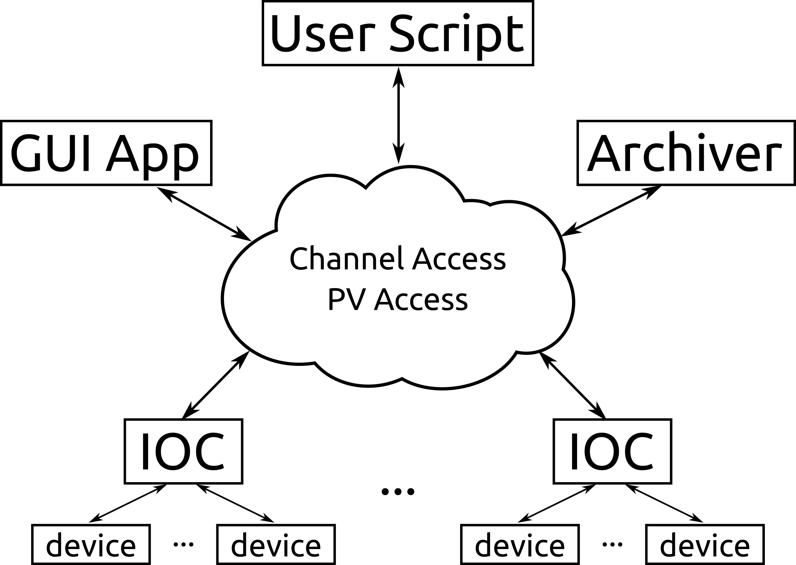Figure 1: Simplified EPICS architecture
(I can expand more if needed. I feel that this section is just for the reader to get a feel for the complexity of the software being modified to use Rust)

Section 4: Methodology
In order to evaluate Rust's safety features, an existing mature open source project, EPICS, was chosen to be the subject of this study. First, a custom tool was developed to help analyze and classify issues in the EPICS' issue tracker, hosted in Launchpad. The issues, selected from the pool of issues with existing fixes, were classified into ten broad classes, which will be described in the next section. Then, 6 individual bugs from different classes were chosen to be reimplemented in Rust, in order to test Rust's ability to detect the existing issues with the code.

Subsection 4.1: Issue classification
EPICS, being almost three decades old, has a long history in its issue tracker. Currently, EPICS' core components use Launchpad as their issue tracker, having migrated from Mantis circa 2002. Other, newer components live on GitHub, and use GitHub's issue tracker. In this study, only Launchpad's issues were considered.
Since the goal of this paper is to evaluate Rust's ability to catch bugs, we chose to filter the issues by the tags "Fix Committed" and "Fix Released", so we can be more certain about the class each issue belongs to. As of the writing of this paper, there are 413 issues that have either the "Fix Committed" or the "Fix Released" tag. In order to help sift through and classify the issues in a reasonable amount of time, a custom classifier tool was developed to query Launchpad's servers via its API, present the information in a web page in a convenient form and store the classification information in a SQLite database, so it can be queried later. A screenshot of this tool is shown in Figure 2.
The issue classifier presents a list of issue ID numbers on the left column, ordered from most to least recent, according to one of three categories: All, containing all available issues with "Fix Committed" or "Fix Release" tags; Unclassified, with issues that were not given any classification by the author; and Of Interest, which are a subset of the classified issues that will be reimplemented in Rust for this study.
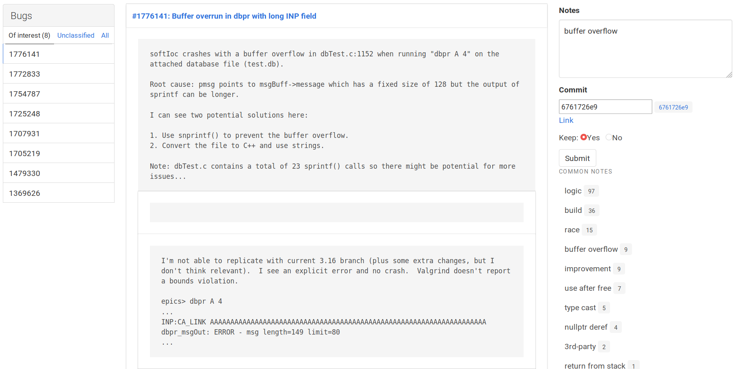Figure 2: Custom issue classifier
The center column contains the issue's ID and title, with an hyperlink to the issue's page on Launchpad, and the issue's description and comments below it.
On the right column there are a few fields of interest. The first one, named Notes, is a string corresponding to the issue classification given by the author. The second one, Commit, contains the commit hash in which the issue was fixed. The tool automatically looks at the version control history of the EPICS repository and searches for the issue ID in the commit messages. If the tool finds such a commit, it presents the commit hash as a suggestion, to the right of the input text box, that can be clicked to automatically fill that box. If a commit hash is present in the SQLite database, the tool presents a Link hyperlink to that commit's page on the GitHub mirror of the EPICS project. The last field, named Keep, serves as an indication of whether that particular issue will be put in the Of Interest group. By clicking the Submit button, the user causes the information that was entered to be committed to the database. Below the Submit button there is a list of classifications from other issues, presented in decreasing order of appearance. If the user clicks on a particular item from this list, the item's text is copied to the Notes field.
Figure 3: Issue classification chart
This custom tool enabled the author to classify the most recent 185 issues, spanning almost 10 years, in a reasonable time frame. Each issue was put in one of ten categories, as shown in Figure 3, at the author's discretion:
- Logic: issues of this class are bugs on the software operation logic that don't cause the system to crash. These usually describe incorrect or unexpected behavior by the software and are not of interest for this study. There were 97 (52.4 %) issues classified as logic.
- Build system: the EPICS framework predates build systems such as CMake. Therefore, EPICS authors had to roll out their own build system, built on top of Makefiles, that can have different targets (Windows, Linux, RTEMS, vxWorks, etc). Issues in this class refer to bugs in the EPICS build system itself, and are not of interest for this study. There were 36 (19.4 %) issues classified as build system.
- Race condition: a number of issues arose from race conditions between EPICS many execution threads. These threads often communicate via shared memory, which can easily lead to issues if data access is not properly synchronized. Rust claims to be capable of detecting this kind of issue using their concept of lifetimes and ownership. There were 15 (8.1 %) issues classified as race condition.
- Buffer overflow: issues that referred to out-of-bounds buffer reads and/or writes were classified as buffer overflows. Rust detects invalid accesses at runtime and safely stops the program (which Rust calls "panic"), instead of potentially allowing the program to continue like C and C++ can. There were 9 (4.8 %) issues classified as buffer overflow.
- Improvement: issues with this classification were not bugs at all; they were opened to request improvements or new features to be implemented. These issues are not of interest for this study. There were 9 (4.8 %) issues classified as improvement.
- Use after free: some issues referred to code that was attempting to use a resource after it had been released. Rust has the concept of lifetimes to prevent the use of a resource after it is "Dropped". There were 7 (3.7 %) issues classified as use after free.
- Type cast: a few issues arose from C/C++'s implicit type casting and from unaligned explicit casts on platforms that don't support unaligned access. Rust prevents this class of bugs by having a strict type system that requires explicit casting. There were 5 (2.7 %) issues classified as type cast.
- Null pointer dereference: issues of this nature refer to code that tries to dereference a pointer that was set to NULL. Rust can statically detect some cases of null dereference. There were 4 (2.1 %) issues classified as null pointer dereference.
- Third-party: EPICS relies on a few third-party libraries, such as yacc and flex, to build parsers for its Domain Specific Language for specifying IOC database files, and this class of issues refers to bugs with the interaction between EPICS and such libraries. Issues of this nature are not of interest for this study. There were 2 (1.0 %) issues classified as third-party.
- Return from stack: the single issue of this nature refers to a case where a function was allocating data on the stack and then passing that data to a second function to be run on a separate thread. Since the threads would run independently, there was no guarantee that the data seen by the second thread would remain valid. It is equivalent to a function simply returning a reference to data allocated on its stack. Rust can defend against this kind of bug with the concept of lifetimes. There was 1 (0.5 %) issue classified as return from stack.

Subsection 4.2: Bug reimplementation
As noted throughout the previous section, 6 classes of issues are subject of this study: race condition, buffer overflow, use after free, type cast, null pointer dereference and return from stack. One representative bug from each class was chosen to be reimplemented in simplified C or C++ and in Rust. Then, each pair of programs was compiled by their respective compilers and run, if compilation succeeded. The difference in behavior between compilers and compiled programs was then analyzed. All tests were run on an Intel i7-4700MQ CPU with 16 GB of RAM, running Ubuntu 18.04.2. The C and C++ compilers used were the system's gcc and g++, respectively, both at version 7.3.0. The Rust compiler version was 1.33.0, the latest one available at time of writing.

Subsection 4.2.1: Buffer overflow bug
A buffer overflow bug consists of writing to a buffer past its end. This kind of bug can lead to security vulnerabilities in which an attacker can potentially take control of the program. C and C++ do not check array reads or writes since these operations get translated to pointer arithmetic, which do not get bounds checked at all, as Kernighan and Ritchie put it:
Rather more surprising, at least at first sight, is the fact that a reference to a[i] can also be written as *(a+i). In evaluating a[i], C converts it to *(a+i) immediately; the two forms are completely equivalent. [14]
The EPICS issue # 1776141 was chosen as an example of this class of bugs.
(DESCRIBE BUG)
(DESCRIBE BEHAVIOR)
(DESCRIBE RUST)
 | Source Code | Compilation and Execution Results
C | #include <stdio.h>  typedef struct msgBuff {  char message[128];  } TAB_BUFFER;  int main(void) {  TAB_BUFFER buf;  char *type = "dummy";  char *pdbentry = "dummy";  // Write >128 chars  char *pfield_name =  "123456789012345678901234567890"  "123456789012345678901234567890"  "123456789012345678901234567890"  "123456789012345678901234567890"  "123456789012345678901234567890";  sprintf(buf.message, "%-4sL %s %s",  pfield_name, type, pdbentry);  return 0;  } | $ gcc -Wall -Wextra main.c -o main  $ ./main  *** stack smashing detected ***: <unknown> terminated  Aborted (core dumped)
Rust | struct MsgBuff {  message: [u8; 128]  }  fn main() {  let mut m = MsgBuff {  message: [0; 128]  };  let type_ = "dummy";  let pdbentry = "dummy";  let pfield_name =  "123456789012345678901234567890\  123456789012345678901234567890\  123456789012345678901234567890\  123456789012345678901234567890\  123456789012345678901234567890";  let formatted = format!(  "{:<4}L {} {}", pfield_name,  type_, pdbentry);  m.message.copy_from_slice(  formatted.as_bytes());  } | $ cargo build  Compiling bug1776141 v0.1.0 (/home/bmartins/comsw6156/paper/rust/bug1776141)  Finished dev [unoptimized + debuginfo] target(s) in 0.21s  $ cargo run  Finished dev [unoptimized + debuginfo] target(s) in 0.01s  Running `target/debug/bug1776141`  thread 'main' panicked at 'assertion failed: `(left == right)`  left: `128`,  right: `163`: destination and source slices have different lengths', src/libcore/slice/mod.rs:1965:9  note: Run with `RUST_BACKTRACE=1` environment variable to display a backtrace.

Subsection 4.2.2: Use after free bug

861214
 | Source Code | Compilation and Execution Results
C++ | #include <stdio.h>  struct Dummy {  int d;  Dummy(int d):d(d) {}  };  int main(void) {  Dummy *dummy = new Dummy(42);  delete dummy;  printf("%d\n", dummy->d);  return 0;  } | $ g++ -Wall -Wextra main.cpp -o main  $ ./main  0
Rust | #[derive(Debug)]  struct Dummy(i32);  fn main() {  let a = Dummy(42);  drop(a);  println!("{:?}", a);  } | $ cargo build  Compiling bug861214 v0.1.0 (/home/bmartins/comsw6156/paper/rust/bug861214)  error[E0382]: borrow of moved value: `a`  --> src/main.rs:7:22  |  6 | drop(a);  | - value moved here  7 | println!("{:?}", a);  | ^ value borrowed here after move  |  = note: move occurs because `a` has type `Dummy`, which does not implement the `Copy` trait  error: aborting due to previous error  For more information about this error, try `rustc --explain E0382`.  error: Could not compile `bug861214`.  To learn more, run the command again with --verbose.

Subsection 4.2.3: Type cast bug
1707931

 | Source Code | Compilation and Execution Results
C | #include <stdio.h>  int main(void) {  unsigned int u = 42;  if (u < 0)  printf("Should never happen");  int i = -42;  unsigned int u2 = i;  if (u2 < 0)  printf("Should never happen");  return 0;  } | $ gcc -Wall -Wextra main.cpp -o main  main.c: In function ‘main’:  main.c:5:11: warning: comparison of unsigned expression < 0 is always false [-Wtype-limits]  if (u < 0)  ^  main.c:10:12: warning: comparison of unsigned expression < 0 is always false [-Wtype-limits]  if (u2 < 0)  ^  $ ./main  $
Rust | fn main() {  let u = 42u32;  if u < 0 {  println!("Should never happen");  }  let i = -42i32;  let u:u32 = i;  if u < 0 {  println!("Should never happen");  }  } | $ cargo build  Compiling bug1707931 v0.1.0 (/home/bmartins/comsw6156/paper/rust/bug1707931)  error[E0308]: mismatched types  --> src/main.rs:8:17  |  8 | let u:u32 = i;  | ^ expected u32, found i32  error: aborting due to previous error  For more information about this error, try `rustc --explain E0308`.  error: Could not compile `bug1707931`.  To learn more, run the command again with --verbose.

Subsection 4.2.4: Null pointer dereference bug
1369626
 | Source Code | Compilation and Execution Results
C | typedef void caEventCallbackFunc(int arg);  int main(void) {  caEventCallbackFunc *cb = NULL;  cb(0);  return 0;  } | $ gcc -Wall -Wextra main.c -o main  $ ./main  Segmentation fault (core dumped)
Rust | type CaEventCallbackFunc =  *const fn (i32) -> ();  fn main() {  let cb : CaEventCallbackFunc =  std::ptr::null();  (*cb)(0);  } | $ cargo build  Compiling bug1369626 v0.1.0 (/home/bmartins/comsw6156/paper/rust/bug1369626)  error[E0133]: dereference of raw pointer is unsafe and requires unsafe function or block  --> src/main.rs:5:5  |  5 | (*cb)(0);  | ^^^^^ dereference of raw pointer  |  = note: raw pointers may be NULL, dangling or unaligned; they can violate aliasing rules and cause data races: all of these are undefined behavior  error: aborting due to previous error  For more information about this error, try `rustc --explain E0133`.  error: Could not compile `bug1369626`.  To learn more, run the command again with --verbose.

Subsection 4.2.5: Return from stack bug
1705219
 | Source Code | Compilation and Execution
C | #include <stdio.h>  char *get_str(void) {  char s[64] = "dummy";  return s;  }  int main(void) {  char *s = get_str();  printf("%s\n", s);  return 0;  } | $ gcc -Wall -Wextra main.c -o main  main.c: In function ‘get_str’:  main.c:5:12: warning: function returns address of local variable [-Wreturn-local-addr]  return s;  ^  $ ./main  Segmentation fault (core dumped)
Rust | fn get_str() -> &str {  let s:&str = "dummy";  return s;  }  fn main() {  let s = get_str();  println!("{}", s);  } | $ cargo build  Compiling bug1705219 v0.1.0 (/home/bmartins/comsw6156/paper/rust/bug1705219)  error[E0106]: missing lifetime specifier  --> src/main.rs:1:17  |  1 | fn get_str() -> &str {  | ^ help: consider giving it a 'static lifetime: `&'static`  |  = help: this function's return type contains a borrowed value, but there is no value for it to be borrowed from  error: aborting due to previous error  For more information about this error, try `rustc --explain E0106`.  error: Could not compile `bug1705219`.  To learn more, run the command again with --verbose.

Subsection 4.2.6: Race condition bug

Rust code taken from the book, since hard to take from EPICS. C++ code follows
 | Source Code | Compilation and Execution Results
C++ | #include <thread>  #include <vector>  void incr(int* counter) {  *counter += 1;  }  int main(void) {  int counter = 0;  std::vector<std::thread> handles;  for (int i = 0; i < 10; ++i)  handles.push_back(std::thread(incr, &counter));  for (auto& handle : handles)  handle.join();  printf("Result: %d\n", counter);  } | $ g++ -Wall -Wextra main.cpp -o main -lpthread  $ ./main  Result: 10
Rust | use std::thread;  fn main() {  let mut counter = 0;  let mut handles = vec![];  for _ in 0..10 {  let handle = thread::spawn( || {  counter += 1;  });  handles.push(handle);  }  for handle in handles {  handle.join().unwrap();  }  println!("Result: {}", counter);  } | $ cargo build  Compiling bugrace v0.1.0 (/home/bmartins/comsw6156/paper/rust/bugrace)  error[E0499]: cannot borrow `counter` as mutable more than once at a time  --> src/main.rs:8:37  |  8 | let handle = thread::spawn( || {  | - ^^ mutable borrow starts here in previous iteration of loop  | ______________________|  | |  9 | | counter += 1;  | | ------- borrows occur due to use of `counter` in closure  10 | | });  | |__________- argument requires that `counter` is borrowed for `'static`  <-- error messages snipped -->  Some errors occurred: E0373, E0499, E0502.  For more information about an error, try `rustc --explain E0373`.  error: Could not compile `bugrace`.  To learn more, run the command again with --verbose.

Section 5: Results
(Here I will present the selected bugs, potentially their simplified version in C/C++, the translated version in Rust and Rust's compiler output. I will evaluate if the known bug was caught by the compiler and if the message given is clear. I will also present my evaluation on whether the translations were sufficiently straightforward to be done.)

Section 6: Conclusion
(In the conclusion section, my expected conclusion is that Rust will have caught all given bugs, but that the translation won't be as straightforward as it could be, given the reports from other people about Rust's steep learning curve)

References

[1] C. A. R. Hoare, “An Axiomatic Basis for Computer Programming,” Commun ACM, vol. 12, no. 10, pp. 576–580, Oct. 1969.
[2] J. C. Reynolds, “Separation Logic: A Logic for Shared Mutable Data Structures,” in Proceedings of the 17th Annual IEEE Symposium on Logic in Computer Science, Washington, DC, USA, 2002, pp. 55–74.
[3] R. van Tonder and C. L. Goues, “Static Automated Program Repair for Heap Properties,” in Proceedings of the 40th International Conference on Software Engineering, New York, NY, USA, 2018, pp. 151–162.
[4] J. Toman, S. Pernsteiner, and E. Torlak, “Crust: A Bounded Verifier for Rust (N),” in 2015 30th IEEE/ACM International Conference on Automated Software Engineering (ASE), 2015, pp. 75–80.
[5] M. Lindner, J. Aparicius, and P. Lindgren, “No Panic! Verification of Rust Programs by Symbolic Execution,” in 2018 IEEE 16th International Conference on Industrial Informatics (INDIN), 2018, pp. 108–114.
[6] K. Dewey, J. Roesch, and B. Hardekopf, “Fuzzing the Rust Typechecker Using CLP (T),” in 2015 30th IEEE/ACM International Conference on Automated Software Engineering (ASE), 2015, pp. 482–493.
[7] R. Jung, J.-H. Jourdan, R. Krebbers, and D. Dreyer, “RustBelt: Securing the Foundations of the Rust Programming Language,” Proc ACM Program Lang, vol. 2, no. POPL, pp. 66:1–66:34, Dec. 2017.
[8] N. D. Matsakis and F. S. Klock II, “The Rust Language,” in Proceedings of the 2014 ACM SIGAda Annual Conference on High Integrity Language Technology, New York, NY, USA, 2014, pp. 103–104.
[9] B. Anderson et al., “Engineering the Servo Web Browser Engine Using Rust,” in Proceedings of the 38th International Conference on Software Engineering Companion, New York, NY, USA, 2016, pp. 81–89.
[10] L. R. Dalesio, A. J. (Los A. N. L. Kozubal, and M. R. (Argonne N. L. Kraimer, “EPICS architecture,” Los Alamos National Lab., NM (United States), LA-UR-91-3543; CONF-911116-9, Jan. 1991.
[11] “EPICS Channel Access 4.13.1 Reference Manual.” [Online]. Available: https://epics.anl.gov/base/R7-0/2-docs/CAref.html. [Accessed: 24-Feb-2019].
[12] “pvAccess Protocol Specification.” [Online]. Available: http://epics-pvdata.sourceforge.net/pvAccess_Protocol_Specification.html. [Accessed: 24-Feb-2019].
[13] “Projects - EPICS Controls.” .
[14] B. W. Kernighan and D. M. Ritchie, in The C Programming Language, 1st ed., Prentice-Hall, 1978, p. 94.

