 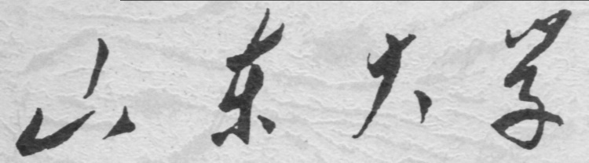

**School of Information Science and Engineering**

**2019－2020 school year**

Digital Image Processing Experiment Report

Course Name： Digital Image Processing

Title of Experiment： The Application of Wavelet Transform in Digital Image Processing

Major and Class Class 3, Communication Engineering

Student ID 201600121116

Studeng Name 张子超

Date 2019/5/9

# 1． Objectives:

1.Have an initial recognition of scale functions and wavelet functions.

2.Learn functions related to wavelet transform in matlab.

3.Practice the primary application of wavelet transform in digital image processing.

# 2． Experiment Content:

Display scale functions and wavelet functions, have a recognition of wavelet filter. Wavelet functions in two dimensions and reconstruction functions. Wavelet coefficient processing function. Conduct image compression and edge extraction.

# 3． Experiment Steps:

## 1). Know the attributes of all kinds of wavelets

Display the attributes of different kinds of wavelets:

Type >> waveinfo('haar'), the command console shows:

Information on Haar wavelet.

Haar Wavelet

General characteristics: Compactly supported

wavelet, the oldest and the simplest wavelet.

scaling function phi = 1 on [0 1] and 0 otherwise.

wavelet function psi = 1 on [0 0.5), = -1 on [0.5 1] and 0 otherwise.

Family Haar

Short name haar

Examples haar is the same as db1

Orthogonal yes

Biorthogonal yes

Compact support yes

DWT possible

CWT possible

Support width 1

Filters length 2

Regularity haar is not continuous

Symmetry yes

Number of vanishing

moments for psi 1

Reference: I. Daubechies,

Ten lectures on wavelets,

CBMS, SIAM, 61, 1994, 194-202.

## 2). Observe wavelet functions and their scale functions

[ phi, psi, xval ] = wavefun ('db3',4);   
figure,plot(xval,phi);

figure,plot(xval,psi);

The result is as follows:



## 3). Obtain wavelet filter.

Type command

>> [Lo_D,Hi_D,Lo_R,Hi_R]=wfilters('sym4')

Lo_D =

-0.0758 -0.0296 0.4976 0.8037 0.2979 -0.0992 -0.0126 0.0322

Hi_D =

-0.0322 -0.0126 0.0992 0.2979 -0.8037 0.4976 0.0296 -0.0758

Lo_R =

0.0322 -0.0126 -0.0992 0.2979 0.8037 0.4976 -0.0296 -0.0758

Hi_R =

-0.0758 0.0296 0.4976 -0.8037 0.2979 0.0992 -0.0126 -0.0322

## 4. Wavelet transform function in two dimensions and reconstruction functions.

x=imread( 'lena256.bmp');  
[C, S] = wavedec2(x, 3, 'db4');

g = waverec2(C, S, 'db4');  
figure,imshow(g,[])；





## 5. Check and process with wavelet coefficient.

>> a=appcoef2(C,S,'db4')

A turns out a matrix with 38 rows and 38 columns.

>> D=detcoef2('all',C,S,3)

D turns out a mat matrix with 38 rows and 38 columns, too.

## 6. Conduct image compression and edge extraction with wavelet transform

f=imread('Fig0316(a)(moon).tif');  
[c1, s1] = wavedec2(f, 3, 'haar');  
newc1 = wthcoef2('t', c1, s1, [2 1]);  
g = waverec2(newc1, s1, 'haar');  
figure,imshow(g,[]);  
newc1 = wthcoef2('a', c1, s1);  
g = waverec2(newc1, s1, 'haar');  
figure,imshow(g,[])





# 4． Conclusions and Experiences:

Wavelet can be uesd in image compression, the compressed image firstly transmitted and then send the details, which is no hurry. When digital images are to be viewed or processed at multiple resolutions, the discrete wavelet transform is the mathematical tool of choice. In addition to being an efficient, highly intuitive framework for the representation and storage of multiresolution images, the DWT provides powerful insight into an image’s spatial and frequency characteristics.