# **Políticas e consentimentos**

**INSTITUTO SUPERIOR DE ENGENHARIA DE LISBOA**

**Aula prática 3**

**RDF**

Representação e Processamento do Conhecimento

Bruno Costa, n.º 36868

João Silva, nº 42086

Docente: Paulo Trigo

**Abril, 2021**

## Grafo Jogos olimpicos

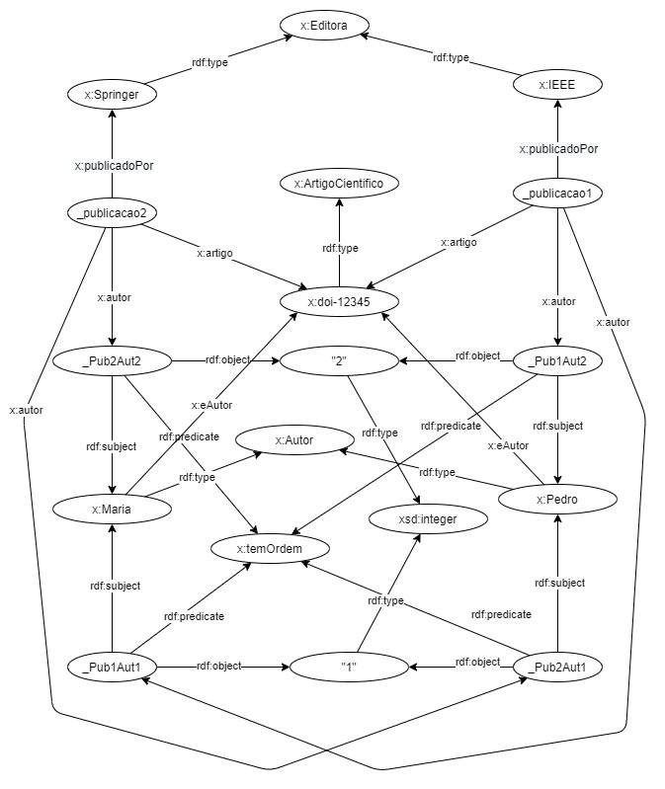

Figura 1 - Grafo Editoras

<?xml version="1.0" encoding="UTF-8"?>

<!DOCTYPE rdf:RDF [<!ENTITY E "http://book/#">]>

<rdf:RDF

xmlns:rdf="http://www.w3.org/1999/02/22-rdf-syntax-ns#"

xmlns:E="http://book/#"

>

<E:Editora rdf:about="&E;IEEE" />

<E:Editora rdf:about="&E;Springer" />

<E:ArtigoCientifico rdf:about="&E;doi-12345" />

<E:Autor rdf:about="&E;Pedro" />

<E:Autor rdf:about="&E;Maria" />

<E:Publicacao rdf:ID="_pub1">

<E:publicadoPor rdf:resource="&E;Springer" />

<E:artigo rdf:resource="&E;doi-12345" />

<E:autor rdf:resource="#_pub1a1" />

<E:autor rdf:resource="#_pub1a2" />

</E:Publicacao>

<rdf:Statement rdf:ID="_pub1a1">

<rdf:subject rdf:resource="&E;Maria"/>

<rdf:predicate rdf:resource="&E;temOrdem"/>

<rdf:object rdf:resource="http://www.w3.org/2001/XMLSchema#1"/>

</rdf:Statement>

<rdf:Statement rdf:ID="_pub1a2">

<rdf:subject rdf:resource="&E;Pedro"/>

<rdf:predicate rdf:resource="&E;temOrdem"/>

<rdf:object rdf:resource="http://www.w3.org/2001/XMLSchema#2"/>

</rdf:Statement>

<E:Publicacao rdf:ID="_pub2">

<E:publicadoPor rdf:resource="&E;IEEE" />

<E:artigo rdf:resource="&E;doi-12345" />

<E:autor rdf:resource="#_pub2a1" />

<E:autor rdf:resource="#_pub2a2" />

</E:Publicacao>

<rdf:Statement rdf:ID="_pub2a1">

<rdf:subject rdf:resource="&E;Pedro"/>

<rdf:predicate rdf:resource="&E;temOrdem"/>

<rdf:object rdf:resource="http://www.w3.org/2001/XMLSchema#1"/>

</rdf:Statement>

<rdf:Statement rdf:ID="_pub2a2">

<rdf:subject rdf:resource="&E;Maria"/>

<rdf:predicate rdf:resource="&E;temOrdem"/>

<rdf:object rdf:resource="http://www.w3.org/2001/XMLSchema#2"/>

</rdf:Statement>

</rdf:RDF>

Figura 2 - Representação parcial XML do Grafo Editoras

<http://book/#IEEE> <http://www.w3.org/1999/02/22-rdf-syntax-ns#type> <http://book/#Editora> .

<http://book/#Springer> <http://www.w3.org/1999/02/22-rdf-syntax-ns#type> <http://book/#Editora> .

<http://book/#doi-12345> <http://www.w3.org/1999/02/22-rdf-syntax-ns#type> <http://book/#ArtigoCientifico> .

<http://book/#Pedro> <http://www.w3.org/1999/02/22-rdf-syntax-ns#type> <http://book/#Autor> .

<http://book/#Maria> <http://www.w3.org/1999/02/22-rdf-syntax-ns#type> <http://book/#Autor> .

_:pub1 <http://www.w3.org/1999/02/22-rdf-syntax-ns#type> <http://book/#Publicacao> .

_:pub1 <http://book/#publicadoPor> <http://book/#Springer> .

_:pub1 <http://book/#artigo> <http://book/#doi-12345> .

_:pub1 <http://book/#autor> _:pub1a1 .

_:pub1 <http://book/#autor> _:pub1a2 .

_:pub1a1 <http://www.w3.org/1999/02/22-rdf-syntax-ns#type> <http://www.w3.org/1999/02/22-rdf-syntax-ns#Statement> .

_:pub1a1 <http://www.w3.org/1999/02/22-rdf-syntax-ns#subject> <http://book/#Maria> .

_:pub1a1 <http://www.w3.org/1999/02/22-rdf-syntax-ns#predicate> <http://book/#temOrdem> .

_:pub1a1 <http://www.w3.org/1999/02/22-rdf-syntax-ns#object> <http://www.w3.org/2001/XMLSchema#1> .

_:pub1a2 <http://www.w3.org/1999/02/22-rdf-syntax-ns#type> <http://www.w3.org/1999/02/22-rdf-syntax-ns#Statement> .

_:pub1a2 <http://www.w3.org/1999/02/22-rdf-syntax-ns#subject> <http://book/#Pedro> .

_:pub1a2 <http://www.w3.org/1999/02/22-rdf-syntax-ns#predicate> <http://book/#temOrdem> .

_:pub1a2 <http://www.w3.org/1999/02/22-rdf-syntax-ns#object> <http://www.w3.org/2001/XMLSchema#2> .

_:pub2 <http://www.w3.org/1999/02/22-rdf-syntax-ns#type> <http://book/#Publicacao> .

_:pub2 <http://book/#publicadoPor> <http://book/#IEEE> .

_:pub2 <http://book/#artigo> <http://book/#doi-12345> .

_:pub2 <http://book/#autor> _:pub2a1 .

_:pub2 <http://book/#autor> _:pub2a2 .

_:pub2a1 <http://www.w3.org/1999/02/22-rdf-syntax-ns#type> <http://www.w3.org/1999/02/22-rdf-syntax-ns#Statement> .

_:pub2a1 <http://www.w3.org/1999/02/22-rdf-syntax-ns#subject> <http://book/#Pedro> .

_:pub2a1 <http://www.w3.org/1999/02/22-rdf-syntax-ns#predicate> <http://book/#temOrdem> .

_:pub2a1 <http://www.w3.org/1999/02/22-rdf-syntax-ns#object> <http://www.w3.org/2001/XMLSchema#1> .

_:pub2a2 <http://www.w3.org/1999/02/22-rdf-syntax-ns#type> <http://www.w3.org/1999/02/22-rdf-syntax-ns#Statement> .

_:pub2a2 <http://www.w3.org/1999/02/22-rdf-syntax-ns#subject> <http://book/#Maria> .

_:pub2a2 <http://www.w3.org/1999/02/22-rdf-syntax-ns#predicate> <http://book/#temOrdem> .

_:_pub2a2 <http://www.w3.org/1999/02/22-rdf-syntax-ns#object> <http://www.w3.org/2001/XMLSchema#2> .

Figura 3 - Representação parcial N-Triples do Grafo Editoras

## Preferencias de Editoras

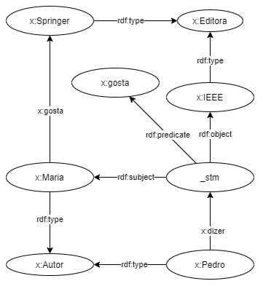

Figura 4 - Grafo das preferencias de Editoras

**<** <http://book/#Pedro> <http://www.w3.org/1999/02/22-rdf-syntax-ns#type> <http://book/#Autor> .

<http://book/#Springer> <http://www.w3.org/1999/02/22-rdf-syntax-ns#type> <http://book/#Editora> .

<http://book/#IEEE> <http://www.w3.org/1999/02/22-rdf-syntax-ns#type> <http://book/#Editora> .

<http://book/#Maria> <http://www.w3.org/1999/02/22-rdf-syntax-ns#type> <http://book/#Autor> .

<http://book/#Pedro> <http://book/#dizer> <http://book/#_stm> .

_:_stm <http://www.w3.org/1999/02/22-rdf-syntax-ns#type> <http://www.w3.org/1999/02/22-rdf-syntax-ns#Statement> .

_:_stm <http://www.w3.org/1999/02/22-rdf-syntax-ns#subject> <http://book/#Maria> .

_:_stm <http://www.w3.org/1999/02/22-rdf-syntax-ns#predicate> <http://book/#gosta> .

_:_stm <http://www.w3.org/1999/02/22-rdf-syntax-ns#object> <http://book/#IEEE> .

<http://book/#Maria> <http://book/#gosta> <http://book/#Springer> .

Figura 5 Repesentação N-Triples da critica do Pedro

<?xml version="1.0" encoding="UTF-8"?>

<!DOCTYPE rdf:RDF [<!ENTITY E "http://book/#">]>

<rdf:RDF

xmlns:rdf="http://www.w3.org/1999/02/22-rdf-syntax-ns#"

xmlns:E="http://book/#"

>

<E:Editora rdf:about="&E;IEEE" />

<E:Editora rdf:about="&E;Springer" />

<rdf:Statement rdf:nodeID="_stm">

<rdf:predicate rdf:resource="http://book/#gosta"/>

<rdf:subject rdf:resource="http://book/#Maria"/>

<rdf:object rdf:resource="http://book/#IEEE"/>

</rdf:Statement>

<E:Autor rdf:about="http://book/#Pedro">

<E:dizer rdf:nodeID="_stm"/>

</E:Autor>

<E:Autor rdf:about="http://book/#Maria">

<E:gosta rdf:resource="http://book/#Springer"/>

</E:Autor>

</rdf:RDF>

Figura 6 - Representação XML da critica do Pedro

## Unificação dos grafos

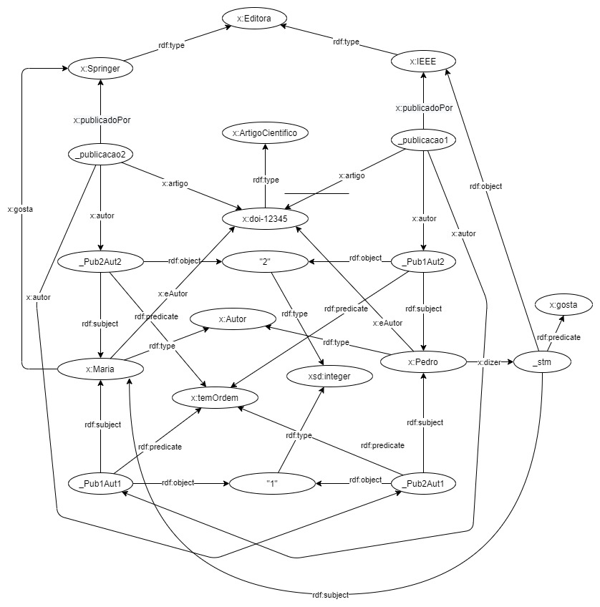

Figura 7 - Grafo dos Editoreas e da preferencias de editoras

Figura 8 - Representação Xml do grafo Editoreas e da preferencias de editoras

<?xml version="1.0" encoding="utf-8"?>

<rdf:RDF

xmlns:rdf="http://www.w3.org/1999/02/22-rdf-syntax-ns#"

xmlns:ns1="http://book/#"

>

<ns1:Publicacao rdf:nodeID="_pub1">

<ns1:artigo rdf:resource="http://book/#doi-12345"/>

<ns1:autor>

<rdf:Statement rdf:nodeID="_pub1a1">

<rdf:object rdf:resource="http://www.w3.org/2001/XMLSchema#1"/>

<rdf:predicate rdf:resource="http://book/#temOrdem"/>

<rdf:subject rdf:resource="http://book/#Maria"/>

</rdf:Statement>

</ns1:autor>

<ns1:publicadoPor rdf:resource="http://book/#Springer"/>

<ns1:autor>

<rdf:Statement rdf:nodeID="_pub1a2">

<rdf:predicate rdf:resource="http://book/#temOrdem"/>

<rdf:object rdf:resource="http://www.w3.org/2001/XMLSchema#2"/>

<rdf:subject rdf:resource="http://book/#Pedro"/>

</rdf:Statement>

</ns1:autor>

</ns1:Publicacao>

<ns1:Publicacao rdf:nodeID="_pub2">

<ns1:autor>

<rdf:Statement rdf:nodeID="_pub2a1">

<rdf:subject rdf:resource="http://book/#Pedro"/>

<rdf:predicate rdf:resource="http://book/#temOrdem"/>

<rdf:object rdf:resource="http://www.w3.org/2001/XMLSchema#1"/>

</rdf:Statement>

</ns1:autor>

<ns1:artigo rdf:resource="http://book/#doi-12345"/>

<ns1:publicadoPor rdf:resource="http://book/#IEEE"/>

<ns1:autor>

<rdf:Statement rdf:nodeID="_pub2a2">

<rdf:predicate rdf:resource="http://book/#temOrdem"/>

<rdf:subject rdf:resource="http://book/#Maria"/>

<rdf:object rdf:resource="http://www.w3.org/2001/XMLSchema#2"/>

</rdf:Statement>

</ns1:autor>

</ns1:Publicacao>

<ns1:Autor rdf:about="http://book/#Maria">

<ns1:gosta rdf:resource="http://book/#Springer"/>

<ns1:eAutor rdf:resource="http://book/#doi-12345"/>

</ns1:Autor>

<ns1:Autor rdf:about="http://book/#Pedro">

<ns1:dizer>

<rdf:Statement rdf:nodeID="_stm">

<rdf:predicate rdf:resource="http://book/#gosta"/>

<rdf:subject rdf:resource="http://book/#Maria"/>

<rdf:object rdf:resource="http://book/#IEEE"/>

</rdf:Statement>

</ns1:dizer>

<ns1:eAutor rdf:resource="http://book/#doi-12345"/>

</ns1:Autor>

<ns1:ArtigoCientifico rdf:about="http://book/#doi-12345"/>

<ns1:Editora rdf:about="http://book/#Springer"/>

<ns1:Editora rdf:about="http://book/#IEEE"/>

</rdf:RDF>

Figura 9 - Formato N-Triples do grafo das Editoras e da preferencias de editoras

_:_pub2a1 <http://www.w3.org/1999/02/22-rdf-syntax-ns#object> <http://www.w3.org/2001/XMLSchema#1> .

_:_pub1a2 <http://www.w3.org/1999/02/22-rdf-syntax-ns#predicate> <http://book/#temOrdem> .

_:_pub2a1 <http://www.w3.org/1999/02/22-rdf-syntax-ns#type> <http://www.w3.org/1999/02/22-rdf-syntax-ns#Statement> .

_:_pub1 <http://book/#publicadoPor> <http://book/#Springer> .

<http://book/#Maria> <http://www.w3.org/1999/02/22-rdf-syntax-ns#type> <http://book/#Autor> .

_:_pub1 <http://book/#autor> _:_pub1a2 .

_:_pub1 <http://www.w3.org/1999/02/22-rdf-syntax-ns#type> <http://book/#Publicacao> .

_:_stm <http://www.w3.org/1999/02/22-rdf-syntax-ns#object> <http://book/#IEEE> .

_:_pub2a2 <http://www.w3.org/1999/02/22-rdf-syntax-ns#subject> <http://book/#Maria> .

_:_pub1 <http://book/#autor> _:_pub1a1 .

_:_pub1a2 <http://www.w3.org/1999/02/22-rdf-syntax-ns#subject> <http://book/#Pedro> .

<http://book/#Pedro> <http://book/#dizer> _:_stm .

_:_pub2 <http://book/#artigo> <http://book/#doi-12345> .

_:_pub2 <http://book/#autor> _:_pub2a2 .

_:_stm <http://www.w3.org/1999/02/22-rdf-syntax-ns#predicate> <http://book/#gosta> .

_:_pub2a1 <http://www.w3.org/1999/02/22-rdf-syntax-ns#predicate> <http://book/#temOrdem> .

<http://book/#doi-12345> <http://www.w3.org/1999/02/22-rdf-syntax-ns#type> <http://book/#ArtigoCientifico> .

<http://book/#Pedro> <http://book/#eAutor> <http://book/#doi-12345> .

_:_pub1a1 <http://www.w3.org/1999/02/22-rdf-syntax-ns#type> <http://www.w3.org/1999/02/22-rdf-syntax-ns#Statement> .

<http://book/#Springer> <http://www.w3.org/1999/02/22-rdf-syntax-ns#type> <http://book/#Editora> .

_:_pub1a2 <http://www.w3.org/1999/02/22-rdf-syntax-ns#type> <http://www.w3.org/1999/02/22-rdf-syntax-ns#Statement> .

_:_pub2a2 <http://www.w3.org/1999/02/22-rdf-syntax-ns#type> <http://www.w3.org/1999/02/22-rdf-syntax-ns#Statement> .

_:_pub2 <http://www.w3.org/1999/02/22-rdf-syntax-ns#type> <http://book/#Publicacao> .

_:_stm <http://www.w3.org/1999/02/22-rdf-syntax-ns#subject> <http://book/#Maria> .

_:_pub1a1 <http://www.w3.org/1999/02/22-rdf-syntax-ns#object> <http://www.w3.org/2001/XMLSchema#1> .

_:_pub1a1 <http://www.w3.org/1999/02/22-rdf-syntax-ns#subject> <http://book/#Maria> .

_:_pub1 <http://book/#artigo> <http://book/#doi-12345> .

_:_pub1a2 <http://www.w3.org/1999/02/22-rdf-syntax-ns#object> <http://www.w3.org/2001/XMLSchema#2> .

<http://book/#Maria> <http://book/#eAutor> <http://book/#doi-12345> .

<http://book/#Maria> <http://book/#gosta> <http://book/#Springer> .

_:_pub2 <http://book/#publicadoPor> <http://book/#IEEE> .

_:_stm <http://www.w3.org/1999/02/22-rdf-syntax-ns#type> <http://www.w3.org/1999/02/22-rdf-syntax-ns#Statement> .

_:_pub2a2 <http://www.w3.org/1999/02/22-rdf-syntax-ns#predicate> <http://book/#temOrdem> .

_:_pub1a1 <http://www.w3.org/1999/02/22-rdf-syntax-ns#predicate> <http://book/#temOrdem> .

_:_pub2a1 <http://www.w3.org/1999/02/22-rdf-syntax-ns#subject> <http://book/#Pedro> .

<http://book/#Pedro> <http://www.w3.org/1999/02/22-rdf-syntax-ns#type> <http://book/#Autor> .

_:_pub2 <http://book/#autor> _:_pub2a1 .

_:_pub2a2 <http://www.w3.org/1999/02/22-rdf-syntax-ns#object> <http://www.w3.org/2001/XMLSchema#2> .

<http://book/#IEEE> <http://www.w3.org/1999/02/22-rdf-syntax-ns#type> <http://book/#Editora> .