# **Políticas e consentimentos**

**INSTITUTO SUPERIOR DE ENGENHARIA DE LISBOA**

**Aula prática 2**

**RDF**

Representação e Processamento do Conhecimento

Bruno Costa, n.º 36868

João Silva, nº 42086

Docente: Paulo Trigo

**Abril, 2021**

## Grafo Jogos olimpicos

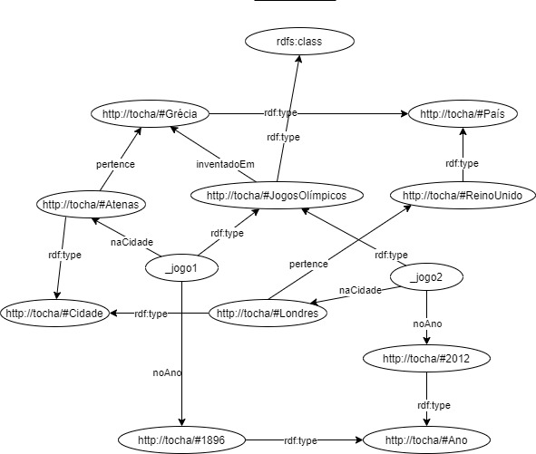

Figura 1 - Grafo Jogos Olímpicos

<?xml version=**"1.0"** encoding=**"utf-8"**?>

<rdf:RDF

xmlns:tocha=**"http://tocha/"**

xmlns:rdf=**"http://www.w3.org/1999/02/22-rdf-syntax-ns#"**

>

<tocha:JogosOlimpicos rdf:nodeID=**"_jogo1"**>

<tocha:noAno rdf:resource=**"http://tocha/#1896"** />

<tocha:naCidade rdf:resource=**"http://tocha/#Atenas"** />

</tocha:JogosOlimpicos>

<tocha:Ano rdf:about=**"http://tocha/#1896"**>

</tocha:Ano>

<tocha:Cidade rdf:about=**"http://tocha/#Atenas"**>

<tocha:pertence rdf:resource=**"http://tocha/#Grecia"** />

</tocha:Cidade>

<tocha:Pais rdf:about=**"http://tocha/#Grecia"**>

</tocha:Pais>

</rdf:RDF>

Figura 2 - Representação parcial XML do Grafo Jogos Olímpicos

_:jogo1 **<**http://www.w3.org/1999/02/22-rdf-syntax-ns#type**>** **<**http://tocha/JogosOlimpicos**>** .

_:jogo1 **<**http://tocha/noAno**>** **<**http://tocha/#1896**>** .

_:jogo1 **<**http://tocha/naCidade**>** **<**http://tocha/#Atenas**>** .

**<**http://tocha/#1896**>** **<**http://www.w3.org/1999/02/22-rdf-syntax-ns#type**>** **<**http://tocha/Ano**>** .

**<**http://tocha/#Atenas**>** **<**http://www.w3.org/1999/02/22-rdf-syntax-ns#type**>** **<**http://tocha/Cidade**>** .

**<**http://tocha/#Atenas**>** **<**http://tocha/pertence**>** **<**http://tocha/Grecia**>** .

**<**http://tocha/#Grecia**>** **<**http://www.w3.org/1999/02/22-rdf-syntax-ns#type**>** **<**http://tocha/Pais**>** .

Figura 3 - Representação parcial N-Triples do Grafo Jogos Olímpicos

## Critica do Pedro

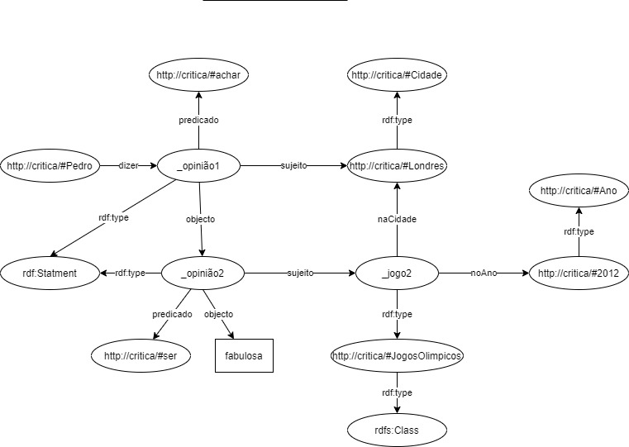

Figura 4 - Grafo da Critica do Pedro

**<**http://critica/#Pedro**>** **<**http://critica/#dizer**>** _:opiniao1 .

_:opiniao1 **<**http://www.w3.org/1999/02/22-rdf-syntax-ns#type**>** **<**http://www.w3.org/1999/02/22-rdf-syntax-ns#Statement**>** .

_:opiniao1 **<**http://www.w3.org/1999/02/22-rdf-syntax-ns#subject**>** **<**http://critica/#Londres**>** .

_:opiniao1 **<**http://www.w3.org/1999/02/22-rdf-syntax-ns#predicate**>** **<**http://critica/#achar**>** .

_:opiniao1 **<**http://www.w3.org/1999/02/22-rdf-syntax-ns#object**>** _:opiniao2 .

_:opiniao2 **<**http://www.w3.org/1999/02/22-rdf-syntax-ns#type**>** **<**http://www.w3.org/1999/02/22-rdf-syntax-ns#Statement**>** .

_:opiniao2 **<**http://www.w3.org/1999/02/22-rdf-syntax-ns#subject**>** _:jogo2 .

_:opiniao2 **<**http://www.w3.org/1999/02/22-rdf-syntax-ns#predicate**>** **<**http://critica/#ser**>** .

_:opiniao2 **<**http://www.w3.org/1999/02/22-rdf-syntax-ns#object**>** "fabulosa" .

_:jogo2 **<**http://www.w3.org/1999/02/22-rdf-syntax-ns#type**>** **<**http://critica/#JogosOlimpicos**>** .

_:jogo2 **<**http://critica/#naCidade**>** **<**http://critica/#Londres**>** .

_:jogo2 **<**http://critica/#noAno**>** **<**http://critica/#2012**>** .

**<**http://critica/#Londres**>** **<**http://www.w3.org/1999/02/22-rdf-syntax-ns#type**>** **<**http://critica/#Cidade**>** .

**<**http://critica/#JogosOlimpicos**>** **<**http://www.w3.org/1999/02/22-rdf-syntax-ns#type**>** **<**http://www.w3.org/2000/01/rdf-schema#Class**>** .

**<**http://critica/#2012**>** **<**http://www.w3.org/1999/02/22-rdf-syntax-ns#type**>** **<**http://critica/#Ano**>** .

Figura 5 Repesentação N-Triples da critica do Pedro

<?xml version=**"1.0"** encoding=**"UTF-8"**?>

<!DOCTYPE rdf:RDF [<!ENTITY E "http://critica/#">

**]>**

<rdf:RDF

xmlns:rdf=**"http://www.w3.org/1999/02/22-rdf-syntax-ns#"**

xmlns:E=**"http://critica/#"**

>

<rdf:Description rdf:about=**"&E;Pedro"**>

<E:dizer rdf:resource=**"#_opiniao1"**/>

</rdf:Description>

<rdf:Statement rdf:ID=**"_opiniao1"**>

<rdf:subject rdf:resource=**"&E;Londres"**/>

<rdf:predicate rdf:resource=**"&E;achar"**/>

<rdf:object rdf:resource=**"#_opiniao2"**/>

</rdf:Statement>

<rdf:Statement rdf:ID=**"_opiniao2"**>

<rdf:subject rdf:resource=**"&E;_jogo2"**/>

<rdf:predicate rdf:resource=**"&E;ser"**/>

<rdf:object>**fabulosa**</rdf:object>

</rdf:Statement>

<E:JogosOlimpicos rdf:about=**"http://critica/#_jogo2"**>

<E:noAno rdf:resource=**"http://critica/#2012"** />

<E:naCidade rdf:resource=**"http://critica/#Londres"** />

</E:JogosOlimpicos>

<E:Ano rdf:about=**"http://critica/#2012"**>

</E:Ano>

<E:Cidade rdf:about=**"http://critica/#Londres"**>

</E:Cidade>

</rdf:RDF>

Figura 6 - Representação XML da critica do Pedro

## Unificação dos grafos

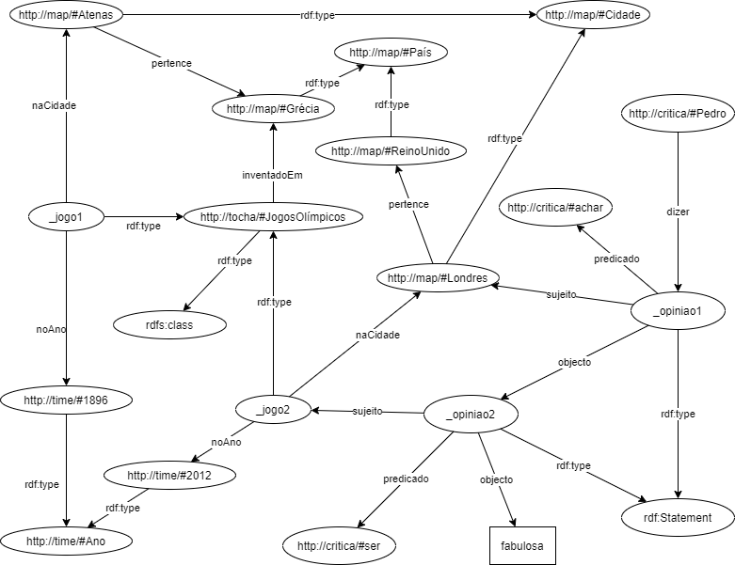

Figura 7 - Grafo dos Jogos Olimpicos e da critica do Pedro

Figura 8 - Representação Xml do grafo dos Jogos Olimpicos e da critica do Pedro

<?xml version=**"1.0"** encoding=**"utf-8"**?>

<rdf:RDF

xmlns:ns1=**"http://map/#"**

xmlns:rdf=**"http://www.w3.org/1999/02/22-rdf-syntax-ns#"**

xmlns:rdfs=**"http://www.w3.org/2000/01/rdf-schema#"**

xmlns:ns2=**"http://critica/#"**

xmlns:ns3=**"http://tocha/#"**

xmlns:ns4=**"http://time/#"**

>

<ns3:JogosOlimpicos rdf:nodeID=**"_jogo1"**>

<ns3:noAno rdf:resource=**"http://time/#1896"**/>

<ns3:naCidade rdf:resource=**"http://map/#Atenas"**/>

</ns3:JogosOlimpicos>

<rdf:Description rdf:about=**"http://critica/#Pedro"**>

<ns2:dizer>

<rdf:Statement rdf:nodeID=**"_opiniao1"**>

<rdf:predicate rdf:resource=**"http://critica/#achar"**/>

<rdf:subject rdf:resource=**"http://map/#Londres"**/>

<rdf:object>

<rdf:Statement rdf:nodeID=**"_opiniao2"**>

<rdf:predicate rdf:resource=**"http://critica/#ser"**/>

<rdf:object>**Fabulosa**</rdf:object>

<rdf:subject>

<ns3:JogosOlimpicos rdf:nodeID=**"_jogo2"**>

<ns3:naCidade rdf:resource=**"http://map/#Londres"**/>

<ns3:noAno rdf:resource=**"http://time/#2012"**/>

</ns3:JogosOlimpicos>

</rdf:subject>

</rdf:Statement>

</rdf:object>

</rdf:Statement>

</ns2:dizer>

</rdf:Description>

<rdfs:Class rdf:about=**"http://tocha/#JogosOlimpicos"**>

<ns3:inventadoEm rdf:resource=**"http://map/#Grecia"**/>

</rdfs:Class>

<ns4:Ano rdf:about=**"http://time/#2012"**/>

<ns1:Cidade rdf:about=**"http://map/#Londres"**>

<ns1:pertence rdf:resource=**"http://map/#Reino_Unido"**/>

</ns1:Cidade>

<ns1:Cidade rdf:about=**"http://map/#Atenas"**>

<ns1:pertence rdf:resource=**"http://map/#Grecia"**/>

</ns1:Cidade>

<ns1:País rdf:about=**"http://map/#Reino_Unido"**/>

<ns4:Ano rdf:about=**"http://time/#1896"**/>

<ns1:País rdf:about=**"http://map/#Grecia"**/>

</rdf:RDF>

Figura 9 - Formato N-Triples do grafo dos Jogos Olimpicos e da Critica do Pedro

**<**http://tocha/#1896**>** **<**http://www.w3.org/1999/02/22-rdf-syntax-ns#type**>** **<**http://tocha/#Ano**>** .

**<**http://tocha/#2012**>** **<**http://www.w3.org/1999/02/22-rdf-syntax-ns#type**>** **<**http://tocha/#Ano**>** .

_:_opiniao2 **<**http://www.w3.org/1999/02/22-rdf-syntax-ns#predicate**>** **<**http://tocha/#ser**>** .

_:_opiniao2 **<**http://www.w3.org/1999/02/22-rdf-syntax-ns#type**>** **<**http://www.w3.org/1999/02/22-rdf-syntax-ns#Statement**>** .

**<**http://tocha/#Londres**>** **<**http://www.w3.org/1999/02/22-rdf-syntax-ns#type**>** **<**http://tocha/#Cidade**>** .

_:_jogo1 **<**http://tocha/#naCidade**>** **<**http://tocha/#Atenas**>** .

_:_opiniao1 **<**http://www.w3.org/1999/02/22-rdf-syntax-ns#type**>** **<**http://www.w3.org/1999/02/22-rdf-syntax-ns#Statement**>** .

_:_opiniao1 **<**http://www.w3.org/1999/02/22-rdf-syntax-ns#object**>** _:_opiniao2 .

**<**http://tocha/#JogosOlimpicos**>** **<**http://www.w3.org/1999/02/22-rdf-syntax-ns#type**>** **<**http://www.w3.org/2000/01/rdf-schema#Class**>** .

_:_opiniao1 **<**http://www.w3.org/1999/02/22-rdf-syntax-ns#predicate**>** **<**http://tocha/#achar**>** .

**<**http://tocha/#Londres**>** **<**http://tocha/#pertence**>** **<**http://tocha/#Reino_Unido**>** .

_:_jogo2 **<**http://tocha/#naCidade**>** **<**http://tocha/#Londres**>** .

_:_opiniao2 **<**http://www.w3.org/1999/02/22-rdf-syntax-ns#subject**>** _:_jogo2 .

**<**http://tocha/#Atenas**>** **<**http://tocha/#pertence**>** **<**http://tocha/#Grecia**>** .

_:_jogo1 **<**http://tocha/#noAno**>** **<**http://tocha/#1896**>** .

_:_opiniao2 **<**http://www.w3.org/1999/02/22-rdf-syntax-ns#object**>** "fabuloso" .

_:_jogo2 **<**http://www.w3.org/1999/02/22-rdf-syntax-ns#type**>** **<**http://tocha/#JogosOlimpicos**>** .

**<**http://tocha/#Reino_Unido**>** **<**http://www.w3.org/1999/02/22-rdf-syntax-ns#type**>** **<**http://tocha/#Pa\u00EDs**>** .

**<**http://tocha/#JogosOlimpicos**>** **<**http://tocha/#inventadoEm**>** **<**http://tocha/#Grecia**>** .

_:_jogo2 **<**http://tocha/#noAno**>** **<**http://tocha/#2012**>** .

**<**http://tocha/#Atenas**>** **<**http://www.w3.org/1999/02/22-rdf-syntax-ns#type**>** **<**http://tocha/#Cidade**>** .

_:_opiniao1 **<**http://www.w3.org/1999/02/22-rdf-syntax-ns#subject**>** **<**http://tocha/#Londres**>** .

**<**http://tocha/#Grecia**>** **<**http://www.w3.org/1999/02/22-rdf-syntax-ns#type**>** **<**http://tocha/#Pa\u00EDs**>** .

**<**http://critica/#Pedro**>** **<**http://critica/#dizer**>** _:_opiniao1 .

_:_jogo1 **<**http://www.w3.org/1999/02/22-rdf-syntax-ns#type**>** **<**http://tocha/#JogosOlimpicos**>** .