 | Doho Car Service Ltda  CNPJ: 65.862.278/0001-13  Rua Áureo Fernandes de Faria, 181 – Distrito Industrial II – Jales/SP – Brazil  Phone: +55 (17) 3632-1540 | E-mail: contato@doho.com.br

Date: November 28, 2025

To Whom It May Concern,

This letter is issued to confirm the service relationship between Doho Car Service Ltda and Mr. Bruno Azevedo Souza, who has been engaged as an independent contractor providing specialized Information Technology services.

Position (NOC): User Support Technician – NOC 22221
Contract Type: Independent contractor (self-employed). No employment relationship exists.
Start Date: February 15, 2017
End Date: Present
Average Weekly Hours: Approximately 8 hours/week
Monthly Compensation: R$ 1,000.00
Work Modality: Remote and on‑site, depending on operational needs.

Summary of Main Duties (fully aligned with NOC 22221):
• Provide remote and on-site technical support to users
• Troubleshoot hardware, software, and network issues
• Install, maintain, and configure IT equipment
• Maintain servers, networks, printers, and security systems (CCTV)
• Document performed work and provide technical recommendations
• Assist in planning and implementing IT infrastructure improvements

This letter is being provided at the request of Mr. Bruno for employment and immigration purposes in Canada.

Verification & Authenticity

This letter can be verified using the QR Code included below, which directs to the official verification page hosted by Doho Car Service Ltda.
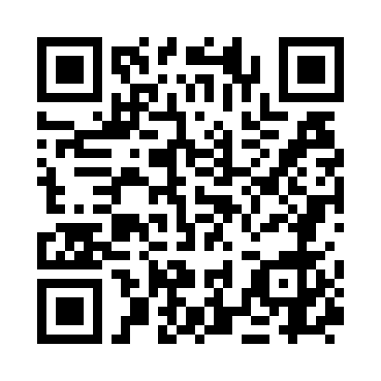

Responsible Officer:
Luiz Claudio Akira Doho
Chief Executive Officer (CEO)
Phone: +55 (17) 99602-7983
E-mail: doho.adm@doho.com.br

