Home Documentation
Documentation Team
2025-11-02
Table of Contents

Home

Index

VMware Inventory OPA
A Python CLI tool for managing VMware inventory data from Excel exports into a structured database.

Features

Core Functionality
- 📥 Excel Import: Load VMware inventory data from Excel files
- 💾 Database Storage: Store inventory in SQLite, PostgreSQL, or MySQL
- ⚡ CLI Interface: Simple command-line interface for data management
- 📊 Statistics: Query and analyze inventory data
- 🔍 Filtering: Filter VMs by datacenter, cluster, and other attributes
- 🏷️ Label Management: Organize VMs and folders with custom labels
- 💾 Backup & Restore: Full database and label backup/restore capabilities
- 📈 Label Quality: Comprehensive label coverage analysis and reporting

Interactive Dashboard
- 🖥️ Web Interface: Rich Streamlit-based dashboard with multiple views
- 📈 Advanced Analytics: CPU vs Memory patterns, OS distribution, cluster efficiency
- ⚖️ Comparison Tools: Side-by-side datacenter, cluster, and host comparisons
- 📁 Folder Analysis: Comprehensive folder-level resource and storage analytics with label filtering
- 🔎 VM Explorer: Advanced search with regex pattern matching and label filters
- 🔍 VM Search: Dedicated regex-based search with advanced filters
- 🏷️ Folder Labelling: Complete label management UI with inheritance and bulk operations
- 📊 Data Quality: Field completeness analysis, recommendations, and label quality reporting
- 💾 Database Backup: Dedicated backup/restore page with download capability
- 🚀 Migration Planning: Multi-target migration planning with 6Rs framework, cost estimation, and duration modeling

PDF Export
- 📄 Professional Reports: Generate comprehensive PDF reports with 20+ visualizations
- 🎨 Multiple Formats: Standard, Extended (all charts), or Summary (tables only)
- ⚙️ Customizable: Configurable page size, chart quality (DPI), color schemes
- 📑 Rich Content: Executive summaries, infrastructure analysis, resource metrics, storage efficiency

Architecture
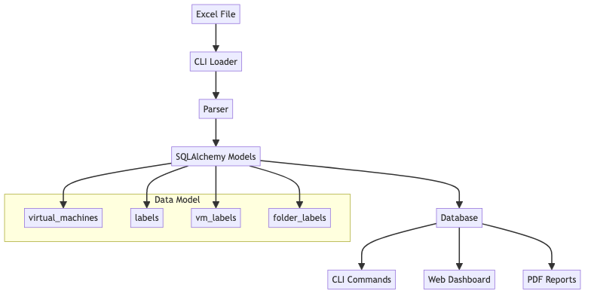

Quick Start
### Install the package
pipx install inv-vmware-opa
### Load data from Excel
uv run python -m src.cli load inputs/vmware-inv.xlsx --clear
### View statistics
uv run python -m src.cli stats
### List VMs
uv run python -m src.cli list --limit 10

Use Cases
- Inventory Management: Track and organize VMware infrastructure
- Reporting: Generate statistics and reports from inventory data
- Analysis: Query and filter VMs by various attributes
- Migration Planning: Analyze VM distributions and resource usage

Documentation
- Data Model - Complete database schema and table reference
- CLI Commands - Command-line interface guide
- Dashboard - Web interface documentation
- PDF Export - Report generation guide
- Getting Started - Quick start guide

Requirements
- Python 3.10 or higher
- SQLAlchemy 2.0+
- Click 8.0+
- Pandas 2.0+
- OpenPyXL 3.0+
- Streamlit 1.28+ (for dashboard)

License
MIT License

