Architecture Documentation
Documentation Team
2025-11-01
Table of Contents

Architecture

Context Diagram

RH OVE Ecosystem Context Diagram

Overview
This context diagram provides a high-level view of the RH OVE (Red Hat OpenShift Virtualization Engine) ecosystem within the broader enterprise environment. It illustrates the system boundaries, external entities, data flows, and key integrations that define how the RH OVE ecosystem interacts with users, external systems, and enterprise services.

Executive Summary
The RH OVE ecosystem represents a strategic modernization initiative that transforms enterprise virtualization infrastructure while preserving existing investments. This platform enables organizations to migrate from traditional virtualization (VMware) to a cloud-native, Kubernetes-based solution that supports both virtual machines and containers on a unified platform.

High-Level Business Context
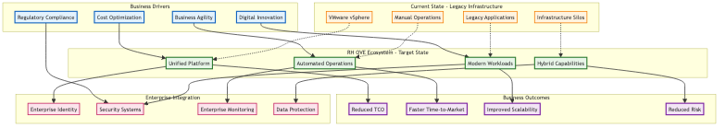

Strategic Value Proposition

Modernization Without Disruption
- Migrate from VMware to cloud-native platform while maintaining existing VM workloads
- Gradual transformation path that minimizes business risk
- Unified platform for both virtual machines and containers

Cost Optimization
- Eliminate VMware licensing costs and vendor lock-in
- Reduce infrastructure complexity and operational overhead
- Optimize resource utilization through intelligent workload placement

Enhanced Agility
- GitOps-driven automation for rapid deployment and scaling
- Self-service capabilities for development teams
- Faster time-to-market for new applications and services

Enterprise-Grade Security and Compliance
- Zero-trust architecture with micro-segmentation
- Integrated security scanning and policy enforcement
- Comprehensive audit trails and compliance reporting

System Context
The RH OVE ecosystem operates as a comprehensive multi-cluster virtualization platform that bridges traditional virtualization workloads with modern cloud-native operations, providing seamless integration with enterprise infrastructure and services.

Context Diagram
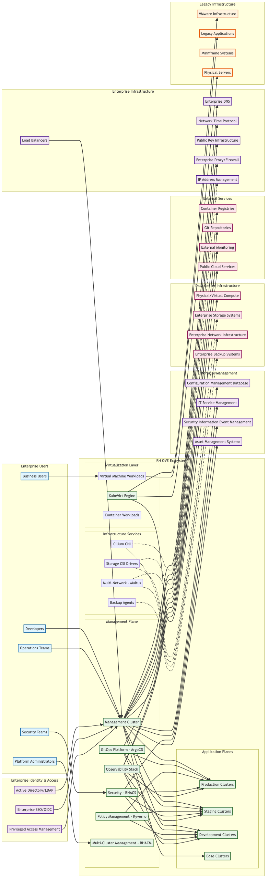

System Boundaries and Responsibilities

RH OVE Ecosystem Core
The central system encompasses: - Management Plane: Centralized governance, policy, and operations control - Application Planes: Multiple clusters for different environments and purposes - Virtualization Layer: KubeVirt-based VM and container workload execution - Infrastructure Services: Networking, storage, and backup integration

Key External Integrations

Identity and Access Management
- Active Directory/LDAP: Enterprise user directory integration
- Enterprise SSO/OIDC: Single sign-on and OAuth/OIDC authentication
- Privileged Access Management: Elevated access control and auditing

Enterprise Management Systems
- CMDB: Configuration item tracking and relationship mapping
- ITSM: Service request and incident management integration
- SIEM: Security event correlation and threat detection
- Asset Management: Hardware and software asset tracking

Infrastructure Dependencies
- Enterprise DNS: Name resolution services
- NTP: Time synchronization across all components
- PKI: Certificate management and trust establishment
- IPAM: IP Address Management for network planning and allocation
- Network Infrastructure: Physical and virtual networking
- Storage Systems: Persistent storage for VMs and containers
- Backup Systems: Data protection and recovery services

Development and Operations
- Git Repositories: Source code and configuration management
- Container Registries: Image storage and distribution
- External Monitoring: Enterprise monitoring system integration
- Public Cloud Services: Hybrid and multi-cloud connectivity

Legacy System Integration
The RH OVE ecosystem provides migration paths and integration capabilities for: - VMware Infrastructure: VM migration and workload transformation - Legacy Applications: Containerization and modernization support - Physical Servers: Bare metal integration and management - Mainframe Systems: API integration and data exchange

Data Flow Patterns

Inbound Data Flows
- User Authentication: From enterprise identity systems
- Configuration Data: From Git repositories and CMDB
- Monitoring Metrics: To enterprise monitoring systems
- Security Events: To SIEM platforms
- Backup Data: From enterprise backup systems

Outbound Data Flows
- Audit Logs: To compliance and logging systems
- Performance Metrics: To enterprise dashboards
- Security Alerts: To security operations centers
- Configuration Changes: To change management systems
- Service Status: To IT service management platforms

Bidirectional Integration
- Identity Federation: Continuous authentication and authorization
- Policy Synchronization: Enterprise policy distribution and compliance
- Asset Discovery: Dynamic configuration item updates
- Network Connectivity: Secure communication channels

Security Boundaries

Trust Zones
- Management Zone: High-security administrative functions
- Production Zone: Business-critical workload execution
- Development Zone: Lower-trust development activities
- DMZ: External-facing services and integrations

Security Controls
- Network Segmentation: Micro-segmentation with Cilium
- Zero Trust Architecture: Identity-based access controls
- Encryption: End-to-end data protection
- Audit Logging: Comprehensive activity tracking

Scalability and Growth
The context diagram illustrates the ecosystem’s ability to: - Horizontal Scaling: Add application clusters as needed - Geographic Distribution: Deploy across multiple data centers - Hybrid Integration: Seamlessly connect on-premises and cloud resources - Legacy Modernization: Gradual transformation of existing systems

Operational Model

Day-1 Operations (Deployment)
- Initial cluster provisioning and configuration
- Integration with enterprise systems
- Security policy establishment
- Baseline monitoring setup

Day-2 Operations (Management)
- Ongoing cluster lifecycle management
- Policy updates and compliance monitoring
- Performance optimization and scaling
- Security incident response
This context diagram serves as the foundation for understanding how the RH OVE ecosystem integrates with and enhances existing enterprise infrastructure while providing a modern, scalable platform for virtualization and containerization workloads.

Global Overview

Global Architecture Overview

Overview
The RH OVE ecosystem is designed as a multi-cluster architecture that separates concerns between management operations and application workloads. This design provides scalability, security, and operational efficiency by dedicating specialized clusters for different purposes while maintaining centralized governance and oversight.

Architecture Principles

Separation of Concerns
- Management Cluster: Centralized control plane for governance, policy, monitoring, and operations
- Application Clusters: Dedicated workload execution environments for virtual machines and containers
- Clear Boundaries: Well-defined interfaces and responsibilities between cluster types

Scalability and Growth
- Horizontal Scaling: Add application clusters as demand grows
- Regional Distribution: Deploy clusters across different geographic locations
- Resource Optimization: Right-size clusters based on workload requirements

Security and Compliance
- Zero Trust Architecture: Network-level security between clusters
- Centralized Policy Management: Consistent security policies across all clusters
- Compliance Monitoring: Unified compliance reporting and auditing

Multi-Cluster Topology
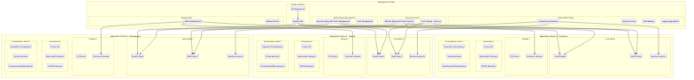

Management Cluster Components

Core Management Services

Red Hat Advanced Cluster Management (RHACM)
apiVersion: operator.open-cluster-management.io/v1
kind: MultiClusterHub
metadata:
name: multiclusterhub
namespace: open-cluster-management
spec:
availabilityConfig: High
enableClusterBackup: true
overrides:
components:
- name: multicluster-observability-operator
enabled: true
- name: cluster-lifecycle
enabled: true
- name: cluster-permission
enabled: true
Responsibilities: - Cluster lifecycle management - Policy distribution and compliance - Application deployment coordination - Resource optimization across clusters

ArgoCD Hub Configuration
apiVersion: argoproj.io/v1alpha1
kind: ArgoCD
metadata:
name: argocd-hub
namespace: argocd
spec:
server:
route:
enabled: true
tls:
termination: reencrypt
replicas: 3
controller:
resources:
requests:
cpu: 500m
memory: 1Gi
limits:
cpu: 2
memory: 4Gi
dex:
openShiftOAuth: true
ha:
enabled: true
rbac:
defaultPolicy: 'role:readonly'
policy: |
p, role:admin, applications, *, */*, allow
p, role:admin, clusters, *, *, allow
p, role:admin, repositories, *, *, allow
g, argocd-admins, role:admin
Responsibilities: - GitOps workflow orchestration - Application deployment to target clusters - Configuration drift detection and remediation - Multi-cluster application synchronization

Security and Compliance

Red Hat Advanced Cluster Security (RHACS)
apiVersion: platform.stackrox.io/v1alpha1
kind: Central
metadata:
name: stackrox-central-services
namespace: stackrox
spec:
central:
exposure:
loadBalancer:
enabled: true
persistence:
persistentVolumeClaim:
claimName: central-db
resources:
requests:
cpu: 1500m
memory: 4Gi
limits:
cpu: 4000m
memory: 8Gi
scanner:
resources:
requests:
cpu: 200m
memory: 200Mi
limits:
cpu: 2000m
memory: 4Gi
Responsibilities: - Centralized security policy management - Vulnerability scanning across clusters - Runtime threat detection - Compliance reporting and audit trails

Policy Engine (Kyverno)
apiVersion: kyverno.io/v1
kind: ClusterPolicy
metadata:
name: multi-cluster-vm-policy
spec:
validationFailureAction: enforce
background: true
rules:
- name: require-vm-labels
match:
any:
- resources:
kinds:
- VirtualMachine
validate:
message: "VMs must have required labels: environment, owner, backup-policy"
pattern:
metadata:
labels:
environment: "?*"
owner: "?*"
backup-policy: "?*"

Observability and Monitoring

Federated Prometheus Configuration
apiVersion: monitoring.coreos.com/v1
kind: Prometheus
metadata:
name: prometheus-federation
namespace: monitoring
spec:
replicas: 3
retention: 30d
storage:
volumeClaimTemplate:
spec:
accessModes: ["ReadWriteOnce"]
resources:
requests:
storage: 500Gi
serviceAccountName: prometheus
serviceMonitorSelector:
matchLabels:
prometheus: federation
additionalScrapeConfigs:
name: additional-scrape-configs
key: prometheus-additional.yaml
Federation Configuration:
- job_name: 'federate-app-clusters'
scrape_interval: 15s
honor_labels: true
metrics_path: '/federate'
params:
'match[]':
- '{job=~"kubernetes-.*"}'
- '{job=~"node-.*"}'
- '{job=~"kubevirt-.*"}'
static_configs:
- targets:
- 'prometheus-app-cluster-1.monitoring.svc.cluster.local:9090'
- 'prometheus-app-cluster-2.monitoring.svc.cluster.local:9090'
- 'prometheus-app-cluster-n.monitoring.svc.cluster.local:9090'

Centralized Logging
apiVersion: logging.openshift.io/v1
kind: ClusterLogForwarder
metadata:
name: central-log-forwarder
namespace: openshift-logging
spec:
outputs:
- name: central-elasticsearch
type: elasticsearch
url: https://elasticsearch-central.logging.svc.cluster.local:9200
secret:
name: elasticsearch-central-secret
pipelines:
- name: forward-app-logs
inputRefs:
- application
- infrastructure
- audit
outputRefs:
- central-elasticsearch

Application Cluster Architecture

Cluster Sizing and Resource Allocation

Production Cluster Profile
apiVersion: v1
kind: ConfigMap
metadata:
name: cluster-profile-production
data:
profile: |
cluster_type: production
node_count: 12
master_nodes: 3
worker_nodes: 9
storage_nodes: 3
node_specifications:
master:
cpu: 16
memory: 64Gi
storage: 500Gi SSD
worker:
cpu: 32
memory: 128Gi
storage: 1Ti NVMe
storage:
cpu: 8
memory: 32Gi
storage: 4Ti SSD
network_configuration:
cni: cilium
multi_network: multus
sr_iov: enabled
encryption: wireguard
virtualization:
kubevirt_version: "v1.1.0"
nested_virtualization: true
hugepages: 1Gi
cpu_pinning: enabled

Staging/Development Cluster Profile
apiVersion: v1
kind: ConfigMap
metadata:
name: cluster-profile-staging
data:
profile: |
cluster_type: staging
node_count: 6
master_nodes: 3
worker_nodes: 3
node_specifications:
master:
cpu: 8
memory: 32Gi
storage: 200Gi SSD
worker:
cpu: 16
memory: 64Gi
storage: 500Gi SSD
network_configuration:
cni: cilium
multi_network: multus
sr_iov: optional
encryption: ipsec
virtualization:
kubevirt_version: "v1.1.0"
nested_virtualization: false
hugepages: optional
cpu_pinning: disabled

Virtualization Stack Configuration

OpenShift Virtualization Deployment
apiVersion: hco.kubevirt.io/v1beta1
kind: HyperConverged
metadata:
name: kubevirt-hyperconverged
namespace: openshift-cnv
spec:
infra:
nodePlacement:
nodeSelector:
node-role.kubernetes.io/worker: ""
workloads:
nodePlacement:
nodeSelector:
node-role.kubernetes.io/worker: ""
featureGates:
enableCommonBootImageImport: true
deployTektonTaskResources: true
enableApplicationAwareQuota: true
configuration:
network:
networkBinding:
plugins:
macvtap: {}
passt: {}
virtualMachineOptions:
disableFreePageReporting: false
disableSerialConsoleLog: false

Multi-Network Configuration

Network Attachment Definitions for Different Environments
### Production Network Configuration
apiVersion: k8s.cni.cncf.io/v1
kind: NetworkAttachmentDefinition
metadata:
name: prod-management-network
namespace: vm-production
spec:
config: |
{
"cniVersion": "0.3.1",
"name": "prod-management-network",
"type": "macvlan",
"master": "ens192",
"mode": "bridge",
"ipam": {
"type": "static"
}
}
---
### Staging Network Configuration
apiVersion: k8s.cni.cncf.io/v1
kind: NetworkAttachmentDefinition
metadata:
name: staging-management-network
namespace: vm-staging
spec:
config: |
{
"cniVersion": "0.3.1",
"name": "staging-management-network",
"type": "macvlan",
"master": "ens192",
"mode": "bridge",
"vlan": 100,
"ipam": {
"type": "dhcp"
}
}

Cluster Lifecycle Management

Cluster Provisioning Workflow
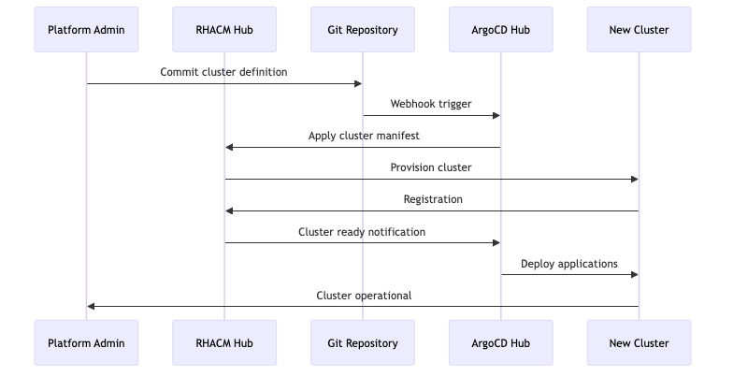

Cluster Template
apiVersion: cluster.open-cluster-management.io/v1
kind: ManagedCluster
metadata:
name: app-cluster-{{ .Values.environment }}-{{ .Values.region }}
labels:
environment: {{ .Values.environment }}
region: {{ .Values.region }}
cluster.open-cluster-management.io/clusterset: {{ .Values.clusterset }}
spec:
hubAcceptsClient: true
leaseDurationSeconds: 60
---
apiVersion: agent.open-cluster-management.io/v1
kind: KlusterletAddonConfig
metadata:
name: app-cluster-{{ .Values.environment }}-{{ .Values.region }}
namespace: app-cluster-{{ .Values.environment }}-{{ .Values.region }}
spec:
clusterName: app-cluster-{{ .Values.environment }}-{{ .Values.region }}
clusterNamespace: app-cluster-{{ .Values.environment }}-{{ .Values.region }}
clusterLabels:
environment: {{ .Values.environment }}
region: {{ .Values.region }}
applicationManager:
enabled: true
policyController:
enabled: true
searchCollector:
enabled: true
certPolicyController:
enabled: true

Multi-Cluster Networking

Cluster Network Isolation
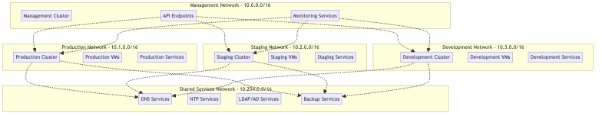

Service Mesh Integration
apiVersion: networking.istio.io/v1beta1
kind: VirtualService
metadata:
name: cross-cluster-vm-service
spec:
hosts:
- vm-service.production.svc.cluster.local
gateways:
- mesh
- cross-cluster-gateway
http:
- match:
- headers:
cluster:
exact: staging
route:
- destination:
host: vm-service.staging.svc.cluster.local
- route:
- destination:
host: vm-service.production.svc.cluster.local

Disaster Recovery and Business Continuity

Multi-Cluster Backup Strategy
apiVersion: velero.io/v1
kind: Schedule
metadata:
name: multi-cluster-backup
namespace: velero
spec:
schedule: "0 2 * * *" # Daily at 2 AM
template:
includedNamespaces:
- vm-production
- vm-staging
- openshift-cnv
excludedResources:
- pods
- replicasets
snapshotVolumes: true
ttl: 720h # 30 days
hooks:
resources:
- name: vm-backup-hook
includedNamespaces:
- vm-production
- vm-staging
labelSelector:
matchLabels:
backup.kubevirt.io/enable: "true"
pre:
- exec:
container: virt-launcher
command:
- /bin/bash
- -c
- "virtctl freeze --namespace $NAMESPACE $VM_NAME"
post:
- exec:
container: virt-launcher
command:
- /bin/bash
- -c
- "virtctl unfreeze --namespace $NAMESPACE $VM_NAME"

Cross-Cluster Failover
apiVersion: cluster.open-cluster-management.io/v1beta1
kind: Placement
metadata:
name: vm-workload-placement
namespace: vm-production
spec:
predicates:
- requiredClusterSelector:
labelSelector:
matchLabels:
environment: production
region: primary
- requiredClusterSelector:
labelSelector:
matchLabels:
environment: production
region: secondary
numberOfClusters: 2
prioritizerPolicy:
mode: Additive
configurations:
- scoreCoordinate:
type: BuiltIn
builtIn: Steady
weight: 1
- scoreCoordinate:
type: BuiltIn
builtIn: ResourceAllocatableCPU
weight: 1

Scalability and Performance

Cluster Auto-Scaling
apiVersion: machine.openshift.io/v1beta1
kind: MachineAutoscaler
metadata:
name: worker-autoscaler
namespace: openshift-machine-api
spec:
minReplicas: 3
maxReplicas: 20
scaleTargetRef:
apiVersion: machine.openshift.io/v1beta1
kind: MachineSet
name: worker-machineset
---
apiVersion: autoscaling.openshift.io/v1
kind: ClusterAutoscaler
metadata:
name: default
spec:
podPriorityThreshold: -10
resourceLimits:
maxNodesTotal: 50
cores:
min: 16
max: 1000
memory:
min: 64Gi
max: 4000Gi
scaleDown:
enabled: true
delayAfterAdd: 10m
delayAfterDelete: 10s
delayAfterFailure: 30s
unneededTime: 60s

VM Resource Management
apiVersion: kubevirt.io/v1
kind: VirtualMachine
metadata:
name: scalable-vm-template
namespace: vm-production
spec:
template:
spec:
domain:
cpu:
cores: 4
sockets: 1
threads: 1
memory:
guest: 8Gi
resources:
requests:
cpu: 2
memory: 4Gi
limits:
cpu: 4
memory: 8Gi
devices:
autoattachPodInterface: false
autoattachSerialConsole: true
autoattachGraphicsDevice: true
evictionStrategy: LiveMigrate
terminationGracePeriodSeconds: 180
nodeSelector:
node-role.kubernetes.io/worker: ""
vm-workload: "true"
affinity:
podAntiAffinity:
preferredDuringSchedulingIgnoredDuringExecution:
- weight: 100
podAffinityTerm:
labelSelector:
matchExpressions:
- key: vm.kubevirt.io/name
operator: Exists
topologyKey: kubernetes.io/hostname

Operational Procedures

Day-2 Operations Workflow
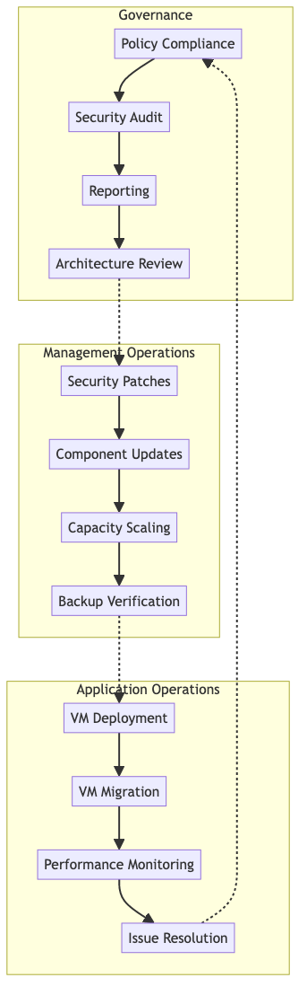

Monitoring and Alerting
apiVersion: monitoring.coreos.com/v1
kind: PrometheusRule
metadata:
name: multi-cluster-alerts
namespace: monitoring
spec:
groups:
- name: cluster.health
rules:
- alert: ClusterDown
expr: up{job="kubernetes-apiservers"} == 0
for: 5m
labels:
severity: critical
annotations:
summary: "Cluster {{ $labels.cluster }} is down"
description: "Cluster {{ $labels.cluster }} has been down for more than 5 minutes"
- alert: VMHighMemory
expr: kubevirt_vm_memory_usage_bytes / kubevirt_vm_memory_available_bytes > 0.9
for: 10m
labels:
severity: warning
annotations:
summary: "VM {{ $labels.name }} high memory usage"
description: "VM {{ $labels.name }} in cluster {{ $labels.cluster }} has high memory usage"
- alert: VMMigrationFailed
expr: increase(kubevirt_vm_migration_failed_total[5m]) > 0
labels:
severity: critical
annotations:
summary: "VM migration failed"
description: "VM migration failed in cluster {{ $labels.cluster }}"

Best Practices and Recommendations

Cluster Design Guidelines
- Resource Planning
  - Size clusters based on workload requirements
  - Plan for 20-30% overhead for system components
  - Consider NUMA topology for high-performance VMs
- Network Segmentation
  - Isolate management and data plane traffic
  - Use VLANs for multi-tenant environments
  - Implement east-west encryption
- Storage Strategy
  - Use local storage for high-performance workloads
  - Implement storage classes for different performance tiers
  - Plan for backup and disaster recovery
- Security Architecture
  - Implement pod security standards
  - Use network policies for microsegmentation
  - Regular security scanning and compliance checks

Operational Excellence
- GitOps Workflow
  - All changes through version control
  - Automated testing and validation
  - Rollback capabilities
- Monitoring Strategy
  - Proactive alerting and monitoring
  - Centralized logging and metrics
  - Regular performance reviews
- Disaster Recovery
  - Regular backup testing
  - Cross-region replication
  - Documented recovery procedures
This global architecture overview provides a comprehensive foundation for understanding how the RH OVE ecosystem scales across multiple clusters while maintaining centralized governance, security, and operational efficiency. The architecture supports growth from small deployments to large-scale multi-region installations while preserving consistent management and security practices.

Overview

RH OVE Solution Design and Architecture

Overview
This document provides an overview of the RH OVE solution, detailing the architecture, deployment, and management strategies.

Design Principles
- Utilize a namespace-based topology for isolation and security.
- Implement Cilium for network security using eBPF.
- Integrate multiplex workloads to optimize resource utilization.

Network Architecture
Mermaid diagram for network architecture:
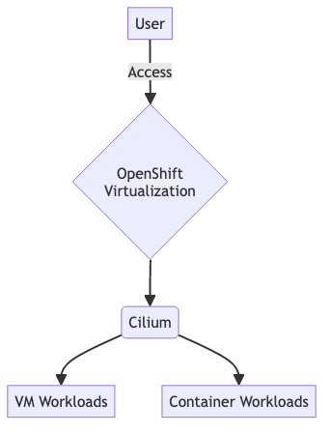

Storage Architecture
Include storage considerations and architecture here.

Design Principles

Design Principles

Overview
The RH OVE solution is built on fundamental design principles that ensure scalability, security, and operational efficiency for hybrid container and VM workloads.

Core Principles

1. Application Namespace-Based Topology
Based on the analysis from our research, using an application namespace-based topology is considered a best practice for RH OVE clusters.
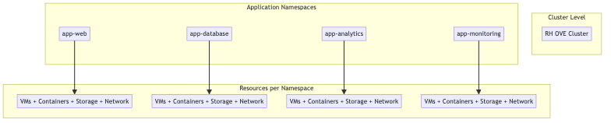
Benefits: - Isolation and Security: Strong RBAC and network policy enforcement - Operational Efficiency: Simplified management and troubleshooting - Network Segregation: Namespace-scoped NetworkAttachmentDefinitions - Scalability: Prevents resource clutter and performance bottlenecks - Policy Management: Granular security policies and quotas
Implementation: - Group related VMs and Kubernetes resources by application or business domain - Apply consistent labeling for automation and cost management - Combine with network policies and RBAC rules - Designate separate namespaces for dev, test, and prod environments

2. Mixed Workload Strategy
Multiplexing Kubernetes container workloads and VM workloads on the same RH OVE cluster is highly advantageous:
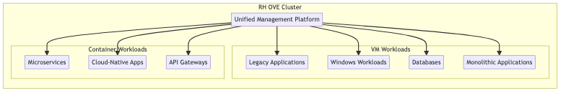
Advantages: - Unified Management: Same Kubernetes-native interface for all workloads - Resource Optimization: Better hardware consolidation - Flexibility: Gradual modernization path for legacy applications - Streamlined DevOps: Integrated CI/CD pipelines for all workload types - Advanced Platform Features: HA, storage provisioning, monitoring for all

3. Security-First Design
Implement defense-in-depth security across all layers:

4. GitOps-Driven Operations
Implement infrastructure and application management through GitOps principles:
Benefits: - Single Source of Truth: All configurations version-controlled in Git - Declarative Management: Infrastructure as Code for VMs and containers - Automation: Reduced human error through automated deployments - Auditability: Complete change tracking and rollback capabilities - Collaboration: Peer review through pull requests

5. Observability and Monitoring
Comprehensive monitoring strategy across all workload types:
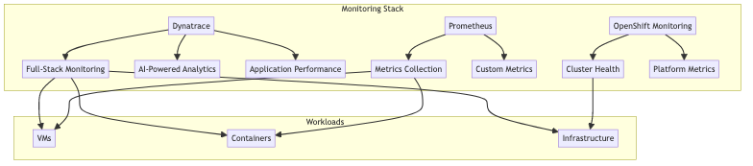

Implementation Guidelines

Namespace Design
### Example namespace structure
apiVersion: v1
kind: Namespace
metadata:
name: app-web-prod
labels:
app: web
environment: production
tier: frontend
annotations:
network-policy: strict
backup-policy: daily

Resource Quotas
apiVersion: v1
kind: ResourceQuota
metadata:
name: compute-quota
namespace: app-web-prod
spec:
hard:
requests.cpu: "10"
requests.memory: 20Gi
limits.cpu: "20"
limits.memory: 40Gi
persistentvolumeclaims: "10"

Network Policies
apiVersion: networking.k8s.io/v1
kind: NetworkPolicy
metadata:
name: app-web-netpol
namespace: app-web-prod
spec:
podSelector:
matchLabels:
app: web
policyTypes:
- Ingress
- Egress
ingress:
- from:
- namespaceSelector:
matchLabels:
name: app-gateway-prod

Best Practices

Design Decisions
- Plan namespace strategy early: Define naming conventions and access hierarchies
- Implement least privilege: Use RBAC and network policies consistently
- Design for scale: Consider resource limits and node capacity planning
- Plan for disaster recovery: Include backup and restoration strategies

Operational Considerations
- Monitor resource utilization: Prevent resource contention between workload types
- Implement proper logging: Centralized logging for both VMs and containers
- Regular security assessments: Continuous compliance and vulnerability management
- Performance testing: Regular load testing for mixed workload scenarios
These design principles ensure that the RH OVE solution provides a robust, secure, and scalable platform for modern hybrid workloads while supporting organizational transformation initiatives.

Network

Network Architecture

Overview
The RH OVE network architecture leverages Cilium CNI for enhanced security and observability, providing advanced network capabilities through eBPF technology for both container and VM workloads.

Cilium CNI Integration
Based on our research, using Cilium for RH OVE is widely regarded as a strong, future-proof approach with several key advantages:

Benefits
- Red Hat Certification: Cilium is a certified CNI plugin for OpenShift
- eBPF-Powered Enforcement: Advanced security, visibility, and traffic control
- Multi-platform Support: Works for both containers and VMs in hybrid environments
- High Performance: Superior performance compared to traditional iptables-based CNIs
- Service Mesh Capabilities: L7 security and observability without sidecar proxies

Network Architecture Diagram
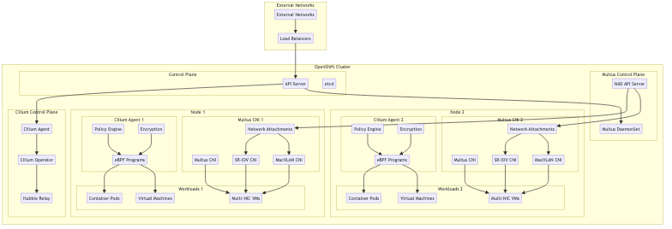

Network Security Features

Identity-Aware Security
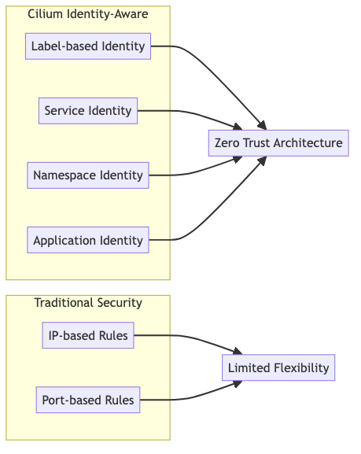

Network Policies

Basic Network Policy for VMs
apiVersion: cilium.io/v2
kind: CiliumNetworkPolicy
metadata:
name: vm-web-policy
namespace: app-web-prod
spec:
endpointSelector:
matchLabels:
app: web-vm
ingress:
- fromEndpoints:
- matchLabels:
app: api-gateway
toPorts:
- ports:
- port: "80"
protocol: TCP
- port: "443"
protocol: TCP
egress:
- toEndpoints:
- matchLabels:
app: database-vm
toPorts:
- ports:
- port: "5432"
protocol: TCP

L7 HTTP Policy
apiVersion: cilium.io/v2
kind: CiliumNetworkPolicy
metadata:
name: l7-http-policy
spec:
endpointSelector:
matchLabels:
app: web-api
ingress:
- fromEndpoints:
- matchLabels:
app: frontend
toPorts:
- ports:
- port: "80"
protocol: TCP
rules:
http:
- method: "GET"
path: "/api/v1/.*"
- method: "POST"
path: "/api/v1/users"

Multi-Tenant Networking

Namespace Isolation
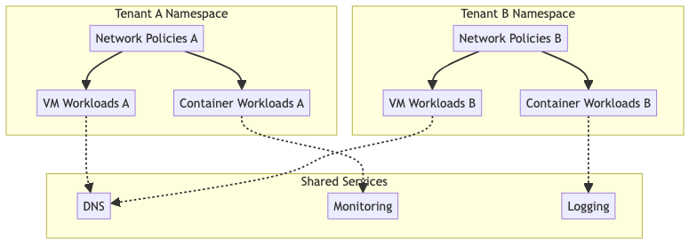

NetworkAttachmentDefinition for VMs
apiVersion: k8s.cni.cncf.io/v1
kind: NetworkAttachmentDefinition
metadata:
name: vm-network
namespace: app-database-prod
spec:
config: |
{
"cniVersion": "0.3.1",
"name": "vm-network",
"type": "cilium-cni",
"ipam": {
"type": "cilium"
}
}

Multus Multi-Network Configuration

Overview
Multus CNI enables attaching multiple network interfaces to pods and VMs, allowing for complex networking scenarios such as: - Separation of management and data traffic - VLAN-based network segmentation - High-performance networking with SR-IOV - Legacy application networking requirements
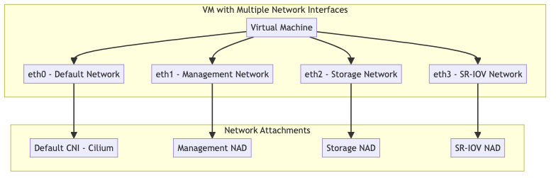

Multus Installation
Multus is typically installed as part of OpenShift Container Platform:
### Verify Multus is installed
oc get network.operator.openshift.io cluster -o yaml
### Check Multus DaemonSet
oc get ds multus -n openshift-multus

Network Attachment Definitions (NADs)

Management Network NAD
apiVersion: k8s.cni.cncf.io/v1
kind: NetworkAttachmentDefinition
metadata:
name: management-network
namespace: vm-infrastructure
spec:
config: |
{
"cniVersion": "0.3.1",
"name": "management-network",
"type": "macvlan",
"master": "ens192",
"mode": "bridge",
"ipam": {
"type": "static",
"addresses": [
{
"address": "192.168.100.0/24",
"gateway": "192.168.100.1"
}
],
"dns": {
"nameservers": ["192.168.100.10", "8.8.8.8"]
}
}
}

Storage Network NAD
apiVersion: k8s.cni.cncf.io/v1
kind: NetworkAttachmentDefinition
metadata:
name: storage-network
namespace: vm-infrastructure
spec:
config: |
{
"cniVersion": "0.3.1",
"name": "storage-network",
"type": "macvlan",
"master": "ens224",
"mode": "bridge",
"ipam": {
"type": "static",
"addresses": [
{
"address": "10.0.200.0/24"
}
]
}
}

VLAN-based Network NAD
apiVersion: k8s.cni.cncf.io/v1
kind: NetworkAttachmentDefinition
metadata:
name: vlan-100-network
namespace: vm-production
spec:
config: |
{
"cniVersion": "0.3.1",
"name": "vlan-100-network",
"type": "macvlan",
"master": "ens192.100",
"mode": "bridge",
"ipam": {
"type": "dhcp"
}
}

SR-IOV Network NAD
apiVersion: k8s.cni.cncf.io/v1
kind: NetworkAttachmentDefinition
metadata:
name: sriov-high-performance
namespace: vm-production
spec:
config: |
{
"cniVersion": "0.3.1",
"name": "sriov-high-performance",
"type": "sriov",
"deviceID": "1017",
"vf": 0,
"ipam": {
"type": "static",
"addresses": [
{
"address": "10.0.50.0/24"
}
]
}
}

VM Configuration with Multiple Network Cards

VM with Multiple Interfaces
apiVersion: kubevirt.io/v1
kind: VirtualMachine
metadata:
name: multi-network-vm
namespace: vm-infrastructure
annotations:
k8s.v1.cni.cncf.io/networks: |
[
{
"name": "management-network",
"ips": ["192.168.100.50/24"]
},
{
"name": "storage-network",
"ips": ["10.0.200.50/24"]
},
{
"name": "vlan-100-network"
}
]
spec:
running: true
template:
metadata:
labels:
app: multi-network-app
spec:
domain:
cpu:
cores: 4
memory:
guest: 8Gi
devices:
interfaces:
- name: default
masquerade: {}
- name: management
bridge: {}
- name: storage
bridge: {}
- name: vlan-network
bridge: {}
disks:
- name: rootdisk
disk:
bus: virtio
resources:
requests:
cpu: 4
memory: 8Gi
networks:
- name: default
pod: {}
- name: management
multus:
networkName: management-network
- name: storage
multus:
networkName: storage-network
- name: vlan-network
multus:
networkName: vlan-100-network
volumes:
- name: rootdisk
dataVolume:
name: multi-network-vm-root

High-Performance VM with SR-IOV
apiVersion: kubevirt.io/v1
kind: VirtualMachine
metadata:
name: high-perf-vm
namespace: vm-production
annotations:
k8s.v1.cni.cncf.io/networks: |
[
{
"name": "management-network",
"ips": ["192.168.100.100/24"]
},
{
"name": "sriov-high-performance",
"ips": ["10.0.50.100/24"]
}
]
spec:
running: true
template:
metadata:
labels:
app: high-performance-app
spec:
domain:
cpu:
cores: 8
dedicatedCpuPlacement: true
memory:
guest: 16Gi
hugepages:
pageSize: 1Gi
devices:
interfaces:
- name: default
masquerade: {}
- name: management
bridge: {}
- name: sriov-net
sriov: {}
disks:
- name: rootdisk
disk:
bus: virtio
resources:
requests:
cpu: 8
memory: 16Gi
hugepages-1Gi: 16Gi
networks:
- name: default
pod: {}
- name: management
multus:
networkName: management-network
- name: sriov-net
multus:
networkName: sriov-high-performance
volumes:
- name: rootdisk
dataVolume:
name: high-perf-vm-root

Advanced Multus Configurations

Bond Network Interface
apiVersion: k8s.cni.cncf.io/v1
kind: NetworkAttachmentDefinition
metadata:
name: bond-network
namespace: vm-infrastructure
spec:
config: |
{
"cniVersion": "0.3.1",
"name": "bond-network",
"type": "bond",
"mode": "active-backup",
"miimon": "100",
"links": [
{"name": "ens192"},
{"name": "ens224"}
],
"ipam": {
"type": "static",
"addresses": [
{
"address": "10.0.100.0/24",
"gateway": "10.0.100.1"
}
]
}
}

OVS Bridge Network
apiVersion: k8s.cni.cncf.io/v1
kind: NetworkAttachmentDefinition
metadata:
name: ovs-bridge-network
namespace: vm-infrastructure
spec:
config: |
{
"cniVersion": "0.3.1",
"name": "ovs-bridge-network",
"type": "ovs",
"bridge": "br-data",
"vlan": 200,
"ipam": {
"type": "static",
"addresses": [
{
"address": "10.0.200.0/24"
}
]
}
}

Encryption and Security

Transparent Encryption
Cilium supports both IPsec and WireGuard for transparent encryption:
### Cilium ConfigMap for WireGuard encryption
apiVersion: v1
kind: ConfigMap
metadata:
name: cilium-config
namespace: kube-system
data:
enable-wireguard: "true"
wireguard-userspace-fallback: "true"

Service Mesh without Sidecars
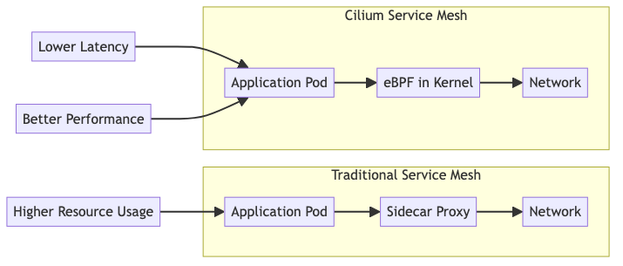

Observability with Hubble

Network Visibility
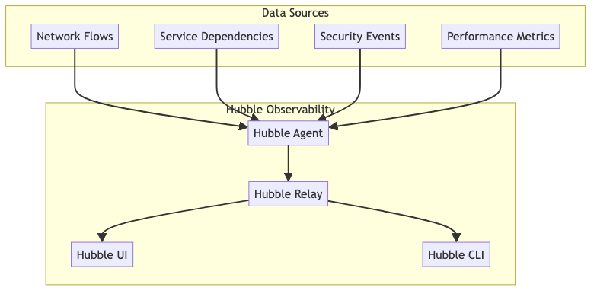

Hubble Configuration
apiVersion: v1
kind: ConfigMap
metadata:
name: cilium-config
namespace: kube-system
data:
enable-hubble: "true"
hubble-listen-address: ":4244"
hubble-socket-path: "/var/run/cilium/hubble.sock"
hubble-metrics-server: ":9091"
hubble-metrics: >-
dns:query;ignoreAAAA
drop
tcp
flow
icmp
http

VM-Specific Networking

VM Network Integration
apiVersion: kubevirt.io/v1
kind: VirtualMachine
metadata:
name: database-vm
namespace: app-database-prod
spec:
template:
spec:
networks:
- name: default
pod: {}
- name: vm-network
multus:
networkName: vm-network
domain:
devices:
interfaces:
- name: default
masquerade: {}
- name: vm-network
bridge: {}

Performance Optimization

eBPF Performance Benefits
- Bypass iptables overhead: Direct kernel-space processing
- Reduced context switches: Fewer user-space to kernel-space transitions
- Optimized packet processing: Custom eBPF programs for specific workloads
- Hardware acceleration: Support for XDP (eXpress Data Path)

Network Performance Tuning
### Cilium DaemonSet configuration for performance
apiVersion: apps/v1
kind: DaemonSet
metadata:
name: cilium
spec:
template:
spec:
containers:
- name: cilium-agent
args:
- --enable-bandwidth-manager=true
- --enable-local-redirect-policy=true
- --kube-proxy-replacement=strict
resources:
requests:
cpu: 100m
memory: 128Mi
limits:
cpu: 500m
memory: 512Mi

Integration with External Systems

Load Balancer Integration
apiVersion: cilium.io/v2alpha1
kind: CiliumLoadBalancerIPPool
metadata:
name: vm-pool
spec:
cidrs:
- cidr: "10.100.0.0/24"
---
apiVersion: v1
kind: Service
metadata:
name: vm-web-service
annotations:
io.cilium/lb-ipam-ips: "10.100.0.10"
spec:
type: LoadBalancer
selector:
app: web-vm
ports:
- port: 80
targetPort: 8080

Troubleshooting and Monitoring

Network Flow Monitoring
### Monitor network flows
hubble observe --namespace app-web-prod
### Check policy violations
hubble observe --verdict DENIED
### Monitor specific VM traffic
hubble observe --pod vm-database-vm-xxx

Performance Metrics
Key metrics to monitor: - Network throughput per VM/pod - Policy enforcement latency - eBPF program execution time - Hubble flow processing rate
This network architecture provides enterprise-grade security, performance, and observability for mixed VM and container workloads in the RH OVE environment.

Storage

Storage Architecture

Overview
The RH OVE storage architecture provides unified storage management for both container and VM workloads, leveraging Kubernetes-native storage concepts while supporting traditional VM storage requirements.

Storage Components
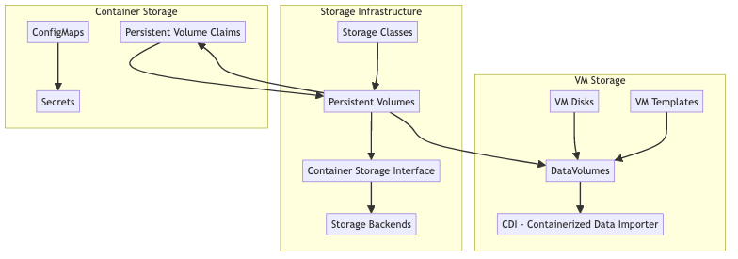

DataVolume Management

DataVolume CRD
DataVolumes are the primary mechanism for managing VM storage in RH OVE:
apiVersion: cdi.kubevirt.io/v1beta1
kind: DataVolume
metadata:
name: web-vm-disk
namespace: app-web-prod
spec:
pvc:
accessModes:
- ReadWriteOnce
resources:
requests:
storage: 50Gi
storageClassName: fast-ssd
source:
registry:
url: "docker://registry.redhat.io/rhel8/rhel:latest"

Storage Import Patterns
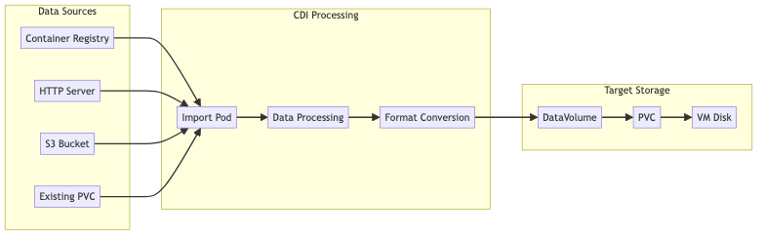

Storage Classes and Performance Tiers

Performance Tiers
### High Performance SSD Storage Class
apiVersion: storage.k8s.io/v1
kind: StorageClass
metadata:
name: high-performance-ssd
provisioner: kubernetes.io/no-provisioner
parameters:
type: ssd
iops: "10000"
throughput: "500Mi"
reclaimPolicy: Delete
volumeBindingMode: WaitForFirstConsumer
---
### Standard HDD Storage Class
apiVersion: storage.k8s.io/v1
kind: StorageClass
metadata:
name: standard-hdd
provisioner: kubernetes.io/no-provisioner
parameters:
type: hdd
iops: "1000"
throughput: "100Mi"
reclaimPolicy: Retain
volumeBindingMode: WaitForFirstConsumer
---
### Archive Storage Class
apiVersion: storage.k8s.io/v1
kind: StorageClass
metadata:
name: archive-storage
provisioner: kubernetes.io/no-provisioner
parameters:
type: archive
iops: "100"
throughput: "50Mi"
reclaimPolicy: Retain
volumeBindingMode: WaitForFirstConsumer

VM Disk Configuration

VM with Multiple Disks
apiVersion: kubevirt.io/v1
kind: VirtualMachine
metadata:
name: database-vm
namespace: app-database-prod
spec:
template:
spec:
domain:
devices:
disks:
- name: rootdisk
disk:
bus: virtio
- name: datadisk
disk:
bus: virtio
- name: logdisk
disk:
bus: virtio
resources:
requests:
memory: 8Gi
cpu: 4
volumes:
- name: rootdisk
dataVolume:
name: db-vm-root
- name: datadisk
dataVolume:
name: db-vm-data
- name: logdisk
dataVolume:
name: db-vm-logs

DataVolume for Different Use Cases
### Boot disk from registry
apiVersion: cdi.kubevirt.io/v1beta1
kind: DataVolume
metadata:
name: db-vm-root
spec:
pvc:
accessModes: [ReadWriteOnce]
resources:
requests:
storage: 30Gi
storageClassName: high-performance-ssd
source:
registry:
url: "docker://registry.access.redhat.com/rhel8/rhel:latest"
---
### Data disk - blank
apiVersion: cdi.kubevirt.io/v1beta1
kind: DataVolume
metadata:
name: db-vm-data
spec:
pvc:
accessModes: [ReadWriteOnce]
resources:
requests:
storage: 500Gi
storageClassName: standard-hdd
source:
blank: {}
---
### Log disk - blank
apiVersion: cdi.kubevirt.io/v1beta1
kind: DataVolume
metadata:
name: db-vm-logs
spec:
pvc:
accessModes: [ReadWriteOnce]
resources:
requests:
storage: 100Gi
storageClassName: standard-hdd
source:
blank: {}

Storage Backup Integration

Rubrik Integration for VM Storage
Based on our research, Rubrik provides certified integration with RH OVE for VM backup:
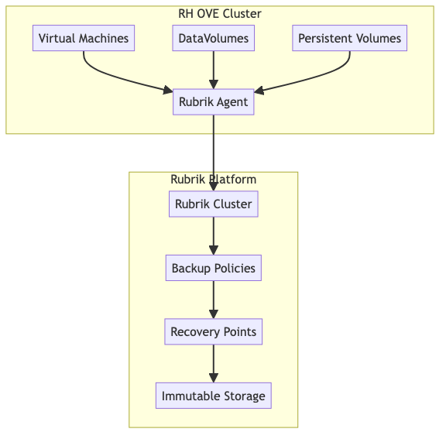

Backup Policy Configuration
apiVersion: v1
kind: ConfigMap
metadata:
name: rubrik-backup-policy
namespace: app-database-prod
data:
policy.yaml: |
vm_backup_policy:
name: "database-vm-backup"
frequency: "daily"
retention: "30d"
snapshot_consistency: "crash-consistent"
backup_window: "02:00-06:00"
exclude_disks:
- "temp-disk"
- "swap-disk"

Storage Monitoring and Performance

Storage Metrics
Key storage metrics to monitor:
apiVersion: monitoring.coreos.com/v1
kind: ServiceMonitor
metadata:
name: storage-metrics
spec:
selector:
matchLabels:
app: cdi-controller
endpoints:
- port: metrics
interval: 30s
path: /metrics

Performance Monitoring
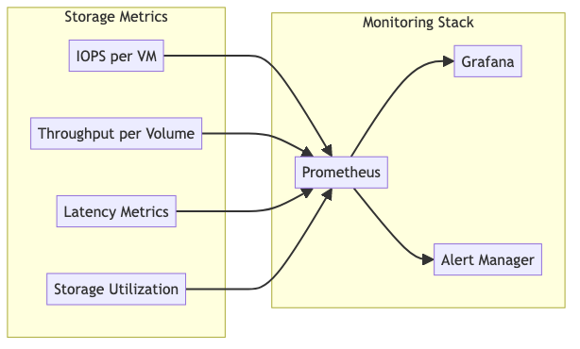

Storage Operations

Volume Expansion
### Expand a DataVolume
apiVersion: cdi.kubevirt.io/v1beta1
kind: DataVolume
metadata:
name: web-vm-disk
namespace: app-web-prod
spec:
pvc:
accessModes: [ReadWriteOnce]
resources:
requests:
storage: 100Gi # Increased from 50Gi
storageClassName: fast-ssd
source:
pvc:
name: web-vm-disk
namespace: app-web-prod

Volume Cloning
### Clone a DataVolume for VM template
apiVersion: cdi.kubevirt.io/v1beta1
kind: DataVolume
metadata:
name: web-vm-template-clone
namespace: vm-templates
spec:
pvc:
accessModes: [ReadWriteOnce]
resources:
requests:
storage: 50Gi
storageClassName: fast-ssd
source:
pvc:
name: web-vm-golden-image
namespace: vm-templates

Snapshot Management
apiVersion: snapshot.storage.k8s.io/v1
kind: VolumeSnapshot
metadata:
name: db-vm-snapshot-pre-upgrade
namespace: app-database-prod
spec:
volumeSnapshotClassName: csi-snapshotter
source:
persistentVolumeClaimName: db-vm-data

Storage Security

Encryption at Rest
apiVersion: storage.k8s.io/v1
kind: StorageClass
metadata:
name: encrypted-storage
provisioner: ebs.csi.aws.com
parameters:
type: gp3
encrypted: "true"
kmsKeyId: "arn:aws:kms:region:account:key/key-id"
reclaimPolicy: Delete
volumeBindingMode: WaitForFirstConsumer

Access Control
apiVersion: rbac.authorization.k8s.io/v1
kind: Role
metadata:
namespace: app-database-prod
name: storage-admin
rules:
- apiGroups: [""]
resources: ["persistentvolumeclaims"]
verbs: ["get", "list", "create", "update", "patch", "delete"]
- apiGroups: ["cdi.kubevirt.io"]
resources: ["datavolumes"]
verbs: ["get", "list", "create", "update", "patch", "delete"]
- apiGroups: ["snapshot.storage.k8s.io"]
resources: ["volumesnapshots"]
verbs: ["get", "list", "create", "delete"]

Best Practices

Storage Planning
- Right-size storage: Match storage performance to workload requirements
- Use appropriate storage classes: Different tiers for different use cases
- Plan for growth: Consider volume expansion capabilities
- Backup strategy: Regular snapshots and external backups

Performance Optimization
- Use SSD for high-IOPS workloads: Database and application storage
- Separate storage by function: OS, data, logs, and temp on different volumes
- Monitor storage metrics: Track IOPS, throughput, and latency
- Implement storage quotas: Prevent storage exhaustion

Security Considerations
- Enable encryption at rest: For sensitive data storage
- Implement access controls: RBAC for storage resources
- Regular security scanning: Check for storage-related vulnerabilities
- Audit storage access: Monitor who accesses what storage
This storage architecture ensures reliable, performant, and secure storage management for the hybrid VM and container workloads in the RH OVE environment.

Iam

Identity and Access Management (IAM) Strategy

Overview
This document outlines the comprehensive Identity and Access Management (IAM) strategy for the RH OVE multi-cluster ecosystem, implementing authentication and authorization using OpenID Connect (OIDC) providers with enterprise-grade security controls.

Executive Summary
The IAM strategy for the RH OVE multi-cluster ecosystem provides enterprise-grade identity and access management through a comprehensive OIDC-based approach that ensures security, compliance, and operational efficiency across all clusters and services.

Key Components

1. Architecture Components
- Mermaid diagram showing OIDC provider integration across management and application clusters
- Identity Provider selection with Keycloak as the recommended solution (Red Hat SSO)
- Service integration with ArgoCD, Grafana, Prometheus, and Kubernetes Dashboard
- Dex OIDC Proxy deployment for centralized authentication

2. Authentication Implementation
- OpenShift OAuth configuration with native OIDC integration
- Dex OIDC Proxy for service-to-service authentication
- Multi-Factor Authentication using Keycloak authentication flows with mandatory MFA for admin accounts
- JWT token management with proper security controls and time-limited tokens
- Single Sign-On (SSO) seamless access across all clusters and services

3. Authorization Implementation
- Kubernetes RBAC integration with OIDC groups mapping
- ArgoCD RBAC configuration for GitOps access control with application-specific permissions
- Service Account token management with time-limited tokens and projected volumes
- Namespace-scoped permissions aligned with application teams and business units
- Role-Based Access Control with predefined organizational roles

4. User Lifecycle Management
- SCIM integration for automated user provisioning and deprovisioning
- Group-based access control with predefined roles (platform-admins, web-developers, database-admins, security-auditors)
- Python automation examples for user management workflows
- Self-service capabilities for password reset and account recovery

5. Security Controls
- Token security with JWT validation rules and proper expiration policies
- Network security policies for authentication services with ingress/egress controls
- Encryption and key management with AES-256 and regular key rotation
- Zero Trust Principles implementation with least-privilege access patterns

6. Monitoring and Audit
- Prometheus metrics for authentication monitoring and alerting
- Grafana dashboards for IAM visibility and operational insights
- Kubernetes audit policies for compliance logging and security tracking
- Automated access reviews and compliance reporting for SOC 2, GDPR, HIPAA
- Failed authentication tracking and security incident response

7. Disaster Recovery
- Identity provider backup strategies with automated daily backups
- Multi-region failover configuration for high availability
- High availability for authentication services with automated health checks

Technical Implementation Highlights
- OIDC Provider Integration: Keycloak (Red Hat SSO) as primary, with Auth0/Okta alternatives
- Multi-Factor Authentication: Mandatory for administrative accounts with TOTP/SMS support
- Service Account Automation: Time-limited tokens (15min-2hours) with proper lifecycle management
- Audit and Compliance: Complete alignment with SOC 2, GDPR, and HIPAA requirements
- Enterprise Integration: LDAP/Active Directory federation for existing identity infrastructure

Business Benefits
- Enhanced Security Posture: Zero trust principles with identity-aware access controls
- Operational Efficiency: Centralized identity management across all clusters and services
- Compliance Readiness: Automated audit trails and regulatory framework alignment
- Developer Experience: Single sign-on with self-service capabilities
- Cost Optimization: Reduced operational overhead through automation

Implementation Phases
- Phase 1: Design and Planning (Identity provider selection, architecture design)
- Phase 2: Deployment and Configuration (OIDC integration, RBAC implementation)
- Phase 3: Testing and Validation (Security testing, SSO validation, user acceptance)
- Phase 4: Monitoring and Maintenance (Metrics setup, audit automation, user training)
This IAM strategy ensures robust and flexible identity management, leveraging existing enterprise IAM solutions for seamless integration and compliance within the RH OVE multi-cluster ecosystem while providing a foundation for future growth and regulatory requirements.

Architecture Components

OIDC Provider Integration
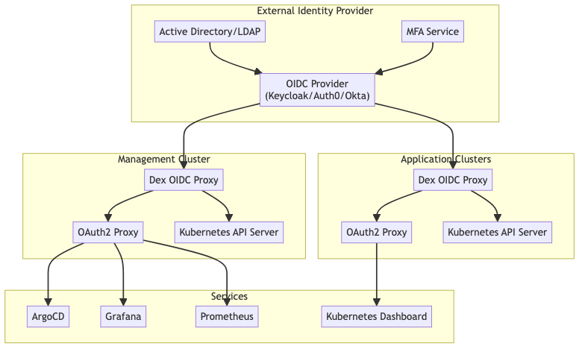

Identity Provider Selection

Recommended: Keycloak (Red Hat SSO)
- Advantages: Open source, Red Hat supported, full OIDC compliance
- Features: User federation, social login, fine-grained authorization
- Integration: Native OpenShift integration, Kubernetes RBAC mapping

Alternative: Enterprise Solutions
- Auth0: SaaS solution with extensive integrations
- Okta: Enterprise-grade with advanced security features
- Azure AD: Microsoft ecosystem integration

Authentication Implementation

OpenShift OAuth Configuration
apiVersion: config.openshift.io/v1
kind: OAuth
metadata:
name: cluster
spec:
identityProviders:
- name: keycloak-oidc
mappingMethod: claim
type: OpenID
openID:
clientID: openshift-cluster
clientSecret:
name: oidc-client-secret
issuer: https://keycloak.company.com/auth/realms/openshift
claims:
preferredUsername:
- preferred_username
name:
- name
email:
- email
groups:
- groups

Dex OIDC Proxy Configuration
apiVersion: v1
kind: ConfigMap
metadata:
name: dex-config
namespace: auth-system
data:
config.yaml: |
issuer: https://dex.company.com
storage:
type: kubernetes
config:
inCluster: true
web:
https: 0.0.0.0:5556
tlsCert: /etc/dex/tls/tls.crt
tlsKey: /etc/dex/tls/tls.key
connectors:
- type: oidc
id: keycloak
name: Keycloak
config:
issuer: https://keycloak.company.com/auth/realms/company
clientID: dex-client
clientSecret: $DEX_CLIENT_SECRET
redirectURI: https://dex.company.com/callback
scopes:
- openid
- profile
- email
- groups
staticClients:
- id: kubernetes
redirectURIs:
- https://kubectl.company.com/callback
name: 'Kubernetes CLI'
secret: $KUBERNETES_CLIENT_SECRET
- id: argocd
redirectURIs:
- https://argocd.company.com/auth/callback
name: 'ArgoCD'
secret: $ARGOCD_CLIENT_SECRET

Multi-Factor Authentication
### Keycloak Authentication Flow
authenticationFlows:
- alias: "browser-with-mfa"
description: "Browser flow with mandatory MFA"
providerId: "basic-flow"
topLevel: true
builtIn: false
authenticationExecutions:
- authenticator: "auth-cookie"
requirement: "ALTERNATIVE"
- authenticator: "auth-spnego"
requirement: "DISABLED"
- authenticator: "identity-provider-redirector"
requirement: "ALTERNATIVE"
- flowAlias: "forms"
requirement: "ALTERNATIVE"
- alias: "forms"
description: "Username, password, otp and other auth forms."
providerId: "basic-flow"
topLevel: false
builtIn: false
authenticationExecutions:
- authenticator: "auth-username-password-form"
requirement: "REQUIRED"
- authenticator: "auth-otp-form"
requirement: "REQUIRED"

Authorization Implementation

Kubernetes RBAC Integration
### ClusterRole for Platform Administrators
apiVersion: rbac.authorization.k8s.io/v1
kind: ClusterRole
metadata:
name: platform-admin
rules:
- apiGroups: ["*"]
resources: ["*"]
verbs: ["*"]
---
### ClusterRoleBinding with OIDC Groups
apiVersion: rbac.authorization.k8s.io/v1
kind: ClusterRoleBinding
metadata:
name: platform-admin-binding
subjects:
- kind: Group
name: "platform-admins"
apiGroup: rbac.authorization.k8s.io
roleRef:
kind: ClusterRole
name: platform-admin
apiGroup: rbac.authorization.k8s.io
---
### Namespace-scoped Role for Application Teams
apiVersion: rbac.authorization.k8s.io/v1
kind: Role
metadata:
namespace: app-web-prod
name: app-developer
rules:
- apiGroups: [""]
resources: ["pods", "services", "configmaps", "secrets"]
verbs: ["get", "list", "create", "update", "patch", "delete"]
- apiGroups: ["apps"]
resources: ["deployments", "replicasets"]
verbs: ["get", "list", "create", "update", "patch", "delete"]
- apiGroups: ["kubevirt.io"]
resources: ["virtualmachines", "virtualmachineinstances"]
verbs: ["get", "list", "create", "update", "patch", "delete"]
---
### RoleBinding with OIDC Groups
apiVersion: rbac.authorization.k8s.io/v1
kind: RoleBinding
metadata:
name: app-developer-binding
namespace: app-web-prod
subjects:
- kind: Group
name: "web-developers"
apiGroup: rbac.authorization.k8s.io
roleRef:
kind: Role
name: app-developer
apiGroup: rbac.authorization.k8s.io

ArgoCD RBAC Integration
apiVersion: v1
kind: ConfigMap
metadata:
name: argocd-rbac-cm
namespace: argocd
data:
policy.default: role:readonly
policy.csv: |
# Platform Administrators
g, platform-admins, role:admin
# Application Teams
g, web-developers, role:web-app-admin
g, database-admins, role:database-admin
# Custom Roles
role:web-app-admin, applications, *, app-web-*/*, allow
role:web-app-admin, repositories, *, *, allow
role:web-app-admin, certificates, *, *, deny
role:database-admin, applications, *, app-database-*/*, allow
role:database-admin, repositories, *, *, allow
role:database-admin, certificates, *, *, deny

Service Account Token Management
### Time-limited Service Account Tokens
apiVersion: v1
kind: Secret
metadata:
name: build-robot-secret
annotations:
kubernetes.io/service-account.name: build-robot
kubernetes.io/service-account.token-ttl: "3600" # 1 hour
type: kubernetes.io/service-account-token
---
### Projected Service Account Token (Preferred)
apiVersion: v1
kind: Pod
metadata:
name: nginx
spec:
serviceAccountName: build-robot
containers:
- image: nginx
name: nginx
volumeMounts:
- mountPath: /var/run/secrets/tokens
name: vault-token
volumes:
- name: vault-token
projected:
sources:
- serviceAccountToken:
path: vault-token
expirationSeconds: 7200 # 2 hours
audience: vault

User Lifecycle Management

Automated User Provisioning
### SCIM Integration Example
class SCIMUserProvisioning:
def __init__(self, keycloak_client, kubernetes_client):
self.keycloak = keycloak_client
self.k8s = kubernetes_client
def provision_user(self, user_data):
# Create user in Keycloak
user = self.keycloak.create_user({
"username": user_data["username"],
"email": user_data["email"],
"firstName": user_data["firstName"],
"lastName": user_data["lastName"],
"enabled": True,
"groups": user_data["groups"]
})
# Assign groups based on role
for group in user_data["groups"]:
self.keycloak.assign_group_to_user(user["id"], group)
# Create ServiceAccount if needed
if user_data.get("service_account"):
self.create_service_account(user_data["username"])
def deprovision_user(self, username):
# Remove from Keycloak
user = self.keycloak.get_user_by_username(username)
self.keycloak.delete_user(user["id"])
# Clean up Kubernetes resources
self.cleanup_user_resources(username)

Group-Based Access Control
### Keycloak Group Configuration
groups:
- name: "platform-admins"
description: "Platform administrators with full cluster access"
attributes:
kubernetes-role: ["cluster-admin"]
argocd-role: ["admin"]
- name: "web-developers"
description: "Web application developers"
attributes:
kubernetes-role: ["app-developer"]
kubernetes-namespaces: ["app-web-prod", "app-web-staging", "app-web-dev"]
argocd-role: ["web-app-admin"]
- name: "database-admins"
description: "Database administrators"
attributes:
kubernetes-role: ["app-developer"]
kubernetes-namespaces: ["app-database-prod", "app-database-staging"]
argocd-role: ["database-admin"]
- name: "security-auditors"
description: "Security team with read-only access"
attributes:
kubernetes-role: ["view"]
argocd-role: ["readonly"]

Security Controls

Token Security
### JWT Token Configuration
jwtPolicy:
issuer: "https://keycloak.company.com/auth/realms/company"
audiences:
- "kubernetes"
- "argocd"
- "grafana"
jwksUri: "https://keycloak.company.com/auth/realms/company/protocol/openid_connect/certs"
### Token Validation Rules
tokenValidation:
expiration:
accessToken: 900 # 15 minutes
refreshToken: 3600 # 1 hour
idToken: 300 # 5 minutes
claims:
required:
- "iss"
- "aud"
- "exp"
- "iat"
- "sub"
groups: "groups"
email: "email"
name: "name"

Network Security
### Network Policy for Auth Services
apiVersion: networking.k8s.io/v1
kind: NetworkPolicy
metadata:
name: auth-system-netpol
namespace: auth-system
spec:
podSelector:
matchLabels:
app: dex
policyTypes:
- Ingress
- Egress
ingress:
- from:
- namespaceSelector:
matchLabels:
name: ingress-nginx
ports:
- protocol: TCP
port: 5556
egress:
- to: []
ports:
- protocol: TCP
port: 443 # HTTPS to external OIDC provider
- to:
- namespaceSelector:
matchLabels:
name: kube-system
ports:
- protocol: TCP
port: 443 # Kubernetes API

Monitoring and Audit

Authentication Metrics
### Prometheus ServiceMonitor for Dex
apiVersion: monitoring.coreos.com/v1
kind: ServiceMonitor
metadata:
name: dex-metrics
namespace: auth-system
spec:
selector:
matchLabels:
app: dex
endpoints:
- port: metrics
interval: 30s
path: /metrics
---
### Grafana Dashboard Configuration
dashboard:
title: "IAM Authentication Metrics"
panels:
- title: "Authentication Requests"
type: "graph"
targets:
- expr: "rate(dex_requests_total[5m])"
legendFormat: "{{method}} {{code}}"
- title: "Active Sessions"
type: "stat"
targets:
- expr: "dex_sessions_active"
- title: "Failed Logins"
type: "graph"
targets:
- expr: "rate(dex_requests_total{code!~"2.."}[5m])"
legendFormat: "Failed Authentications"

Audit Logging
### Kubernetes Audit Policy
apiVersion: audit.k8s.io/v1
kind: Policy
rules:
### Log authentication events
- level: Request
namespaces: ["kube-system", "auth-system"]
verbs: ["create", "update", "delete"]
resources:
- group: ""
resources: ["secrets", "serviceaccounts"]
- group: "rbac.authorization.k8s.io"
resources: ["roles", "rolebindings", "clusterroles", "clusterrolebindings"]
### Log user actions in application namespaces
- level: Metadata
namespaces: ["app-web-prod", "app-database-prod"]
verbs: ["create", "update", "delete"]
users: ["system:serviceaccount:*"]
omitStages:
- RequestReceived

Compliance Reporting
### Automated Access Review
class AccessReviewAutomation:
def __init__(self, k8s_client, keycloak_client):
self.k8s = k8s_client
self.keycloak = keycloak_client
def generate_access_report(self):
report = {
"timestamp": datetime.now().isoformat(),
"users": [],
"service_accounts": [],
"orphaned_resources": []
}
# Get all users from Keycloak
keycloak_users = self.keycloak.get_all_users()
for user in keycloak_users:
user_report = {
"username": user["username"],
"email": user["email"],
"groups": self.keycloak.get_user_groups(user["id"]),
"last_login": user.get("lastAccess"),
"kubernetes_access": self.get_k8s_user_access(user["username"])
}
report["users"].append(user_report)
return report
def get_k8s_user_access(self, username):
# Get user's effective permissions
access = []
# Check ClusterRoleBindings
cluster_bindings = self.k8s.list_cluster_role_binding()
for binding in cluster_bindings.items:
if self.user_in_binding(username, binding):
access.append({
"type": "cluster",
"role": binding.role_ref.name,
"binding": binding.metadata.name
})
# Check RoleBindings per namespace
for namespace in self.get_user_namespaces(username):
role_bindings = self.k8s.list_namespaced_role_binding(namespace)
for binding in role_bindings.items:
if self.user_in_binding(username, binding):
access.append({
"type": "namespace",
"namespace": namespace,
"role": binding.role_ref.name,
"binding": binding.metadata.name
})
return access

Disaster Recovery

Identity Provider Backup
### Keycloak Backup Configuration
apiVersion: batch/v1
kind: CronJob
metadata:
name: keycloak-backup
namespace: auth-system
spec:
schedule: "0 2 * * *" # Daily at 2 AM
jobTemplate:
spec:
template:
spec:
containers:
- name: backup
image: postgres:13
command:
- /bin/bash
- -c
- |
pg_dump -h keycloak-db -U keycloak keycloak > /backup/keycloak-$(date +%Y%m%d).sql
aws s3 cp /backup/keycloak-$(date +%Y%m%d).sql s3://iam-backups/
env:
- name: PGPASSWORD
valueFrom:
secretKeyRef:
name: keycloak-db-secret
key: password
volumeMounts:
- name: backup-volume
mountPath: /backup
volumes:
- name: backup-volume
emptyDir: {}
restartPolicy: OnFailure

Failover Configuration
### Multi-Region OIDC Provider Setup
regions:
primary:
region: "us-east-1"
keycloak_url: "https://keycloak-primary.company.com"
dex_url: "https://dex-primary.company.com"
secondary:
region: "us-west-2"
keycloak_url: "https://keycloak-secondary.company.com"
dex_url: "https://dex-secondary.company.com"
### Automated Failover Logic
failover:
health_check_interval: 30s
failure_threshold: 3
recovery_threshold: 2
dns_ttl: 60 # Low TTL for quick failover
This comprehensive IAM strategy provides enterprise-grade identity and access management for the RH OVE multi-cluster ecosystem, ensuring security, compliance, and operational efficiency through OIDC-based authentication and Kubernetes-native authorization.

Adr Table

Architecture Decision Records (ADR) Table
This document provides a comprehensive overview of all architectural decisions made for the RH OVE multi-cluster ecosystem.

ADR Summary Table
ADR | Title | Status | Date | Context | Decision
ADR-001 | Multi-Cluster Architecture Pattern | Accepted | 2024-12-01 | Need to support multiple environments with centralized governance and scalable infrastructure | Implement multi-cluster pattern with one management cluster and multiple application clusters
ADR-002 | GitOps with ArgoCD Hub Architecture | Accepted | 2024-12-01 | Require consistent, auditable, scalable deployment approach across multiple clusters | Implement GitOps using ArgoCD in hub-spoke pattern with Git-based configuration
ADR-003 | Namespace-Based Cluster Topology | Accepted | 2024-12-01 | Need efficient organizational strategy for mixed VM and container workloads with isolation and security | Implement application namespace-based topology organized by business application
ADR-004 | Admission Controller Strategy | Accepted | 2024-12-01 | Require flexible, secure, policy-driven approach for resource admission and validation | Implement layered admission control using OpenShift built-in controllers, KubeVirt webhooks, and Kyverno policies
ADR-005 | Cilium CNI with Multus Multi-Network Strategy | Accepted | 2024-12-01 | Need advanced networking for container and VM workloads with enterprise-grade security and performance | Implement Cilium as primary CNI with Multus for multi-network support using eBPF-powered networking
ADR-006 | Backup Strategy for RH OVE Ecosystem | Accepted | 2024-12-01 | Ensure data protection and recovery across multi-cluster environment with business continuity requirements | Adopt centralized backup strategy using Rubrik for VM and containerized workloads
ADR-007 | Monitoring Strategy for RH OVE Ecosystem | Accepted | 2024-12-01 | Need comprehensive monitoring for operational visibility, performance management, and incident response | Implement integrated monitoring using Prometheus/Grafana, Dynatrace, and Hubble
ADR-008 | Identity and Access Management (IAM) Strategy | Accepted | 2024-12-01 | Need enterprise-grade identity and access management across multi-cluster ecosystem | Implement comprehensive IAM using OIDC providers with Keycloak, integrated with Kubernetes RBAC

Detailed ADR Information

ADR-001: Multi-Cluster Architecture Pattern
Key Components: - Management Cluster: RHACM, ArgoCD Hub, RHACS, Federated Prometheus, Centralized logging, Rubrik backup management - Application Clusters: Production (HA, performance-optimized), Staging (production-like), Development (resource-optimized) - Network Architecture: Dedicated segments per cluster, VPN/private connectivity, zero-trust principles
Benefits: Separation of concerns, horizontal scalability, security isolation, operational efficiency, fault isolation, resource optimization
Trade-offs: Increased network complexity, additional operational overhead, potential data sync challenges

ADR-002: GitOps with ArgoCD Hub Architecture
Key Components: - ArgoCD Hub: Centralized instance in management cluster with HA (3 replicas) - ArgoCD Agents: Lightweight agents in application clusters - Repository Structure: Clusters, applications (base/overlays), infrastructure (networking/storage/monitoring) - Application of Applications Pattern: Root ArgoCD app manages cluster-specific applications
Benefits: Declarative configuration, complete audit trail, pull-based security, consistency, easy rollbacks, self-healing
Trade-offs: Learning curve for GitOps workflows, Git repository complexity, network dependencies, secret management complexity

ADR-003: Namespace-Based Cluster Topology
Key Components: - Naming Convention: {app-name}-{environment} (e.g., app-web-prod, app-database-staging) - Standard Templates: Namespace with labels, ResourceQuota, LimitRange, NetworkPolicies - Cross-Namespace Communication: Controlled via NetworkPolicies with explicit allow rules - RBAC Integration: Namespace-level roles aligned with application teams
Benefits: Strong isolation, simplified RBAC, clear resource attribution, network microsegmentation, operational clarity, compliance alignment
Trade-offs: Initial complexity in planning boundaries, cross-app dependency management, shared services challenges

ADR-004: Admission Controller Strategy
Key Components: - OpenShift Built-in: Security Context Constraints, RBAC enforcement, quotas and limits - KubeVirt Webhooks: Validation and mutation webhooks for VM specifications - Kyverno Policies: Configuration validation, resource constraints, dynamic policy application
Benefits: Centralized policy management, dynamic policy application, security enforcement, misconfiguration prevention, extensibility
Trade-offs: Complex rule management, performance overhead, learning curve for policy authors

ADR-005: Cilium CNI with Multus Multi-Network Strategy
Key Components: - Cilium Features: eBPF performance, identity-aware security, L7 security, service mesh capabilities, WireGuard encryption - Multus Integration: Multi-network support, legacy network integration, SR-IOV for high performance, network segmentation - Hubble Observability: Network flow monitoring, policy violation detection, security auditing - NetworkAttachmentDefinitions: Management, storage, and data networks with VLAN support
Benefits: Superior eBPF performance (10-100x better than iptables), identity-aware policies, L7 security without sidecars, deep observability, multi-network support
Trade-offs: Learning curve for eBPF concepts, debugging complexity, higher memory usage, potential compatibility issues

ADR-006: Backup Strategy for RH OVE Ecosystem
Key Components: - Rubrik Management: Centralized in management cluster with unified policy management - Backup Architecture: Management cluster (Rubrik node), Application clusters (Edge devices, agents), Cloud archive (long-term retention) - Policy Configuration: Daily backups (24h RPO), weekly full with daily incrementals, AES-256 encryption, cloud replication - Compliance: GDPR, HIPAA, SOC 2 alignment with audit trails and access control
Benefits: Unified management, policy-driven, deduplication/compression, cloud integration, application consistency
Trade-offs: Higher upfront costs than open-source alternatives, training requirements for administrators

ADR-007: Monitoring Strategy for RH OVE Ecosystem
Key Components: - Prometheus/Grafana: Scalable metrics collection, customizable dashboards, real-time metrics, integrated alerting - Dynatrace: Full-stack monitoring, AI-powered analytics, cloud-native support, unified observability - Hubble: eBPF-powered network insights, high throughput flow capture, Cilium integration - Integration: Federated Prometheus (3 replicas, 500Gi storage), OAuth SSO, automated tagging
Benefits: Operational efficiency with reduced MTTR, proactive performance management, unified observability across clusters
Trade-offs: Integration complexity, resource overhead, training requirements for multiple tools

ADR-008: Identity and Access Management (IAM) Strategy
Key Components: - Keycloak (Red Hat SSO): Primary OIDC provider with LDAP/AD integration, MFA support, group-based access control - Dex OIDC Proxy: Service authentication across clusters with static client configuration - OpenShift OAuth Integration: Native cluster authentication with OIDC claims mapping - RBAC Integration: Kubernetes-native authorization with group-based role assignments - Service Account Management: Time-limited tokens with projected volumes and automated lifecycle
Benefits: Centralized identity management, single sign-on across all services, enterprise LDAP/AD integration, MFA enforcement, zero trust security, complete audit trails, compliance ready (SOC 2, GDPR, HIPAA)
Trade-offs: Initial setup complexity, additional infrastructure dependencies, OIDC/Keycloak learning curve, identity provider availability critical, token lifecycle management complexity

Cross-ADR Dependencies
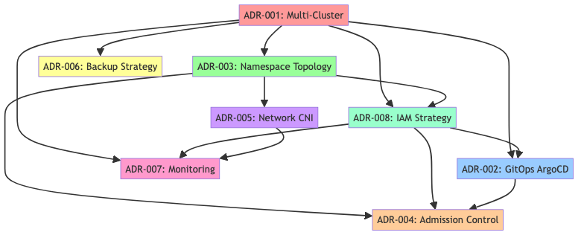

Implementation Timeline
Phase | ADRs | Duration | Dependencies | Key Deliverables
Phase 1: Foundation | ADR-001, ADR-003 | 4-6 weeks | Infrastructure setup | Multi-cluster setup, namespace topology
Phase 2: Identity & Access | ADR-008 | 3-4 weeks | Foundation complete | Keycloak deployment, OIDC integration, MFA setup
Phase 3: GitOps & Policy | ADR-002, ADR-004 | 3-4 weeks | Foundation + IAM complete | ArgoCD hub with OIDC auth, admission controllers
Phase 4: Networking | ADR-005 | 2-3 weeks | Foundation complete | Cilium CNI, Multus, network policies
Phase 5: Operations | ADR-006, ADR-007 | 4-5 weeks | All previous phases | Backup strategy, monitoring with IAM integration

Detailed Phase Dependencies
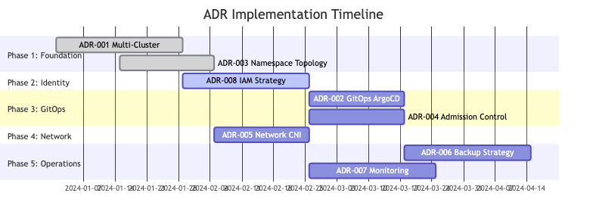

Critical Path Analysis
Critical Dependencies: - ADR-008 (IAM) must be completed before GitOps and Admission Control implementation - ADR-003 (Namespace Topology) enables proper RBAC integration with IAM - ADR-007 (Monitoring) requires IAM integration for authentication and authorization - ADR-002 (GitOps) requires IAM for secure access control and audit trails
Parallel Implementation Opportunities: - ADR-005 (Network CNI) can be implemented in parallel with IAM setup - ADR-006 (Backup) and ADR-007 (Monitoring) can be implemented concurrently in final phase
This comprehensive table provides a complete overview of all architectural decisions, their relationships, and implementation considerations for the RH OVE multi-cluster ecosystem.

Adr 001 Multi Cluster Pattern

ADR-001: Multi-Cluster Architecture Pattern

Status
Accepted

Date
2024-12-01

Context
The RH OVE ecosystem needs to support multiple environments (production, staging, development) while maintaining centralized governance, security, and operational oversight. The organization requires scalable infrastructure that can grow horizontally and support geographic distribution.

Decision
We will implement a multi-cluster architecture pattern with: - One Management Cluster: Centralized control plane for governance, GitOps, security, and monitoring - Multiple Application Clusters: Dedicated workload execution environments per environment type

Rationale

Advantages
- Separation of Concerns: Clear boundaries between management and workload execution
- Scalability: Horizontal scaling by adding application clusters as needed
- Security: Network-level isolation between environments
- Operational Efficiency: Centralized management reduces operational overhead
- Fault Isolation: Issues in one cluster don’t affect others
- Resource Optimization: Right-size clusters based on workload requirements

Alternatives Considered
- Single Large Cluster: Rejected due to blast radius and resource contention
- Completely Separate Clusters: Rejected due to operational complexity and lack of centralized governance
- Namespace-based Multi-tenancy: Rejected due to insufficient isolation for production workloads

Implementation Details

Management Cluster Components
- Red Hat Advanced Cluster Management (RHACM)
- ArgoCD Hub for GitOps
- Red Hat Advanced Cluster Security (RHACS)
- Federated Prometheus for monitoring
- Centralized logging aggregation
- Rubrik backup management

Application Cluster Types
- Production: High-availability, performance-optimized
- Staging: Production-like for testing
- Development: Resource-optimized for development workflows

Network Architecture
- Dedicated network segments per cluster type
- VPN/Private connectivity between management and application clusters
- Zero-trust network principles

Consequences

Positive
- Improved security posture through cluster-level isolation
- Simplified compliance and audit processes
- Better resource utilization and cost optimization
- Enhanced disaster recovery capabilities
- Reduced blast radius for security incidents

Negative
- Increased network complexity
- Additional operational overhead for cluster lifecycle management
- Potential data synchronization challenges
- Learning curve for multi-cluster operations

Compliance Considerations
- Meets enterprise security requirements for environment isolation
- Supports regulatory compliance through audit trail separation
- Enables data residency requirements through geographic cluster placement

Monitoring and Observability
- Centralized metrics collection via Prometheus federation
- Unified logging through log forwarding to management cluster
- Cross-cluster distributed tracing capabilities
- Centralized alerting and incident management

Adr 002 Gitops Argocd

ADR-002: GitOps with ArgoCD Hub Architecture

Status
Accepted

Date
2024-12-01

Context
The multi-cluster RH OVE ecosystem requires a consistent, auditable, and scalable approach to application deployment and configuration management across multiple clusters. Traditional CI/CD approaches with push-based deployments create security concerns and operational complexity in multi-cluster environments.

Decision
We will implement GitOps using ArgoCD in a hub-spoke pattern: - ArgoCD Hub: Centralized ArgoCD instance in the management cluster - ArgoCD Agents: Lightweight agents in each application cluster - Git-based Configuration: All infrastructure and application configurations stored in Git repositories

Rationale

Advantages
- Declarative Configuration: Infrastructure and applications defined as code
- Audit Trail: Complete Git history of all changes
- Security: Pull-based model eliminates need for external access to clusters
- Consistency: Identical deployment processes across all environments
- Rollback Capability: Easy rollback using Git revert operations
- Self-Healing: Automatic drift correction and reconciliation

Alternatives Considered
- Jenkins-based CI/CD: Rejected due to security concerns with push-based deployments
- Tekton Pipelines: Rejected due to complexity in multi-cluster scenarios
- Fleet by Rancher: Rejected due to vendor lock-in concerns
- Flux: Rejected due to preference for ArgoCD’s UI and workflow capabilities

Implementation Details

ArgoCD Hub Configuration
apiVersion: argoproj.io/v1alpha1
kind: ArgoCD
metadata:
name: argocd-hub
namespace: argocd
spec:
server:
replicas: 3
route:
enabled: true
tls:
termination: reencrypt
ha:
enabled: true
dex:
openShiftOAuth: true
rbac:
defaultPolicy: 'role:readonly'

Repository Structure
gitops-repo/
├── clusters/
│ ├── management/
│ ├── production/
│ ├── staging/
│ └── development/
├── applications/
│ ├── base/
│ └── overlays/
└── infrastructure/
├── networking/
├── storage/
└── monitoring/

Application of Applications Pattern
- Root ArgoCD Application manages cluster-specific applications
- Environment-specific overlays using Kustomize
- Automated sync policies for non-production environments
- Manual sync for production deployments

Consequences

Positive
- Enhanced Security: No direct cluster access required for deployments
- Improved Compliance: Complete audit trail through Git history
- Reduced Operational Overhead: Automated deployment and drift correction
- Better Collaboration: Git-based workflows familiar to development teams
- Disaster Recovery: Easy recreation of cluster state from Git

Negative
- Learning Curve: Teams need to adapt to GitOps workflows
- Git Repository Complexity: Large repositories can become difficult to manage
- Network Dependencies: Requires reliable connectivity to Git repositories
- Secret Management: Additional complexity for managing sensitive data

Security Considerations
- ArgoCD service accounts use minimal required permissions
- Private Git repositories with SSH key authentication
- RBAC integration with OpenShift OAuth
- Secret management through External Secrets Operator
- Network policies restrict ArgoCD communication

Monitoring and Alerting
- ArgoCD application health monitoring
- Git repository sync status tracking
- Deployment success/failure notifications
- Performance metrics for sync operations
- Custom dashboards for GitOps workflows

Migration Strategy
- Phase 1: Deploy ArgoCD hub in management cluster
- Phase 2: Migrate existing applications to Git repositories
- Phase 3: Configure ArgoCD applications for each cluster
- Phase 4: Implement automated sync for non-production
- Phase 5: Train teams on GitOps workflows

Adr 003 Cluster Topology

ADR-003: Namespace-Based Cluster Topology

Status
Accepted

Date
2024-12-01

Context
The RH OVE ecosystem requires an efficient organizational strategy for managing mixed VM and container workloads within clusters. We need to balance isolation, security, resource management, and operational simplicity while supporting multi-tenant use cases.

Decision
We will implement an application namespace-based topology where resources are organized by business application or domain rather than by resource type or technology stack.

Topology Structure
Cluster
├── app-web-prod (namespace)
│ ├── VMs (web servers)
│ ├── Containers (microservices)
│ ├── Storage (PVCs, DataVolumes)
│ └── Network (NetworkPolicies, NADs)
├── app-database-prod (namespace)
│ ├── VMs (database servers)
│ ├── Containers (database operators)
│ ├── Storage (high-performance storage)
│ └── Network (isolated database networks)
└── app-monitoring-prod (namespace)
├── VMs (legacy monitoring tools)
├── Containers (modern observability stack)
├── Storage (metrics and logs storage)
└── Network (monitoring networks)

Rationale

Advantages
- Strong Isolation: Each application has its own security boundary
- Simplified RBAC: Teams get namespace-level access aligned with their applications
- Clear Resource Attribution: Easy to track costs and resource usage per application
- Network Microsegmentation: Network policies can be application-specific
- Operational Clarity: Troubleshooting and maintenance scoped to business context
- Compliance Alignment: Audit boundaries match business applications

Alternatives Considered

1. Technology-Based Topology
- Structure: Separate namespaces for VMs vs containers
- Rejected: Creates artificial barriers between related workloads
- Issues: Complex cross-namespace communication, unclear ownership

2. Environment-Based Topology Only
- Structure: Single namespace per environment (prod, staging, dev)
- Rejected: Poor isolation between different applications
- Issues: Resource contention, security boundary concerns

3. Team-Based Topology
- Structure: Namespaces per team/department
- Rejected: Teams often work on multiple applications
- Issues: Unclear application boundaries, resource conflicts

Implementation Details

Namespace Naming Convention
### Pattern: {app-name}-{environment}
### Examples:
- app-web-prod
- app-web-staging
- app-web-dev
- app-database-prod
- app-analytics-prod
- shared-monitoring-prod
- shared-storage-prod

Standard Namespace Template
apiVersion: v1
kind: Namespace
metadata:
name: app-web-prod
labels:
application: web
environment: production
tier: frontend
cost-center: "12345"
owner: web-team
annotations:
backup-policy: "daily"
monitoring-enabled: "true"
network-policy: "strict"
compliance-level: "high"
spec:
finalizers:
- kubernetes
---
### Resource Quota per namespace
apiVersion: v1
kind: ResourceQuota
metadata:
name: compute-quota
namespace: app-web-prod
spec:
hard:
requests.cpu: "20"
requests.memory: 40Gi
limits.cpu: "40"
limits.memory: 80Gi
persistentvolumeclaims: "20"
services: "10"
secrets: "20"
configmaps: "20"
---
### Limit Range per namespace
apiVersion: v1
kind: LimitRange
metadata:
name: resource-limits
namespace: app-web-prod
spec:
limits:
- default:
cpu: "2"
memory: 4Gi
defaultRequest:
cpu: 100m
memory: 128Mi
type: Container
- default:
cpu: "8"
memory: 16Gi
defaultRequest:
cpu: "2"
memory: 4Gi
type: PersistentVolumeClaim

Cross-Namespace Communication Policy
apiVersion: networking.k8s.io/v1
kind: NetworkPolicy
metadata:
name: allow-app-communication
namespace: app-web-prod
spec:
podSelector: {}
policyTypes:
- Ingress
- Egress
ingress:
# Allow ingress from gateway namespace
- from:
- namespaceSelector:
matchLabels:
name: shared-gateway-prod
egress:
# Allow egress to database namespace
- to:
- namespaceSelector:
matchLabels:
application: database
environment: production
ports:
- protocol: TCP
port: 5432
# Allow egress to shared services
- to:
- namespaceSelector:
matchLabels:
tier: shared-services

Governance and Management

Namespace Lifecycle Management
apiVersion: argoproj.io/v1alpha1
kind: Application
metadata:
name: namespace-manager
namespace: argocd
spec:
project: infrastructure
source:
repoURL: https://git.company.com/infrastructure/namespaces
targetRevision: HEAD
path: namespaces
destination:
server: https://kubernetes.default.svc
syncPolicy:
automated:
prune: false
selfHeal: true
syncOptions:
- CreateNamespace=true

RBAC Template per Namespace
apiVersion: rbac.authorization.k8s.io/v1
kind: Role
metadata:
namespace: app-web-prod
name: app-admin
rules:
- apiGroups: [""]
resources: ["*"]
verbs: ["*"]
- apiGroups: ["apps", "extensions"]
resources: ["*"]
verbs: ["*"]
- apiGroups: ["kubevirt.io"]
resources: ["*"]
verbs: ["*"]
- apiGroups: ["cdi.kubevirt.io"]
resources: ["*"]
verbs: ["*"]
---
apiVersion: rbac.authorization.k8s.io/v1
kind: RoleBinding
metadata:
name: app-admin-binding
namespace: app-web-prod
subjects:
- kind: Group
name: web-team
apiGroup: rbac.authorization.k8s.io
roleRef:
kind: Role
name: app-admin
apiGroup: rbac.authorization.k8s.io

Consequences

Positive
- Clear Ownership: Each namespace has a clear business owner
- Improved Security: Strong isolation boundaries between applications
- Simplified Operations: Easier to manage, monitor, and troubleshoot
- Better Resource Management: Clear resource attribution and quota management
- Compliance Ready: Audit boundaries align with business applications

Negative
- Initial Complexity: Requires careful planning of namespace boundaries
- Cross-App Dependencies: Need clear policies for inter-namespace communication
- Shared Services Challenge: Need strategy for common services (monitoring, logging)
- Learning Curve: Teams need to understand namespace-based organization

Migration Strategy

Phase 1: Planning and Design
- Inventory existing applications and their dependencies
- Define namespace naming conventions and standards
- Create RBAC and network policy templates

Phase 2: Shared Services Migration
- Create shared services namespaces (monitoring, logging, gateway)
- Migrate common infrastructure components
- Establish cross-namespace communication patterns

Phase 3: Application Migration
- Start with least critical applications
- Create application-specific namespaces with proper quotas and policies
- Migrate workloads and validate functionality

Phase 4: Governance Implementation
- Implement automated namespace provisioning
- Enable monitoring and alerting per namespace
- Create operational runbooks for namespace management

Monitoring and Compliance

Namespace-Level Metrics
- Resource utilization per namespace
- Cost attribution per application
- Security policy violations
- Cross-namespace communication patterns

Compliance Reporting
- Resource usage reports per business unit
- Security posture per application
- Audit logs scoped to business context
- Data residency compliance per namespace
This topology provides a solid foundation for managing complex multi-tenant RH OVE environments while maintaining security, operational clarity, and business alignment.

Adr 004 Admission Controller

ADR-004: Admission Controller Strategy

Status
Accepted

Date
2024-12-01

Context
The RH OVE ecosystem requires a flexible, secure, and policy-driven approach for managing resource admission and validation within clusters. Implementing appropriate admission control policies ensures compliance, security, and operational consistency.

Decision
We will implement a layered admission control strategy utilizing OpenShift’s built-in admission controllers, KubeVirt webhooks, Kyverno policies, and OIDC-integrated RBAC enforcement via Keycloak.

Rationale

Advantages
- Centralized Policy Management: Simplify governance with cluster-wide policies
- Dynamic Policy Application: Adjust policies without redeploying cluster components
- Security Enforcement: Validate resource configurations before persistence
- Prevention of Misconfiguration: Guard against policy violations
- Identity-based Access Management: Integration with OIDC providers for enhanced user identity verification
- Extensibility: Easy to introduce new policies as needs evolve

Alternatives Considered
- Legacy Admission Controllers: Rejected due to limited flexibility and poor integration
- Custom Webhooks: Rejected due to complexity in management and maintenance
- Third-Party Solutions: Rejected due to integration difficulties and vendor lock-in

Implementation Details

OpenShift Built-in Admission
- Security Context Constraints: Default and custom SCCs for VM and container workloads
- RBAC Enforcements: Actionable role- and label-based access controls
- Quotas and Limit Ranges: Ensuring fair resource allocation per team

KubeVirt Webhooks
- Validation Webhooks: Enforce configuration standards for VM specs
- Mutation Webhooks: Apply defaults and constraints to VM definitions

Kyverno Policies
- Configuration Validation: Ensure compliance with organization best practices
- Resource Constraints: Limit what configurations may be used / deployed
- Dynamic Policies: Automate policy reapplication based on changes

Compliance Considerations
- Auditability: Policy applications and violation logging
- Policy-as-Code: Centralized version control and history of policy changes
- Enforcement vs Warning: Progressive policy application based on audit

Consequences

Positive
- Improved Security Posture: Clusters protected from non-compliant configurations
- Enhanced Compliance Auditability: Documentation and reporting of policy compliance
- Reduced Operational Risk: Guard against human error and unsafe configurations

Negative
- Complex Rule Management: Need mature processes to handle policy lifecycle
- Performance Overhead: May introduce latency to resource creation/update
- Learning Curve: Required training for policy authors

Implementation Plan

Phase 1: Planning
- Identify key compliance and security requirements
- Design initial policy set and test environment
- Engage stakeholders to define policy boundaries

Phase 2: Rollout
- Deploy core admission controllers with policy-as-code principles, leveraging IAM for authentication and authorization
- Begin enforcement in non-production environments
- Gradually extend to production with monitoring and logging

Phase 3: Monitoring and Adjustment
- Enable continuous policy evaluation and audit logging
- Conduct regular policy reviews and updates
- Train teams on policy creation and maintenance

Compliance and Observability

Monitoring
- Policy applicability and compliance dashboards
- Alerts for policy violations and enforcement actions

Logging and Reporting
- Centralized logging of admission requests and results
- Automated compliance reports tied to policy adherence

Adr 005 Network Cni

ADR-005: Cilium CNI with Multus Multi-Network Strategy

Status
Accepted

Date
2024-12-01

Context
The RH OVE ecosystem requires advanced networking capabilities to support both container and VM workloads with enterprise-grade security, performance, and observability. Traditional iptables-based CNI solutions lack the performance and security features needed for modern hybrid workloads.

Decision
We will implement Cilium as the primary CNI with Multus for multi-network support, providing eBPF-powered networking with advanced security and observability capabilities.

Rationale

Advantages of Cilium
- eBPF Performance: Superior performance compared to iptables-based solutions
- Identity-Aware Security: Security policies based on workload identity, not IP addresses
- L7 Security: Application-layer security without sidecar proxies
- Service Mesh Capabilities: Built-in service mesh functionality
- Red Hat Certification: Certified CNI plugin for OpenShift
- Hubble Observability: Deep network visibility and monitoring
- Transparent Encryption: Built-in WireGuard and IPsec support

Advantages of Multus Integration
- Multi-Network Support: Attach multiple network interfaces to VMs
- Legacy Network Integration: Support for existing VLAN-based networks
- Performance Networks: SR-IOV for high-performance workloads
- Network Segmentation: Separate management, storage, and data networks

Alternatives Considered

1. OVN-Kubernetes (OpenShift Default)
- Pros: Native OpenShift integration, mature
- Cons: Limited eBPF features, performance overhead
- Rejected: Cilium provides superior performance and security

2. Calico
- Pros: Strong network policies, eBPF support
- Cons: No built-in service mesh, complex multi-network setup
- Rejected: Cilium offers better integrated solution

3. Flannel
- Pros: Simple, lightweight
- Cons: Limited security features, no eBPF support
- Rejected: Insufficient for enterprise requirements

Implementation Details

Cilium Configuration
apiVersion: v1
kind: ConfigMap
metadata:
name: cilium-config
namespace: kube-system
data:
# Enable Cilium features
enable-ipv4: "true"
enable-ipv6: "false"
# eBPF configuration
enable-bpf-masquerade: "true"
enable-host-reachable-services: "true"
# Security features
enable-l7-proxy: "true"
enable-policy: "default"
policy-enforcement-mode: "default"
# Service mesh capabilities
enable-envoy-config: "true"
# Encryption
enable-wireguard: "true"
wireguard-userspace-fallback: "true"
# Observability
enable-hubble: "true"
hubble-listen-address: ":4244"
hubble-metrics-server: ":9091"
hubble-metrics: |
dns:query;ignoreAAAA
drop
tcp
flow
icmp
http
# Performance optimizations
enable-bandwidth-manager: "true"
enable-local-redirect-policy: "true"
kube-proxy-replacement: "strict"

Multus Installation
apiVersion: operator.openshift.io/v1
kind: Network
metadata:
name: cluster
spec:
additionalNetworks:
- name: management-network
namespace: default
type: Raw
rawCNIConfig: |
{
"cniVersion": "0.3.1",
"name": "management-network",
"type": "macvlan",
"master": "ens192",
"mode": "bridge",
"ipam": {
"type": "static"
}
}

Network Attachment Definitions
### Management Network
apiVersion: k8s.cni.cncf.io/v1
kind: NetworkAttachmentDefinition
metadata:
name: management-net
namespace: vm-infrastructure
spec:
config: |
{
"cniVersion": "0.3.1",
"name": "management-net",
"type": "macvlan",
"master": "ens192",
"mode": "bridge",
"ipam": {
"type": "static",
"addresses": [
{
"address": "192.168.100.0/24",
"gateway": "192.168.100.1"
}
]
}
}
---
### High-Performance SR-IOV Network
apiVersion: k8s.cni.cncf.io/v1
kind: NetworkAttachmentDefinition
metadata:
name: sriov-net
namespace: vm-production
spec:
config: |
{
"cniVersion": "0.3.1",
"name": "sriov-net",
"type": "sriov",
"deviceID": "1017",
"vf": 0,
"ipam": {
"type": "static"
}
}

Identity-Aware Network Policies
apiVersion: cilium.io/v2
kind: CiliumNetworkPolicy
metadata:
name: web-to-database-policy
namespace: app-web-prod
spec:
endpointSelector:
matchLabels:
app: web-frontend
egress:
- toEndpoints:
- matchLabels:
app: database
environment: production
toPorts:
- ports:
- port: "5432"
protocol: TCP
rules:
http:
- method: "GET"
path: "/health"

L7 Security Policies
apiVersion: cilium.io/v2
kind: CiliumNetworkPolicy
metadata:
name: api-security-policy
namespace: app-api-prod
spec:
endpointSelector:
matchLabels:
app: api-server
ingress:
- fromEndpoints:
- matchLabels:
app: web-frontend
toPorts:
- ports:
- port: "8080"
protocol: TCP
rules:
http:
- method: "GET"
path: "/api/v1/.*"
- method: "POST"
path: "/api/v1/users"
headers:
- "Content-Type: application/json"

VM Multi-Network Configuration
apiVersion: kubevirt.io/v1
kind: VirtualMachine
metadata:
name: multi-network-vm
namespace: vm-infrastructure
annotations:
k8s.v1.cni.cncf.io/networks: |
[
{
"name": "management-net",
"ips": ["192.168.100.10/24"]
},
{
"name": "storage-net",
"ips": ["10.0.1.10/24"]
}
]
spec:
running: true
template:
spec:
domain:
devices:
interfaces:
- name: default
masquerade: {}
- name: management
bridge: {}
- name: storage
bridge: {}
networks:
- name: default
pod: {}
- name: management
multus:
networkName: management-net
- name: storage
multus:
networkName: storage-net

Security Implementation

Transparent Encryption
### WireGuard encryption configuration
apiVersion: v1
kind: ConfigMap
metadata:
name: cilium-config
namespace: kube-system
data:
enable-wireguard: "true"
wireguard-userspace-fallback: "true"
encryption-node: "true"

Zero Trust Network Policies
apiVersion: cilium.io/v2
kind: CiliumNetworkPolicy
metadata:
name: default-deny-all
namespace: app-web-prod
spec:
endpointSelector: {}
ingress: []
egress:
# Allow DNS
- toEndpoints:
- matchLabels:
k8s:io.kubernetes.pod.namespace: kube-system
k8s:k8s-app: kube-dns
toPorts:
- ports:
- port: "53"
protocol: UDP

Observability with Hubble

Hubble Relay Configuration
apiVersion: v1
kind: ConfigMap
metadata:
name: hubble-config
namespace: kube-system
data:
config.yaml: |
server:
address: 0.0.0.0:4245
relay:
address: hubble-relay.kube-system.svc.cluster.local:80
tls:
enabled: false

Network Flow Monitoring
### Monitor network flows
hubble observe --namespace app-web-prod
### Check policy violations
hubble observe --verdict DENIED
### Monitor specific VM traffic
hubble observe --pod vm-database-xxx

Performance Optimization

eBPF Host Routing
apiVersion: v1
kind: ConfigMap
metadata:
name: cilium-config
namespace: kube-system
data:
enable-host-routing: "true"
enable-external-ips: "true"
enable-node-port: "true"
enable-host-port: "true"

Bandwidth Management
apiVersion: cilium.io/v2
kind: CiliumBandwidthPolicy
metadata:
name: bandwidth-limit
namespace: app-web-prod
spec:
endpointSelector:
matchLabels:
app: web-frontend
egress:
- bandwidth: "100M"
- bandwidth: "1G"
dscp: 46 # High priority traffic

Consequences

Positive
- Superior Performance: eBPF provides 10-100x better performance than iptables
- Enhanced Security: Identity-aware policies and L7 security without sidecars
- Deep Observability: Hubble provides comprehensive network visibility
- Future-Proof: eBPF is the future of Linux networking
- Multi-Network Support: Seamless integration with legacy and high-performance networks

Negative
- Learning Curve: Teams need to learn eBPF concepts and Cilium specifics
- Debugging Complexity: eBPF programs can be harder to debug than traditional networking
- Resource Requirements: Higher memory usage compared to simpler CNI solutions
- Compatibility Concerns: Some legacy applications may need network policy adjustments

Migration Strategy

Phase 1: Preparation
- Audit existing network policies and requirements
- Set up test clusters with Cilium/Multus
- Train operations team on eBPF and Cilium concepts

Phase 2: Non-Production Deployment
- Deploy Cilium in development and staging clusters
- Migrate network policies to Cilium format
- Implement Hubble monitoring and alerting

Phase 3: Production Migration
- Schedule maintenance window for CNI migration
- Deploy Cilium with careful monitoring
- Gradually enable advanced features (encryption, L7 policies)

Phase 4: Advanced Features
- Enable service mesh capabilities
- Implement advanced security policies
- Optimize performance settings based on workload patterns

Monitoring and Alerting

Key Metrics
- Network throughput per namespace/pod
- Policy enforcement latency
- eBPF program load and execution time
- Hubble flow processing rate
- Encryption overhead metrics

Alerting Rules
groups:
- name: cilium-alerts
rules:
- alert: CiliumAgentDown
expr: up{job="cilium-agent"} == 0
for: 5m
labels:
severity: critical
- alert: NetworkPolicyViolation
expr: increase(cilium_policy_verdicts_total{verdict="DENIED"}[5m]) > 10
labels:
severity: warning
This network architecture provides enterprise-grade performance, security, and observability for the RH OVE ecosystem while supporting both modern cloud-native applications and traditional VM workloads.

Adr 006 Backup Strategy

ADR-006: Backup Strategy for RH OVE Ecosystem

Status
Accepted

Date
2024-12-01

Context
Ensuring data protection and recovery is crucial for the RH OVE multi-cluster environment. The solution must support frequent, secure, and efficient backups across clusters, aligning with business continuity and compliance requirements.

Decision
Adopt a centralized backup strategy using Rubrik for VM and containerized workloads, providing consistency, compliance, and ease of management.

Rationale

Advantages
- Unified Management: Single pane of glass for managing backups across clusters
- Policy-Driven: Flexibility in configuring backup policies per application/business need
- Deduplication and Compression: Reduce storage costs by minimizing redundant data
- Cloud Integration: Support for hybrid cloud scenarios and long-term data retention
- Application Consistency: Automated application-aware snapshot management

Alternatives Considered
- Velero: Open-source alternative
  - Pros: Strong integration with Kubernetes ecosystems
  - Cons: Complexity in VM integration and limited cloud support
  - Rejected: Difficulties in ensuring VM workload consistency and enterprise support
- DIY Scripting Solutions: Custom in-house scripts
  - Pros: Potentially customizable
  - Cons: Highly error-prone, difficult to manage at scale
  - Rejected: Lack of enterprise features, consistency guarantees, and support

Implementation Details

Backup Policy Design
- Daily Backups: RPO of 24 hours for critical workloads
- Weekly Full Backup with Daily Incrementals: Optimizes storage usage
- Data Encryption: Both in transit and at rest using AES-256

Backup Architecture
Backup Architecture
├── Management Cluster
│ ├── Rubrik Management Node
│ └── Centralized Backup Policy Management
├── Application Clusters
│ ├── Rubrik Edge Devices
│ ├── Local Snapshot Agents
│ └── Data Replica Agents
└── Cloud Archive
├── Long Term Retention Storage
└── Cross-Region DR Copies

Configuration Example
apiVersion: backup.rubrik.com/v1alpha1
kind: BackupPolicy
metadata:
name: application-backup-policy
namespace: backup
spec:
frequency: "24h"
retention:
local: "30d"
cloud: "365d"
snapshotConsistency: "crash-consistent"
includeVolumes: "all"
excludeVolumes:
- "scratch"
encryption: enabled
replication:
target: cloud-archive
frequency: "12h"

Security and Compliance Considerations
- Data Encryption: All backup data encrypted with AES-256
- Access Control: Role-based access for backup management and retrieval
- Audit Trails: Detailed logging of backup and restore operations
- Compliance Alignment: Meets GDPR, HIPAA, and SOC 2 requirements

Consequences

Positive
- Reduced Risk: Comprehensive DR strategy minimizes impact of data loss events
- Operational Visibility: Centralized monitoring and alerting of backup status
- Strategic Flexibility: Support for hybrid cloud and multi-region deployments

Negative
- Cost Considerations: Could incur higher upfront Costa than open-source alternatives
- Training Requirement: Backup administrators require training in Rubrik solutions

Migration Strategy

Phase 1: Planning
- Define business-critical systems and RPO/RTO requirements
- Design initial backup policy and architecture
- Identify data sovereignty and compliance requirements

Phase 2: Non-Production Deployment
- Pilot Rubrik deployment in development environment
- Test backup and restore operations thoroughly
- Validate compliance alignment with internal and external audits

Phase 3: Production Rollout
- Deploy Rubrik management in the production environment
- Migrate to production backup policies with minimal downtime
- Enable monitoring and alerting on backup status

Phase 4: Continuous Improvement
- Regular policy reviews to adapt to changing business needs
- Leverage Rubrik analytics for optimizations and reporting
- Update DR plans based on lessons learned and testing

Monitoring and Metrics

Key Monitoring Metrics
- Backup success/failure rates
- Storage consumption over time
- Deduplication and compression efficiency
- RPO and RTO performance

Alerting Setup
groups:
- name: backup-alerts
rules:
- alert: BackupFailure
expr: rubrik_backup_failed{job="rubrik-agent"}  0
for: 10m
labels:
severity: critical
- alert: RPOViolation
expr: rubrik_backup_rpo{target="24h"} =r 24 * 60 * 60
labels:
severity: warning
This comprehensive backup strategy ensures that RH OVE can achieve high data availability, integrity, and compliance, aligning with enterprise best practices for data protection and disaster recovery.

Adr 007 Monitoring Strategy

ADR-007: Monitoring Strategy for RH OVE Ecosystem

Status
Accepted

Date
2024-12-01

Context
For the RH OVE multi-cluster setup, a comprehensive monitoring solution is necessary to ensure operational visibility, performance management, and incident response capability for both containerized and VM-based workloads.

Decision
Implement an integrated monitoring solution using Prometheus and Grafana for metrics collection and visualization, enhanced by Dynatrace for application performance monitoring and Hubble for network observability.

Rationale

Prometheus & Grafana
- Scalability: Native Kubernetes support, able to scale for large environments
- Flexibility: Customizable dashboards and extensibility with plugins
- Community Support: Active ecosystem with numerous exporters and integrations
- Real-time Metrics: Capable of handling thousands of unique time-series metrics
- Alerting: Integrated alert management with Prometheus Alertmanager

Dynatrace
- Full-Stack Monitoring: Covers both infrastructure and application layers
- AI-Powered Analytics: Automated anomaly detection and root cause analysis
- Cloud-Native Support: Strong support for Kubernetes and container environments
- Unified Observability: Centralized insights across microservices and legacy apps

Hubble
- eBPF-powered Network Insights: Detailed flow visibility and security audits
- High Throughput: Capable of capturing thousands of network flows per second
- Deployment Simplicity: Out-of-the-box integration with Cilium

Alternatives Considered
- OpenShift Monitoring Stack
  - Pros: Native solution, well-integrated
  - Cons: Lacks depth in application performance monitoring
  - Rejected: Chosen instead for basic cluster health visibility
- Elastic Stack
  - Pros: Full-text search capabilities
  - Cons: Complexity and resource consumption
  - Rejected: Simplified requirements focused on metrics
- DataDog
  - Pros: Comprehensive feature set, SaaS model
  - Cons: Cost concerns for large-scale deployment
  - Rejected: Cost prohibitive compared to chosen solutions

Implementation Details

Prometheus Configuration
apiVersion: monitoring.coreos.com/v1
kind: Prometheus
metadata:
name: global-prometheus
namespace: monitoring
spec:
replicas: 3
serviceAccountName: prometheus
serviceMonitorSelector:
matchLabels:
team: observability
storage:
volumeClaimTemplate:
spec:
accessModes:
- ReadWriteOnce
resources:
requests:
storage: 500Gi

Grafana Setup
- Dashboards: Pre-configured dashboards for cluster health, application performance, VM metrics
- Themes: Custom theming for alignment with corporate branding
- User Access Control: Integrated with OAuth for SSO

Dynatrace Integration
- Deployment of OneAgent across clusters for full-stack visibility
- Integration with CI/CD pipelines for real-time performance feedback
- Automated tagging for dynamic cloud workloads

Hubble Configuration
- Enable flow aggregation and analysis for detailed network observability
- Real-time flow filtering and visualization of network policies

Security and Compliance Considerations
- Data Encryption: All telemetry data encrypted in transit
- Role-Based Access Control: Segmented access to monitoring data
- Compliance Monitoring: Automated checks for regulatory compliance
- Audit Logging: Capture all configuration and access attempts

Consequences

Positive
- Operational Efficiency: Reduce MTTR with real-time insights and alerting
- Proactive Performance Management: Identify and resolve issues before impacting users
- Unified Observability: Single-pane monitoring across clusters and applications

Negative
- Complexity of Integration: Requires coordination across multiple tools
- Resource Overhead: Higher costs in terms of storage and compute resources
- Training Requirements: Teams need to become familiar with monitoring tools

Migration Strategy

Phase 1: Initial Setup and Configuration
- Deploy base Prometheus and Grafana setup in the management cluster
- Establish Dynatrace integration for application monitoring
- Enable Hubble for network flow visibility

Phase 2: Metrics and Dashboard Customization
- Design and implement custom dashboards for key performance indicators
- Configure alerting thresholds and incident response playbooks
- Integrate monitoring data with existing ITSM tools

Phase 3: Continuous Optimization
- Conduct regular review of metrics and dashboards for continuous improvement
- Leverage Dynatrace AI insights for proactive tuning and capacity planning
- Regularly assess network flow policies for efficiency and security

Monitoring and Metrics

Key Performance Indicators
- CPU, memory, and storage utilization
- Network latency and throughput
- Application response times and error rates
- VM and container health

Alerting Rules
- Resource exhaustion (CPU, Memory, Storage)
- Network policy violations
- Anomalous application behavior
This robust monitoring strategy ensures RH OVE achieves operational excellence, rapid issue resolution, and strategic insight into both infrastructure performance and applications across the multi-cluster environment.

Adr 008 Iam Strategy

ADR-008: Identity and Access Management (IAM) Strategy

Status
Accepted

Date
2024-12-01

Context
The RH OVE multi-cluster ecosystem requires enterprise-grade identity and access management to ensure secure authentication and authorization across all clusters and services. Traditional cluster-specific authentication creates operational complexity and security risks in multi-cluster environments.

Decision
We will implement a comprehensive IAM strategy using OpenID Connect (OIDC) providers with Keycloak as the primary identity provider, integrated with Kubernetes-native RBAC and service mesh authentication.

Rationale

Advantages
- Centralized Identity Management: Single source of truth for user identities across all clusters
- Single Sign-On (SSO): Seamless authentication across all services and clusters
- Enterprise Integration: Native integration with existing LDAP/Active Directory infrastructure
- Multi-Factor Authentication: Enhanced security with mandatory MFA for administrative accounts
- Audit and Compliance: Complete audit trail for SOC 2, GDPR, and HIPAA compliance
- Zero Trust Security: Identity-aware access controls with least-privilege principles
- Scalability: Supports horizontal scaling across multiple clusters and regions

Alternatives Considered

1. Basic Kubernetes ServiceAccount Authentication
- Pros: Simple, native Kubernetes integration
- Cons: No centralized management, limited audit capabilities, poor user experience
- Rejected: Insufficient for enterprise requirements

2. LDAP Direct Integration
- Pros: Direct integration with existing directory services
- Cons: No OIDC compliance, limited multi-cluster support, poor web service integration
- Rejected: Limited modern authentication capabilities

3. Commercial Solutions (Auth0, Okta)
- Pros: Feature-rich, managed service
- Cons: Vendor lock-in, higher costs, limited customization
- Alternative: Considered for specific use cases but Keycloak preferred for primary solution

Implementation Details

Core Components

Identity Provider: Keycloak (Red Hat SSO)
### Keycloak Deployment Configuration
apiVersion: apps/v1
kind: Deployment
metadata:
name: keycloak
namespace: auth-system
spec:
replicas: 3
selector:
matchLabels:
app: keycloak
template:
spec:
containers:
- name: keycloak
image: quay.io/keycloak/keycloak:20.0
env:
- name: KC_DB
value: postgres
- name: KC_DB_URL
value: jdbc:postgresql://postgres:5432/keycloak
- name: KC_HOSTNAME_STRICT
value: "false"
- name: KC_HTTP_ENABLED
value: "true"
- name: KC_PROXY
value: edge

OIDC Integration with OpenShift
apiVersion: config.openshift.io/v1
kind: OAuth
metadata:
name: cluster
spec:
identityProviders:
- name: keycloak-oidc
mappingMethod: claim
type: OpenID
openID:
clientID: openshift-cluster
clientSecret:
name: oidc-client-secret
issuer: https://keycloak.company.com/auth/realms/openshift
claims:
preferredUsername: [preferred_username]
name: [name]
email: [email]
groups: [groups]

Dex OIDC Proxy for Service Authentication
apiVersion: v1
kind: ConfigMap
metadata:
name: dex-config
namespace: auth-system
data:
config.yaml: |
issuer: https://dex.company.com
storage:
type: kubernetes
config:
inCluster: true
connectors:
- type: oidc
id: keycloak
name: Keycloak
config:
issuer: https://keycloak.company.com/auth/realms/company
clientID: dex-client
clientSecret: $DEX_CLIENT_SECRET
scopes: [openid, profile, email, groups]

Authentication Flow
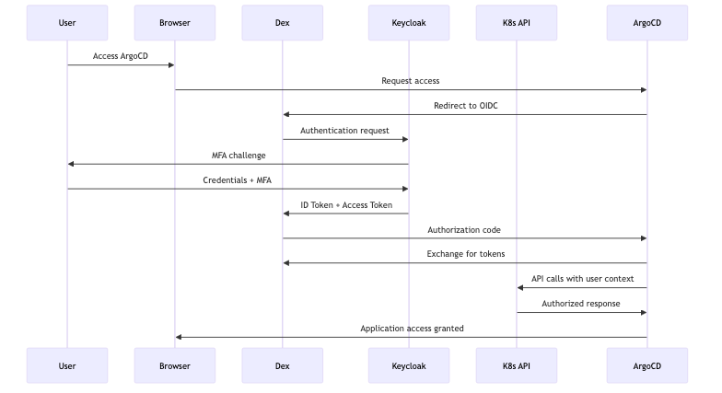

Authorization Model

Group-Based RBAC
### Keycloak Groups mapped to Kubernetes RBAC
groups:
platform-admins:
kubernetes-role: cluster-admin
argocd-role: admin
web-developers:
kubernetes-role: developer
kubernetes-namespaces: [app-web-prod, app-web-staging, app-web-dev]
argocd-role: web-app-admin
database-admins:
kubernetes-role: developer
kubernetes-namespaces: [app-database-prod, app-database-staging]
argocd-role: database-admin
security-auditors:
kubernetes-role: view
argocd-role: readonly

Kubernetes RBAC Integration
apiVersion: rbac.authorization.k8s.io/v1
kind: ClusterRoleBinding
metadata:
name: platform-admin-binding
subjects:
- kind: Group
name: "platform-admins"
apiGroup: rbac.authorization.k8s.io
roleRef:
kind: ClusterRole
name: cluster-admin
apiGroup: rbac.authorization.k8s.io

Security Controls

Token Management
- Access Tokens: 15-minute expiration
- Refresh Tokens: 1-hour expiration
- ID Tokens: 5-minute expiration
- Service Account Tokens: 2-hour expiration with projected volumes

Multi-Factor Authentication
### Mandatory MFA Flow in Keycloak
authenticationFlows:
- alias: "browser-with-mfa"
description: "Browser flow with mandatory MFA"
authenticationExecutions:
- authenticator: "auth-username-password-form"
requirement: "REQUIRED"
- authenticator: "auth-otp-form"
requirement: "REQUIRED"

Network Security
- Network policies restricting authentication service communication
- TLS 1.3 encryption for all authentication traffic
- Certificate-based mutual TLS for service-to-service communication

User Lifecycle Management

Automated Provisioning
- SCIM integration for user provisioning/deprovisioning
- Automated group assignment based on organizational roles
- ServiceAccount creation for automated systems

Self-Service Capabilities
- Password reset and account recovery
- MFA device management
- Access request workflows

Monitoring and Audit

Metrics and Monitoring
### Prometheus ServiceMonitor for Authentication Metrics
apiVersion: monitoring.coreos.com/v1
kind: ServiceMonitor
metadata:
name: dex-metrics
namespace: auth-system
spec:
selector:
matchLabels:
app: dex
endpoints:
- port: metrics
interval: 30s

Audit Logging
- Complete authentication audit trail
- RBAC change tracking
- Failed authentication monitoring
- Compliance reporting automation

Key Metrics
- Authentication success/failure rates
- Active user sessions
- Token expiration and renewal rates
- MFA adoption rates
- Policy violation incidents

Disaster Recovery

High Availability
- Multi-replica Keycloak deployment with database clustering
- Cross-region identity provider replication
- Automated failover with health checks

Backup Strategy
### Daily Keycloak Database Backup
apiVersion: batch/v1
kind: CronJob
metadata:
name: keycloak-backup
namespace: auth-system
spec:
schedule: "0 2 * * *"
jobTemplate:
spec:
template:
spec:
containers:
- name: backup
image: postgres:13
command: ["/bin/bash", "-c"]
args:
- pg_dump -h keycloak-db -U keycloak keycloak > /backup/keycloak-$(date +%Y%m%d).sql && aws s3 cp /backup/keycloak-$(date +%Y%m%d).sql s3://iam-backups/

Consequences

Positive
- Enhanced Security: Zero trust identity-aware access controls
- Operational Efficiency: Centralized identity management reduces operational overhead
- Compliance Ready: Built-in audit trails and regulatory framework alignment
- Developer Experience: Single sign-on with self-service capabilities
- Scalability: Supports multi-cluster and multi-region deployments
- Cost Optimization: Reduced manual identity management tasks

Negative
- Initial Complexity: Setup and configuration require specialized knowledge
- Dependencies: Additional infrastructure components to manage and monitor
- Learning Curve: Teams need training on OIDC and Keycloak administration
- Single Point of Failure: Identity provider availability critical for system access
- Token Management: Requires careful handling of token lifecycle and security

Migration Strategy

Phase 1: Infrastructure Setup (2-3 weeks)
- Deploy Keycloak in management cluster with HA configuration
- Configure LDAP/AD integration and user federation
- Set up Dex OIDC proxy in all clusters
- Implement network policies and security controls

Phase 2: Service Integration (3-4 weeks)
- Configure OpenShift OAuth with OIDC
- Integrate ArgoCD with OIDC authentication
- Configure Grafana and Prometheus with OIDC
- Set up RBAC mappings and group assignments

Phase 3: User Migration (2-3 weeks)
- Migrate existing users to new identity system
- Configure MFA for all administrative accounts
- Test authentication flows and access controls
- Train users on new authentication experience

Phase 4: Monitoring and Optimization (1-2 weeks)
- Deploy monitoring and alerting for authentication services
- Configure audit logging and compliance reporting
- Optimize token lifecycle and security policies
- Document operational procedures and runbooks

Compliance Considerations

Regulatory Alignment
- SOC 2 Type II: Automated audit trails and access controls
- GDPR: Right to be forgotten and data minimization
- HIPAA: PHI access controls and audit logging
- SOX: Financial system access controls and separation of duties

Audit Requirements
- All authentication events logged with timestamps
- RBAC changes tracked with user attribution
- Failed authentication attempts monitored and alerted
- Regular access reviews automated with reporting
This IAM strategy provides enterprise-grade identity and access management for the RH OVE multi-cluster ecosystem, ensuring security, compliance, and operational efficiency through modern OIDC-based authentication and Kubernetes-native authorization.

Requirements Table

Requirements Summary Table
This document provides a comprehensive overview of all functional and non-functional requirements for the RH OVE multi-cluster ecosystem.

Functional Requirements Summary
Requirement ID | Category | Title | ADR Reference | Acceptance Criteria Summary
FR-001.1 | Multi-Cluster Management | Cluster Topology Management | ADR-003 | Namespace patterns {app-name}-{environment}, cross-namespace policies, resource quotas
FR-001.2 | Multi-Cluster Management | Multi-Cluster Governance | ADR-001 | RHACM cluster lifecycle, centralized policies, monitoring aggregation
FR-002.1 | GitOps Integration | ArgoCD Hub Architecture | ADR-002 | HA ArgoCD Hub, Application of Applications, automated/manual sync
FR-002.2 | GitOps Integration | Configuration Management | ADR-002 | Git-based config, Kustomize overlays, drift detection
FR-003.1 | Policy Management | Layered Admission Control | ADR-004 | Kyverno, Security Context Constraints, policy-as-code
FR-003.2 | Policy Management | Security Policy Enforcement | ADR-004 | Blocking/warning modes, violation reporting, exemption workflows
FR-004.1 | Networking | Cilium CNI Implementation | ADR-005 | Cilium with Hubble, identity-aware policies, WireGuard encryption
FR-004.2 | Networking | Multi-Network Support | ADR-005 | Multus NADs, multiple VM interfaces, VLAN segmentation, SR-IOV
FR-004.3 | Networking | Zero Trust Security | ADR-005 | Default-deny policies, L7 enforcement, flow monitoring
FR-005.1 | Backup & DR | Centralized Backup Management | ADR-006 | Rubrik management, policy-driven scheduling, VM snapshots
FR-005.2 | Backup & DR | Disaster Recovery Capabilities | ADR-006 | Cloud replication, point-in-time recovery, cross-cluster failover
FR-006.1 | Monitoring | Integrated Monitoring Stack | ADR-007 | Federated Prometheus, Grafana, Dynatrace, Hubble integration
FR-006.2 | Monitoring | Proactive Monitoring and Alerting | ADR-007 | Threshold/anomaly detection, ITSM integration, runbook automation
FR-007.1 | VM Management | VM Lifecycle Management | KubeVirt | VM CRUD operations, live migration, template management
FR-007.2 | VM Management | Storage Management | KubeVirt | Multiple storage classes, volume expansion, image import
FR-008.1 | Security | Identity and Access Management | ADR-008 | Keycloak OIDC, LDAP/AD federation, SSO, Dex proxy, OAuth integration, RBAC
FR-008.2 | Security | Multi-Factor Authentication and Security Controls | ADR-008 | Mandatory MFA, token security, TLS 1.3, mutual TLS, SCIM automation
FR-008.3 | Security | Compliance Management | ADR-008 | SOC 2/GDPR/HIPAA with IAM, automated access reviews, incident tracking
FR-009.1 | Developer Experience | Self-Service Capabilities | DevEx | Web interfaces, CLI tools, template provisioning
FR-009.2 | Developer Experience | CI/CD Integration | DevOps | Git webhooks, image building, deployment strategies

Non-Functional Requirements Summary

Performance Requirements
Requirement ID | Category | Metric | Target Value | Rationale
FR-NFR-001 | Latency | API Response Time | < 200ms (95th percentile) | User experience optimization
FR-NFR-002 | Latency | Cross-Cluster Communication | < 50ms | Real-time data synchronization
FR-NFR-003 | Latency | VM Startup Time | < 60 seconds | Rapid workload provisioning
FR-NFR-004 | Throughput | VM Deployment Rate | 100+ VMs/hour/cluster | Support for scaling events
FR-NFR-005 | Throughput | Monitoring Metrics | 10,000+ metrics/second | Comprehensive observability
FR-NFR-006 | Throughput | Log Processing | 1GB+ logs/hour | Adequate logging capacity
FR-NFR-007 | Resource Utilization | CPU Usage | ≤ 80% under normal load | Performance headroom
FR-NFR-008 | Resource Utilization | Memory Usage | ≤ 85% under normal load | Stability margin
FR-NFR-009 | Resource Utilization | Storage Usage | ≤ 90% capacity | Growth accommodation

Availability Requirements
Requirement ID | Category | Metric | Target Value | Business Impact
FR-NFR-010 | Uptime | Production Clusters | 99.9% (< 8.77 hours/year downtime) | Business continuity
FR-NFR-011 | Uptime | Management Cluster | 99.95% (< 4.38 hours/year downtime) | Central control availability
FR-NFR-012 | Failover | Critical Services | < 30 seconds failover time | Minimal service disruption
FR-NFR-013 | Disaster Recovery | RPO (Recovery Point Objective) | < 4 hours | Data loss tolerance
FR-NFR-014 | Disaster Recovery | RTO (Recovery Time Objective) | < 8 hours | Recovery time tolerance
FR-NFR-015 | Disaster Recovery | Cross-Region Failover | < 15 minutes | Geographic resilience

Scalability Requirements
Requirement ID | Category | Metric | Target Value | Scalability Dimension
FR-NFR-016 | Horizontal Scaling | Application Clusters | Minimum 10 clusters | Multi-environment support
FR-NFR-017 | Horizontal Scaling | Pods per Cluster | 1000+ pods | Workload density
FR-NFR-018 | Horizontal Scaling | Total Containers | 50,000+ across all clusters | Enterprise scale
FR-NFR-019 | Vertical Scaling | VM Resources | Up to 64 vCPUs, 512GB RAM | Large workload support
FR-NFR-020 | Vertical Scaling | Storage Volumes | Up to 100TB per volume | Big data capabilities
FR-NFR-021 | Vertical Scaling | Network Bandwidth | Up to 25Gbps per node | High-performance networking

Security Requirements
Requirement ID | Category | Requirement | Implementation | Compliance Impact
FR-NFR-022 | Authentication | Multi-Factor Authentication | All API access | Enhanced security posture
FR-NFR-023 | Authorization | RBAC Enforcement | All cluster components | Access control consistency
FR-NFR-024 | Authentication | Service Account Tokens | Time-limited tokens | Reduced credential exposure
FR-NFR-025 | Data Protection | Encryption in Transit | TLS 1.3+ | Data confidentiality
FR-NFR-026 | Data Protection | Encryption at Rest | AES-256 | Data protection compliance
FR-NFR-027 | Key Management | Key Rotation | Every 90 days | Security best practices
FR-NFR-028 | Network Security | Inter-Cluster Encryption | All communications | End-to-end security
FR-NFR-029 | Network Security | Network Policies | Deny by default | Zero trust implementation
FR-NFR-030 | Network Security | Environment Isolation | Network segmentation | Security boundaries
FR-NFR-031 | Compliance | SOC 2 Compliance | Type II certification | Regulatory adherence
FR-NFR-032 | Audit | Log Retention | 7 years | Compliance requirements
FR-NFR-033 | Security | Vulnerability Scanning | Daily scans | Proactive security

Reliability Requirements
Requirement ID | Category | Requirement | Target | Reliability Impact
FR-NFR-034 | Fault Tolerance | Single Node Failure | No service interruption | High availability
FR-NFR-035 | Fault Tolerance | Single AZ Failure | Continued operation | Geographic resilience
FR-NFR-036 | Data Replication | Minimum Replicas | 3 nodes | Data durability
FR-NFR-037 | Error Handling | Error Logging | All errors with severity | Operational visibility
FR-NFR-038 | Error Handling | Retry Logic | Exponential backoff | Resilient operations
FR-NFR-039 | Error Handling | Critical Error Alerting | Automated notifications | Rapid incident response
FR-NFR-040 | Monitoring | Health Coverage | 99% system coverage | Comprehensive monitoring
FR-NFR-041 | Monitoring | Metrics Retention | Minimum 1 year | Historical analysis
FR-NFR-042 | Observability | Distributed Tracing | All services | End-to-end visibility

Maintainability Requirements
Requirement ID | Category | Requirement | Implementation | Operational Impact
FR-NFR-043 | Deployment | Zero-Downtime Updates | Rolling deployments | Service continuity
FR-NFR-044 | Deployment | Rollback Capability | < 5 minutes | Rapid recovery
FR-NFR-045 | Testing | Automated Test Coverage | 90%+ functionality | Quality assurance
FR-NFR-046 | Configuration | Version Control | All configuration | Change management
FR-NFR-047 | Configuration | Change Auditability | All changes tracked | Compliance and debugging
FR-NFR-048 | Infrastructure | Infrastructure as Code | All deployments | Consistency and repeatability
FR-NFR-049 | Documentation | API Specifications | OpenAPI for all APIs | Developer experience
FR-NFR-050 | Documentation | Operational Runbooks | All procedures | Operational consistency
FR-NFR-051 | Documentation | Architecture Decisions | ADR documentation | Knowledge management

Usability Requirements
Requirement ID | Category | Requirement | Standard/Implementation | User Impact
FR-NFR-052 | User Interface | Responsive Design | Mobile-friendly web UI | Multi-device access
FR-NFR-053 | API Design | RESTful Principles | Standard REST API | Developer experience
FR-NFR-054 | CLI Tools | Help Documentation | Comprehensive help | User self-service
FR-NFR-055 | Accessibility | WCAG Compliance | 2.1 AA standards | Inclusive design
FR-NFR-056 | Localization | Multi-Language Support | International users | Global accessibility
FR-NFR-057 | Accessibility | High Contrast Mode | Visual accessibility | Enhanced usability

Capacity Requirements
Requirement ID | Category | Resource | Minimum Capacity | Scaling Consideration
FR-NFR-058 | Storage | Usable Storage | 100TB per production cluster | Data growth accommodation
FR-NFR-059 | Storage | IOPS Performance | 10,000+ IOPS per cluster | High-performance workloads
FR-NFR-060 | Storage | Backup Retention | 5 years | Compliance and recovery
FR-NFR-061 | Network | Inter-Cluster Connectivity | 10Gbps minimum | High-bandwidth applications
FR-NFR-062 | Network | Intra-Cluster Latency | ≤ 5ms maximum | Real-time applications
FR-NFR-063 | Network | MTU Support | 9000 bytes (jumbo frames) | Network optimization
FR-NFR-064 | Compute | CPU Capacity | 1000 vCPUs per production cluster | Computational workloads
FR-NFR-065 | Compute | Memory Capacity | 4TB RAM per production cluster | Memory-intensive applications
FR-NFR-066 | Compute | GPU Support | 8+ GPUs per cluster | AI/ML workloads

Compliance & Regulatory Requirements
Requirement ID | Category | Requirement | Implementation | Regulatory Framework
FR-NFR-067 | Data Governance | Data Classification | Automated labeling | Privacy regulations
FR-NFR-068 | Data Protection | PII Handling | Encryption and access control | GDPR, HIPAA
FR-NFR-069 | Data Governance | Retention Policies | Automated enforcement | Legal requirements
FR-NFR-070 | Audit | Administrative Logging | All admin actions | SOX, SOC 2
FR-NFR-071 | Audit | Log Integrity | Tamper-proof, timestamped | Legal evidence
FR-NFR-072 | Compliance | Automated Reporting | Compliance dashboards | Regulatory reporting
FR-NFR-073 | Privacy | Right to be Forgotten | Data deletion capability | GDPR Article 17
FR-NFR-074 | Privacy | Data Minimization | Principle enforcement | Privacy by design
FR-NFR-075 | Privacy | Privacy by Design | Built-in privacy controls | Proactive compliance

Requirements Traceability Matrix

ADR to Requirements Mapping
ADR | Related Functional Requirements | Related Non-Functional Requirements
ADR-001: Multi-Cluster Pattern | FR-001.1, FR-001.2 | FR-NFR-010, FR-NFR-011, FR-NFR-016, FR-NFR-034, FR-NFR-035
ADR-002: GitOps ArgoCD | FR-002.1, FR-002.2 | FR-NFR-043, FR-NFR-044, FR-NFR-046, FR-NFR-047, FR-NFR-048
ADR-003: Namespace Topology | FR-001.1, FR-008.1 | FR-NFR-023, FR-NFR-030, FR-NFR-067, FR-NFR-068
ADR-004: Admission Controller | FR-003.1, FR-003.2 | FR-NFR-022, FR-NFR-023, FR-NFR-031, FR-NFR-037, FR-NFR-070
ADR-005: Cilium CNI | FR-004.1, FR-004.2, FR-004.3 | FR-NFR-002, FR-NFR-021, FR-NFR-028, FR-NFR-029, FR-NFR-061, FR-NFR-062
ADR-006: Backup Strategy | FR-005.1, FR-005.2 | FR-NFR-013, FR-NFR-014, FR-NFR-015, FR-NFR-032, FR-NFR-060
ADR-007: Monitoring Strategy | FR-006.1, FR-006.2 | FR-NFR-005, FR-NFR-040, FR-NFR-041, FR-NFR-042, FR-NFR-072
ADR-008: IAM Strategy | FR-008.1, FR-008.2, FR-008.3 | FR-NFR-022, FR-NFR-023, FR-NFR-024, FR-NFR-025, FR-NFR-031, FR-NFR-070, FR-NFR-073

Requirements Coverage Analysis
Category | Total Requirements | Critical Requirements | Implementation Status
Functional Requirements | 19 sub-requirements | 12 critical | Architecture defined
Performance Requirements | 9 requirements | 6 critical | Targets established
Availability Requirements | 6 requirements | 6 critical | SLAs defined
Scalability Requirements | 6 requirements | 4 critical | Capacity planned
Security Requirements | 12 requirements | 12 critical | Controls specified
Reliability Requirements | 9 requirements | 6 critical | Patterns established
Maintainability Requirements | 9 requirements | 5 critical | Processes defined
Usability Requirements | 6 requirements | 2 critical | Standards adopted
Capacity Requirements | 9 requirements | 6 critical | Minimums established
Compliance Requirements | 9 requirements | 9 critical | Frameworks aligned

Requirements Validation Criteria

Functional Requirements Validation
- FR Validation Method: Acceptance criteria testing, integration testing, user acceptance testing
- FR Success Metrics: All acceptance criteria met, integration tests pass, user stories completed
- FR Review Frequency: Sprint reviews, milestone assessments, release validation

Non-Functional Requirements Validation
- NFR Validation Method: Performance testing, load testing, security testing, compliance auditing
- NFR Success Metrics: All targets met or exceeded, benchmarks achieved, compliance verified
- NFR Review Frequency: Continuous monitoring, quarterly assessments, annual compliance reviews
This comprehensive requirements table provides complete traceability from high-level business needs through detailed technical requirements, enabling effective validation and implementation tracking for the RH OVE multi-cluster ecosystem.

Fr

Functional Requirements

Overview
This document outlines the functional requirements for the RH OVE multi-cluster ecosystem, derived from the architectural decisions documented in our ADRs.

FR-001: Multi-Cluster Management

FR-001.1: Cluster Topology Management
- Requirement: The system must implement application namespace-based topology for workload organization
- Rationale: Based on ADR-003, ensures strong isolation, simplified RBAC, and clear resource attribution
- Acceptance Criteria:
  - Support namespace patterns: {app-name}-{environment}
  - Implement cross-namespace communication policies
  - Enable namespace-level resource quotas and limits

FR-001.2: Multi-Cluster Governance
- Requirement: The system must support centralized governance across multiple application clusters from a management cluster
- Rationale: Based on ADR-001, provides separation of concerns and operational efficiency
- Acceptance Criteria:
  - Deploy and manage policies from management cluster to application clusters
  - Support cluster lifecycle management through RHACM
  - Enable centralized monitoring and logging aggregation

FR-002: GitOps Integration

FR-002.1: ArgoCD Hub Architecture
- Requirement: The system must implement GitOps using ArgoCD in a hub-spoke pattern
- Rationale: Based on ADR-002, provides declarative configuration and audit trails
- Acceptance Criteria:
  - Deploy ArgoCD Hub in management cluster with high availability
  - Support Application of Applications pattern
  - Enable automated sync for non-production, manual sync for production
  - Integrate with Git repositories for all infrastructure and application configurations

FR-002.2: Configuration Management
- Requirement: All infrastructure and application configurations must be stored in Git repositories
- Rationale: Ensures version control, auditability, and rollback capabilities
- Acceptance Criteria:
  - Support environment-specific overlays using Kustomize
  - Enable automated deployment pipeline with proper approval workflows
  - Provide drift detection and automatic remediation

FR-003: Admission Control and Policy Management

FR-003.1: Layered Admission Control
- Requirement: The system must implement layered admission control using OpenShift built-in controllers, KubeVirt webhooks, and Kyverno policies
- Rationale: Based on ADR-004, provides flexible, secure, and policy-driven resource validation
- Acceptance Criteria:
  - Deploy Kyverno for custom policy management
  - Implement Security Context Constraints for VM and container workloads
  - Support policy-as-code with version control and automated deployment

FR-003.2: Security Policy Enforcement
- Requirement: The system must validate and enforce security policies before resource persistence
- Rationale: Prevents misconfiguration and ensures compliance
- Acceptance Criteria:
  - Support both blocking and warning policy modes
  - Provide detailed policy violation reporting
  - Enable policy exemptions with proper approval workflows

FR-004: Networking and Connectivity

FR-004.1: Cilium CNI Implementation
- Requirement: The system must use Cilium as the primary CNI with eBPF-powered networking
- Rationale: Based on ADR-005, provides superior performance, identity-aware security, and L7 capabilities
- Acceptance Criteria:
  - Deploy Cilium with Hubble for network observability
  - Implement identity-aware network policies
  - Support transparent encryption using WireGuard
  - Enable service mesh capabilities without sidecar proxies

FR-004.2: Multi-Network Support
- Requirement: The system must support Multus for multi-network configurations
- Rationale: Enables legacy network integration, SR-IOV, and network segmentation
- Acceptance Criteria:
  - Support NetworkAttachmentDefinitions for management, storage, and data networks
  - Enable multiple network interfaces for VMs
  - Support VLAN-based network segmentation
  - Provide high-performance networking with SR-IOV

FR-004.3: Zero Trust Security
- Requirement: The system must implement zero trust network principles
- Rationale: Ensures security by default with explicit allow policies
- Acceptance Criteria:
  - Implement default-deny network policies
  - Support L7 HTTP/HTTPS policy enforcement
  - Enable network flow monitoring and policy violation alerting

FR-005: Backup and Disaster Recovery

FR-005.1: Centralized Backup Management
- Requirement: The system must implement centralized backup using Rubrik for unified VM and container workload protection
- Rationale: Based on ADR-006, provides consistency, compliance, and operational efficiency
- Acceptance Criteria:
  - Deploy Rubrik management in management cluster
  - Support policy-driven backup scheduling and retention
  - Enable application-consistent snapshots for VMs
  - Provide deduplication and compression for storage optimization

FR-005.2: Disaster Recovery Capabilities
- Requirement: The system must support cross-region disaster recovery and failover
- Rationale: Ensures business continuity and meets compliance requirements
- Acceptance Criteria:
  - Support automated backup replication to cloud storage
  - Enable point-in-time recovery for critical workloads
  - Provide recovery testing and validation capabilities
  - Support cross-cluster failover scenarios

FR-006: Monitoring and Observability

FR-006.1: Integrated Monitoring Stack
- Requirement: The system must implement integrated monitoring using Prometheus, Grafana, Dynatrace, and Hubble
- Rationale: Based on ADR-007, provides comprehensive observability across infrastructure and applications
- Acceptance Criteria:
  - Deploy federated Prometheus for metrics collection across clusters
  - Implement custom Grafana dashboards for infrastructure and application metrics
  - Integrate Dynatrace for full-stack application performance monitoring
  - Enable Hubble for network flow visibility and security monitoring

FR-006.2: Proactive Monitoring and Alerting
- Requirement: The system must provide proactive monitoring with intelligent alerting
- Rationale: Enables early detection and resolution of issues
- Acceptance Criteria:
  - Support threshold-based and anomaly detection alerting
  - Integrate with incident management systems
  - Provide runbook automation for common issues
  - Enable custom alerting rules per application namespace

FR-007: Virtual Machine Management

FR-007.1: VM Lifecycle Management
- Requirement: The system must support complete VM lifecycle management using KubeVirt
- Rationale: Provides unified management of VMs and containers
- Acceptance Criteria:
  - Support VM creation, scaling, and termination
  - Enable VM live migration for maintenance
  - Provide VM template management and cloning
  - Support both Windows and Linux guest operating systems

FR-007.2: Storage Management
- Requirement: The system must provide flexible storage management for VMs using DataVolumes and CDI
- Rationale: Enables efficient storage provisioning and management
- Acceptance Criteria:
  - Support multiple storage classes for different performance tiers
  - Enable volume expansion and snapshotting
  - Provide image import from registries, HTTP, and S3 sources
  - Support persistent volume cloning for template workflows

FR-008: Security and Compliance

FR-008.1: Identity and Access Management
- Requirement: The system must integrate with enterprise identity providers using OIDC for centralized authentication and authorization
- Rationale: Based on ADR-008, ensures consistent security policies, audit trails, and enterprise integration
- Acceptance Criteria:
  - Deploy Keycloak (Red Hat SSO) as primary OIDC provider with HA configuration
  - Support LDAP/Active Directory federation for existing user directories
  - Implement Single Sign-On (SSO) across all clusters and services
  - Deploy Dex OIDC proxy for service authentication
  - Integrate OpenShift OAuth with OIDC claims mapping
  - Implement namespace-based RBAC with OIDC group delegation
  - Enable service account automation with time-limited tokens (15min-2hours)
  - Provide comprehensive audit logging for all authentication and authorization events

FR-008.2: Multi-Factor Authentication and Security Controls
- Requirement: The system must enforce multi-factor authentication and implement comprehensive security controls
- Rationale: Based on ADR-008, ensures zero trust security principles and enhanced threat protection
- Acceptance Criteria:
  - Enforce mandatory MFA for all administrative accounts using TOTP/SMS
  - Implement token security with proper expiration policies (access: 15min, refresh: 1hour, ID: 5min)
  - Deploy network policies restricting authentication service communication
  - Support TLS 1.3 encryption for all authentication traffic
  - Enable certificate-based mutual TLS for service-to-service communication
  - Implement automated user provisioning/deprovisioning via SCIM integration
  - Support self-service password reset and MFA device management

FR-008.3: Compliance Management
- Requirement: The system must support automated compliance checking and reporting with IAM integration
- Rationale: Ensures adherence to regulatory requirements with comprehensive identity audit trails
- Acceptance Criteria:
  - Support SOC 2, GDPR, and HIPAA compliance frameworks with identity-aware controls
  - Enable automated compliance scanning and reporting with authentication metrics
  - Provide policy violation tracking and remediation workflows
  - Support data classification and handling policies
  - Generate automated access review reports with RBAC analysis
  - Track failed authentication attempts and security incidents
  - Support “right to be forgotten” with automated user data deletion

FR-009: Developer Experience

FR-009.1: Self-Service Capabilities
- Requirement: The system must provide self-service capabilities for development teams
- Rationale: Improves developer productivity and reduces operational overhead
- Acceptance Criteria:
  - Provide web-based interfaces for resource management
  - Support CLI tools for automation and scripting
  - Enable template-based resource provisioning
  - Provide comprehensive documentation and tutorials

FR-009.2: CI/CD Integration
- Requirement: The system must integrate with existing CI/CD pipelines
- Rationale: Enables automated testing and deployment workflows
- Acceptance Criteria:
  - Support webhook integration with Git repositories
  - Enable automated image building and scanning
  - Provide integration with popular CI/CD tools (Jenkins, GitLab CI, etc.)
  - Support blue-green and canary deployment strategies

Nfr

Non-Functional Requirements

Overview
This document outlines the non-functional requirements for the RH OVE multi-cluster ecosystem, defining quality attributes and constraints.

Performance Requirements

Latency
- FR-NFR-001: API response time must be < 200ms for 95% of requests
- FR-NFR-002: Cross-cluster communication latency must be < 50ms
- FR-NFR-003: VM startup time must be < 60 seconds for standard workloads

Throughput
- FR-NFR-004: System must support deployment of 100+ VMs per hour per cluster
- FR-NFR-005: Monitoring system must handle 10,000+ metrics per second
- FR-NFR-006: Log aggregation must process 1GB+ of logs per hour

Resource Utilization
- FR-NFR-007: CPU utilization must not exceed 80% under normal load
- FR-NFR-008: Memory utilization must not exceed 85% under normal load
- FR-NFR-009: Storage utilization must not exceed 90% capacity

Availability Requirements

Uptime
- FR-NFR-010: Production clusters must achieve 99.9% uptime (< 8.77 hours downtime/year)
- FR-NFR-011: Management cluster must achieve 99.95% uptime (< 4.38 hours downtime/year)
- FR-NFR-012: Critical services must have < 30 seconds failover time

Disaster Recovery
- FR-NFR-013: RPO (Recovery Point Objective) must be < 4 hours
- FR-NFR-014: RTO (Recovery Time Objective) must be < 8 hours
- FR-NFR-015: Cross-region failover must complete within 15 minutes

Scalability Requirements

Horizontal Scaling
- FR-NFR-016: System must support minimum 10 application clusters
- FR-NFR-017: Each cluster must support 1000+ pods
- FR-NFR-018: System must scale to 50,000+ containers across all clusters

Vertical Scaling
- FR-NFR-019: Individual VMs must scale up to 64 vCPUs and 512GB RAM
- FR-NFR-020: Storage volumes must scale up to 100TB per volume
- FR-NFR-021: Network bandwidth must scale to 25Gbps per node

Security Requirements

Authentication & Authorization
- FR-NFR-022: All API access must use multi-factor authentication
- FR-NFR-023: RBAC must be enforced across all cluster components
- FR-NFR-024: Service accounts must use time-limited tokens

Data Protection
- FR-NFR-025: All data in transit must be encrypted (TLS 1.3+)
- FR-NFR-026: All data at rest must be encrypted (AES-256)
- FR-NFR-027: Encryption keys must be rotated every 90 days

Network Security
- FR-NFR-028: All inter-cluster communication must be encrypted
- FR-NFR-029: Network policies must deny by default
- FR-NFR-030: Network segmentation must isolate environments

Compliance
- FR-NFR-031: System must maintain SOC 2 Type II compliance
- FR-NFR-032: Audit logs must be retained for 7 years
- FR-NFR-033: Security scanning must occur daily

Reliability Requirements

Fault Tolerance
- FR-NFR-034: System must survive single node failures without service interruption
- FR-NFR-035: System must survive single AZ failures in multi-AZ deployments
- FR-NFR-036: Data must be replicated across minimum 3 nodes

Error Handling
- FR-NFR-037: All errors must be logged with appropriate severity levels
- FR-NFR-038: Transient errors must be retried with exponential backoff
- FR-NFR-039: Critical errors must trigger automated alerting

Monitoring & Observability
- FR-NFR-040: System health must be monitored with 99% coverage
- FR-NFR-041: Metrics retention must be minimum 1 year
- FR-NFR-042: Distributed tracing must be enabled for all services

Maintainability Requirements

Deployment & Updates
- FR-NFR-043: Zero-downtime deployments must be supported
- FR-NFR-044: Rollback capability must be available within 5 minutes
- FR-NFR-045: Automated testing must cover 90%+ of functionality

Configuration Management
- FR-NFR-046: All configuration must be version controlled
- FR-NFR-047: Configuration changes must be auditable
- FR-NFR-048: Infrastructure as Code must be used for all deployments

Documentation
- FR-NFR-049: All APIs must have OpenAPI specifications
- FR-NFR-050: Runbooks must be available for all operational procedures
- FR-NFR-051: Architecture decisions must be documented in ADRs

Usability Requirements

User Interface
- FR-NFR-052: Web UI must be responsive and mobile-friendly
- FR-NFR-053: API must follow RESTful design principles
- FR-NFR-054: CLI tools must provide comprehensive help documentation

Accessibility
- FR-NFR-055: Web interfaces must meet WCAG 2.1 AA standards
- FR-NFR-056: Multi-language support must be available
- FR-NFR-057: High contrast mode must be supported

Capacity Requirements

Storage
- FR-NFR-058: Minimum 100TB usable storage per production cluster
- FR-NFR-059: Storage must support 10,000+ IOPS per cluster
- FR-NFR-060: Backup storage must retain data for 5 years

Network
- FR-NFR-061: Minimum 10Gbps connectivity between clusters
- FR-NFR-062: Maximum 5ms latency within cluster networks
- FR-NFR-063: Network must support jumbo frames (9000 MTU)

Compute
- FR-NFR-064: Minimum 1000 vCPUs available per production cluster
- FR-NFR-065: Minimum 4TB RAM available per production cluster
- FR-NFR-066: Support for GPU workloads (minimum 8 GPUs per cluster)

Compliance & Regulatory Requirements

Data Governance
- FR-NFR-067: Data must be classified and labeled appropriately
- FR-NFR-068: PII data must be encrypted and access-controlled
- FR-NFR-069: Data retention policies must be automatically enforced

Audit & Logging
- FR-NFR-070: All administrative actions must be logged
- FR-NFR-071: Logs must be tamper-proof and timestamped
- FR-NFR-072: Compliance reports must be generated automatically

Privacy
- FR-NFR-073: Right to be forgotten must be supported
- FR-NFR-074: Data minimization principles must be enforced
- FR-NFR-075: Privacy by design must be implemented

