Deployment Documentation
Documentation Team
2025-11-01
Table of Contents

Deployment

Prerequisites

Prerequisites

Overview
This document outlines the prerequisites for deploying the RH OVE ecosystem, including infrastructure requirements, software dependencies, and configuration prerequisites.

Infrastructure Requirements

Hardware Requirements
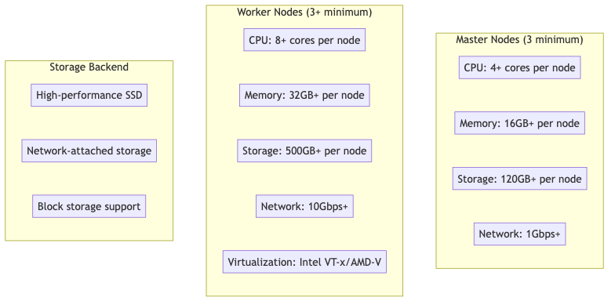

Virtualization Support
Ensure hardware virtualization is enabled:
### Check for Intel VT-x
grep -E "(vmx|svm)" /proc/cpuinfo
### Check if virtualization is enabled in BIOS
lscpu | grep Virtualization
### Verify KVM modules are loaded
lsmod | grep kvm

Network Requirements
- Cluster Network: Internal cluster communication
- Service Network: Service-to-service communication
- Pod Network: Pod-to-pod communication
- External Access: Load balancer and ingress traffic
### Network configuration example
cluster_network:
cidr: "10.128.0.0/14"
host_prefix: 23
service_network:
- "172.30.0.0/16"
machine_networks:
- cidr: "192.168.1.0/24"

Software Prerequisites

OpenShift Container Platform
- Version: OpenShift 4.12+ (recommended 4.14+)
- Installation Method: IPI (Installer Provisioned Infrastructure) or UPI (User Provisioned Infrastructure)
- Cluster Admin Access: Required for operator installation

Required Operators
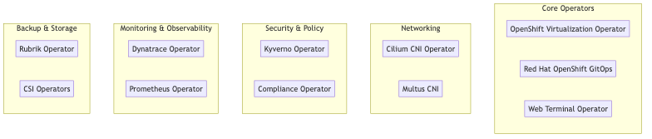

Storage Requirements

Container Storage Interface (CSI) Drivers
### Example CSI StorageClass
apiVersion: storage.k8s.io/v1
kind: StorageClass
metadata:
name: rh-ove-ssd
provisioner: ebs.csi.aws.com
parameters:
type: gp3
encrypted: "true"
reclaimPolicy: Delete
volumeBindingMode: WaitForFirstConsumer
allowVolumeExpansion: true

Storage Classes Required
- Fast SSD: For VM boot disks and high-IOPS workloads
- Standard HDD: For data storage and backup
- Archive: For long-term storage and compliance

Network Prerequisites

DNS Configuration
### DNS configuration for cluster
dns:
base_domain: "ove.example.com"
cluster_domain: "cluster.local"
metadata:
name: "rh-ove-cluster"

Load Balancer Configuration
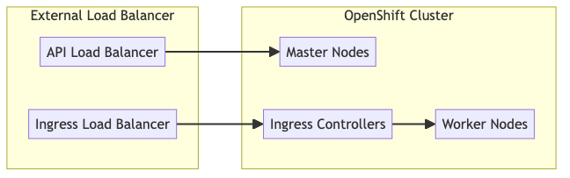

Firewall Rules
Required ports for RH OVE:
Port Range | Protocol | Purpose
6443 | TCP | Kubernetes API server
22623 | TCP | Machine config server
80/443 | TCP | HTTP/HTTPS ingress
9000-9999 | TCP | Host level services
10250-10259 | TCP | Kubernetes node ports
30000-32767 | TCP | NodePort services

Security Prerequisites

Certificate Management
### TLS certificate configuration
tls:
ca_cert: |
-----BEGIN CERTIFICATE-----
# CA certificate content
-----END CERTIFICATE-----
api_cert: |
-----BEGIN CERTIFICATE-----
# API server certificate
-----END CERTIFICATE-----

RBAC Configuration
Prepare service accounts and roles:
apiVersion: v1
kind: ServiceAccount
metadata:
name: rh-ove-admin
namespace: openshift-cnv
---
apiVersion: rbac.authorization.k8s.io/v1
kind: ClusterRoleBinding
metadata:
name: rh-ove-admin-binding
roleRef:
apiGroup: rbac.authorization.k8s.io
kind: ClusterRole
name: cluster-admin
subjects:
- kind: ServiceAccount
name: rh-ove-admin
namespace: openshift-cnv

External System Prerequisites

Git Repository Setup
For GitOps implementation:
### Create GitOps repository structure
mkdir -p rh-ove-gitops/{applications,infrastructure,policies}
### Initialize Git repository
cd rh-ove-gitops
git init
git remote add origin https://git.example.com/rh-ove-gitops.git

Rubrik Backup System
Prerequisites for Rubrik integration:
- Rubrik cluster: Version 5.0+
- Network connectivity: Cluster to Rubrik management network
- Service account: With backup and restore permissions
- API access: Rubrik REST API credentials
### Rubrik connection configuration
apiVersion: v1
kind: Secret
metadata:
name: rubrik-credentials
namespace: rubrik-system
type: Opaque
stringData:
username: "rubrik-service-account"
password: "secure-password"
cluster-address: "rubrik.example.com"

Dynatrace Monitoring
Prerequisites for Dynatrace integration:
- Dynatrace tenant: SaaS or Managed
- API tokens: With required permissions
- Network access: Cluster to Dynatrace endpoints
### Dynatrace API token secret
apiVersion: v1
kind: Secret
metadata:
name: dynakube
namespace: dynatrace
type: Opaque
stringData:
apiToken: "dt0c01.xxxxx"
dataIngestToken: "dt0c01.yyyyy"

ServiceNow CMDB
For CMDB integration:
- ServiceNow instance: With CMDB module
- Service account: With CMDB read/write permissions
- API access: REST API and webhooks configured

Validation Checklist

Pre-Installation Checks
### Validation script example
apiVersion: v1
kind: ConfigMap
metadata:
name: pre-install-checks
data:
validate.sh: |
#!/bin/bash
# Check OpenShift version
oc version
# Verify cluster resources
oc get nodes
oc get storageclass
# Check virtualization support
oc get nodes -o json | jq '.items[].status.allocatable'
# Validate network connectivity
curl -k https://registry.redhat.io/health

Resource Verification
### Check available resources
oc adm top nodes
### Verify storage classes
oc get storageclass
### Check network plugins
oc get network.config/cluster -o yaml
### Validate image registry access
oc get imagestreams -n openshift

Installation Timeline
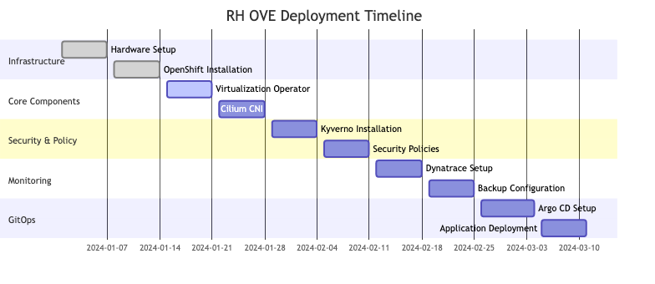
This comprehensive prerequisites guide ensures all necessary components and configurations are in place before beginning the RH OVE deployment process.

Installation

Installation Guide

Overview
This installation guide provides step-by-step instructions to deploy the RH OVE ecosystem using a multi-cluster architecture. The deployment follows a hub-and-spoke pattern with one management cluster and multiple application clusters for different environments (production, staging, development).

Multi-Cluster Architecture
The RH OVE ecosystem consists of:
- 1 Management Cluster: Centralized control plane for governance, policy, monitoring, and GitOps
- N Application Clusters: Dedicated workload execution environments for virtual machines and containers

Installation Flow
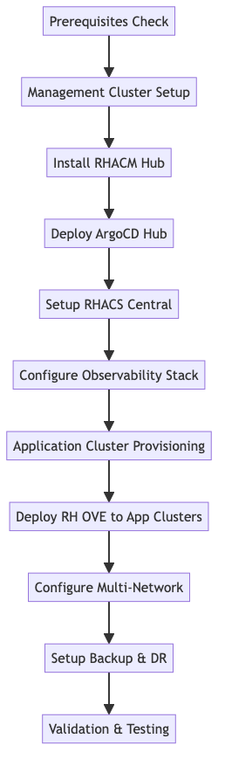

Core Component Installation

OpenShift Cluster Setup
- Install OpenShift
  - Follow OpenShift Installation Docs to set up the cluster.
  - Choose between IPI or UPI depending on your infrastructure.
- Verify Cluster Health
- oc get nodes
oc get pods -n openshift-apiserver

Virtualization Operator
- Install OpenShift Virtualization
- oc apply -f https://path/to/virtualization-operator.yaml
- Verify Installation
- oc get pods -n openshift-cnv
oc get kubevirt.kubevirt.io/kubevirt -n openshift-cnv

Cilium CNI
- Install Cilium
- helm repo add cilium https://helm.cilium.io/
helm install cilium cilium/cilium --namespace kube-system
- Verify Cilium Status
- cilium status

Kyverno Policy Engine
- Install Kyverno
- kubectl create -f https://github.com/kyverno/kyverno/releases/download/v1.5.2/install.yaml
- Apply Policies
- kubectl apply -f /path/to/policy-files

Monitoring Setup

Dynatrace Integration
- Install Dynatrace Operator
- oc apply -f https://path/to/dynatrace-operator.yaml
- Configure DynaKube
- oc apply -f /path/to/dynakube-config.yaml
- Verify Monitoring
- oc get pods -n dynatrace

Prometheus and Grafana
- Install Prometheus Operator
- oc apply -f https://path/to/prometheus-operator.yaml
- Setup Grafana
- oc apply -f https://path/to/grafana-deployment.yaml

Backup Configuration

Rubrik Integration
- Install Rubrik Operator
- oc apply -f https://path/to/rubrik-operator.yaml
- Verify Backup
- oc get pods -n rubrik

GitOps Setup

Argo CD Installation
- Install Argo CD
- oc apply -n argocd -f https://path/to/argocd-install.yaml
- Access Argo CD UI
  - Forward Argo CD API server port:
  - oc port-forward svc/argocd-server -n argocd 8080:443
- Login to Argo CD
  - Open https://localhost:8080 in your browser.
- Deploy Applications
- argocd app create my-app --repo https://git.example.com/my-app --path ./
argocd app sync my-app

Security Hardening
- Configure RBAC
- oc apply -f /path/to/rbac-config.yaml
- Enable Pod Security
- oc apply -f /path/to/pod-security.yaml
- Firewall Adjustments
  - Ensure only necessary ports are open (refer to prerequisites).

Validation Steps

Verify All Deployments
oc get all --all-namespaces

Check Monitoring Dashboards
- Confirm metrics collection in Grafana and Dynatrace.

Post-Installation Tasks

Documentation
- Update MkDocs with new components.

Backup Verification
- Test Rubrik backups for VM and container data.

Conclusion
This guide ensures a smooth installation process for RH OVE, covering all critical steps and components necessary for successful deployment and operation. Follow each section carefully to complete the installation.

Configuration

Deployment Configuration

Overview
This document provides configuration guidelines for the RH OVE deployment, focusing on customization and parameters essential for adapting the solution to your specific environment.

OpenShift Configuration

Cluster Configuration
Customize your OpenShift cluster with the necessary configurations to optimize performance and security:
apiVersion: config.openshift.io/v1
kind: ClusterVersion
metadata:
name: version
spec:
channel: stable
upstream: https://api.openshift.com/api/upgrades_info/v1/graph
### Customization to networking
apiVersion: operator.openshift.io/v1
kind: Network
metadata:
name: cluster
spec:
clusterNetwork:
- cidr: 10.128.0.0/14
hostPrefix: 23
serviceNetwork:
- 172.30.0.0/16

Node Configuration
Optimize your nodes for workload management:
apiVersion: machineconfiguration.openshift.io/v1
kind: MachineConfigPool
metadata:
name: worker
spec:
machineConfigSelector:
matchExpressions:
- key: machineconfiguration.openshift.io/role
operator: In
values:
- worker
nodeSelector:
matchLabels:
node-role.kubernetes.io/worker: ""
### Taints to manage workloads effectively.
apiVersion: v1
kind: Node
metadata:
name: node-1
spec:
taints:
- key: app
value: high-performing
effect: NoSchedule

Network Configuration
Customize your Cilium CNI settings:
apiVersion: cilium.io/v2
kind: CiliumNetworkConfig
metadata:
name: cilium-config
spec:
endpointRoutes: true
devices:
- eth0
autoDirectNodeRoutes: true
### Policy for specific namespace isolation requirements
apiVersion: cilium.io/v2
kind: CiliumNetworkPolicy
metadata:
name: namespace-isolation-policy
namespace: critical-apps
spec:
endpointSelector:
matchLabels:
app: critical-environment
ingress:
fromEndpoints:
- matchLabels:
access: dedicated

Storage Configuration
Manage your storage setups efficiently:
apiVersion: storage.k8s.io/v1
kind: StorageClass
metadata:
name: performance-storage
provisioner: ebs.csi.aws.com
parameters:
type: io1
iopsPerGB: "50"
encrypted: "true"
reclaimPolicy: Retain
volumeBindingMode: WaitForFirstConsumer
### PVC for critical workloads needing high IOPS
apiVersion: v1
kind: PersistentVolumeClaim
metadata:
name: critical-workload-pvc
spec:
accessModes:
- ReadWriteOnce
resources:
requests:
storage: 100Gi
storageClassName: performance-storage

Security Configuration
Strengthen the security of your deployment:
### Role-based access control
apiVersion: rbac.authorization.k8s.io/v1
kind: Role
metadata:
namespace: secure-namespace
name: critical-role
rules:
- apiGroups:
- ""
resources:
- pods
- services
verbs:
- get
- list
- watch
### Pod Security Policies
apiVersion: policy/v1beta1
kind: PodSecurityPolicy
metadata:
name: restricted-psp
spec:
privileged: false
allowPrivilegeEscalation: false
requiredDropCapabilities:
- ALL
volumes:
- 'configMap'
- 'emptyDir'
- 'persistentVolumeClaim'

Conclusion
By properly configuring these parameters, you can ensure that your RH OVE deployment is optimized for performance, security, and operational effectiveness. Adjust configurations based on specific organizational policies and workload demands.

