Home Documentation
Documentation Team
2025-11-01
Table of Contents

Home

Index

RH OVE Ecosystem Design and Management
Welcome to the comprehensive guide for designing, deploying, and managing the multi-cluster RH OVE ecosystem.

Solution Overview
This documentation covers a complete multi-cluster RH OVE implementation consisting of:
- 1 Management Cluster: Centralized control plane for governance, policy, monitoring, and GitOps
- N Application Clusters: Dedicated workload execution environments for virtual machines and containers
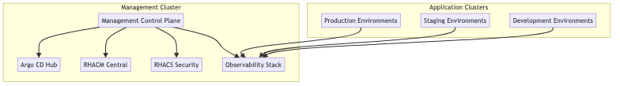

Key Features

1. Design Phase
- Multi-cluster topology for separation of management and workloads
- Centralized governance through the management cluster
- Consistent security using RHACS and Kyverno policies

2. Deployment Phase
- Rubrik integration for enterprise backup and recovery
- Dynatrace monitoring for comprehensive observability
- GitOps methodology using Argo CD for declarative management

3. Management Phase
- Enhanced admission control with OpenShift defaults plus Kyverno policies
- CRD-based management leveraging KubeVirt resources
- Event-driven integrations with CMDB systems

4. Best Practices
- Resource management and multi-tenancy
- Security and isolation enforcement
- Continuous improvement through monitoring

5. References
Comprehensive product documentation and URIs for all integrated components.

Getting Started
- Review the Architecture Overview
- Follow the Installation Guide
- Configure Admission Control
- Set up Monitoring

Architecture Diagram
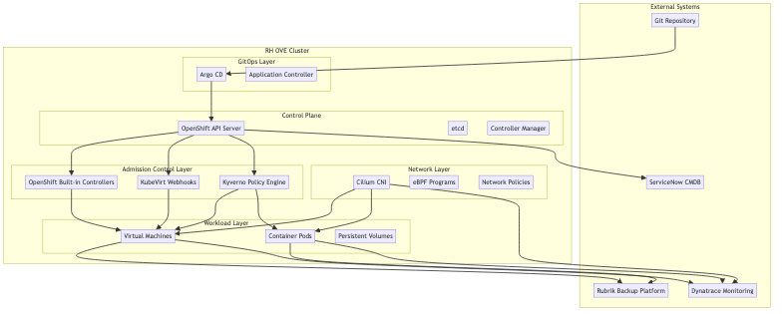
This solution provides a modern, secure, and scalable approach to managing virtualized workloads alongside containerized applications in a unified OpenShift platform.

