Management Documentation
Documentation Team
2025-11-01
Table of Contents

Management

Admission Control

Admission Control Strategy

Overview
The RH OVE solution implements a comprehensive admission control strategy that combines OpenShift’s built-in controllers with KubeVirt-specific webhooks and Kyverno policy engine for enhanced security and governance.

Architecture
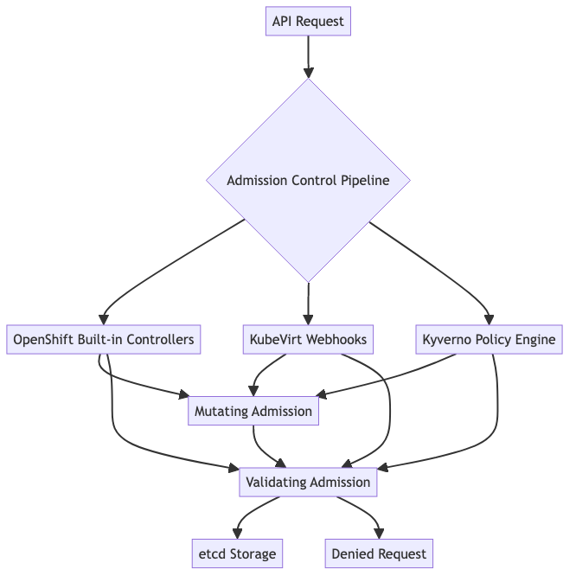

Default OpenShift Admission Controllers
RH OVE inherits all standard OpenShift admission controllers including:
- LimitRanger: Enforces resource limits and requests
- ServiceAccount: Manages service account tokens
- PodNodeSelector: Controls node placement
- SecurityContextConstraint (SCC): Enforces security policies
- ResourceQuota: Manages namespace-level resource limits
- MutatingAdmissionWebhook: Allows custom mutation logic
- ValidatingAdmissionWebhook: Allows custom validation logic

KubeVirt-Specific Admission Webhooks
KubeVirt automatically registers webhooks for virtualization resources:
- VirtualMachine validation: Ensures VM configurations are valid
- VirtualMachineInstance validation: Validates running VM instances
- DataVolume validation: Verifies storage configurations
- Migration validation: Checks migration prerequisites

Kyverno Policy Engine Integration

Installation
Deploy Kyverno via Helm or manifests:
apiVersion: v1
kind: Namespace
metadata:
name: kyverno
---
apiVersion: apps/v1
kind: Deployment
metadata:
name: kyverno
namespace: kyverno
spec:
replicas: 1
selector:
matchLabels:
app: kyverno
template:
metadata:
labels:
app: kyverno
spec:
containers:
- name: kyverno
image: ghcr.io/kyverno/kyverno:latest

VM-Specific Policies

Resource Limits Policy
apiVersion: kyverno.io/v1
kind: ClusterPolicy
metadata:
name: vm-resource-limits
spec:
validationFailureAction: enforce
background: true
rules:
- name: require-vm-resource-limits
match:
any:
- resources:
kinds:
- VirtualMachine
validate:
message: "VirtualMachine must have CPU and memory limits defined"
pattern:
spec:
template:
spec:
domain:
cpu:
cores: ">0"
memory:
guest: ">0"

VM Security Policy
apiVersion: kyverno.io/v1
kind: ClusterPolicy
metadata:
name: vm-security-policy
spec:
validationFailureAction: enforce
rules:
- name: disallow-privileged-vms
match:
any:
- resources:
kinds:
- VirtualMachine
validate:
message: "Privileged VMs are not allowed"
pattern:
spec:
template:
spec:
domain:
features:
smm:
enabled: "false"

Namespace Isolation Policy
apiVersion: kyverno.io/v1
kind: ClusterPolicy
metadata:
name: vm-namespace-isolation
spec:
validationFailureAction: enforce
rules:
- name: require-namespace-labels
match:
any:
- resources:
kinds:
- VirtualMachine
validate:
message: "VirtualMachines must be in properly labeled namespaces"
pattern:
metadata:
namespace: "!default"

Multi-Tenant Policies

Application-Based Namespace Policy
apiVersion: kyverno.io/v1
kind: ClusterPolicy
metadata:
name: application-namespace-policy
spec:
validationFailureAction: enforce
rules:
- name: enforce-app-namespace-pattern
match:
any:
- resources:
kinds:
- VirtualMachine
- VirtualMachineInstance
validate:
message: "VMs must be deployed in application-specific namespaces"
pattern:
metadata:
namespace: "app-*"

Policy Enforcement Flow
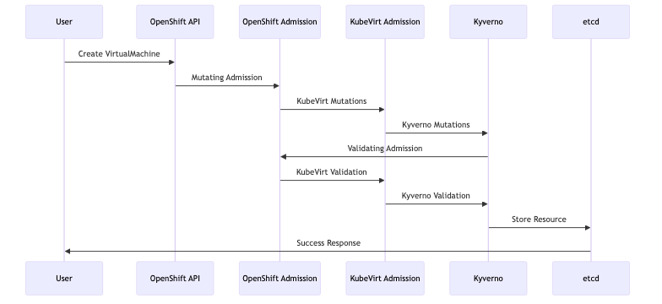

Best Practices

Policy Development
- Start with monitoring mode: Use validationFailureAction: audit initially
- Test thoroughly: Validate policies in non-production environments
- Use exceptions sparingly: Avoid broad policy exceptions
- Version control: Store policies in Git repositories

Performance Considerations
- Optimize policy matching: Use specific resource selectors
- Minimize policy overlap: Avoid redundant validation rules
- Monitor admission latency: Track policy evaluation performance
- Use background processing: Enable background validation where appropriate

Monitoring and Troubleshooting

Policy Violations Dashboard
Monitor policy violations using Prometheus metrics:
apiVersion: v1
kind: ServiceMonitor
metadata:
name: kyverno-metrics
spec:
selector:
matchLabels:
app: kyverno
endpoints:
- port: metrics

Common Troubleshooting
- Policy not applying: Check policy syntax and matching criteria
- Performance issues: Review policy complexity and scope
- Conflicts: Examine interaction between different admission controllers
- Debugging: Use kubectl describe to view admission controller events

Integration with GitOps
Store all policies in Git and deploy via Argo CD:
apiVersion: argoproj.io/v1alpha1
kind: Application
metadata:
name: kyverno-policies
spec:
source:
repoURL: https://git.example.com/rh-ove-policies
path: policies/
targetRevision: main
destination:
server: https://kubernetes.default.svc
syncPolicy:
automated:
prune: true
selfHeal: true
This comprehensive admission control strategy ensures that all workloads, both containers and VMs, comply with organizational security and operational policies while maintaining the flexibility needed for modern application development.

Gitops

GitOps Operations

Overview
This document outlines the GitOps approach for managing the multi-cluster RH OVE ecosystem, providing guidelines for implementing Infrastructure as Code (IaC) and application deployment through Git-based workflows across management and application clusters.

Multi-Cluster GitOps Principles
The RH OVE ecosystem implements GitOps across a hub-and-spoke architecture:
- Centralized Control: ArgoCD Hub manages deployments to multiple application clusters
- Single Source of Truth: All cluster and VM configurations stored in Git repositories
- Declarative Management: Infrastructure as Code for clusters, VMs, and containers
- Multi-Environment Support: Separate overlays for production, staging, and development clusters
- Policy Distribution: Centralized policy management with cluster-specific enforcement
- Automated Rollbacks: Complete change tracking and rollback capabilities across clusters

Multi-Cluster Architecture
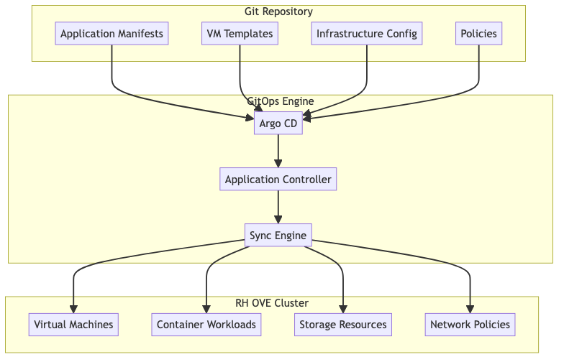

Repository Structure

Recommended Git Repository Layout
rh-ove-gitops/
├── applications/
│ ├── web-app/
│ │ ├── base/
│ │ │ ├── kustomization.yaml
│ │ │ ├── deployment.yaml
│ │ │ └── service.yaml
│ │ └── overlays/
│ │ ├── dev/
│ │ ├── staging/
│ │ └── prod/
│ └── database-vm/
│ ├── vm-definition.yaml
│ ├── datavolume.yaml
│ └── service.yaml
├── infrastructure/
│ ├── storage-classes/
│ ├── network-policies/
│ └── rbac/
├── vm-templates/
│ ├── rhel8-template.yaml
│ ├── windows-template.yaml
│ └── ubuntu-template.yaml
└── policies/
├── kyverno/
└── gatekeeper/

Argo CD Configuration

Application Definition
apiVersion: argoproj.io/v1alpha1
kind: Application
metadata:
name: database-vm-app
namespace: argocd
spec:
project: default
source:
repoURL: https://git.example.com/rh-ove-gitops
targetRevision: main
path: applications/database-vm
destination:
server: https://kubernetes.default.svc
namespace: app-database-prod
syncPolicy:
automated:
prune: true
selfHeal: true
syncOptions:
- CreateNamespace=true

AppProject for VM Workloads
apiVersion: argoproj.io/v1alpha1
kind: AppProject
metadata:
name: vm-workloads
namespace: argocd
spec:
description: Project for VM-based applications
sourceRepos:
- https://git.example.com/rh-ove-gitops
destinations:
- namespace: 'app-*'
server: https://kubernetes.default.svc
clusterResourceWhitelist:
- group: ''
kind: Namespace
- group: 'kubevirt.io'
kind: VirtualMachine
- group: 'cdi.kubevirt.io'
kind: DataVolume
namespaceResourceWhitelist:
- group: ''
kind: Service
- group: ''
kind: ConfigMap
- group: ''
kind: Secret

VM Management through GitOps

Virtual Machine Definition
apiVersion: kubevirt.io/v1
kind: VirtualMachine
metadata:
name: web-server-vm
namespace: app-web-prod
labels:
app: web-server
managed-by: argocd
spec:
running: true
template:
metadata:
labels:
app: web-server
version: v1.2.0
spec:
domain:
cpu:
cores: 2
memory:
guest: 4Gi
devices:
disks:
- name: rootdisk
disk:
bus: virtio
- name: datadisk
disk:
bus: virtio
interfaces:
- name: default
masquerade: {}
networks:
- name: default
pod: {}
volumes:
- name: rootdisk
dataVolume:
name: web-server-root
- name: datadisk
dataVolume:
name: web-server-data

DataVolume Configuration
apiVersion: cdi.kubevirt.io/v1beta1
kind: DataVolume
metadata:
name: web-server-root
namespace: app-web-prod
spec:
pvc:
accessModes:
- ReadWriteOnce
resources:
requests:
storage: 30Gi
storageClassName: fast-ssd
source:
registry:
url: "docker://registry.redhat.io/rhel8/rhel:latest"
---
apiVersion: cdi.kubevirt.io/v1beta1
kind: DataVolume
metadata:
name: web-server-data
namespace: app-web-prod
spec:
pvc:
accessModes:
- ReadWriteOnce
resources:
requests:
storage: 100Gi
storageClassName: standard-hdd
source:
blank: {}

Multi-Environment Management

Environment-Specific Overlays
### overlays/prod/kustomization.yaml
apiVersion: kustomize.config.k8s.io/v1beta1
kind: Kustomization
resources:
- ../../base
patchesStrategicMerge:
- vm-resources.yaml
- storage-config.yaml
patches:
- target:
kind: VirtualMachine
name: web-server-vm
patch: |-
- op: replace
path: /spec/template/spec/domain/cpu/cores
value: 4
- op: replace
path: /spec/template/spec/domain/memory/guest
value: 8Gi

Environment Promotion Workflow
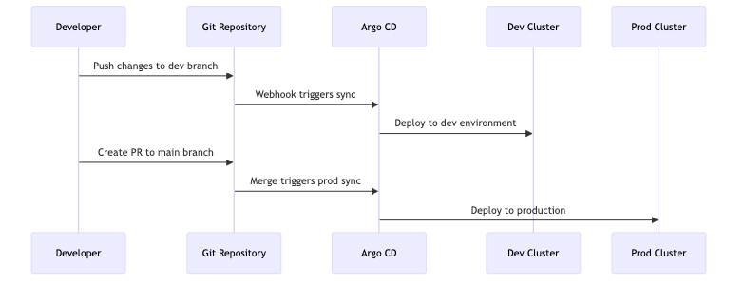

CI/CD Integration

GitLab CI Pipeline
### .gitlab-ci.yml
stages:
- validate
- test
- deploy
validate-manifests:
stage: validate
script:
- kubeval manifests/*.yaml
- kustomize build overlays/dev | kubeval
vm-integration-test:
stage: test
script:
- kubectl apply --dry-run=client -f vm-definitions/
- virtctl validate vm-definitions/
deploy-to-dev:
stage: deploy
script:
- argocd app sync dev-environment
only:
- develop
deploy-to-prod:
stage: deploy
script:
- argocd app sync prod-environment
only:
- main

Security and Compliance

Policy as Code
### policies/kyverno/vm-security-policy.yaml
apiVersion: kyverno.io/v1
kind: ClusterPolicy
metadata:
name: vm-security-standards
spec:
validationFailureAction: enforce
background: true
rules:
- name: require-vm-labels
match:
any:
- resources:
kinds:
- VirtualMachine
validate:
message: "VMs must have required labels"
pattern:
metadata:
labels:
app: "?*"
version: "?*"
managed-by: "argocd"

RBAC for GitOps
apiVersion: rbac.authorization.k8s.io/v1
kind: ClusterRole
metadata:
name: argocd-application-controller
rules:
- apiGroups:
- ""
resources:
- "*"
verbs:
- "*"
- apiGroups:
- "kubevirt.io"
resources:
- "*"
verbs:
- "*"
- apiGroups:
- "cdi.kubevirt.io"
resources:
- "*"
verbs:
- "*"

Monitoring and Observability

GitOps Metrics
Key metrics to monitor: - Sync success rate - Deployment frequency - Mean time to recovery - Application health status

Dashboard Configuration
apiVersion: v1
kind: ConfigMap
metadata:
name: argocd-cm
data:
url: https://argocd.example.com
statusbadge.enabled: "true"
application.instanceLabelKey: argocd.argoproj.io/instance

Disaster Recovery

Backup Strategy
apiVersion: v1
kind: ConfigMap
metadata:
name: backup-config
data:
backup-strategy.yaml: |
applications:
- name: critical-vms
backup_frequency: "daily"
retention: "30d"
git_ref: "backup/$(date +%Y%m%d)"
infrastructure:
- name: cluster-config
backup_frequency: "weekly"
retention: "12w"

Recovery Procedures
- Application Recovery
- # Restore from specific commit
argocd app set myapp --revision abc123
argocd app sync myapp
- Full Environment Recovery
- # Deploy entire environment from Git
argocd app create disaster-recovery \
--repo https://git.example.com/rh-ove-gitops \
--path recovery/full-environment \
--dest-server https://kubernetes.default.svc

Best Practices

Development Workflow
- Feature branches: Use feature branches for new VM deployments
- Pull requests: Require peer review for all changes
- Automated testing: Validate manifests before merge
- Progressive deployment: Use staging environments before production

Operational Guidelines
- Secrets management: Use external secret management (e.g., Vault)
- Resource limits: Define appropriate CPU/memory limits for VMs
- Monitoring: Implement comprehensive monitoring for all deployments
- Documentation: Keep README files updated in each application directory
This GitOps approach ensures consistent, auditable, and automated management of VM and container workloads in the RH OVE environment.

Monitoring

Monitoring and Observability

Overview
This document provides comprehensive monitoring and observability strategies for the RH OVE ecosystem, covering infrastructure, virtual machines, containers, and application performance monitoring using Dynatrace and other monitoring tools.

Monitoring Architecture
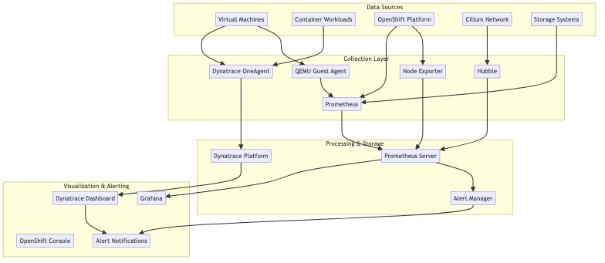

Dynatrace Integration
Based on our research, integrating RH OVE monitoring stack with Dynatrace provides comprehensive visibility for VMs and Kubernetes workloads.

Dynatrace Operator Installation
apiVersion: dynatrace.com/v1beta1
kind: DynaKube
metadata:
name: dynakube
namespace: dynatrace
spec:
apiUrl: https://your-environment-id.live.dynatrace.com/api
oneAgent:
classicFullStack:
tolerations:
- key: node-role.kubernetes.io/master
operator: Exists
effect: NoSchedule
resources:
requests:
cpu: 100m
memory: 512Mi
limits:
cpu: 300m
memory: 1Gi
activeGate:
capabilities:
- kubernetes-monitoring
- routing
resources:
requests:
cpu: 150m
memory: 512Mi
limits:
cpu: 500m
memory: 1Gi

VM-Specific Monitoring Configuration
apiVersion: kubevirt.io/v1
kind: VirtualMachine
metadata:
name: monitored-vm
namespace: app-prod
annotations:
dynatrace.com/inject: "true"
dynatrace.com/vm-monitoring: "enabled"
spec:
template:
metadata:
labels:
app: web-server
monitoring: enabled
spec:
domain:
devices:
interfaces:
- name: default
masquerade: {}
resources:
requests:
memory: 4Gi
cpu: 2
volumes:
- name: qemu-guest-agent
serviceAccount:
serviceAccountName: qemu-guest-agent

Prometheus Configuration

ServiceMonitor for VM Metrics
apiVersion: monitoring.coreos.com/v1
kind: ServiceMonitor
metadata:
name: vm-metrics
namespace: monitoring
spec:
selector:
matchLabels:
app: kubevirt-prometheus-metrics
endpoints:
- port: metrics
interval: 30s
path: /metrics

Custom Metrics for VMs
apiVersion: monitoring.coreos.com/v1
kind: PrometheusRule
metadata:
name: vm-monitoring-rules
namespace: monitoring
spec:
groups:
- name: vm.rules
rules:
- alert: VMHighCPUUsage
expr: kubevirt_vm_cpu_usage_percentage > 80
for: 5m
labels:
severity: warning
annotations:
summary: "VM {{ $labels.name }} has high CPU usage"
description: "VM {{ $labels.name }} in namespace {{ $labels.namespace }} has CPU usage above 80% for more than 5 minutes."
- alert: VMHighMemoryUsage
expr: kubevirt_vm_memory_usage_percentage > 85
for: 5m
labels:
severity: warning
annotations:
summary: "VM {{ $labels.name }} has high memory usage"
description: "VM {{ $labels.name }} in namespace {{ $labels.namespace }} has memory usage above 85% for more than 5 minutes."

Network Monitoring with Hubble

Hubble Configuration
apiVersion: v1
kind: ConfigMap
metadata:
name: cilium-config
namespace: kube-system
data:
enable-hubble: "true"
hubble-listen-address: ":4244"
hubble-metrics-server: ":9091"
hubble-metrics: |
dns:query;ignoreAAAA
drop
tcp
flow
icmp
http

Network Flow Monitoring
apiVersion: monitoring.coreos.com/v1
kind: ServiceMonitor
metadata:
name: hubble-metrics
spec:
selector:
matchLabels:
k8s-app: hubble
endpoints:
- port: hubble-metrics
interval: 30s

Storage Monitoring

CDI and Storage Metrics
apiVersion: monitoring.coreos.com/v1
kind: ServiceMonitor
metadata:
name: cdi-controller-metrics
spec:
selector:
matchLabels:
app: cdi-controller
endpoints:
- port: metrics
interval: 30s
path: /metrics

Storage Performance Alerts
apiVersion: monitoring.coreos.com/v1
kind: PrometheusRule
metadata:
name: storage-monitoring-rules
spec:
groups:
- name: storage.rules
rules:
- alert: HighStorageLatency
expr: kubelet_volume_stats_available_bytes / kubelet_volume_stats_capacity_bytes < 0.1
for: 5m
labels:
severity: critical
annotations:
summary: "Storage volume {{ $labels.persistentvolumeclaim }} is running out of space"
- alert: DataVolumeImportFailed
expr: increase(cdi_import_progress_total{phase="Failed"}[5m]) > 0
labels:
severity: warning
annotations:
summary: "DataVolume import failed"

Application Performance Monitoring

Guest Agent Installation
For enhanced VM monitoring, install QEMU Guest Agent:
### Inside RHEL/CentOS VM
sudo yum install qemu-guest-agent
sudo systemctl enable qemu-guest-agent
sudo systemctl start qemu-guest-agent
### Inside Ubuntu VM
sudo apt-get install qemu-guest-agent
sudo systemctl enable qemu-guest-agent
sudo systemctl start qemu-guest-agent
### Inside Windows VM
### Download and install virtio-win guest tools

Node Exporter for VM Guests
apiVersion: apps/v1
kind: DaemonSet
metadata:
name: node-exporter-vm
spec:
selector:
matchLabels:
app: node-exporter-vm
template:
metadata:
labels:
app: node-exporter-vm
spec:
containers:
- name: node-exporter
image: prom/node-exporter:latest
ports:
- containerPort: 9100
volumeMounts:
- name: proc
mountPath: /host/proc
readOnly: true
- name: sys
mountPath: /host/sys
readOnly: true
volumes:
- name: proc
hostPath:
path: /proc
- name: sys
hostPath:
path: /sys

Dashboard Configuration

Grafana Dashboard for VMs
{
"dashboard": {
"title": "RH OVE Virtual Machine Monitoring",
"panels": [
{
"title": "VM CPU Usage",
"type": "graph",
"targets": [
{
"expr": "kubevirt_vm_cpu_usage_percentage",
"legendFormat": "{{name}}"
}
]
},
{
"title": "VM Memory Usage",
"type": "graph",
"targets": [
{
"expr": "kubevirt_vm_memory_usage_percentage",
"legendFormat": "{{name}}"
}
]
},
{
"title": "VM Network I/O",
"type": "graph",
"targets": [
{
"expr": "rate(kubevirt_vm_network_receive_bytes_total[5m])",
"legendFormat": "{{name}} - RX"
},
{
"expr": "rate(kubevirt_vm_network_transmit_bytes_total[5m])",
"legendFormat": "{{name}} - TX"
}
]
}
]
}
}

Dynatrace Dashboard Configuration
apiVersion: v1
kind: ConfigMap
metadata:
name: dynatrace-dashboard-config
data:
vm-overview.json: |
{
"dashboardMetadata": {
"name": "RH OVE VM Overview",
"shared": true,
"tags": ["rh-ove", "virtualization"]
},
"tiles": [
{
"name": "VM Performance",
"tileType": "CUSTOM_CHARTING",
"configured": true,
"queries": [
{
"metric": "builtin:host.cpu.usage",
"aggregation": {
"type": "AVG"
},
"filterBy": {
"neType": "HOST",
"tags": ["vm:kubevirt"]
}
}
]
}
]
}

Alerting Strategy

Alert Routing Configuration
apiVersion: v1
kind: ConfigMap
metadata:
name: alertmanager-config
data:
alertmanager.yml: |
global:
smtp_smarthost: 'smtp.example.com:587'
smtp_from: 'alerts@example.com'
route:
group_by: ['alertname', 'cluster', 'service']
group_wait: 10s
group_interval: 10s
repeat_interval: 1h
receiver: 'web.hook'
routes:
- match:
severity: critical
receiver: 'critical-alerts'
- match:
service: vm
receiver: 'vm-alerts'
receivers:
- name: 'web.hook'
webhook_configs:
- url: 'http://webhook.example.com/alerts'
- name: 'critical-alerts'
email_configs:
- to: 'oncall@example.com'
subject: 'CRITICAL: {{ .GroupLabels.alertname }}'
body: |
{{ range .Alerts }}
Alert: {{ .Annotations.summary }}
Description: {{ .Annotations.description }}
{{ end }}
- name: 'vm-alerts'
slack_configs:
- api_url: 'https://hooks.slack.com/services/...'
channel: '#vm-alerts'
title: 'VM Alert: {{ .GroupLabels.alertname }}'

Logging Strategy

Centralized Logging for VMs
apiVersion: logging.coreos.com/v1
kind: ClusterLogForwarder
metadata:
name: vm-logs
namespace: openshift-logging
spec:
outputs:
- name: vm-logs-output
type: elasticsearch
url: https://elasticsearch.example.com:9200
elasticsearch:
index: vm-logs-{.log_type}-{.@timestamp.YYYY.MM.dd}
pipelines:
- name: vm-logs-pipeline
inputRefs:
- application
filterRefs:
- vm-log-filter
outputRefs:
- vm-logs-output

Performance Optimization

Monitoring Resource Optimization
apiVersion: v1
kind: ResourceQuota
metadata:
name: monitoring-quota
namespace: monitoring
spec:
hard:
requests.cpu: "2"
requests.memory: 4Gi
limits.cpu: "4"
limits.memory: 8Gi
persistentvolumeclaims: "5"

Metrics Retention Policy
apiVersion: v1
kind: ConfigMap
metadata:
name: prometheus-config
data:
prometheus.yml: |
global:
scrape_interval: 30s
evaluation_interval: 30s
external_labels:
cluster: 'rh-ove-cluster'
rule_files:
- "vm-monitoring-rules.yml"
scrape_configs:
- job_name: 'kubevirt-vms'
kubernetes_sd_configs:
- role: pod
relabel_configs:
- source_labels: [__meta_kubernetes_pod_label_kubevirt_io]
target_label: vm_name

Troubleshooting Monitoring

Common Issues and Solutions
- OneAgent not reporting VM data
- # Check OneAgent status
oc get pods -n dynatrace
oc describe pod dynatrace-oneagent-xxx
# Verify VM annotations
oc get vm -o yaml | grep -A5 annotations
- Missing VM metrics in Prometheus
- # Check ServiceMonitor configuration
oc get servicemonitor -n monitoring
# Verify metrics endpoint
oc port-forward svc/kubevirt-prometheus-metrics 8080:8080
curl localhost:8080/metrics
- Network flow data not appearing
- # Check Hubble status
cilium status
hubble status
# Verify Hubble configuration
oc get configmap cilium-config -n kube-system -o yaml
This comprehensive monitoring strategy ensures full visibility into the RH OVE ecosystem, covering infrastructure, virtual machines, containers, and application performance.

Backup

Backup & Recovery

Overview
This document outlines the backup and recovery strategies for the RH OVE ecosystem. It highlights the integration with Rubrik, detailing how to efficiently back up and restore both VM and container data.

Backup Strategy

Rubrik Integration
Utilize Rubrik’s capabilities to ensure robust data protection:
- Certified Integration: Rubrik is certified for RH OVE, providing seamless data protection.
- Immutable Backups: Ensure data safety with air-gapped, tamper-proof backups.
- Policy-Driven: Simplify backup management with declarative policies for VM workloads.

Backup Configuration
apiVersion: v1
kind: ConfigMap
metadata:
name: rubrik-backup-config
namespace: rubrik-system
data:
backupPolicy.yaml: |
policies:
- name: daily-VM-backup
frequency: daily
retention: 30d
exclude: 'temp-volumes'
schedules:
- name: nightly-backup
time: '02:00'
days:
- Monday
- Wednesday
- Friday

Data Volume Backup
Backup specific DataVolumes using Rubrik advanced features:
apiVersion: rubrik.com/v1
kind: DataProtectionPolicy
metadata:
name: data-volume-backup
spec:
dataprotection:
enable: true
rubrikCluster:
name: rubrik-cluster1
snapshot:
schedule: nightly
retention: 31
datavolume:
selector:
matchLabels:
app: production

Recovery Strategy

Rubrik Recovery
Rubrik’s high-speed recovery ensures minimal downtime for critical workloads:
- Instant Restore: Quickly recover VMs from snapshots directly on RH OVE.
- File-Level Restore: Execute rapid recovery at the file level for broad access needs.
- Automated Recovery Paths: Simplify recovery workflows through automation.

Recovery Plan
Define a detailed recovery plan to access Rubrik’s capability.
apiVersion: v1
kind: ConfigMap
metadata:
name: recovery-plan
namespace: recovery
spec:
paths:
critical-apps:
- name: app1
vm: app1-vm
backup: latest
action: restore
- name: app2
vm: app2-vm
backup: nightly
action: restore
hooks:
preRestore:
- /scripts/pre-restore.sh
postRestore:
- /scripts/post-restore.sh

Testing and Validation

Backup Verification
Regularly test backups to ensure integrity and reliability:
- Backup Verification Schedules: Conduct routine checks on backup snapshots for quality assurance.
- Periodic Restore Drills: Simulate restore scenarios to assess recovery time objectives.

Recovery Assurance
Ensure recovery processes are validated and documented:
- Recovery Testing: Periodically execute recovery processes within a non-production environment.
- Documentation: Maintain up-to-date recovery documentation with steps, tools, and responsible parties.

Monitoring and Alerts
Utilize monitoring tools to track backup and restore activities:
- Alerting Policies: Implement alerts for failed backups, missed schedules, or data integrity issues.
- Monitoring Dashboards: Use dashboards to visualize backup/recovery activities and efficiency metrics.

Conclusion
By following these backup and recovery strategies, organizations can ensure the safety, integrity, and availability of their critical data within the RH OVE ecosystem. Taking advantage of Rubrik’s robust integration further enhances data resilience, minimizing risks associated with data loss.

