RH OVE Home Documentation

Red Hat OpenShift Virtualization Ecosystem Team

2025-08-04

Table of Contents

# Home

## Index

### RH OVE Ecosystem Design and Management

Welcome to the comprehensive guide for designing, deploying, and managing the multi-cluster RH OVE ecosystem.

#### Solution Overview

This documentation covers a complete multi-cluster RH OVE implementation consisting of:

* **1 Management Cluster**: Centralized control plane for governance, policy, monitoring, and GitOps
* **N Application Clusters**: Dedicated workload execution environments for virtual machines and containers

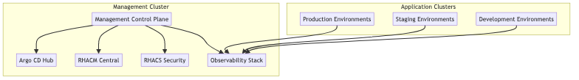

#### Key Features

##### 1. Design Phase

* **Multi-cluster topology** for separation of management and workloads
* **Centralized governance** through the management cluster
* **Consistent security** using RHACS and Kyverno policies

##### 2. Deployment Phase

* **Rubrik integration** for enterprise backup and recovery
* **Dynatrace monitoring** for comprehensive observability
* **GitOps methodology** using Argo CD for declarative management

##### 3. Management Phase

* **Enhanced admission control** with OpenShift defaults plus Kyverno policies
* **CRD-based management** leveraging KubeVirt resources
* **Event-driven integrations** with CMDB systems

##### 4. Best Practices

* Resource management and multi-tenancy
* Security and isolation enforcement
* Continuous improvement through monitoring

##### 5. References

Comprehensive product documentation and URIs for all integrated components.

#### Getting Started

1. Review the [Architecture Overview](architecture/overview.md)
2. Follow the [Installation Guide](deployment/installation.md)
3. Configure [Admission Control](management/admission-control.md)
4. Set up [Monitoring](management/monitoring.md)

#### Architecture Diagram

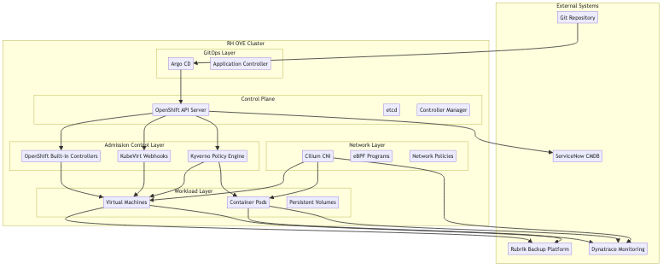

This solution provides a modern, secure, and scalable approach to managing virtualized workloads alongside containerized applications in a unified OpenShift platform.