Simulation

Steve Brunwasser

2025-05-28

# 1

$$y_{ij}=β_{0j}+β_{1j}X_{1ij}+β_{2j}X_{2ij}+e_{ij}$$

$$β_{0j}=γ_{00}+γ_{01}+u_{0j}$$

$$β_{1j}=γ_{10}+γ_{11}w_{j}+u_{1j}$$

$$β_{2j}=γ_{20}+u_{2j}$$

$$ϵ_{ij}∼N\left(0,σ^{2}\right)$$

x <- rnorm(100, 100, 15)  
y <- rnorm(100, 100, 15)  
  
plot(x, y)

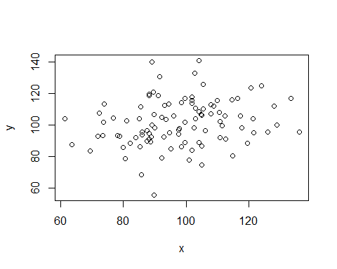

Figure 1.1: Scatterplot

Here is a scatterplot (Figure 1.1)