William Brunner

5/6/2022

Stardew Valley Ore Value Calculator – By Will Brunner

The topic of my project was to create a calculator that takes user input to calculate the amount of profit one might make after a day in the mines in the video game “Stardew Valley.” There is no such system in game that tells you the value of your loot (without mods), so this program was created to achieve that goal.

While most other items you pick up in the mine have other uses, gems are most often sold once you return home at the end of the day. While it would be useful to know the value of other things you find, most people are going to end up keeping everything else they pick up.

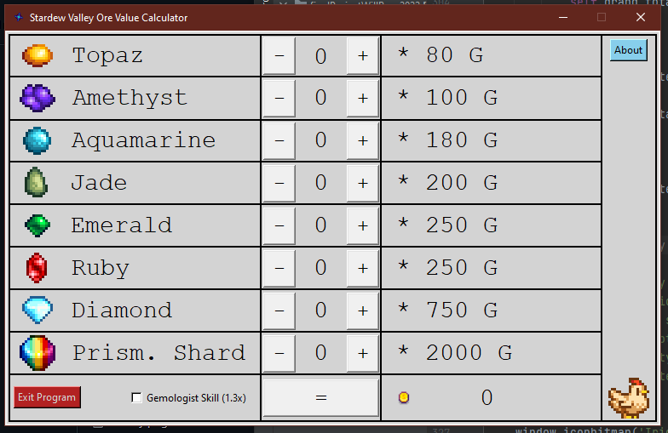

My goals for my application are the following: to give people an easier time calculating profits in game without extra modifications to the original files, and to make that process as simple as I can. Finally, I wanted a program that would not crash and implemented various checks to achieve that goal. A side goal was to make it aesthetically pleasing.

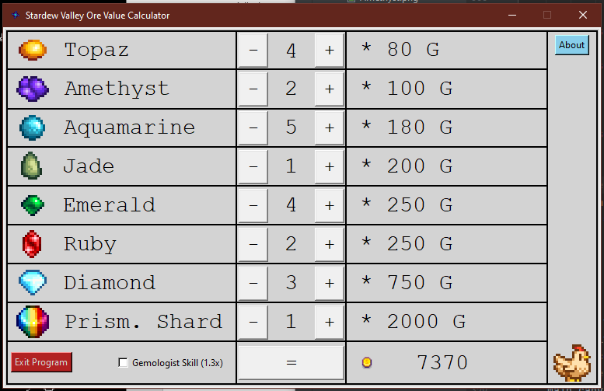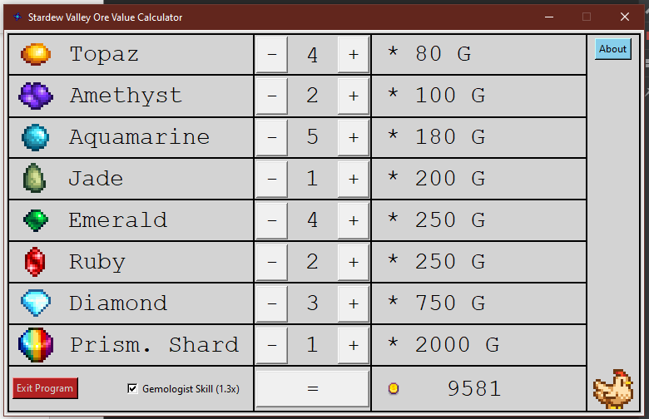My target audience is anyone who plays the video game “Stardew Valley.” From what I have seen, that means all ages and accessibility levels. If the calculator is on your system, then you should have no trouble finding things and using them.

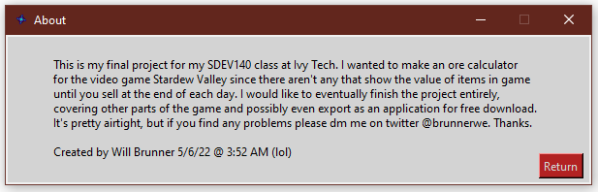

**VALIDATTION TESTING:**

I chose random numbers of gems and calculated them manually to compare the outcome- the outcomes were the same. When I went to test the 1.3x function though, I found that the results were not the same. For some reason the only extra item being calculated with the bonus in mind was the prismatic shard. This was probably because of the way I set the function up. I had every multiple calculated AND had the 1.3x bonus bracketed around all those functions. This messed up the calculations, so I turned the 1.3x into a separate calculation to the already completed total one line below. This fixed the problem. Aside from that, everything else worked fine. Screenshots of the comparison are displayed above.