Name: _________________ Instructor: Yosef Alayev
Queens College, CS211(Spring 2007)

Quiz #1

Directions: Answer the following questions on the quiz paper.

We want to represent a Complex Number. A complex number is a number in the form of 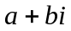where and are real numbers and is an imaginary unit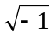. is a real part of a complex number and is an imaginary part of a complex number. Complex numbers can be added, subtracted, multiplied, and divided. Example: given 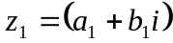 and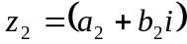.

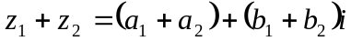
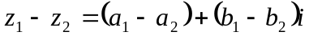
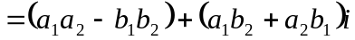
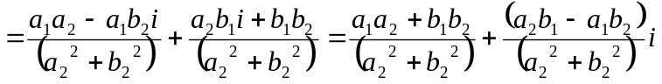
Complex numbers have conjugates. Conjugate of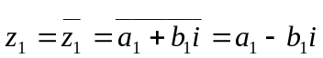. Complex numbers have length. Length of 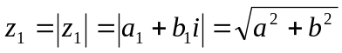

1. Write the .h file for this class to support all of these operations providing all the necessary functions.

2. Write the portions of .cpp file for this class. In particular, implement:
a) 2-argument constructor
b) Mutator Functions
c) Add method

