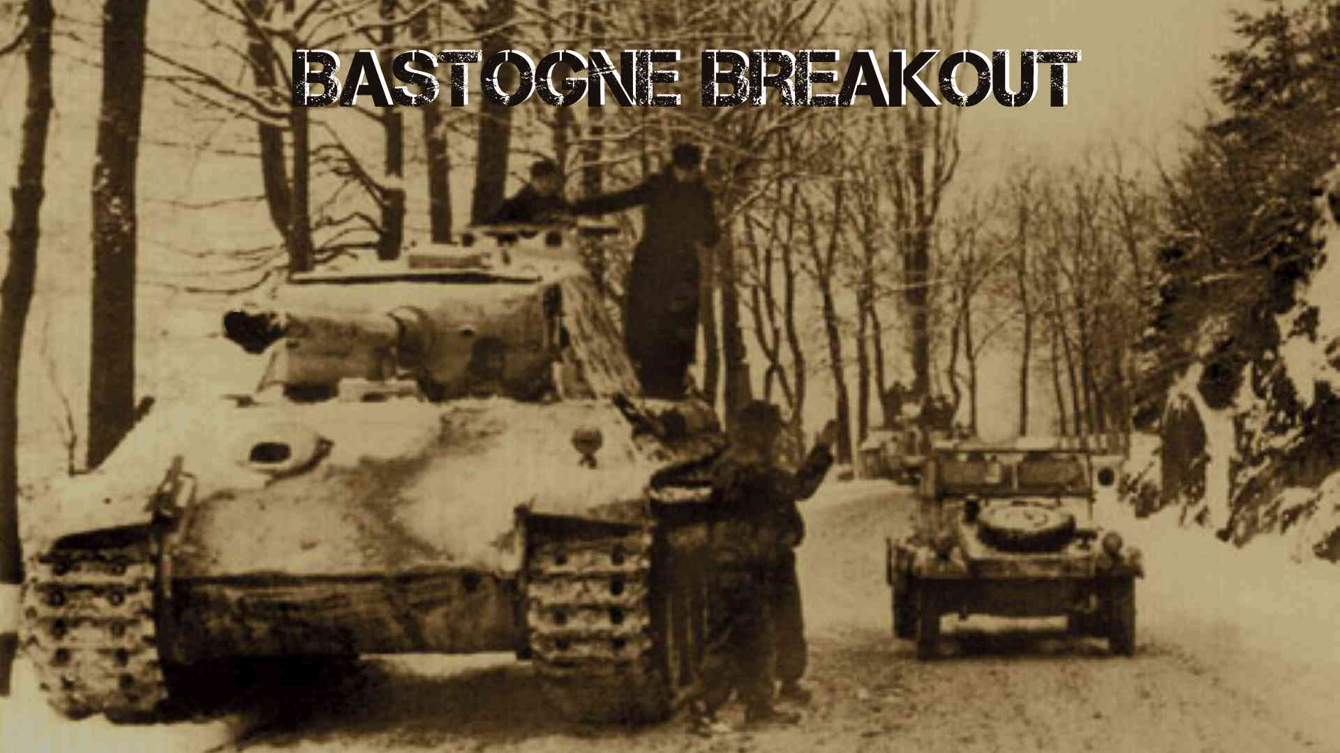

1. IntroductIon
2. 2.0 components
   1. Fourth Edition Rules
   2. Maps
   3. Charts,Tables, and Tracks
   4. Counters
3. 3.0 scenarIos
   1. General Course of a Game
   2. Setting Up
   3. Turns

3.4 Winning a Game

4.0 sequence of play

4.1 Turn Sequence

4.2 Night Turns

4.3 Rain Turns

5.0 movement

5.1 Movement Limitations

5.2 Effects of Terrain on Movement

5.3 Enemy Units and Zones of Control

5.4 Movement and Friendly Units

5.5 Exiting the Map

5.6 Entering the Map

6.0 combat

6.1 Which Units Attack and Defend

6.2 Calculating the Odds

6.3 Terrain Effects on Combat

6.4 Combat Results

6.5 Elimination and Exchange

6.6 Retreating After Combat

6.7 Advancing After Combat

# Introduction

Bastogne Breakout is a simulation of the German winter offensive in 1944 called the Battle of the Bulge. Its focus is the south part of the battle over control of the road network around the Belgium city of Bastogne. This was crucial for the breakthrough of the German LVIII Panzer Corp on it route to Namur. The user can control the German and Allied forces called Hot Seat mode. The user can play in solitaire mode against the Computer(AI). Currently the computer only plays the allied side.

Control of the game is mainly through left clicking the mouse on counters and icons. See Input section.

# Components

**2.1** **Map**

The game is played on a map which is a representation of the actual terrain around Bastogne and Wiltz in December 1944.

The map is overlaid with hexagons to govern movement, combat and supply rules. Each hexagon is associated with a specific terrain type which effect movement, supply and combat.

**Map Scale:** Each hex represents 1 mile or 1.6 kilometer from side to side.

The map can be scrolled either through keyboard arrow keys or mouse panning.

The map can be zoomed with “+” or “-“ keyboard or mouse wheel.

**2.2** **Counters**

I:\Bastogne\Prod\bridgeblown.png Playing pieces called Counters represent the actual units involved in the battles as well as informational markers. Each playing counter represents an actual unit involved in the battle. They represent battalions, regiments, brigades and kampfgruppen(ad hoc German units). See counter section.

**2.3 Tables, Charts and Icons**

The following are used to carry out or record certain game functions.

* Terrain Effects Chart (**TEC**) – summarizes the effects of terrain on movement, supply and combat.
* Combat Results Table (**CRT**) – resolve combat.
* Bombardment Results Table (**BRT**) – resolve bombardments by artillery and air power.
* Available Aircraft Display (**AAD**) – airpower available to allies for that turn.
* Phase and Date Display (**PDD**) – in progress phase and date.
* Computer Functions Button (**CFB**) – computer functions available to the user to display game information.
* Bridge Repair Table (**BRT**) – summarizes die roll needed to repair a bridge.
* Reinforcement Display Window (**RDW**) – display all reinforcement eligible for this scenario.
* Informational markers are used for Supply sources, Reinforcement entry hexes, exit areas, Bombard selection and Bombard commitment.

**2.3 Cards**

Cards are used to affect game play. There are a limited number available to each side. They are played at the start of the game turn. See Cards.

# Scenarios

* 1. **Introduction Scenario** - The Germans must control all of the Bastogne and Wiltz hexes. Six game turns.
  2. **Second Panzer goes West** – The Germans must exit the all units of the Second Panzer division off of the roads on the west side of the board. They must all be in supply. Seven Game Turns.
  3. **Bastogne Breakout**  – The Germans must exit the all units of the Second Panzer division and elements of Panzer Lehr off of the roads on the west side of the board. They must all be in supply. Eight Game Turns.(not available this release)
  4. **Counterattack**  – The Germans must exit the all units of the Second Panzer division and elements of Panzer Lehr off of the roads on the west side of the board. They must all be in supply. Nine Game Turns.(not available this release)

# Sequence Of Play

At the start of the game the German player selects which cards they will place in their hand. The Allied player then selects their card. The game now begins.

The game is played in game turns representing one day of the battle. The German player starts, completes their sequence followed by the Allied player. Each turn is composed of a number of phases which must be completed before the next phase can begin. Certain phase require the other player to have control. This continues until maximum number of turns for that scenario is reached. The winner is the determined.

**4.1** **Game Phases**

**Allied Card** – The Allied Player now can play any and all cards in their hand which available for this turn.

**German Card** – The German Player now can play any and all cards in their hand which available for this turn.

**German Roll for Bridge Repair** – If the German player can now attempt to repair a Blown Bridge by rolling dice on BRT. Only one bridge can be repaired per turn. If more than 1 bridge has been blown the Germans can left click on bridge they wish to repair.

**German Limber Artillery** – The German Player now can change status of their artillery counters to limbered or unlimbered. Regular artillery must be limbered to move and unlimbered to bombard. For mobile artillery limbering and unlimbering changes movement and bombardment efficiencies. All German counters are shaded at the start of this phase. All eligible for limber/unlimber will be unshaded.

**German Movement** – The German Player now can move all eligible units. All German counters are shaded at the start of this phase. All eligible for movement will be unshaded. Left click on eligible units to show which hexes it can move to. See the Movement rules. Movement can include Mobile Assault (**MA**) attacks as part of movement. See the Combat section.

**Allied Defensive Barrage** – The Allied Player now target all in range German Units that can be bombarded. A bombard selection icon will be overlaid on eligible German units to be bombarded.

**German Offensive Barrage** – The German Player can now target in range allied units. See above.

**German Barrage Resolve -** The Computer will now animate all of the targeted bombardments. See the Bombard section.

**German Combat** – The German Player can now attack all eligible Allied units. These units will be identified by the attack icon. Left click on the icon to start the Attack. See Combat section.

**German Exploitation** – Any German motorized units that did not participate in movement or combat this turn are now eligible for movement. This can include Mobile Assault attacks as well.

**I:\Bastogne\Prod\truck.pngGerman Supply** – The German player attempts to provide supply for all of their units. See Supply.

**Allied Reinforcements**  – The computer displays the RDW for that turn for the Allies. See Reinforcement section.

**Allied Movement** – Same as German Movement except for Allied units.

**German Barrage Defend**  – Same as Allied Defensive Barrage German except for Allied units.

**Allied Offensive Barrage** – The Allied Player can now target in range German units. See above.

**Allied Barrage Resolve -** The Computer will now animate all of the targeted bombardments. See the Bombard section.

**Allied Combat** – The Allied Player can now attack all eligible German units. These units will be identified by the attack icon. Left click on the icon to start the Attack. See Combat section.

**Allied Exploitation** – Any Allied motorized units that did not participate in movement or combat this turn are now eligible for movement. This can include Mobile Assault attacks as well.

**Allied Supply** – The Computer automatically determines which allied units are in supply.

**Allied Supply** – The Computer automatically determines which allied units are in supply.

**End Game Turn** – The Computer checks to see if end of game and if it is determines the winner. If not end of game the computer will advance turn by 1, roll dice for weather and roll dice for Air Support

# Movement

Counters are moved one at a time from the hex they are occupying trough a path of adjacent hexes on the map hex grid. Each hex grid incurs movement points that are subtracted from its Movement Allowance (MA). The points are dependent on the terrain type in the hex (see TEC). Once the MA is at zero the counter can move no further. If it enters and enemy controlled hex it may make an MA. If successful it may continue moving.

When the chosen counter is left clicked the computer will highlight the chosen counter and highlight all possible hexes that the counter can reach as well as MOA’s possible.

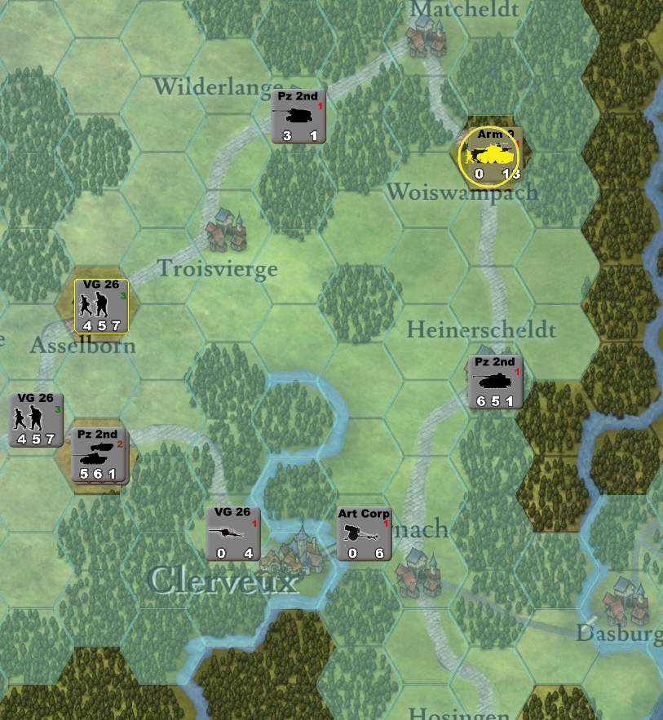

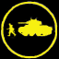The user left clicks on the move-to hex to initiate move. To cancel move left click on a hex which has not been highlighted. To start a MOA left click on the MOA symbol.

**5.1 Movement Limitations**

* **Unused Movement Points** cannot be saved for later in the movement phase or for subsequent turns. It can not be transferred to other counters.
* **Movement End** once the highlighted hex for possible moves has been touched, the computer will move the counter and move is over for the counter. It cannot be undone.
* **Combat** occur as part of movement see MOA in combat section.

**5.2 Effects of Terrain on Movement**

The basic per hex movement point is 1 MP per hex. Certain hexes and crossing certain hex sides may cost extra. Costs are cumulative .This is described in the TEC and below:

* **Hex sides** – rivers block mechanized units and artillery from crossing if there is not a bridge present. Infantry cost is +3 MP. Major and minors roads must cross a hex side to lower the MP cost for movement between hexes. MP is ½ for both except it is 1 for Supply transports on minor roads.
* **Combat -**occurs as part of movement when a counter tries to enter a hex containing an enemy unit. See MOA in combat section. The cost for entering a enemy hex is +3 MP. After successful completion of the combat the counter can continue moving. If the unit stated its move in a ZOC it cannot do a MOA. In that case the move is over.
* **ZOC** –The six hexes that surround a combat unit are the zone of control for that unit. ZOC does not extend across non-bridge river hex sides.
  + Towed artillery does not exert a ZOC.
  + It costs +2 MP to enter a ZOC.
  + Units that start their turn in a ZOC cannot make a MOA in their turn.
  + Transport unit cannot enter a ZOC unless there is German unit occupying it.

**5.3 Movement and Friendly Units**

Units may move freely through hexes that contain other units with the following exceptions:

* **Major Roads** – if there are greater than 4 steps occupying the hex add +3 MP, if greater than 2 add +1MP.
* **Minor Roads** – if there are greater than 4 steps occupying the hex add +3 MP, if greater than 2 add +2MP.

**5.4 Reinforcements entering the board.**

Only the allied side has reinforcements and they enter the board on specific locations see the **RDW**.