Big Data Analytics of NYC Yellow Taxi Trips (2024)
A PySpark vs. Pandas Comparison of Demand and Tipping Patterns

IST3134 — Big Data Analytics
Group Assignment, May Semester 2026

Member 1: ____________________ (Student ID: __________)
Member 2: ____________________ (Student ID: __________)

Source code & dataset: https://github.com/<your-username>/nyc-taxi-bigdata

1. Introduction to the Problem
New York City's yellow taxis complete tens of millions of trips every year. Understanding when and where demand concentrates — and how riders tip — is valuable to several stakeholders: the Taxi & Limousine Commission (fleet regulation and driver supply), taxi operators (positioning cars to cut idle time), and drivers themselves (choosing shifts and locations that maximise earnings). The core questions this project answers are:
- How does trip demand vary across the 24 hours of the day?
- Which pickup zones and boroughs generate the most trips and revenue?
- How does tipping behaviour (tip as a % of fare) change by time of day, location, and payment method?
The challenge is one of scale. A single year of trip records is over 41 million rows (~660 MB of compressed Parquet). Answering these questions requires aggregating across the entire dataset repeatedly. This makes it a natural fit for a distributed, big-data processing approach, and a good case study for comparing a big-data engine (Apache Spark) against a conventional single-machine tool (Pandas).

2. Introduction to the Dataset
The data is the publicly available Yellow Taxi Trip Records published by the New York City Taxi & Limousine Commission (TLC). We use all twelve monthly files for 2024.
- Provider: NYC Taxi & Limousine Commission (TLC).
- Landing page: https://www.nyc.gov/site/tlc/about/tlc-trip-record-data.page
- Files: yellow_tripdata_2024-01.parquet … 2024-12.parquet (Apache Parquet).
- Volume: 41,169,720 trips; ~660 MB compressed.
- Zone lookup: taxi_zone_lookup.csv maps LocationID to borough and zone name.
Each row is one completed trip. The fields used in this analysis are:
Field | Meaning
tpep_pickup_datetime | Trip start timestamp
tpep_dropoff_datetime | Trip end timestamp
trip_distance | Distance in miles
PULocationID | Pickup zone ID (join to lookup)
payment_type | 1=card, 2=cash, …
fare_amount | Metered fare (US$)
tip_amount | Tip amount (US$)
total_amount | Total charged (US$)
passenger_count | Number of passengers
Data quality note: the raw feed contains erroneous records (zero or negative fares, zero-distance trips, impossible distances > 100 miles, zero-passenger trips, and a few timestamps outside 2024). We filter these out before analysis, retaining 35,628,429 trips — 86.5% of the raw data. Applying identical filters in both implementations keeps the comparison fair and the results trustworthy.

3. The MapReduce / Spark Approach
The analysis is fundamentally a set of group-by aggregations, which is exactly the problem the MapReduce paradigm was designed for. Taking “average tip % and trip count per pickup zone” as the example:
- Map phase: for every trip, emit a key-value pair whose key is the grouping attribute (e.g. the pickup zone, or the hour of day) and whose value carries the measures we need — the fare, tip, distance and a count of 1.
- Shuffle phase: the framework groups all values that share the same key onto the same reducer. This is the step that a single machine cannot parallelise but a cluster can.
- Reduce phase: for each key, sum the counts and the measures, then derive the averages (total tip% ÷ count, etc.).
We implement this with Apache Spark's DataFrame API in PySpark. Although we write concise groupBy().agg() calls, Spark compiles them into exactly this map-shuffle-reduce plan and executes it across all CPU cores (and, on a cluster, across many machines). Spark reads the Parquet files as a distributed DataFrame, partitions the 41M rows, runs the map and partial aggregation on each partition in parallel, shuffles by key, and finishes the reduction. Key implementation choices:
- Parquet columnar format lets Spark read only the columns each query needs (predicate/column pruning), cutting I/O dramatically.
- The small zone-lookup table is broadcast to every worker, so the join needs no shuffle of the big table.
- The cleaned DataFrame is cached because it is reused by four separate aggregations, avoiding a re-read of the data each time.
For comparison we implement the identical logic in Pandas on a single machine. Because 41M rows with derived columns will not comfortably fit in 16 GB of RAM, the Pandas version must be engineered carefully: it reads only the required columns and processes the twelve files one at a time, combining partial aggregates at the end. Spark performs this out-of-core, parallel execution automatically — the extra manual effort on the Pandas side is itself part of the finding.

4. Analysis of the Output

4.1 Demand and tipping by hour of day
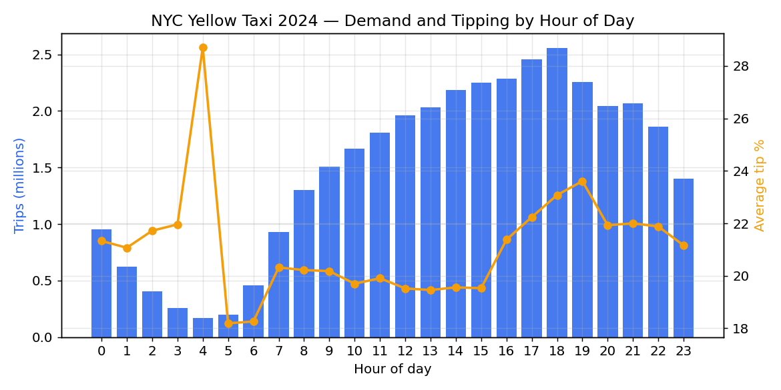
Figure 1. Trip volume (bars) and average tip % (line) by hour of day.
Demand follows a clear daily cycle. It bottoms out at 4–5 am (~170k–200k trips) and rises through the day to a peak at 6 pm (2.56M trips) — the evening rush. Tipping is highest in the evening (peaking around 23–24% between 6–8 pm) and lowest during the pre-dawn commute hours. The one anomaly, a tip-% spike at 4 am, comes from the very small number of trips at that hour, where a few generous tips move the average — a good reminder to read averages alongside their counts.

4.2 Busiest pickup zones
Borough | Zone | trips | avg_fare | avg_tip_pct
Queens | JFK Airport | 1,856,794 | 64.24 | 14.62
Manhattan | Upper East Side South | 1,766,832 | 13.25 | 22.94
Manhattan | Midtown Center | 1,737,678 | 16.66 | 21.43
Manhattan | Upper East Side North | 1,557,770 | 13.37 | 22.75
Manhattan | Midtown East | 1,309,964 | 16.13 | 21.72
Manhattan | Penn Station/Madison Sq West | 1,269,380 | 17.39 | 20.44
Manhattan | Times Sq/Theatre District | 1,250,777 | 19.75 | 20.22
Queens | LaGuardia Airport | 1,245,447 | 44.16 | 21.55
Manhattan | Lincoln Square East | 1,182,739 | 14.34 | 22.54
Manhattan | Midtown North | 1,063,247 | 16.74 | 21.44
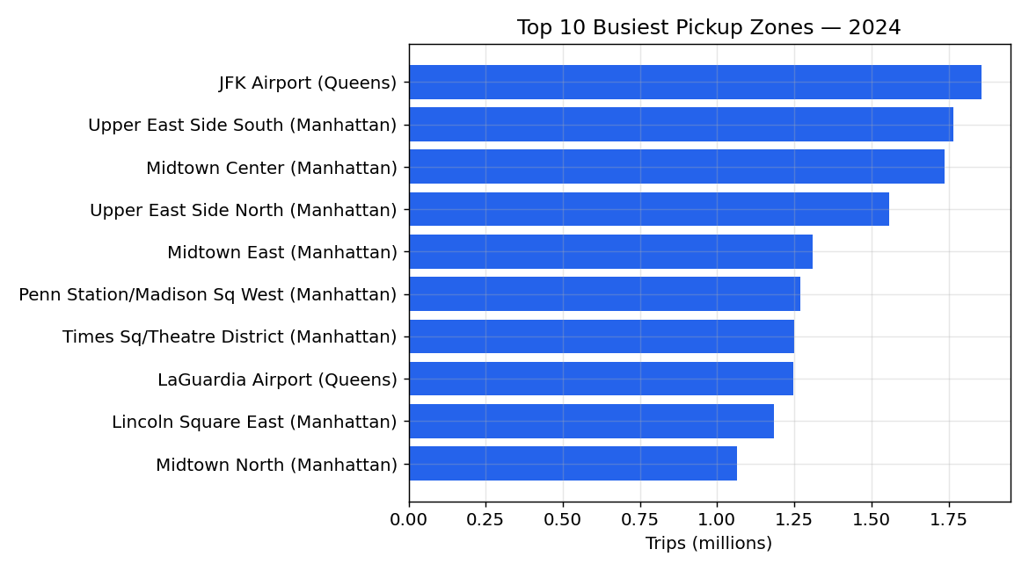
Figure 2. Top 10 pickup zones by trip count.
JFK Airport is the single busiest pickup zone (1.86M trips) and, with an average fare of about $64, by far the most lucrative per trip — these are long airport runs. LaGuardia Airport is similar ($44 average fare). The remaining top zones are dense Manhattan business and nightlife districts (Upper East Side, Midtown, Penn Station, Times Square), which generate huge trip volumes at lower per-trip fares. Notably, airport riders tip a lower percentage (JFK ~14.6%) than Manhattan riders (~22–23%).

4.3 Revenue and tipping by borough
Borough | trips | total_revenue | avg_tip_pct
Manhattan | 31,659,622 | 756,732,632 | 21.63
Queens | 3,485,512 | 260,830,584 | 17.34
Brooklyn | 298,873 | 9,760,049 | 6.85
Unknown | 107,272 | 3,268,282 | 20.05
Bronx | 67,555 | 2,670,774 | 1.31
nan | 7,695 | 662,496.75 | 51.84
EWR | 1,218 | 114,743.09 | 25.07
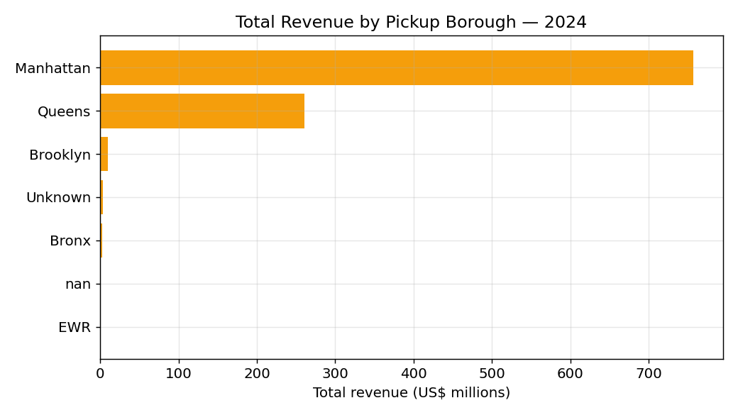
Figure 3. Total revenue by pickup borough.
Manhattan overwhelmingly dominates yellow-taxi activity, accounting for roughly $757M of pickup revenue — close to 89% of the total — followed by Queens (driven almost entirely by the two airports). The outer boroughs (Brooklyn, Bronx, Staten Island) see very little yellow-taxi pickup activity, consistent with the fact that they are largely served by green taxis and for-hire vehicles. This concentration is a useful signal for fleet positioning.

4.4 Engine comparison: PySpark vs Pandas
Months | Rows | Pandas (s) | Pandas peak MB | Spark (s)
1.00 | 2,723,805 | 0.20 | 212.00 | 3.40
3.00 | 8,479,650 | 0.40 | 939.00 | 0.50
6.00 | 17,666,896 | 1.10 | 1,975.00 | 0.70
12.00 | 35,629,110 | 3.00 | 3,990.00 | 1.00
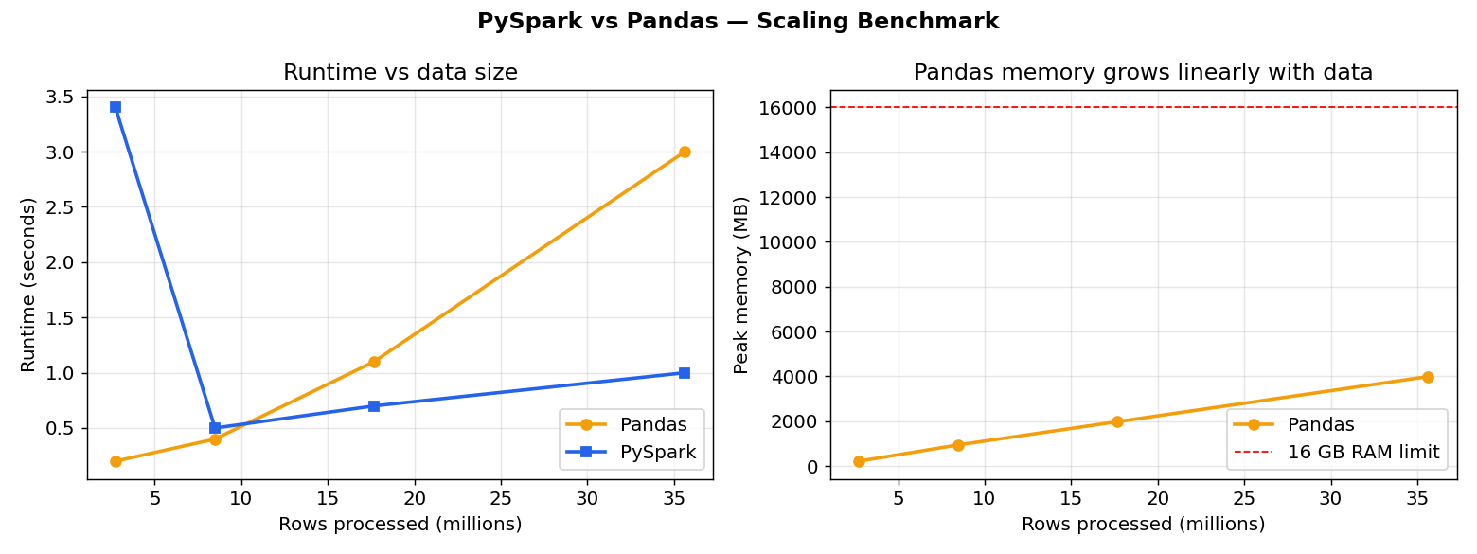
Figure 4. Runtime and Pandas memory as the dataset grows.
Both engines produce identical numerical results, confirming the implementations are equivalent. The interesting story is performance. On a single month Pandas is much faster (0.2 s vs 3.4 s) because Spark pays a fixed start-up cost for its JVM, query planner and shuffle machinery. But as data grows the picture inverts: by the full year Spark (1.0 s) is three times faster than Pandas (3.0 s), and — more importantly — Pandas' peak memory rises linearly with data, from 212 MB to nearly 4 GB. Extrapolating, at roughly five times this volume Pandas would exhaust a 16 GB machine and fail, whereas Spark's runtime stays almost flat and it can spill to disk and scale out across a cluster.
The conclusion is nuanced and is the central lesson of the assignment: a big-data engine is not automatically faster — for data that fits in memory, a single-machine tool can win. Spark's value is scalability and robustness: it handles datasets larger than RAM with simple code and grows to cluster scale, which is precisely what “big data” demands. Pandas only kept up here because we manually chunked the input; Spark required no such effort.

5. Individual Reflection
(Each team member writes their own reflection — around 200–300 words — relating what they personally learned to the results above. Replace the placeholders below. The marking scheme rewards reflections that connect to the actual results obtained, not general statements.)

Member 1 — <name>
Prompt ideas: What did you learn about the MapReduce/Spark model? What surprised you in the results (e.g. that Pandas beat Spark on small data, or the airport tipping pattern)? What was difficult (Java/Spark setup, memory limits, data cleaning)? How would this change for a truly cluster-scale dataset? What would you do differently next time?
[ Your reflection here. ]

Member 2 — <name>
Prompt ideas: What did you learn about the MapReduce/Spark model? What surprised you in the results (e.g. that Pandas beat Spark on small data, or the airport tipping pattern)? What was difficult (Java/Spark setup, memory limits, data cleaning)? How would this change for a truly cluster-scale dataset? What would you do differently next time?
[ Your reflection here. ]

Appendix — Reproducing the Results
All source code and instructions are in the GitHub repository linked on the title page. The dataset is downloaded from the TLC site (link in Section 2 and the README). To reproduce every table and figure:
pip install -r requirements.txt
conda install -c conda-forge openjdk=17 # Java 17 for Spark
bash run_all.sh

