**Business Requirements for MLIK**

**Contents**

Contents

1. System Overview 3

2. Requirements Scope 3

2.1 In Scope 3

2.2 Out of Scope 3

3. Functional Requirements 4

3.1 UML Use Case Diagram 5

3.1 UML Use Case Specifications 5

3.1.1 Login 5

3.1.2 Register 6

3.1.3 Order History 7

3.1.4 Adjust quantity 8

3.1.5 Clear cart 9

3.1.6 Delete product from cart 10

3.1.7 Purchase Cart 11

3.1.8 Add product to cart from product list 13

3.1.9 Go to product page 14

3.1.10 Select category 15

3.1.10 Add product to cart from product page 16

3.1.11 Add product page 17

3.1.12 Go to product list 18

3.1.13 Go to cart 18

3.1.14 Go to account 19

3.1.15 Go to add product page 20

4. Non-Functional Requirements 21

5. Data Model 22

6. UI Screen Mock-ups 23

6.1 Product page 23

7. Change Log 27

**Table of Figures**

Figure 1 - UML Use Case Diagram 3

Figure 2 - Data Model Diagram 22

Figure 3 - Product CSS 23

Figure 4 - Login Page and Checkout Screen 24

Figure 5 - Product Page 25

Figure 6 - Main Page and Products List 26

## System Overview

This system will provide an interface for clients of MLIK to access our database of products and services. The system will be accessible using a web browser to connect to our server. The users will be able to log in with their account and purchase products.

## Requirements Scope

### 2.1 In Scope

R01 - The client must be able to add products to the web site

R02 - Users must be able to display products by categories

R03 - Customers must register to place orders

Must provide a fully functioning shopping cart utility where a customer can:

* R04 - display the current items in the cart.
* R05 - add selected products to the cart.
* R06 - delete products (individually or all) from their cart.
* R07 - adjust the quantity of a selected product currently in the cart.
* R08 - preserve the contents of the cart if the user’s session is disconnected.
* R09 - have the cart accessible regardless from any machine the customer is logging in.
* R10 - create a file containing the order confirmation that at a future date can be mailed to the client as an email message
* R11 - include a secure, online payment process.

R12 - Allow customers to view their order history.

R13 - Provide an intuitive, consistent look and feel to the user interface.

R14 - Use free open source software.

R15 - At least all in-scope requirements fully implemented and deployed in 8 weeks.

R16 – Privacy Agreement

* + - All users must be shown a new privacy page informing them of this new law, what personal information is being collected on them and how that information will be used.
    - Users must then either accept the terms or decline them.
    - Users that decline the terms will not be allowed to use the site.
    - The system must be able to prove that an existing user has seen the new privacy page and either accepted or decline the terms.

### 2.2 Out of Scope

* R17 - A search facility for the products must be provided.
* R18 - Allow the order to be shipped to an alternate address and name other than the user’s own.
* R19 - Allow customers to change their order after they have created it.
* R20 - Allow customers to view the status of their orders.
* R21 - Allow customers to provide reviews for any of the products they have purchased.
* R22 - Must be able to display the evaluation reviews for any products.
* R23 - Allow customers to change their registration information.
* R24 - Provide customers with appropriate product recommendations when they log in.
* R25 - Provide customers with any product recommendations when they look at a particular product.

## Functional Requirements

* R01 - The client must be able to add products to the web site.
* R02 - User must be able to display products by categories.
* R04 - Website’s functionality must include the ability to display the current items in the cart.
* R05 - Website’s functionality must include the ability to add selected products to the cart.
* R06 - Website’s functionality must include the ability to delete products (individually or all) from their cart.
* R07 - Website’s functionality must include the ability to adjust the quantity of a selected product currently in the cart.
* R12 - Website will allow customers to view their order history.
* R13 - Provide an intuitive, consistent look and feel to the user interface of the website.

### 3.1 UML Use Case Diagram

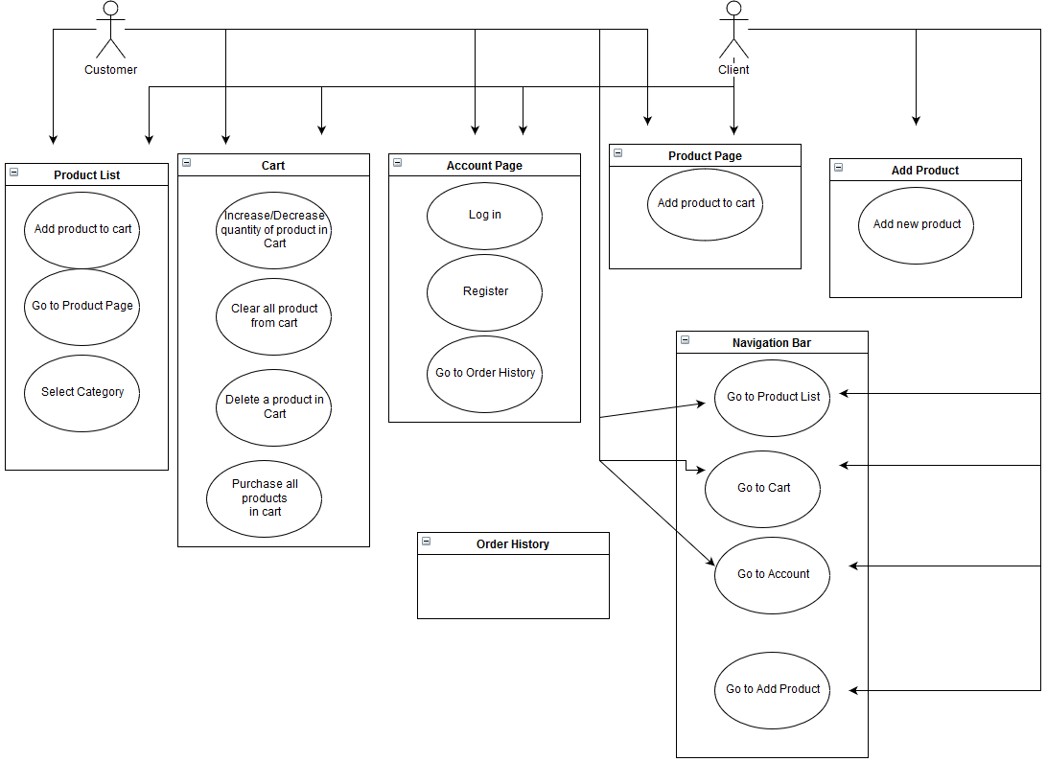

**Figure 1 - UML Use Case Diagram**

### 3.1 UML Use Case Specifications

### 3.1.1 Login

|  |  |  |  |
| --- | --- | --- | --- |
| **Use Case Name:** | Login | **Use Case ID:** | AP01 |
| **Primary Actor:** | Customer, Client | | |
| **Description:** | Users logs into their account. | | |
| **Triggering Event:** | User clicks on account page link | | |
| **Steps Performed (Main Path)** | | | |
| 1. The user is presented with a login form | | | |
| 1. The user completes and submits the form | | | |
| 1. The user is brought to the privacy agreement acceptance page. | | | |
| **Extensions or Alternate Scenarios** | | | |
| 1. The user’s credentials do not match records, error message is displayed. Return to step 1. | | | |
| 1. The form does is not submitted properly, error message displayed. Return to step 1. | | | |
| 1. The user is not already registered. An error message is displayed. | | | |
| 1. User accepts privacy agreement. Logged in and taken to home page. | | | |
| 1. User declines privacy agreement. Logged out and taken to home page. | | | |
| **Pre-Conditions:** | The computer must be connected to the system | | |
| **Post-Conditions:** | Cart is updated with user’s items | | |
| **Assumptions:** | User is not already logged in | | |
| **Success Guarantee:** | User is logged in, can read privacy agreement, can maintain their cart, view order history, and place orders | | |
| **Outstanding Issues:** | 1. Does the system track if there is already a user logged on? 2. How large is the risk of an error occurring when submitting a form? 3. How secure is the user’s data when it is submitted? | | |
| **Priority:** | High | | |

### 3.1.2 Register

|  |  |  |  |
| --- | --- | --- | --- |
| **Use Case Name:** | Register | **Use Case ID:** | AP02 |
| **Primary Actor:** | Customer, Client | | |
| **Description:** | Users creates their account. | | |
| **Triggering Event:** | User then clicks on register link. | | |
| **Steps Performed (Main Path)** | | | |
| 1. The user is presented with a form 2. The user completes and submits the form 3. The user is brought to the log-in page | | | |
| **Extensions or Alternate Scenarios** | | | |
| 2a. The user’s unique ID matches another user’s. An error message is displayed. Return to step 1.  2b. The form does is not submitted properly. An error message is displayed. Return to step 1. | | | |
| **Pre-Conditions:** | The user must be connected to the system | | |
| **Post-Conditions:** | User is registered | | |
| **Assumptions:** | User is not already logged in | | |
| **Success Guarantee:** | User is registered | | |
| **Outstanding Issues:** | 1. Does the system track if there is already a user logged on? 2. How large is the risk of an error occurring when submitting a form? 3. How secure is the user’s data when it is submitted? | | |
| **Priority:** | High | | |

### 3.1.3 Order History

|  |  |  |  |
| --- | --- | --- | --- |
| **Use Case Name:** | Go to Order History | **Use Case ID:** | AP03 |
| **Primary Actor:** | Customer, Client | | |
| **Description:** | Users views their order history | | |
| **Triggering Event:** | User clicks on account page link | | |
| **Steps Performed (Main Path)** | | | |
| 1. User clicks on order history link 2. Order history is shown in popup window | | | |
| **Extensions or Alternate Scenarios** | | | |
| 2a. If no order history exists, page displays a brief message | | | |
| **Pre-Conditions:** | User has clicked on the account page | | |
| **Post-Conditions:** | User can view their own order details | | |
| **Assumptions:** | User logged in | | |
| **Success Guarantee:** | User can view their previous orders | | |
| **Outstanding Issues:** | None | | |
| **Priority:** | Medium | | |

### 3.1.4 Adjust quantity

|  |  |  |  |
| --- | --- | --- | --- |
| **Use Case Name:** | Quantity Adjustment | **Use Case ID:** | C01 |
| **Primary Actor:** | User | | |
| **Description:** | User wants to increase or decrease the quantity of a product in the cart | | |
| **Triggering Event:** | User wants more or less in the cart | | |
| **Steps Performed (Main Path)** | | | |
| 1. User is on their cart page | | | |
| 1. User scrolls (if necessary) to the desired product | | | |
| 1. Using up arrow to increment the product quantity or down arrow to decrement the product quantity the customer will adjust to the desired amount of product | | | |
|  | | | |
| **Extensions or Alternate Scenarios** | | | |
| 3a. User attempts to decrement to a number below one the quantity counter will not decrement | | | |
| 3b. User attempts to increment to a number above the stock limit the counter will not increment | | | |
| 3c. User attempts to increment to number above shipping limit the counter will not increment | | | |
|  | | | |
| **Pre-Conditions:** | 1. User is on the cart page 2. User is logged in 3. User has a product in their cart | | |
| **Post-Conditions:** | 1. Product has a quantity value attached to it | | |
| **Assumptions:** | 1. User has items in the cart | | |
| **Success Guarantee:** | 1. Product counter has been changed to desired amount | | |
| **Outstanding Issues:** |  | | |
| **Priority:** | Medium | | |

### 3.1.5 Clear cart

|  |  |  |  |
| --- | --- | --- | --- |
| **Use Case Name:** | Clear All from Cart | **Use Case ID:** | C02 |
| **Primary Actor:** | User | | |
| **Description:** | Remove all products from cart | | |
| **Triggering Event:** | User wants to empty cart | | |
| **Steps Performed (Main Path)** | | | |
| 1.User is on cart page | | | |
| 2. User clicks empty cart button | | | |
| 3. System will empty the entire cart of customer | | | |
|  | | | |
| **Extensions or Alternate Scenarios** | | | |
| 3a. If the cart is already empty the system will do nothing | | | |
|  | | | |
| **Pre-Conditions:** | 1. Customer has an account  2. Customer is on cart page | | |
| **Post-Conditions:** | 1. Cart is empty | | |
| **Assumptions:** | 1. User has an account | | |
| **Success Guarantee:** | 1. All products removed from cart | | |
| **Outstanding Issues:** |  | | |
| **Priority:** | Low | | |

### 3.1.6 Delete product from cart

|  |  |  |  |
| --- | --- | --- | --- |
| **Use Case Name:** | Delete Product in Cart | **Use Case ID:** | C03 |
| **Primary Actor:** | User | | |
| **Description:** | Remove a product in cart | | |
| **Triggering Event:** |  | | |
| **Steps Performed (Main Path)** | | | |
| 1. User on cart page | | | |
| 2. User navigates to product they want to remove | | | |
| 3. User clicks the “red x” next to the product | | | |
| 4. System removes the product from the cart | | | |
|  | | | |
| **Extensions or Alternate Scenarios** | | | |
| 3a. If there are no products in the cart there will be no “red x” on the page | | | |
|  | | | |
| **Pre-Conditions:** | 1. User is on the cart page  2. User has products in the cart | | |
| **Post-Conditions:** | 1. Product removed from the cart | | |
| **Assumptions:** | 1.User is on the cart page | | |
| **Success Guarantee:** | 1. Product removed | | |
| **Outstanding Issues:** |  | | |
| **Priority:** | High | | |

### 3.1.7 Purchase Cart

|  |  |  |  |
| --- | --- | --- | --- |
| **Use Case Name:** | Purchase Cart | **Use Case ID:** | C04 |
| **Primary Actor:** | User | | |
| **Description:** | Purchase all products in users cart | | |
| **Triggering Event:** | Clicks buy button | | |
| **Steps Performed (Main Path)** | | | |
| 1. On cart page | | | |
| 2. User is logged in or registered | | | |
| 3. User clicks purchase all button | | | |
| 4. System processes all products in cart as sold and creates receipt in receipt file | | | |
| 5. User enters payment | | | |
| 6. System moves products to a shipment | | | |
| 7. Cart is emptied | | | |
| **Extensions or Alternate Scenarios** | | | |
| 4a. No products in cart none marked as sold | | | |
| 6a. No products in cart no shipment is processed | | | |
|  | | | |
| **Pre-Conditions:** | 1. User is registered user  2. Cart has products in it | | |
| **Post-Conditions:** | 1. Products removed from inventory 2. Remove products from cart 3. Removed products added to shipment | | |
| **Assumptions:** | 1. User payment is valid | | |
| **Success Guarantee:** | 1. Products removed from inventory 2. Products removed from cart 3. Products moved to shipment | | |
| **Outstanding Issues:** | 1. User payment invalid | | |
| **Priority:** | Critical | | |

### 3.1.8 Add product to cart from product list

|  |  |  |  |
| --- | --- | --- | --- |
| **Use Case Name:** | Add product to cart | **Use Case ID:** | **PL01** |
| **Primary Actor:** | Customer | | |
| **Description:** | A user who logged in may add one product to cart | | |
| **Triggering Event:** | Mouse click by user who is logged in | | |
| **Steps Performed (Main Path)** | | | |
| 1. The user is presented with a selection of products | | | |
| 1. At product list page, the user clicks the button to add the desired product to cart | | | |
|  | | | |
| **Extensions or Alternate Scenarios** | | | |
| 2a. If customer is not logged in, they will be redirected to a logon page upon clicking the “Add to Cart” button | | | |
|  | | | |
| **Pre-Conditions:** | User is not logged in  The system contains a number of products greater than or equal to one | | |
| **Post-Conditions:** | Customer now has the desired product in their cart | | |
| **Assumptions:** |  | | |
| **Success Guarantee:** | Customer has added the desired product to their cart | | |
| **Outstanding Issues:** | 1. If the user was redirected to the log on page, will it send them back to the product list page after they successfully log in? 2. Product of same type in cart what will happen? | | |
| **Priority:** | High | | |

### 3.1.9 Go to product page

|  |  |  |  |
| --- | --- | --- | --- |
| **Use Case Name:** | Go to product page | **Use Case ID** | **PL02** |
| **Primary Actor:** | Customer or Client | | |
| **Description:** | A user can go from product list to the product page by clicking on the relevant link | | |
| **Triggering Event:** | A mouse click, by the user | | |
| **Steps Performed (Main Path)** | | | |
| 1. The user is at the product list page | | | |
| 1. The user clicks on the link to the desired product page | | | |
| 1. The user is then at the desired product page | | | |
|  | | | |
| **Extensions or Alternate Scenarios** | | | |
|  | | | |
| **Pre-Conditions:** | The user is at the product list page | | |
| **Post-Conditions:** | The user is at the desired product page | | |
| **Assumptions:** | The system contains at least one item on the product list page | | |
| **Success Guarantee:** | The user is then at the desired product page | | |
| **Outstanding Issues:** |  | | |
| **Priority:** | High | | |

### 3.1.10 Select category

|  |  |  |  |
| --- | --- | --- | --- |
| **Use Case Name:** | Select Category | **Use Case ID** | **PL03** |
| **Primary Actor:** | Customer | | |
| **Description:** | A user can restrict the products shown in the product list by their associated category | | |
| **Triggering Event:** | A drop down menu, operated by the user | | |
| **Steps Performed (Main Path)** | | | |
| 1. The user clicks on the drop down menu | | | |
| 1. The user is presented with a selection of categories | | | |
| 1. The user then selects the chosen category they wish to restrict the products list too | | | |
|  | | | |
| **Extensions or Alternate Scenarios** | | | |
|  | | | |
| **Pre-Conditions:** | The system contains a number of products greater than or equal to one | | |
| **Post-Conditions:** | The products shown in the product list are then restricted in view to the user | | |
| **Assumptions:** | The system contains at least one category for items | | |
| **Success Guarantee:** | The system contains a number of products greater than or equal to one | | |
| **Outstanding Issues:** |  | | |
| **Priority:** | Medium | | |

### 3.1.10 Add product to cart from product page

|  |  |  |  |
| --- | --- | --- | --- |
| **Use Case Name:** | Add product to cart | **Use Case ID:** | **PP01** |
| **Primary Actor:** | Customer | | |
| **Description:** | A user who logged in may add one product to cart | | |
| **Triggering Event:** | Mouse click by user who is logged in | | |
| **Steps Performed (Main Path)** | | | |
| 1. The user is at the product page | | | |
| 1. The user clicks the button to add the desired product to cart | | | |
|  | | | |
| **Extensions or Alternate Scenarios** | | | |
| 2a. If customer is not logged in, they will be redirected to a logon page upon clicking the “Add to Cart” button | | | |
|  | | | |
| **Pre-Conditions:** | User is not logged in  The user is at the desired product page | | |
| **Post-Conditions:** | Customer now has the desired product in their cart | | |
| **Assumptions:** |  | | |
| **Success Guarantee:** | Customer has added the desired product to their cart | | |
| **Outstanding Issues:** | 1. If the user was redirected to the log on page, will it send them back to the product list page after they successfully log in? 2. What if the same product is already in the cart? | | |
| **Priority:** | High | | |

### 3.1.11 Add product page

|  |  |  |  |
| --- | --- | --- | --- |
| **Use Case Name:** | Add Product | **Use Case ID:** | **AP01** |
| **Primary Actor:** | Client | | |
| **Description:** | A Client who is logged in may add a product to the catalog | | |
| **Triggering Event:** | A form is filled out with product information and submitted | | |
| **Steps Performed (Main Path)** | | | |
| 1. The Client navigates to the “Add Product” page | | | |
| 2. The Client fills out the form with the appropriate information with the product | | | |
| 3. The Client clicks the “Submit” button to confirm changes in the system | | | |
|  | | | |
| **Extensions or Alternate Scenarios** | | | |
| 1a. If the Client is not logged in they will not be able to view the page and will be redirected to the main page of the site | | | |
|  | | | |
| **Pre-Conditions:** | Client is logged into an administrator account  The user has navigated to the “Add Product” page | | |
| **Post-Conditions:** | Customer now has the desired product in their cart | | |
| **Assumptions:** |  | | |
| **Success Guarantee:** | The new product will be added to the catalog and will be visible to customers | | |
| **Outstanding Issues:** | What will happen if a product already exist in the database?  What happens if a product with same name but different attributes is in the database? | | |
| **Priority:** | High | | |

### 3.1.12 Go to product list

|  |  |  |  |
| --- | --- | --- | --- |
| **Use Case Name:** | Go to product list | **Use Case ID:** | **NB01** |
| **Primary Actor:** | User | | |
| **Description:** | Anyone on the site can use the navigation bar to go to the product list page | | |
| **Triggering Event:** | A user clicks on the products list link on the navigation bar | | |
| **Steps Performed (Main Path)** | | | |
| The user is on any page on the site | | | |
| The user clicks on the product list button on the navigation bar | | | |
| **Extensions or Alternate Scenarios** | | | |
|  | | | |
| **Pre-Conditions:** | The user is on the website | | |
| **Post-Conditions:** | The user is now on the product list page | | |
| **Assumptions:** |  | | |
| **Success Guarantee:** | The user is now on the product list page | | |
| **Outstanding Issues:** |  | | |
| **Priority:** | High | | |

### 3.1.13 Go to cart

|  |  |  |  |
| --- | --- | --- | --- |
| **Use Case Name:** | Go to cart | **Use Case ID:** | **NB02** |
| **Primary Actor:** | User | | |
| **Description:** | Anyone on the site can use the navigation bar to go to the cart page | | |
| **Triggering Event:** | A user clicks on the “My Cart” link on the navigation bar | | |
| **Steps Performed (Main Path)** | | | |
| 1. The user is on any page on the site | | | |
| 1. The user clicks on the “My Cart” button on the navigation bar | | | |
|  | | | |
| **Extensions or Alternate Scenarios** | | | |
|  | | | |
| **Pre-Conditions:** | The user is on the website | | |
| **Post-Conditions:** | The user is now on the cart page | | |
| **Assumptions:** |  | | |
| **Success Guarantee:** | The user is now on the cart page | | |
| **Outstanding Issues:** |  | | |
| **Priority:** | High | | |

### 3.1.14 Go to account

|  |  |  |  |
| --- | --- | --- | --- |
| **Use Case Name:** | Go to account | **Use Case ID:** | **NB03** |
| **Primary Actor:** | User | | |
| **Description:** | A user who is logged in may go to their account page | | |
| **Triggering Event:** | A user clicks on the “My account” link on the navigation bar | | |
| **Steps Performed (Main Path)** | | | |
| 1. The user is on any page on the site | | | |
| 2. The user clicks on the “My account” button on the navigation bar | | | |
|  | | | |
| **Extensions or Alternate Scenarios** | | | |
|  | | | |
| **Pre-Conditions:** | The user is on the website and logged in | | |
| **Post-Conditions:** | The user is now on their account page | | |
| **Assumptions:** |  | | |
| **Success Guarantee:** | The user is now on their account page | | |
| **Outstanding Issues:** |  | | |
| **Priority:** | High | | |

### 3.1.15 Go to add product page

|  |  |  |  |
| --- | --- | --- | --- |
| **Use Case Name:** | Go to add product page | **Use Case ID:** | **NB04** |
| **Primary Actor:** | Client | | |
| **Description:** | A client who is logged in with an administrative account may go to the add product page | | |
| **Triggering Event:** | A client clicks on the “Add Product” link on the navigation bar | | |
| **Steps Performed (Main Path)** | | | |
| 1. The client is on any page on the site | | | |
| 2. The client clicks on the ““Add Product” button on the navigation bar | | | |
|  | | | |
| **Extensions or Alternate Scenarios** | | | |
| 1a. If the user is logged in without an administrative account, the “Add Product” button will not show on the navigation bar | | | |
|  | | | |
| **Pre-Conditions:** | The user is on the website and logged in to an administrative account | | |
| **Post-Conditions:** | The user is now on the “Add Product” page | | |
| **Assumptions:** |  | | |
| **Success Guarantee:** | The user is now on the “Add Product” page | | |
| **Outstanding Issues:** |  | | |
| **Priority:** | High | | |

## Non-Functional Requirements

* + R03 - Customers must register to place orders.
  + R09 - Website functionality will have the cart accessible regardless from any machine the customer is logging in.
  + R10 - create a file containing the order confirmation that at a future date can be mailed to the client as an email message
  + R11 - Website will include a secure, online payment process.
  + R13 - Provide an intuitive, consistent look and feel to the user interface of the website.
  + R14 - Use free open source software.
  + R15 - At least all in-scope requirements fully implemented and deployed in 8 weeks.

## Data Model

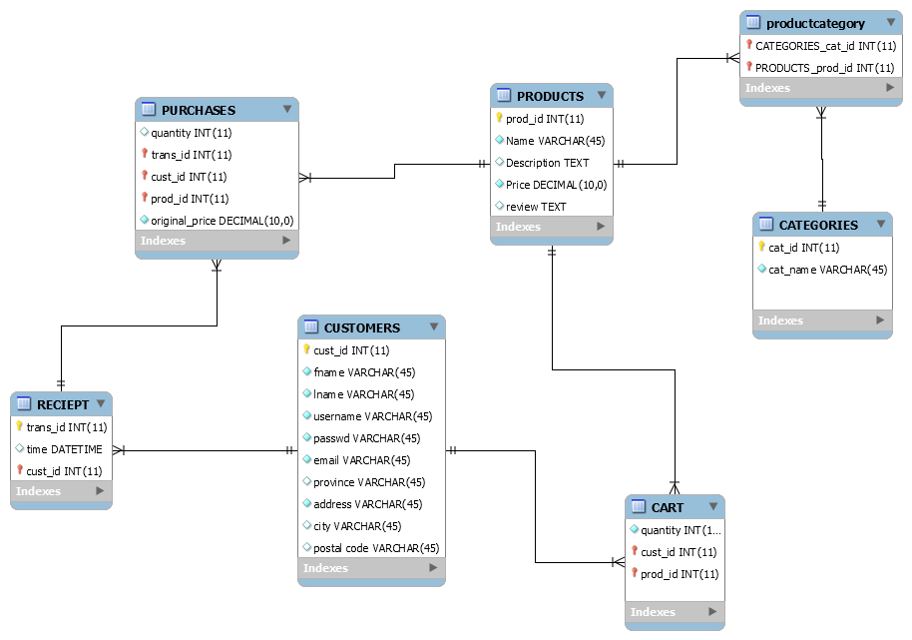

**Figure 2 - Data Model Diagram**

## UI Screen Mock-ups

### 6.1 Product page

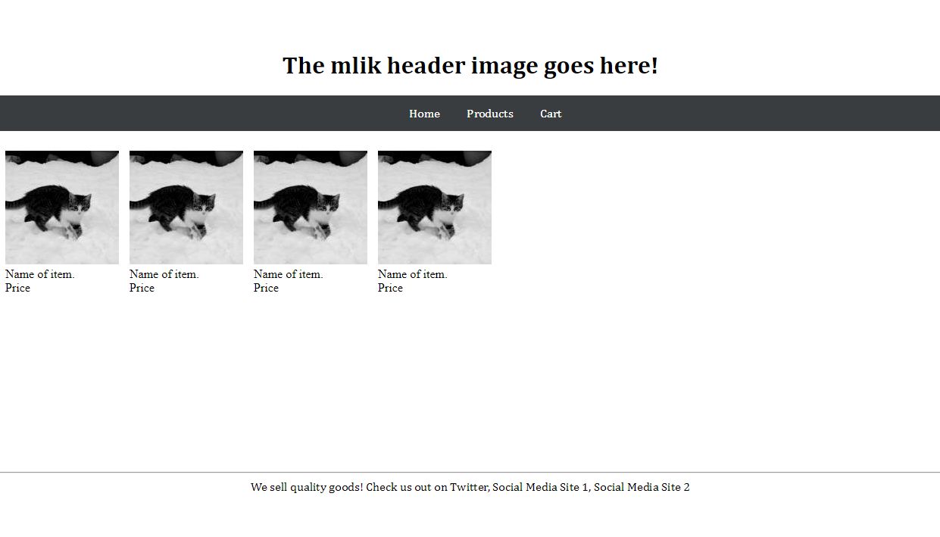

**Figure 3 - Products CSS**

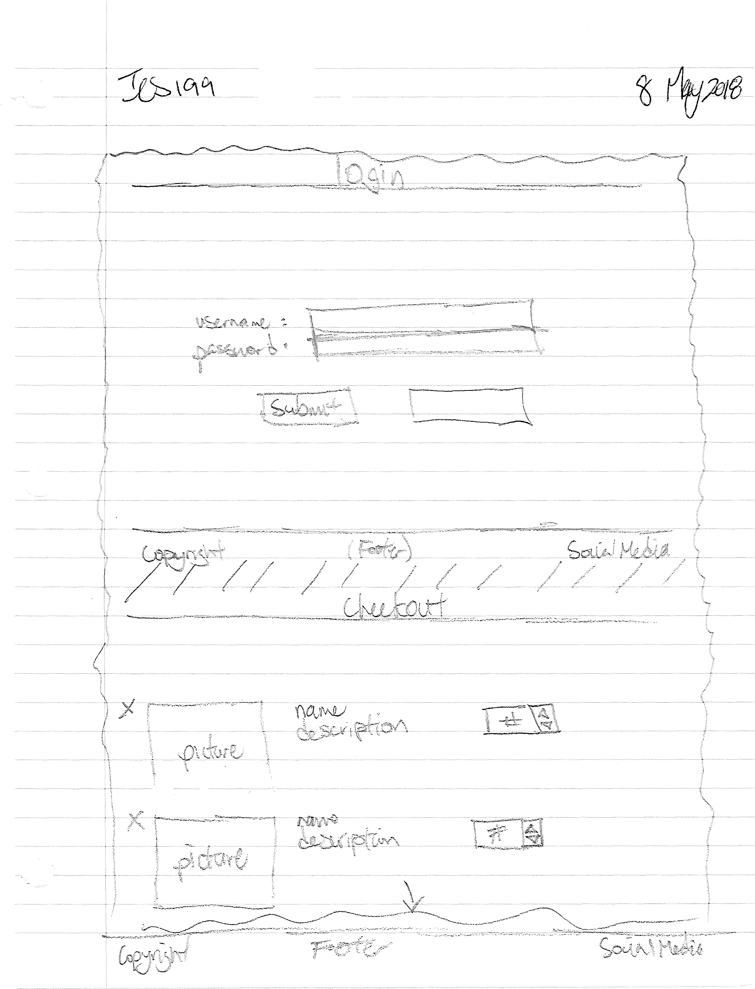

**Figure 4 - Login Page and Checkout Screen**

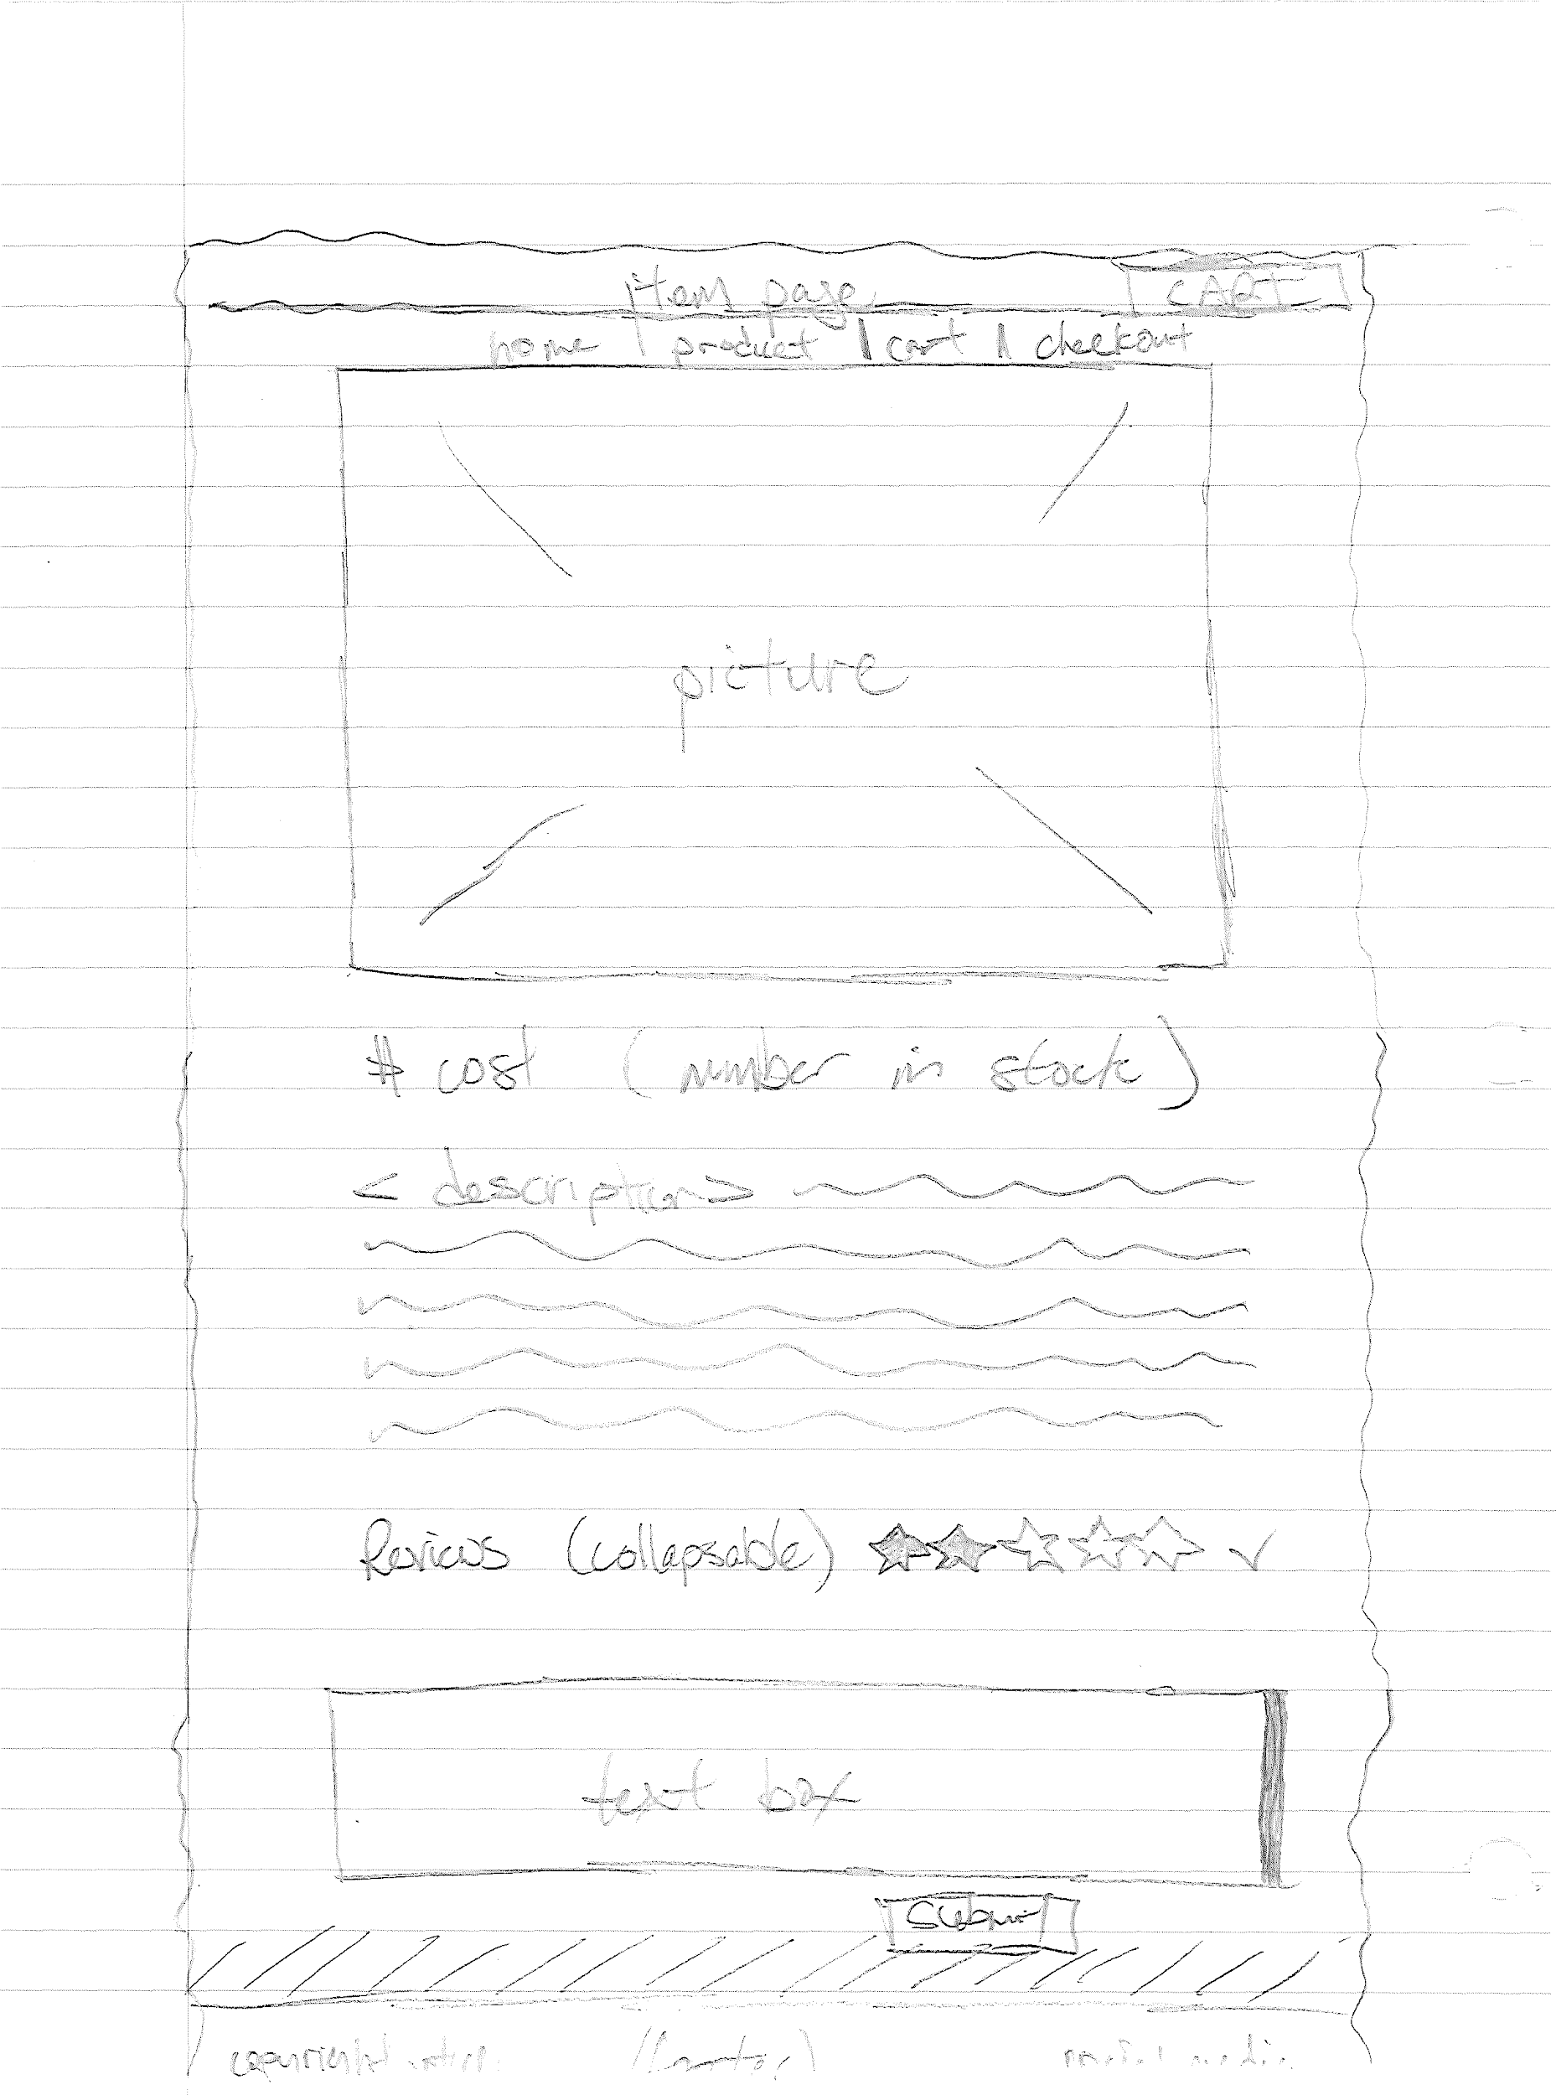

**Figure 5 - Product Page**

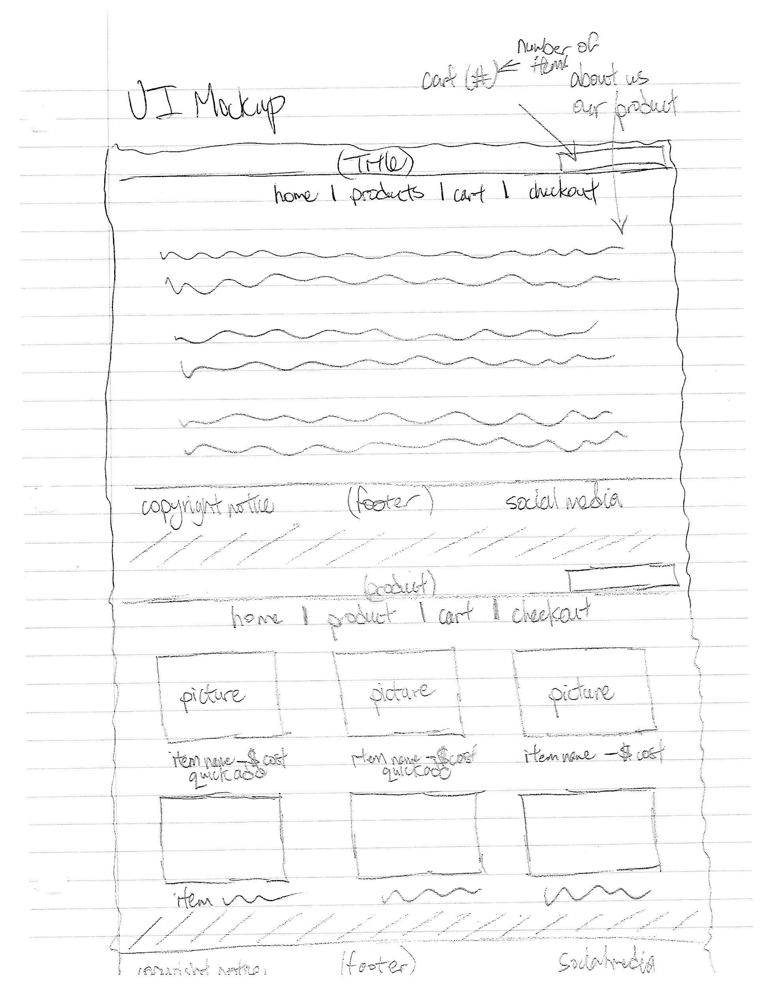

**Figure 6 - Main Page and Products List**

# Change Log

* Changed R10 as requested by client.
* Added new requirement R16 as requested by client.