**Business Requirement for MLIK: Lactate goods and services**

**Contents**

1. System Overview 2

2. Requirements Scope 2

2.1 In Scope 2

2.2 Out of Scope 2

3. Functional Requirements 2

3.1 UML Use Case Diagram 2

3.1 UML Use Case Specifications 3

4. Non-Functional Requirements 5

5. Data Model 5

6. UI Screen Mockups 6

**Table of Figures**

Figure 1 - UML Use Case Diagram 3

Figure 2 - Data Model Diagram 4

Figure 3 - Cart 5

Figure 4 - Login Screen 5

## System Overview

This system will provide an interface for clients of MLIK to access our database of products and services. The system will be accessible using a web browser to connect to our server. The users will be able to log in with their account and purchase products.

## Requirements Scope

This section shows what business functionality is in-scope and out-of-scope for implementation.

### 2.1 In Scope

* R01 - The client must be able to add products to the web site
* R02 - Must be able to display products by categories
* R03 - Customers must register to place orders
* Must provide a fully functioning shopping cart utility where a customer can:
  + R04 - display the current items in the cart
  + R05 - add selected products to the cart
  + R06 - delete products (individually or all) from their cart
  + R07 - adjust the quantity of a selected product currently in the cart
  + R08 - preserve the contents of the cart if the user’s session is disconnected
  + R09 - have the cart accessible regardless from any machine the customer is logging in
  + R10 - provide a confirmation email sent to the client after they place their order
  + R11 - include a secure, online payment process
* R12 - Allow customers to view their order history
* R13 - Provide an intuitive, consistent look and feel to the user interface
* R14 - Use free open source software
* R15 - Have the system fully tested and up and running in 8 weeks

### 2.2 Out of Scope

* R16 - Must provide a search facility for the products
* R17 - Allow the order to be shipped to a different address and person other than the user
* R18 - Allow customers to change their order after they have created it
* R19 - Allow customers to view the status of their orders
* R20 - Allow customers to provide reviews for any of the products they have purchased
* R21 - Must be able to display the evaluation reviews for any products
* R22 - Allow customers to change their registration information
* R23 - Provide customers with appropriate product recommendations when they log in
* R24 - Provide customers with any product recommendations when they look at a particular product

## Functional Requirements

* R01 - The client must be able to add products to the web site
* R02 - Must be able to display products by categories
* R04 - display the current items in the cart
* R05 - add selected products to the cart
* R06 - delete products (individually or all) from their cart
* R07 - adjust the quantity of a selected product currently in the cart
* R12 - Allow customers to view their order history
* R13 - Provide an intuitive, consistent look and feel to the user interface

### 3.1 UML Use Case Diagram

*< Insert your UML Use Case Diagram here. This diagram is a representation of the user’s interaction with the system that shows the relationship between the user and the different use cases in which the user is involved.*

*For Example:*

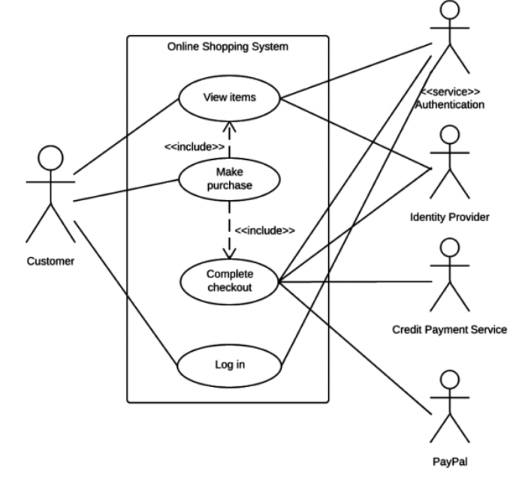

**Figure 1 - UML Use Case Diagram**

### 3.1 UML Use Case Specifications

*< Complete the following use case specifications for each of the use case from your use case diagram.*

|  |  |
| --- | --- |
| *Use Case Name* | *The name of your use case, keep it short and sweet* |
| *Use Case Id* | *ID to represent your use case* |
| *Primary Actor* | *Who is the main actor that this use case represents* |
| *Description* | *Provide a descriptive text on what the user case does in paragraph form.* |
| *Trigger Event* | *What event triggers this use case* |
| *Steps Performed*  *(Main Path)* | *List all the steps that the use case will perform.*  *This flow should be the events of the use case when everything is perfect; there are no errors, no exceptions. This is the "happy day scenario". The exceptions will be handled in the "Alternate Flows" section.* |
| *Pre-condition* | *What conditions must be met before this use case can start* |
| *Post-conditions* | *What conditions occur once the use case has completed.* |
| *Assumptions* | *What assumptions have been made about the use case?* |
| *Alternate Flows* | *The most significant alternatives work flow for the steps performed in the use case.* |
| *Success Guarantee* | *What occurs if the use case is successful?* |
| *Outstanding Issues* | *What outstanding issues are there that need to be addressed in the use case? i.e. missing requirements on certain details.* |
| *Priority* | *What is the priority of the use case, Low, Medium or High.* |

*>*

*3.1.1 <Use Case Name>*

|  |  |  |  |
| --- | --- | --- | --- |
| **Use Case Name:** |  | **Use Case ID:** |  |
| **Primary Actor:** |  | | |
| **Description:** |  | | |
| **Triggering Event:** |  | | |
| **Steps Performed (Main Path)** | | | |
|  | | | |
|  | | | |
|  | | | |
|  | | | |
|  | | | |
| **Extensions or Alternate Scenarios** | | | |
|  | | | |
|  | | | |
|  | | | |
|  | | | |
| **Pre-Conditions:** |  | | |
| **Post-Conditions:** |  | | |
| **Assumptions:** |  | | |
| **Success Guarantee:** |  | | |
| **Outstanding Issues:** |  | | |
| **Priority:** |  | | |

## Non-Functional Requirements

* R03 - Customers must register to place orders
* R09 - have the cart accessible regardless from any machine the customer is logging in
* R10 - provide a confirmation email sent to the client after they place their order
* R11 - include a secure, online payment process
* R14 - Use free open source software
* R15 - Have the system fully tested and up and running in 8 weeks

## Data Model

*<Include your Entity Relation diagram that you create in MySQL Workbench here.*

*For Example:*

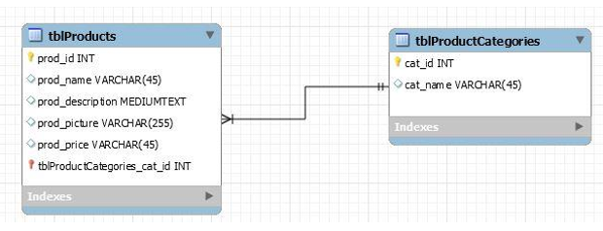

**Figure 2 - Data Model Diagram**

*>*

## UI Screen Mockups

*<Include your any screen mock-ups here for the web site, indicate which use case they are for*

*For Example*

*6.1 The following screen is for UC001 and shows the current contents of the shopping cart.*

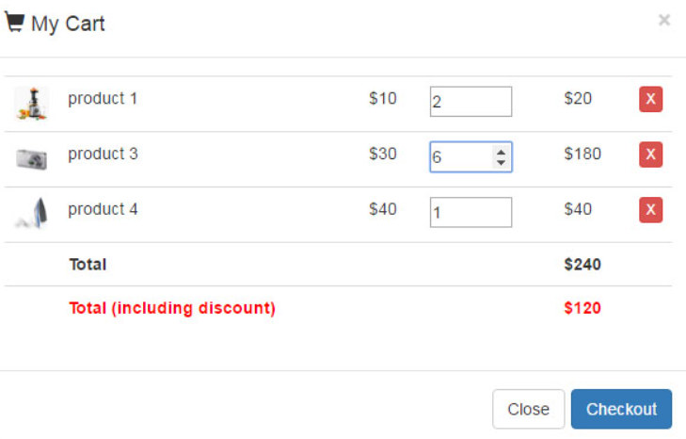

**Figure 3 - Cart**

*6.2 The following screen is the for use case UC002 and shows the login screen.*

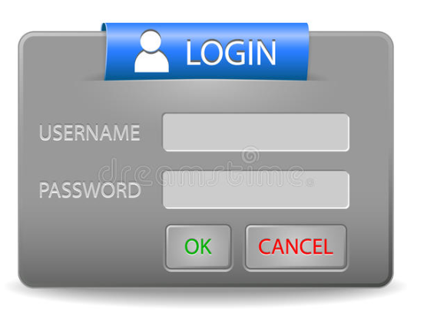

**Figure 4 - Login Screen**