A common rhetorical device in popular financial media is to compare the market capitalization of companies to the Gross Domestic Product (GDP) of countries and suggest that today’s largest companies are now “bigger” than most countries. The comparison is eye-catching: if a company such as Apple or Nvidia has a market value larger than the annual GDP of many nations, it sounds as if the company has somehow become larger than those countries themselves. This can quickly lead a reader to imagine dystopian states of techno-feudalism, or economies made up of mega-monopoly conglomerates with private armies and independently administered land holdings where international law does not apply.

But reality is much less compelling. Market capitalization and GDP are both expressed in dollars, but they are not equivalent measures. Market capitalization, or market cap, is the market’s current estimate of the value of a company’s equity. It is measured at a point in time and can be roughly calculated as share price multiplied by the current number of shares outstanding. By contrast, GDP measures the value of goods and services produced by a country over one year. In essence, market cap is closer to a price tag for a good, while GDP is closer to the annual dollar value of sales of that good.

This mismatch between a point-in-time value and a rate of accumulation makes the direct comparison logically flawed. Saying that Apple’s market capitalization is larger than the GDP of most major economies is like saying, “My investment portfolio is worth more than my annual salary.” The statement may be numerically true, but it does not mean the portfolio is “larger” than personal income in any meaningful economic sense. It compares a stock of value at one point in time with a flow of income over a period of time.

A more useful comparison would match like with like: either a static value compared to a static value, or a rate compared to a rate. Some examples of useful comparisons would be:
Type of Measure | Company Measure | Country Measure
Value | Market Capitalization | National Wealth
Value | Enterprise Value | National Wealth + National Debt
Annual Rate | Revenue | Gross Output
Annual Rate | Value Added | GDP
Annual Rate | Earnings | Corporate profits component of GDP

The problem with each of these comparisons is that one side of the comparison is difficult to source. Market cap and enterprise value can be calculated easily for public companies that report on a quarterly basis, whereas national wealth is not a regularly reported measure and is subject to many assumptions and unreliable survey results across many international jurisdictions. Similar issues can be raised for the rest of the comparisons listed, which leaves us at an interesting crossroads. Is there actually something useful being communicated by comparing market cap and GDP? After all, both measures are readily available from reliable sources, which cannot be said for many of the more direct methods of comparison.

The answer is yes. The headlines do communicate something real: investors are assigning a present value to future company earnings, reflected in market cap, that is in line with the annual economic productivity, or GDP, of some of the largest nations. Even with this charitable framing, the comparison still falls flat. Taking market cap as a present value measure of all future company earnings and comparing it to the economic value created in a country in a single year leaves a big question: what if we found the present value of GDP and compared market cap to that figure?
Although this method would also be subject to assumptions, we can lean on the work of Professor Aswath Damodaran from the Stern School of Business at NYU to address the largest issue: estimating the country risk premium. For those interested, the details of the calculation can be found below the table showing the results.

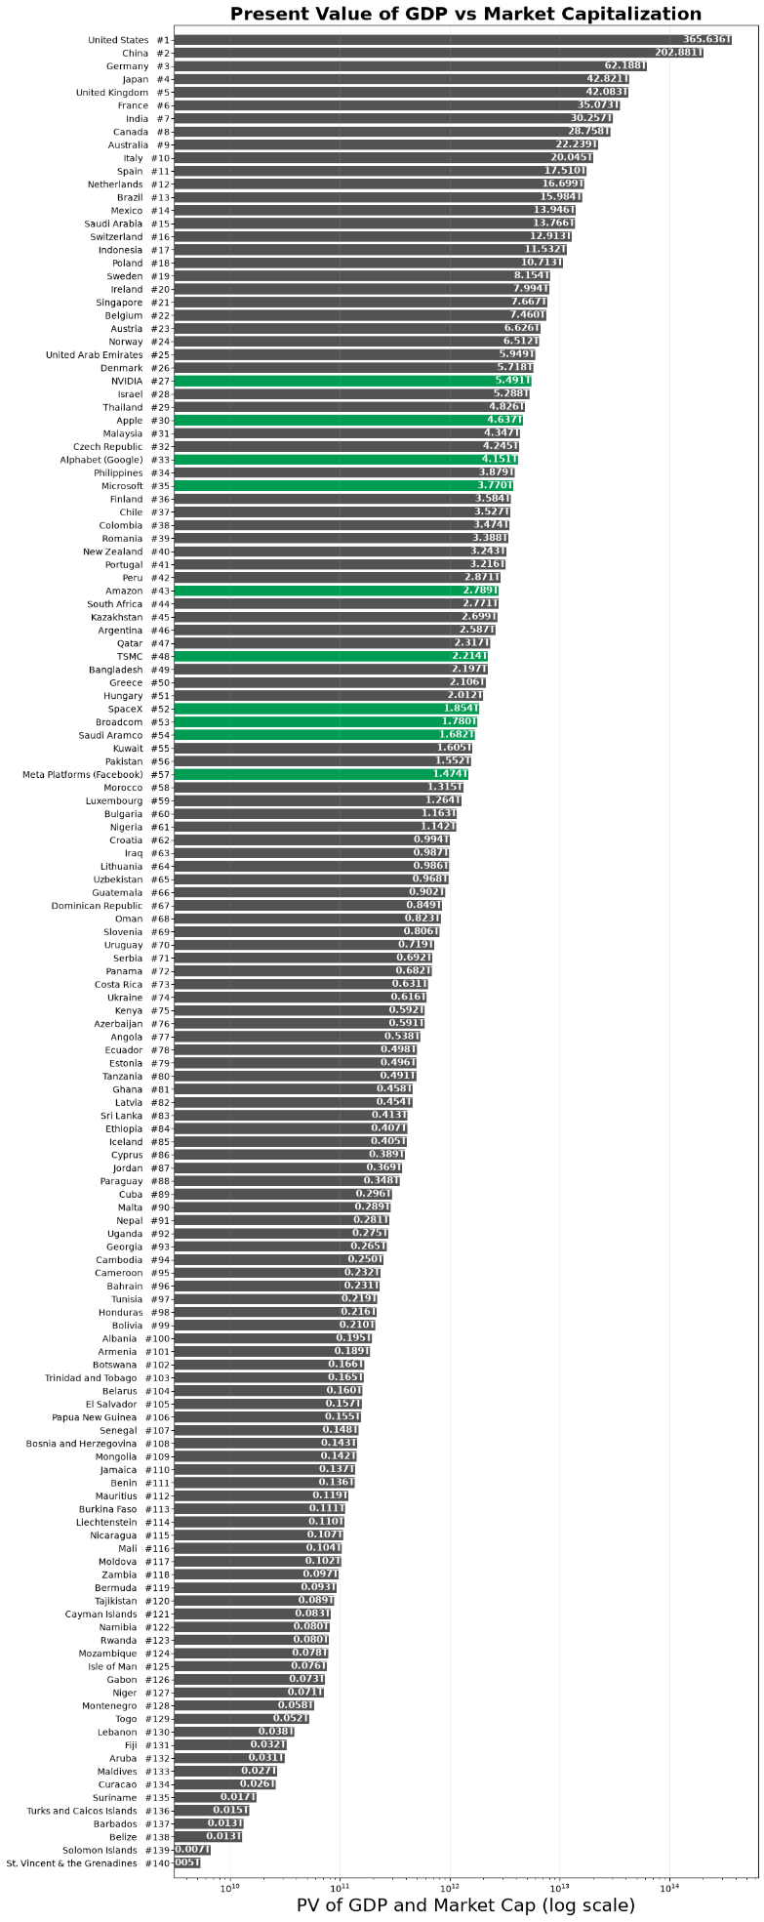
The results are revealing. None of the largest companies crack the top ten economies once we compare market cap to the present value of GDP, but they still rank surprisingly high against some of the world’s most important nations. I will leave the political interpretation of “important” to the reader. The technical takeaway is more straightforward: for Nvidia, currently the largest company by market cap, to enter the top ten it would need to overtake Italy at roughly $20 trillion. That would require almost a 400% increase from its current value. To reach the number three spot ahead of Germany’s roughly $62 trillion present value of GDP, as one article suggests it already has, Nvidia would need to rise by more than 1,100%! The point is not that this is impossible, but that the headline version neglects to mention the true scale of the comparison. These companies are enormous, but when measured against countries on more comparable terms, the world’s largest economies are still very much in the lead.

Details of the Calculation:
The comparison table was built in a series of steps, starting with country-level risk-premium data and then supplementing it with macroeconomic and market-capitalization inputs.

First, the country list in the original country-risk-premium dataset from Professor Damodaran was matched to World Bank country names. Because the labels in the risk-premium file do not always align exactly with World Bank naming conventions, a translation layer was created to map the country names used in the analysis to the corresponding World Bank country codes. Unfortunately the mapping was not 1:1 due to differences in the some naming convention so some of the countries were dropped from the original list. Once this translation table was established, it was used to pull annual GDP data for each country from the World Bank’s World Development Indicators database, specifically the indicator for gross domestic product in current US dollars.

For each country, the most recent GDP level was taken as the starting point and then the expected annual GDP growth rate was estimated using a trailing compound annual growth rate over the prior 10-year period. In formula terms, the calculation is:
$$g={\left(\frac{GDP_{t}}{GDP_{t-10}}\right)}^{1/10}-1$$

where $GDP_{t}$ is the country’s most recent GDP figure and $GDP_{t-10}$ is the GDP level 10 years earlier. This is a simple forecasting assumption designed to proxy the long-run growth rate of the economy rather than to estimate a more complex macroeconomic model. Countries with incomplete or missing GDP histories were excluded from the growth-rate calculation, and the resulting growth estimate was then joined back to the original country-risk-premium dataset.

The next step was to calculate the present value of GDP. The logic follows a simplified perpetuity-style valuation: the future GDP level is estimated by applying the expected growth rate to the current GDP level, and this is then discounted by the implied cost of equity. In the model, the cost of equity is approximated as:

$$r=r_{f}+ERP+CRP+g$$

where $r_{f}$ is the risk-free rate, $ERP$ is the equity risk premium, $CRP$ is the country risk premium, and $g$ is the expected GDP growth rate. The present value of GDP was then computed as:

$$PV_{GDP}=\frac{GDP_{1}}{r-g}$$

where $GDP_{1}$ is the projected next-period GDP level. This is a stylized valuation framework, not a full valuation model, and it is intended to translate each country’s economic scale into a comparable, single-number measure for ranking purposes.

The company side of the table was built using market-capitalization data from CompaniesMarketCap.com. The list was filtered to active public companies and ranked by market capitalization, with the values expressed in USD. These company market-cap values were then combined with the country-level present-value-of-GDP values in a single comparison.

Sources used
- Country risk premium dataset: https://pages.stern.nyu.edu/~adamodar//New_Home_Page/home.htm
- World Bank country metadata: World Bank API, country metadata endpoint (https://api.worldbank.org/v2/country/all?format=json)
- GDP series: World Bank World Development Indicators, indicator NY.GDP.MKTP.CD
- Company market-cap data: https://companiesmarketcap.com/ website, via HTML table extraction
- Risk-free rate assumption: set internally in the model at 4.25% for the analysis period

This appendix is intended to document the mechanics of the calculation, not to imply that the resulting values are intended as precise estimates of intrinsic value. They are best understood as a structured comparison based on consistent assumptions and a transparent data pipeline.

