With the listing of SpaceX and the growth of data centers and industrial output climbing some discussion of the

Shortages of available elements and minerals for industrial production
SpaceX and the commercialization of extra terrestrial bodies
fabs on the moon
data centers in orbit
mining asteroids for materials
what will be the constraints to production at those scales
Oddo-Harkins rule, elements with odd atomic numbers are less plentiful then elements with even atomic numbers
Could lead to supply constraints and increased costs as humanity moves industry off world

Nuclear Physics and Commodity Pricing

SpaceX has been pushing the limits of what is possible in space transportation for some time now. Some readers may know that before I started working in financial services I spent several years as a launch operations engineer in Cape Canaveral. I was working on the Delta IV rocket for United Launch Alliance and had a front row seat to SpaceX’s growth. Since leaving the industry in 2020 they have continued to move at an incredible pace. Now they have become publicly listed and are making big moves with their new Louisiana purchase. SpaceX has also hit a significant milestone in their Starlink constellation. Just recently they launched the final planned delivery of Starlink satellites on a Falcon 9 rocket from Cape Canaveral. Deliveries will continue from Vandenberg Space Force Base in California. But no additional Starlink satellites will be added to equatorial orbits until the new Starship rocket begins deliveries sometime next year. This is significant for two reasons. One is that it indicates that the Starlink constellation is mature enough to not require constant resupply. Two is that it indicates that the Starship vehicle is close to being flight ready. Up to this point Starship has only done suborbital test flights.

This could be a whole separate post about my time at ULA and what I learned there…

Today, metal prices reflect a complicated mixture of geology, extraction costs, refining capacity, transportation, industrial demand, substitution, recycling, and geopolitics. But imagine an economy, several centuries from now, in which mining and manufacturing are no longer confined to Earth. Would there be any additional factors to consider when pricing these commodities? Spoiler: I expect there will be.

The factor that I am alluding to is nuclear physics, specifically something called the Oddo-Harkins rule. Named after 19th century physicists Guisseppe Oddo and William Draper Harkins the rule states that the relative abundance of elements with an even atomic number will be higher than the relative abundance of immediately adjacent elements with an odd atomic number. This may sound arcane and unimportant, but consider that Aluminum, Copper, Silver, and Gold all have odd atomic numbers.
Although you are probably here for the economic argument, the scientific explanation for the rule is quite interesting. Basically, elements are formed in stars through nuclear fusion. Extreme heat a pressure in stars cause lower atomic number elements to fuse together with their neighbors to form higher atomic number elements. The lowest atomic number element by Hydrogen with an atomic number of 1 (it is made of one proton and one neutron). Two Hydrogen atoms fuse to make a Helium (atomic number 2), and helium atoms fuse in stable configurations until Iron is made (atomic number 26). [continue to describe the mechanism by which heavier elements are made, and why the oddo harkins rule is apparent].

This can be visualized by plotting the abundance of each element against its atomic number. In the chart below this has been done with even number elements in navy and odd number elements in gray to make the pattern more apparent.

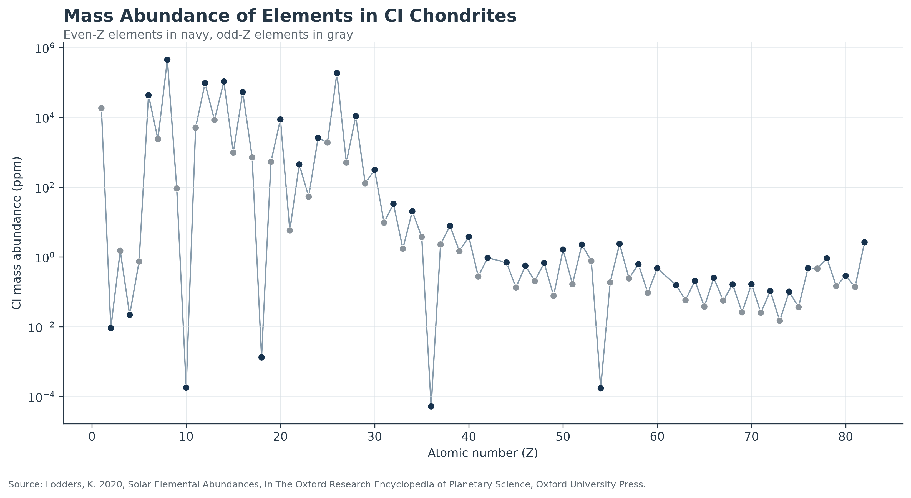

As you can see it is a rule, not a law. Not every element follows the rule, for example Bismuth is very low [give reason].

It is important to note where the data comes from and what exactly it is measuring. Basically this data is a proxy for the distribution of elements in the solar system, it does not account for local variation and heterogeneity. If the Earth was composed exactly in this way we would never find any ore deposits, so we know the solar system is not composed this way but it is a convenient measurement tool and this survey of CI Chondrites is the closest we can get right now to a complete survey of the solar system.

Now for the economics. Does the pattern correspond to current commodity prices? No, the pattern does not. The pattern that roughly emerges is that the heavier elements tend to be more expensive. As we move into the stars this may be something to watch, prices may converge to the relative abundance of elements but of course this only accounts for the supply side of the equation.

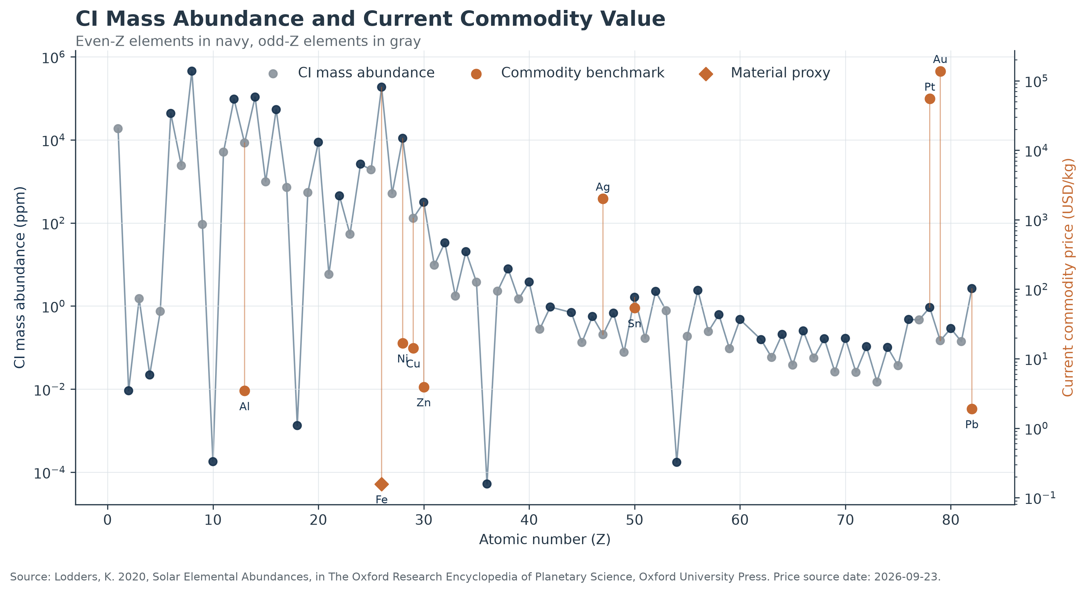

Molded draft
The Economics of the Periodic Table
Today, metal prices reflect a complicated mixture of geology, extraction costs, refining capacity, transportation, industrial demand, substitution, recycling, and geopolitics. But imagine an economy several centuries from now in which mining and manufacturing are no longer confined to Earth. Would there be additional factors to consider when pricing these commodities?

One of those factors may come from an unexpected place: nuclear physics. More specifically, something called the Oddo-Harkins rule. Named for Giuseppe Oddo and William Draper Harkins, who independently described the pattern in the early 20th century, the Oddo-Harkins rule observes that elements with even atomic numbers tend to be more abundant than the elements with odd atomic numbers immediately adjacent to them. [en.wikipedia.org]
That may sound arcane and economically unimportant. But consider that Aluminum, Copper, Silver, and Gold all have odd atomic numbers.

Before describing the eventual economic impact of the rule, we should understand why the pattern exists in the first place.

An element's atomic number is simply the number of protons in its nucleus. Hydrogen has one proton and therefore atomic number 1. Helium has two protons and is atomic number 2, and so on. However, the atomic number is not just a record of how many protons are in an atom’s nucleus, they also give a hint to how that element was formed.

Under the immense temperatures and pressures inside stars, nuclear fusion reactions combine nuclei of separate elements into heavier elements. One particularly important version of this reaction is the “alpha process”. This is where an alpha particle (an atom of Helium-4, which contains 2 protons and 2 neutrons) fuses with a neighboring atom. When an alpha particle is incorporated into a nucleus of the other atom, the atomic number rises by two. That naturally creates a pathway favoring even-numbered elements:

$$C\left(6\right)→O\left(8\right)→Ne\left(10\right)→Mg\left(12\right)→Si\left(14\right)→…$$
Atomic nucleus configurations with paired protons and neutrons tend to be more stable than unpaired configurations. That nuclear stability contributes further to the greater abundance of many even-numbered elements. [sciencenotes.org] This process helps explain the Oddo-Harkins pattern for elements from Carbon through Iron. [en.wikipedia.org] Past Iron the fusion reaction consumes energy rather than producing it so elements heavier than iron are not made inside of stars, rather through processes such as neutron star collisions and supernovae.

Put more simply: the universe did not manufacture every element with equal ease. Some elements are fundamentally more common than others in part because of the nuclear processes that created them. Before geology creates scarcity, nuclear physics creates scarcity.

We can see this by plotting elemental abundance against atomic number.
[INSERT FIGURE: Mass Abundance of Elements in CI Chondrites]

In the chart above, even-numbered elements are shown in navy and odd-numbered elements in gray. The vertical axis is logarithmic, meaning each major step represents a tenfold or hundredfold change rather than a simple linear increase. The data is derived from observations of the atomic composition of CI Chondrites meteorites. These meteorites are used as a proxy for the composition of the solar system as a whole because they are very old, older than the solar system, so by taking many measurements of their compositions we can understand the composition of the building blocks of every planet, moon, and asteroid in our solar system. Arguably this is the only solar system we will have access to for physical resources so it stands to reason that we should be more concerned with the local availability of resources than, say, the availability of resources on a universal scale.

Today's commodity markets obviously don't price metals according to the availability of extraterrestrial materials. They price materials available on Earth, under today's supply chains, technologies, and patterns of demand. But it is interesting to put the two datasets together anyway and consider how, as we expand into the solar system this relative abundance measure may act as a supply constraint and influence the relative value of these commodities.
[INSERT FIGURE: CI Mass Abundance and Current Commodity Value]
The gray and navy series represents CI mass abundance. The orange observations represent current commodity prices for elements where a reasonably comparable market price can be established. Today's commodity-price structure does not resemble the Oddo-Harkins pattern.

Iron can be cosmically abundant and inexpensive because enormous quantities are accessible, production infrastructure is mature and supply is enormous. Gold and platinum occupy completely different economic positions. Copper, aluminum, silver and nickel each have their own geology, extraction technology and industrial demand.
The chart is therefore comparing two different concepts:
$$\text{Fundamental elemental abundance}$$
with
$$\text{Present-day economic scarcity}$$
Today, the second is determined overwhelmingly on Earth.
But what happens if that constraint eventually changes?
Changing the size of the sandbox
Imagine that, centuries from now, transportation and extraction technologies have advanced enough that raw materials can be economically recovered from numerous asteroids, moons or other solid bodies.
Earth's geology would no longer represent the entirety of humanity's accessible resource base.
At that point, perhaps the underlying abundance of the elements becomes more economically important.
I'm not suggesting commodity prices would simply converge to some mathematical function of CI-chondrite abundance. Supply is only one side of a market, and abundance isn't even sufficient to describe supply.
An element can be common overall but economically useless if it is dispersed across huge volumes of material, difficult to separate, or located somewhere prohibitively expensive to reach. A much rarer element could be easier to access if physical processes have concentrated it into rich deposits.
So:
$$\text{Elemental Abundance}≠\text{Economically Accessible Supply}$$
A more complete model would eventually have to consider:
$$\text{Economic Scarcity}=f\left(\text{abundance} , \text{concentration} , \text{location} , \text{extraction} , \text{energy} , \text{transport} , \text{demand} , \text{substitution} , \text{recycling}\right)$$
For now, I want to start with only the first variable.
What did nature give us?
That turns the charts above into a baseline rather than a conclusion.
Today's commodity prices mostly tell us about scarcity within the peculiar geology, technology and economy of one planet. If humanity's economic frontier eventually expands throughout the solar system, perhaps some of those relationships begin to change.
And if they do, we may discover something rather interesting:
the supply side of tomorrow's commodity markets began billions of years before there were markets at all, inside the stars that manufactured the elements.

Today, metal prices reflect a complicated mix of factors ranging from geology and extraction costs to industrial demand and geopolitics. But imagine an economy several centuries from now in which mining and manufacturing are no longer confined to Earth. One would imagine that having access to the solar system would ensure a functionally unlimited supply of raw material. Unfortunately, that may not be the case.

Similar to how Earth's geology makes some raw materials more abundant than others, nature produced some elements in greater quantities than others. The elements around us were produced through several processes of nucleosynthesis, beginning with the Big Bang and continuing in stars and violent stellar events. These processes did not produce an even distribution of elements, and one striking pattern is described by something called the Oddo-Harkins rule.

Named for Giuseppe Oddo and William Draper Harkins, who independently described the pattern in the early 20th century, the Oddo-Harkins rule observes that elements with even atomic numbers tend to be more abundant than immediately adjacent odd-numbered elements. [en.wikipedia.org] One reason for this pattern is that helium nuclei, which contain two protons and two neutrons, are important building blocks in stellar nucleosynthesis. Adding helium nuclei therefore builds elements two atomic numbers at a time, naturally favoring even-numbered elements. That may sound arcane and economically unimportant. But consider that aluminum, copper, silver, and gold all have odd atomic numbers.

We can visualize this pattern by plotting elemental mass abundance against atomic number.

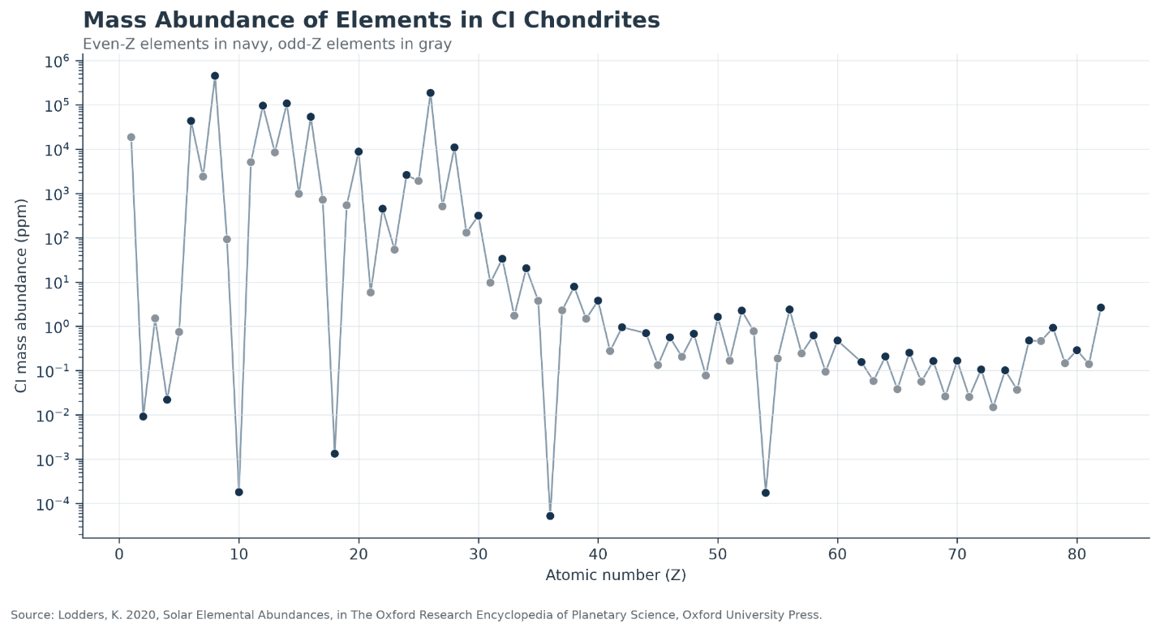

In the chart above, even-numbered elements are shown in navy and odd-numbered elements in gray. The vertical axis is logarithmic, so each major step represents a 10x change rather than a simple linear increase. The data is derived from observations of the atomic composition of Carbonaceous Ivuna (CI) Chondrites meteorites. These meteorites are used as a proxy for the composition of the solar system as a whole because they are very old, some contain material that is older than the solar system. By taking measurements of their compositions, we can better understand the raw materials of the solar system. Every planet, moon, and asteroid was made from material like this, so by understanding its composition we can get close to understanding what materials are available. Arguably this is the only solar system we will have access to for physical resources so it stands to reason that we should be more concerned with the local availability of resources than, say, the availability of resources on a universal scale.

Today's commodity markets obviously don't price metals according to the availability of extraterrestrial materials. They price materials available on Earth, under today's economic conditions. But it is interesting to put the two datasets together anyway and consider how, as we expand into the solar system, this relative abundance measure may act as a supply constraint and influence the relative value of these commodities.

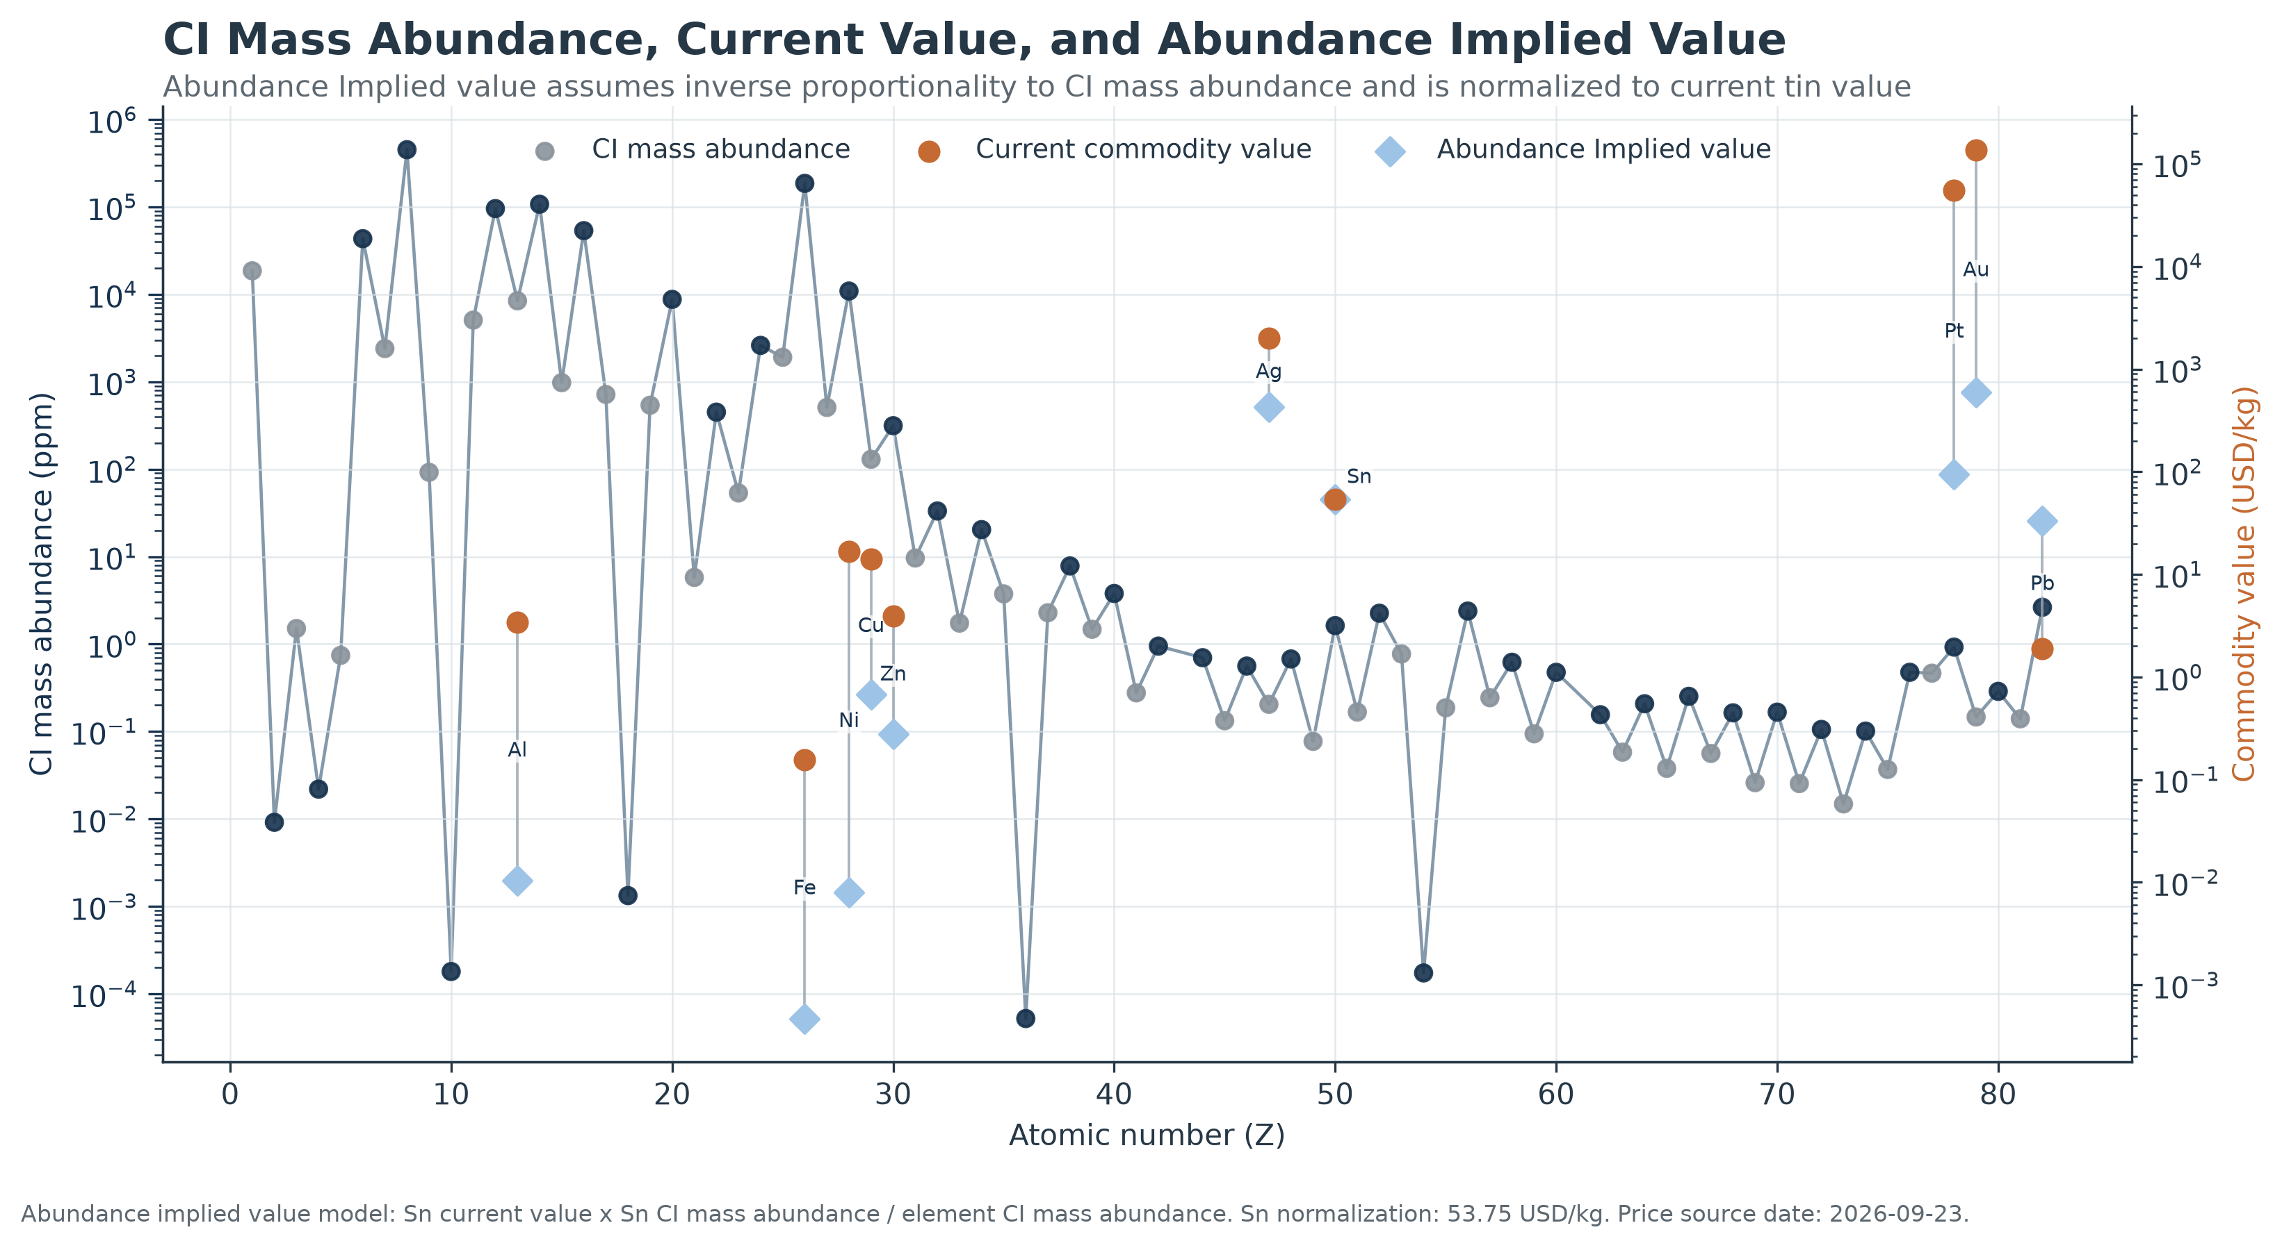
Again, the gray and navy series represents CI mass abundance. The orange observations represent current commodity prices for elements where a reasonably comparable market price can be established. And the blue diamonds represent the abundance implied value of those commodities assuming the price is inversely proportional to abundance and using Sn (tin) as a normalization point. It is important to state that this is a very rough calculation and is conducted in the interest of seeing the thought experiment through to its logical conclusion, rather than an attempt to project actual commodity prices.

Today's commodity prices mostly tell us about scarcity, geology, technology, and the economy of one planet. If humanity's economic frontier eventually expands throughout the solar system, perhaps the underlying abundance of the elements will begin to exert a greater influence on their relative values. The abundance-implied values shown here illustrate what that relationship might look like in the extreme case where abundance becomes the dominant supply constraint. While this is all highly speculative, what is certain, is that the supply side of tomorrow's commodity markets began billions of years ago, inside stars.

Sources
- Katharina Lodders (2021), “Relative Atomic Solar System Abundances, Mass Fractions, and Atomic Masses of the Elements and Their Isotopes, Composition of the Solar Photosphere, and Compositions of the Major Chondritic Meteorite Groups,” Space Science Reviews, 217, Article 44.
DOI: 10.1007/s11214-021-00825-8. View publication [link.springer.com], [profiles.wustl.edu]
- Katharina Lodders, Maria Bergemann, and Herbert Palme (2025), “Solar System Elemental Abundances from the Solar Photosphere and CI-Chondrites,” Space Science Reviews, 221.
DOI: 10.1007/s11214-025-01146-w. View publication [link.springer.com], [par.nsf.gov]
- William D. Harkins (1917), “The Evolution of the Elements and the Stability of Complex Atoms. I. A New Periodic System Which Shows a Relation Between the Abundance of the Elements and the Structure of the Nuclei of Atoms,” Journal of the American Chemical Society, 39(5), 856–879.
DOI: 10.1021/ja02250a002. View publication [scilit.com]
- NASA Cosmicopia: Nucleosynthesis, NASA Goddard Space Flight Center.
NASA overview [cosmicopia...c.nasa.gov]
Further Reading
- Katharina Lodders, Maria Bergemann, and Herbert Palme (2025), “Solar System Elemental Abundances from the Solar Photosphere and CI-Chondrites.”
Read the paper [par.nsf.gov]
- Katharina Lodders (2021), “Relative Atomic Solar System Abundances, Mass Fractions, and Atomic Masses...”
Read the paper [link.springer.com]
- NASA: What is Your Cosmic Connection to the Elements?
NASA explainer [imagine.gs...c.nasa.gov]

