A local restaurant is planning on doing some remodeling. As a result of the remodel, the restaurant will lose about 10% of its seating capacity. The restaurant owners are worried that this decrease in seating will result in excessive waiting times for its customers which will eventually effect business. They have asked a group of local developers to create a simulation that will calculate the average wait time based on seating capacity and the average flow of customers.

At any given time, the restaurant can expect 20 to 60 customers an hour. The current capacity of the restaurant is 45 and the average time a customer spends at a table is 30 minutes. For the simulation to be effective, two queues will need to be utilized. The first queue will be used for customers that are seated and will remove patrons from this queue every 30 minutes. However, the queue will reach capacity at 45 seated customers. The second queue will be used for those waiting to be seated. Customers in this queue will be removed from this queue and placed in the seated queue as soon as a spot is available. In order to measure the average wait time, customers placed within this queue will need to have the time they are placed on the queue and the time they are seated monitored. Finally, this simulation will also need to be run for a restaurant with 90% the seating capacity or approximately 40 seats as well as simulate service for the 8 hours the restaurant is open daily.

Questions:
-Is the remodel going to cause too long of wait times for customers?
-what is the average wait time for a restaurant with various seating capabilities?

Main Simulation Steps:
- Create a queue for available seats. Cap this queue at the designated seating capacity for the restaurant and create a timer to associate to each customer that counts down from 30 minutes. The queue is empty to start.
- Create a queue for waiting customers. Give each customer a timestamp upon arrival. This queue is empty to start.
- Have customers enter the restaurant at a rate between 20 to 60 customers per hour.
  - Check if there are available seats. If there are place customer in seated queue and begin 30 minute timer for customer.
    - Every 30 minutes, pop a member from this queue.
  - If seats are not available, place customer in waiting queue and apply a timestamp to the customer.
    - Once a seat is available, pop a member from the waiting queue.
    - Subtract the timestamp for this customer from the current time and add it to a list for later processing.
    - Add the recently popped member of the waiting queue to the seated queue.
- Have this program run for 8 simulated hours while making sure to randomly change the rate of customers per hour every hour.
- Once the simulation is complete, calculate the average wait time from the list of wait times.
- Repeat simulation for 90% of the previous seating capacity.

Assumptions:
- As capacity fills, the average time customers stay at their table stays constant.
- First customers seated are the first ones to leave.
- Customers don't leave once they have been placed in the waiting queue.

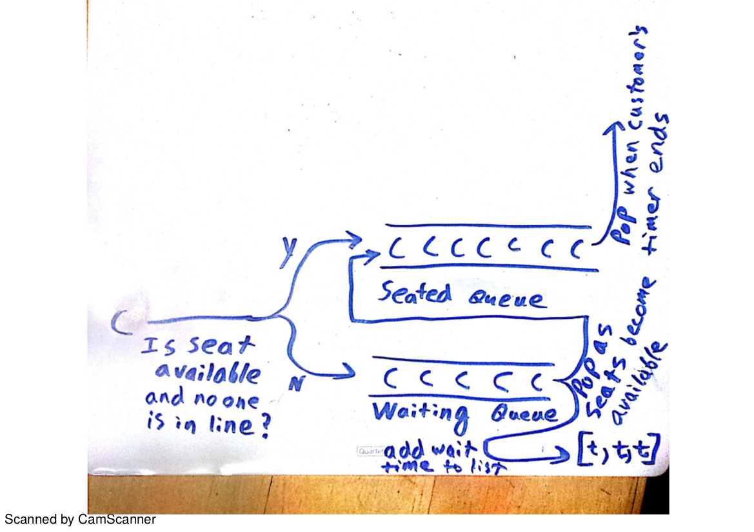

Justification:
- In both the situation of customers waiting to be seated and seated customers, a queue accurately depicts how a restaurant would operate in reality. Generally, patrons of a restaurant spend a predictable amount of time at a table with a few exceptions. In the case of a waiting line, the appropriateness of a queue is obvious.

