**Chapter 1**

**DEVICES FOR CONNECTING NETWORKS**

**Learning Objectives:**

1. Describe how LAN network transmission equipment works, including repeaters, MAUs, hubs, bridges, routers, switches, and gateways.
2. Describe how WAN network equipment works, including modems, ISDN adapters, cable modems, DSL modems and routers, access servers, and remote routers.
3. Design a router-based network.

**DISCUSSION PROPER**

**LAN TRANSMISSION DEVICES**

It uses of LAN transmission equipment that connecting devices on a single network, creating and connecting multiple networks or sub network in setting up some enterprise networks. Connecting devices that will be discussed are Repeaters, MAUs, hubs, bridges, routers, switches, and gateways.

**REPEATER**

A repeater operates at the physical layer. Its job is to regenerate the signal over the same network before the signal becomes too weak or corrupted so as to extend the length to which the signal can be transmitted over the same network. An important point to be noted about repeaters is that they do not amplify the signal. When the signal becomes weak, they copy the signal bit by bit and regenerate it at the original strength. It is a 2 port device.

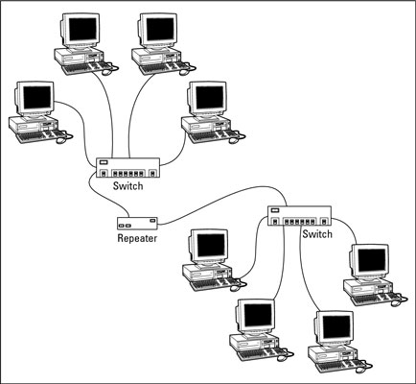**Figure 1-1 Two LAN segment connected by a Repeater**

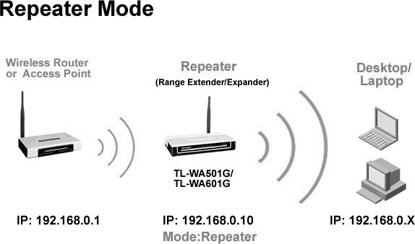

**Figure 1-2 Using Wireless Repeater**

**Uses of Repeaters**

1. Extend cable segments.
2. Extend a wireless signal.
3. Increase number of nodes beyond segment.
4. Sense a network problem and shut down a segment.
5. Connect to components in other network devices.
6. Connect segments using different media.
7. Extend backbone cable segments in LANs, CANs, and MANs.
8. Extend long, fiber-optic cable segments.
9. Increase communication distance of T-carrier lines.

## Types of Repeaters

According to the *types of signals* that they regenerate, repeaters can be classified into two categories:

* **Analog Repeaters** − they can only amplify the analog signal.
* **Digital Repeaters** − they can reconstruct a distorted signal.

According to the *types of networks* that they connect, repeaters can be categorized into two types:

* **Wired Repeaters** − they are used in wired LANs.
* **Wireless Repeaters** −they are used in wireless LANs and cellular networks.

According to the *domain of LANs* they connect, repeaters can be divided into two categories:

* **Local Repeaters** − they connect LAN segments separated by small distance.
* **Remote Repeaters** − they connect LANs that are far from each other.

## Advantages of Repeaters

1. Repeaters are simple to install and can easily extend the length or the coverage area of networks.
2. They are cost effective.
3. Repeaters don’t require any processing overhead. The only time they need to be investigated is in case of degradation of performance.
4. They can connect signals using different types of cables.

## Disadvantages of Repeaters

1. Repeaters cannot connect dissimilar networks.
2. They cannot differentiate between actual signal and noise.
3. They cannot reduce network traffic or congestion.
4. Most networks have limitations upon the number of repeaters that can be deployed.

**MULTISTATION ACCESS UNIT (MAU or MSAU)**

It is a hub that connects computers and other devices to a token-ring network. The MAU **physically connects computers in a star topology** while retaining **token ring’s logical ring structure**.

However, every message passes through every computer, each passing it on to the next in a *continuing circle* until it arrives at its proper destination. This leaves the token-ring topology vulnerable in that a single non-operating node can break the ring.

The MAU solves this problem because it has the ability to bypass non-operating nodes and maintain the ring structure.MAU technology evolved into newer devices: **Control Access Unit (CAU)**: allows several connected, stack able units to count as one MAU. CAUs also come with options for gathering information used in network performance management.

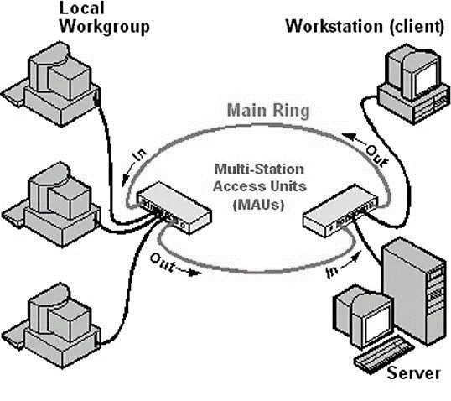**Figure 1-3 Several MAUs can be interconnected via their Ring-In/ Ring-Out ports to expand the network.**

**Tasks performed by MAU**

1. Connect nodes in a *logical ring* through a *physical star topology.*
2. Move the token and frames around the ring.
3. Amplify data signals.
4. Expand token ring network by daisy-chain connections.
5. Provide for orderly movement of data.
6. Shut down ports to malfunctioning nodes.

**HUB**

It is a central network device connecting nodes in a star topology. It is basically a *multiport repeater*. It connects multiple wires coming from different branches. For example, the connector in star topology which connects different stations. Hubs cannot filter data, so data packets are sent to all connected devices.  In other words, [collision domain](https://en.wikipedia.org/wiki/Collision_domain) of all hosts connected through hub remains one.  Also, they do not have the intelligence to find out best path for data packets which leads to inefficiencies and wastage.

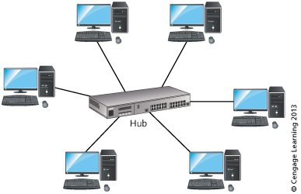

**Figure 1-4 Hub**

**Functions of a Hub**

1. Centrally connect multiple nodes into one network.
2. Permit connections on single or multiple LANs.
3. Provide multi-protocol services.
4. Consolidate the network backbone.
5. Provide connections for several different media types.
6. Enable centralized network management and design.

**Types of Hub**

**Active Hub -**these are the hubs which have their own power supply and can clean, boost, and relay the signal along with the network. It serves both as a repeater as well as wiring centre. These are used to extend the maximum distance between nodes.

**Passive Hub -**these are the hubs which collect wiring from nodes and power supply from active hub. These hubs relay signals onto the network without cleaning and boosting them and can’t be used to extend the distance between nodes.

**Intelligent Hub -**it work like active hubs and include remote management capabilities. They also provide flexible data rates to network devices. It also enables an administrator to monitor the traffic passing through the hub and to configure each port in the hub.

**BRIDGE**

A bridge is a type of computer network device that provides interconnection with other bridge networks that use the same protocol. Bridge devices work at the data link layer of the Open System Interconnect (OSI) model, connecting two different networks together and providing communication between them. Bridges are similar to repeaters and hubs in that they broadcast data to every node.

However, bridges maintain the media access control (MAC) address table as soon as they discover new segments, so subsequent transmissions are sent to only to the desired recipient.

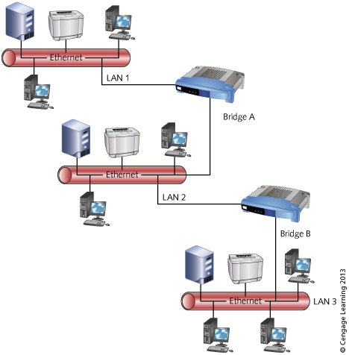

**Figure 1-5 Bridge Connection**

The working principle of a bridge is, it blocks or forwards the data depending on the destination MAC address and this address is written into every data frame.

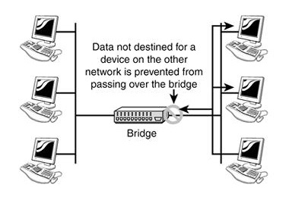

**Figure 1-6 Working Principle of a bridg**e

**Functions of a Bridge**

1. Extend a LAN when the maximum connection limit is reached.

**Example: the 30-node limit on an Ethernet bus.**

1. Extend a LAN beyond the length limit.

**Example: beyond 185 meters for a thinnet segment.**

1. Segment LANs to reduce data traffic bottlenecks.
2. Prevent unauthorized access to a LAN.
3. Learning: learn network topology and device addresses. Information is stored in a bridging table.
4. Filtering: do not flood certain frames, discard others. Enables the bridge to be used for security purposes.
5. Forwarding: transmit frames to destination. Based on data built-in to the bridging table.

**Types of Bridges**

**Local - directly connects two LANs in close proximity. Also used to segment traffic to reduce bottlenecks.**

**Remote - join distant networks. Used to join networks in different cities or states.**

**ROUTER**

Routers are networking devices operating at layer 3 or a network layer of the OSI model. They are responsible for *receiving, analyzing, and forwarding data packets* among the connected computer networks.

When a data packet arrives, the router inspects the destination address, consults its routing tables to decide the optimal route and then transfers the packet along this route. Routers are manufactured by some popular companies like Cisco, D=Link, HP, 3Com, Juniper and Nortel.

A router also the first line of security from intrusion into a network. Enabling the highest level of security on the router turns on things like the firewall, and is the best way to keep your computer system and information safe from attack.

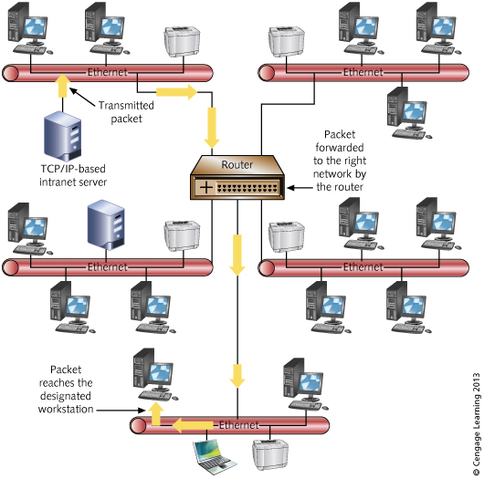

**Figure 1-7 Router**

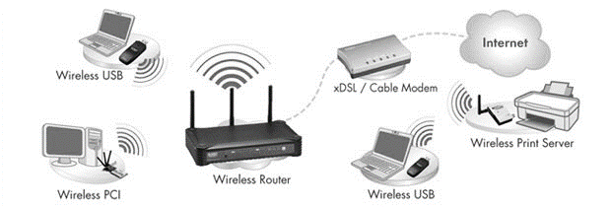**Figure 1-8 Using Wireless Router**

**General functions of a Router**

1. **Reduce traffic by efficiently directing packets from one network to another.**
2. **Join neighboring or distant networks.**
3. **Connect dissimilar networks.**
4. **Prevent bottlenecks by isolating portions of a network.**
5. **Secure portions of a network by acting as a firewall.**

## Routing Table

The functioning of a router depends largely upon the routing table stored in it. The routing table stores the available routes for all destinations. The router consults the routing table to determine the optimal route through which the data packets can be sent.

**A routing table typically contains the following entities**

* IP addresses and subnet mask of the nodes in the network.
* IP addresses of the routers in the network.
* Interface information among the network devices and channels.

**Routing tables are of two types**

**Static Routing Table** − also known as non-adaptive routing which doesn’t change routing table unless the network administrator changes or modify them manually.  It is suitable for small networks containing 2-3 routers.

**Dynamic Routing Table** − also known as adaptive routing which change routing table according to the change in topology. Dynamic routing uses complex routing algorithms and it does not provide high security like static routing. It is suited for larger networks having large number of routers.

**Table 1-1 Difference between Static and Dynamic Routing**

|  |  |  |
| --- | --- | --- |
| **S.NO** | **STATIC ROUTING** | **DYNAMIC ROUTING** |
| 1. | In static routing routes are user defined. | In dynamic routing, routes are updated according to topology. |
| 2. | Static routing does not use complex routing algorithms. | Dynamic routing uses complex routing algorithms. |
| 3. | Static routing provides high or more security. | Dynamic routing provides less security. |
| 4. | Static routing is manual. | Dynamic routing is automated. |
| 5. | Static routing is implemented in small networks. | Dynamic routing is implemented in large networks. |
| 6. | In static routing, additional resources are not required. | In dynamic routing, additional resources are required. |
| 7. | In static routing, failure of link disrupts the rerouting. | In dynamic routing, failure of link does not interrupt the rerouting. |

## Types of Routers

A variety of routers are available depending upon their *usages*.

**Wireless Router** − they provide WiFi connection WiFi devices like laptops, smartphones etc. They can also provide standard Ethernet routing. For indoor connections, the range is 150 feet while its 300 feet for outdoor connections.

**Broadband Routers** − they are used to connect to the Internet through telephone and to use voice over *Internet Protocol (VoIP)* technology for providing high-speed Internet access. They are configured and provided by the Internet *Service Provider (ISP).*

**Core Routers** − they can route data packets within a given network, but cannot route the packets between the networks. They helps to link all devices within a network thus forming the backbone of network. It is used by ISP and communication interfaces.

**SWITCH**

  A switch is used to network multiple computers together. Switches made for the consumer market are typically small, flat boxes with 4 to 8 Ethernet ports. These ports can connect to computers, cable or DSL modems, and other switches. High-end switches can have more than **50 ports** and often are rack mounted.

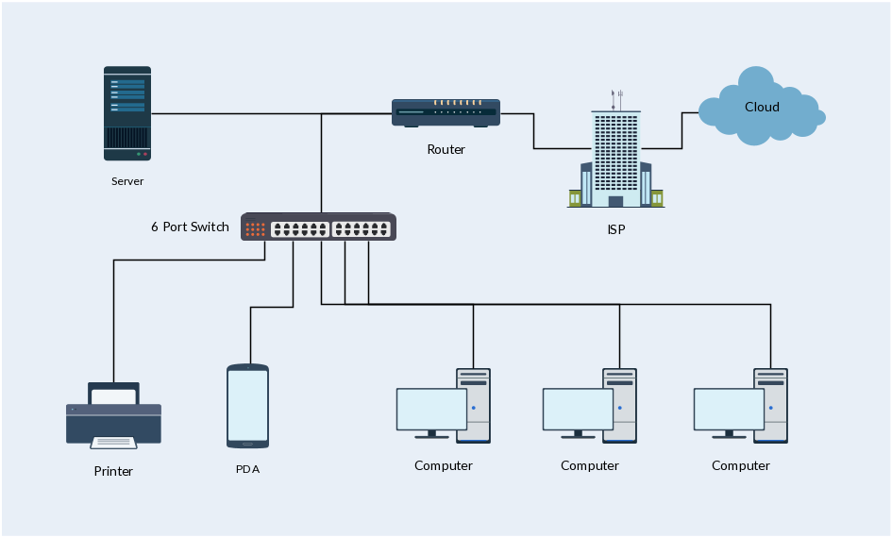Switches are more advanced than [hubs](https://techterms.com/definition/hub) and less capable than [routers](https://techterms.com/definition/router). Unlike hubs, switches can limit the traffic to and from each port so that each device connected to the switch has a sufficient amount of bandwidth. For this reason, you can think of a switch as a "smart hub." However, switches don't provide the firewall and logging capabilities that routers do. Routers can often be configured by software (typically via a Web interface), while switches only work the way the hardware was designed.

**Figure 1-9 Switch Network Diagram**

**LAN uses two switching techniques (unlike bridges)**

* **Cut-through:** forward portions of frame before entire frame is received.
* **Store-and-forward**: frame is buffered until entire frame is received.

## Types of Switches

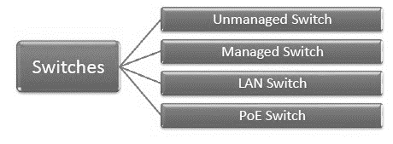

**Unmanaged Switch-** these are inexpensive switches commonly used in home networks and small businesses. They can be set up by simply plugging in to the network, after which they instantly start operating. When more devices needs to be added, more switches are simply added by this plug and play method. They are referred to as u managed since they do not require to be configured or monitored.

**Managed Switch-** these are costly switches that are used in organization with large and complex networks, since they can be customized to augment the functionalities of a standard switch. The augmented features may be *Quality of Service (QoS)* like higher security levels, better precision control and complete network management. Despite their cost, they are preferred in growing organizations due to their scalability and flexibility. Simple *Network Management Protocol (SNMP)* is used for configuring managed switches.

**LAN Switch -** *Local Area Network (LAN)* switches connect devices in the internal LAN of an organization. They are also referred to as Ethernet switches or data switches. These switches are particularly helpful in reducing network congestion or bottlenecks. They allocate bandwidth in a manner so that there is no overlapping of data packets in a network.

**PoE Switch -** *Power over Ethernet (PoE)* switches are used in PoE Gigabit Ethernets. PoE technology combines data and power transmission over the same cable so that devices connected to it can receive both electricity as well as data over the same line. PoE switches offer greater flexibility and simplify the cabling connections.

**GATEWAY**

A gateway interconnecting networks above the network layer is the most complex network interconnection device. It is used only for interconnection of different networks between two high-level protocols. The Gateways can be used for both WAN and LAN interconnects.

A gateway is a **computer system or device** that serves as a transitional task. The gateway is a translator between two systems that use different communication protocols, data formats or languages, or even completely different architectures. Unlike the bridges, which simply convey information, the Gateways repackage the information they receive to suit the needs of the destination system.

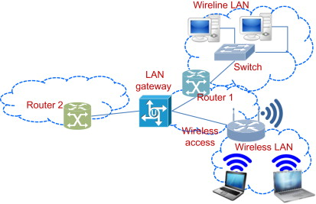**Figure 1-10 LAN Gateway**

**Functions of a Gateway**

1. Convert common protocols to specialized type.
2. Convert message formats from one format to another.
3. Translate different addressing schemes.
4. Link a host computer to a LAN.
5. Provide terminal emulation for connections to host.
6. Direct electronic mail to the right network destination.
7. Connect networks with different architectures.

## Types of Gateways

On basis of direction of data flow, gateways are broadly divided into two categories:

* **Unidirectional Gateways - t**hey allow data to flow in only one direction. Changes made in the source node are replicated in the destination node, but not vice-versa. They can be used as archiving tools.
* **Bidirectional Gateways- t**hey allow data to flow in both directions. They can be used as synchronization tools.

**WAN TRANSMISSION DEVICES**

A Wide Area Network (also known as WAN) is a large network of information that is not tied to a single location. WANs can facilitate communication, the sharing of information and much more between devices from around the world through a WAN provider.

**Characteristics of WAN transmission equipment**

1. May have analog component or be completely digital.
2. Converts signal for long distance communications.
3. Creates multiple channels in medium (grow bandwidth).

**FREQUENTLY USED WAN TRANSMISSION DEVICES**

**ANALOG TELEPHONE MODEMS**

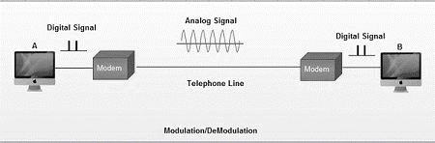The word **modem** stands for “modulator/demodulator,” which refers to the fact that **modems** convert digital transmission signals to **analog** signals and vice versa. Modems use two communication formats the synchronous and asynchronous. **Synchronous** continuous data bursts controlled by a clock signal while **Asynchronous** discrete signals delimited by start and stop bits.

**Figure 1-11 Modem**

When an analog facility is used for data communication between two digital devices called **Data Terminal Equipment (DTE)**, modems are used at each end. DTE can be a terminal or a computer.

The modem at the transmitting end converts the digital signal generated by DTE into an analog signal by modulating a carrier. This modem at the receiving end demodulates the carrier and hand over the demodulated digital signal to the DTE.

**ISDN Adapters**

*Integrated Services Digital Network (ISDN)* is a circuit-switched telephone network system that transmits both data and voice over a digital line. It is a set of communication standards to transmit data, voice, and signaling. These digital lines could be copper lines. It was designed to move outdated landline technology to digital. ISDN connections have a reputation for providing better speeds and higher quality than traditional connections. Faster speeds and better connections allow data transmissions to travel more reliably.

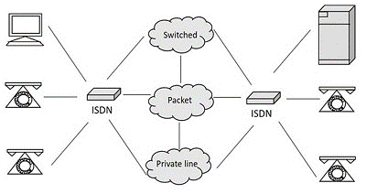

**Figure 1-12 ISDN Adapter**

**CABLE TV MODEMS**

**Cable modem**, [modem](https://www.britannica.com/technology/modem) used to convert [analog](https://www.merriam-webster.com/dictionary/analog) data signals to digital form and vice versa, for transmission or receipt over [cable television](https://www.britannica.com/technology/cable-television) lines, especially for connecting to the [Internet](https://www.britannica.com/technology/Internet).

A cable modem modulates and demodulates signals like a telephone modem but is a much more complex device. Data can be transferred over cable lines much more quickly than over traditional phone lines. Transmission rates range from about 8 *megabits per second (Mbps)* for basic services to some 50 Mbps for premium services. Uses two channels (frequencies) to communicate, the upstream and downstream. Upstream transmits outgoing data, sound, TV signals while downstream receives and blend incoming signals. Modem speeds may differ upstream and downstream.

**Example:** 30 Mbps upstream, 15 Mbps downstream.

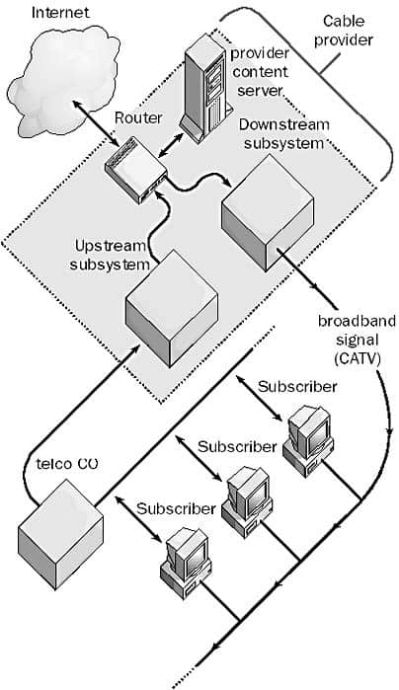

**Figure 1-13 Upstream and Downstream system**

**DSL MODEMS and ROUTERS**

*Digital Subscriber Line (DSL)* works over copper wire likes ISDN. It requires intelligent adapter in connecting computer or router. The maximum upstream and downstream transmission rates are 200 Mbps and maximum distance from user to Telco without a repeater is 5.5 kilometers (3.4 miles. DSL networks utilize combined DSL adapter/router that can be used to direct network traffic and to create a firewall so that only authorized users can access network services.

Advantages of DSL over cable is dedicated DSL line is more secure and DSL line provides full bandwidth for the link (unlike cable modem, which is shared by other users).

**ACCESS SERVERS**

It combines WAN communications into one device*. Internet Service Providers (ISP)* use *Network Attached Storage (NAS)* to provide Internet access to their remote users. NAS works by enabling simultaneous connections between multiple remote users through a dial-up connection, wired/wireless medium or multiple supported analog/digital connectivity interfaces. Upon successful user authentication, Internet access is granted.

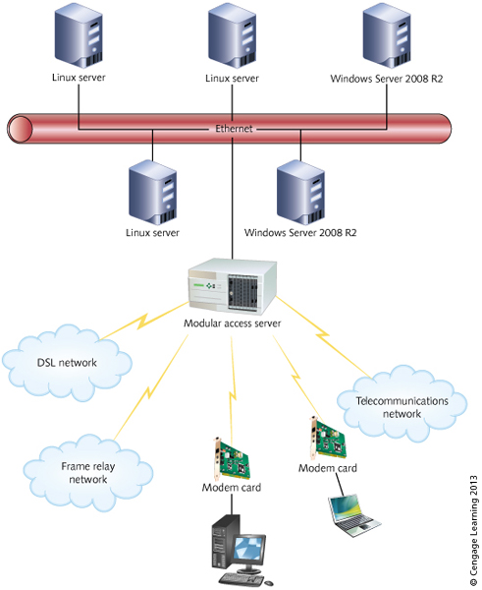

**Figure 1-14 Using an Access Server**

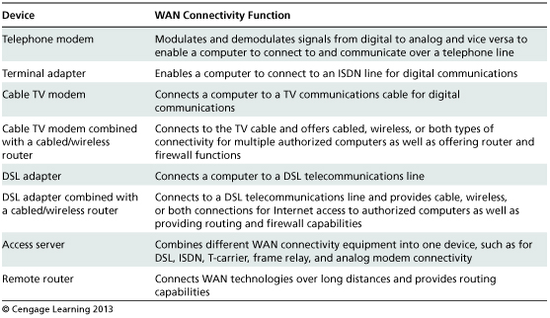**Figure 1-15 WAN Connectivity Devices**

**SUMMARY**

Early networks use repeaters to expand network communications when the *Institute of Electrical and Electronics Engineers (IEEE)* limits are reached or to extend the range of wireless communications. Some network devices incorporate repeater functions as they implement more complex network options such as filtering and forwarding packets and frames

Routers and switches incorporate some bridging functions for networking and are used in centralized star-based networks to connect segments and to link networks to one another. Routers and switches can be equipped with intelligence to help in collecting network data and for centralized network management. Routers are popular because they control traffic patterns and they play a dual role providing both LAN and WAN connectivity

Switches are popular because they are faster than hubs. Hub is commonly used to connect segments of a LAN. It contains multiple ports. When a packet arrives at one port, it is copied to the other ports so that all segments of the LAN can see all packets. Switch support any packet protocol. It filters and forwards packets between LAN segments.

Analog modems used over PTSN lines have been used for many years in the past. Cable modems have a widespread presence because they can be used over existing cable TV lines and offer high-speed access. Access servers provide a single unit in which to combine all types of telecommunications connectivity (modems, T-1, ISDN, and DSL).Remote routers are used to join LANs at remote sites into WANs.