**Chapter 2**

**CONNECTING THROUGH A WIRELESS NETWORK**

**Learning Objectives:**

1. Explain current wireless networking technologies.
2. Describe radio wave technologies.
3. Explain 802.11 radio wave networking.
4. Consider design options for wireless networks.

**DISCUSSION PROPER**

**CURRENT WIRELESS NETWORKING TECHNOLOGIES**

Wireless technology resolves many wire-based issues and wireless media are forms of electromagnetic radiation.

**Advantages of Wireless Networks**

1. Enabling communications in areas where a wired network would be difficult to install.
2. Reducing installation costs.
3. Providing “anywhere” access to users that cannot be tied down to a cable.
4. Simplifying small office and home office networking.

**Three major current Wireless Networking Technologies**

1. Radio wave technologies (short range and a popular option).

2. Infrared technologies (short range).

3. Terrestrial and satellite microwave technologies (long range).

**RADIO WAVE TECHNOLOGIES**

A radio wave is a type of electromagnetic signal designed to carry information through the air over relatively long distances. Sometimes radio waves are referred to as **Radio Frequency (RF)** signals. These signals oscillate at a very high frequency, which allows the waves to travel through the air similar to waves on an ocean. Radio waves have been in use for many years. They provide the means for carrying music to FM radios and video to televisions.

In addition, radio waves are the primary means for carrying data over a wireless network. The **frequency** of a radio wave is the number of times per second that the signal repeats itself. The unit for frequency is *Hertz (Hz)*, which is actually the number of cycles occurring each second. In fact, an old convention for the unit for frequency is *cycles per second (cps).* 802.11 WLANs use radio waves having frequencies of 2.4 GHz and 5 GHz, which means that the signal includes 2,400,000,000 cycles per second and 5,000,000,000 cycles per second, respectively.

The **amplitude** of a radio wave indicates its strength. The measure for amplitude is generally power, which is analogous to the amount of effort a person needs to exert to ride a bicycle over a specific distance. Radio waves have amplitudes with units of watts, which represent the amount of power in the signal. Watts have linear characteristics that follow mathematical relationships we are all very familiar with. For example, the result of doubling 10 *milliwatts (mW)* is 20 mW.

**Spread spectrum** radio components use either direct sequence or frequency hopping for spreading the signal. Direct sequence modulates a radio carrier by a digital code with a bit rate much higher than the information signal bandwidth.The ffrequency range is 902–928 MHz range and data transfer range is 1–600 Mbps. Other radio wave technologies include *Bluetooth, HiperLAN, Infrared, WiMAX, HiperMAN, and cellular phone*.

**Directional signal transmitted between buildings**

* Transmission involves sending and receiving antennas
* Wave is short in length and low-power (1-10 watts)
* Suitable for line-of-sight transmission
* Signal goes from point to point on earth's surface
* Limitations due to interruptions, such as hills
* 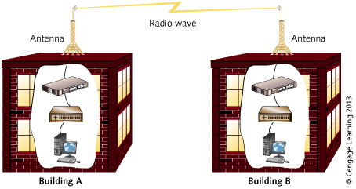Data capacity range: 1 Mbps to over 300 Mbps

**Figure 2-1 Wireless Communications by Radio Waves**

**Advantages to radio wave communications**

1. Can save money where it is difficult or expensive to run cable.
2. Useful in situations where portable computers deployed.
3. Relatively easy and inexpensive to install.

**Disadvantages to radio wave communications**

1. Wireless networks are more susceptible to interference (such as interference caused by certain building materials and by surrounding electrical devices).
2. Some wireless frequencies are shared by amateur radio operators, the US military, and cell phone companies – can cause interference.
3. Interference from natural obstacles.
4. Inadequate security.

**IEEE 802.11 RADIO WAVE NETWORKING**

It is the IEEE 802.11 group. The most influential wireless standards includes 802.11a, 802.11b, 802.11g, and 802.11n. Communication with 802.11 devices is non-proprietary. There is a features of 802.11 standards that encompass either fixed or mobile wireless stations and involve two kinds of communications the asynchronous is the discrete units with a start and stop bit and synchronous is the signal has timing restrictions. To support SNMP protocol and network authentication. To operate at two lower OSI layers: Data Link and Physical and Recognize indoor and outdoor wireless communication.

**WIRELESS COMPONENTS**

Wireless networks use an **Access Point (AP)**, also called a **Wireless Access point (WAP)**, to provide a gateway to the wired network and a wireless local area network adapter (WLAN adapter or simply wireless adapter) to provide a link between a wireless client PC and the AP.

An **Access Point** connects to the wired network (or directly to a cable/DSL modem) and can simultaneously provide wireless links to many wireless adapters. A typical AP allows 32 or 64 wireless adapters to be connected simultaneously.May support the following types of network interfaces: AUI, 10Base2, 10BaseT, 100Base technologies, 1000Base technologies, 40 GB Ethernet technologies, 100 GB Ethernet technologies, FDDI, Cable modem port, or DSL telecommunications port.

An **Antenna** is a device that radiates and receives radio waves. Most are either directional or omnidirectional.

* **Directional Antenna** sends radio waves in one main direction. Amplifies signal better than omnidirectional antenna. It gains amplification of radiated signal and for application transmitting signals between buildings, each building has an antenna, antennas connected to access points, signal has more gain in one direction and small portion of signal is radiated outward.

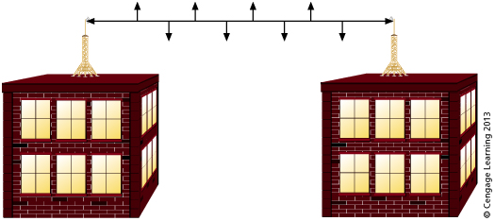

**Figure 2-2 Directional Antenna**

* **Omnidirectional Antenna** [receive](https://www.sciencedirect.com/topics/computer-science/receive-antenna) signals equally from all directions. Directional antennas pull in signals better from one direction. It deployed varies with device such as WNIC on portable devices use a Snap-On antenna, access point for indoor network and outdoor access point connects to antenna via a cable.

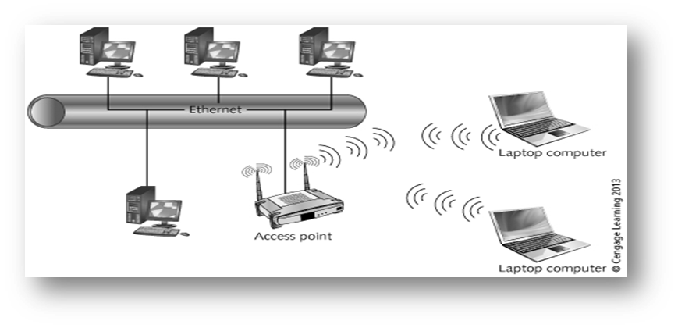

**Figure 2-3 Omnidirectional Antenna**

**WIRELESS NETWORKING ACCESS METHODS**

The **access method** is a way of sharing a common transmission medium (cable, wireless link) between several hosts. Two access methods are priority-based and CSMA/CA.

* **Priority-based access** is an access point device functions as a point coordinator, point coordinator establishes contention-free period during which it polls stations to see which devices need to transmit and intended for time sensitive communications**.**
* **Carrier Sense Multiple Access/Collision Avoidance (CSMA/CA)** also called the distributed coordination function and coordinate nodes using DIFS delay and back-off time. CSMA/CA works to avoid collisions.

**TRANSMISSION SPEEDS**

The rate at which data are moved across a communications channel. Following are the transmission speeds of common LAN and WAN technologies. It correspond to the Physical layer of the OSI model.

Transmission speeds are defined through four IEEE standards: *802.11a, 802.11b, 802.11g, and 802.11n.* There are two newer very-high-speed wireless LAN standards under development: *802.11ac and 802.11ad.*

* **802.11a** transmits data over a [wireless](https://techterms.com/definition/wireless) network. It uses a 5 GHz [frequency](https://techterms.com/definition/frequency) band and supports data transfer rates of 54 [Mbps](https://techterms.com/definition/mbps), or 6.75 [megabytes](https://techterms.com/definition/megabyte) per second.
* **802.11b** outlines speeds in the 2.4 GHz frequency range with a minimum speed of 1 Mbps up to the maximum speed of 11 Mbps.
* **802.11g** has very Fast operating speed and signal range is also good and is not easily obstructed. It supports three transmission methods on the 2.4 GHz band.There’s a restrictions and considerations using 802.11g that devices must support minimum speeds by standard, slightly shorter range than 802.11b, smaller bandwidth (90 MHz) than 802.11a or 802.11b and devices combine with 802.11b devices on one LAN.
* **802.11n** uses a technology called multiple-input multiple-output (MIMO) with spatial multiplexing. Multiple frames can be aggregated together in one transmission. Number of times a channel must be acquired and released is significantly reduced due to frame aggregation, making it more efficient than other 802.11 technologies can use 20 and 40 MHz channels within the 2.4 and 5 GHz bands. At this writing, most 802.11n devices have a top speed of 300+ Mbps.
* **802.11ac** is currently under development. It designed around the technologies used by 802.11n and expands transmission capabilities to use the 80 MHz channel for even wider bandwidth.
* **802.11ad** is also under development. It targeted at accomplishing transmission speeds of roughly 7 Gbps. Operates using the 60 MHz channel. Designed for shorter transmission distances (likely to be restricted by walls and manufacturers are looking at 802.11ad for Wi-Fi based phone communications and HD movies on big-screen wireless TVs.

**ALTERNATIVE RADIO WAVE TECHNOLOGIES**

The popular alternatives to 802.11 group are:

**Bluetooth**

Occurs in 2.4 GHz range (2.4–2.4835 GHz. Uses high wattage transmissions that can reach up to 100 meters and can use asynchronous or synchronous communication.

**Bluetooth devices are divided into three classes based on range**:

* ***Class 1:*** up to about 100 meters.
* ***Class 2:*** up to about 10 meters such as wireless devices such as keyboards, mice, microphones, and audio devices.
* ***Class 3:*** up to about 1 meter used for close range transmissions such as medical monitoring devices, watches, and exercise monitoring.

**High-Performance Radio Local Area Network (HiperLAN)**

There’s a features of second version, HiperLAN2 that transmits at up to 54 Mbps in the 5 GHz range. Compatible with Ethernet. Supports Data Encryption Standard (DES) and Quality of Service (QoS).

**Infrared Technologies**

Broadcasts in single direction or all directions. Advantages of infrared medium are inexpensive, difficult to intercept and not susceptible to *Radio-Frequency Interference (RFI) or Electromagnetic Interference (EMI).* Slow data transmissions (between 1 and 16 Mbps), does not penetrate walls and experiences interference from strong visible light, these are the disadvantages of infrared medium.

**Wireless Metropolitan Area Network (MAN)**

*Worldwide Interoperability for Microwave Access (WiMAX)* operates in the 2 to 66 GHz range. The IEEE 802.16 standard provides connectivity up to 75 Mbps with a reach of up to 48 kilometers (30 miles).WiMAX can be a cost-effective way to create a network over several miles.

**Wireless Hotspots**

The locations that provide a public access point to users. There’s two type of wireless hotspots:

* **Stationary**: examples include a library, an airport, a coffee shop, or hotel.
* **Mobile**: 3G and 4G networks make it possible for individuals to create their own wireless hotspots from any location that is accessible by a cell phone.

**Cellular Phone Communications**

It works on the basis of packet radio. Smartphone or cell phone acts as a radio transmitter and receiver equipped with an omnidirectional antenna.

**Microwave Technologies**

Have theoretical bandwidth up to 720 Mbps and beyond work in one of two ways:

* **Terrestrial Microwave** two directional parabolic antennas (dishes. It performed in ranges of 4–6 GHz and 21–23 GHz. Uses of terrestrial microwave transmission, the cabling costs are too high whereas cabling and wireless options not possible.
* **Satellite Microwave t**ransmits signal between three antennas, one antenna on a satellite in space. Connection speeds are currently at 2-3 Mbps with newer systems providing up to 12 Mbps. The user equipment needed for satellite communication are satellite dish about 2 or 3 feet in diameter, digital modems to transmit and receive signals, coaxial (TV-like) cables from the modems to dish ,USB cable from modems to a USB port on computer and software from provider to enable computer setup.

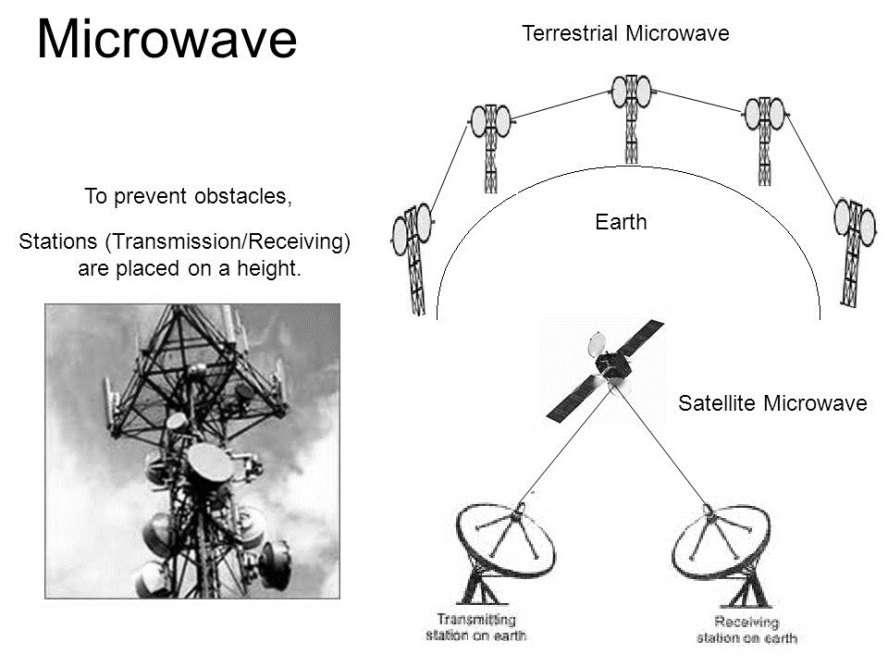

**Figure 2-4 Terrestrial and Satellite Microwave**

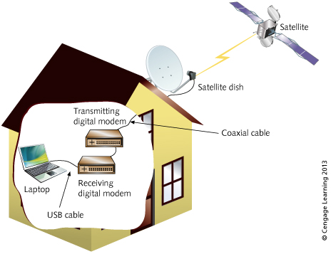

**Figure 2-5 Satellite Communications Setup**

**SUMMARY**

Wireless network technologies: radio wave, infrared, microwave, and satellite wireless networks. Wireless networks are used in areas where wired networks are difficult to install, are used to reduce network installation costs, and are used to enable mobile computing.

Radio wave technologies typically use line-of-sight communications. Radio wave technologies also use spread spectrum communications IEEE 802.11 parts: WNIC, access points, antennas802.11 standards group: 802.11a, 802.11b, 802.11g, and 802.11n. Standards in development: 802.11ac and 802.11ad. Radio technology alternatives include Bluetooth and HiperLAN. 802.11R standard uses diffused infrared light transmissions for small networks.

Wireless MANs use the 802.16 (WiMAX) standard for communication up to 48 kilometers. Wireless mobile hotspots can be established using a 3G/4G mobile device.

Cellular phone communications use base stations for each cell and connect base stations to call switching centers to direct calls.

Microwave networking comes in two forms: terrestrial microwave and satellite microwave.