**Chapter 4**

**UNDERSTANDING AN IP ADDRESS**

**Learning Objectives:**

1. Discuss how IP addressing works.
2. Understanding IPv4 and IPv6 addressing.
3. Discuss the role of Subnetting.
4. Discuss how IP address configuration.

**DISCUSSION PROPER**

**How IP addressing works**

Internet Protocols enables packets to reach different sub-networks on a LAN and different networks on a WAN, provided that such networks use transport options that are TCP/IP compatible, including Ethernet, FDDI, ISDN, DSL, Framel relay, ATM (with conversion), MPLS, and SONET.

**IP as a Connectionless Protocol**

IP is a connectionless protocol because its primary mission is to provide network-to-network addressing and routing information and to change the size of packets when the size varies from network to network, such as from Ethernet to FDDI.

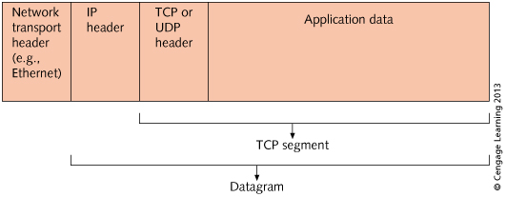**Figure 4-1 TCP/IP Packet Encapsulation**

**Using Internet Protocol version 4 (IPv4)**

IPv4 address format is called the dotted decimal notation address. It is 32 bits long and contains four fields, which are decimal values representing 8-bit binary octets. An IPv4 address in binary octet format looks like this: 10000001.00000101.00001010.01100100. This number converts to 129.5.10.100 in decimal format. Part of the address is the network identifier (network ID), and another part is the host identifier (host ID).

There are five IP address classes, Class A through Class E, and each is used with a different type of network. The address classes reflects the size of the network and whether the packet is unicast or multicast.

* **Unicast** is a transmission in which one packet is sent from a server to each client the requests a file or an application, as is done with a video presentation. If five clients request the video presentation, the server sends five packets per each transmission to the five clients.
* **Multicast,** means that the server is able to treat all five clients as a group and send one packet per transmission that reaches all five clients. Multicast can be used to significantly reduce network traffic when transmitting multimedia applications.
* **Broadcast**, which sends a communication to all points on a specific network (router are often configured so that they do not forward broadcasts to other networks).

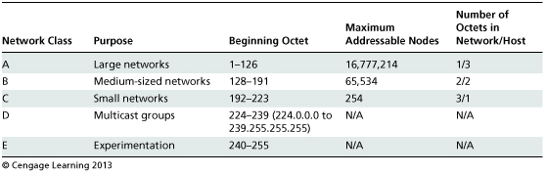

**Figure 4-2 IP address classes**

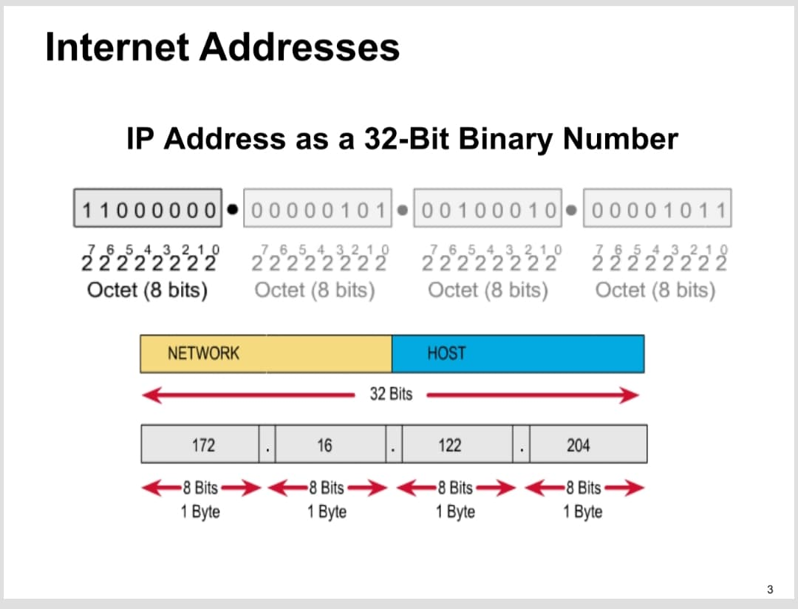

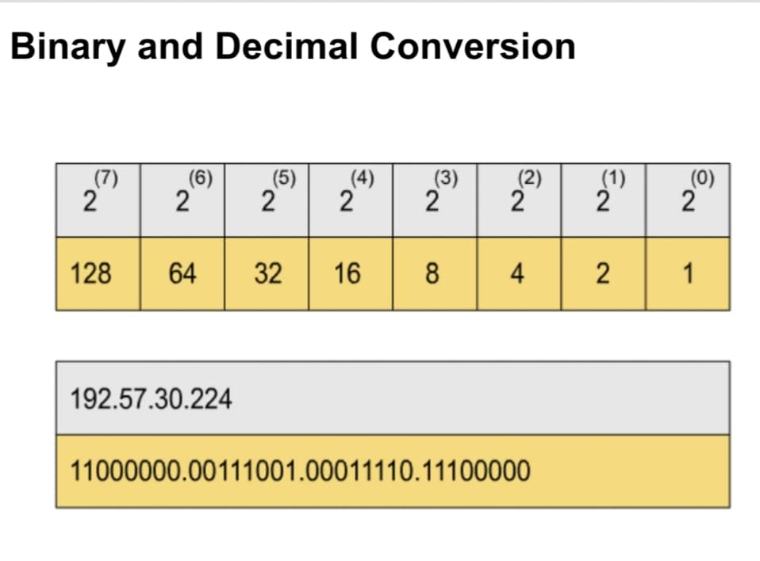**Figure 4-3 IP Address as a 32-Bit Binary Number**

**Figure 4-4 Binary and Decimal Conversion**

**IPv4 Address Rules**

* Network number 127.0.0.0 cannot be assigned.
* Certain IP network numbers reserved as private.
* No one can use private addresses on Internet.
* Network number cannot be assigned to any device.
* Highest number on a network cannot be assigned.

**Using Internet Protocol version 6 (IPv6)**

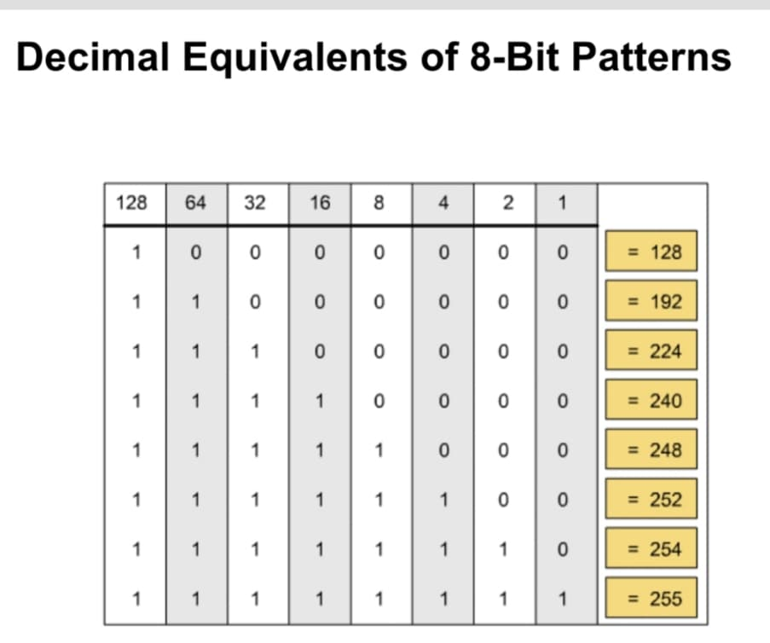IPv6 developed through IETF initiative. The IPv6 overcomes limitations of IPv4, because IPv4 has no provision for network security or advanced routing options and IPv4 offers no options for handling streaming video or video conferencing.IPv6 uses eight 16-bit hexadecimal fields example:1042:0071:0000:0000:07ac:0522:210c:425b.

**Figure 4-5 Decimal Equivalents of 8-bit Decimal Conversion**

**Features of IPv6**

* 128-bit address capability.
* Single address associated with multiple interfaces.
* Address auto configuration and CIDR addressing.
* 40-byte header instead of IPv4’s 20-byte header.
* New IP extension headers for special needs.
* Includes more routing and security options.
* Use of IP security (IPsec).
* Simpler automatic address configuration.
* More compact and efficient routing tables.
* Replacement of ARP by Neighbor Discovery.

**The Role of Subnet Mask**

TCP/IP address require a configured subnet mask. A subnet mask is used for two purposes: to show the class of addressing used, and to divide a network into sub networks to control network traffic. The subnet mask enables an application to determine which part of the address is for the network ID and which is for the host ID, example, and a subnet mask for a Class A network is all binary ones in the first octet and all binary 0s in the remaining octets: 11111111.00000000.00000000.00000000 (255.0.0.0).

**Creating Subnetworks**

To divide the network into subnetworks, the subnet mask contains a subnet ID, determined by the network administrator, which the network and hosts IDs. Example, the entire third octet in a Class B address could be designated to indicate the subnet ID, which would be an octet of 11111111.11111111.11111111.00000000 (255.255.255.0).

Note that using a subnet mask to divide a network into a series of smaller networks enables Layer 3 device effectively ignore traditional address class designations, and therefore, it creates more options for segmenting networks through multiple subnets ad additional network addresses. A newer way to ignore address class designation is using **Classless Interdomain Routing (CIDR)** addressing, which puts a **slash (/)** after the dotted decimal notation. For example, 165.100.18.44/18, meaning 18 bits needed for network ID, 14 for host ID (32 -18)

**Static IP Configuration - Windows 7**

1. Click the Start menu. Next, click on the Control Panel option.

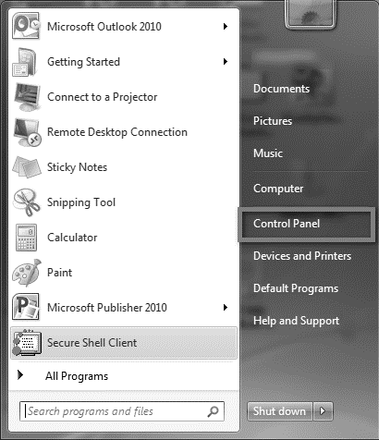

**Figure 4-6 Windows 7 Control Panel**

1. Click on the Network and Sharing Center option.

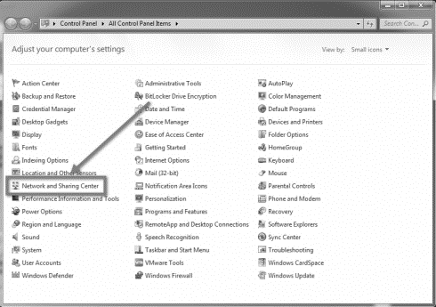

**Figure 4-7 Windows 7 Network Sharing**

1. Click on Change adapter settings from the left side menu.

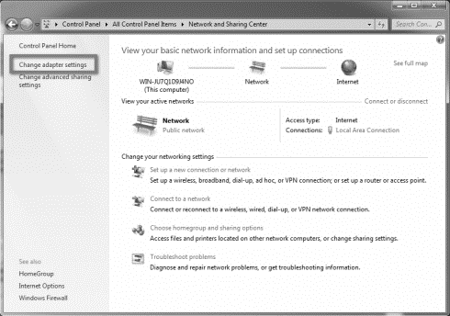

**Figure 4-8 Windows 7 Adapter Settings**

1. Right-click on the Local Area Connection icon, then select Properties.

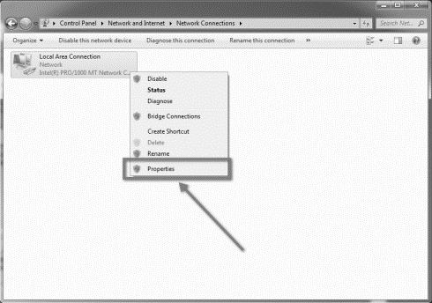

**Figure 4-9 Windows 7 Network Connections**

1. In the window that opens, click on the Internet Protocol Version 4 (TCP/IPv4) (you may need to scroll down to find it). Next, click on the Properties button.

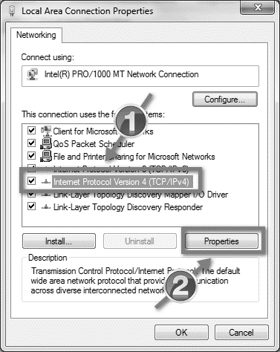

**Figure 4-10 LAN Properties**

1. In the window that opens, click the Use the following IP address: radio button. In the IP address: Subnet mask: and Default gateway: number fields, insert the numbers that were assigned to you by OIT.

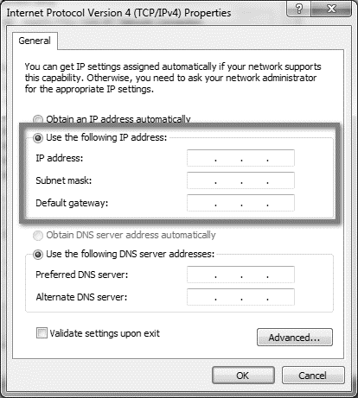

**Figure 4-11 IPv4 Properties**

1. Next, click the Use the following DNS server addresses: radio button. Next, in the Preferred DNS server: and Alternate DNS server: number fields, input the numbers that were assigned by OIT. Then click the OK button.

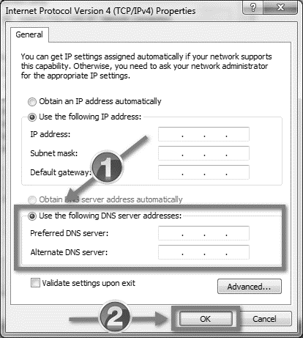

**Figure 4-12 DNS Configuration**

1. Click OK in the other window. You can now start using your new internet connection. If for some reason the internet connection doesn't start working right away, restart the computer and try again.

### To enable DHCP or change other TCP/IP settings in Windows in Windows 8.1

1. Select the **Start**button, start typing **View network connections**, and then select **View network connections**in the list.
2. Right-click the connection that you want to change, and then select **Properties**. If you're prompted for an administrator password or confirmation, type the password or provide confirmation.
3. Select the **Networking** tab. Under **This connection uses the following items**, select either **Internet Protocol Version 4 (TCP/IPv4)** and then select **Properties**.
4. To specify IPv4 IP address settings, do one of the following:
   * To get IP settings automatically using DHCP, select **Obtain an IP address automatically**, and then select **OK**.
   * To specify an IP address, select **Use the following IP address**, and then, in the **IP address, Subnet mask**, and **Default gateway** boxes, type the IP address settings.
5. To specify DNS server address settings, do one of the following:
   * To get a DNS server address automatically using DHCP, select **Obtain DNS server address automatically**, and then select **OK**.
   * To specify a DNS server address, select **Use the following DNS server addresses**, and then, in the **Preferred DNS server** and **Alternate DNS server** boxes, type the addresses of the primary and secondary DNS servers.
6. To change advanced DNS, WINS, and IP settings, select **Advanced**.

### To enable DHCP or change other TCP/IP settings in Windows in Windows 10

1. Select **Start**, then select **Settings** > **Network & Internet**.
2. Do one of the following:

* For a Wi-Fi network, select **Wi-Fi** > **Manage known networks**. Choose the network you want to change the settings for, then select **Properties.**
* For an Ethernet network, select **Ethernet**, then select the Ethernet network you’re connected to.

1. Under **IP assignment**, select **Edit**.
2. Under **Edit IP settings**, select **Automatic (DHCP)** or **Manual**.

To specify IPv4 settings manually:

* Under **Edit IP settings**, choose **Manual**, then turn on **IPv4**.
* To specify an IP address, in the **IP address, Subnet prefix length**, and **Gateway** boxes, type the IP address settings.
* To specify a DNS server address, in the **Preferred DNS** and **Alternate DNS** boxes, type the addresses of the primary and secondary DNS servers.
* When you select **Automatic (DHCP)**, the IP address settings and DNS server address setting are set automatically by your router or other access point (recommended).
* When you select **Manual**, you can manually set your IP address settings and DNS server address.

1. When you’re done, select **Save**.

**SUMMARY**

IP enables data transfer and routing with packet addressing. UDP used with IP (instead of TCP) in certain non-critical situations.

IPv4 is predominantly in use today but has the limitation that IPv4 addresses are almost all used up.

IPv6 is newest version of IP which is not yet employed on many networks.

A subnetting, or sub networking, is the process of splitting a single large network into two or more strands. This means that an otherwise mammoth and unwieldy network can be subdivided into smaller, more localized networks.

The IP Configuration window configures the Internet Protocol parameters, allowing the device to receive and send IP packets. In its factory default configuration, the switch operates as a multiport learning bridge with network connectivity provided by the ports on the switch.