UNIT I: Self from Various Perspectives

LESSON 3

**ANTHROPOLOGICAL PERSPECTIVE OF SELF**

**LEARNING OBJECTIVES**

1. Discover the meaning of Anthropology
2. Identify the subjects of inquiry and goals of Anthropology.
3. Explain anthropological perspectives on culture
4. Describe culture as a complex whole.
5. Identify aspects of culture and society.
6. Recognize the Value of Anthropology for the 21st Century

**Anthropology** is the study of people, past and present. It centers on the understanding of human condition in its cultural aspect. (Gallinero, 2018)

Katherin Ewing, an anthropologist and professor, described the self as encompassing the “physical organism, possessing psychological functioning and social attributes.”

Joseph LeDoux, a neuroscientist, conceptualized the implicit and explicit aspects of the self. He said that self is not static; it is added to and subtracted from by genetic maturation, learning, stress, ageing, and disease.

**TWO ASPECTS OF SELF**

EXPLICIT. The aspect of the self that you are consciously aware of.

IMPLICIT. The aspect of self that is not immediately available to the consciousness.

**Self as representation**

“Self is illusory. People construct a series of self-representations that are based on selected cultural concepts of person and selected chains of personal memories.”

-EWING (1989)

**CULTURE**

It is a method of inherited conceptions uttered in symbolic forms by means of which people communicate, perpetuate, and develop their knowledge and attitudes toward life

Material culture

* Concrete and visible
* Designed by its environment and history

Non-material culture

* Abstract and non-visible
* Values, beliefs, norms, rules, morals, language, organizations, institutions

Anthropology considers human experience as interaction of:

**NATURE**. Genetic inheritance which sets the individual’s potentials.

**NURTURE**. Socio-cultural environment.

“Human beings are cultural animals as they make the meaning of object, persons, behaviors, emotions, and events, and behave in conformity with meanings they presume true”

-Robbins

**SELF AS EMBEDDED IN CULTURE**

Cultural traditions and social practices regulate, express, and transform the human psyche, resulting less in psychic unity for humankind than in ethnic divergences in mind, self, and emotion.

**Two Ways of Self-Construction**

(according to cultural anthropologists)

**INDIVIDUALISTIC CULTURE**. Represents the self as separate, distinct, with emphasis on internal attributes or traits, skills and values

**COLLECTIVISTIC CULTURE**. The essential connection between individual to other people

**Catherine Raeff (2010),** a Developmental Psychologist believed that culture influence how an individual view the following:

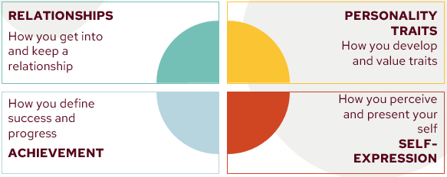

**IDENTITY STRUGGLE**

It is a difference between the identity a person claims to possess and the identity attributed to that person by others

To achieve self-identification, the individuals have to get over many hindrances like traditionally established habits and externally imposed self-images.