UNIT I: Self from Various Perspectives

LESSON 4

**PSYCHOLOGICAL PERSPECTIVE OF SELF**

**LEARNING OBJECTIVES**

1. Explain how self is viewed in the field of psychology
2. Discuss various psychological theories of self-development
3. Describe the fundamental distinctions between self-concepts

**Psychology** It is the scientific study of how human think, feel, and behave. It primarily involves the cognitive aspect of an individual.

Self-theorists argue that it is natural for human to form theories about themselves, both as a single entity and as a group, to make meaning of one’s existence and experience.

Jean Piaget is a Swiss clinical psychologist who was first to make a systematic study of the acquisition of understanding in children. He pioneered the Theory of Cognitive Development and Constructivist Theory.

**BASIC COMPONENTS OF PIAGET’s COGNITIVE THEORY**

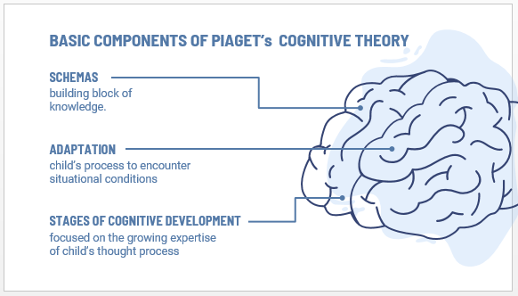

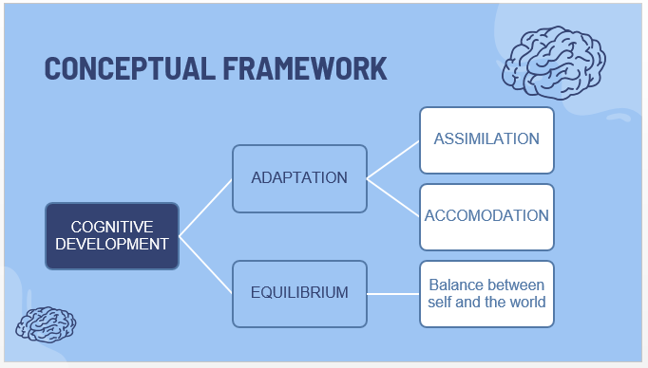

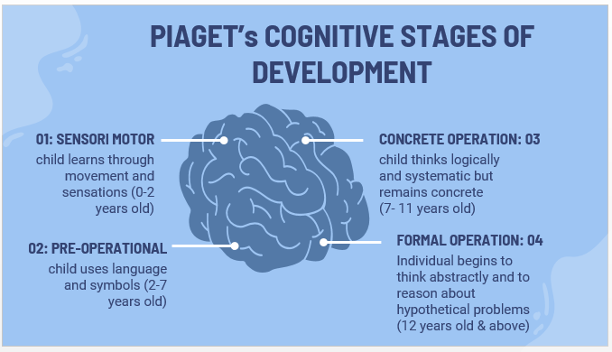

**Dr. Susan Harter** elaborated on the emergence of self-concept and asserted that the wide developmental changes is observe across: early childhood, later childhood, adolescence, emerging adults.

**2 Important Concepts of Self** by Dr. Susan Harter

**Self-esteem**. Also known as self-worth which refers to the individual’s overall acceptance of self. Involves the degree of self-success.

**Self-concept**. Individual perception of self that remains comparatively consistent and steady overtime, context and developmental stages.

**Development of Self Concept** (according to Harter)

1. **Early childhood**. Child describes the self in terms of concrete and observable characteristics.

2. **Middle to late childhood**. Self is described in terms of trait-like constructs.

3. **Adolescence**. Emergence of more abstract self-definitions, such as inner thoughts, emotions, attitudes, and motives.

4. **Emerging Adults**. Having vision of “possible self.”

**SELF IMAGE**

There is a saying that self-image develops as they grow older and a strong one is necessary

**William James**, Father of American Psychology; His ground-breaking masterpiece was “The Principle of Psychology”. He asserted that self lies at the center of mental life.

**2 Elements of Self by William James**

**ME-self** (object). Refers to the individuals personal experiences.

**I-self** (thinker). Rational yet subjective; pure ego

**4 Features of I-self**

(according to William James)

1. *A sense of being the agent or initiator of behavior.* I believe my actions have an impact; that I cause an effect in my environment.

2. *A sense of being unique*. This is how I am different from everything in my environment. I perceive there is only one Me.

3. *A sense of continuity*. I am the same person from day to day.

4. *A sense of awareness about being aware.* I understand what is going on in and around me I know I understand it.

**THREE ASPECTS OF SELF-HOOD or DIMENSIONS OF ME-SELF**

*Material self.* Physical appearance.

*Social Self*. Social Skills and interpersonal skills.

*Spiritual self*. Personality, character and defining values.

**Carl Rogers** is an American psychologist who was one of the founders of humanistic approach to psychology. He asserted that all behavior is motivated by self-actualizing tendencies and these drive you to reach your potential.

1. **Ideal self**

* Notions influenced by parents
* What you admire in others
* What society sees acceptable
* What you think is the best interest

2. **Real self**

* One who you are
* It is how you behave in a certain situation
* It is who you are in reality
* How you think, feel, and act

***CONGRUENCE***. Rogers also suggests that people tend to have a concept of their “ideal self.” The problem is that our image of who we think we should be does not always match up with our perceptions of who we are today. When our self-image does not line up with our ideal self, we are in a state of incongruence.

**Roy Baumeister**, a social psychologist who said that the concept of the self loses its meaning if a person has multiple selves... The essence of the self involves integration of diverse experiences into a unity...In short unity is one of the defining features of selfhood and identity.

***Unity of consciousness*** is the concept that at any given moment the contents of consciousness are experienced as a single integrated state, even though they will consist of a multiplicity of perceptions, thoughts, feelings, and so forth.

**Gordon Allport** proposed the theory called “Personality Trait Theory”, asserting that every person possess “traits.”, which are essential characteristics that never, ever changes and sticks with you all your life.

**Eric** **Berne**, a psychiatrist who developed the “Transactional Analysis Model” as the basis for understanding behavior. He also conceptualized three parts of a person known as “EGO STATES”

**Two Notions in Transactional Analysis**

1. Every person has three parts called “ego states” in his/her personality.

2. People communicate with one another assuming riles of any of these ego states.

**EGO STATES**

*Parent Ego state*. The voice of authority

*Adult Ego state*. Rational person

*Child Ego states*. Composed of three – natural, little professor, adaptive

**Gregg Henriques**, auniversity professor and author who proposed that the human self has three related, but separable domains.

**Three Domains of Human Self**

(according to Henriques)

1. *Experiential Self*. Described as the theater of consciousness.

2. *Private Self-Conscious*. Described as the narrator or interpreter.

3. *Public Self/Persona*. Described as the image projected to the public

**John Bowlby & Donald Winnicott,** developmental psychologists, asserted that children are very adjusted to their parents’ feelings and needs. They unconsciously acknowledge that they need their parents’ permission in order to survive, so they strive to meet their needs as much as possible.

**CONCEPT OF SELF** by Bowlby and Winnicott

*True Self.* Our feelings and desires.

*False Self*. Changes its behavior, inhibits feelings, and forces needs aside in order to survive.

**Healthy False Self**

* One which allows someone to be functional in the society
* Still connected with the true self

**Unhealthy False Self**

* One that fits into society through forced compliance rather than a desire to adapt