Naka required pero pwede padin mag save kahit hindi lagyan.

Kapag inispam yung save button, nag duduplicate

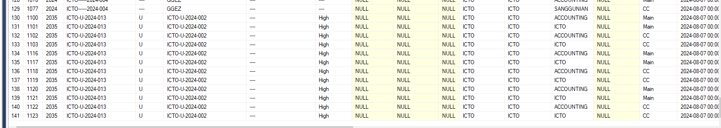

Kapag inispam yung release button, nag duduplicate.

Inispam ko receive button

Wala value yung returned_by although returned na status