zMine User Manual

Objective: Get as much gold in 30 seconds while avoiding enemies and traps!

Controls:

**Move with the arrow keys.** Even if you cannot move in the desired direction, you will be facing that way. Positioning is key!

**Press F five times in a row to mine a wall.** You must be facing that direction, moving or facing another direction will reset the count. Pick a target and do not look back!

**Press Space to place a bomb.** Bombs will detonate in a few seconds, clearing everything in a two tile radius, enemies and players. This will also mine all walls and obtain you gold no matter how far away. Sweet!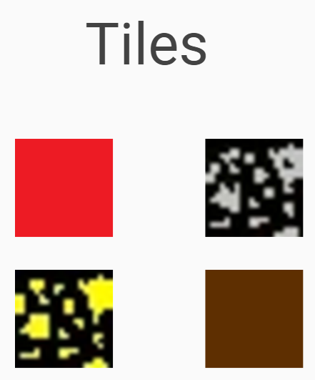

Top left: Trap tile - Kills if the player is standing on or next to it!

Top right: Silver tile

Bottom left: Gold tile

Bottom Right: Dirt tile - Passable

Blue Tile: The spawn point marker.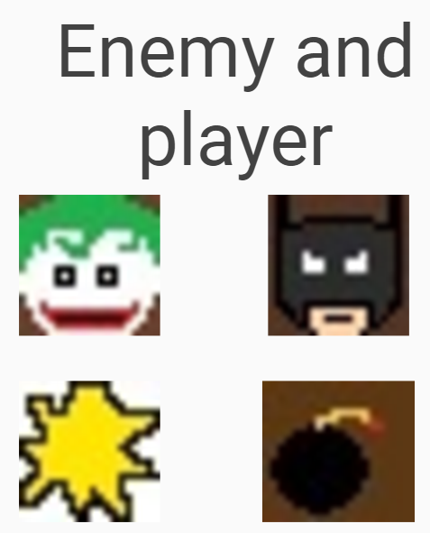

Black Tile: It is junk! Or the fog of war.

Top left: Enemy - Deals damage around it. Stay away!

Top right: It’s the player's sprite, take care of it!

Bottom left: An attack animation for enemies.

Bottom right: A bomb.