# CPRG-352 - Web Application Programming

## Lab 5

## Topic: JSTL

In this lab you will be storing multiple data values in a HttpSession and displaying using JSTL.

You are asked to create a web application called ***ShoppingList*** which allows a user to create a shopping list of items which will be displayed in the browser. The user will be able to register his/her name, and then add or delete items from the list.

The application must store the username and the list of items as an attribute of an ***HttpSession*** in the application.

The application should consist of a single Servlet (ShoppingListServlet) and two jsps (register.jsp, shoppingList.jsp). The only URL is /ShoppingList. For this lab there is no need to create a layered architecture.

Example: user accesses application, sees ShoppingList page

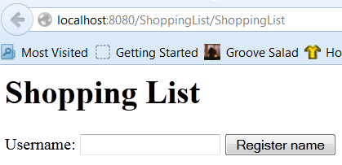

Initially the page shows only a heading and a form allowing the user to enter his/her username (anything is allowed for the username). When the user clicks on the “***Register name***” button, their name is used to create an **HttpSession** for the user. Store the username provided in an attribute of it called “**username**”.

Example: the user has registered a username

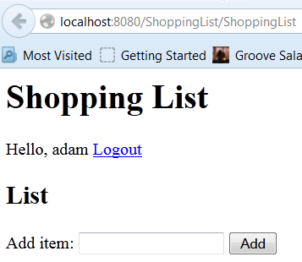

Because the user has registered a username (“**adam**”) the ***ShoppingList*** page now shows a welcome message (including the username), a “***Logout***” hyperlink, and a form allowing the user to add items to his/her shopping list.

Example: user adds “apples” to their list

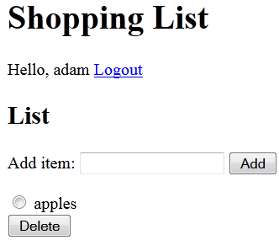

Under the shopping list form “**apples**” is displayed. Beside it is a radio button that the user can select and then click on the “***Delete***” button to delete that item from the list.

Example: user adds a “beachball” to the list

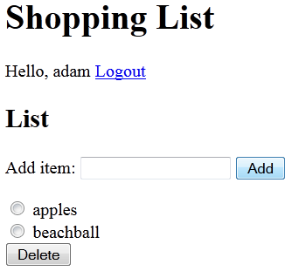

“**beachball**” is added to the bottom of the list. Further items will be added in the same way.

Example: the user deletes “apples” from the list

The user selects the radio button beside “**apples**” and clicks on the “***Delete***” button:

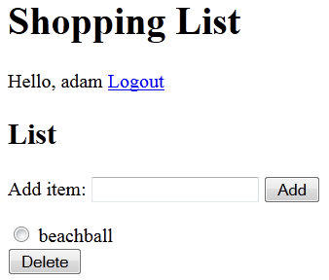

The user should be able to add and delete any items to/from the list as required.

Example: the user logs out of the application

The user clicks on the “***Logout***” hyperlink in the page to leave the application. This link destroys the **HttpSession** for the user.

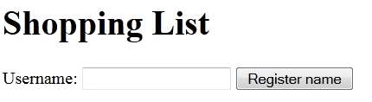

Invalidating (destroying) the **HttpSession** resets the application.

## Application Requirements

Both the username and list of items for the shopping list must be stored in the **HttpSession**. You can store an **ArrayList<String>** (or equivalent data structure of your choice) in the session object and use it to hold the shopping list items. A simple String can hold the username.

All buttons and links, must use the parameter key “action”. The key/value pairs are:

* action=register
* action=add
* action=delete
* action=logout

If you have extra time, add simple pagination. A page consists of 10 items. Allow the user to easily move to next and previous pages.