ROOFTOP ESCAPE — OUTBREAK
Player Feedback Report
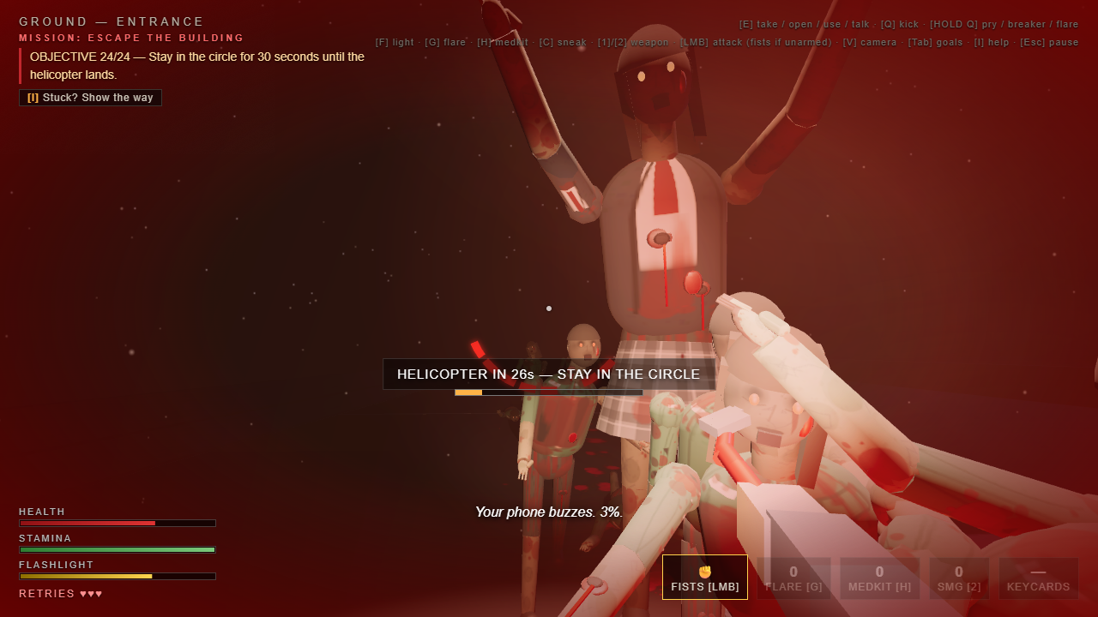
The rooftop finale after the feedback: a 34-zombie siege and the boss that F05 and F06 asked for.
AI + Innovative Design · Open FIESTA, Tsinghua University
Group 01 — Rooftop Escape
Bryan Tjandra (2026280195) · Phan Ngoc Anh (2026280645) · 侯嘉琪 (2026214164)
Play: https://bryan273.github.io/rooftop-escape/
Code: https://github.com/bryan273/rooftop-escape
Collected 19–21 September 2026 · 13 respondents · 14 feedback entries · 16 evidence screenshots

1. Executive summary
Fourteen pieces of feedback were collected from thirteen people over three days, through a structured GitHub issue form and through chat groups (WeChat, QQ, Messenger, WhatsApp, Instagram). Replies came in Chinese, Vietnamese, Indonesian and English; every entry in section 3 is quoted in the original with a translation, and each one is marked with what we did about it.
What players liked (unprompted, repeated by several people): the atmosphere and the sound design — one tester wrote that they “would not dare play alone at night” — the story and the in-world notes, the colour palette and the key prompts, the puzzle progression, and the graphics.
The main criticisms, ordered by how often they came up:
# | Criticism | Raised by | Status
1 | The game is too easy — especially the rooftop finale (“you just stand there and empty a magazine, 1 shot 1 kill”) | F04, F05, F06, F07, F13 | ✅ addressed: enemy health doubled, 34-zombie siege, boss
2 | Zombie AI bugs: aggro across floors, enemies on unvisited floors, a crawler attacking from the floor | F03, F08, F09 | ✅ addressed: grid pathfinding, floor-group fix, no attacks through walls
3 | Onboarding and clarity: not sure what to do next; 14 keys taught at once; wordy instructions | F10, F11, F13 | 🟡 partly: one-line mission + [I] help and arrow; staged onboarding still planned
4 | UI bug: [Esc] in a note popup opened the pause menu | F08, F11 | ✅ fixed
5 | Polish: camera snapping 180°, no gun tracer, footsteps revealing hidden zombies | F11, F13, F14 | 🔭 planned — the camera snap is the top open defect
Fifteen concrete changes shipped as a direct result of this feedback (section 4); nine items remain open and are listed with reasons in section 5.

2. How the feedback was collected
Channel | How | Entries
GitHub Issues — structured form (mode · how far · best moment · most frustrating moment · bugs) | The play link was shared together with the issue link | F03, F04, F10
WeChat / QQ group chats (classmates) | Play link posted in the group, free-form replies | F01, F02, F08, F14
Messenger / WhatsApp / Instagram (friends outside the course) | Play link sent one-to-one with a request for honest criticism | F05, F06, F07, F09, F11, F12, F13
The structured form asks the same five questions every time, so answers can be compared; the chat conversations were unfiltered and produced most of the bug reports. Screenshots of every reply are embedded in section 3 and also included as separate files in 04_Feedback/evidence/.

3. Feedback log — every entry, the evidence, and the action taken
Legend: ✅ implemented · 🟡 partly implemented · 🔭 planned (future work) · 💬 praise, no action needed.

F01 — cp_cp
WeChat group · 21 Sep 2026
「感觉配色挺好看、然后按键提示也很详细。」
Translation: “The colour palette looks good, and the key prompts are very detailed.”
💬 PRAISE — no action needed
What we did: Kept as a constraint when we later simplified the HUD: the on-screen key legend stays visible at all times (see F13).
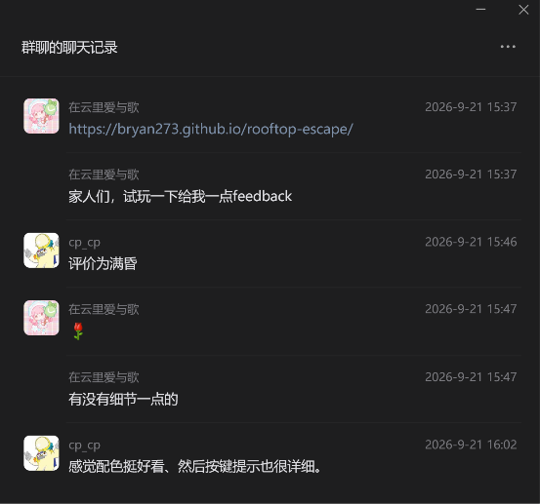
Evidence F01 — F01.png

F02 — Meo
WeChat group · 21 Sep 2026
「很有氛围感，音乐恰到好处，指示做的也不错，晚上不敢一个人玩。」
Translation: “Great atmosphere, the music is just right, the instructions are well done — I would not dare play alone at night.”
💬 PRAISE — no action needed
What we did: Validates the audio design (heartbeat/tension system, recorded SFX, environmental audio).

Evidence F02 — F02.png

F03 — Oranger-I
GitHub issue #2 · structured form
Mode: Nightmare · How far: 14 mins · Best moment: “shoot teacher Pu” · Most frustrating: “A zombie is lying on the ground attacking me” · Bugs: zero
🟡 PARTLY IMPLEMENTED
What we did: The crawler was hard to read and hard to fight. It now carries a health bar above its body (lowered for the crawling pose), and bare fists were added as a permanent fallback weapon, so being caught empty-handed is no longer helpless. Commit 29293e1. Still open: a dedicated “shake it off” reaction when a crawler grabs your ankles.
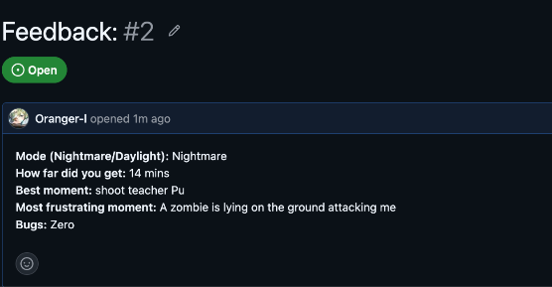
Evidence F03 — F03.png

F04 — phantuanhung1998-coder
GitHub issue #1
“1. The story is great. 2. I was able to play through the whole game. 3. You should add difficulty levels. 4. The zombies’ design should be more terrifying. 5. Add more weapons. 6. Overall really good — you should make a sequel.”
🟡 PARTLY IMPLEMENTED
What we did: Difficulty (3): raised across the board instead of a separate slider — enemy health roughly doubled (shambler 3→7 hp), the rooftop sends up to 34 enemies, and a boss was added; the two modes (Nightmare / Daylight Drill) remain the selectable difficulty. Scarier design (4) and more weapons (5) are future work — the current roster is fists / crowbar / SMG plus flares.
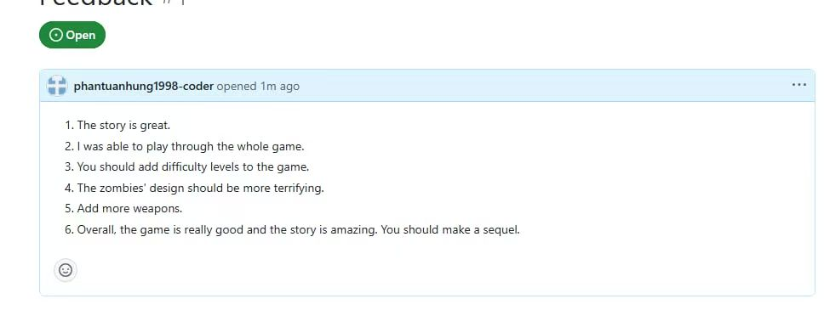
Evidence F04 — F04.png

F05 — Nguyễn Phùng Huy
Messenger · 19 Sep 2026
“…khi đã lên đến tầng thượng thì cảm giác muốn win game của người chơi rất cao, kiểu boss ở màn cuối ấy, nên nếu m tăng thêm chi tiết cho zom … cũng tăng thêm phần kịch tính với cả thú vị cho game.”
Translation: “Once you reach the rooftop the player really wants to win — it feels like it should have a boss for the final stage. Adding more detail to the zombies would make it more dramatic and more fun.”
✅ IMPLEMENTED
What we did: The finale now ends with a named boss, THE BUTCHER: 1.75× size, 60 hp (about ten SMG rounds), a permanent health bar, and its own entrance as it climbs over the parapet ~16 s after the flare is lit. Commit 29293e1.
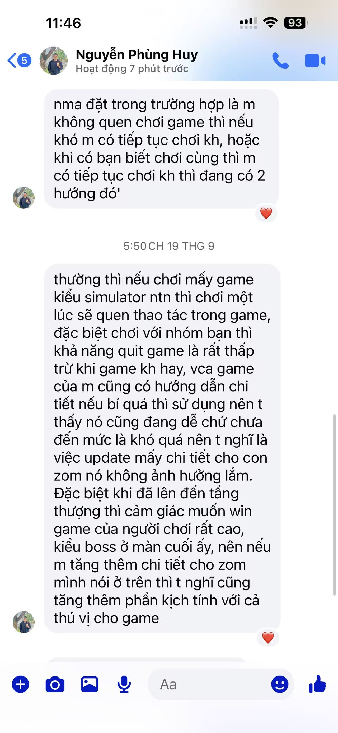
Evidence F05 — F05.png

F06 — Nguyễn Phùng Huy
Messenger · same session
“uh thế có khi m phải up cái level ở sân thượng lên, đạn m cho nhiều thì chỉ cần đứng sấy nguyên một băng như thế thì ez quá … uh bắn nó cũng dễ chết, 1 phát 1 … kiểu đứng trong cái vòng đó thì phải kịch tính hơn, vd bno lao từ tứ phía.”
Translation: “You should raise the level of the rooftop: with that much ammo you just stand there and empty a magazine — too easy. They also die in one shot. Holding that circle should be more dramatic — for example, have them charge in from all sides.”
✅ IMPLEMENTED
What we did: A shambler now takes two body shots (one head shot) and a brute three; the 30-second hold sends up to 34 zombies in waves of four every four seconds, entering from four directions — the roof door, both parapets and the west face. Commit 29293e1.
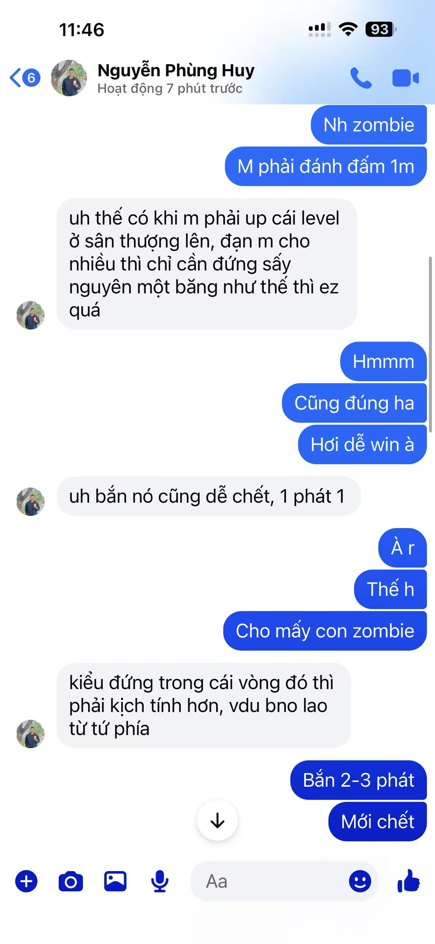
Evidence F06 — F06.png

F07 — Nguyễn Phùng Huy
Messenger · same session
“Còn về phần đồ họa với cả cốt truyện thì quá ok rồi … nếu m có thời gian thì có thể tăng độ khó lên một tí chẳng hạn: cho mấy con zom chạy nhanh hơn, sống dai hơn làm cho người chơi dễ chết hơn để tăng tính replay.”
Translation: “Graphics and story are already great … if you have time, raise the difficulty a bit: make the zombies faster and tankier so the player dies more easily — it adds replay value.”
🟡 PARTLY IMPLEMENTED
What we did: “Tankier” is done (health roughly doubled, boss added). “Faster” was deliberately not applied globally: enemies already move at three different paces (0.8× / 1.0× / 1.18×) and uniformly faster enemies removed the stalking tension in playtests. A separate Hard mode that raises speed on top of the current tuning is the planned next step.
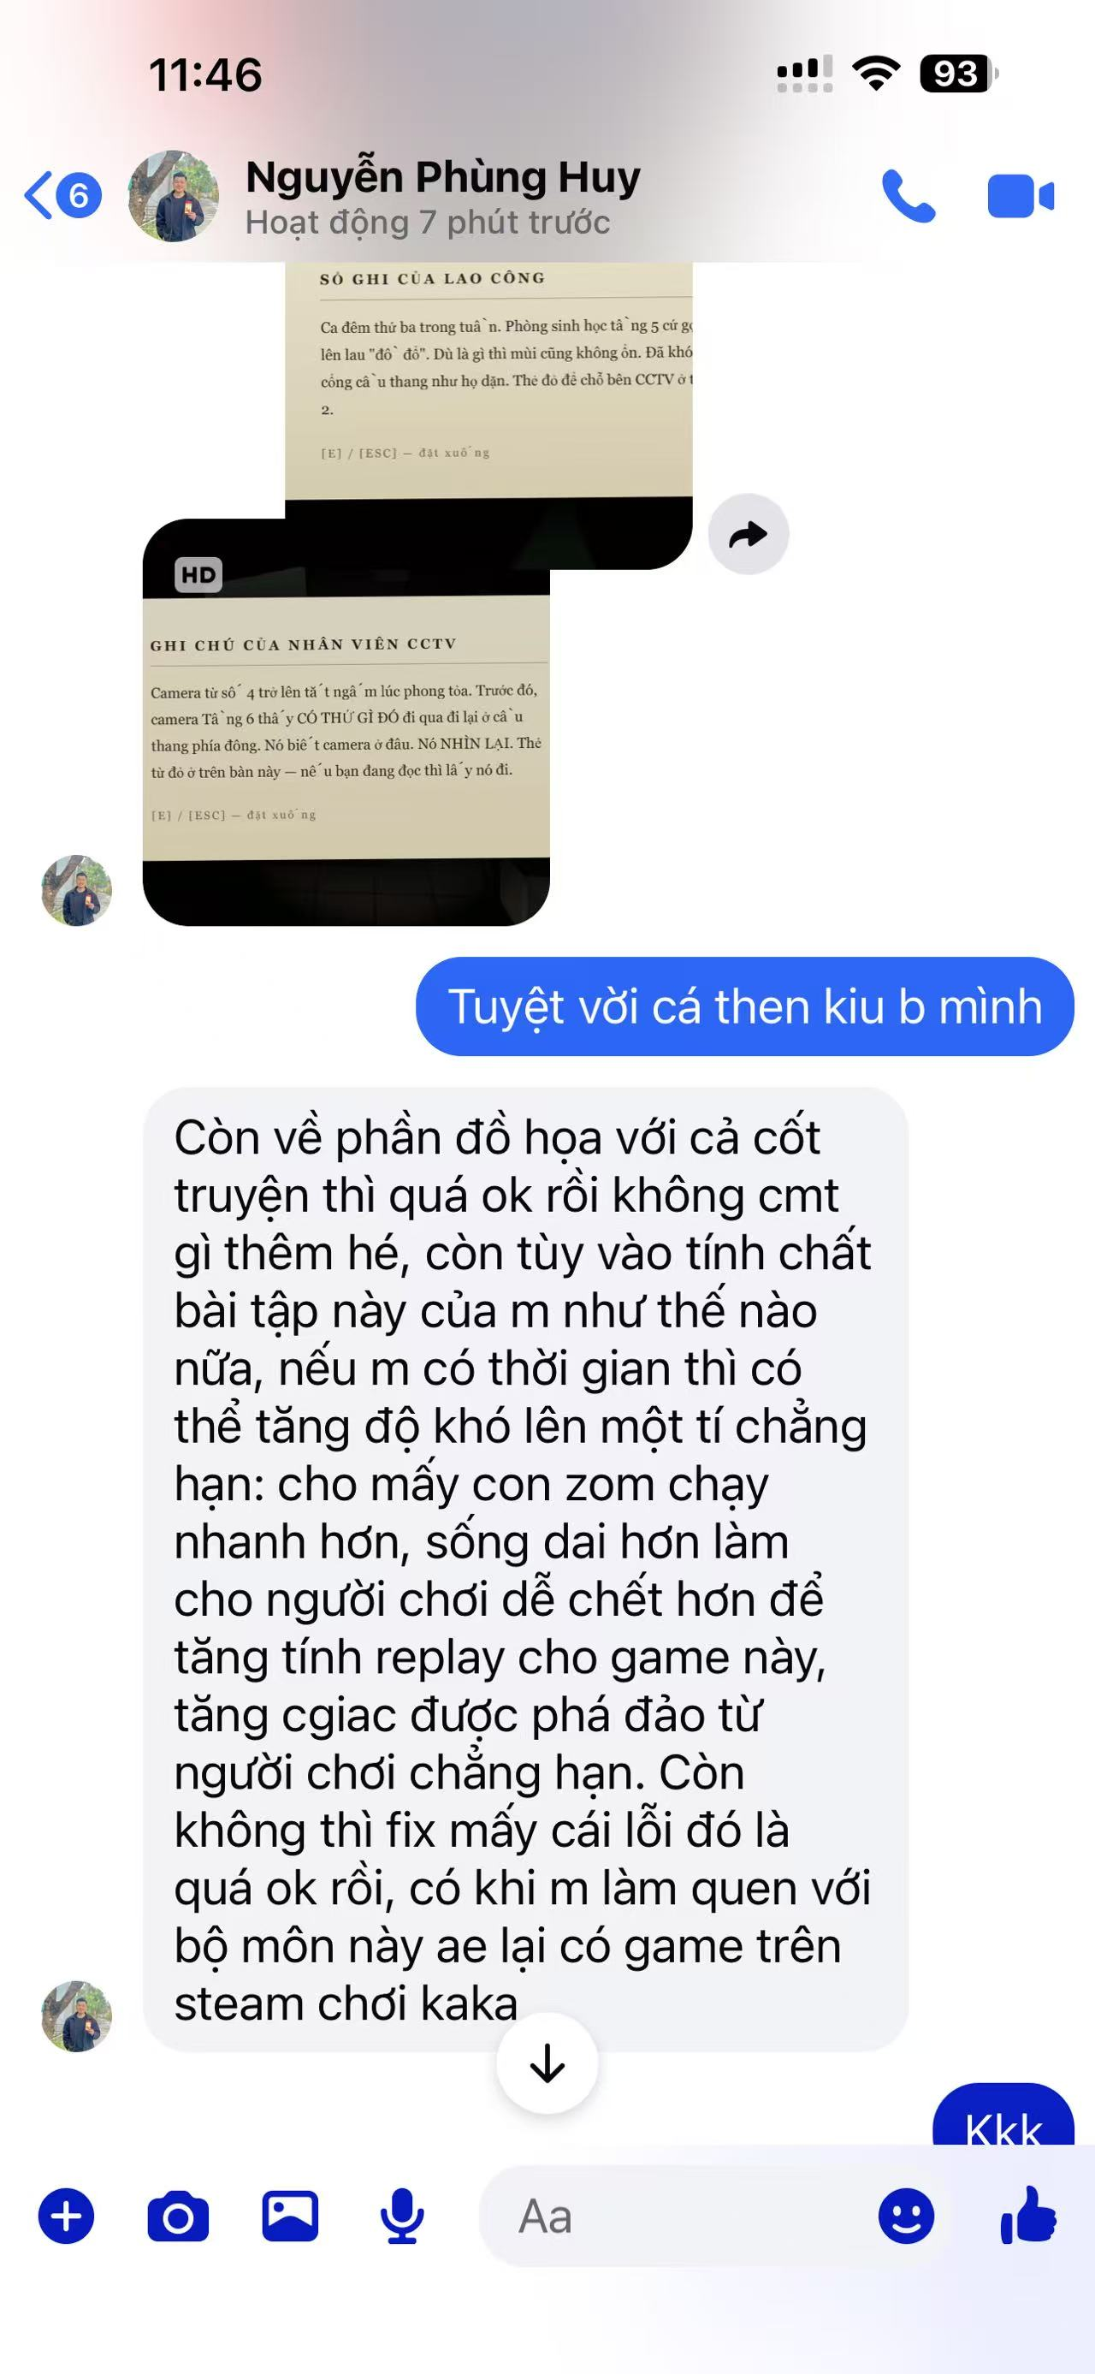
Evidence F07 — F07.png

F08 — 堂前燕
QQ group · 21 Sep 2026
「小怪的机制是不是有点问题，疑似会刷除了还没去过的层级的怪」/「一直在走来走去有音效」/「交互物品出二级菜单时，提示可以按 e 或 esc 退出，实际按 esc 的话会跳到暂停页面」
Translation: “Is something wrong with the enemy mechanic? It seems to spawn enemies on floors I have not visited yet.” / “There is a footstep sound the whole time while walking around.” / “When an item opens a second-level menu the hint says press E or Esc to exit, but pressing Esc jumps to the pause screen.”
✅ IMPLEMENTED
What we did: Esc bug fixed — Esc inside a note or second-level popup now closes the popup instead of opening the pause menu (commit 427932d). Enemies on unvisited floors fixed — a zombie that changed floor stayed rendered in its old floor group, so it appeared in the wrong place; it now moves to its current floor group (commit 8bb092d). Footstep audio is distance-attenuated and was reduced again in commit 8376491; an explicit volume option is planned.

Evidence F08 — F08.png

F09 — Leonardo Matthew 姚毅海
Chat (Indonesian)
“aku udah main sampek floor 3 … tapiii ada satu problem ko: zombie dari floor atas bisa ke agro waktu masih di floor bawah. trus waktu pindah floor misale dari floor 1 ke floor 2 zombie nya kan ke agro waktu kita naik tapi zombie ne lari ke arah satunya … Tapi function e sama guide e jelas seh, lumayan cepet pahame.”
Translation: “I played up to floor 3 … but there is one problem: zombies on the floor above aggro while you are still on the floor below. And when you move from floor 1 to floor 2 they aggro but then run the other way … the functions and the guide are clear though, easy to pick up.”
✅ IMPLEMENTED
What we did: Two root causes. (a) Targeting read the player’s floor from the wrong field, so a zombie one floor up believed you were next to it. (b) Movement was straight-line steering, so once it lost the direct line it walked into a wall and looked like it was running the wrong way. Zombies now use a 0.5 m walkable grid with a breadth-first flow field per floor: they leave the room through the doorway, round partitions and follow the corridor. Commits 8bb092d and f255fc9.
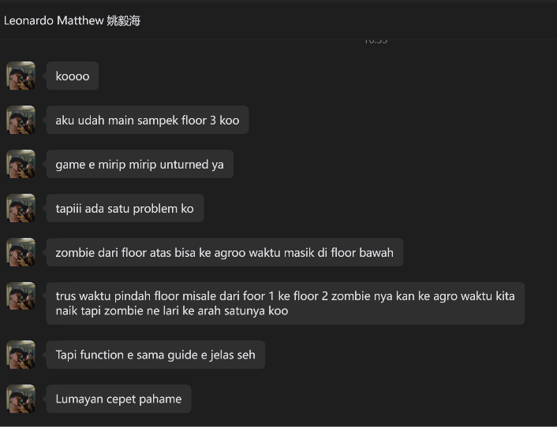
Evidence F09 — F09.png

F10 — bihurin31204
GitHub issue #3 · structured form
Mode: Daylight. Best moment: “exploring the environment and figuring out what to do next. The puzzle progression and atmosphere make the game feel engaging, and the dynamic audio adds to the tension.” Most frustrating: “Sometimes I wasn’t completely sure what I was supposed to do next, especially when there were multiple areas to explore. A slightly clearer objective indicator could make the progression easier to follow.” Bugs: none.
✅ IMPLEMENTED
What we did: The HUD always shows a one-line mission; pressing [I] opens the “HOW” panel together with the objective arrow and the distance to it. The arrow stays hidden until asked for on purpose — exploring first is the intended experience and the help is one key away.
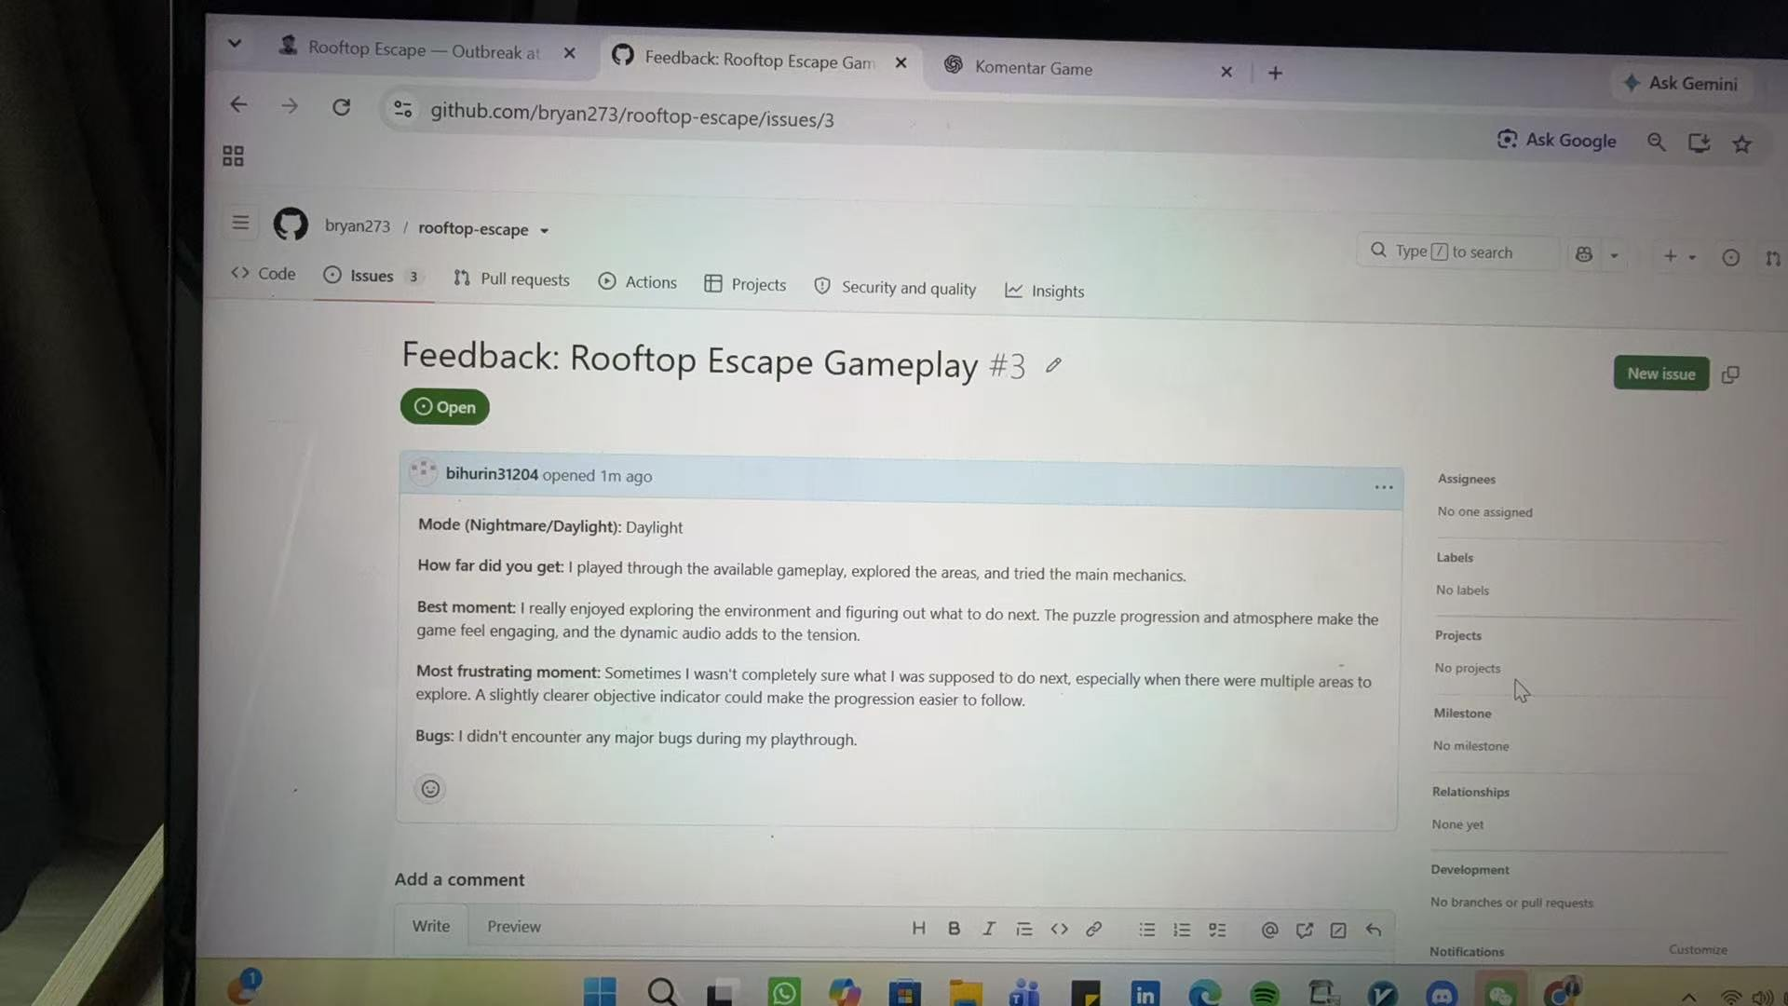
Evidence F10 — F10.png

F11 — Hani
Chat (Indonesian)
“GW HRS MAIN YG NIGHT MODE JG NIH — jantungku” / “yg night mode kalo mau lu bikin lebih serem lagi kayaknya kasih satu lantai gak ada suara zombie jadi tenang gitu, terus nanti tiba-tiba pas buka pintu ada jumpscare zombienya didepan mukalu” / “kadang tuh gua ke-spoiler sama zombienya karena ada suara langkah mereka” / “apa itu item item depan pintu ngalangin” / “stairs nunjuk sono tapi jalan buntu” / “tombol esc, resume kadang error”
Translation: “I had to play night mode too — my heart!” / “To make night mode scarier: give one floor with no zombie sounds so it feels calm, then a jumpscare right in your face when you open a door.” / “Sometimes the zombies are spoiled for me by their footsteps.” / “What are those items blocking the door?” / “The stairs arrow points there but it is a dead end.” / “The Esc / resume button sometimes errors.”
✅ IMPLEMENTED
What we did: Esc/resume fixed (commit 427932d). Floor arrows were rotated the wrong way and pointed away from the stairwell — fixed. Doorways now have a keep-clear zone so loot and furniture cannot spawn in front of a door. Planned: the silent-floor-then-door-jumpscare pacing beat, and a quiet stalker variant so footsteps do not always give enemies away (removing footsteps outright would break the threat ring, which is the game’s main readability tool).
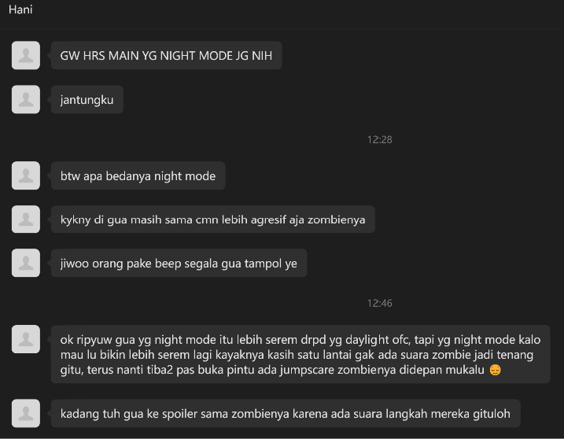
Evidence F11 — F11-a.png
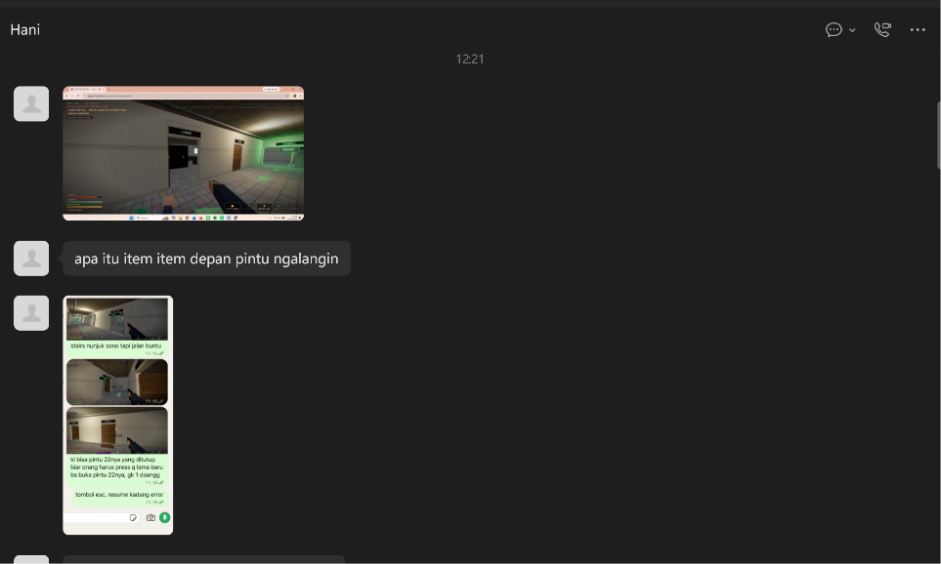
Evidence F11 — F11-b.png

F12 — Daniel Ferdiansyah
Chat (Indonesian)
“soundnya ngeri juga wokwkw” / “anjirr grafisnya oke juga kak” / “bikin solo kah”
Translation: “The sound is genuinely scary.” / “The graphics are good too.” / “Did you make this solo?”
💬 PRAISE — no action needed
What we did: No action — audio and visuals confirmed as strengths.
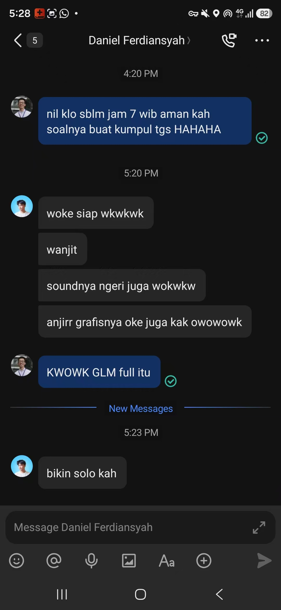
Evidence F12 — F12.png

F13 — Bryan ’Ilman
Chat (Indonesian) · two sessions with screen recordings
“di level beginner kenapa terang banget jadi fungsi flashlight ga dibutuhkan” / “camera kadang gabisa gerak ke arah kanan, kayak layarnya mentok sampe tengah” / “gw kesusahan cari backup generator setelah dapet red key, butuh petunjuk yg clear, singkat/padat krn yg skrng kerasa terlalu bertele-tele” / “resources terlalu banyak untuk survival game” / “HUDnya langsung nyemplungin 14 tombol di dua baris atas, plus objective, plus hint, plus subtitle radio … mungkin ajarin 3 tombol dulu (WASD, E, Q), sisanya munculin pas pertama kali dibutuhin” / “konsekuensi ketika bunuh Ji-eun ga terlalu kerasa ke gameplay, tapi dari segi cerita oke sih”
Translation: “In beginner level it is so bright the flashlight is not needed.” / “The camera sometimes cannot turn right, as if the screen stops halfway.” / “I struggled to find the backup generator after the red key; the instructions need to be clear and concise — the current ones are too long-winded.” / “Too many resources for a survival game.” / “The HUD drops 14 keys on you at once, plus objective, plus hint, plus radio subtitle … maybe teach three keys first (WASD, E, Q) and reveal the rest when they are first needed.” / “Killing Ji-eun has no real gameplay consequence, though it works story-wise.”
✅ IMPLEMENTED
What we did: Ji-eun consequence implemented: about 2.6 s after she dies the safe room is breached and ten zombies (one a brute) come down the corridor, with a message that says plainly why (commit 29293e1). Instruction length fixed: a one-line objective, with the step-by-step “HOW” behind [I]. Partly done: enemies need two to four times more hits, so the same loot is consumed far faster — an explicit loot reduction for Nightmare is still planned; and the mission panel and arrow are now hidden by default, but the full staged onboarding (teach WASD/E/Q first) is planned. Open bug: the camera occasionally stops turning right — highest-priority remaining defect, see F14. Daylight Drill is intentionally bright; the flashlight matters in Nightmare.
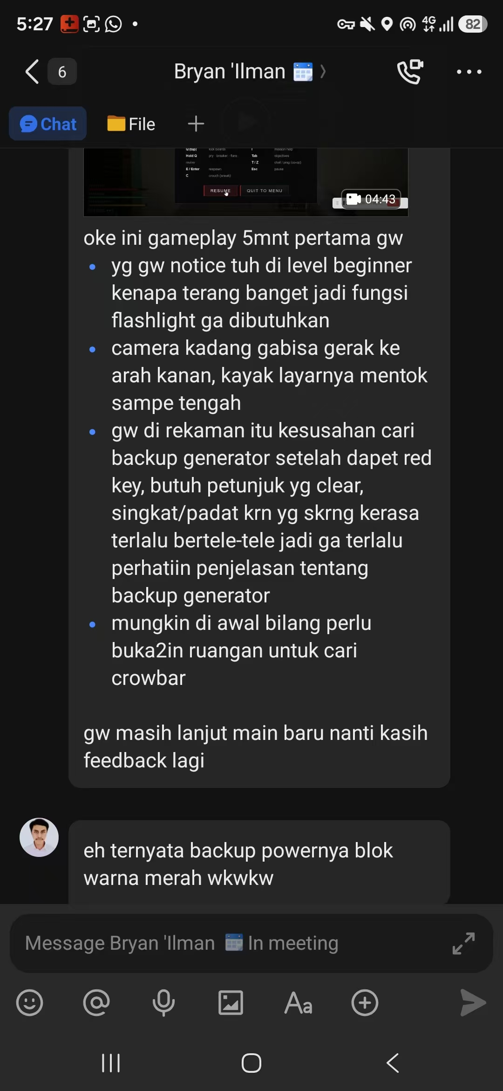
Evidence F13 — F13-a.png
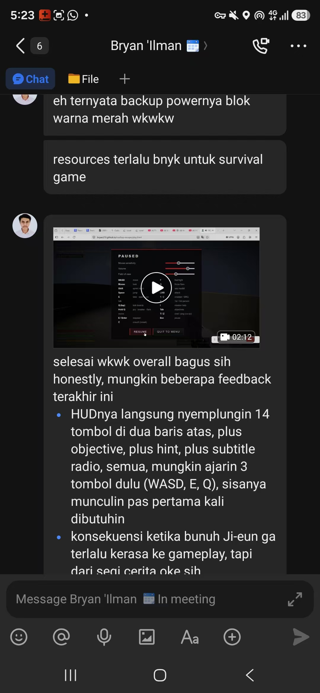
Evidence F13 — F13-b.png

F14 — FLAME · 一天八十根树枝
WeChat group · 21 Sep 2026
「枪械没有弹道和开火特效」/「转视角的时候有时候会突然转到180度」
Translation: “The gun has no tracer or muzzle-flash effect.” / “When turning the camera it sometimes suddenly snaps 180 degrees.”
🔭 PLANNED (future work)
What we did: Gun VFX: there is a muzzle light but no tracer; a tracer line plus a brighter flash is a small, high-value polish item. Camera snap: reported independently by F13, which makes it the most important remaining defect. Suspected cause is a large accumulated mouse delta delivered in one event after pointer lock is re-acquired; planned fix is to clamp the per-event delta and drop the first event after a lock change.
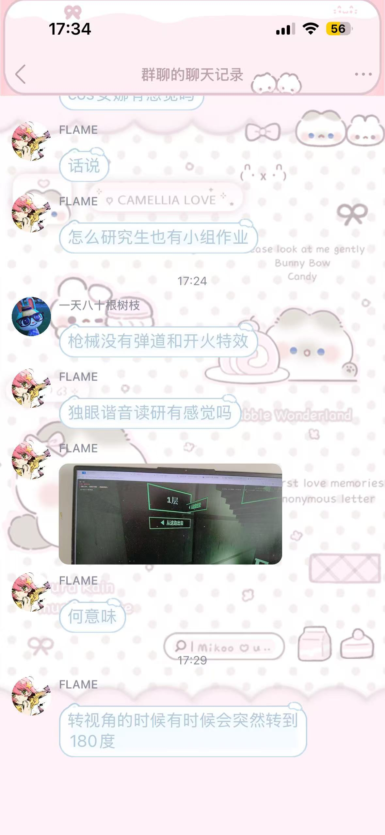
Evidence F14 — F14.png

4. What changed because of this feedback
# | Change shipped | Asked for by | Commit
1 | Rooftop boss “THE BUTCHER” (60 hp, ~10 SMG rounds, permanent health bar) | F05 | 29293e1
2 | Rooftop siege: up to 34 zombies, waves of 4, from 4 directions, mixed types | F06, F07 | 29293e1
3 | Enemies take 2–4× more killing (shambler 3→7 hp, brute 8→16; head shots still reward aim) | F04, F06, F07, F13 | 29293e1
4 | Health bar above hurt enemies | F03 | 29293e1
5 | Bare fists as a permanent fallback weapon (~4 punches per shambler) | F03 | 29293e1
6 | Killing Ji-eun now has a gameplay consequence (10 zombies breach the safe room) | F13 | 29293e1
7 | Objective arrow + “HOW” panel on [I]; one-line mission otherwise | F10, F13 | 8065279, 29293e1
8 | Zombie pathfinding: 0.5 m walkable grid + BFS flow field (they use doors and corridors) | F09, F08 | 8bb092d, f255fc9
9 | No attacks through walls or closed doors (reach test separated from line of sight) | F09, F03 | 8bb092d
10 | Fully hidden enemies are no longer drawn — no arms poking through thin walls | F11, F09 | f255fc9
11 | Zombies rendered on the wrong floor group (appearing on unvisited floors) fixed | F08 | 8bb092d
12 | [Esc] closes a note instead of opening the pause menu | F08, F11 | 427932d
13 | Floor arrows and the stairwell sign pointed the wrong way; overlapping signs fixed; doorways kept clear of loot | F11 | 8065279, 8330792
14 | Ambient audio lowered; distant breathing removed | F08 | 8376491
15 | Laptops with touchscreens were wrongly blocked as “mobile device” | reported while sharing the link | 98aecf8

5. Open items and future work
Priority | Item | From
High | Camera occasionally snaps 180° / stops turning right (clamp per-event mouse delta; drop the first event after a pointer-lock change) | F13, F14
High | Staged onboarding: teach WASD/E/Q first, reveal each key the first time it is needed | F13
Medium | Lower loot density in Nightmare (“too many resources for a survival game”) | F13
Medium | Scarier enemy design; a Hard mode that also raises speed | F04, F07
Medium | More weapons (shotgun, heavier melee) | F04
Medium | Pacing beat: one deliberately silent floor, then a door jumpscare | F11
Low | Gun tracer and a stronger muzzle flash | F14
Low | Quiet stalker variant so footsteps do not always give enemies away | F11, F08
Low | Crawler “shake it off” interaction when it grabs your ankles | F03

6. Notes on this report
Every quote is transcribed from the screenshots reproduced in section 3; the translations are ours. Nothing has been invented or softened — the criticism section is deliberately longer than the praise section.
F05, F06 and F07 are the same person across one conversation, so fourteen entries represent thirteen distinct people and sixteen evidence images.
Feedback we did not act on is listed in section 5 with the reason, rather than being left out.
Verification: the changes in section 4 are covered by the project’s headless test harness, which plays the full 24-step mission chain on every build and currently passes 64/64 (Nightmare), 66/66 (Daylight), 64/64 (Chinese) and 61/61 (co-op) checks, plus a two-browser co-op test at 17/17.

