**2020/21 Semester 2 CX1104 Lab 4 (3 Questions)**

**Q1a**. **Write a program to test** if a set of vectors {v1,v2,…,vn} is an **orthogonal set.**

**Q1b**. Output which pairs are not orthogonal. Test it for the column vectors of A, where

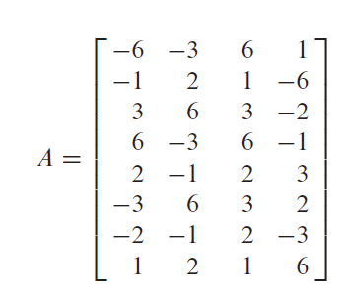

**Q1c.** Is it always true (in executing program on dot product) that 2 vectors **v.w** ≠ 0 means **v** is not orthogonal to **w**? If it is not necessary true, give an example and propose a fix.

**Q2.** Write a module **“Orthonormalisation”** that defines a a procedure orthonormalise(L) with the following specs:

* Input: a list L of linearly independent Vecs
* Output: a list L* of len(L) **orthonormal** Vecs such that, for i= 1,2,…, len(L), the first i Vecs of L* and the first i Vecs of L span the same space.

Hint: Your can follow this outline or you can use your own preferred method:

1. Define orthogonalise(L) first, then call upon it,
2. Compute the list of norms of the resulting vectors, and
3. Return the list resulting from normalizing each of the vectors resulting from Step 1.
4. Display your output if the input list of Vecs is [4,3,1,2], [8,9,-5,-5], [10,1,-1,5].

**Q3a.** **Write a program** to **compute the QR factorization of matrix A = QR**, where Q is orthonormal and R is upper triangular. (refer to lecture notes for the theory). You may assume A consists of linearly independent vectors.

**Q3b.** Compute the QR factorization of **A, formed by the 3 column vectors in Q2**.