Cheng Zhong

ANLY 503

Nov 17th 208

Professor Ami Gates

ANLY 503 Individual Assignment 2 Write Up

This program will first read 400 human face images into the program as a matrix. Each column in the matrix will represent an image (10304 pixels each). Then the program will find the mean face of 400 images and use PCA to reduce the dimension in order to find the top k eigenfaces. The user can choose any k value between 1 and 400. What is more, the program will input a test image and find the most similar image from the database.

1. The first function in the program ***image_to_matrix()*** will read all the pictures into the program as a matrix. Each row represents an image and then we make the transpose to the matrix and the function will return the transpose matrix. Each column will represent an image and there are 10304 rows which means that each image has 10304 pixels.

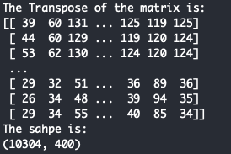

1. The second function in the program ***plot_mean_face()*** will calculate the mean value of each row in the matrix and generate a mean vector that represents the mean face. Also, the function will show the mean face image and return the mean vector and a normalized matrix. By subtract the mean vector from the original matrix, we got the normalized matrix.

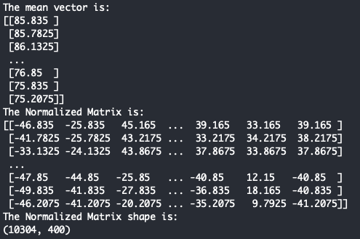

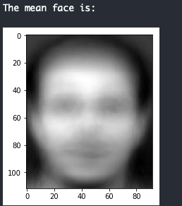

1. The third part of the program includes three functions: ***image_pca(), k_select(), projected_eigenvec()***. The three functions will perform the PCA process and calculate the eigenvalues and eigenvectors. Also, the k_select() function will ask user to pick a k number between 1 and 400. The functions will return a sorted eigenvalues vector and a matrix include all the eigenvectors.
   * Explanation on Eigenvalues and Eigenvectors:

If v is a nonzero vector and λ is a number such that Av = λv, then v is said to be an eigenvector of A with eigenvalue λ.

* + Explanation on PCA:
    - * 1. For example, we take the normalized image matrix from the second function as matrix *A*. Matrix *A* is a 10304*400 matrix.
        2. Then the reduced version of the covariance matrix is *C’*.
        3. *C’ =ATA* which is a 400*400 matrix.
        4. Thus we have *ATAV = λV => C’V = λV*, *V* is the eigenvector for *C*’. The shape of V is 400*400
        5. We choose the k highest eigenvalues and corresponding eigenvectors. The k vectors are best account for the distribution of the face images which is the PCA that reduced the dimension of the matrix. Then the shape of reduced V becomes 400*k
        6. Then we have *(AAT )AV = λ(AV)*, so *AV* is the eigenvectors *for AAT*. The shape for *AAT*is 10304*10304, we have the shape of *AV* is 10304*k. Thus *AV* is the eigenfaces and we projected it back to the normal space.

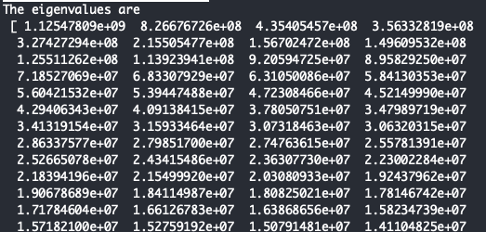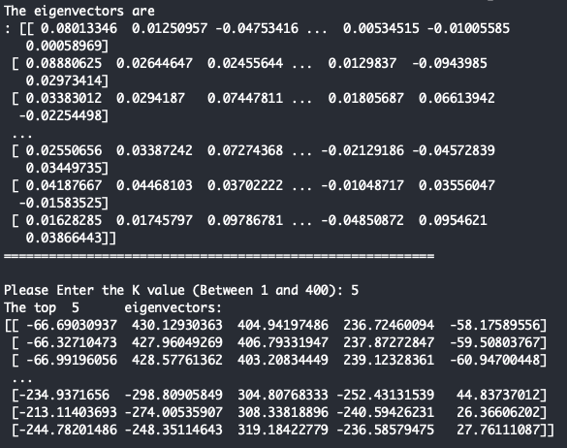

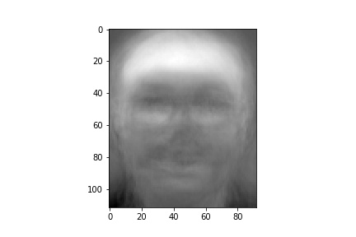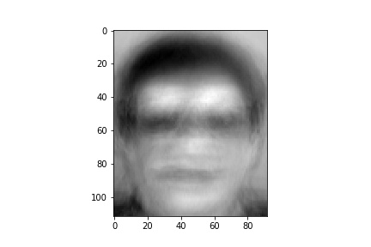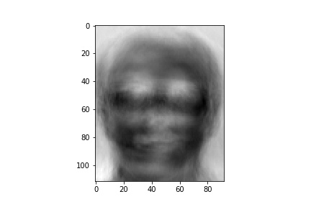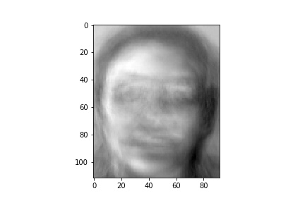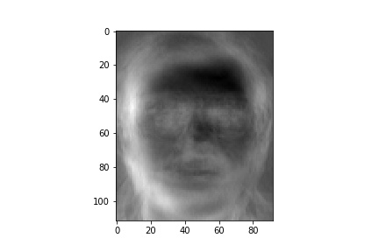

(The top 5 eigenfaces)

1. The last part of the program is the function ***face_prediction()*** predicting an input face image. The function will take an input image and save it as a jpg file. Then do the previous process like read it into a matrix, calculate the mean face, do the PCA and project it to eigenface reduced space using the eigenfaces matrix. Then it will compare this image to every other image in the database and calculate the Euclidean distance between each face in database and the test face. Thus the image has the smallest distance will be the predicted image in the database.

Test Result:

Test1: For test 1, I used the picture in filepath ﻿FACESdata/s16/8.pgm as the test image. And the result shows that the distance is 0 and it successfully detected the same image in the database.

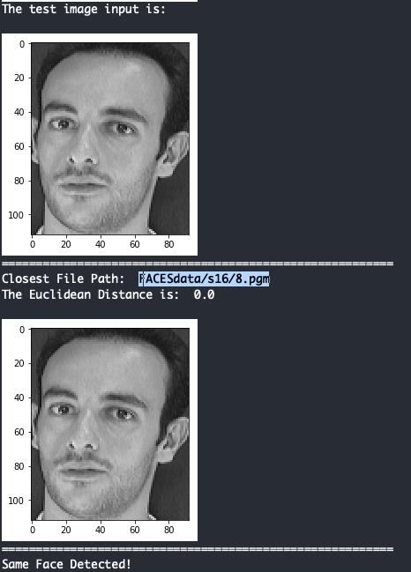

Test 2: For test 2, I removed the picture in filepath ﻿ ﻿FACESdata/s24/1.pgm as the test image. And the program successfully detected another face image in the same folder has the smallest distance. From the picture, we can see that these two people are obviously the same person.

