# Auditor Guide

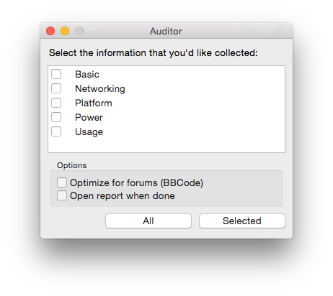

## Heading 2

View and edit this document in Word on your computer, tablet, or phone. You can edit text; easily insert content such as pictures, shapes, and tables; and seamlessly save the document to the cloud from Word on your Windows, Mac, Android, or iOS device.

“Quote”

Use styles to easily format your Word documents in no time:

* For example, this text uses the List Bullet style.
* On the Home tab of the ribbon, check out Styles to apply the formatting you want with just a tap.