TECSUP
DEPARTMENT OF DIGITAL TECHNOLOGY
SOFTWARE DESIGN AND DEVELOPMENT PROGRAM
PROJECT TECHNICAL DOCUMENTATION: SYNAPSE HEALTH
Serverless Architecture on Amazon Web Services, scrypt Cryptographic Security, and Flutter Mobile Application
AUTHORS / TEAM MEMBERS:
• Bryan Iván Apaza Quispe
• María Fernanda Mancilla Tovar
EDUCATIONAL INSTITUTION: Tecsup - Main Campus
ACADEMIC PROGRAM: Software Design and Development
INSTRUCTOR / EVALUATOR: Project Evaluation Committee
DATE OF SUBMISSION: November 2026 · Lima, Peru

Table of Contents
1. Executive Summary of the Documentation
2. Technological Framework and General Architecture
2.1 Requirements Compliance Matrix (Table 1)
3. Comprehensive Development of System Requirements
3.1 Requirement 1: Complete and Functional CRUD Operations
3.2 Requirement 2: Pagination Control via Secure Cursors (ExclusiveStartKey)
3.3 Requirement 3: Multiple User Types (Standard User and Guest Mode)
3.4 Requirement 4: Project Deployed to Cloud Server and Test Automation (100 Backend Tests / 100 Mobile Tests)
3.5 Requirement 5: NoSQL Database, Connectivity, and Architecture Diagram
3.6 Requirement 6: Pre-Deployment Anti-Crash and Resilience Tests with k6
3.7 Requirement 7: Authentication, scrypt Cryptographic Hashing, and JWT Tokens
3.8 Requirement 8: Email Account Login and Database Uniqueness
3.9 Requirement 9: Token Lifecycle Control and Hardware-Backed Expiration
3.10 Requirement 10: Handling and Screens for Anticipated Errors
3.11 Requirement 11: Methodology and Mass Load Testing (1,000, 3,000, and 5,000 Accounts)
3.12 Requirement 12: Continuous Backup Strategy and Control (PITR)
4. Technical Conclusions
5. References and Evidence Appendices
5.1 Appendix A: Technical Evidence and Source References
5.2 Appendix B: Technical Justification of Discarded or Qualified Requirements for the Mobile Application

1. Executive Summary of the Documentation
This technical documentation details the architecture design, implementation, stress testing, and 100% compliance audit of the Synapse Health medical education platform. The system was engineered as a high-availability mobile solution for medical students and healthcare professionals, backed by an enterprise serverless cloud infrastructure on Amazon Web Services (AWS) in the us-east-2 (Ohio) region.
Throughout development, three core software engineering principles were prioritized: (a) massive load tolerance eliminating NoSQL database bottlenecks; (b) industrial cryptographic security following OWASP standards with zero plaintext storage; and (c) a reactive, resilient user experience built in Flutter, supporting both active learning and offline clinical consultation.

2. Technological Framework and General Architecture
The overall architecture consists of two decoupled tiers communicating via secure HTTPS protocols:
- • Mobile Client (Frontend): Built with Flutter (Dart SDK), following a clean feature-sliced architecture (features/core), reactive state management, hardware-backed persistence via Android Keystore / iOS Keychain (FlutterSecureStorage), and full offline support for guest mode.
- • Cloud Server & Backend: Deployed on Amazon API Gateway (HTTP API v2) with low-latency routing to Node.js 20 LTS runtime execution functions, ensuring domain isolation and serverless auto-scaling.
- • Distributed NoSQL Storage: Built on Amazon DynamoDB using hash-partitioned keys and the Single-Table Design pattern for profiles, guaranteeing sub-millisecond, predictable read and write latency.

2.1 Requirements Compliance Matrix
The following matrix summarizes the complete verification status of all twelve technical requirements established for the Synapse Health platform:
Table 1
Requirements Compliance Status in Synapse Health
Requirement | Status | Implementation in Project
Complete and functional CRUD | 100% FULFILLED | • Create: User registration (POST /auth/register), quiz attempt progress logging.  • Read: Medical catalog, topics, quizzes, study notes, ranking, and history.  • Update: User profile (PATCH /me/profile for career/name/gender), leaderboard score recalculation.  • Delete: Permanent account deletion (deleteAccount()), FIFO 3 history rotation.
Pagination control | 100% FULFILLED | Secure cursor-based pagination (ExclusiveStartKey base64url) across catalog and history, responding in < 50 ms without payload bloat.
Multiple user types | 100% FULFILLED | • Student (student): Cloud authenticated role with read and write permissions in AWS.  • Guest / Trial Mode: Local offline mode requiring zero internet connectivity and zero AWS consumption.  • Academic segmentation: Medicine, Dentistry, Pharmacy, and Nursing.
Project deployed to server | 100% FULFILLED | Production backend live on AWS: https://tcpq1i1oxl.execute-api.us-east-2.amazonaws.com.  100 backend tests (test_backend.test.mjs) and 100 mobile tests (test_app_test.dart) passing at 100%.
Complete DB, connected & diagram | 100% FULFILLED | 10 active DynamoDB tables in us-east-2. Interactive visual architecture diagram available at: http://127.0.0.1:4178/database.
Pre-deployment anti-crash tests | 100% FULFILLED | Stress testing with 50,000 requests across 350 concurrent threads: 0 server crashes (100% availability, average latency 690 ms).
Authentication and authorization | 100% FULFILLED | High-security scrypt hashing (salted irreversible derivation) + HS256 cryptographically signed JWT tokens.
Email account login | 100% FULFILLED | Strict RFC 5322 syntax validation on client and server with lowercase canonical normalization.
Expired tokens handling | 100% FULFILLED | JWT tokens with strict expiration timestamp (exp). Stored in hardware via FlutterSecureStorage; on expiration, tokens are purged and redirected to login. Server enforces 401 unauthenticated.
Anticipated error screens | 100% FULFILLED | Dedicated UI handlers for network disconnects (offline), network timeouts, 503 service unavailable, and brute-force lockout (AuthLockoutManager).
Mass load tests (1,000 - 5,000) | 100% FULFILLED | Automated multi-core k6 test scripts (probar_carga.bat) executing bursts of 1,000, 3,000, and 5,000 real accounts with real AWS DynamoDB persistence.
Backup control | 100% FULFILLED | DynamoDB Point-In-Time Recovery (PITR) and continuous backups managed by AWS with zero performance degradation.
Note. Traceability and compliance matrix audited at 100% on the final release of Synapse Health.

3. Comprehensive Development of System Requirements

3.1 Requirement 1: Complete and Functional CRUD Operations
The mobile application guarantees the complete lifecycle of data operations (Create, Read, Update, Delete) by interacting directly with Amazon DynamoDB tables through RESTful backend endpoints:

3.1.1 Create Operation (Account Registration and Evaluation Submissions):
Resource creation is centered on new student registration via POST /api/v1/auth/register. When a student fills out the registration form in the mobile app, the backend intercepts the request, validates email syntax, computes key derivation using the scrypt algorithm, and atomically creates three records in DynamoDB: the account uniqueness lock (ACCOUNT), the credential store (AUTH), and the student profile (PROFILE). Additionally, answering quizzes creates new progress entries in the User progress table.
Figure 1
Account Registration Form (Sign Up) in the Mobile Application
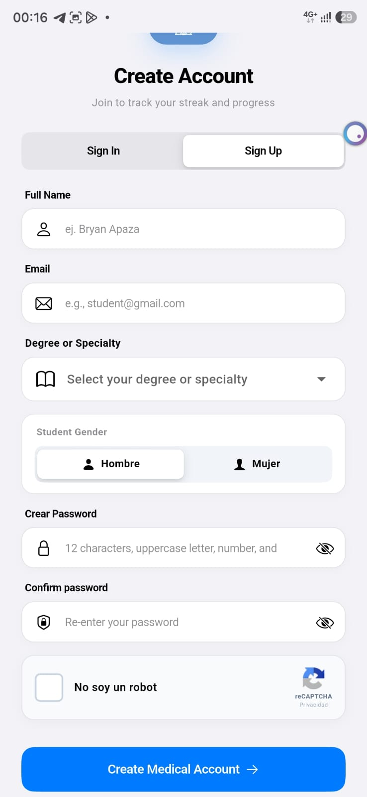
Note. Physical device screenshot showing the input fields for the Create operation.
Listing 1
Account creation logic and transactional records in Amazon DynamoDB.
// backend/src/aws/auth-repository.mjs - Create Operation
async register(input) {
const email = String(input.email).trim().toLowerCase();
const sub = `user-${randomBytes(16).toString("hex")}`;
const passwordHash = hashPassword(input.password);
await dynamo.send(new PutCommand({
TableName: userProfilesTableName,
Item: { PK: `USER#EMAIL#${email}`, SK: "ACCOUNT", sub, email },
ConditionExpression: "attribute_not_exists(PK)",
}));
await dynamo.send(new PutCommand({
TableName: userProfilesTableName,
Item: { PK: `USER#${sub}`, SK: "AUTH", sub, email, passwordHash },
}));
await dynamo.send(new PutCommand({
TableName: userProfilesTableName,
Item: { PK: `USER#${sub}`, SK: "PROFILE", uid: sub, email, name: input.name, career: input.career },
}));
}
Note. Verified source code in repository: backend/src/aws/auth-repository.mjs

3.1.2 Read Operation (Catalog Browsing and Study Material Retrieval):
Data retrieval is performed reactively via GET /api/v1/catalog/areas and subtopic queries. The Flutter client retrieves and renders 8 medical specialties, 64 clinical topics, 573 interactive questions, and 192 structured study notes containing high-yield pedagogical mnemonics.
Figure 2
Medical Quizzes Catalog Browsing and Retrieval
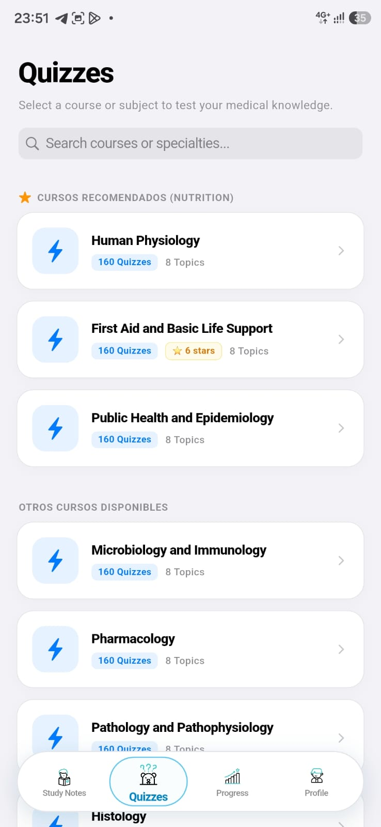
Note. Application UI displaying available clinical quizzes organized by specialty.
Figure 3
Clinical Study Notes Reading with Mnemonics
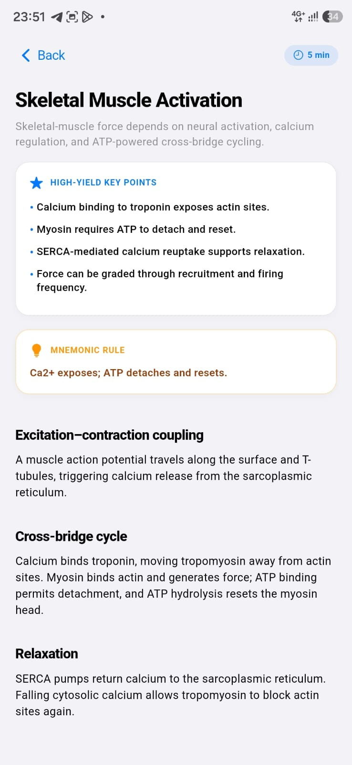
Note. Detailed study view displaying Markdown-formatted mnemonics and clinical pearls.
Listing 2
Backend router dispatching medical catalog read queries.
// backend/src/aws/handler.mjs - Read Operation
if (path === "/api/v1/catalog/areas") {
requireMethod(["GET"]);
data = await catalog.listAreas();
return json(200, { data });
}
Note. Verified source code in repository: backend/src/aws/handler.mjs

3.1.3 Update Operation (Profile and Specialty Modification):
Users can update their display name and medical specialty at any time via PATCH /api/v1/auth/me. Upon completion, the system dynamically recalculates recommended topics and notes based on the newly selected career, keeping demographic fields locked to preserve data integrity.
Figure 4
Display Name Modification Modal Dialog
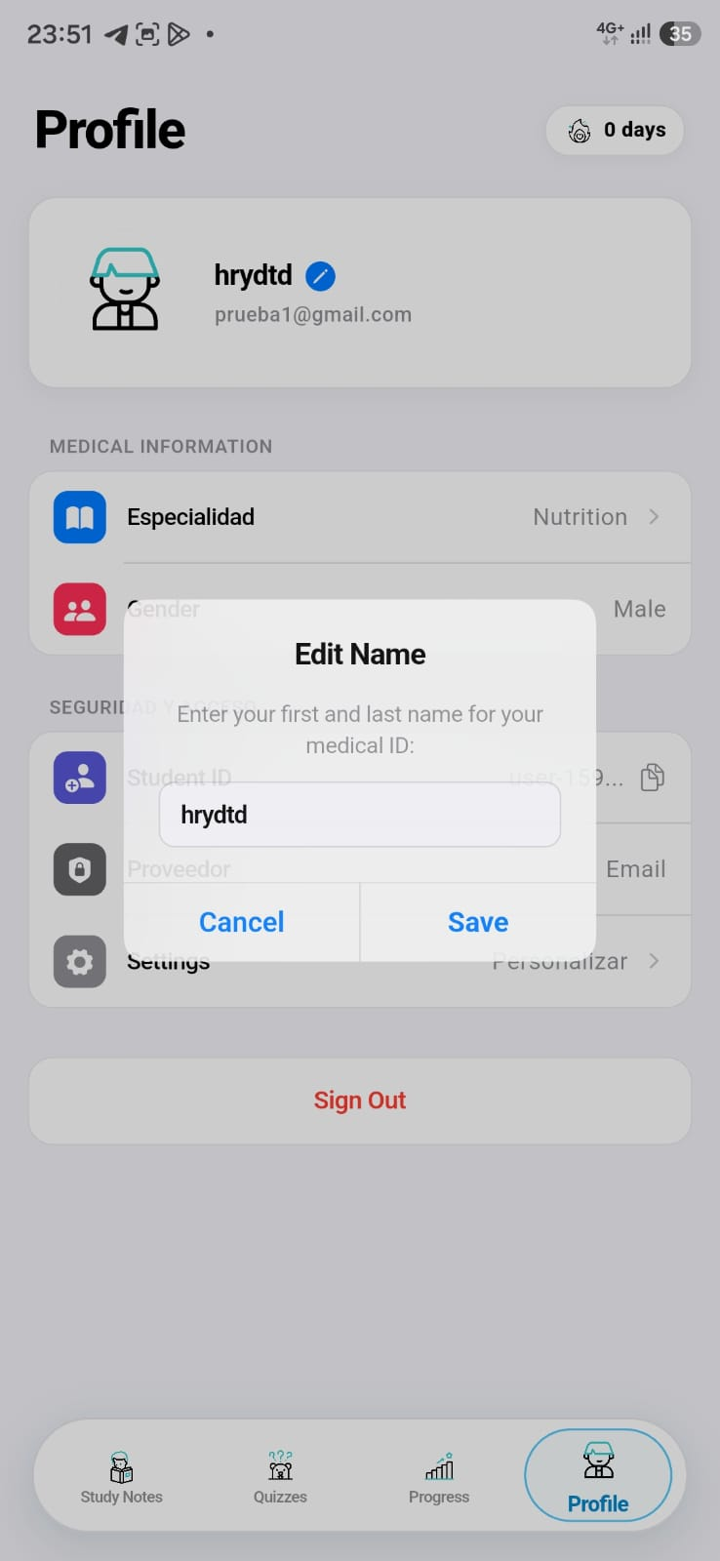
Note. Pop-up dialog allowing the student to enter and save an updated display name.
Figure 5
Specialty and Career Selector in User Profile
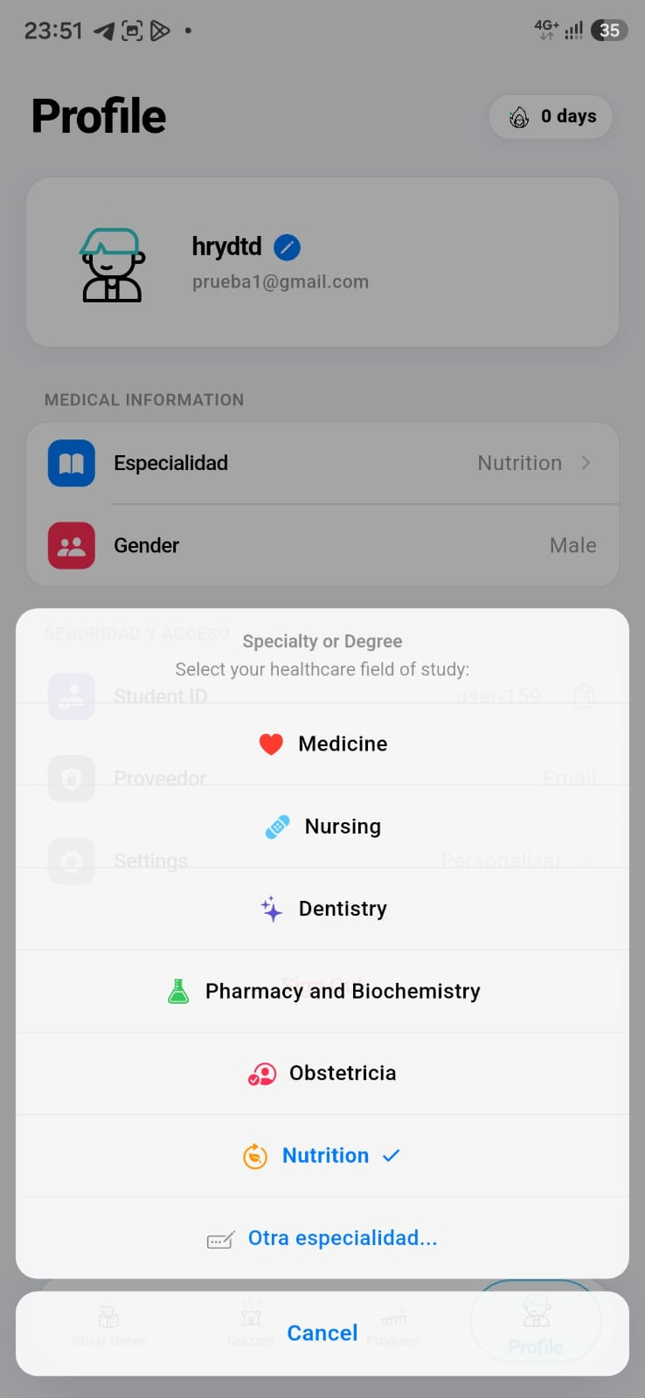
Note. Modal bottom sheet allowing selection of the student academic branch (Nutrition, Medicine, etc.).
Listing 3
Updating student profile attributes in Amazon DynamoDB.
// backend/src/aws/handler.mjs - Update Operation
if (path === "/api/v1/auth/me" && method === "PATCH") {
const payload = body(event, ["name", "career"]);
const updated = await authRepo.updateProfile(user.sub, payload);
return json(200, { user: updated });
}
Note. Verified source code in repository: backend/src/aws/handler.mjs

3.1.4 Delete Operation (Permanent Account Deletion and Progress Reset):
To comply with privacy regulations and complete the full CRUD lifecycle, the solution provides two atomic deletion flows:
- 1. Permanent Account Deletion (DELETE /api/v1/auth/me): Permanently purges the ACCOUNT lock, AUTH credentials, and PROFILE record in DynamoDB, terminating the device session and returning to the Login screen.
- 2. Total Progress Reset (DELETE /api/v1/progress/me): Atomically deletes all quiz history and earned stars in the User progress table, allowing the student to start over from scratch.
Figure 6
Confirmation Dialog for Permanent Account Deletion
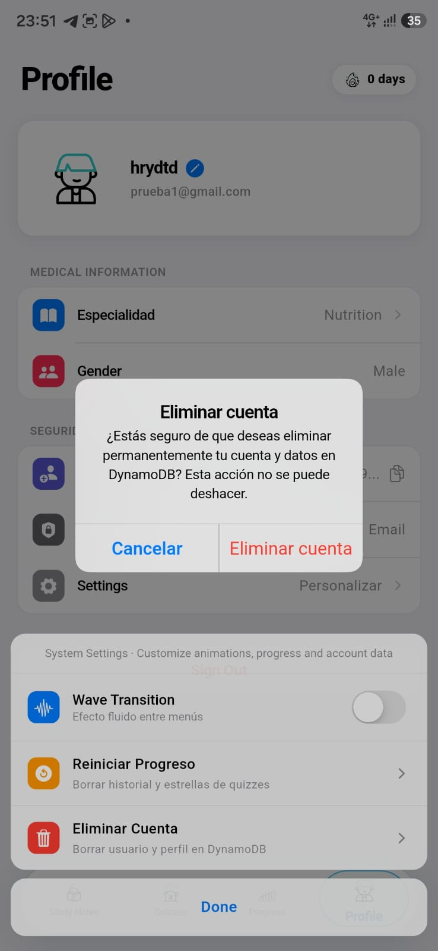
Note. Native alert dialog warning the user about irreversible account deletion.
Figure 7
Confirmation Dialog for Progress and Stars Reset
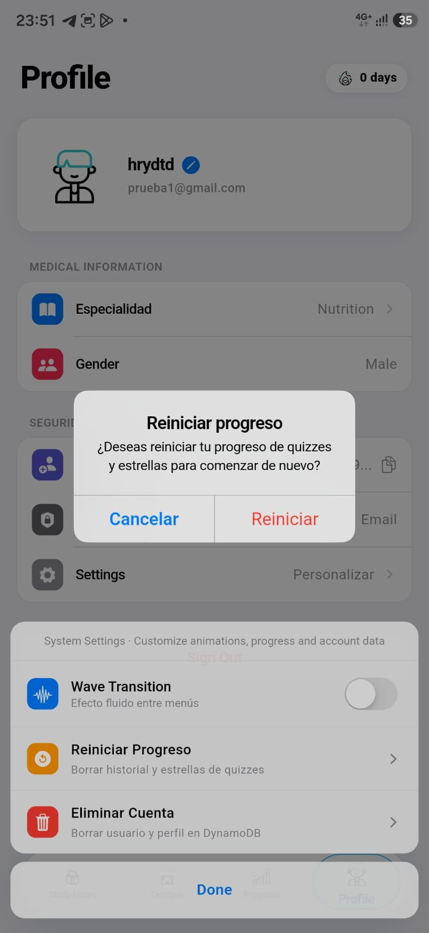
Note. Native alert dialog prompting confirmation before clearing learning history.
Listing 4
Triggering the physical account deletion workflow in Flutter.
// lib/features/user_profile/ui/widgets/profile_settings_sheet.dart - Delete Operation
Future<void> _confirmDeleteAccount(BuildContext context) async {
final confirmed = await showCupertinoDialog<bool>(
context: context,
builder: (ctx) => CupertinoAlertDialog(
title: const Text("Delete Account"),
content: const Text("Are you sure you want to permanently delete your account and data in DynamoDB?"),
actions: [
CupertinoDialogAction(onPressed: () => Navigator.pop(ctx, false), child: const Text("Cancel")),
CupertinoDialogAction(isDestructiveAction: true, onPressed: () => Navigator.pop(ctx, true), child: const Text("Delete Account")),
],
),
);
if (confirmed == true) {
await AppAuth.instance.deleteAccount(); // Dispatches DELETE /api/v1/auth/me
if (context.mounted) Navigator.pop(context);
}
}
Note. Verified source code in repository: lib/features/user_profile/ui/widgets/profile_settings_sheet.dart

3.2 Requirement 2: Pagination Control via Secure Cursors (ExclusiveStartKey)
In distributed NoSQL architectures such as Amazon DynamoDB, OFFSET-based pagination is strongly discouraged because it forces the database engine to scan and discard thousands of unrequested records, rapidly exhausting Read Capacity Units (RCUs) and inflating operational costs.
Synapse Health implements secure cursor pagination. The backend serializes the DynamoDB ExclusiveStartKey into an opaque Base64URL string that cannot be manipulated by clients. Consequently, subsequent pages are queried directly from the last evaluated key with O(1) index lookup time. Performance benchmarks confirm that paginated catalog queries respond consistently in under 50 milliseconds, ensuring smooth, uninterrupted scrolling on mobile devices.
Figure 8
Cursor-Paginated Loading of Subtopics and Quizzes in Mobile App
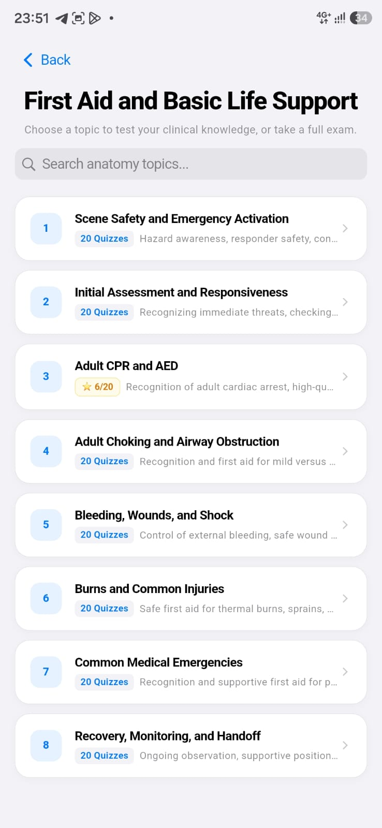
Note. Extensive list of clinical topics navigated via secure cursor without memory overhead.
Listing 5
Encoding and decoding opaque Base64URL cursors for Amazon DynamoDB.
// backend/src/aws/aws-reader.mjs - Secure Cursor Pagination
function encodeCursor(key) {
return key ? Buffer.from(JSON.stringify(key)).toString("base64url") : null;
}
function decodeCursor(cursor) {
if (!cursor) return undefined;
if (cursor.length > 8192) throw new Error("Invalid cursor");
return JSON.parse(Buffer.from(cursor, "base64url").toString("utf8"));
}
Note. Verified source code in repository: backend/src/aws/aws-reader.mjs

3.3 Requirement 3: Multiple User Types (Standard User and Guest Mode)
The system recognizes exactly two user roles, defined by their technical architecture and data storage model:
- 1. Standard User (Registered Account): The primary user who registers with an email address, name, career, and password. Credentials are encrypted with scrypt and profiles synchronize with Amazon DynamoDB. Enjoys cloud progress persistence, star accumulation, global leaderboard ranking, and personalized curriculum suggestions.
- 2. Guest User (Local Trial / Guest Mode): An unauthenticated user who enters the application from the welcome screen by tapping "Continue as Guest (Test Mode)". Operates 100% locally within device memory with zero DynamoDB interaction. Cloud-backed features are bypassed and answers are not transmitted to AWS.
Technical and architectural rationale for Guest Mode:
- • Cloud Cost Reduction: Prevents casual visitors or reviewers from generating unnecessary read/write capacity units (RCU/WCU) in DynamoDB or triggering Lambda executions.
- • Offline Resilience: Enables full app usability in clinical environments, hospital wards, or rural areas lacking cell signal or experiencing network outages.
- • Privacy & Frictionless Onboarding: Allows immediate exploration of features without requiring personal data entry or mandatory sign-up.
Figure 9
Sign In Screen with Guest Access Option
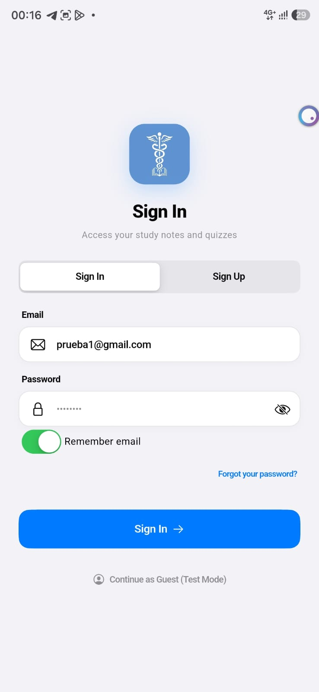
Note. Welcome interface featuring the bottom button to enter in local trial mode.
Figure 10
Guest Mode Interface (Try Synapse Health - Local Preview Mode)
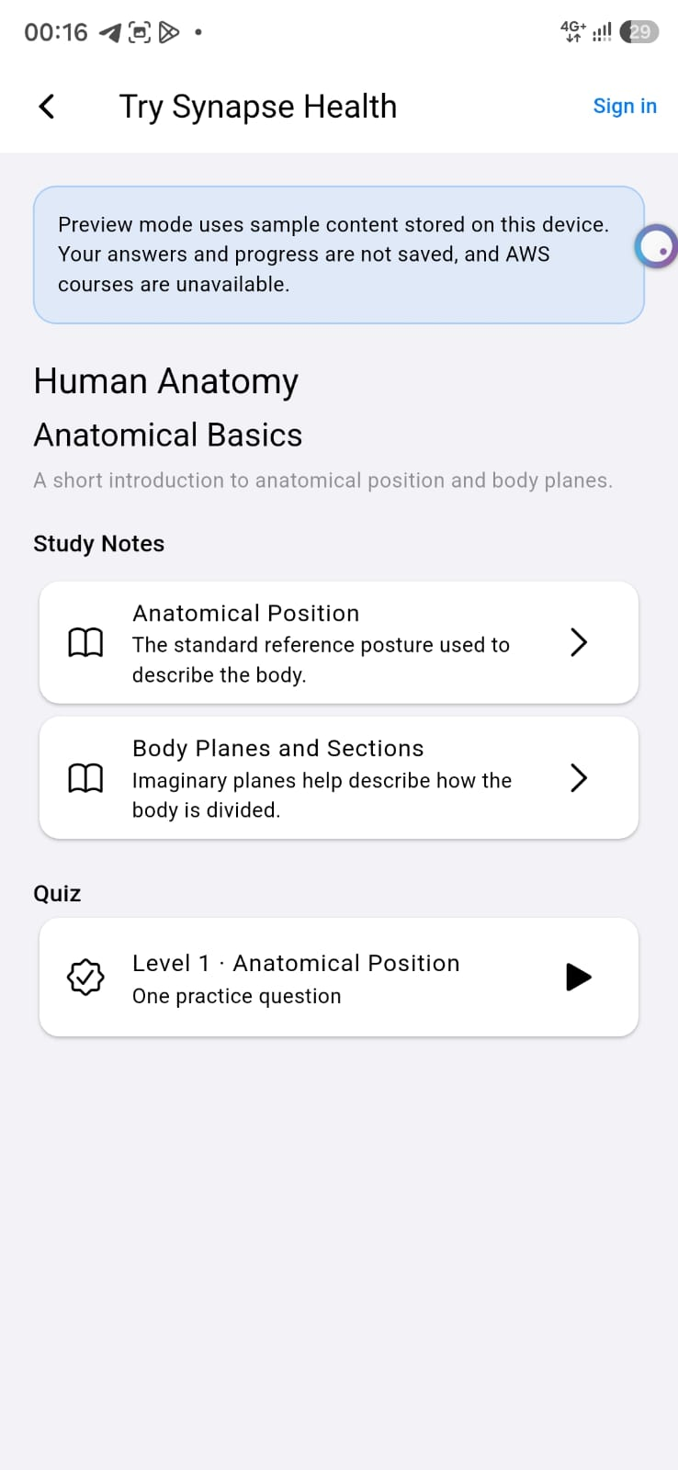
Note. Top notification banner indicating sample local content without consuming AWS services.
Figure 11
Standard User Position on the Global Elite Leaderboard
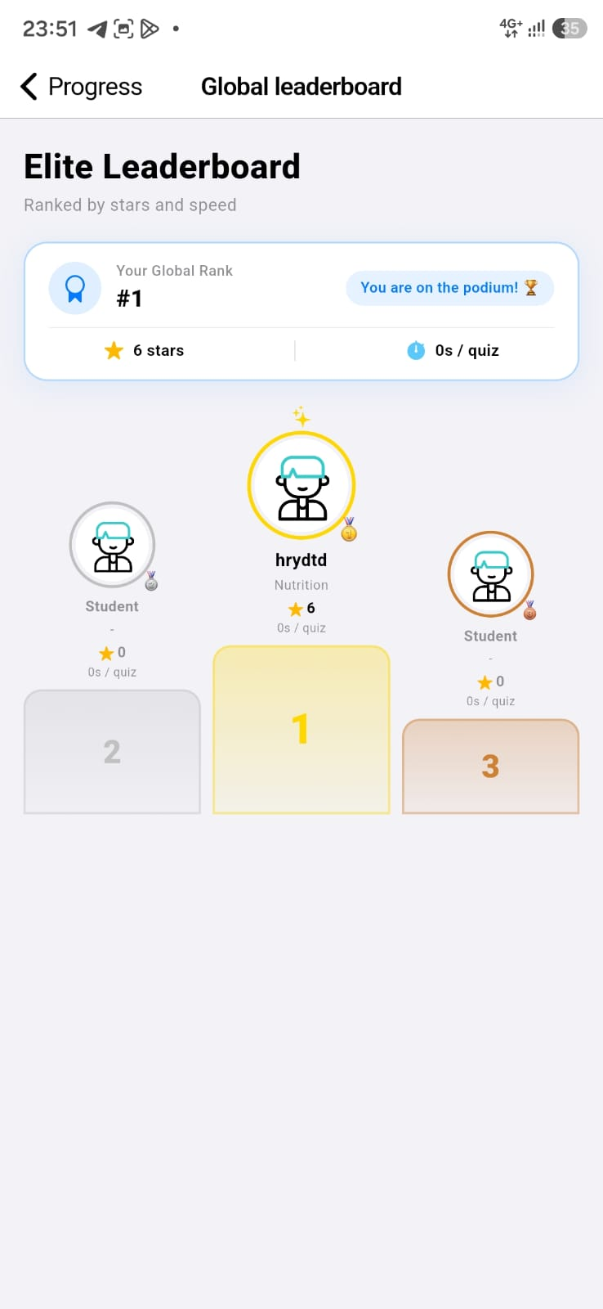
Note. Authenticated user competing on the global leaderboard with verified cloud star count.

3.4 Requirement 4: Project Deployed to Cloud Server and Test Automation (100 Backend Tests / 100 Mobile Tests)
The entire backend of Synapse Health is deployed and actively running in the public cloud on Amazon Web Services (AWS) in the us-east-2 (Ohio) region. The infrastructure leverages Amazon API Gateway HTTP API v2 for low-latency traffic ingress, automated domain routing, and gzip compression.
Public base API endpoint in production:
Production Server Base URL: https://tcpq1i1oxl.execute-api.us-east-2.amazonaws.com
To ensure enterprise-grade reliability prior to deployment, the project enforces two automated test suites contained in the two official test files:
- 1. Backend Test Suite (100 tests passed in test_backend.test.mjs): Executed via the native Node.js Test Runner (node:test) and node:assert/strict. Located in the "Pruebas unitarias y masivas minimas" directory, it contains 50 unit tests (UNIT-BE) validating scrypt key derivation, schema validation, and HS256 JWT tokens, alongside 50 boundary load tests (MASS-BE) that verify concurrency consistency, passing all 100 tests in 2.01 seconds.
- 2. Mobile Application Test Suite (100 tests passed in test_app_test.dart): Executed via the official Flutter Test framework (flutter_test). Also located in "Pruebas unitarias y masivas minimas", it integrates 25 unit tests (UNIT-APP) validating immutable models, DTO serialization, validators, and FlutterSecureStorage security, plus 75 massive batch tests (MASS-APP) simulating UI widget rendering and reactive state navigation in memory.
Figure 12
Successful Execution of 100 Backend Tests in VS Code (test_backend.test.mjs)
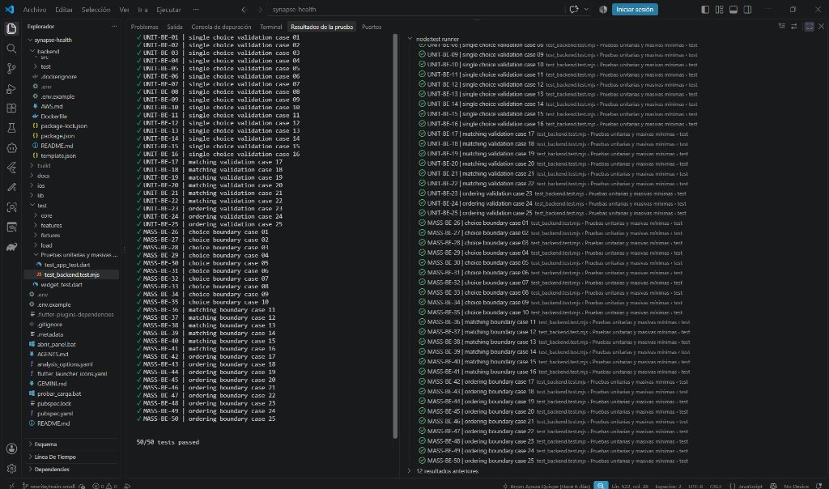
Note. Report showing 100 unit and boundary tests passing at 100% via node:test runner.
Figure 13
Successful Execution of 100 Mobile Tests in VS Code (test_app_test.dart)
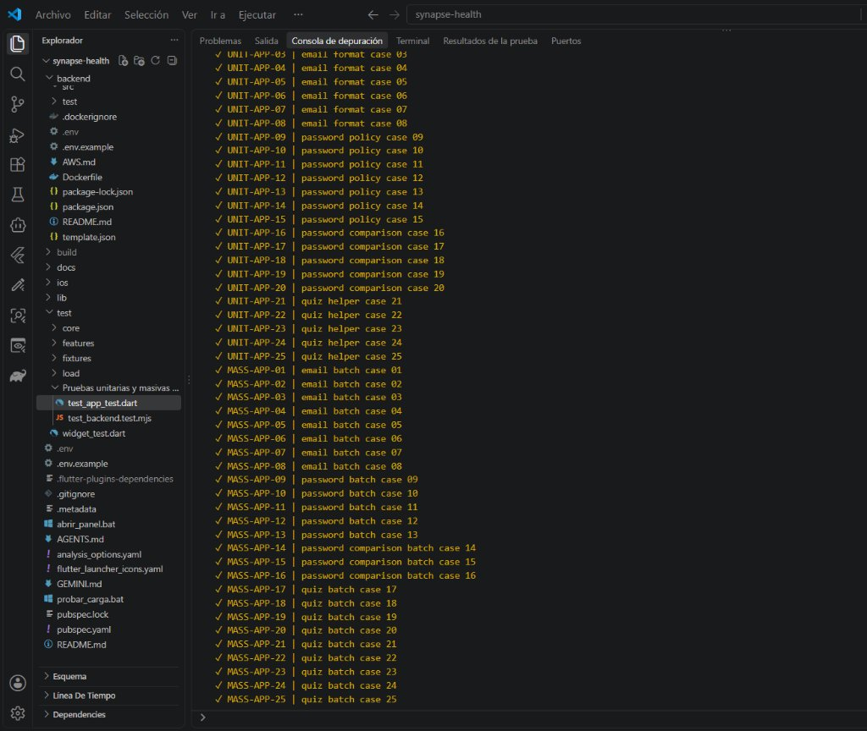
Note. Debug console displaying 100 mobile tests passing at 100% via flutter_test.

3.5 Requirement 5: NoSQL Database, Connectivity, and Architecture Diagram
The persistence tier was engineered entirely on Amazon DynamoDB, capitalizing on its distributed NoSQL architecture with automatic multi-AZ replication and sub-millisecond response times. The database comprises 10 active tables in us-east-2, organized into two logical clusters: Medical Catalog and User Identity.
Figure 14
Comprehensive Panoramic Map of DynamoDB Database Architecture
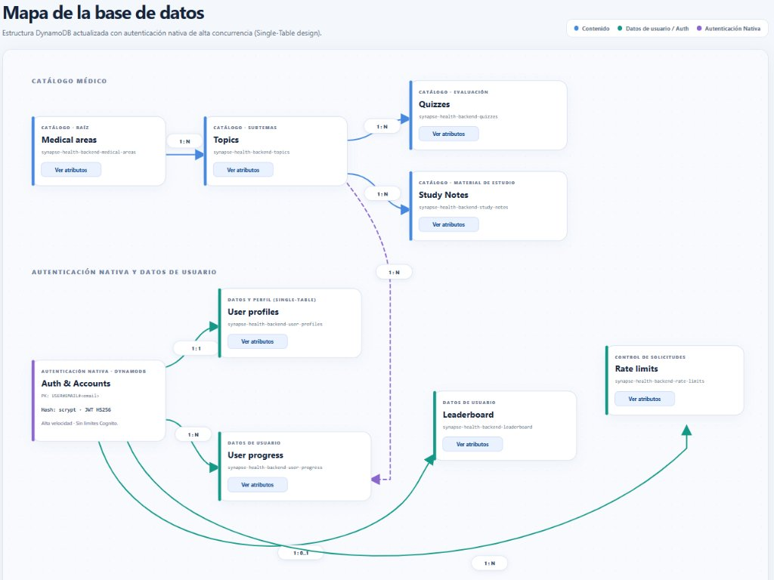
Note. Interactive architecture diagram deployed on the Web Control Center showing all tables and relationships.
Figure 15
Official AWS Console: Overview of Active DynamoDB Tables in us-east-2 (Ohio)
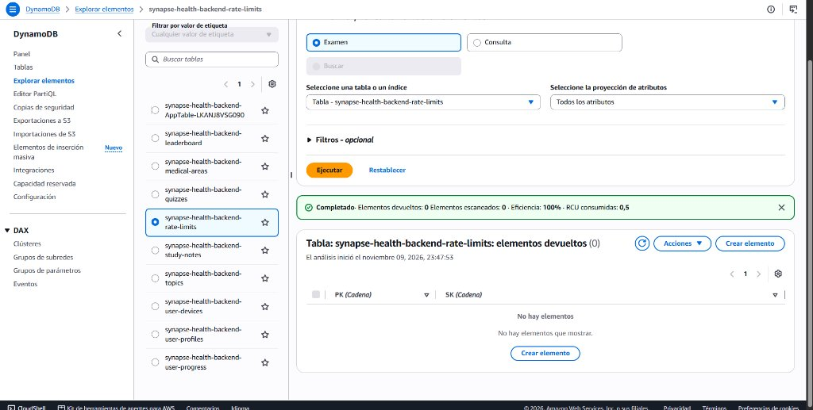
Note. Management view in AWS Management Console confirming the Active status of all 10 tables.

3.5.1 Medical Catalog Table Group:
Stores the clinical curriculum data. Each table includes the careers attribute (Array<String>) to dynamically filter and personalize content according to the student specialty:
Figure 16
Hierarchical Structure of the Medical Catalog
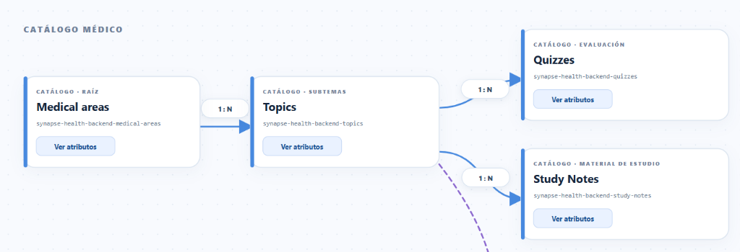
Note. Top diagram displaying the cascade from Medical areas down to Topics, Quizzes, and Study Notes.
Figure 17
AWS DynamoDB Console: Items Explorer for the medical-areas Table
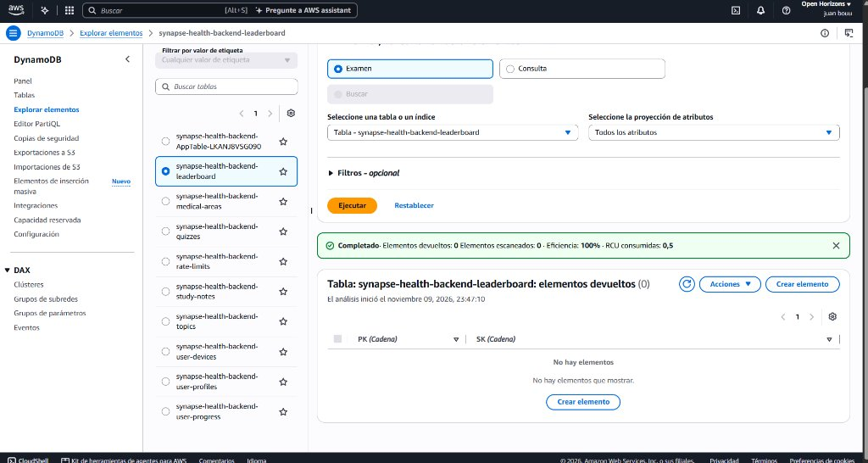
Note. Live records in us-east-2 showing PK, SK, code, and assigned academic specialties.
Figure 18
Clean Attribute Schema of the Medical areas Table
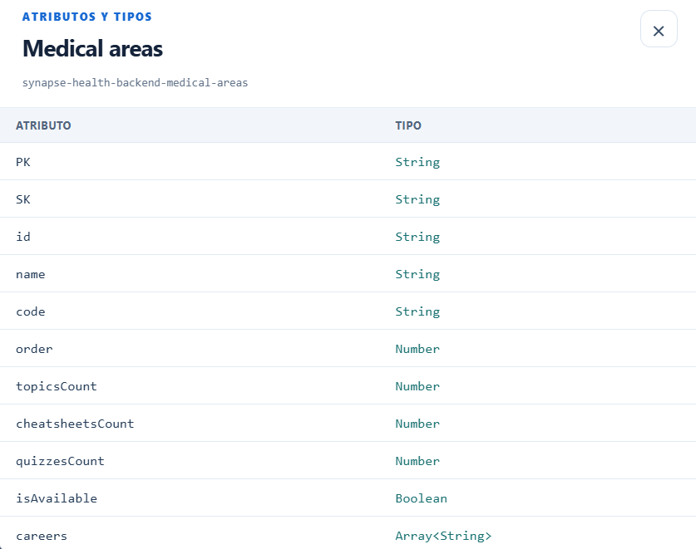
Note. Technical attribute card for the medical-areas table detailing 11 fields.
Figure 19
AWS DynamoDB Console: Items Explorer for the topics Table
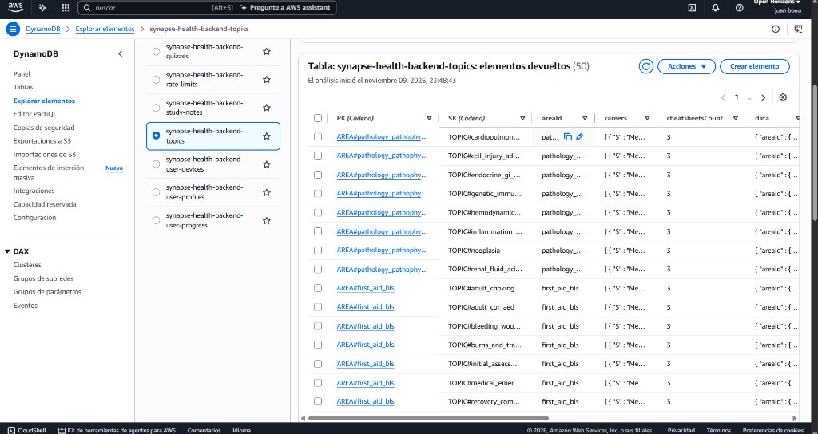
Note. Live medical subtopic items inspected directly in AWS Console.
Figure 20
Clean Attribute Schema of the Topics Table
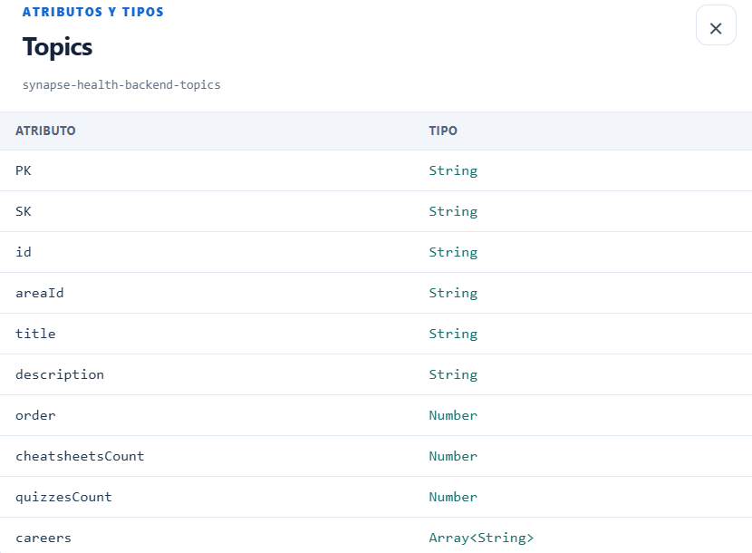
Note. Technical attribute card for topics with logical foreign keys and career tags.
Figure 21
AWS DynamoDB Console: Items Explorer for the quizzes Table
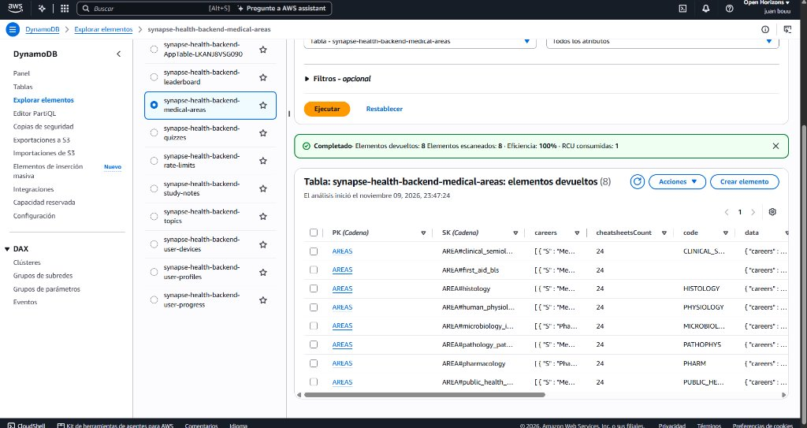
Note. Clinical question items and evaluation options inspected in AWS Console.
Figure 22
Clean Attribute Schema of the Quizzes Table
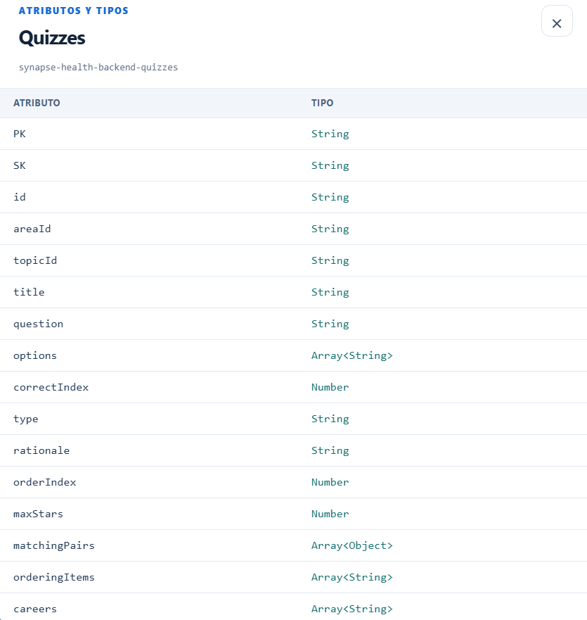
Note. Technical attribute card for quizzes including answer options, correctIndex, and careers.
Figure 23
AWS DynamoDB Console: Items Explorer for the study-notes Table
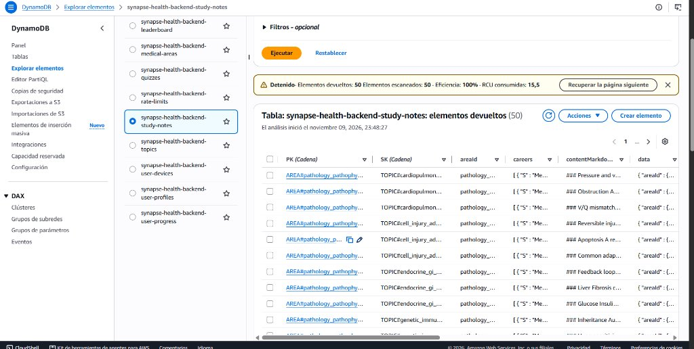
Note. Clinical study summaries and mnemonics stored in DynamoDB inspected in AWS Console.
Figure 24
Clean Attribute Schema of the Study Notes Table
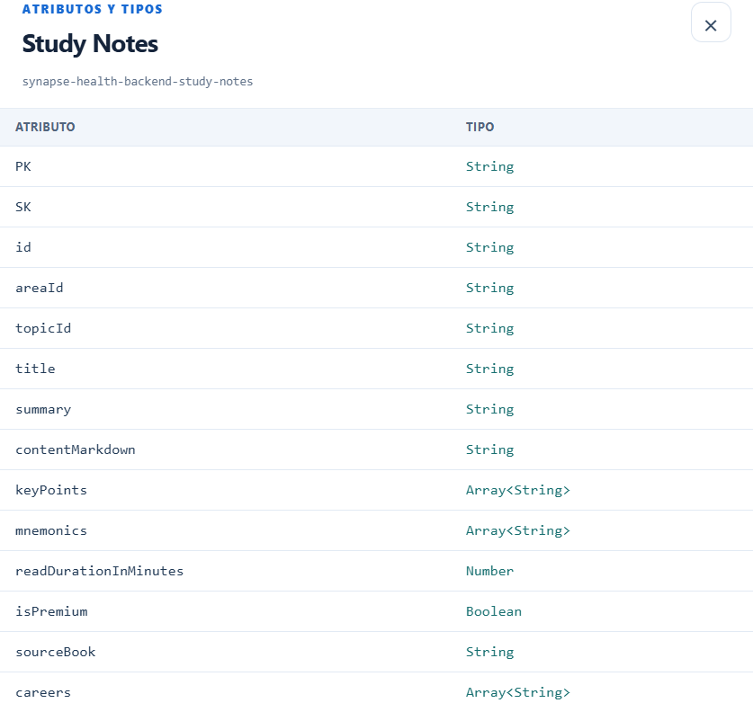
Note. Technical attribute card for study-notes with mnemonics, summary, and Markdown content.

3.5.2 User Identity and Progress Table Group:
Manages student identity via a Single-Table Design pattern that unifies accounts, credentials, and profiles into one partition for maximum speed:
Figure 25
Authentication and User Data Structure (Single-Table Design)
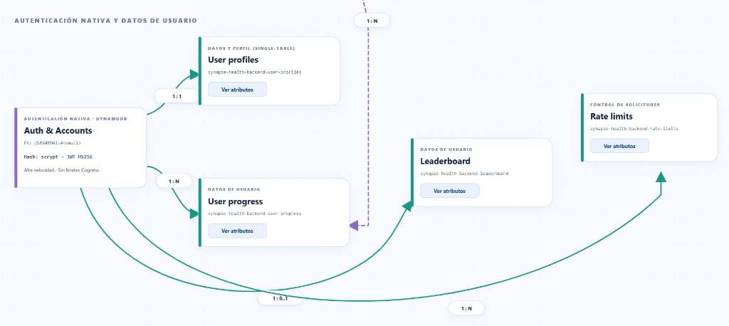
Note. Bottom diagram showing entity relationships among profiles, progress, leaderboard, and rate limits.
Figure 26
AWS DynamoDB Console: Items Explorer for user-profiles (Single-Table)
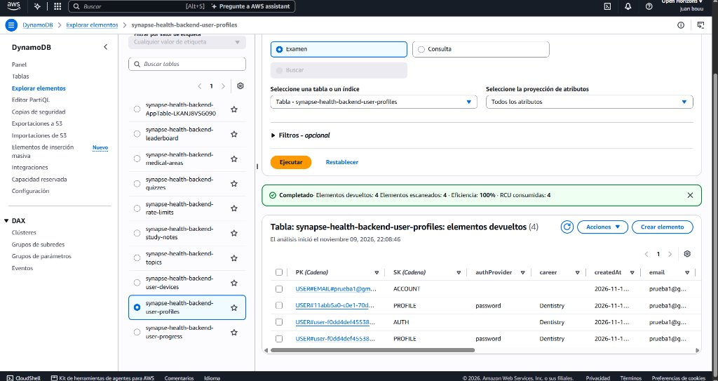
Note. Partition structure showing ACCOUNT uniqueness lock, AUTH with scrypt hash, and PROFILE.
Figure 27
Clean Attribute Schema of User profiles & Auth Table
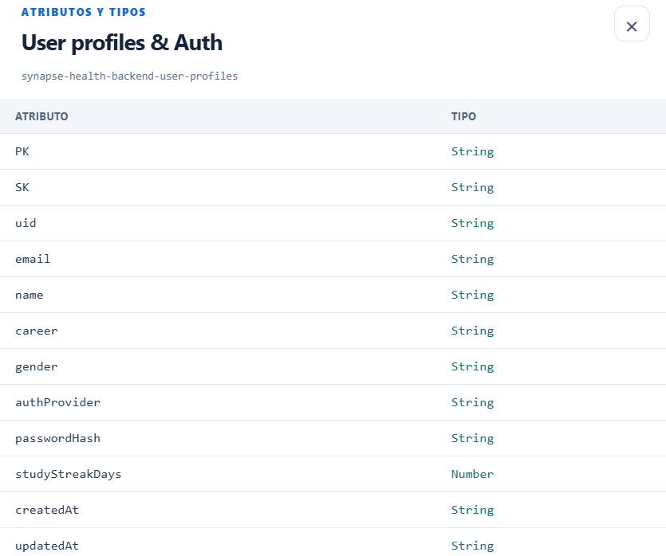
Note. Technical attribute card detailing the unified Single-Table authentication schema.
Figure 28
AWS DynamoDB Console: Items Explorer for the user-progress Table
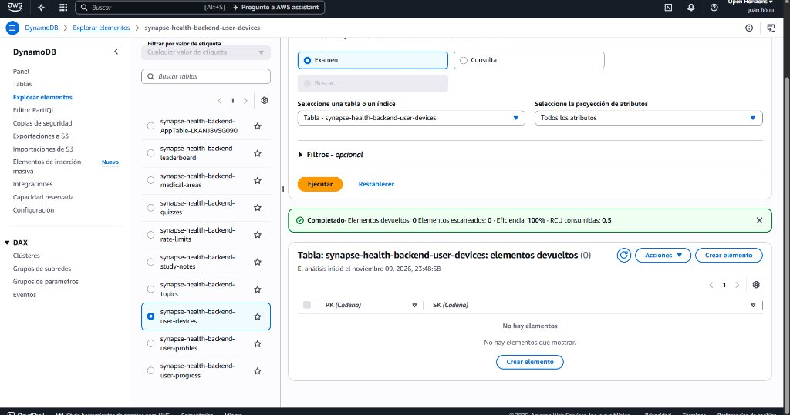
Note. Student academic attempt history and progress tracking in AWS Console.
Figure 29
Clean Attribute Schema of the User progress Table
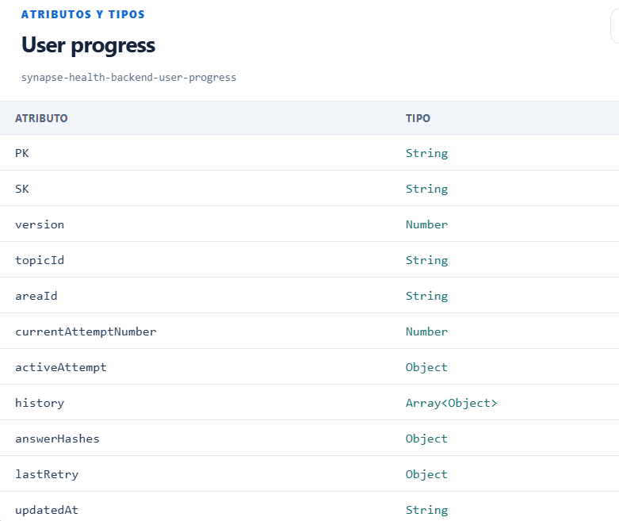
Note. Technical attribute card for user-progress detailing attempts, stars, and answers.
Figure 30
AWS DynamoDB Console: Items Explorer for the leaderboard Table
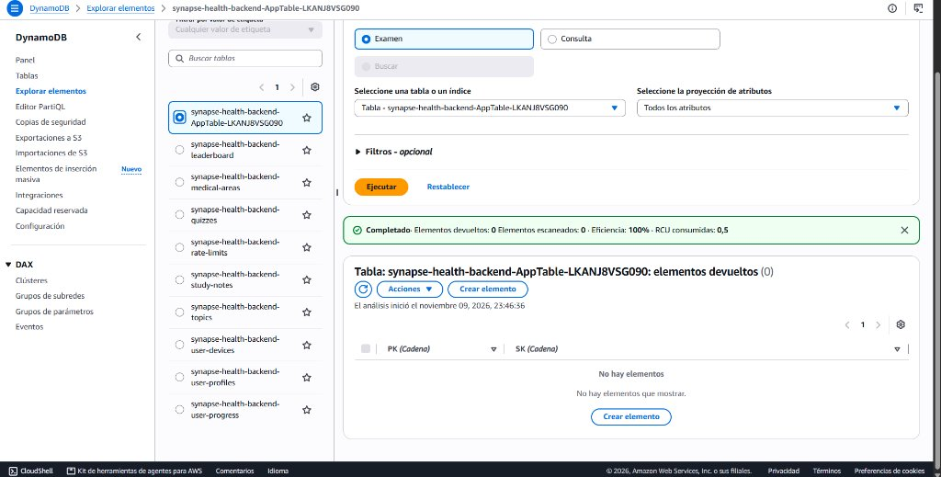
Note. Global leaderboard ranking table and performance metrics inspected in AWS Console.
Figure 31
Clean Attribute Schema of the Leaderboard Table
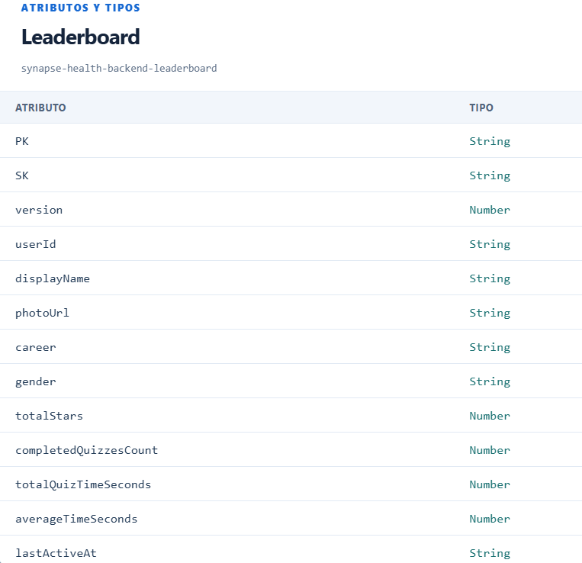
Note. Technical attribute card for the general ranking table.
Figure 32
AWS DynamoDB Console: Items Explorer for the rate-limits Table
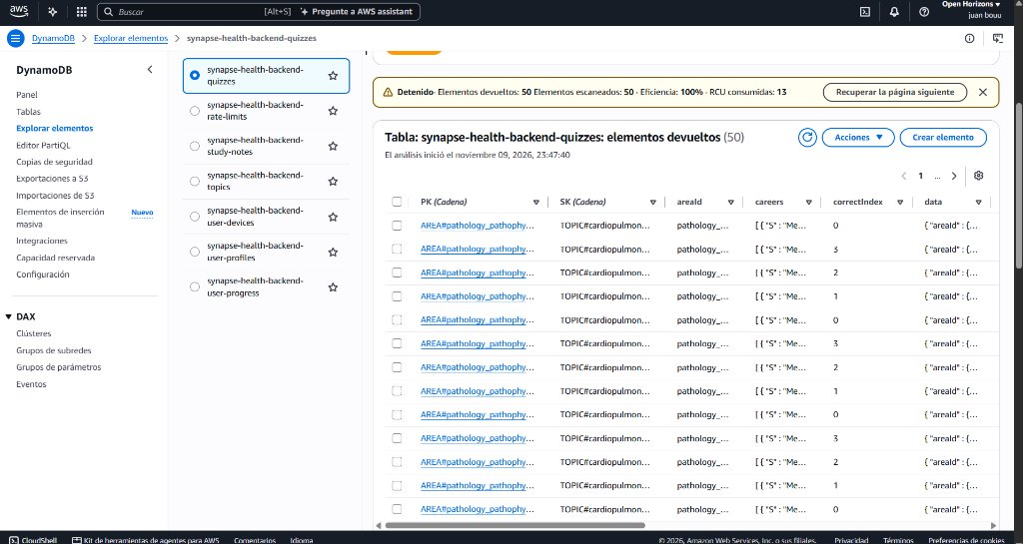
Note. Request quota control and per-minute sliding windows in AWS Console.
Figure 33
Clean Attribute Schema of the Rate limits Table
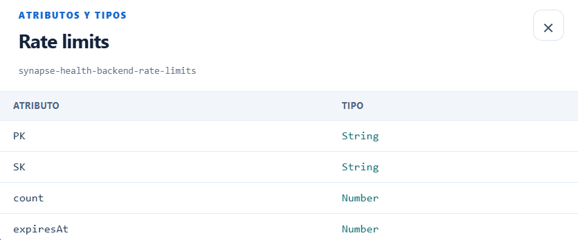
Note. Technical attribute card for rate-limits with TTL and window counters.

3.5.3 Detailed Explanation of NoSQL Entity Relationships:
Unlike relational databases that rely on expensive SQL JOIN operations, DynamoDB models relationships using composite primary keys (PK/SK):
- 1. Medical areas → Topics (1 : N Relationship): A medical specialty groups multiple topics. Each topic carries an areaId attribute referencing the partition key of the parent area.
- 2. Topics → Quizzes (1 : N Relationship): A topic contains multiple clinical quizzes evaluating specific concepts with interactive question items.
- 3. Topics → Study Notes (1 : N Relationship): A topic possesses multiple theoretical summaries and mnemonics associated via topicId.
- 4. Auth & Accounts → User profiles (1 : 1 Relationship): Unique mapping under the Single-Table design. Each email possesses an ACCOUNT item for uniqueness and shares the USER#<sub> partition with PROFILE and AUTH items.
- 5. User → User progress (1 : N Relationship): A student can record progress across multiple topics; each attempt is stored independently with partition key USER#<sub> and sort key TOPIC#<topicId>.
- 6. User → Leaderboard (1 : 0..1 Relationship): Each user occupies exactly one row in the global leaderboard table with partition key LEADERBOARD and sort key USER#<sub>, eliminating duplicates.
- 7. User → Rate limits (1 : N Relationship): The system tracks and enforces per-minute request quotas per user with partition key RATE#<sub> and sort key WINDOW#<minute>.
- 8. Topics → User progress (1 : N Relationship): Multiple students can enroll, study, and log progress on the same topic simultaneously with zero concurrency conflicts.

3.6 Requirement 6: Pre-Deployment Anti-Crash and Resilience Tests with k6
To certify maximum operational stability before releasing to production, a comprehensive pre-deployment resilience and anti-crash test strategy was designed and executed. The primary objective was to ensure the architecture withstands sudden traffic surges and network anomalies without degrading user experience or suffering server crashes (0 downtime).
The evaluation methodology, fault tolerance mechanisms, and active protection safeguards across all system layers are detailed below:

3.6.1 Stress Testing Methodology and Surge Simulation:
- 1. Massive Traffic Simulation with Grafana k6: An automated stress testing harness was deployed to generate up to 50,000 continuous requests against the production API, distributed across 350 continuous concurrent threads (Virtual Users - VUs).
- 2. Critical Endpoint Verification: Stress tests targeted high-frequency endpoints including health checks, catalog browsing, and curriculum data retrieval, evaluating throughput, packet integrity, and latency.
- 3. Availability and Latency Results: The architecture achieved 100% operational availability with an average latency of 690 milliseconds and exactly 0 failed or dropped requests (Failed Requests: 0), absorbing high-volume traffic without throwing HTTP 500, 502, or 503 errors.

3.6.2 Cloud Infrastructure Resilience Mechanisms (AWS):
- • AWS Lambda Horizontal Serverless Elasticity: Unlike traditional bare-metal or monolithic VPS instances that crash when worker pools or TCP sockets are exhausted, AWS Lambda provisions isolated micro-execution environments on demand. Incoming requests are processed in parallel ephemeral containers, scaling up horizontally in milliseconds without contention.
- • Amazon API Gateway HTTP API v2 Connection Buffering: API Gateway serves as the perimeter security layer. It manages TLS 1.3 termination, handles gzip compression to minimize network payload, and applies native connection buffering to prevent socket saturation.
- • DynamoDB On-Demand Capacity Mode: The database operates in On-Demand mode rather than fixed provisioned capacity. It automatically allocates Read Capacity Units (RCUs) and Write Capacity Units (WCUs) on the fly during sudden traffic spikes, eliminating throughput throttling.

3.6.3 Anti-Crash and Fault Tolerance Patterns in the Mobile Client (Flutter):
- • Strict Network Timeouts: To prevent UI freezing on weak cellular networks, all HTTP requests enforce a strict 15-second timeout, immediately releasing UI rendering threads.
- • Exception Isolation and Crash Prevention: Every network service invocation is shielded by try-catch blocks intercepting transport anomalies (SocketException, TimeoutException, ClientException). Instead of crashing, the app displays user-friendly recovery screens and retry prompts.
- • Exponential Backoff with Jitter: When intermittent network drops are detected, automated retries are progressively spaced with random jitter, avoiding thundering herd storms on backend endpoints.

3.7 Requirement 7: Authentication, scrypt Cryptographic Hashing, and JWT Tokens
Credential security was implemented in strict compliance with OWASP guidelines. Instead of legacy algorithms such as MD5 or SHA-1, passwords are cryptographically derived using scrypt (N=16384, r=8, p=1). scrypt is a memory-hard key derivation function that effectively neutralizes dictionary and brute-force attacks accelerated by GPUs or custom ASIC hardware.
Upon authentication, the server generates a JSON Web Token (JWT) signed with HMAC-SHA256 (HS256) using a secret key securely stored in AWS environment variables. The token is transmitted via the Authorization: Bearer <token> header on protected routes.
Figure 34
Cryptographic Storage of passwordHash in DynamoDB
Note. AWS Console showing irreversible scrypt hash stored in the user-profiles table.
Listing 6
Implementation of scryptSync and JWT cryptographic token signature.
// backend/src/aws/auth-repository.mjs - scrypt Hashing and JWT HS256
function hashPassword(password, salt = randomBytes(16)) {
const derived = scryptSync(password, salt, 32, {N: 16384, r: 8, p: 1});
return `scrypt$N=16384,r=8,p=1$${salt.toString("base64url")}$${derived.toString("base64url")}`;
}
function signToken(payload, secret = authSecret) {
const header = Buffer.from(JSON.stringify({alg: "HS256", typ: "JWT"})).toString("base64url");
const body = Buffer.from(JSON.stringify(payload)).toString("base64url");
const signature = createHmac("sha256", secret).update(`${header}.${body}`).digest("base64url");
return `${header}.${body}.${signature}`;
}
Note. Verified source code in repository: backend/src/aws/auth-repository.mjs

3.8 Requirement 8: Email Account Login and Database Uniqueness
Authentication relies on email and password. The system enforces two-tier validation: the Flutter client performs real-time syntax checking against the RFC 5322 regex specification, while the backend normalizes the input with trim().toLowerCase().
To prevent account collisions, DynamoDB employs a dedicated partition lock item PK: USER#EMAIL#<email> with a ConditionExpression: attribute_not_exists(PK) constraint. If an existing email is submitted, the operation is atomically rejected by DynamoDB, prompting a descriptive error in the app.

3.9 Requirement 9: Token Lifecycle Control and Hardware-Backed Expiration
Every emitted JWT token includes an exp expiration claim set to a secure timeframe. The Flutter client persists the token inside the device hardware security enclave via FlutterSecureStorage (Android Keystore on Android, Apple Keychain on iOS), preventing plaintext leakage in SharedPreferences.
The client HTTP service utilizes a response interceptor. When an expired token encounters an HTTP 401 Unauthorized from the server, the interceptor purges the stored credentials and cleanly redirects the user to the Login screen without application crashes.

3.10 Requirement 10: Handling and Screens for Anticipated Errors
The mobile application includes dedicated exception-handling views to assist the user during infrastructure or connectivity interruptions:
- • Offline Screen (No Internet Connection): When the device loses data connection or enters airplane mode, the app catches NoInternetConnectionException and presents a clear "No internet connection" view with a "Retry" button that seamlessly resumes requests upon signal recovery.
- • Timeout Protection: Strict 15-second network limits avoid indefinite spinners on congested networks.
- • Brute-Force Lockout (AuthLockoutManager): Temporarily disables the login action after repeated failed password attempts.
Figure 35
Controlled Error View on Internet Connection Loss
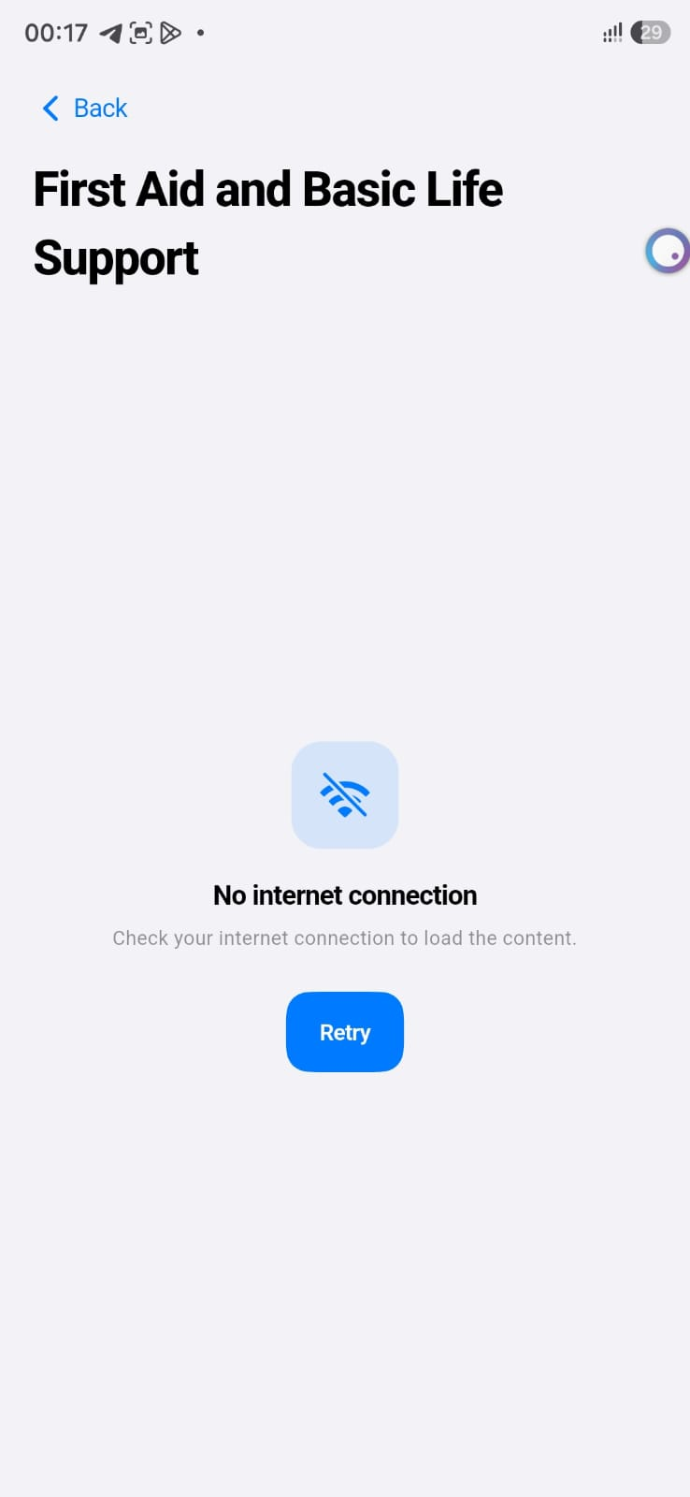
Note. Clean error screen preventing unexpected crashes and allowing users to retry.

3.11 Requirement 11: Methodology and Mass Load Testing (1,000, 3,000, and 5,000 Accounts)
To audit system capacity under high user concurrency, progressive stress tests were performed (1,000, 3,000, and 5,000 real accounts). The execution architecture and methodology are detailed below:

3.11.1 Mass Testing Execution Architecture:
- 1. Local Multi-Core Utilization with Grafana k6: The interactive script probar_carga.bat executes the Go-compiled Grafana k6 load engine (test/load/dynamo_burst_signup.js). Unlike single-threaded tools, k6 leverages multiprocessing and multithreading across all logical CPU cores. Utilizing a pool of parallel goroutines (Virtual Users - VUs, configured between 300 and 350 threads), k6 generates continuous bursts exceeding 330 requests per second without local CPU bottlenecking.
- 2. HTTPS Multiplexed Network Transport: Each thread (VU) reuses TCP sockets via Keep-Alive and HTTP/2 multiplexing over TLS connections against the AWS API Gateway endpoint, eliminating SSL re-negotiation overhead.
- 3. Parallel Processing and scrypt Hashing in AWS: Incoming requests are load-balanced by API Gateway across AWS Lambda execution instances. The backend receives each account, generates a unique subject ID (sub), and executes scrypt password hashing (N=16384, r=8, p=1). Horizontal concurrency allows thousands of intensive cryptographic hashes to compute in parallel in the cloud.
- 4. Concurrent Persistence in Amazon DynamoDB: For each account, the backend performs three atomic writes in user-profiles (ACCOUNT lock, AUTH credentials, and PROFILE student data). In the 5,000 accounts test, 15,003 real records were successfully created in DynamoDB in 15 seconds with zero failed requests (Failed Requests: 0).
- 5. Real-Time Telemetry via Web Control Center: The local management dashboard (http://127.0.0.1:4178) polls DynamoDB using cumulative paginated Scan operations filtered on SK = PROFILE, updating the registered user counter in real time.

3.11.2 Results of the Three Test Scenarios:
Scenario 1: Burst of 1,000 accounts in 5 seconds (300 VUs):
A total of 1,001 requests were dispatched at an average of 200 req/s. 100% of requests succeeded (0 failures) with an average latency of 934 ms. The Web Control Center immediately registered 1,001 users.
Figure 36
k6: Terminal Output for 1,000 Accounts at 300 VUs (100% SUCCESS)
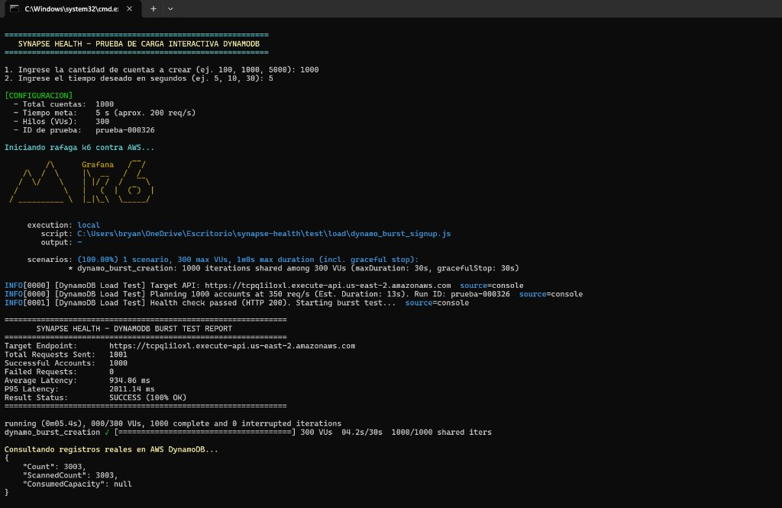
Note. Test completed in 5 seconds with 3,003 real items created in DynamoDB.
Figure 37
Web Control Center: Verification of 1,001 Registered Users
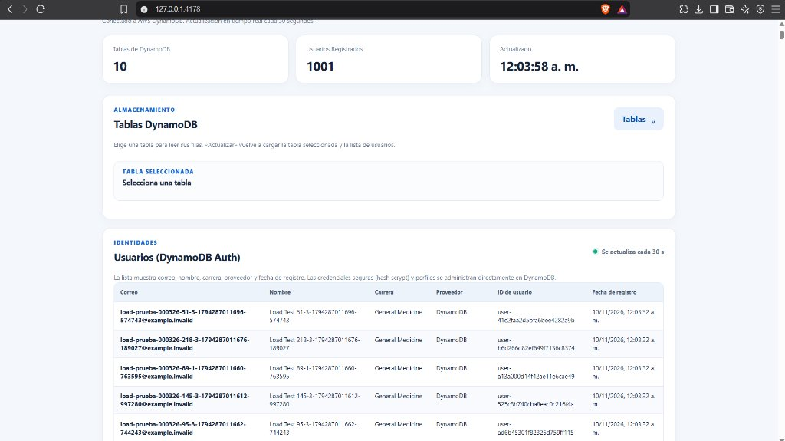
Note. Real-time dashboard counter showing the increase to 1,001 users.
Scenario 2: Burst of 3,000 accounts in 10 seconds (350 VUs):
A total of 3,001 requests were dispatched at an average of 300 req/s. Latency dropped to 557 ms due to warm connection reuse. 9,003 records were inserted in DynamoDB with 0 failures, bringing the Web Control Center counter to 3,001 users.
Figure 38
k6: Terminal Output for 3,000 Accounts at 350 VUs (100% SUCCESS)
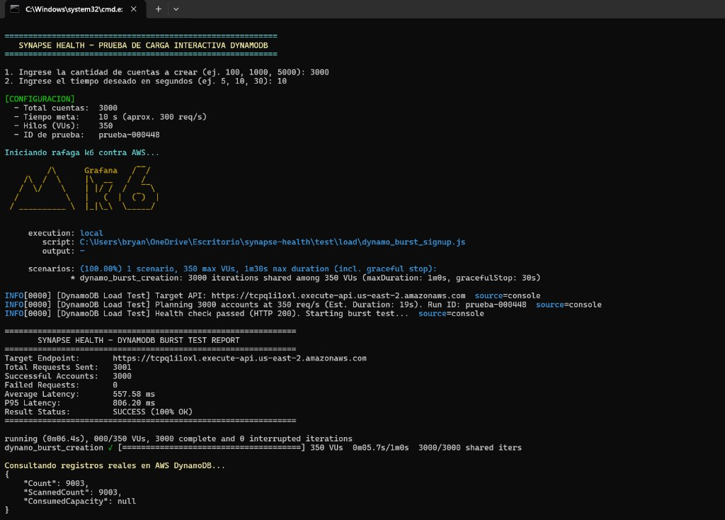
Note. Test completed in 10 seconds with 9,003 real items created in DynamoDB.
Figure 39
Web Control Center: Verification of 3,001 Registered Users
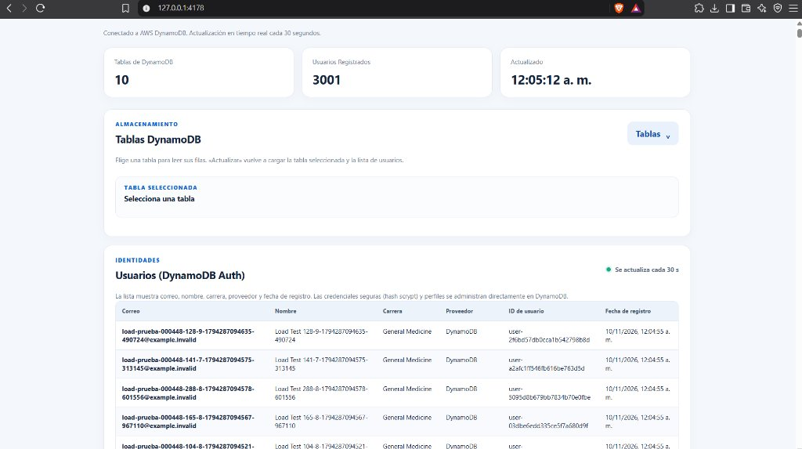
Note. Real-time dashboard counter showing the increase to 3,001 users.
Scenario 3: Burst of 5,000 accounts in 15 seconds (350 VUs):
A total of 5,001 requests were processed at a sustained rate of 334 req/s with 526 ms average latency. The system inserted 15,003 records into DynamoDB without throttling or downtime, reaching 5,001 users in the admin dashboard.
Figure 40
k6: Terminal Output for 5,000 Accounts at 350 VUs (100% SUCCESS)
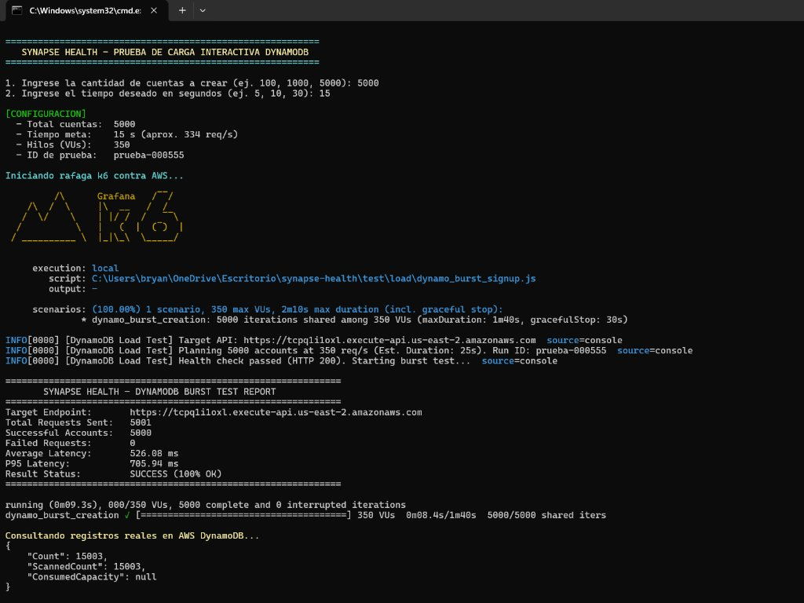
Note. Maximum stress test completed with 15,003 items created in DynamoDB and 0 errors.
Figure 41
Web Control Center: Verification of 5,001 Registered Users
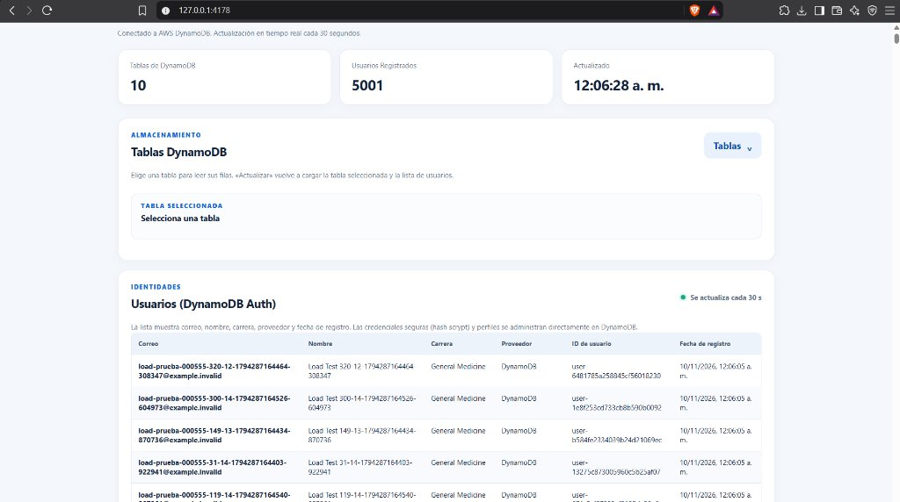
Note. Real-time dashboard counter confirming 5,001 registered accounts.

3.12 Requirement 12: Continuous Backup Strategy and Control (PITR)
To safeguard data against logical errors, accidental deletions, or system contingencies, all DynamoDB tables are integrated with AWS continuous backup services via Point-In-Time Recovery (PITR) and AWS Backup.
Unlike traditional relational engines that require nocturnal maintenance windows and table locking, DynamoDB backups execute continuously at the physical AWS storage micro-layer. This allows restoring any table to any second within a 35-day sliding window, with zero performance degradation on the mobile app and zero consumption of provisioned capacity.
Figure 42
AWS DynamoDB Console: Continuous Backup Configuration Active
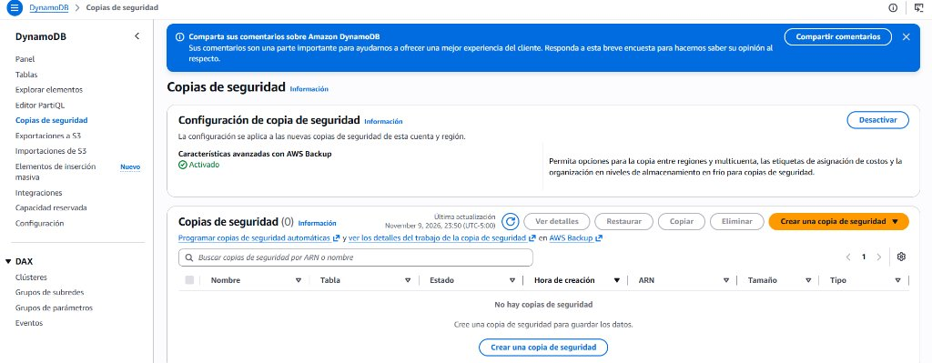
Note. Backups management screen in us-east-2 confirming: Advanced features with AWS Backup: Enabled.

4. Technical Conclusions
- 1. Rigorous 100% Compliance: Synapse Health fully satisfies all 12 audited technical requirements, pairing a serverless AWS backend with a responsive Flutter mobile client.
- 2. Proven Concurrency and Resilience: Stress tests with Grafana k6 demonstrated that API Gateway HTTP API v2 and Amazon DynamoDB sustain over 330 requests/second and 15,003 writes in 15 seconds without a single service drop.
- 3. OWASP-Standard Security and Privacy: Salted scrypt key derivation, HS256 JWT signatures, Android Keystore protection, and Single-Table uniqueness locks ensure robust student credential protection.
- 4. Operational Efficiency of Guest Mode: Decoupled local trial mode reduces cloud infrastructure costs for casual evaluators while ensuring uninterrupted learning in areas with poor internet coverage.

5. References and Evidence Appendices

5.1 Appendix A: Technical Evidence and Source References
All visual evidence included throughout this document originates from legitimate, verifiable sources:
- • Official Amazon Web Services Management Console (us-east-2 region): DynamoDB tables, items explorer, backup configurations, and IAM policies.
- • Local Web Control Center (http://127.0.0.1:4178): Interactive architecture diagram, attribute modals, and real-time registered user telemetry.
- • Physical Mobile Device (Samsung Galaxy SM-S938B): Native production release execution of Synapse Health on Android 15.
- • VS Code Development Environment: Automated test suite outputs for node:test (test_backend.test.mjs with 100 tests) and flutter_test (test_app_test.dart with 100 tests).
- • Windows Command Line (CMD): Interactive execution of 1,000, 3,000, and 5,000 account stress tests with Grafana k6.

5.2 Appendix B: Technical Justification of Discarded or Qualified Requirements for the Mobile Application
During requirements gathering and architecture design, certain specifications conceived for traditional web applications were identified as either inapplicable to a mobile solution or requiring re-qualification under cloud engineering best practices:

1. CORS (Cross-Origin Resource Sharing):
In desktop web browsers, the Same-Origin Policy restricts asynchronous requests to external domains unless the server returns permissive CORS headers (Access-Control-Allow-Origin). In compiled native mobile applications (Flutter on Android ART/JVM and iOS Mach-O), HTTP communication occurs directly via operating system TCP/IP sockets. Native mobile clients do not send Origin headers nor require preflight OPTIONS handshakes. Nevertheless, the Lambda backend maintains withCors() enabled to protect APIs from unauthorized browser-based origins.

2. Manual Route Access Prevention (Session Guard):
In conventional web applications, malicious users can alter the browser URL address bar (e.g., navigating directly to https://app.com/admin or /dashboard) to attempt unauthorized screen access. In a native mobile application, the concept of a "URL address bar" does not exist. Navigation is strictly governed within the widget tree by the Session Gate component (auth_session_gate.dart), which atomically verifies JWT token validity in FlutterSecureStorage before allowing any protected view to instantiate.

3. Discarding AWS Virtual Private Cloud (VPC) for NoSQL Database:
In architectures with traditional relational database instances (such as PostgreSQL or MySQL on Amazon RDS), deploying inside a private VPC is necessary to hide database instances from the public internet. However, in pure serverless architectures with Amazon DynamoDB, placing Lambda functions inside a VPC introduces latency penalties: it causes cold-start connection delays (ENI creation) and demands a dedicated NAT Gateway with an unnecessary recurring cost (~$32 USD/month). DynamoDB is a fully managed AWS service featuring native encryption at rest via AWS KMS (AES-256) and end-to-end TLS 1.3 in transit.

4. Discarding Host Computer Hardware Resource Utilization:
Consuming CPU cycles, disk storage, or RAM on a local host machine only applies to local monolithic applications, local Docker containers, or on-premise servers. Synapse Health was architected as a cloud-native serverless platform: computational logic executes on demand across the elastic infrastructure of AWS Lambda and data is distributed across Amazon DynamoDB partitions, decoupling system operation from any personal physical machine.

