Feature engineering:

Adjust the size and orientation of boxes:

1. Boxes of dimension (3, 6, 3) are the same as boxes of dimension (3, 3, 6) rotated. If initial variability in size is reduced, problem is more simplified for combination learning. Since boxes can come in in all rotations, making them more uniform and ordered will help reduce complexity

Adjust the size of vertices array:

1. When constraining available vertices to only 3 “tripoints” for each box placement, this will give us an array list of size 2n+1
- Pros: better box placement, fewer boxes need to be repacked due to failing physics check, fewer max step to pack all boxes, fewer “holes” in placement
- Cons: placement positions are constrained, some large spots remain unfilled due to lack of available vertex there, takes more time to train, smaller chance of getting it right
2. When loosening vertices array to include all 7 vertices for the next box’s placement, our vertex array size becomes 6n+1 (currently giving the best results)
- Pros: more placement choices, least constraining, more complexity and flexibility
- cons: a lot of boxes need to be repacked, increases the likelihood of bad box placement, high max step to finish packing due to increased need to repack, least stable model
3. When constraining vertices selection down to one vertex with picking the smallest subspace to pack a box, vertex position will not be one of the features (still to be tested)
- Pros: circumvents very bad box placement, no boxes will need to be repacked due to space check beforehand, least number of max step to finish packing, small spaces filled up first so less likely to have small empty spaces, most stable model
- Cons: simple heuristics bottlenecks, computationally expensive, does not take full advantage of neural networks

Normalize discrete vector array action space into continuous action space:

1. selecting from Action space currently has 3 discrete branches: select rotation from rotations, select box from boxes, and select vertex from vertices. The vertex vector is a three-dimensional vector representing coordinates in x,y,z space within the Unity engine. Normalizing the vertex vector from a discrete variable, representing an absolute position of say (8.25, 4.50, 16.75), to a continuous variable, between 0.0 and 1.0 of say (0.345, 0.134, 0.488), may better enable the agent to learn the relative space of the bin filled and the remaining unfilled bin space.

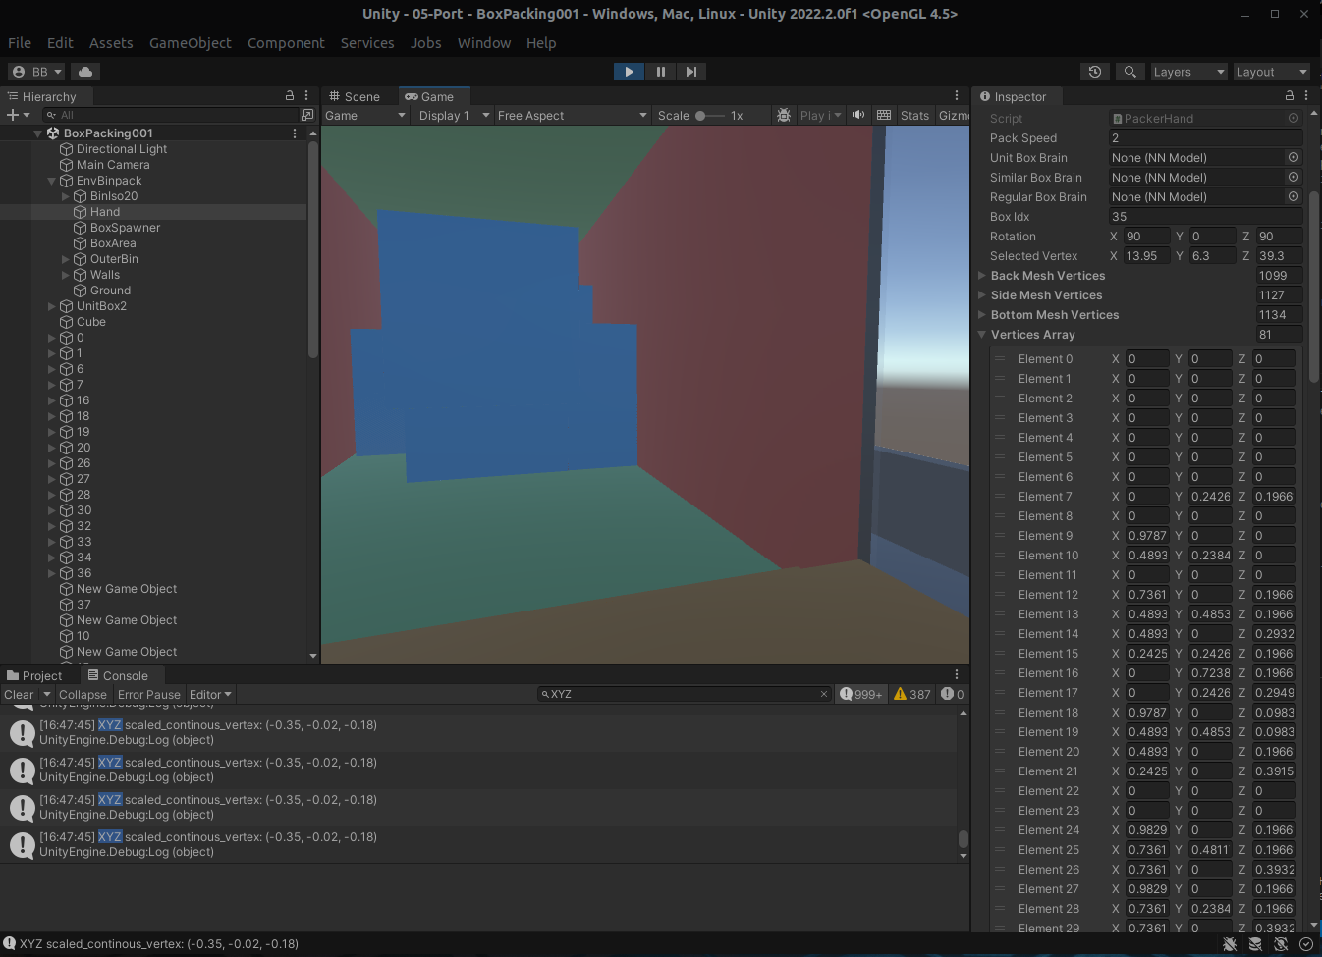
Furthermore our end goal is to be able to find an approach that deals with the variable size vertices array, and perhaps normalizing to continuous variables may enable us to consider other models that are better suited for yet require a continuous action space and state space. For example, even our current implementation of PPO is suited for continuous state and action space:

