Document performance, interpretation, and learning in markdown
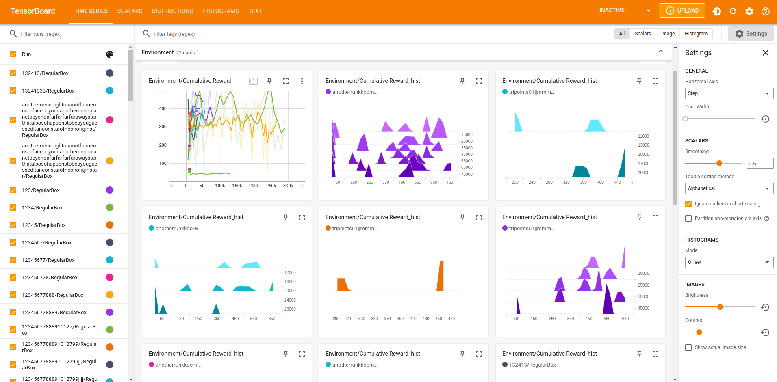
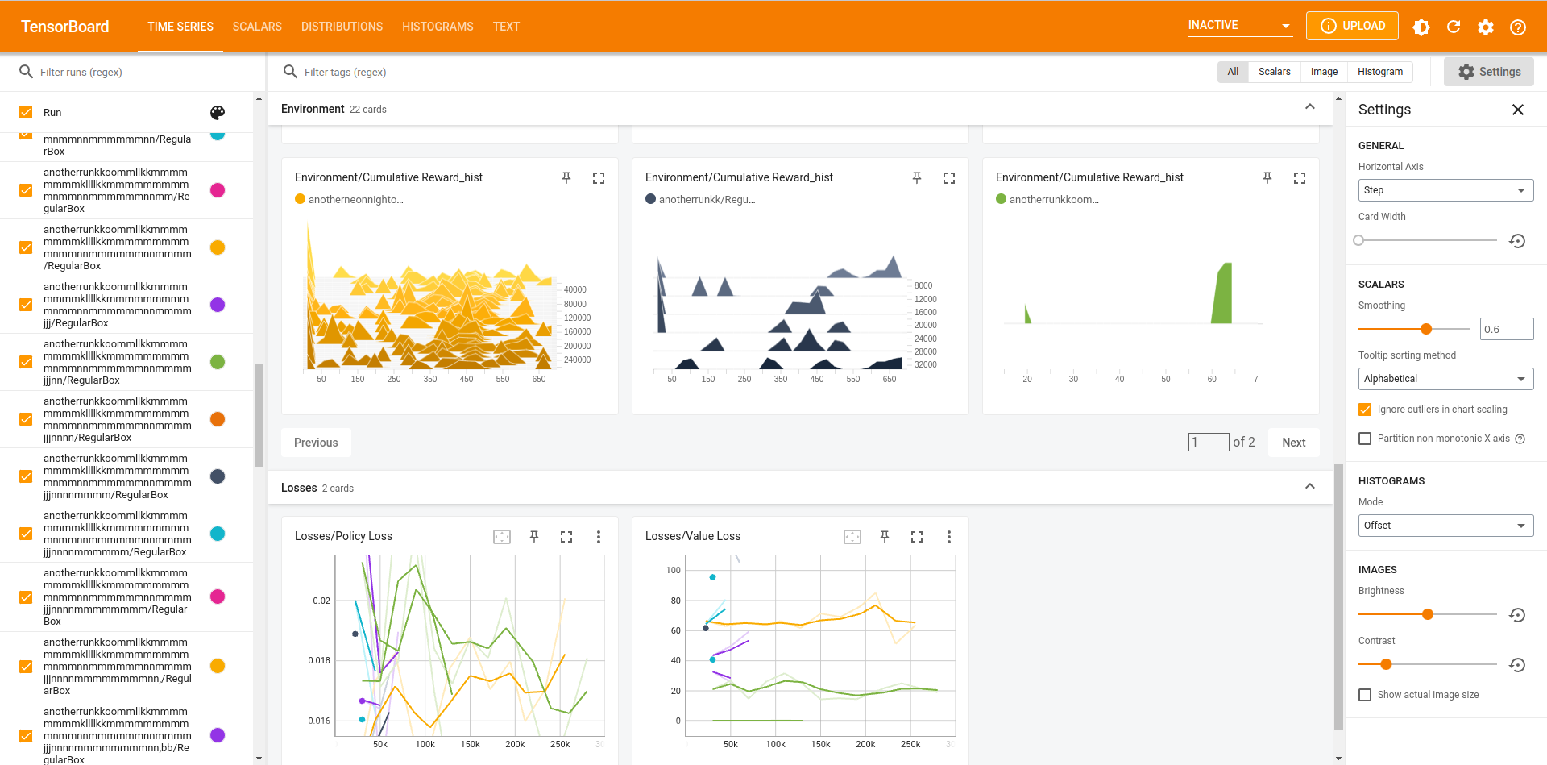

This is the Tensorboard results of our training data from this week. We have improved our Unity environment to allow for more realistic, flexible, and trainable packing. First we added physics checks to ensure “safe packing”, which means no boxes will fall down due to their center of gravity being off. We also use a vertices array list and an additional check for overlap to guarantees that all of the boxes are in contact without overlapping.

However, as the tensorboard results show, our model did not train well given that it did not converge close to the maximum reward with low std. In most of our training data, we had 3 discrete branches of action space: a list of box sizes, a list of vertices, and a list of possible rotations. If we have 40 boxes, we’ll have 2n+1, or 81 number of vertices where n is the number of boxes if we use our tripoints method, and 6 rotations. This generates 40 * 81 * 6, or 19440 combination of actions that can be chosen. The complexity will greatly increase if we flex our vertices array to allow for 7n+1 number of vertices. This is probably one of the reasons learning couldn’t be done properly. Our current key goal is therefore to reduce the number of possible combinations of actions in the action space.
Another very important reason that the current RL model we use, which is the PPO, failed to train is that part of our action space, which is a variable array of vertices that constantly permutes from episode to episode and being populated during an episode, does not lead to trainable weights. Another ongoing goal is to research more in depth recent discoveries such as Set Transformers that combat the problem of having a high number of combinations/permutations. Our team has planned next to discuss the paper: Set Transformer: A Framework for Attention-based Permutation-Invariant Neural Networks

