Bryan Bernigen

13520034

**LEMBAR JAWABAN LATIHAN PRAKTIKUM**

**IF2240 Basis Data**

1. **Soal**
2. Buatlah query untuk menampilkan seluruh data continents.

**Jawaban query :**

|  |
| --- |
| SELECT * FROM continents; |

**Hasil screenshot :**

|  |
| --- |
|  |

1. Buatlah query untuk menampilkan nama negara dan luasnya dengan luas lebih dari 11100000 satuan.

**Jawaban query :**

|  |
| --- |
| SELECT name FROM countries WHERE area > 11100000; |

**Hasil screenshot :**

|  |
| --- |
|  |

1. Buatlah query untuk menampilkan nama-nama negara yang berasal dari continent Asia.

**Jawaban query :**

|  |
| --- |
| SELECT c.name FROM countries c, regions r, continents cn WHERE c.region_id=r.region_id AND r.continent_id=cn.continent_id AND cn.name LIKE "Asia"; |

**Hasil screenshot :**

|  |
| --- |
|  |

1. **Skema Basis Data**

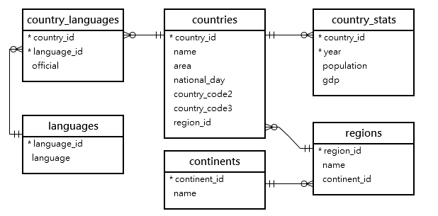

|  |
| --- |
| countries = (country_id, name, area, national_day, country_code2, country_code3, region_id)  country_languages = (country_id, language_id, official)  languages = (language_id, language)  country_stats = (country_id, year, population, gdp)  regions = (region_id, name, continent_id)  continents = (continent_id, name) |