**DOKUMEN SCHEDULING**

Judul Proyek: CourseReview

Kelas/Kelompok: K01 / 10

Anggota Kelompok:

13520019 / Maharani Ayu Putri Irawan

  13520034/ Bryan Bernigen

13520040/ Ng Kyle

13520115/ Maria Khelli

|  |  |  |  |  |  |  |  |  |  |  |
| --- | --- | --- | --- | --- | --- | --- | --- | --- | --- | --- |
|  | Name | Deskripsi | Predecessors | Resource | | Deliverables | Penanggung Jawab | Duration | Start | Finish |
| Name | Volume |
| 1 | **Initiating** | **Menginisialisasi proyek** |  |  | **6 days** |  | **Kyle** | **6 days** | **9/30/22 8:00 AM** | **10/10/22 5:00 PM** |
| 2 | Mengidentifikasi stakeholder kunci | Menentukan siapa saja yang memiliki pengaruh besar terhadap proyek |  | Ng Kyle | 1 day | Stakeholder Brief | Kyle | 1 day | 9/30/22 8:00 AM | 10/1/22 12:00 PM |
| Laptop | 1 day |
| 3 | Membuat Business Case | Membuat business case untuk dipresentasikan. business case menentukan apakah proyek disetujui atau tidak | 2 | Ng Kyle | 24 hours | Business Case | Kyle | 2 days | 10/1/22 12:00 PM | 10/5/22 12:00 PM |
| Office Tools | 2 days |
| Laptop | 2 days |
| Kuota Internet | 2 days |
| 4 | Membuat Project Charter | Membuat dokumen peresmian proyek | 3 | Ng Kyle | 24 hours | Project Charter | Kyle | 2 days | 10/5/22 12:00 PM | 10/8/22 12:00 PM |
| Office Tools | 2 days |
| Laptop | 2 days |
| 5 | Melakukan Kick-Off Meeting | Mempertemukan anggota proyek dan stakeholder internal untuk memulai proyek secara resmi | 4 | Ng Kyle | 24 hours | Meeting documentation | Kyle | 1 day | 10/8/22 12:00 PM | 10/10/22 5:00 PM |
| Office Tools | 1 day |
| Laptop | 1 day |
| Kuota Internet | 1 day |
| 6 | **Planning** | **Membuat Perencanaan pengerjaan proyek** | **1** |  | **8 days** |  | Kyle | **8 days** | **10/11/22 8:00 AM** | **10/24/22 5:00 PM** |
| 7 | Melakukan team planning meeting | Mempertemukan seluruh anggota proyek untuk membahas pembagian tugas dan perencanaan kerja |  | Ng Kyle | 12 hours | Plan and Meeting documentation | Kyle | 1 day | 10/11/22 8:00 AM | 10/12/22 1:00 PM |
| 8 | Membuat kontrak | Menentukan hak dan kewajiban tiap anggota yang terlibat dalam tim | 7 | Ng Kyle | 12 hours | MoU and NDA | Kyle | 1 day | 10/12/22 1:00 PM | 10/13/22 5:00 PM |
| Office Tools | 1 day |
| Laptop | 1 day |
| 9 | Membuat scope statement | Mendetailkan deliverable dan tujuan utama proyek | 8 | Ng Kyle | 9 hours | Project Scope Statement | Kyle | 3 days | 10/14/22 8:00 AM | 10/19/22 12:00 PM |
| Maria Khelli | 9 hours |
| Maharani Ayu Putri Irawan | 9 hours |
| Bryan Bernigen | 9 hours |
| Office Tools | 3 days |
| 10 | Membuat Work Breakdown Structure | Membuat rincian tugas secara detail | 9SS | Bryan Bernigen | 36 hours | Work Breakdown Structure | Kyle | 3 days | 10/14/22 8:00 AM | 10/19/22 12:00 PM |
| Maharani Ayu Putri Irawan | 36 hours |
| Maria Khelli | 36 hours |
| Ng Kyle | 36 hours |
| 11 | **Membuat Schedule** | **Membuat penjadwalan SDM, barang, dan tugas** |  |  | **2 days** | **Project Schedule Statement** | Kyle | **2 days** | **10/19/22 12:00 PM** | **10/22/22 12:00 PM** |
| 12 | Menentukan alokasi sumber daya ... | Menentukan alokasi sumber daya agar dapat dialokasikan secara maksimal | 10 | Ng Kyle | 12 hours | dokumentasi alokasi sumber daya | Kyle | 1 day | 10/19/22 12:00 PM | 10/20/22 5:00 PM |
| Office Tools | 1 day |
| 13 | Menentukan durasi setiap tugas | Menentukan durasi setiap task agar timeline dapat dibentuk | 12SS | Ng Kyle | 12 hours | dokumentasipembagian durasi setiap task | Kyle | 1 day | 10/19/22 12:00 PM | 10/20/22 5:00 PM |
| Office Tools | 1 day |
| 14 | Membuat draf Gantt Chart | Membuat timeline | 13SS | Ng Kyle | 12 hours | Gantt Chart | Kyle | 1 day | 10/19/22 12:00 PM | 10/20/22 5:00 PM |
| Office Tools | 1 day |
| 15 | Mereview dan merevisi Gantt Chart | Memperbaiki timeline | 14 | Ng Kyle | 12 hours | Gantt Chart | Kyle | 1 day | 10/21/22 8:00 AM | 10/22/22 12:00 PM |
| Office Tools | 1 day |
| 16 | Membuat estimasi biaya | Menentukan perkiraan biaya yang diperlukan | 15 | Ng Kyle | 12 hours | Project Cost Statement | Kyle | 1 day | 10/22/22 12:00 PM | 10/24/22 5:00 PM |
| Office Tools | 1 day |
| 17 | **Mengeksekusi** |  | **6** |  | **33 days** |  | Rani | **31 days** | **10/25/22 8:00 AM** | **12/17/22 12:00 PM** |
| 18 | Product Backlog | Menentukan fitur-fitur yang akan dibuat |  | Ng Kyle | 12 hours | List fitur yang akan dibuat | Rani | 1 day | 10/25/22 8:00 AM | 10/26/22 12:00 PM |
| Office Tools | 1 day |
| Laptop | 1 day |
| 19 | Sprint planning 1 | Memuat rencana mengenai hal apa saja yang akan dikerjakan di sprint 1 | 18SS | Ng Kyle | 12 hours | Sprint 1 Plan (Product Backlog) | Rani | 1 day | 10/25/22 8:00 AM | 10/26/22 12:00 PM |
| Office Tools | 1 day |
| Laptop | 1 day |
| 20 | **Sprint 1** |  |  |  | **7 days** |  | Rani | **7 days** | **10/26/22 12:00 PM** | **11/7/22 5:00 PM** |
| 21 | Mencari kebutuhan pengguna | Mencari kebutuhan user melalui user story | 19 | Bryan Bernigen | 12 hours | Requirement gathering | Bryan | 1 day | 10/26/22 12:00 PM | 10/27/22 5:00 PM |
| Maharani Ayu Putri Irawan | 12 hours |
| Maria Khelli | 12 hours |
| Ng Kyle | 12 hours |
| Office Tools | 1 day |
| 22 | Melakukan riset kebutuhan | Mengumpulkan data kebutuhan pengguna | 21SS | Bryan Bernigen | 12 hours | SKPL | Bryan | 1 day | 10/26/22 12:00 PM | 10/27/22 5:00 PM |
| Maharani Ayu Putri Irawan | 12 hours |
| Maria Khelli | 12 hours |
| Ng Kyle | 12 hours |
| Office Tools | 1 day |
| Laptop | 1 day |
| 23 | Melakukan analisis kebutuhan | Menentukan kebutuhan fungsional, data, behavioral, dan non fungsional | 22 | Bryan Bernigen | 12 hours | SKPL | Bryan | 1 day | 10/28/22 8:00 AM | 10/29/22 12:00 PM |
| Maharani Ayu Putri Irawan | 12 hours |
| Maria Khelli | 12 hours |
| Ng Kyle | 12 hours |
| IDE | 1 day |
| 24 | Membuat mockup design web | Membuat mock up design web menggunakan figma | 23 | Maharani Ayu Putri Irawan | 5 days | High fidelity design | Khelli | 5 days | 10/29/22 12:00 PM | 11/7/22 5:00 PM |
| 25 | Sprint Review | Mereview hasil sprint dan memperbaharui product backlog | 24 | Ng Kyle | 12 hours | Sprint Review Documentation | Rani | 1 day | 11/8/22 8:00 AM | 11/9/22 12:00 PM |
| Maria Khelli |
| Maharani Ayu Putri Irawan |
| Bryan Bernigen |
| Programming Language | 1 day |
| IDE | 1 day |
| Laptop | 1 day |
| Kuota Internet | 1 day |
| 26 | Sprint Retrospective | Mereview pekerjaan tim dan memperbaiki internal tim | 25SS | Ng Kyle | 12 hours | Retrospective Documentation | Rani | 1 day | 11/8/22 8:00 AM | 11/9/22 12:00 PM |
| Maria Khelli |
| Maharani Ayu Putri Irawan |
| Bryan Bernigen |
| Laptop | 1 day |
| Kuota Internet | 1 day |
| 27 | Sprint Planning 2 | Memuat rencana mengenai hal apa saja yang akan dikerjakan di sprint 2 | 26SS | Ng Kyle | 12 hours | Sprint 2 Plan (Product Backlog) | Rani | 1 day | 11/8/22 8:00 AM | 11/9/22 12:00 PM |
| Maria Khelli | 12 hours |
| Maharani Ayu Putri Irawan | 12 hours |
| Bryan Bernigen | 12 hours |
| Office Tools | 1 day |
| Kuota Internet | 1 day |
| 28 | **Sprint 2** |  |  |  | **12 days** |  | Rani | **10 days** | **11/9/22 12:00 PM** | **11/26/22 12:00 PM** |
| 29 | Membuat front end | Membuat front end menggunakan HTML, CSS, dan JS | 27 | Maharani Ayu Putri Irawan | 120 hours | Working Frontend (UI) | Khelli | 10 days | 11/9/22 12:00 PM | 11/26/22 12:00 PM |
| Programming Language | 10 day |
| IDE | 10 day |
| 30 | Membuat back end | Membuat logic web dan basis data | 29SS | Maria Khelli | 120 hours | Working API | Bryan | 10 days | 11/9/22 12:00 PM | 11/26/22 12:00 PM |
| DBMS | 10 day |
| Programming Language | 10 day |
| IDE | 10 day |
| 31 | Sprint Review | Mereview hasil sprint dan memperbaharui product backlog | 30 | IDE | 1 day | Sprint Review Documentation | Rani | 1 day | 11/26/22 12:00 PM | 11/28/22 5:00 PM |
| Kuota Internet | 1 day |
| Laptop | 1 day |
| Programming Language | 1 day |
| Ng Kyle | 12 hours |
| Maria Khelli | 12 hours |
| Maharani Ayu Putri Irawan | 12 hours |
| Bryan Bernigen | 12 hours |
| 32 | Sprint Retrospective | Mereview pekerjaan tim dan memperbaiki internal tim | 31SS | Kuota Internet | 1 day | Retrospective Documentation | Rani | 1 day | 11/26/22 12:00 PM | 11/28/22 5:00 PM |
| Laptop | 1 day |
| Ng Kyle | 12 hours |
| Maria Khelli | 12 hours |
| Maharani Ayu Putri Irawan | 12 hours |
| Bryan Bernigen | 12 hours |
| 33 | Sprint Planning 3 | Memuat rencana mengenai hal apa saja yang akan dikerjakan di sprint 3 | 32SS | Kuota Internet | 1 day | Sprint 3 Plan (Product Backlog) | Rani | 1 day | 11/26/22 12:00 PM | 11/28/22 5:00 PM |
| Office Tools | 1 day |
| Ng Kyle | 12 hours |
| Maria Khelli | 12 hours |
| Maharani Ayu Putri Irawan | 12 hours |
| Bryan Bernigen | 12 hours |
| 34 | **Sprint 3** |  |  |  | **10 days** |  | Rani | **10 days** | **11/29/22 8:00 AM** | **12/15/22 5:00 PM** |
| 35 | Melakukan integrasi front end dan back end | Menggabungkan tampilan web dengan logic dan basis data | 33 | Maharani Ayu Putri Irawan | 60 hours | Working Web Application | Khelli | 5 days | 11/29/22 8:00 AM | 12/7/22 12:00 PM |
| Maria Khelli | 60 hours |
| 36 | Melakukan testing | Memastikan seluruh fungsionalitas berjalan sesuai dengan rencana | 35 | Bryan Bernigen | 24 hours | Testing Documentation | Bryan | 2 days | 12/7/22 12:00 PM | 12/10/22 12:00 PM |
| DBMS | 2 days |
| 37 | Melakukan deploy | Memindahkan web yang sudah dibuat secara lokal ke server | 36 | Ng Kyle | 12 hours | Web Deployment | Bryan | 2 days | 12/10/22 12:00 PM | 12/14/22 12:00 PM |
| Maria Khelli | 12 hours |
| Maharani Ayu Putri Irawan | 12 hours |
| Bryan Bernigen | 12 hours |
| Laptop | 1 days |
| 38 | Melakukan launching | Mengenalkan web kepada publik secara resmi | 37 | Bryan Bernigen | 16 hours | Running Web | Khelli | 1 day | 12/14/22 12:00 PM | 12/15/22 5:00 PM |
| Laptop | 1 day |
| Kuota Internet | 1 day |
| Hosting | 1 day |
| 39 | Sprint Review | Mereview hasil sprint dan memperbaharui product backlog | 38 | IDE | 1 day | Sprint Review Documentation | Rani | 1 day | 12/16/22 8:00 AM | 12/17/22 12:00 PM |
| Kuota Internet | 1 day |
| Laptop | 1 day |
| Programming Language | 1 day |
| Ng Kyle | 8 hours |
| Maria Khelli | 8 hours |
| Maharani Ayu Putri Irawan | 8 hours |
| Bryan Bernigen | 8 hours |
| 40 | Sprint Retrospective | Mereview pekerjaan tim dan memperbaiki internal tim | 39SS | Kuota Internet | 1 day | Retrospective Documentation | Rani | 1 day | 12/16/22 8:00 AM | 12/17/22 12:00 PM |
| Laptop | 1 day |
| Ng Kyle | 8 hours |
| Maria Khelli | 8 hours |
| Maharani Ayu Putri Irawan | 8 hours |
| Bryan Bernigen | 8 hours |
| 41 | Melakukan Promosi | Mempromosikan web yang dibuat dengan berbagai macam cara | 40SS | Ng Kyle | 8 hours | Promotional Resources | Khelli | 1 day | 12/16/22 8:00 AM | 12/17/22 12:00 PM |
| 42 | **Memonitor dan Mengontrol** |  |  |  | **31 days** |  | Rani | **29 days** | **10/26/22 1:00 PM** | **12/15/22 5:00 PM** |
| 43 | Monitor Sprint 1 | Memastikan sprint berjalan sesuai rencana | 20SS | Ng Kyle | 56 hours | Sprint 1 Monitor Documentation | Rani | 7 days | 10/26/22 1:00 PM | 11/7/22 5:00 PM |
| 44 | Monitor Sprint 2 | Memastikan sprint berjalan sesuai rencana | 28SS | Ng Kyle | 80 hours | Sprint 2 Monitor Documentation | Rani | 10 days | 11/9/22 1:00 PM | 11/26/22 1:00 PM |
| 45 | Monitor Sprint 3 | Memastikan sprint berjalan sesuai rencana | 34SS | Ng Kyle | 80 hours | Sprint 3 Monitor Documentation | Rani | 10 days | 11/29/22 8:00 AM | 12/15/22 5:00 PM |
| 46 | **Penutupan** |  |  |  | **4 days** |  | **Kyle** | **4 days** | **12/17/22 12:00 PM** | **12/24/22 12:00 PM** |
| 47 | Mempersiapkan Laporan Akhir Proyek | Menyusun dokumentasi sistem | 41 | Ng Kyle | 24 hours | Project Closing Documentation | Kyle | 2 days | 12/17/22 12:00 PM | 12/21/22 12:00 PM |
| Maria Khelli | 24 hours |
| Maharani Ayu Putri Irawan | 24 hours |
| Bryan Bernigen | 24 hours |
| Office Tools | 2 days |
| Laptop | 2 days |
| 48 | Mempersiapkan Presentasi Akhir Proyek | Menyiapkan PPT untuk dipaparkan selama presentasi | 47 | Ng Kyle | 24 hours | Project Closing Presentation | Kyle | 2 days | 12/21/22 12:00 PM | 12/24/22 12:00 PM |
| Maria Khelli | 24 hours |
| Maharani Ayu Putri Irawan | 24 hours |
| Bryan Bernigen | 24 hours |
| Office Tools | 2 days |
| Laptop | 2 days |

**Tabel Penggunaan Sumber Daya**

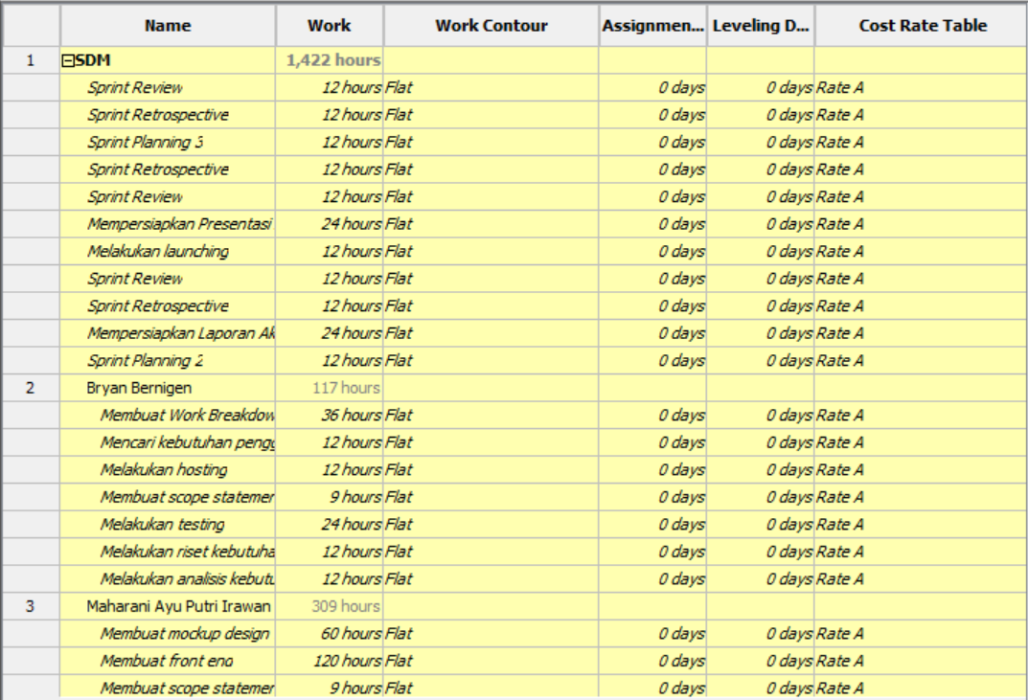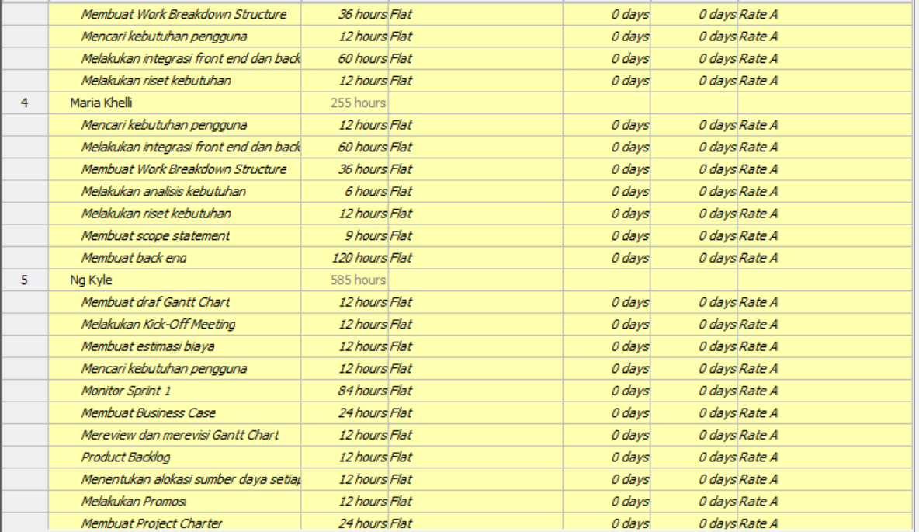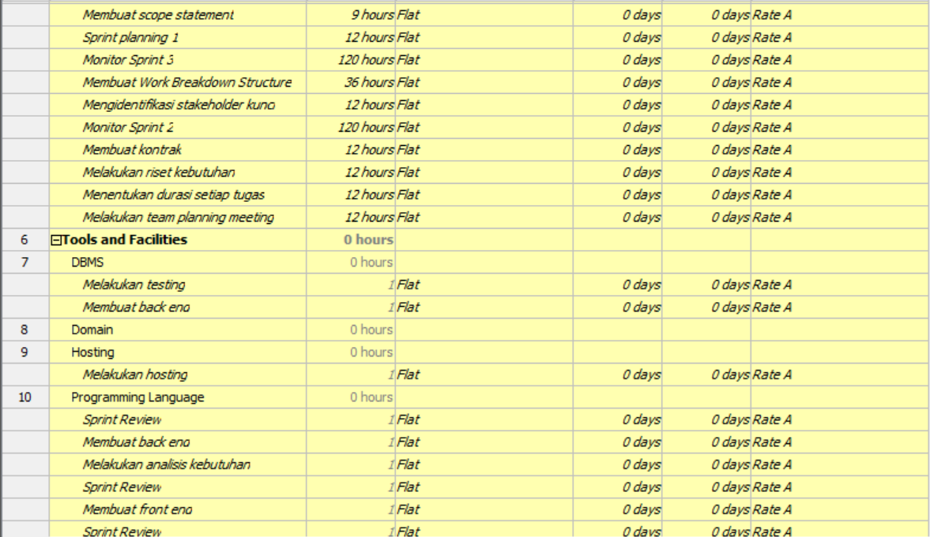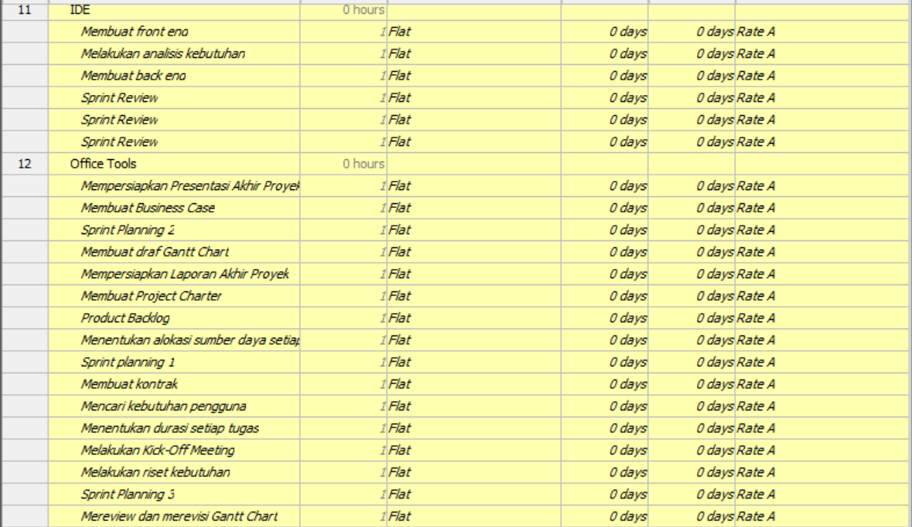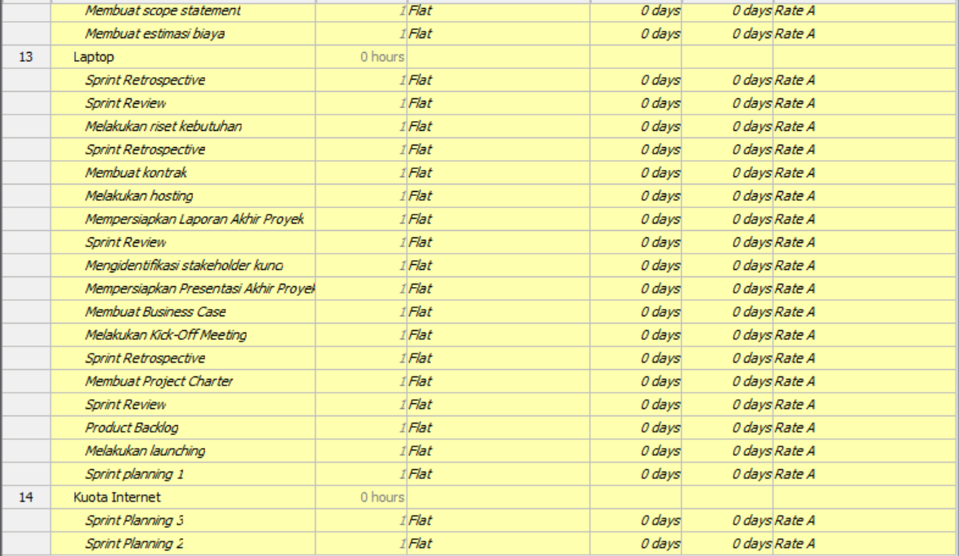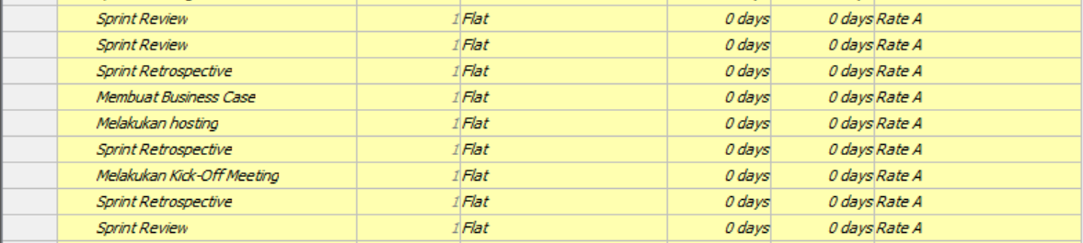

**Resource Breakdown Structure**

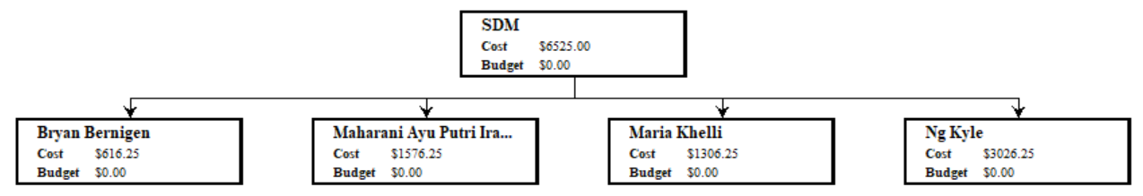

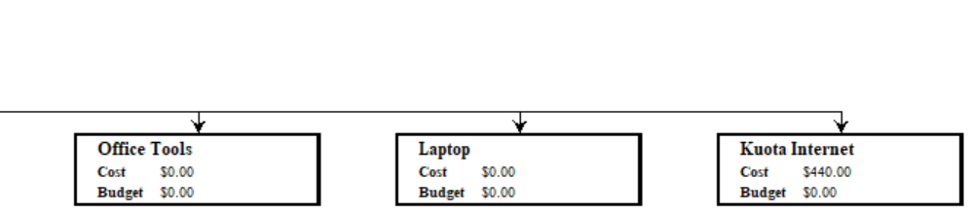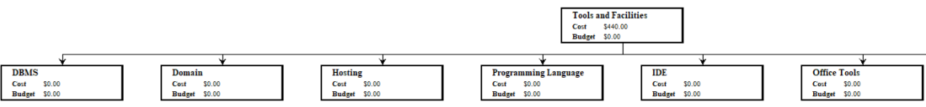

**Network**

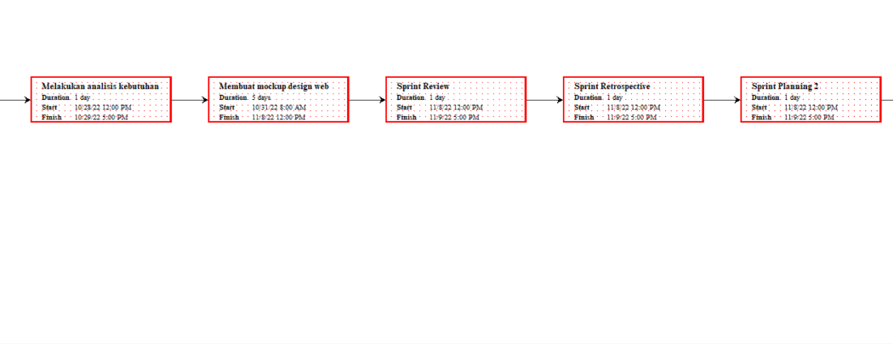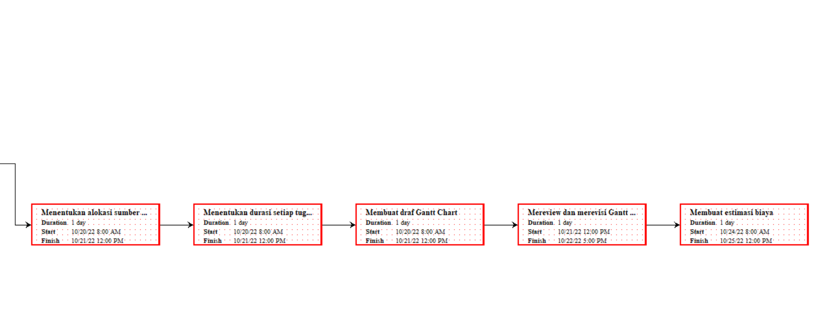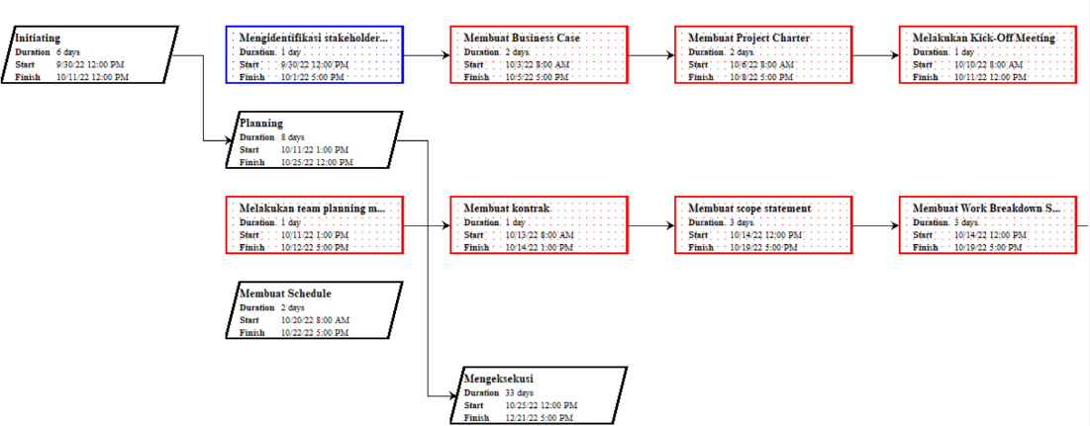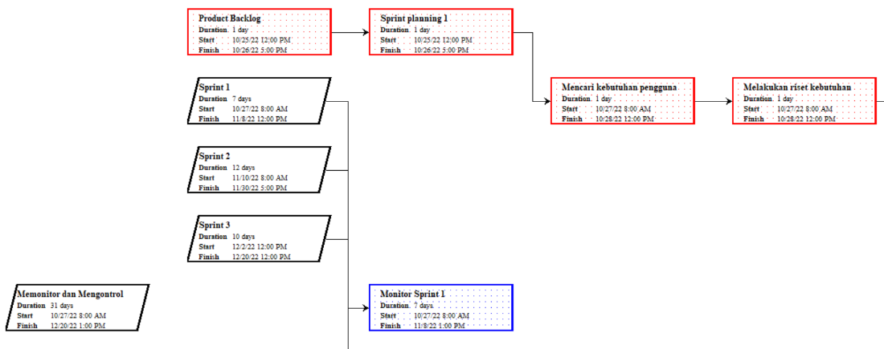

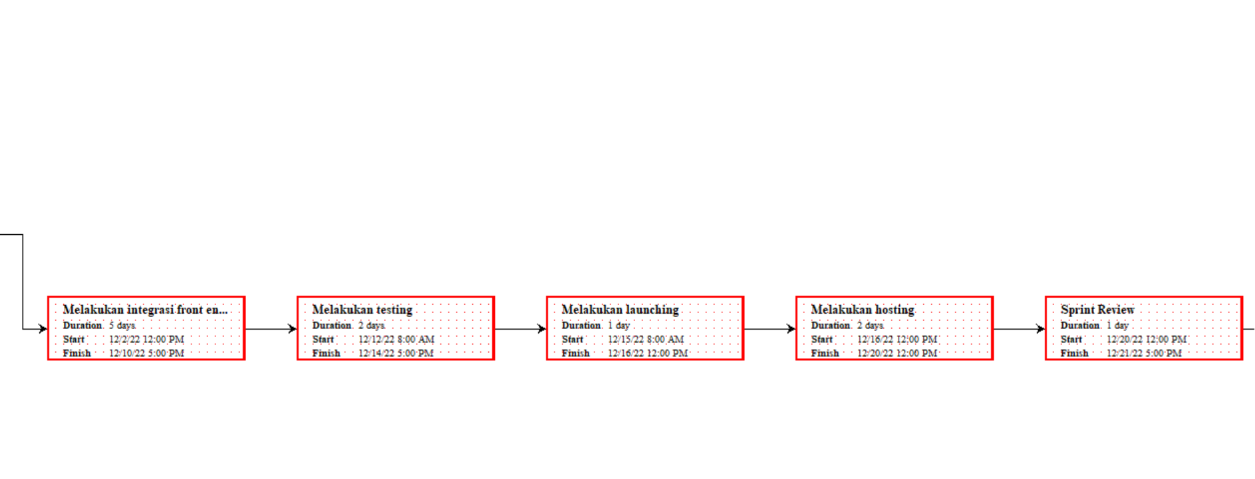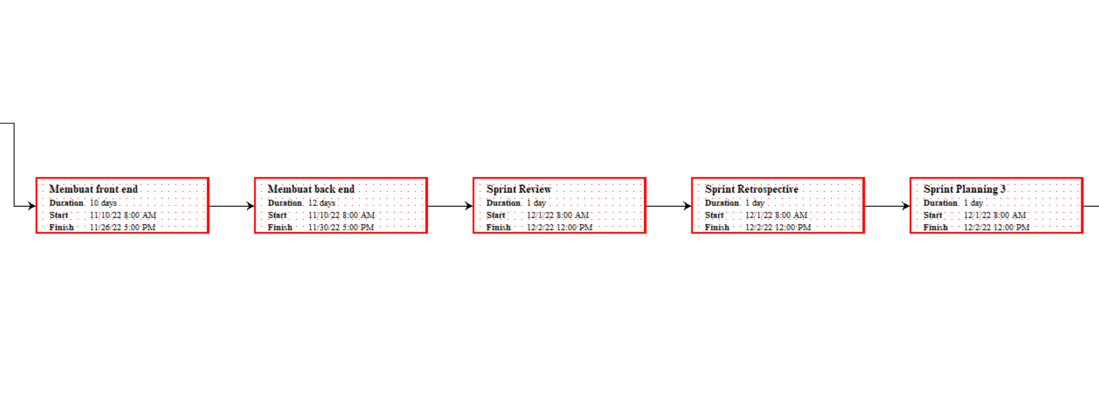

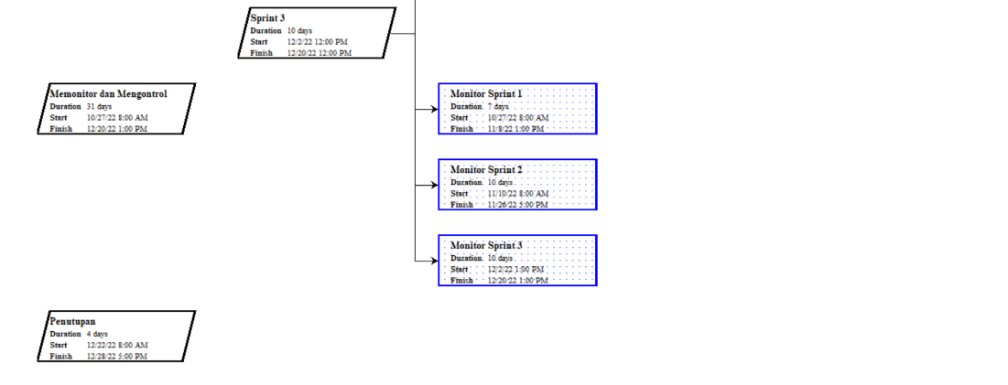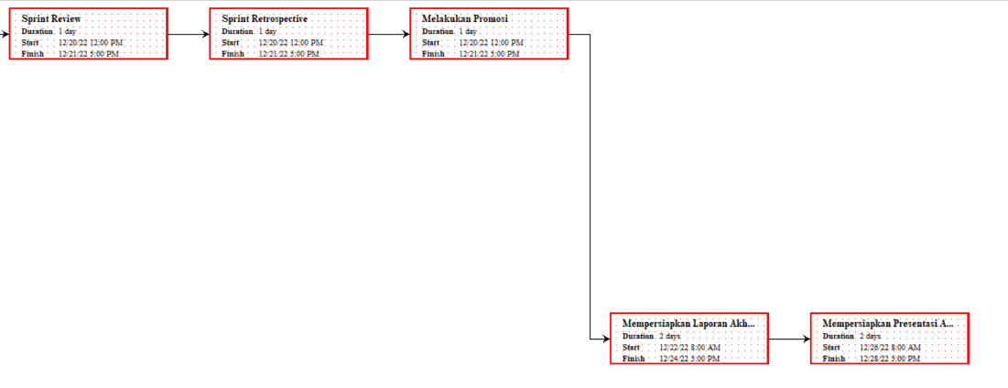

**Gantt Chart**

**Resource Schedules**

**Work Breakdown Structure**

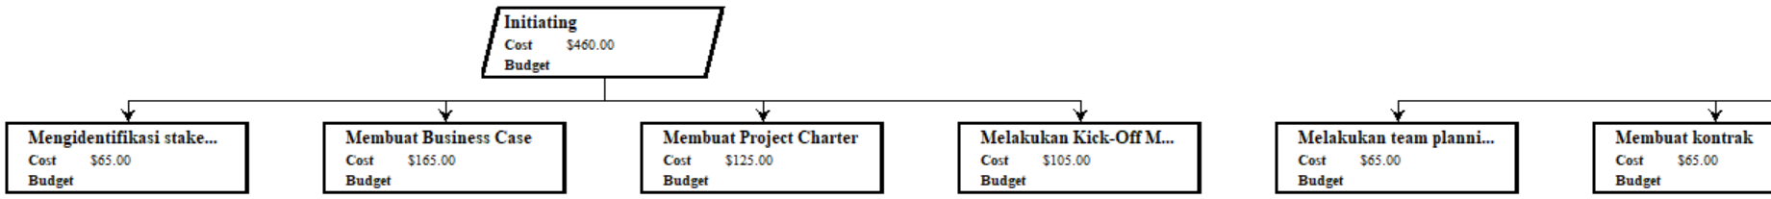

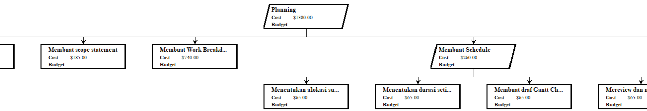

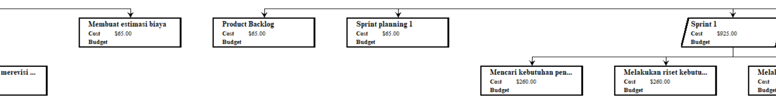

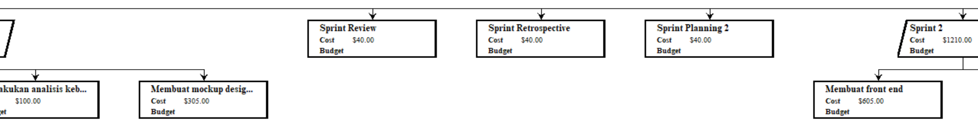

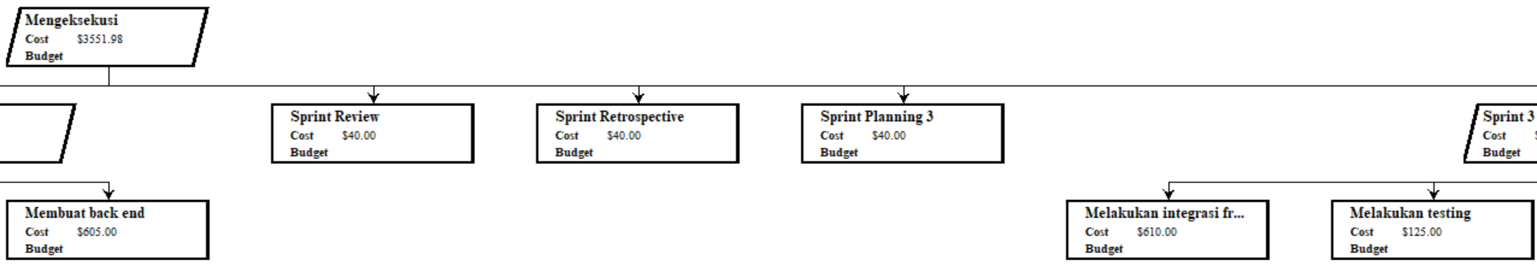

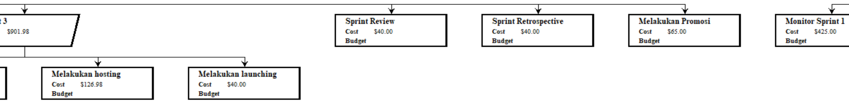

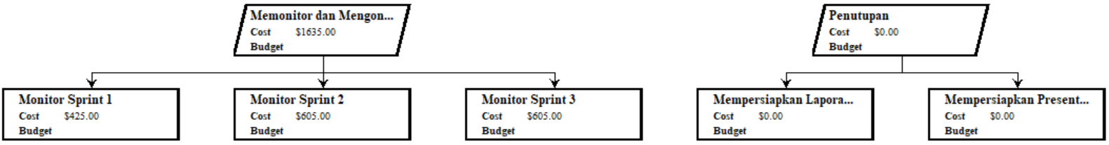

**Resources**

